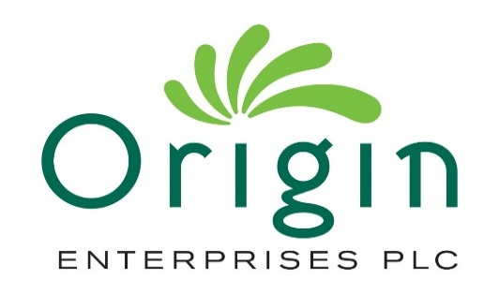

Appointment of Non-Executive Director

Lesley Williams joins Origin Board as independent Director

15 October 2021

Origin Enterprises plc ('Origin' or 'the Group'), the international Agri-Services Group, is pleased to announce the appointment of Ms Lesley Williams to the Board as an independent Non-Executive Director with immediate effect.

Lesley (56) has over 25 years’ experience in capital markets having held senior positions with Investec Bank plc as Head of Irish Equities, Euronext Dublin as Head of Irish Market and Goodbody Stockbrokers as Head of Institutional Equity Sales. She is an independent Non-Executive Director at Irish Continental Group plc and holds a number of directorships in the asset management and international fund sectors. Prior Board memberships include Non-Executive Director of Dublin Port Company, where she also held the position of Chair of the Audit and Risk Committee. Lesley also serves on the board of the Adelaide Health Foundation and is a member of the Euronext ISEQ Index Steering Committee.

Lesley is an Associate member of the Chartered Financial Analyst Institute (CFA) from which she holds a Certificate in ESG Investing and is a Fellow of the Chartered Institute for Securities and Investment. She also holds a Diploma in Company Direction from the Institute of Directors in Ireland and is a business graduate of University College Dublin.

Commenting on the appointment, Rose Hynes, Chairman of Origin said:
“We are delighted to welcome Lesley to the Origin Board. With a background in capital markets, Lesley brings a wealth of executive and non-executive experience, corporate governance expertise and ESG investment insight, further complementing the mix of skills, diversity and experience at Board level to support the Group in its continued growth and development.”

The following information is disclosed pursuant to Rule 17 of the AIM Rules for Companies and Rule 5.22 (b) of Chapter 5: Additional Rules for the Euronext Growth Market operated by Euronext Dublin:

Additional Information – Directorships
Irish Continental Group plc
Aberdeen Standard Investments II ICAV
Alternative Investments Access ICAV
Lindsell Train Global Funds plc
Oskare QIAIF ICAV
Ranmore Global Equity Fund plc
Irish Fund Directors Association
Adelaide Health Foundation

Directorships/Partnerships held in the last 5 years
Dublin Port Company plc

ENDS

There is no other information that is required to be disclosed in accordance with Rule 17, Schedule 2 paragraph (g) of the AIM Rules for Companies and Rule 5.22 (b), Schedule 2 paragraph (g) of Chapter 5: Additional Rules for the Euronext Growth Market operated by Euronext Dublin.

Enquiries

Origin Enterprises plc
TJ Kelly
Chief Financial Officer | Tel: | +353 (0)1 563 4959
Brendan Corcoran  Head of Investor Relations and Group Planning | Tel: | +353 (0)1 563 4900
Goodbody (Euronext Growth (Dublin) Adviser)  Finbarr Griffin | Tel: | +353 (0)1 641 9278
Davy (Nominated Adviser) Anthony Farrell | Tel: | +353 (0)1 614 9993
Numis Securities (Stockbroker) Stuart Skinner | Tel: | +44 (0)20 7260 1314
FTI Consulting (Financial Communications Advisers) Jonathan Neilan/ Patrick Berkery | Tel: | +353 (0)1 765 0884

About Origin Enterprises plc

Origin Enterprises plc is an international Agri-Services group, providing specialist agronomy advice, crop inputs and digital agricultural solutions to farmers, growers, landscapers and amenity professionals. The Group has leading market positions in Ireland, the United Kingdom, Brazil, Poland, Romania and Ukraine. Origin is listed on the Euronext Growth (Dublin) and AIM markets of the Irish and London Stock Exchanges.

Euronext Growth (Dublin) ticker symbol: OIZ
AIM ticker symbol OGN
Website: www.originenterprises.com

