2021/2022
2ND QUARTER & 6 MONTHS

AS PRFoods
Consolidated Unaudited Interim Report
2nd quarter and 6 months of 2021/2022
(translation from the Estonian original)

Business name AS PRFoods
Commercial registry code 11560713
Address Pärnu mnt 141, Tallinn, Estonia
Phone +372 452 1470
Website prfoods.ee
Main activities Production and sale of fish products
Fish farming
Reporting period 1 July 2020 – 31 December 2021
TABLE OF CONTENTS
Corporate Profile 4
Management Report 7
Overview of Economic Activities 7
Management and Supervisory Boards 18
Share and Shareholders 19
Bond and Bondholders 21
Condensed Interim Accounting Report 24
Consolidated Statement of Financial Position 24
Consolidated Statement of Profit or Loss And Comprehensive Income 25
Consolidated Cash Flow Statement 26
Consolidated Statement of Changes in Equity 27
Notes to the Interim Report 28
NOTE 1. Summary of Material Accounting Policies 28
NOTE 2. Cash and Cash Equivalents 28
NOTE 3. Receivables and Prepayments 29
NOTE 4. Inventories 29
NOTE 5. Biological Assets 29
NOTE 6. Tangible Assets 30
NOTE 7. Intangible Assets 31
NOTE 8. Interest-bearing Liabilities 31
NOTE 9. Payables and Prepayments 32
NOTE 10. Equity 33
NOTE 11. Cost of Goods Sold 33
NOTE 12. Related Party Transactions 33
NOTE 13. Associate Companies 34
NOTE 14. Contingent Liabilities 34
Management Board’s Confirmation to the Interim Report 38

Corporate Profile
AS PRFoods (hereinafter the "Group") is a company engaged in fish farming, processing and sales, and its shares are listed on the main list of NASDAQ Tallinn Stock Exchange since 5 May 2010 and its bonds are listed since 6 April 2020.
AS PRFoods’ key market is Finland, where we are amongst the four largest fish production companies. Since the acquisition of John Ross Jr. and Coln Valley Smokery in the summer of 2017, the Group has sales experience to 37 countries in Europe, North and South America, and Asia.
Main activities of the Group are fish farming and manufacturing of fish products. The main products are salmon and rainbow trout products. Approximately 2/3 of the raw fish used in the Group’s rainbow trout production comes from the Group’s fish farms in Swedish lakes, Turku Archipelago area in Finland and from coastal waters of Saaremaa in Estonia, assuring the highest quality and reliable deliveries. The rest of raw fish is purchased mainly from Norway and Denmark. Fish products are manufactured in four modern factories in Renko and Kokkola (Finland), in Saaremaa (Estonia), and in Aberdeen (Great Britain).
Products of the Group are sold as leading brands in their respective operating market and the primary focus is on higher value-added premium products, increasing thereby the profitability of the company.
Heimon Kala is a brand with a long history, originated in Finland and being one of the most beloved fish producers there. In Estonia, Heimon Kala products have been sold since the end of 2018. We process mostly rainbow trout and salmon in our factories, in smaller quantities also whitefish, perch, pikeperch, vendace, Atlantic and Baltic herrings. We always keep the fish in a place of honour – both when farming and processing it – that is why we raise most of our red fish ourselves and smoke it with alder chips in the traditional way. As our product range is quite wide, a favourite product can be found for the whole family – lightly salted trout slices that have won the title of the Best Fish Product in Estonia, children's favourite trout cutlets or trout roe for a more festive occasion.
The Group is actively involved in developing new products for expanding also to new export markets. As introducing the Group’s own brands is in its early stage in Scandinavia and elsewhere in the world, the management expects the Group’s growth period is yet ahead.

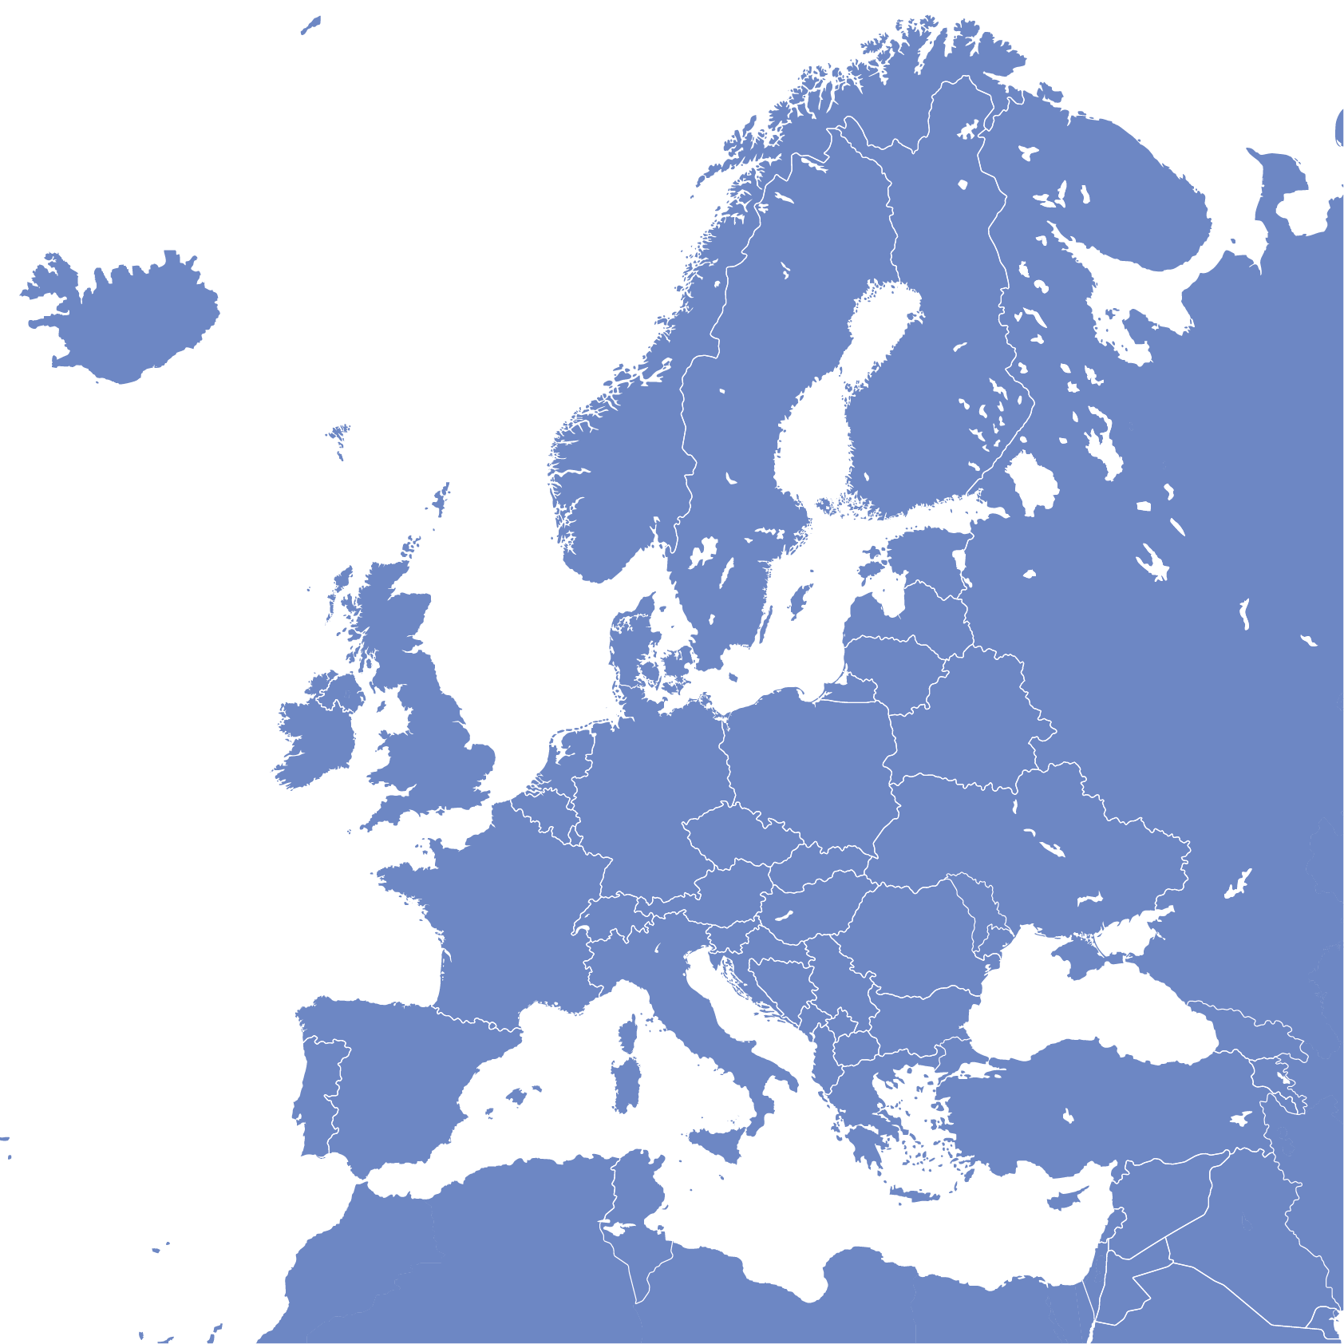





The Geography of Production and Sales
Fish farming | Finland  Sweden  Estonia
Purchase of raw fish | Finland  Sweden  Norway  Denmark
Production | Estonia  Finland  Great Britain
Sales | Finland  Great Britain Estonia


Group Structure as at 31.12.2021
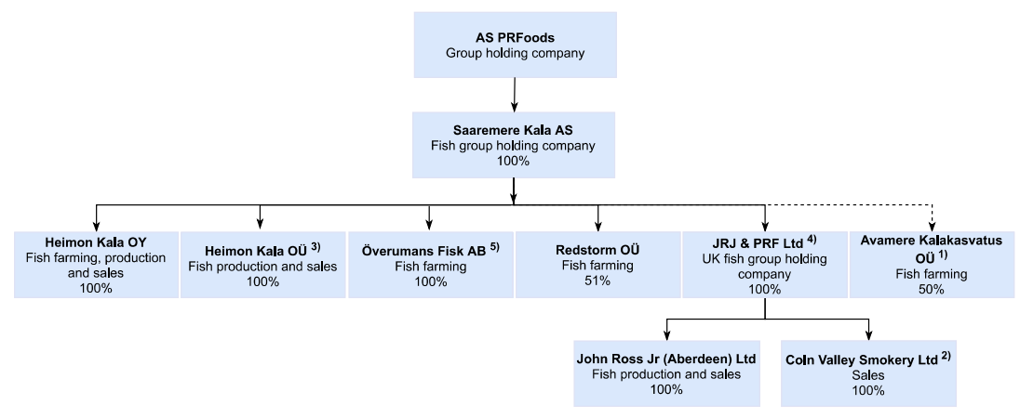
1)The Group does not consolidate Avamere Kalakasvatus OÜ as it holds neither dominant nor significant control over the company
2) 64% of Coln Valley Smokery Ltd shares owned by JRJ & PRF Ltd and 36% by John Ross Jr (Aberdeen) Ltd
3) Froma 01.01.2021 osaühing Vettel continued its activities under the business name Heimon Kala OÜ
4) Saaremere Kala AS will acquireed 15% of the shares of the holding company JRJ & PRF Limited and holds 100% of JRJ & PRF Limited shares
5) Saaremere Kala AS acquireed 100% of the shares of the Överumans Fisk AS

In addition, AS PRFoods holds a 20%-share of AS Toidu- ja Fermentatsioonitehnoloogia Arenduskeskus (Competence Center of Food and Fermentation Technology).
The most significant trademarks of the Group are “PRFoods”, "Heimon Kala" and “John Ross Aberdeen“.

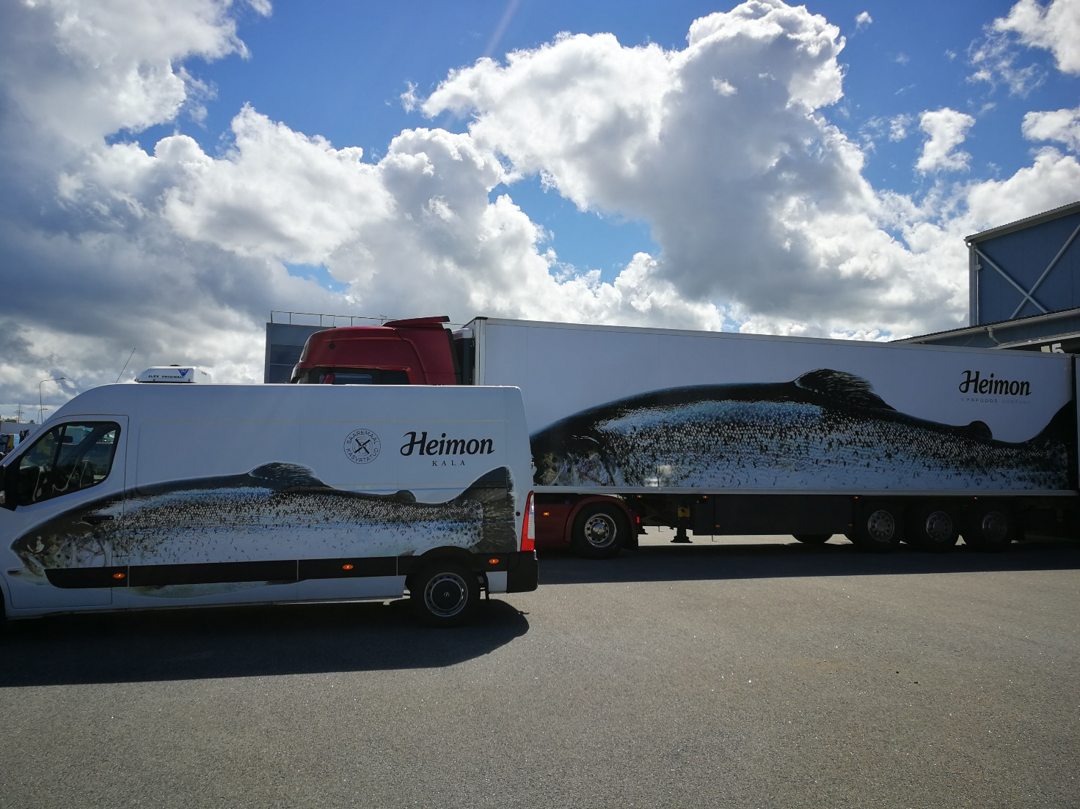
Management report

Management Report

Overview of Economic Activities

Management Commentary
2021 is over and with it also marks the end of Finnish saga. As disclosed, we have sale agreement of 100% shares of Heimon Kala Oy. Even if to consider slight improvement in group operational EBITDA, it was clear that without consolidation it would have been challenging for Heimon Kala Oy to remain an independent company. Multiple management mistakes and constant sale of private label products below cost price, led to decision that selling Heimon Kala Oy is rational decision rather than to keep restructuring and recapitalizing the business. The origin of losses in Finland is the incompetence of Finnish management in 2020 and 2021 to price products and manage cost base. Private label prices offered at the end of 2020 and beginning to 2021 (the pricing cycle in Finland is 6 months forward), didn´t not match raw material prices. In summer 2021 then current management decided to increase production, that caused additional losses, as sales were below cost. After changing the management in fall, company took new direction that took into account real market situation (raw material price increases were record high end of 2021) and these changes have taken effect by now.
Even as we managed to improve group operational EBITDA by 25%, as again whole loss in Q2 and H1 originated from Finland. H1 2021 results per company compared to H1 2020
- Redstorm OÜ sales 1.493 keur, sales increased 504 keur yoy
- Redstorm OÜ EBITDA 165 keur , EBITDA improved by 142 keur
- Överumans Fisk AB sales 5 keur, sales decreased by -1.474 keur. Sales decreased because we moved harvesting of fish to Q1 2022 from end of 2021 to getter better price for biomass
- Överumans Fisk AB operational EBITDA -70 keur, improved by 57 keur;
- Överumans Fisk AB EBITDA incl biomass revaluation was 588 keur, improved by 542 keur ;
- Õverumans Fisk AB EBT was affected by SEK/EUR exhcange rate on inter-company loans, effect in 2021 – 36 keur, last year + 165keur
- John Ross Jr /Coln Valley sales 6
- Heimon Kala OÜ sales were 6,134 meur, decreasing 17% yoy ( we stopped fresh fish trading in Q2)
- Heimon Kala OÜ EBITDA was -433 keur (-415 keur yoy) , negative result was attributable to Finnish sales
- Heimon Kala Oy sales and results are presented in appendix of the report and also as appendix 2 in announcement of sale of Heimon Kala Oy.

1.3. We continue with new structure and PRFoods keeps owning fish farming units Överumans Fisk AB and Redstorm OÜ (Saaremere Kala AS is holding new farming permit applications, in future the licences will be transferred to operational units) and processing units Heimon Kala OÜ in Estonia and John Ross Jr/Coln Valley in Scotland.
We have followed previously agreed action plans to emerge from crisis:

- Reduce debt level – Sale of Finnish unit allows significantly to reduce group debt.
- Restructure completely, potentially sell or close units in Finland: Heimon Kala Oy share sale agreement has been signed and deal will close on 1.3
- Increase sales in retail in UK, EU and Estonia : mission accomplished.
- Strategic goal of group is on fish farming , as units that have been constantly profitable. The target is to achieve licence volume of 10,000 by 2023, that should give additional revenue of 45-50 million euros in future. From Swedish farms we estimate full 2022 harvest to be ca 1500 tons. Estonian farming licenses are realistic to be issued in 2022. If the permits will be issued only n second half of 2022, the full prodcttion volumes will be reached in 2024 not in 2023.
Companies financial costs have risen due to higher debt capital, while one must note that significant portion of debt is convertible or related to related parties, that can be converted together with interest, in order to support company’s equity. Majority shareholders have opened additional credit limit to the company. We believe that after PRFoods has demonstrated that it can operate with profit after sale of Finland, cost of capital for company will also decrease.
The effect of sale of Heimon Kala Oy will be published in Q1 2022 report after the sale on 1.3.

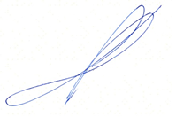

Sincerely,
Indrek Kasela


Unaudited Financial Results of AS PRFoods, the 2ND Quarter of the Financial Year 2021/2022 Compared to the 2ND Quarter of Financial Year 2020/2021
- Unaudited consolidated revenue 15.29 million euros (2Q 2020/2021: 17.04 million euros), a decrease by 10.2%
- Gross margin 14.1% (2Q 2020/2021: 14.9%)
- Negative impact from revaluation of fair value of biological assets 0.75 million euros (2Q 2020/2021: positive impact 0.12 million euros).
- Negative impact from one-offs on the result of the first quarter of the financial year 0.4 million euros (2Q 2020/2021: negative impact 0.3 million euros)
- EBITDA from operations 0.8 million euros (2Q 2020/2021: -0.6 million euros)
- EBITDA -0.32 million euros (2Q 2020/2021: 0.7 million euros), without one-offs EBITDA -0.035 million euros (2Q 2020/2021: -0.43 million euros)
- Operating loss 0.98 million euros (2Q 2020/2021: operating profit 0.03 million euros), without one-offs operating loss 0.61 million euros (2Q 2020/2021: operating loss 0.1 million euros)
- Net loss 1.38 million euros (2Q 2020/2021: net loss 0.20 million euros), without one-offs net loss 1.01 million euros (2Q 2020/2021: net loss 0.13 million euros)
SUMMARY OF FINANCIAL RESULTS: 2ND QUARTER OF 2021/2022 COMPARED TO 2ND qUARTER OF 2020/2021
mln EUR | 2Q 2021/2022 | 2Q 2020/2021 | Change, mln EUR | Change, % | Impact
Sales | 15.29 | 17.03 | -1.74 | -10.2% | ▼
Gross profit | 2.15 | 2.53 | -0.38 | -15.0% | ▼
EBITDA from operations* | 0.80 | 0.64 | 0.16 | 25.1% | ▲
Revaluation of bioassets | -0.75 | 0.12 | -0.87 | -735.1% | ▼
One-off expenses | -0.37 | -0.06 | -0.31 | 496.8% | ▼
EBITDA | -0.32 | 0.70 | -1.02 | -145.9% | ▼
Depreciation and amortisation | -0.66 | -0.66 | 0.01 | -1.2% | ▲
Operating profit (loss) | -0.98 | 0.03 | -1.02 | -2991.2% | ▼
Financial income/expense | -0.38 | -0.13 | -0.26 | 197.7% | ▼
Net profit (loss) | -1.38 | -0.20 | -1.19 | 606.1% | ▼
* before one-offs and fair value adjustment of bioassets

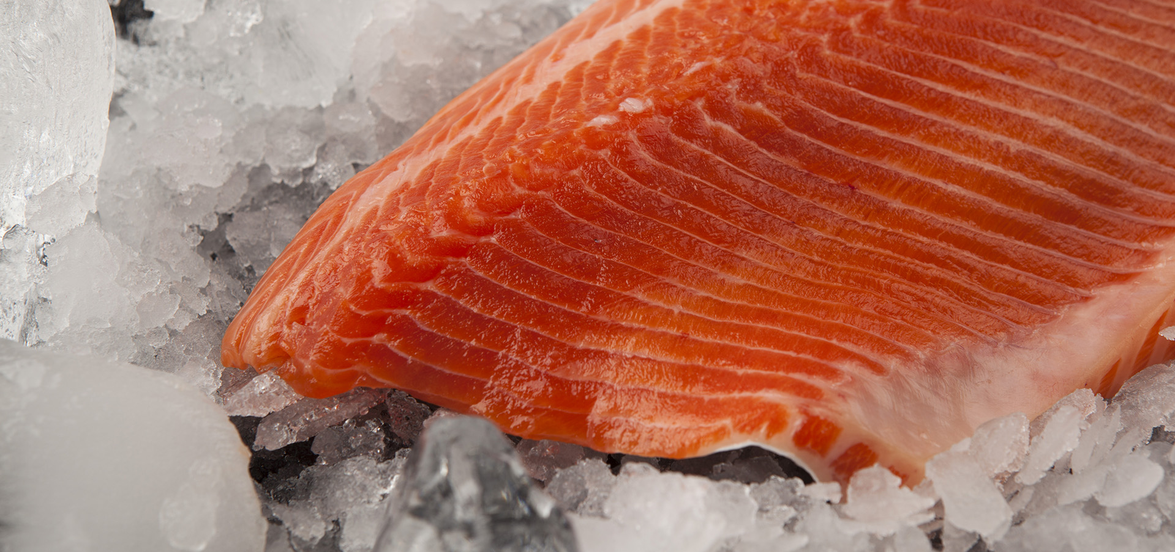

Unaudited Financial Results of AS PRFoods, the 6 months of the Financial Year 2021/2022 Compared to 6 monhts of Financial Year 2020/2021
- Unaudited consolidated revenue 29.50 million euros (6m 2020/2021: 29.77 million euros), a decrease by 0.9%
- Gross margin 9.9% (6m 2020/2021: 12.5%)
- Positive impact from revaluation of fair value of biological assets 0.07 million euros (6m 2020/2021: positive impact 0.2 million euros).
- Negative impact of one-offs on the result by 0.4 million euros (6m 2020/2021: negative impact 0.11 million euros)
- EBITDA from operations -0.35 million euros (6m 2020/2021: 0.3 million euros)
- EBITDA -0.33 million euros (6m 2020/2021: 0.22 million euros), without one-offs EBITDA 0.1 million euros (6m 2020/2021: 0.3 million euros)
- Operating loss 1.65 million euros (6m 2020/2021: operating loss 1.09 million euros), without one-offs operating loss 1.23 million euros (6m 2020/2021: operating loss 0.98 million euros)
- Net loss 2.12 million euros (6m 2020/2021: net loss 1.63 million euros), without one-offs net loss 1.7 million euros (6m 2020/2021: net loss 1.5 million euros)
SUMMARY OF FINANCIAL RESULTS: 6 months OF 2021/2022 COMPARED TO 6 months OF 2020/2021
mln EUR | 6m 2020/2021 | 6m 2019/2020 | Change, mln EUR | Change, % | Impact
Sales | 29.50 | 29.77 | -0.27 | -0.9% | ▼
Gross profit | 2.93 | 3.73 | -0.81 | -21.6% | ▼
EBITDA from operations* | -0.35 | 0.30 | -0.66 | -216.1% | ▼
Revaluation of bioassets | 0.07 | 0.02 | 0.04 | 183.3% | ▲
One-off expenses | -0.41 | -0.11 | -0.30 | 269.6% | ▼
EBITDA | -0.33 | 0.22 | -0.55 | -252.3% | ▼
Depreciation and amortisation | -1.31 | -1.31 | 0.00 | 0.2% | ▼
Operating profit (loss) | -1.65 | -1.09 | -0.56 | 51.0% | ▼
Financial income/expense | -0.37 | -0.44 | 0.07 | -16.0% | ▲
Net profit (loss) | -2.12 | -1.63 | -0.49 | 30.0% | ▼
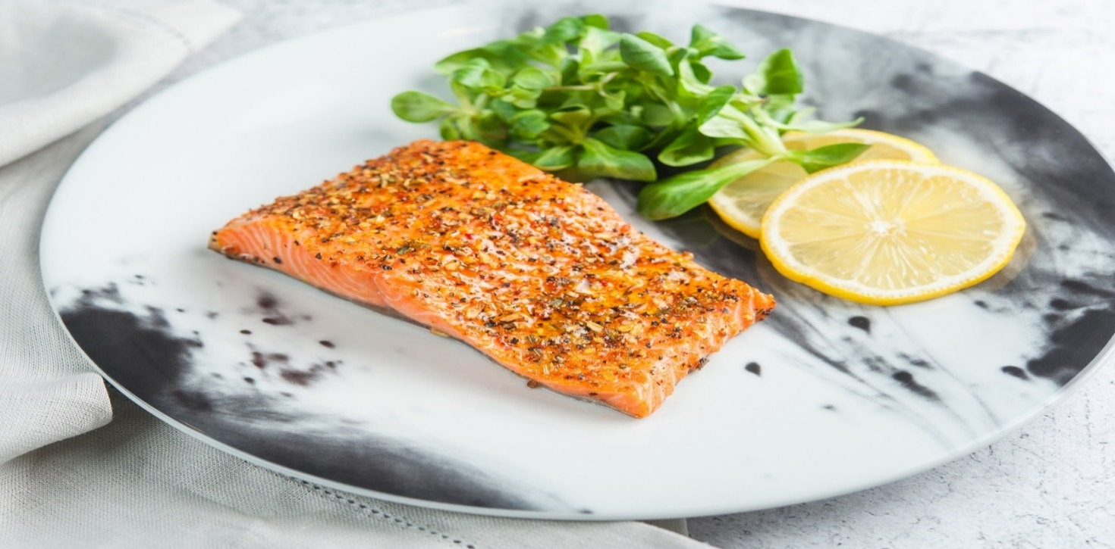
* before one-offs and fair value adjustment of bioassets
KEY RATIOS – INCOME STATEMENT
mln EUR  unless indicated otherwise | 4Q 2021 | 3Q 2021 | 2Q 2021 | 1Q 2021 | 4Q 2020 | 3Q 2020 | 2Q 2020 | 1Q 2020 | 4Q 2019
Sales | 15.3 | 14.2 | 14.7 | 14.2 | 17.0 | 12.7 | 15.1 | 18.5 | 25.4
Gross profit | 2.2 | 0.8 | 0.3 | 0.9 | 2.5 | 1.2 | 0.7 | 2.0 | 4.3
EBITDA from operations | 0.8 | -0.8 | -1.0 | -0.5 | 0.6 | -0.3 | -0.1 | 0.0 | 2.1
EBITDA | -0.3 | 0.0 | -0.7 | -0.7 | 0.7 | -0.5 | -0.1 | -0.9 | 1.4
EBIT | -1.0 | -0.7 | -1.4 | -1.4 | 0.0 | -1.1 | -1.0 | -1.4 | 0.7
EBT | -1.4 | -0.6 | -1.6 | -1.8 | -0.1 | -1.4 | -1.2 | -1.8 | 0.6
Net profit (loss) | -1.4 | -0.7 | -1.7 | -1.8 | -0.2 | -1.4 | -1.3 | -1.7 | 0.5
Gross margin | 14.1% | 5.4% | 2.1% | 6.6% | 14.9% | 9.4% | 4.4% | 10.8% | 17.0%
Operational EBITDA margin | 5.2% | -5.5% | -7.0% | -3.5% | 3.4% | -2.6% | -0.9% | 0.1% | 8.4%
EBITDA margin | -2.1% | -0.1% | -4.8% | -5.3% | 4.1% | -3.8% | -0.5% | -4.6% | 5.3%
EBIT margin | -6.4% | -4.7% | -9.3% | -9.9% | 0.2% | -8.8% | -6.4% | -7.8% | 2.9%
EBT margin | -8.9% | -4.6% | -10.8% | -12.5% | -0.6% | -11.3% | -8.3% | -9.8% | 2.2%
Net margin | -9.1% | -5.2% | -11.6% | -12.5% | -1.2% | -11.3% | -8.4% | -9.2% | 2.0%
Operating expense ratio | 15.1% | 16.3% | 15.4% | 15.6% | 15.6% | 18.2% | 14.0% | 14.3% | 12.5%

EBITDA from operations = Profit (Loss) before one-offs and fair value adjustment of bioassets
EBITDA = Profit (Loss) before interest, tax, depreciation and amortisation
EBIT = Operating profit (loss)
EBT = Profit (Loss) before tax
Gross margin = Gross profit / Net sales
Operational EBITDA margin = EBITDA from operations / Net sales
EBITDA margin = EBITDA / Net sales
EBIT margin = EBIT / Net sales
EBT margin = EBT / Net sales
Net margin = Net earnings / Net sales
Operating expense ratio = Operating expenses / Net sales
KEY RATIOS – BALANCE SHEET
mln EUR  unless indicated otherwise | 31.12. 2021 | 30.09. 2021 | 30.06. 2021 | 31.03. 2021 | 31.12. 2020 | 30.09. 2020 | 30.06. 2020 | 31.03. 2020 | 31.12. 2019
Net debt | 24.2 | 24.2 | 20.9 | 21.4 | 21.9 | 21.5 | 20.7 | 17.0 | 17.8
Equity | 14.9 | 14.9 | 15.8 | 17.6 | 18.6 | 18.5 | 19.8 | 21.6 | 23.3
Working capital | -2.6 | -2.6 | -2.9 | -5.0 | -3.9 | -4.4 | -4.0 | -2.5 | -3.5
Assets | 56.0 | 56.0 | 55.3 | 54.5 | 57.5 | 57.4 | 57.1 | 56.9 | 60.5
Liquidity ratio | 0.9x | 0.9x | 0.9x | 0.8x | 0.8x | 0.8x | 0.8x | 0.9x | 0.9x
Equity ratio | 26.7% | 26.7% | 28.6% | 32.4% | 32.4% | 32.3% | 34.7% | 37.9% | 38.5%
Gearing ratio | 61.8% | 61.8% | 56.9% | 54.9% | 54.0% | 53.7% | 51.1% | 44.0% | 43.3%
Debt to total assets | 0.7x | 0.7x | 0.7x | 0.7x | 0.7x | 0.7x | 0.7x | 0.6x | 0.6x
Net debt to operating EBITDA | -14.3x | -14.3x | -16.9x | -55.3x | 160.0x | 12.8x | 7.5x | 5.3x | 5.3x
ROE | -26.7% | -26.7% | -28.7% | -23.8% | -21.9% | -7.0% | -9.1% | -5.7% | -3.2%
ROA | -7.9% | -7.9% | -9.1% | -8.4% | -7.8% | -2.4% | -3.2% | -2.1% | -1.2%

Net debt = Short- and long-term loans and borrowings – Cash
Working capital = Current assets – Current liabilities
Liquidity ratio = Current assets / Current liabilities
Equity ratio = Equity / Total assets
Gearing ratio = Net debt / (Equity + Net debt)
Debt to total assets = Debt / Total assets
Net debt to operating EBITDA. = Net debt / EBITDA from operations for the trailing 12 months
ROE = Net earnings for the trailing 12 months / Average equity
ROA = Net earnings for the trailing 12 months / Average assets

Balance Sheet
As at 31.12.2021 consolidated total assets of PRFoods stood at 53.0 million euros. The year before i.e. as at 31.12.2020 the balance sheet totalled 57.5 million euros.
The Group`s current assets stood at 14.1 million euros as at 31.12.2021 (31.12.2020: 18.4 million euros). Non-current assets totalled 38.7 million euros (31.12.2021: 39.0 million euros).
Current liabilities totalled 18.1 million euros as at 31.12.2021 (31.12.2020: 22.3 million euros). Non-current liabilities totalled 20.7 million euros (31.12.2020: 16.5 million euros). Equity of PRFoods was 13.9 million euros (31.12.2021: 18.6 million euros).

Revenue
The main products of the Group are salmon and rainbow trout goods. The Group is mainly known as a seller of fresh fish and fish products in Finland, a seller of smoked fish products in the UK and a seller of raw fish in Estonia as well as the biggest supplier of caviar to Estonian stores.
The Group’s revenue during the twelve months of the financial year 2021/2021 was 14.7 million euros, up by 1.5 million euros compared to the same period of the previous financial year, when the sales amounted to 12.7 million euros.
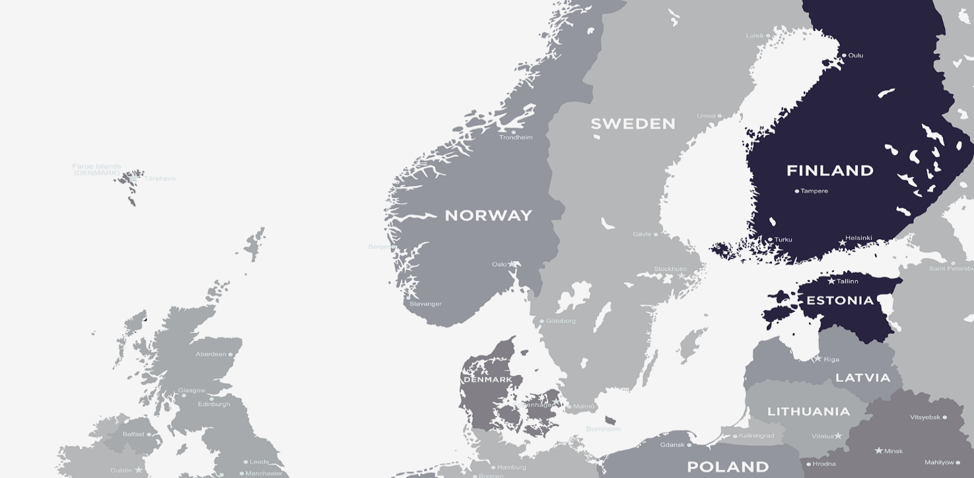
57.7%

19.9%

11.5%

UNITED KINGDOM

GEOGRAPHIC SEGMENTS
mln EUR | 6m 21/22 | Share, % | 6m 20/21 | Share, % | Change, mln EUR | Change,  % | Imp.
Finland | 17.0 | 57.7% | 18.8 | 63.3% | -1.8 | -9.5% | ▼
United Kingdom | 5.9 | 19.9% | 4.7 | 15.9% | 1.1 | 24.0% | ▲
Estonia | 3.4 | 11.5% | 2.5 | 8.3% | 0.9 | 36.6% | ▲
Other | 3.2 | 10.9% | 3.7 | 12.5% | -0.5 | -14.0% | ▼
Total | 29.5 | 100.0% | 29.8 | 100.0% | -0.3 | -0.9% | ▼
Finland with sales revenue of 17.0 million euros and 57.7% of total sales is the largest market of the Group. Revenue of the second largest market, UK. amounted to 5.9 million euros. i.e.. 18.9% of total sales. Revenue of the Estonian market totalled 3.4 million euros. i.e.. 11.5% of the total.
PRODUCT SEGMENTS
mln EUR | 6m 21/22 | Share, % | 6m 20/21 | Share. % | Change. mln EUR | Change.  % | Imp.
Hot & cold smoked fish | 15.2 | 51.5% | 14.2 | 47.8% | 1.0 | 6.7% | ▲
Fresh fish and fillets | 9.2 | 31.0% | 9.6 | 32.3% | -0.5 | -4.8% | ▼
Other fish products | 5.1 | 17.4% | 5.9 | 19.8% | -0.8 | -12.7% | ▼
Other | 0.01 | 0.0% | 0.01 | 0.1% | 0.00 | -48.0% | ▼
Total | 29.5 | 100.0% | 29.8 | 100.0% | -0.3 | -0.9% | ▼
The largest product group of the first quarter of the financial year was hot and cold smoked fish product group, the sales of which amounted to 15.2 million euros and accounted for 51.5% of total sales. The sales of fresh fish and fillets product group of 9.2 million euros accounted for 31.0% of the total.
CLIENT SEGMENTS
mln EUR | 6m 21/22 | Share, % | 6m 20/21 | Share. % | Change. mln EUR | Change.  % | Imp.
Retail chains | 14.1 | 47.9% | 17.1 | 57.4% | -3.0 | -17.3% | ▼
Wholesale | 6.7 | 22.6% | 5.2 | 17.6% | 1.4 | 27.2% | ▲
HoReCa | 6.2 | 21.2% | 5.9 | 20.0% | 0.3 | 5.0% | ▲
Other | 2.5 | 8.3% | 1.5 | 5.0% | 1.0 | 64.4% | ▲
Total | 29.5 | 100.0% | 29.8 | 100.0% | -0.3 | -0.9% | ▲

The largest client group is the retail chains’ group sales of which amounted to 14.1 million euros and accounted for 47.9% of the total sales during the period. Sales to wholesale amounting to 6.7 million euros and sales to HoReCa amounting to 6.2 million euros account for 22.6% and 21.2% respectively of the total sales.

Costs
 | 6m 21/22 | 6m 20/21 | Change | Impact | 6m 21/22 | 6m 20/21 | Change | Impact
 | mln EUR | mln EUR | mln EUR | Impact | as % of sales | as % of sales | %-point | Impact
Sales | 29.50 | 29.77 | -0.27 | ▼ | 100.00% | 100.00%
Cost of goods sold | -26.58 | -26.03 | -0.55 | ▼ | 90.11% | 87.46% | 2.65% | ▼
materials in production & cost of goods purchased for resale | -19.61 | -18.75 | -0.86 | ▼ | 66.46% | 63.00% | 3.46% | ▼
labour costs | -3.24 | -3.30 | 0.06 | ▲ | 10.97% | 11.07% | -0.10% | ▲
depreciation | -1.09 | -1.09 | 0.00 | ▲ | 3.69% | 3.65% | 0.04% | ▼
other cost of goods sold | -2.64 | -2.89 | 0.25 | ▲ | 8.99% | 9.74% | -0.75% | ▲
Operating expenses | -4.70 | -4.99 | 0.29 | ▲ | 15.95% | 16.75% | -0.80% | ▲
labour costs | -1.37 | -1.67 | 0.30 | ▲ | 4.65% | 5.62% | -0.97% | ▲
transport & logistics services | -1.67 | -1.64 | -0.03 | ▼ | 5.64% | 5.51% | 0.13% | ▼
depreciation | -0.23 | -0.22 | -0.01 | ▼ | 0.78% | 0.75% | 0.03% | ▼
advertising. marketing and product development | -0.14 | -0.21 | 0.07 | ▲ | 0.48% | 0.70% | -0.22% | ▲
other operating expenses | -1.29 | -1.25 | -0.04 | ▼ | 4.40% | 4.17% | 0.23% | ▼
Other income/expenses | 0.06 | 0.14 | -0.08 | ▼ | 0.21% | 0.46% | -0.25% | ▼
incl. one-offs | -0.41 | -0.11 | -0.30 | ▼ | -1.40% | -0.38% | -1.02% | ▼
Financial income / expense | -0.37 | -0.44 | 0.07 | ▲ | -1.25% | -1.47% | 0.22% | ▲

Cost of Goods Sold (COGS)
COGS sold was 26.58 million euros and it accounted for 90.11% of the total sales of the six months of the 2021/2022 financial year (6m 2020/2021: 26.03 million euros, 87.46% of sales).

Operating Expenses
Operating expenses amounted to 4.7 million euros and accounted for 15.95% of the total sales (6m 2020/2021: 4.99 million euros, 16.75% of sales).
The majority of operating costs are costs on transport & logistics services and labour, formed 5.64% and 4.65%, respectively.

Personnel
The average number of employees in PRFoods in the 2nd quarter of the financial year 2021/2022 was 280. The Group’s labour costs totalled 2.5 million euros in the 2nd quarter of 2021/2022.
 | 4Q 2021 | 3Q 2021 | 2Q 2021 | 1Q 2021 | 4Q 2020 | 3Q 2020 | 2Q 2020 | 1Q 2020 | 4Q 2019
Average number of employees | 280 | 270 | 272 | 277 | 287 | 282 | 279 | 305 | 348
Finland | 77 | 76 | 77 | 78 | 80 | 76 | 71 | 74 | 991
Estonia | 82 | 82 | 83 | 86 | 89 | 91 | 96 | 101 | 114
UK | 106 | 97 | 97 | 98 | 102 | 98 | 95 | 111 | 125
Sweden | 15 | 15 | 15 | 15 | 16 | 17 | 17 | 19 | 18
Payroll expense. th EUR | 2 519 | 2.089 | 2.209 | 2.089 | 2.727 | 2.241 | 2.168 | 2.559 | 3.161
Monthly average payroll expense per employee. th EUR | 3.0 | 2.58 | 2.71 | 2.51 | 3.11 | 2.65 | 2.59 | 2.80 | 3.03

Fish Farming
The competitive advantage of the Group is its vertical integration – fish farming, production and sales. About two thirds of the raw trout used in the Group’s production is harvested from the Group’s own fish farms in the lakes in Sweden, in the archipelago in Turku area in Finland and in coastal area of Saaremaa, Estonia, ensuring that customers receive fast and high-quality deliveries.
Vertical integration enables the Group to reduce costs in certain phases of fish farming and to also enhance control foremost over fish processing and marketing. In the fish business, as fish are livestock, the quality assurance in the technological process has keenly to be maintained throughout the entire product lifecycle. In addition to improved cost control, the vertical integration enables to reduce risks in fish farming, for instance due to poor quality of feed or base materials, and to secure the volume required for processing as well as price stability of raw material
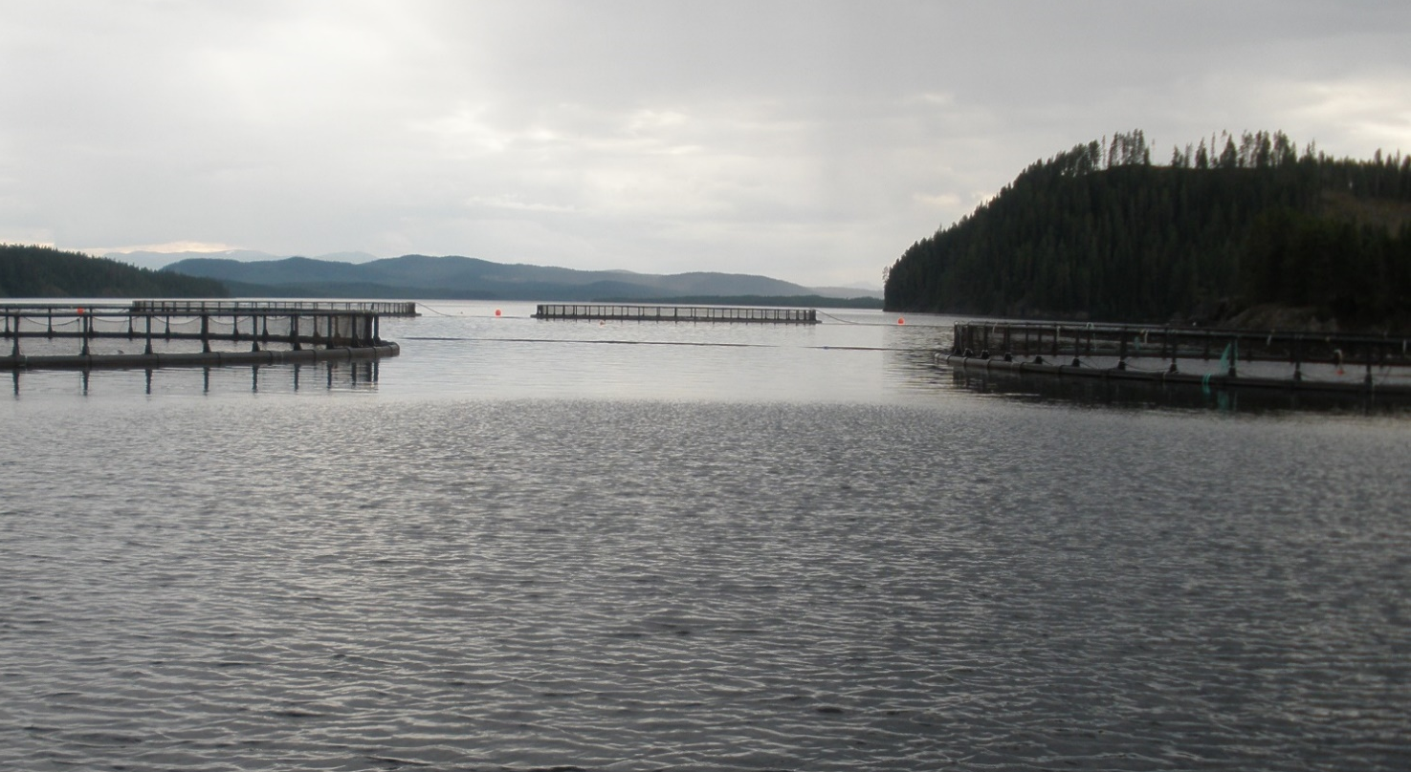
Överumans Fisk AB fish farm in Sweden

Price of Fish
The fish industry is extremely dependent on availability and the price of raw fish. Large producers make their production plans for three years in advance as it is difficult and expensive in shorter perspective to adapt a fish farm’s production cycle to market needs. Therefore, the world market fish supply is relatively rigid in the short-term, while demand is somewhat shifting depending on the season. This imbalance in fish supply and demand results in constantly fluctuating price of raw fish. Moreover, the far-reaching change in supply chains related to the spread of the virus has increased the amplitude and unpredictability of prices. The Group counters the impact of external environment and volatility of fish price through the changes of the Group’s production and sales strategy.
MARKET PRICE OF fISH
EUR/kg | 31.12.2021 | 31.12.2020 | 31.12.21 vs 31.12.20 | 31.12.2019 | 31.12.21 vs 31.12.19 | 31.12.2018 | 31.12.21 vs 31.12.18
Salmon | 6.41 | 4.89 | 31.1% | 7.85 | -18.3% | 6.59 | -2.7%
Rainbow trout | 6.96 | 4.89 | 42.4% | 6.31 | 10.3% | 5.88 | 18.3%

As at the end of the reporting period the price of salmon has increased by 31.1% and the price of rainbow trout has increased by 42.4% compared to the prices a year ago. Over the two-year period the price of salmon has decreased by 18.3% and the trout by 10.3%. The price of salmon has decreased by 2.7% and of rainbow trout has increased by 18.3% compared to the prices three years ago.
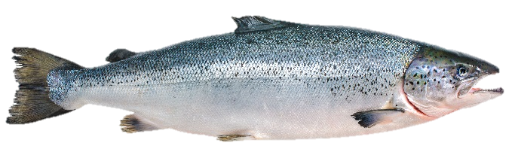
The graphs below illustrate weekly average prices of salmon and rainbow trout since the financial year 2016/2017.

Export Price of Norwegian Salmon

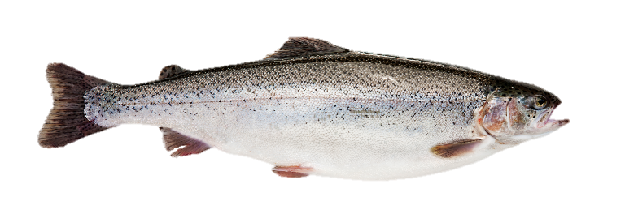

Export Price of Norwegian Rainbow Trout

AVERAGE mARKET PRICE OF fiSH
EUR/kg | 6m 2021/2022 | 6m 2020/2021 | 2021/2022 vs 2020/2021 |  | 6m 2019/2020 |  | 2021/2022 vs 2019/2020 | 6m 2018/2019 | 2021/2022 vs 2018/2019
Salmon | 5.65 | 4.24 | 33.4% | 5.26 |  | 7.4% |  | 5.74 | -1.6%
Rainbow trout | 6.14 | 4.43 | 38.5% | 5.26 |  | 16.8% |  | 5.75 | 6.9%

As at the end of the reporting period the average market prices of salmon and rainbow trout have decreased by 33.4% and 38.5%, respectively compared to the prices of the same period in the previous financial year. Compared to the average prices of a comparable period two years ago the average prices of salmon and trout have decreased.

Biological Assets
Biological assets are fish stock accounted for in PRFoods’ fish farms in live weight. including rainbow trout (Oncorhynchus mykiss) and European whitefish (Coregonus lavaretus).
The Group uses the Norwegian export statistics (source: akvafakta.no) to assess the value of rainbow trout’s stock. For assessing the value of whitefish stock. the monthly market price survey of the Finnish Fish Farmers’ Association is used. When the price of raw fish increases or decreases, so does the value of fish harvested in fish farms of PRFoods. having either a positive or a negative impact on the Group’s financial results.
CHANGE in BIOLOGICAL ASSETS. TONNES
 | 6m 21/22 | 6m 20/21 | Change. tonnes 6m 21/22 vs 6m 20/21 | Change. % 6m 21/22 vs 6m 20/21
Biomass at the beginning of the period | 945 | 987 | -42 | -4.3%
Biomass at the end of the period | 932 | 999 | -67 | -6.7%
Harvested fish (in live weight) | 1 074 | 1 453 | -379 | -26.1%

Biological assets totalled 932 tonnes as at 31.12.2021, a decrease by 67 tonnes. i.e. 6.7% compared to the same period last year. Due to the restructuring of Swedish fish farms and the introduction of new permits, the sale of fish was postponed, so production has not been recorded in the first quarter.
BIOMASS VOLUME AND AVERAGE PRICE. EUR/KG
 | 6m 21/22 |  | 6m 20/21 | Change. tonnes 6m 21/22 vs 6m 20/21 | Change. % 6m 21/22 vs 6m 20/21
Biological assets at the end of period. mln EUR |  | 4.52 | 3.70 | 0.82 | 22.2%
Biomass volume at the end of period. tonnes |  | 932 | 999 | -67 | -6.7%
Average price. EUR/kg |  | 4.85 | 3.71 | 1.15 | 31.0%
Fair value adjustment of biological assets. mln EUR |  | 0.07 | 0.02 | 0.04 | 183.3%

The fair value of biological assets was 4.5 million euros compared to 3.7 million euros a year ago. Average price of biomass was 4.85 euros per kg compared to 3.71 euros per kg during the comparable period a year ago.

Management and Supervisory Boards
The Management Board of AS PRFoods is comprised of one member – Indrek Kasela – who as per the supervisory board's decision serves as the sole member of the management board since 2 February 2015. The management board is independent in its day-to-day management of the business, protects the best interests of all shareholders and thereby ensures the company’s sustainable development in accordance with the set objectives and strategy. It is also responsible for the internal control and risk management processes in the company.
The Supervisory Board of AS PRFoods appoints management board members for a three-year term. The articles of association prescribe the management board to consist of one to four members. Indrek Kasela (born 1971), holds an LL.M (Master of Laws) degree from New York University (1996) and a BA degree in law from the University of Tartu (1994).
In addition to the management position in PRFoods, he is a member of management boards in almost all the Group entities and in several non-Group entities (Lindermann. Birnbaum & Kasela OÜ. ManageTrade OÜ. NBLJK OÜ. etc). He chairs or is a member of supervisory boards among others of the following companies: AS Toode, ELKE Grupi AS, ELKO Grupa AS, EPhaG AS, Salva Kindlustuse AS, Ridge Capital AS, AS Ekspress Grupp, Elering AS, SA Avatud Eesti Fond, Tulundusühistu Tuleva, Eesti Avamere Vesiviljelejate Ühistu. He serves also as a board member in several companies and NPOs domiciled abroad.
The Supervisory Board of AS PRFoods is comprised of six members. The board is chaired by Lauri Kustaa Äimä, members of the supervisory board are Aavo Kokk, Harvey Sawikin, Vesa Jaakko Karo, Arko Kadajane and Kuldar Leis.
The highest governing body of a public limited company is a general meeting of shareholders. General meetings of shareholders are either ordinary or extraordinary.
Pursuant to law, a supervisory board of a public limited company is a supervisory body responsible for planning the activities of a company, organising its management and supervising the activities of its management board. According to the Articles of Association of AS PRFoods, the supervisory board has three to seven members elected by the general meeting of shareholders for the term of three years.
Information on the education and careers of the members of the supervisory board as well as their management positions in other companies is available on PRFoods’ website www.prfoods.ee.
PRFoods’ shares held by the members of the management and supervisory boards and the persons/companies related to them as at 31.12.2021:
Shareholder | Number of shares | Ownership interest
Member of the management board – Indrek Kasela | 1.613.617 | 4.17%
Member of the supervisory board – Kuldar Leis | 1.223.050 | 3.16%
Member of the supervisory board – Lauri Kustaa Äimä | 125.000 | 0.32%
Member of the supervisory board – Vesa Jaakko Karo | 9.000 | 0.23%
Member of the supervisory board – Arko Kadajane | 8.928 | 0.02%
Member of the supervisory board – Harvey Sawikin | 0 | -
Member of the supervisory board – Aavo Kokk | 0 | -
Total number of shares owned by the members of the supervisory and management boards | 3.060.595 | 7.91%

Share and Shareholders
The registered share capital of the company is 7.736.572 euros which is divided to 38.682.860 ordinary shares without nominal value. All shares are freely transferable and of the same kind. i.e. have equal voting and dividend rights.
PRFoods shares are listed in the main list of Nasdaq Tallinn Stock Exchange since 5 May 2010. PRFoods shares do not have an official market maker. PRFoods share is a component in OMX Tallinn General Index.
PRFoods has twice reduced the nominal value of shares with making payments to shareholders: in 2012 by 10 euro cents and in 2015 by 30 euro cents. The general meeting of shareholders from 26 May 2016 resolved to adopt shares without nominal value and on 30 June 2016 the commercial registry registered the shares without nominal value. The accountable nominal value of a share is 0.20 euro (nominal value of a share was 10.0 Estonian kroons until 13 April 2011. 0.60 euro till 3 September 2012. and 0.50 euro till 2 October 2015).

PRFoods Share Price. Indices and Trading Activity
Tallinn Stock Exchange All-Share index increased by 48.92% and PRFoods share price increased 2.70%.
 | Index / Share | Ticker / index | 31.12.2021 | 31.12.2020 | Change
● | PRFoods share | PRF1T | 0.360 | 0.370 | -2.70%
● | OMX Tallinn GI | OMXTGI | 2 001.03 | 1 343.73 | 48.92%

TRADING STATITICS
Price (EUR) | 4Q 2021 | 3Q 2021 | 2Q 2021 | 1Q 2021 | 4Q 2020 | 3Q 2020 | 2Q 2020 | 1Q 2020 | 4Q 2019
Open | 0.376 | 0.425 | 0.380 | 0.370 | 0.374 | 0.418 | 0.398 | 0.461 | 0.430
High | 0.385 | 0.428 | 0.428 | 0.388 | 0.390 | 0.420 | 0.458 | 0.530 | 0.470
Low | 0.310 | 0.360 | 0.380 | 0.362 | 0.344 | 0.370 | 0.380 | 0.361 | 0.410
Last | 0.360 | 0.376 | 0.425 | 0.382 | 0.370 | 0.372 | 0.418 | 0.382 | 0.460
Traded volume. mln | 0.64 | 0.67 | 0.66 | 0.74 | 0.38 | 0.30 | 0.33 | 0.53 | 0.19
Number of trades | 2 614 | 2.443 | 1.935 | 2.098 | 1.573 | 1.131 | 941 | 886 | 251
Average trade volume | 245 | 274 | 340 | 355 | 244 | 267 | 348 | 597 | 750
Turnover. mln | 0.23 | 0.26 | 0.26 | 0.28 | 0.14 | 0.12 | 0.14 | 0.23 | 0.08
Market capitalisation. mln | 13.93 | 14.54 | 16.44 | 14.78 | 14.31 | 14.39 | 16.17 | 14.78 | 17.79

A total of 2.614 trades were conducted with PRFoods’ shares during the 4 quarter of 2021. A total of 639.736 shares changed hands forming 1.7% of the company’s shares. The average trade volume was 245 shares.
Turnover of share trading amounted to 0.23 million euros in 4Q 2021 and the highest share price in 4Q 2021 was 0.385 euros and the lowest was 0.310 euros.
The closing price of the share was 0.360 euro as at 31.12.2021 and the company’s market capitalisation was 13.93 million euros.
THE DYNAMICS OF THE SHARE PRICE AND INDICES FROM 5TH MAY 2010 TO 31ST of DECEMBER 2021
 | Index / Share | Ticker / index | 31.12.2021 | 05.05.2010 | Change
● | PRFoods share. EUR | PRF1T | 0.360 | 0.890 | -59.75%
● | PRFoods adjusted share price. EUR |  | 0.696 | 0.890 | -21.79%
● | OMX Tallinn GI | OMXTGI | 2 001.03 | 594.56 | 236.56%

The decrease of PRFoods’ share price since its listing in 2010. adjusted with the capital reduction payments is 7.7%. The Tallinn Stock Exchange index has increased during the period by 236.6%. PRFoods’ share price unadjusted with the reductions of the share’s nominal value in August of 2012 and 2015 by 40-euro- cents in total has decreased by 59.8%. PRFoods has since the listing of its shares on the stock exchange paid to shareholders a total of 17.3 million euros in the form of dividends and in connection with share capital reductions.

Shareholder Structure
SHAREHOLDERS OF AS PRFOODS
 | Number of shares 31.12.2021 | % of total 31.12.2021 | Number of shares 30.06.2021 | % of total 30.06.2021 | Change
ING Luxembourg S.A. (Nominee account)) | 24,258,366 | 62.71% | 24,258,366 | 62.71% | -
Lindermann, Birnbaum & Kasela OÜ | 1,613,617 | 4.17% | 1,613,617 | 4.17% | -
Ambient Sound Investments OÜ | 1,385,267 | 3.58% | 1,385,267 | 3.58% | -
Firebird Republics Fund Ltd | 1,277,729 | 3.30% | 1,277,729 | 3.30% | -
OÜ Rododendron | 1,219,589 | 3.15% | 1,219,589 | 3.15% | -
Compensa Life Vienna Insurance Group SE | 750,470 | 1.94% | 750,470 | 1.94% | -
Firebird Avrora Fund, Ltd. | 730,678 | 1.89% | 730,678 | 1.89% | -
OÜ Iskra Investeeringud | 285,374 | 0.74% | 377,874 | 0.98% | -92,500
Total of the biggest shareholders | 31,521,090 | 81.48% | 31,613,590 | 81.72% | -92,500
Muud aktsionärid | 6,171,770 | 15.93% | 6,069,270 | 15.69% | 92,500
Oma aktsiad | 1,000,000 | 2.59% | 1,000,000 | 2.59% | -
Total | 38,682,860 | 100.00% | 38,682,860 | 100.00% | -

Bond and Bondholders
PRFoods issued in the 2019/2020 financial year a total of 90,096 bonds in a private placement and 9,904 bonds in a public offering, with nominal value of 100 euros per bond, the interest rate of 6.25% p.a., and with maturity on 22.01.2025. According the terms of the bonds, the interest on the bonds is paid semi-annually (July and January). At the end of bond subscription period, PRFoods owned 4,926 bonds.
Following the completion of the public offering of the bonds, the bonds were listed on Tallinn Stock Exchange. Trading on Nasdaq Tallinn bond list started on 6 April 2020.
As of 31.12.2021, the number of bonds owned by PRFoods is 535 with a nominal value of 53.5 thousand euros.
07.05.2021 PRFoods announced its plan to issue of subordinated convertible notes for the purpose of improving its capital structure, to ensuring a smoother and faster recovery from the negative impacts caused by COVID-19 in the upcoming 2021/2022 financial year. The terms of issue was confirmed: PRFoods issue up to 350 subordinated convertible notes, with the maximum aggregate nominal value of up to 3.5 million euros, the nominal value of 10,000 euros per subordinated convertible bonds, interest rate of 7% per calendar year and maturity date of 1 October 2025.
In addition, PRFoods announced an additional issue of secured bonds (issued in accordance with the terms of issue of PRFoods on 14.01.2020) in the amount of up to 1.0 million euros, with up to 10,000 bonds with a nominal value of 100 euros per bond, maturity date of 22.01.2025 and 6.25% per calendar year. The additional issue was a targeted placement of PRFoods shareholder Amber Trust II S.C.A to refinance the investment loan granted to PRFoods by the said shareholder in connection with the maturity of the loan.
As part of the targeted placement, Amber Trust II S.C.A subscribed for all 10,000 bonds. The issue price of the bond was set by the management board of PRFoods at 100.25 euro per bond, which Amber Trust II SC.A will pay in full prior to the issuance of the secured bonds, off-setting the outstanding issue of the 1.5 million euro investment loan agreement with PRFoods on 14.07.2017. Additional information on set-off in Note 14.
As of 30.09.2021, PRFoods has issued 110,237 bonds, of which 110,000 are secured bonds with a nominal value of 100 euro per secured bond, with a total value of 11.0 million euros, and 237 are subordinated convertible bonds with a nominal value of 10,000 euro per subordinated convertible bond, with a total value of 2.37 million euros.

Bondholder Structure
seven Largest BondHOLDERS OF AS PRFOODS
 | Value of bonds 31.12.2021 | % of total 31.12.2021 | Value of bonds 30.06.2021 | % of total 30.06.2021 | Change
Swedbank Pensionifond K60 | 3,940,000 | 29.4% | 3,940,000 | 29.4% | -
ING Luxembourg S.A. AIF (Nominee account) | 3,070,000 | 23.0% | 3,070,000 | 23.0% | -
Swedbank Pensionifond K30 | 800,000 | 6.0% | 800,000 | 6.0% | -
Rietumu Bankas JSC | 750,000 | 5.6% | 750,000 | 5.6% | -
Spring Capital Growth Fund 1 | 505,300 | 3.8% | 505,300 | 3.8% | -
SEB Banks | 502,700 | 3.8% | 489,100 | 3.6% | 13,600
Compensa Life Vienna Insurance Group SE | 475,800 | 3.5% | 475,800 | 3.6% | -
Total of the biggest bondholders | 10,043,800 | 75.1% | 10,030,200 | 75.0% | 13,600
Others | 3,272,700 | 24.5% | 3,286,300 | 24.6% | -13,600
Own bonds | 53,500 | 0.4% | 53,500 | 0.4% | -
31.12.2021

30.06.202

BONDHOLDERS BY VALUE OF BONDS. 31.12.2021
Value of bonds | Number of bondholders | % of bondholders | Value of bonds | % of bond value
1 … 1 000 | 110 | 38.4% | 64,700 | 0.6%
1 001 … 10 000 | 98 | 34.1% | 417,200 | 3.1%
10 001 … 50 000 | 58 | 20.2% | 1,315,400 | 9.8%
50 001 … 100 000 | 9 | 3.1% | 646,500 | 4.8%
100 001 … | 12 | 4.2% | 10,926,200 | 81.7%
Total | 287 | 100.0% | 13,370,000 | 100.0%

condensed Interim accounting report

Condensed Interim Accounting Report

Consolidated Statement of Financial Position
EUR '000 | Note | 31.12.2021 | 31.12.2020 | 30.06.2021
ASSETS
Cash and cash equivalents | 2 | 498 | 962 | 2,500
Receivables and prepayments | 3 | 4,463 | 4,153 | 3,512
Inventories | 4 | 4,596 | 9,627 | 5,691
Biological assets | 5 | 4,523 | 3,702 | 4,795
Total current assets |  | 14,080 | 18,444 | 16,498
Deferred tax assets |  | 38 | 21 | 38
Long-term financial investments |  | 300 | 232 | 302
Tangible assets | 6 | 14,655 | 15,968 | 15,300
Intangible assets | 7 | 23,715 | 22,841 | 23,460
Total non-current assets |  | 38,708 | 39,062 | 39,100
TOTAL ASSETS |  | 52,788 | 57,506 | 55,598
EQUITY AND LIABILITIES
Interest-bearing liabilities | 8,9 | 6,275 | 9,634 | 7,325
Payables and prepayments | 10 | 11,666 | 12,469 | 12,124
Government grants |  | 207 | 212 | 207
Total current liabilities |  | 18,148 | 22,315 | 19,656
Interest-bearing liabilities | 8,9 | 18,180 | 13,254 | 17,561
Payables and prepayments | 10 | 0 | 596 | 0
Deferred tax liabilities |  | 1,877 | 1,912 | 1,861
Government grants |  | 662 | 785 | 746
Total non-current liabilities |  | 20,719 | 16,547 | 20,168
TOTAL LIABILITIES |  | 38,867 | 38,862 | 39,824
Share capital |  | 7,737 | 7,737 | 7,737
Share premium |  | 14,007 | 14,198 | 14,007
Treasury shares |  | -390 | -390 | -390
Statutory capital reserve |  | 51 | 51 | 51
Currency translation differences |  | 831 | -98 | 559
Retained profit (loss) |  | -8,883 | -3,246 | -6,723
Equity attributable to parent |  | 13,353 | 18,252 | 15,241
Non-controlling interest |  | 568 | 392 | 533
TOTAL EQUITY | 11 | 13,921 | 18,644 | 15,774
TOTAL EQUITY AND LIABILITIES |  | 52,788 | 57,506 | 55,598

Consolidated Statement of Profit or Loss And Comprehensive Income
EUR '000 | Note | 2Q 2021/2022 | 2Q 2020/2021 | 6m 2021/2022 | 6m 2020/2021
Revenue | 12 | 15,292 | 17,029 | 29,499 | 29,766
Cost of goods sold | 13 | -13,139 | -14,496 | -26,572 | -26,033
Gross profit |  | 2,153 | 2,533 | 2,927 | 3,733
Operating expenses |  | -2,395 | -2,663 | -4,704 | -4,985
Selling and distribution expenses |  | -1,668 | -1,809 | -3,249 | -3,367
Administrative expenses |  | -727 | -854 | -1,455 | -1,618
Other income / expense |  | 11 | 46 | 62 | 137
Fair value adjustment on biological assets | 5 | -752 | 118 | 68 | 24
Operating profit (loss) |  | -983 | 34 | -1,647 | -1,091
Financial income / expenses |  | -384 | -129 | -368 | -438
Profit (Loss) before tax |  | -1,367 | -95 | -2,015 | -1,529
Income tax |  | -17 | -101 | -109 | -105
Net profit (loss) for the period |  | -1,384 | -196 | -2,124 | -1,634
Net profit (loss) attributable to:
Owners of the Parent Company |  | -1,242 | -190 | -2,160 | -1,592
Non-controlling interests |  | -142 | -6 | 36 | -42
Total net profit (loss) for the period |  | -1,384 | -196 | -2,124 | -1,634
Other comprehensive income (loss) that may subsequently be classified to profit or loss:
Foreign currency translation differences |  | 384 | 299 | 272 | 268
Total comprehensive income (expense) |  | -1,000 | 103 | -1,852 | -1,366
Total comprehensive income (expense) attributable to:
Owners of the Parent Company |  | -858 | 109 | -1,888 | -1,324
Non-controlling interests |  | -142 | -6 | 36 | -42
Total comprehensive income (expense) for the period |  | -1,000 | 103 | -1,852 | -1,366
Profit (Loss) per share (EUR) | 11 | -0.03 | 0.00 | -0.06 | -0.04
Diluted profit (loss) per share (EUR) | 11 | -0.03 | 0.00 | -0.06 | -0.04

Consolidated Cash Flow Statement
EUR '000 | Note | 6m 2021/2022 | 6m 2020/2021
Cash flow from operating activities
Net profit (loss) |  | -2,124 | -1,634
Adjustments:
Depreciation | 6. 7 | 1,318 | 1,307
Profit from sale and write-offs of fixed assets |  | 0 | 4
Other non-cash items |  | -127 | -979
Changes in receivables and prepayments |  | -832 | -542
Changes in inventories | 4 | 792 | -1,743
Changes in biological assets | 5 | 272 | 547
Changes in payables and prepayments |  | 1,924 | 1,674
Corporate income tax paid |  | 0 | -27
Net cash inflow (outflow) from operating activities |  | 1,223 | -1,393
Cash flow from investing activities
Sale of tangible and intangible fixed assets | 6. 7 | -45 | 22
Purchase of tangible and intangible fixed assets | 6. 7 | -265 | -401
Net cash inflow (outflow) from investing activities |  | -310 | -379
Cash flow from financing activities
Change in overdraft |  | -1,000 | -757
Repayments of loans received |  | -558 | -160
Proceeds from borrowings |  | 0 | 1,803
Change in factored receivables |  | 0 | 0
Repayments of lease liabilities |  | -565 | -332
Proceeds from issuing bonds |  | 0 | 0
Own bonds sale |  | 0 | 347
Interests paid |  | -792 | -443
Net cash inflow (outflow) from financing activities |  | -2,159 | 458
Net increase (decrease) in cash and cash equivalents |  | -2,002 | -1,314
Cash and cash equivalents at beginning of the period | 2 | 2,500 | 2,276
Change in cash and cash equivalents |  | -2,002 | -1,314
Cash and cash equivalents at the end of the period | 2 | 498 | 962

Consolidated Statement of Changes in Equity
EUR '000 | Share capital | Share premium | Treasury shares | Statutory capital reserve | Unrea-lised currency differ. | Retained earnings (-loss) | Total | Non-contr. interests | Total equity
Balance at 30.06.2020 | 7 737 | 14 007 | -390 | 51 | -366 | -1 654 | 19 385 | 434 | 19 819
Net profit (loss) for the year | 0 | 0 | 0 | 0 | 0 | -5 069 | -5 069 | -92 | -5 161
Other comprehensive income (expense) | 0 | 0 | 0 | 0 | 925 | 0 | 925 | 0 | 925
Total comprehensive income (expense) for the period | 0 | 0 | 0 | 0 | 925 | -5 069 | -4 144 | -92 | -4 236
Increase of subsidiary's share capital | 0 | 0 | 0 | 0 | 0 | 0 | 191 | 0 | 191
Balance at 30.06.2021 | 7 737 | 14 007 | -390 | 51 | 559 | -6 723 | 15 241 | 533 | 15 774
Net profit (loss) for the year | 0 | 0 | 0 | 0 | 0 | -2 160 | -2 160 | 36 | -2 124
Other comprehensive income (expense) | 0 | 0 | 0 | 0 | 272 | 0 | 272 | 0 | 272
Total comprehensive income (expense) for the period | 0 | 0 | 0 | 0 | 272 | -2 160 | -1 888 | 36 | -1 852
Balance at 31.12.2021 | 7 737 | 14 007 | -390 | 51 | 831 | -8 883 | 13 353 | 569 | 13 921

Additional information in Note 11.

Notes to the Interim Report

Summary of Material Accounting Policies
AS PRFoods is a company incorporated in Estonia. The interim financial statements compiled as per 31.12.2021 incorporate results of AS PRFoods (hereinafter Parent Company) and companies directly and indirectly held by it: Saaremere Kala AS. Redstorm OÜ and Vettel OÜ in Estonia. Heimon Kala Oy in Finland. Överumans Fisk AB in Sweden. and JRJ & PRF Ltd. John Ross Jr (Aberdeen) Ltd. Coln Valley Smokery Ltd in the United Kingdom (hereinafter also referred to as the Group). The Group has a stake in associate companies: Competence Center of Food and Fermentation Technologies AS and Avamere Kalakasvatus OÜ. JRJ & PRF Ltd. John Ross Jr (Aberdeen) Ltd. Coln Valley Smokery Ltd are consolidated from 01.07.2017 and Redstorm OÜ from 01.07.2018. AS PRFoods’ shares are listed on Nasdaq Tallinn Stock Exchange since 5 May 2010 and the bonds since 6 April 2020.
The Group’s consolidated audited annual report for the financial year that ended on 30 June 2020 is available on PRFoods’ website www.prfoods.ee.
With the decision of the extraordinary general meeting of the shareholders from 11 December 2017 the beginning of a financial year of the Group was amended and starting from 1 July 2018. the financial year begins on 1 July and ends on 30 June. The report is for the financial year which began on 1 July 2020 and will end on 30 June 2021.

Confirmation of Compliance
The current unaudited consolidated interim report complies with the requirements of international accounting standards IAS 34 “Interim Financial Reporting” on condensed interim financial statements.
While preparing the interim report at hand. the same accounting principles as in the audited annual report for the financial year ended on 30.06.2020 were applied. The report does not hold all the information that shall be presented in a full annual report. It should thus be read together with the Group’s audited consolidated annual report for the financial year that ended on 30.06.2020 compiled in accordance with the international finance reporting standards (IFRS) as adopted by the European Union.
In the opinion of the management. this interim report for the 3 months of the financial year 2021/2022 of AS PRFoods presents correctly and fairly the financial results of the Group as a going concern. The current interim report is neither audited nor reviewed by auditors in any other way and contains only the consolidated reports of the Group.

Basis of Preparation
The functional currency is euro. The consolidated interim report is presented in thousands of euros and all numerical indicators have been rounded to the nearest thousand. if not indicated otherwise. In the report. thousand euros is indicated as EUR ‘000.

Cash and Cash Equivalents
EUR '000 | 31.12.2021 | 30.06.2021
Cash on hand | 15 | 14
Bank accounts | 483 | 2,486
Total cash and cash equivalents | 498 | 2,500

Receivables and Prepayments
EUR '000 | 31.12.2021 | 30.06.2021
Trade.receivables | 3,367 | 2,161
Factoring.receivables.with.regress | 577 | 823
Other.receivables | 62 | 73
Prepaid.expenses | 82 | 211
Prepaid.taxes | 252 | 241
Other.prepayments | 123 | 3
Total.receivables.and.prepayments | 4,463 | 3,512

Write-down on receivables was not recognised during the accounting period.

Inventories
EUR ’000 | 31.12.2021 | 30.06.2021
Raw materials and materials | 1,464 | 2,211
Work-in-progress | 1,874 | 2,094
Finished goods | 1,167 | 1,310
Goods purchased for sale | 91 | 76
Total inventories | 4,596 | 5,691

Inventories were written off during the accounting period in the amount of 18 thousand euros.

Biological Assets
EUR ’000 | 31.12.2021 | 30.06.2021
Fry | 322 | 737
Juveniles | 1,430 | 1,673
Fish suitable for harvesting | 2,771 | 2,385
Total biological assets | 4,523 | 4,795

The Group farms in its fish farms located in Estonia. Finland and Sweden rainbow trout (Oncorhynchus mykiss).

CHANGE IN BIOLOGICAL ASSETS
EUR ’000 | 6k 2021/2022 | 6k 2020/2021
Biological assets at beginning of the period | 4,795 | 4,249
Purchased | 67 | 86
Additions | 2,973 | 3,619
Fair value adjustments | 68 | 24
Harvested | -3,337 | -4,377
Fry and live fish sold | - | -4
Exchange rate differences | -43 | 105
Biological assets at end of the period | 4,523 | 3,702

In “Additions” the Group has capitalised expenditures incurred on development of immature biological assets. therefore in the income statement only the gain/loss from “Fair value adjustments” is presented as a separate line. Group measures biological assets in fair value and at acquisition cost. Detailed information on measuring principles is available in the 2019/2020 annual report.

Tangible Assets
EUR ‘000 | Land and buildings | Machinery and equipment | Other tangible assets | Construction in progress. prepayments | Total
Cost at 30.06.2020 | 14,840 | 17,745 | 818 | 1,102 | 34,505
Acquired during the period | 15 | 579 | 21 | 680 | 1,295
Reclassification* | 6 | 1,352 | 2 | -1,360 | 0
Assets sold and written off | 0 | -881 | -13 | 0 | -894
Unrealised currency effect | 182 | 229 | 6 | 0 | 417
Cost at 30.06.2021 | 15,043 | 19,024 | 834 | 422 | 35,323
Acquired during the period | 4 | 188 | 0 | 129 | 321
Reclassification* | 0 | 101 | 0 | -101 | 0
Assets sold and written off | 0 | -13 | 0 | 0 | -13
Unrealised currency effect | 43 | -25 | -1 | -1 | 17
Cost at 31.12.2021 | 15,035 | 19,040 | 833 | 449 | 35,385
Accumulated depreciation at 30.06.2020 | -6,253 | -11,492 | -581 | 0 | -18,326
Depreciation of the period | -855 | -1,361 | -48 | 0 | -2,264
Assets sold and written off | 0 | 726 | 12 | 0 | 738
Unrealised currency effect | -8 | -161 | -2 | 0 | -171
Accumulated depreciation at 30.06.2021 | -7,116 | -12,288 | -619 | 0 | -20,023
Depreciation of the period | -376 | -645 | -25 | 0 | -1046
Assets sold and written off | 0 | 13 | 0 | 0 | 13
Unrealised currency effect | 42 | 22 | -1 | 0 | 70
Accumulated depreciation at 31.12.2021 | -7,278 | -12,578 | -645 | 0 | -20,488
Carrying amount at 30.06.2020 | 8,587 | 6,253 | 237 | 1,102 | 16,179
Carrying amount at 30.06.2021 | 7,927 | 6,736 | 215 | 422 | 15,300
Carrying amount at 30.12.2021 | 7,695 | 6,320 | 191 | 449 | 14,655

Intangible Assets
EUR ‘000 | Goodwill | Trademarks and patents | Immaterial rights | Software licences | Pre-payments | Total
Cost at 30.06.2020 | 14,037 | 8,337 | 1,330 | 485 | 450 | 24,639
Acquired during the period | 0 | 0 | 9 | 15 | 193 | 217
Re-classification | 0 | 0 | 470 | 0 | -470 | 0
Unrealised currency effect | 481 | 460 | 20 | 0 | 8 | 969
Cost at 30.06.2021 | 14,518 | 8,567 | 1,829 | 500 | 181 | 25,825
Acquired during the period | 0 | 0 | 35 | 0 | 73 | 108
Re-classification | 0 | 0 | 0 | 0 | 0 | 0
Unrealised currency effect | 171 | 412 | -7 | 0 | -1 | -49
Cost at 31.12.2021 | 14,689 | 8,979 | 1,857 | 500 | 253 | 26,278
Accumulated depreciation at 30.06.2020 | 0 | -1,157 | -450 | -360 | 0 | -1,967
Depreciation of the period | 0 | -211 | -91 | -50 | 0 | -352
Unrealised currency effect | 0 | -33 | -13 | 0 | 0 | -46
Accumulated depreciation at 30.06.2021 | 0 | -1,401 | -554 | -410 | 0 | -2,365
Depreciation of the period | 0 | 105 | 64 | 23 | 0 | 192
Unrealised currency effect | 0 | 7 | -1 | 0 | 0 | 6
Accumulated depreciation at 31.12.2021 | 0 | -1,513 | -617 | -433 | 0 | -2,563
Carrying amount at 30.06.2020 | 14,037 | 7,180 | 880 | 125 | 450 | 22,672
Carrying amount at 30.06.2021 | 14,518 | 7,166 | 1,275 | 90 | 181 | 23,460
Carrying amount at 31.12.2021 | 14,689 | 7,466 | 1,240 | 67 | 253 | 23,715

Interest-bearing Liabilities
EUR '000 | Note | 31.12.2021 | 30.06.2021
Lease liabilities | 8 | 602 | 614
Overdraft |  | 4,474 | 5,474
Investment loans |  | 711 | 514
Other loans |  | 488 | 723
Total short-term interest-bearing liabilities |  | 6,275 | 7,325
Finance lease liabilities | 8 | 1,866 | 2,079
Listed bonds |  | 12,903 | 12,852
Investment loans |  | 1,244 | 1,942
Other loans |  | 2,167 | 688
Total long-term interest-bearing liabilities |  | 18,180 | 17,561

Investment loans as at 30.06.2021 carry term dates until 31.08 2027. Investment loans are in euros and pounds with interest rates tied to 6-months’ EURIBOR or to the Bank Base rate of UK. Additional information on investment loan terms is available in the Group’s 2018/2019 annual report. Loan interests range from 2.0% to 7.0%. Detailed information is available in the 2019/2020 annual report.

Payables and Prepayments
EUR '000 | 31.12.2021 | 30.06.2021
Trade payables | 9,196 | 7,049
Payables to employees | 807 | 903
Other short-term liabilities | 0 | 2,707
Interest payables | 354 | 344
Other payables | 220 | 258
Tax liabilities. incl.: | 1,089 | 863
Social security tax | 206 | 158
VAT | 393 | 366
Personal income tax | 171 | 101
Corporate income tax | 174 | 98
Other taxes | 145 | 140
Total short-term payables and prepayments | 11,666 | 12,124

Equity

Share Capital
As at 31.12.2021. the Company’s registered share capital is 7.736.572 euros.
As per the resolution of the shareholders’ meeting from 26.05.2016. the shares of AS PRFoods were registered on 30.06.2016 in the Commercial Register without nominal value. The registered share capital of the Company is 7.736.572 euros divided into 38.682.860 ordinary shares without nominal value with accountable value of 0.20 euro per share.
The Articles of Association stipulate 7.000.000 euros as minimal share capital and 28.000.000 euros as maximum share capital. The Articles of Association are available on AS PRFoods website at www.prfoods.ee.

Share Premium
The Company`s share premium comprises mainly of the amount received above the nominal value upon an issue of shares less costs associated with the issue. According to the Commercial Code. a premium may be used to cover a loss of a company if such loss cannot be covered from retained profit of previous periods or from the capital reserve prescribed in the Articles of Association or from other reserves prescribed by the Articles of Association. The premium may also be used to increase share capital via a bonus issue. The share premium may not be distributed to shareholders.
In August 2020. the shareholders of OÜ Redstorm – Saaremere Kala AS and OÜ Fodiator – decided to increase the share capital of the company by 20 euros to 4.020 euros. as a result of which the nominal value of Saaremere Kala AS share increased to 2.050 euros and the nominal value of OÜ Fodiator share to 1.970 euros.
Saaremere Kala AS paid 387.597 euros in kind for the increase of the nominal value of the share. of which 387.587 euros was share premium. Saaremere Kala AS paid for the increase in the nominal value by offsetting the claim acquired by Saaremere Kala AS from OÜ Serenest against OÜ Redstorm in the amount of 387.597 euros.
As a result of the above transaction. the Group's consolidated share premium increased by 189 923 euros.

Own Shares
As at 31.12.2021 AS PRFoods has 1.000.000 own shares. Acquired with an average price of 0.4915 euro per share.

Capital Reserve and Retained Earnings
The Estonian Commercial Code requires companies to create a capital reserve. Each year at least 1/20 of profit for the year has to be transferred to the capital reserve until the reserve amounts to 1/10 of share capital. The capital reserve may be used for covering losses and increasing the share capital but not for making distributions to shareholders.

Cost of Goods Sold
EUR '000 | 6m 2020/2021 | 6m 2021/2022
Materials in production & cost of goods purchased for resale | 19,605 | 18,754
Staff costs | 3,236 | 3,295
Depreciation and amortisation | 1,088 | 1,085
Other costs of goods sold* | 2,643 | 2,899
Total cost of goods sold | 26,572 | 26,033
* Other costs of goods sold includes expenses related to production and fish farming assets (rent. maintenance. insurance. utilities. etc.). staff-related costs and other expenses and subcontracted services.

Related Party Transactions
The Company considers parties to be related when one party has control over the other party or has significant influence over the business decision of the other party.
Related parties include:
- shareholders with significant influence (the largest shareholder of PRFoods is the international investment fund Amber Trust II S.C.A.).
- members of the Supervisory Board and members of all management boards of group entities.
- close family members of the persons mentioned above and the companies related to them.

As at the balance sheet date. there were no receivables from the related parties. liabilities are found in the table below:
Party | Creditor | Payables and prepayments | Payables as at 31.12.2021 | Payables as at 30.06.2021
 |  |  | EUR '000 | EUR '000
Amber Trust II S.C.A. | Shareholder AS PRFoods | Bonds | 2,662 | 2,680
Lindermann, Birnbaum & Kasela OÜ | Contingent consideration | Bonds | 98 | 0
Christopher Leigh | Contingent consideration | Payable for non-controlling interests | 0 | 1.732
Victoria Leigh-Pearson | Contingent consideration | Payable for non-controlling interests | 0 | 975
Total |  |  | 2,760 | 5,387

Associate Companies
Avamere Kalakasvatus OÜ (50% holding)
On 18.01.2019 Avamere Kalakasvatus OÜ was registered in the Estonian Commercial Registry. The company is an associate of AS PRFoods. and it submitted an application to the Technical Regulatory Authority for the building right of the establishment of an offshore fish farming complex in the Estonian waters off the coast of Paldiski. The building right is to allow establishing a rainbow trout farming complex in the offshore cages.

AS Toidu- ja Fermentatsioonitehnoloogia Arenduskeskus (20% holding)
Since 2010 the Group holds 20% in AS Toidu- ja Fermentatsioonitehnoloogia Arenduskeskus (Competence Center of Food and Fermentation Technology).

Contingent Liabilities
Contingent liabilities in connection with setting a mortgage for the benefit of the Customs Board of Finland
A mortgage was set for the benefit of the Finnish Customs Board in the amount of 84 thousand euros. The purpose of the transaction was a more streamlined organisation of the day-to-day operations by reducing persistent prepayments to the Customs Board.
The management estimated that it is improbable that the Finnish Customs Board will liquate the pledged asset.
Contingent liabilities relating to tax boards
The tax authorities may at any time inspect the books and records of the Group within 5 years subsequent to the reported tax year in Estonia and Finland. within 6 years in United Kingdom and within 7 years in Sweden. and may as a result of their inspection impose additional tax assessments. interests and penalties. During the first three months of the financial year and in the previous financial years the tax authorities have not conducted tax audits. The management of the Group is not aware of any circumstances which may give rise to a potential material liability in this respect.
AS PRFoods
On 09.02.2021, the subsidiary of AS PRFoods Saaremere Kala AS signed a share sale agreement, for the transfer of 100% of the shares in Heimon Kala Oy to Nordic Fish Oy. Nordic Fish Oy is the parent company of one of Finland's largest fish farming companies, Nordic Trout Ab, and is owned by the Hukkanen family and Kalaneuvos Oy, which in turn is one of Finland's largest and best-known fish industry companies. The transaction is subject to the approval of the shareholders of AS PRFoods and shareholders voting will be carried out for this without convening a meeting. PRFoods will now focus on the development of fish farming in Sweden and Estonia with the aim of becoming the largest fish farmer in the region.
Purpose of the transaction and impact on AS PRFoods activities
PRFoods has stated in the past that its aim is to exit from loss-making units and activities. In Finland, restructuring and an asset sale were carried out. "We are delighted that Heimon Kala Oy has returned to the ownership of Finnish family business and industry leader. In spite of the difficult effects of the corona period on Heimon Kala Oy's financial results, the Heimon Kala brand is one of the best known in Finland and we believe that the combination of the buyer's Kalaneuvos brand and the Heimon Kala brand will have a long-term positive impact on the Finnish market," said Indrek Kasela, management board member of AS PRFoods. “The Finnish unit was our only loss-making unit and the strategic decision to exit from this business had been planned earlier. After lengthy process, we believe we have found the best new owner for our Finnish business, and we wish them and our employees every success in a new corporate family. AS PRFoods is very pleased with the development of its other subsidiaries, especially with the growth of the Estonian retail market, and we are planning to introduce a new brand this year, which will emphasise our Saaremaa origin. Also, John Ross Jr has recovered very quickly from the effects of corona. Above all, credit must go to our fish farming division, under the leadership of Margus Rebane, which has been our real profit centre throughout our operations. I would count as our greatest achievement, in addition to the strong profitability of our fish farming business, the fact that, in partnership with Biomar, the world's leading fish feed manufacturer, we have developed Blue Impact, the most environmentally friendly fish feed in the Baltic Sea, and all the fish we farm today already carry the Blue Impact label as the most environmentally friendly farmed fish. Given that we have recently received approval to multiply our Swedish farming capacity, we are focusing our attention and investment on Sweden this year. We have also reached a stage in the expansion of our fish farming in Saaremaa where we hope to at least quadruple our current capacity by 2023 at the latest, and in the future, we hope to get at least 5,000 tonnes of additional capacity from Estonia as well. The restoration of fish farming in Estonia is a very significant achievement because, in addition to significant exports, it would finally give Estonian consumers year-round access to local fish in industrial volumes. As we did not see the possibility to increase the farming capacity in Finland, it was more rational to sell both production and fish farming in Finland, especially considering that in the conditions of sharply increased raw material prices, there was no prospect in the short or long term of an independent Finnish unit to achieve similar profitability levels in par with other units of PRFoods. PRFoods was once a pioneer in the consolidation of the Finnish fish market, and we are pleased that the Hukkanen family is taking over this baton from us and wish them once again success in this".
Sales price and payment terms, difference between acquisition and transfer price
The sales price of the shares in Heimon Kala Oy is EUR 1 plus an additional sales price of up to EUR 500,000. Whether the additional sales price will become due, and the exact amount of the additional sales price will depend on whether the fish farming permits applied for from the Finnish Regional State Administrative Agency (AVI) are approved and on the maximum approved usage of feed. An additional sales price of EUR 500,000 will be due if the respective permits are issued with the maximum approved usage of feed of 994,167 kg. If the maximum approved usage of feed is between 0 and 994,167 kg, the additional sales price will be determined linearly between 0 and EUR 500,000. The additional sales price shall be paid within 45 days of the decision of the Finnish Regional State Administrative Agency.
The sales price was agreed on the basis of Heimon Kala Oy's financial performance, net working capital and net debt as at 31.12.2021. Estimated Enterprise Value at time of signing is 6.6 million Euros.
The management board of AS PRFoods wants to draw your attention to the fact that the amount of Heimon Kala Oy net assets and the trend of its changes, which has been presented in Annex 1 of the initial market announcement, is relevant on decision-making concerning the divestment of Heimon Kala Oy shares. Based on the management board’s assessment, the net assets of the company to be sold is 830 thousand euros at the moment of the transaction. In addition, it is important to pay attention to the assessment of the managem ent board presented in the section “Purpose of the transaction and impact on AS PRFoods activities” of the initial market announcement concerning Heimon Kala Oy recent periods’ financial results and on its ability to improve its results
The audited financial statements of Heimon Kala Oy for the last two financial years together with the financial statements for the period 01.07.21-31.12.21 reviewed by KPMG in accordance with the International Standard on Review Engagements (ISRE) 2410 are seen below in the form of a comparative table.

HEIMON KALA OY UNCONSOLIDATED STATEMENT OF FINANCIAL POSITION

EUR '000 | 31.12.2021 | 30.06.2021 | 30.06.2020
ASSETS
Cash and cash equivalents | 224 | 972 | 364
Receivables and prepayments | 2 260 | 1 760 | 2 547
Inventories | 1 763 | 2 652 | 3 404
Biological assets | 642 | 1 478 | 1 463
Total current assets | 4 889 | 6 862 | 7 778
Long-term financial investments | 59 | 758 | 758
Tangible assets | 3 441 | 3 771 | 4 084
Intangible assets | 68 | 54 | 83
Total non-current assets | 3 568 | 4 583 | 4 925
TOTAL ASSETS | 8 457 | 11 445 | 12 703
EQUITY AND LIABILITIES
Interest-bearing liabilities | 539 | 997 | 685
Payables and prepayments | 5 678 | 7 073 | 6 267
Government grants | 28 | 54 | 54
Total current liabilities | 6 245 | 8 124 | 7 006
Interest-bearing liabilities | 716 | 753 | 343
Deferred tax liabilities | 0 | 1 | 57
Government grants | 125 | 127 | 128
Total non current liabilities | 841 | 881 | 528
TOTAL LIABILITIES | 7 086 | 9 005 | 7 534
Share capital | 10 | 10 | 10
Share premium | 113 | 113 | 113
Retained profit (loss) | 1 248 | 2 317 | 5 046
TOTAL EQUITY | 1 371 | 2 440 | 5 169
TOTAL EQUITY AND LIABILITIES | 8 457 | 11 445 | 12 703

HEIMON KALA OY UNCONSOLIDATED INCOME STATEMENT

EUR '000 | 6m 2021/2022 | 12m 2020/2021 | 12m 2019/2020
Revenue | 21 946 | 47 238 | 47 155
Cost of goods sold | -21 225 | -45 381 | -43 619
Gross profit | 721 | 1 857 | 3 536
Operating expenses | -2 232 | -4 555 | -3 833
Selling and distribution expenses | -1 620 | -3 309 | -2 796
Administrative expenses | -612 | -1 246 | -1 037
Other income / expense | -53 | 39 | 104
Operating profit (loss) | -1 564 | -2 659 | -193
Financial income / expenses | 493 | -125 | -61
Profit (Loss) before tax | -1 071 | -2 784 | -254
Income tax | 1 | 56 | 89
Net profit (loss) for the period | -1 070 | -2 728 | -165

Management Board’s Confirmation to the Interim Report
The Management Board confirms the correctness and completeness of the consolidated condensed interim report for the 3nd quarter and 9 months of the financial year 2020/2021 of AS PRFoods and its subsidiaries (together the Group) presented in the pages 7 – 39 hereof and confirms to the best of its knowledge that:
- the activities report of the consolidated interim report presents adequate and fair overview of the development and results of business activities of the Group and the financial position thereof and includes the description of the main risk factors and uncertainties;
- the accounting principles applied in the preparation of the consolidated condensed interim accounting report are in compliance with the International Financial Reporting Standard (IFRS) IAS 34 Interim Financial Reporting as adopted by the European Union;
- the consolidated interim report provides a true and fair overview of the assets. liabilities and financial position of the Group and of the results of its operations and its cash flows.

Indrek Kasela
Member of the Management Board
15 February 2022

