Notification and public disclosure of transactions by persons discharging managerial responsibilities and persons closely associated with them
1. Details of the person discharging managerial responsibilities/ person closely associated
Name | Gintaras Bertašius, Gabrielė Jozūnienė, Martynas Bertašius
2. Reasons for the notification
- Position/ status | General Manager and Chairman of the Board, natural persons closely associated with the General Manager and Chairman of the Board (daughter and son)
- Initial notification/ Amendment | Initial notification
3. Details of the Issure
- Name | AB “VILKYŠKIŲ PIENINĖ”
- LEI code | 5299005NNDRP09PFOY81
4. Details of the transaction
- Description and type of the financial  Identification code | - ordinary registered share  - ISN code: LT0000127508
- Nature of the transaction | Gratuitous transaction according to a donation agreement and a life insurance agreement in an unregulated market
- Price(-s) and volume(-s) | Price(-s) Quantity
  EUR 0 | 219,364 units
- Aggregated information:  — aggregated volume  — price | - 219,364 units  - EUR 0
- Transaction date | 26 April 2023
- Place of the transaction | Outside the trading venue
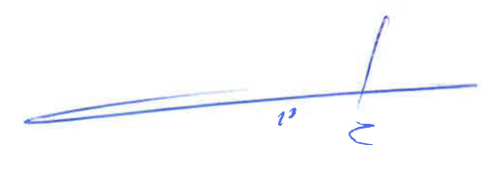

___________________________________
(signature)
General Manager Gintaras Bertašius

