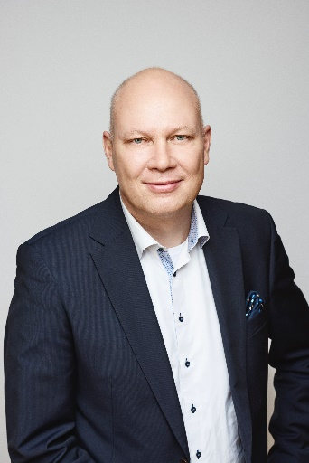
RISTO GAGGL

Born 1968
Master’s degree in production technology,
Helsinki University of Technology
Finnish and Austrian nationality

Professional experience
2011 – 2022 Fiskars Group
Chief Supply Chain Officer (2012 - 12/2022)
Vice President Garden EMEA (2011 - 05/2013)
1999 – 2011 Elcoteq Group
Vice President, Business Excellence (2010 - 2011)
VP Mobile Devices,
VP Operations & Supply Chain Management, Elcoteq personal communications;
Director, Operations & Supply Chain Management Europe;
Operations Manager, North European Operations
Elcoteq Tallinn As: Managing Director
Elcoteq Finland & Hungary: Product Line Manager
1995 - 1999 Fincoil-Teollisuus Oy: Different engineer and manager positions

