Interim Report, 1-3/2017


Tulikivi Corporation
Interim report, 1 January - 31 March 2017: A new soapstone collection was launched and profitability improved

28 April 2017, at 1 p.m.

- The Tulikivi Group’s first-quarter net sales were EUR 5.9 million (EUR 6.3 million in Q1/2016), the operating result in the first quarter was EUR -0.9 (-1.3) million and result before taxes EUR -1.1 (-1.5) million.
- Net cash flow from operating activities in the first quarter was EUR 0.2 (-0.5) million.
- Order books at the end of the review period amounted to EUR 4.2 (4.6) million.
- The new soapstone fireplace collection was very well received on the market
- Future outlook: Net sales in 2017 are expected to be at the previous year’s level, and the operating profit is expected to improve year-on-year.

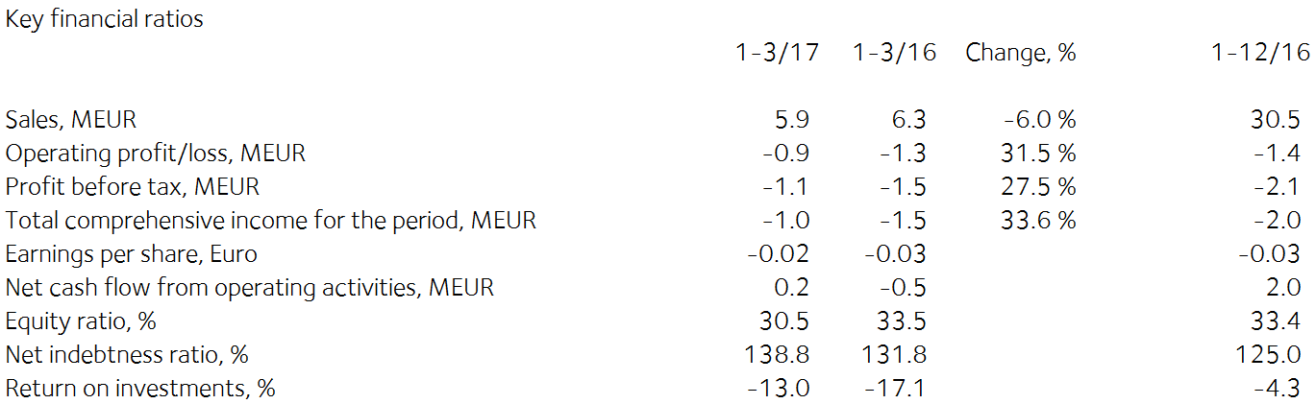

Comments by Heikki Vauhkonen, Managing Director:

Export sales of Tulikivi products increased in the first quarter. The new Karelia collection, launched in Belgium in February, has clearly increased dealers’ and consumers interest in Tulikivi products. As a result of the sales efficiency drive in Central Europe and the new collection, the sales outlook is better for the remainder of the year than it was a year before. Launches will be expanded to all main markets in the second quarter of the year. More extensive marketing to consumers of the new Karelia collection will start in the second half of the year.
The goal of the sales performance drive has been to strengthen Tulikivi’s position in the sales catalogues of current dealers and to identify new dealers where necessary.
The order intake in and net sales in Russia grew on the previous year due to Russia’s improved economy.
In Finland, sales of fireplaces for new homes increased but demand in the renovation market was down from the previous year and as a result, sales in Finland declined in the first quarter.
However, market conditions in fireplace sales continue to be challenging in Finland compared with the peak years due to the continuing low level of low-rise housing construction and low heating energy prices.
In the first quarter, the company’s order intake was EUR 6.9 (6.8) million. Order intake increased in fireplace exports, interior design stones and saunas. Order intake in heater lining stones and also in renovation sales of fireplaces in Finland decreased.
Order books at the end of the reporting period amounted to EUR 4.2 million (4.6).
As a result of the efficiency drive, the company’s profitability improved on the previous year. Due to decreased fixed costs and lower depreciation, the company’s operating result for the review period improved by EUR 0.4 million compared to the previous year.

Even though the operating environment for exports is likely to remain challenging in 2017, the downward trend in net sales is expected to end thanks to the new soapstone fireplace collection and the sales efficiency measures. Profitability is expected to improve in 2017 thanks to gains in cost-efficiency.

The soapstone reserves available to the company increased by 1.6 million cubic metres when the Finnish Safety and Chemicals Agency granted an extension permit to the Vaaralampi mining concession in Juuka on 27 March 2017. The additional reserves correspond to more than 10 years of stone use. A preliminary proposal has been made to exploit the talc reserves in the mining concession in conjunction with the Suomussalmi lining stone plant. The project is different from conventional mining projects in that the reserves are located in conjunction with an existing concession and industrial infrastructure. The project could therefore be much quicker to complete than the usual projects and would involve fewer uncertainties. More investigation and further studies will be carried out in the next few months.

Interim report, 1 January - 31 March 2017

Operating environment

The recovery of low-rise housing construction and renovation projects, and the slight improvement in consumer confidence compared with 2016 have energised the construction sector in Finland. Low-rise housing starts have begun to increase in the EU, which will boost the performance of the fireplace market in the near future. In Russia, the demand for Tulikivi products is increasing but it is dependent on the fluctuating of the rouble and economic developments.

Net sales and result

The Tulikivi Group’s first-quarter net sales were EUR 5.9 million (EUR 6.3 million in Q1/2016), the operating result in the first quarter was EUR -0.9 (-1.3) million and result before taxes EUR -1.1 (-1.5) million. As a result of the efficiency drive, the company’s profitability improved on the previous year. Due to decreased fixed costs and lower depreciation, the company’s operating result for the review period improved by EUR 0.4 million compared to the previous year.

Order books at the end of the reporting period amounted to EUR 4.2 million (4.6). In the first quarter, the company’s order intake was EUR 6.9 (6.8) million. Order intake increased in fireplace exports, interior design stones and saunas. Order intake in heater lining stones and also in renovation sales of fireplaces in Finland decreased.
Net sales in Finland amounted to EUR 3.0 (3.3) million in the review period, or 50.1% (52.9%) of total net sales. In Finland, sales of fireplaces for new homes increased but demand in the renovation market was down from the previous year. Net sales from exports amounted to EUR 2.9 (3.0) million. The principal export countries were Germany, Russia, France, Sweden and Denmark.

Tulikivi has increased its market share in Finland by concluding several cooperation agreements regarding fireplace deliveries to the home-building industry.
Export sales of Tulikivi products increased in the first quarter. The new Karelia collection, launched in Belgium in February, has clearly increased dealers’ and consumers interest in Tulikivi products. As a result of the sales efficiency drive in Central Europe and the new collection, the sales outlook is better for the remainder of the year than it was a year before. Launches will be expanded to all main markets in the second quarter of the year. More extensive marketing of the new Karelia collection to consumers will start in the second half of the year.
The goal of the sales performance drive has been to strengthen Tulikivi’s position in the sales catalogues of current dealers and to identify new dealers where necessary.
With Russia’s improved economic situation, the order intake in and net sales in Russia grew on the previous year.
In order to increase profitability, the company will continue to improve its operational efficiency by targeting savings of EUR 0.5 million in fixed costs in 2017.

Financing

Net cash flow from operating activities in the first quarter was EUR 0.2 (-0.5) million. Working capital released during the review period totalled EUR 0.9 (0.5) million. Working capital totalled EUR 2.8 (5.1) million at the end of March. The target for 2017 is to release working capital by a total of EUR 1.0 million.

Loan repayments totalled EUR 0.2 (0.1) million in the review period. Interest-bearing debt was EUR 16.2 (17.6) million at the end of the review period and net financial expenses were EUR 0.2 (0.2) million in the review period. The Group’s equity ratio at the end of the review period was 30.5% (33.5%). The ratio of interest-bearing net debt to equity, or gearing, was 138.8% (131.8%). The current ratio was 1.0 (1.4). Equity per share was EUR 0.19 (0.22). At the end of the reporting period, the Group’s cash and other liquid assets came to EUR 0.5 (0.7) million. The financing agreement includes covenants concerning EBITDA, the equity ratio and the ratio of debt to EBITDA. The covenants will be examined again on 30 June 2017.

Investments and product development

The Group’s investments totalled EUR 0.5 (0.2) million during the review period.

Research and development expenditure was EUR 0.3 (0.3) million, or 5.3% (4.1%) of net sales. EUR 0.1 (0.1) million of this was capitalised in the balance sheet. In product development, the focus was on developing the soapstone fireplace collection, making good use of the advantages of soapstone as a material for fireplaces and interior design.

In February 2017 the company introduced its new soapstone collection at the Batibouw fair in Belgium. The collection is based on a new kind of surface finish of soapstone and high quality of design. A new surface finishing machine was acquired in conjunction with the collection renewal.
The soapstone reserves available to the company increased by 1.6 million cubic metres when the Finnish Safety and Chemicals Agency granted an extension permit to the Vaaralampi mining concession in Juuka on 27 March 2017. The additional reserves correspond to more than 10 years of stone use.

Personnel

The Group employed an average of 182 (180) people during the review period. Salaries and bonuses during the reporting period totalled EUR 2.2 (2.1) million. The number of personnel will be adjusted through lay-offs in accordance with the level of demand. In addition to temporary lay-offs, 2 (3) members of the office staff have been laid off for the time being. The Tulikivi Group has an incentive pay scheme for all personnel. The company also has a stock option scheme for management that was launched in 2013.

Annual General Meeting

Tulikivi Corporation’s Annual General Meeting, held on 20 April 2017, resolved not to distribute a dividend on the 2016 financial year. Jaakko Aspara, Markku Rönkkö, Paula Salastie, Reijo Svanborg, Jyrki Tähtinen and Heikki Vauhkonen were elected as members of the Board of Directors The Board elected Jyrki Tähtinen as its Chairman. The auditor appointed was KPMG Oy Ab, Authorised Public Accountants, with Kirsi Jantunen, APA, as chief auditor.

The Annual General Meeting authorised the Board of Directors to decide on issuing new shares and on the transfer of Tulikivi Corporation shares held by the company in accordance with the proposals of the Board. Tulikivi can issue new shares or transfer treasury shares held by the company as follows: a maximum of 10,437,748 Series A shares and a maximum of 1,536,500 Series K shares.

The authorisation includes the right to decide on a directed rights issue, deviating from the shareholders’ right of pre-emption, provided that there is compelling financial reason for the company. The authorisation also includes the right to decide on a bonus issue to the company itself, where the number of shares issued to the company is no more than one tenth of the total number of the company’s shares.

The authorisation also includes the right to issue special rights referred to in Chapter 10, section 1, of the Limited Liability Companies Act, which would give entitlement to Tulikivi shares against payment or by setting off the receivable. The authorisation includes the right to pay the company’s share rewards. The Board is authorised to decide on other matters concerning share issues. The authorisation is valid until the 2018 Annual General Meeting.

Treasury shares

The company did not purchase or assign any treasury shares during the reporting period. At the end of the period, the total number of Tulikivi shares held by the company was 124,200 Series A shares, corresponding to 0.2 per cent of the company’s share capital and 0.1 per cent of all voting rights.

Near-term risks and uncertainties

The Group’s most significant risk is the potential continuation of the decline in net sales in the principal market areas. A potential halt in the restarted growth in new construction and renovation projects would affect the demand for Tulikivi products in Finland. The slower-than-predicted recovery of the markets in Central Europe and the uncertain economic situation in Russia also have an impact on the demand for fireplaces.

Maintaining the Group’s financing position at the present level and securing the continuation of financing will depend on an improvement in profitability in the future. If the company’s business operations and result do not develop as planned, the repayment of its debts may create a greater burden on the company’s cash flow than anticipated.

As regards the company’s foreign currency risk, the most significant currencies are the Russian rouble and the U.S. dollar. About 90 per cent of the company’s cash flow is in euros, which means the company’s exposure to foreign currency risks is very low. A weakening of currencies may have an adverse effect on the sales margin.

The risks have been described in greater detail on page 82 of the 2016 annual report.

Future outlook
Net sales in 2017 are expected to be at the previous year’s level, and the operating profit is expected to improve year-on-year.

Events after the review period

A preliminary proposal has been made to exploit the talc reserves in the mining concession that is connected to the Suomussalmi lining stone plant. The project is different from conventional mining projects in that the reserves are located in conjunction with an existing concession and industrial infrastructure. The project could therefore be much quicker to complete than traditional projects and involve fewer uncertainties. More investigation and further studies will be carried out in the next few months.
Depending on the outcome of the study, the company intends to begin exploiting the talc deposit either by developing its own operations, collaborating with a partner or by selling the mining project.
Tulikivi currently has eight mining concessions in Eastern Finland and Kainuu. The soapstone used for fireplaces typically contains some 50 per cent talc, which is why the company has in the past carried out extensive talc deposit surveys in conjunction with surveys of soapstone deposits.

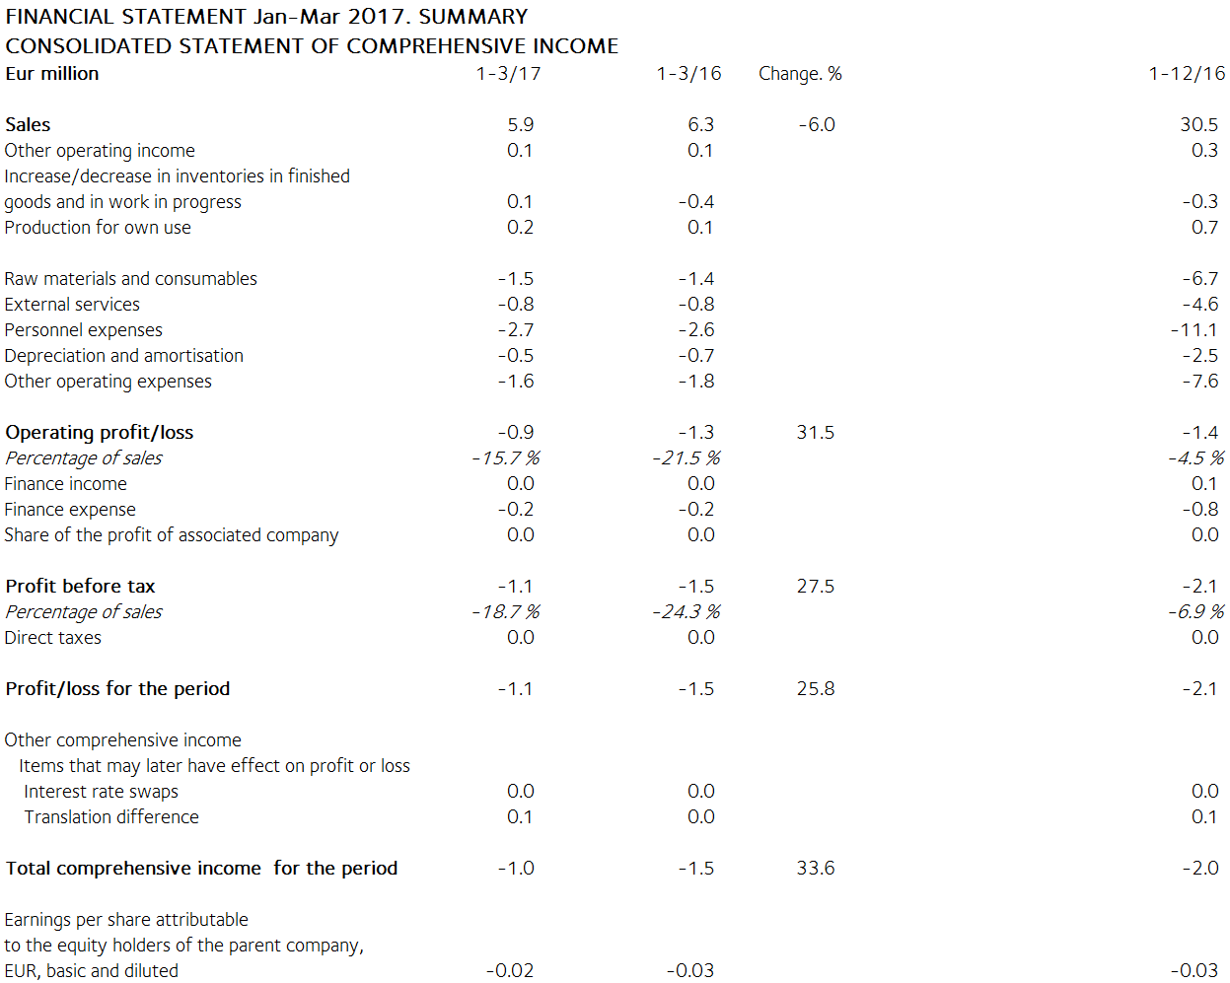

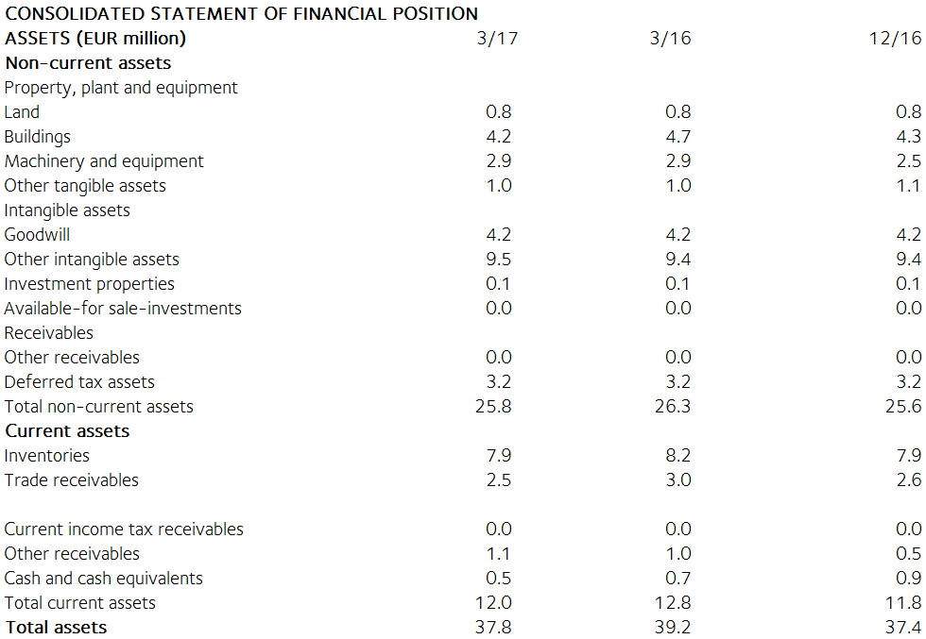

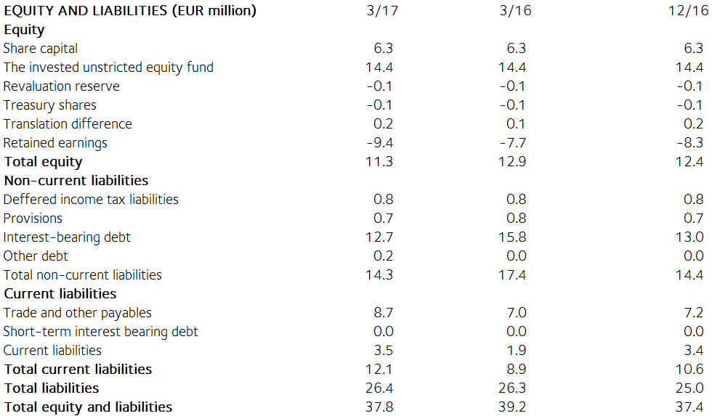

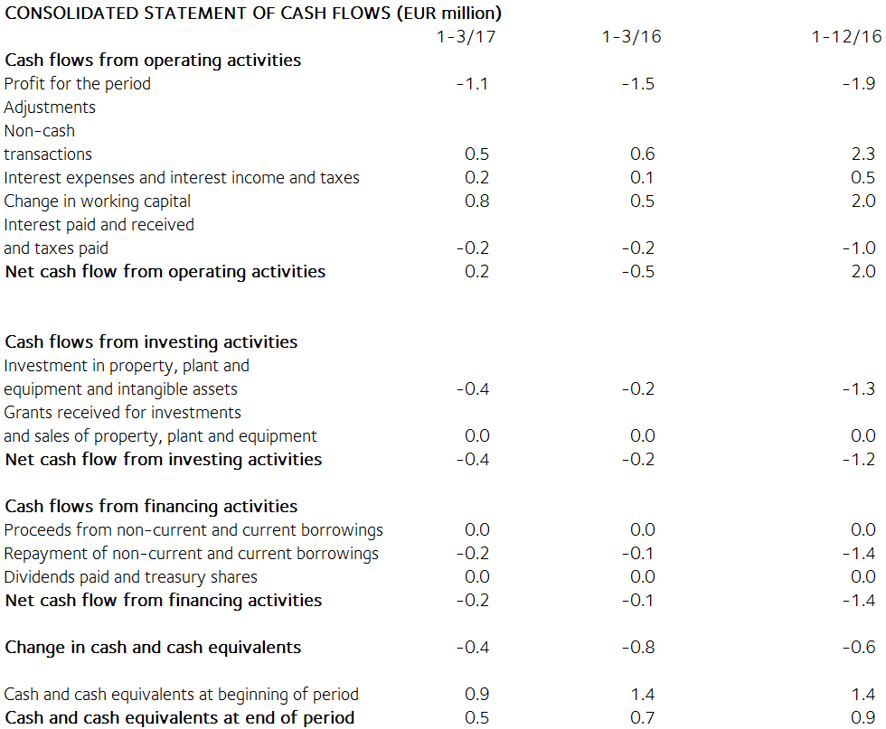

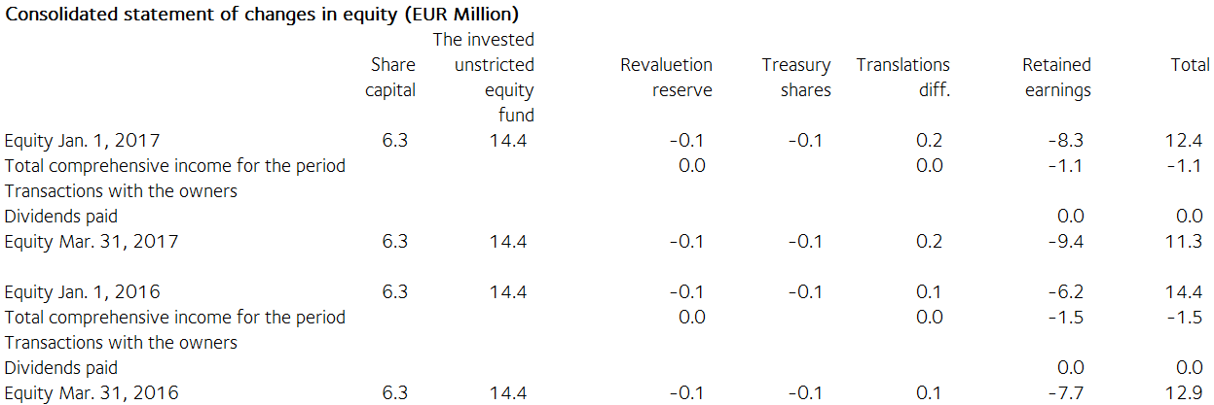

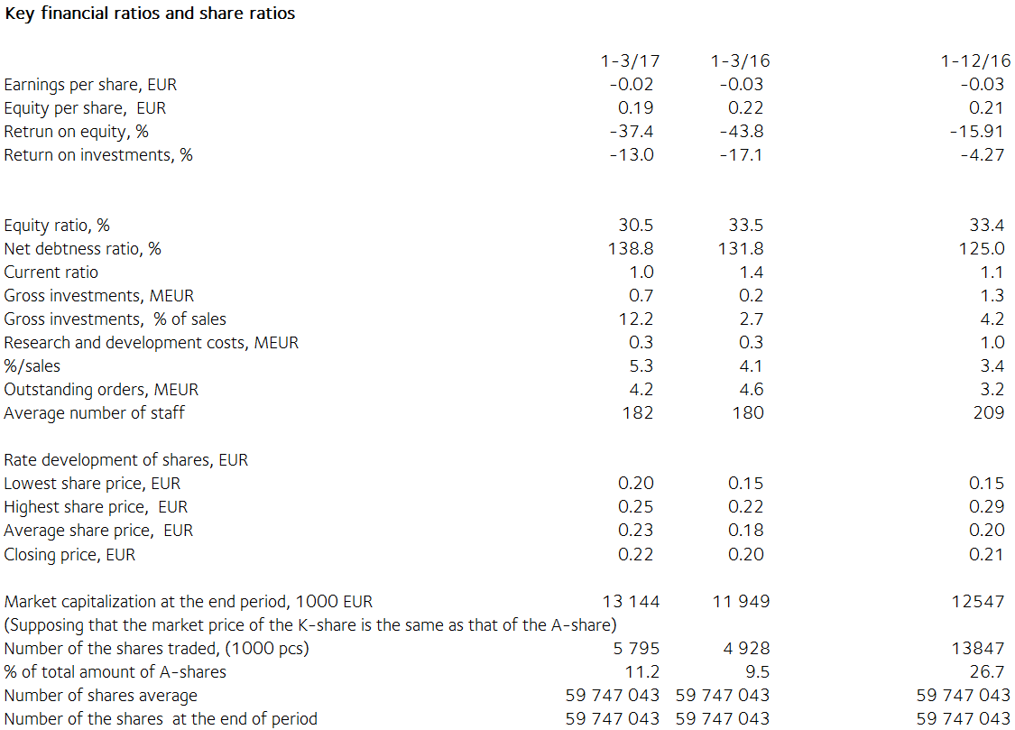

Notes to the financial statements

The information presented in the interim report has not been audited.

This interim report has been prepared in accordance with the standard IAS 34 Interim Financial Reporting. Tulikivi has applied the same IFRS accounting principles in this financial statements release as in the previous consolidated financial statements. The key figures presented in the interim report have been calculated using the same formulas as the latest financial statements for 2016. As there are no non-recurring expenses in this or the previous review period, no figures based on non-recurring expenses are presented. The formulas can be found on page 86 of the 2016 annual report.

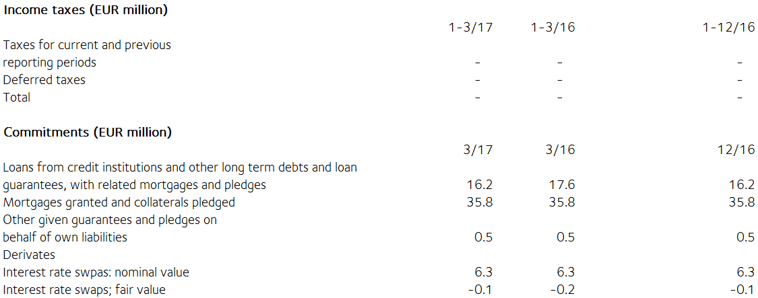

The fair value of derivatives is the gain or loss for closing the contract based on market rates at the balance sheet date. Derivatives are classified as level 2 in the fair value hierarchy. Available for sale financial assets are investments in unlisted shares. They are valued at acquisition cost because their value cannot be reliably determined.

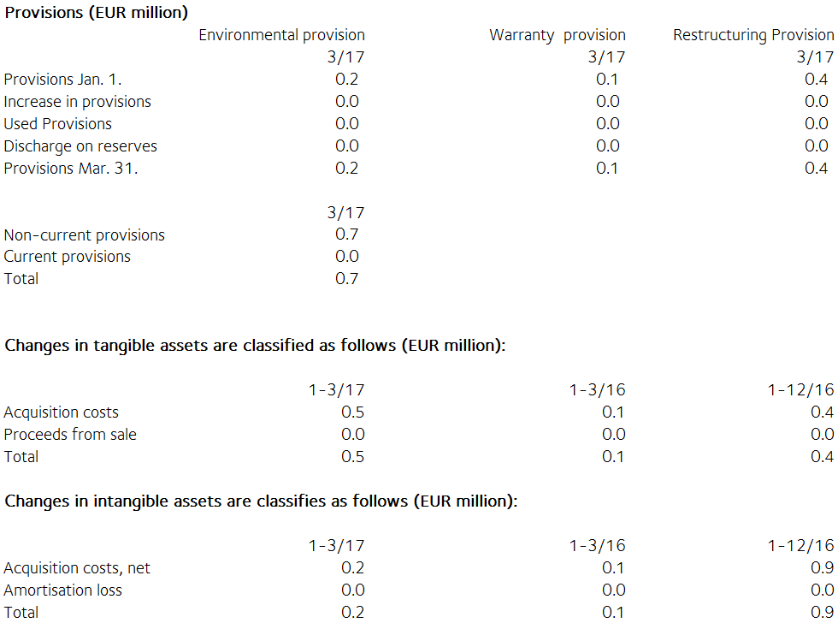

Share capital
Share capital by share series

Number of % of % of Share,
shares shares voting EUR of
rights share
capital
K shares (10 votes) 7 682 500 12.8 59.5 810 255
A shares (1 vote) 52 188 743 87.2 40.5 5 504 220
Total 31 March, 2017 59 871 243 100.0 100.0 6 314 475

There have been no changes in Tulikivi Corporation´s share capital during the review period. According to the Articles of Association, the dividend paid on Series A shares shall be EUR 0.0017 higher than the dividend paid on Series K shares. The A share is listed on NASDAQ OMX Helsinki. At the end of the review period, the company held 124 200 series A shares.

Related party transactions (EUR 1 000)
There are no transactions with associated companies.

Transactions with other related parties
Tulikivi Corporation is a founder member of the Finnish Stone Research Foundation. The company has leased offices and storage facilities from a property owned by the Foundation and North Karelia Educational Federation of Municipalities. The rent paid for these facilities was EUR 9 (12) thousand in the period. The rent corresponds to market rents. The company's sales of services to the Foundation came to EUR 1 (2) thousand.

Management benefits (EUR 1 000)
1-3/17 1-3/16
Salaries and other short-term employee
benefits of the Board of Directors’
members and the Managing Director 65 65

Principal shareholders on 31 March 2017

Name of shareholder Shares Percentage
of votes
Vauhkonen Heikki 6 873 839 45.9%
Elo Mutual Pension Insurance Company 4 545 454 3.5%
Ilmarinen Mutual Pension Insurance Company 3 720 562 2.9%
Elo Eliisa 3 108 536 5.7%
Varma Mutual Pension Insurance Company 2 813 948 2.2%
Toivanen Jouko 2 531 259 2.7%
Finnish Cultural Foundation 2 258 181 2.4%
Mutanen Susanna 1 643 800 6.8%
Fennia Mutual Insurance Company 1 515 151 1.2%
Nikkola Jarkko 1 296 700 1.0%
Others 29 563 813 25.6%

The companies included in the Group are the parent company Tulikivi Corporation, Tulikivi U.S. Inc. and OOO Tulikivi. Group companies also include Tulikivi GmbH and The New Alberene Stone Company, Inc., which are dormant.

TULIKIVI CORPORATION

Board of Directors

Distribution: Nasdaq Helsinki

Key media

www.tulikivi.fi

Additional information: Heikki Vauhkonen, Managing Director, tel. +358 (0)207 636 555

