Interim Report, 1-9/2017


Tulikivi Corporation
Interim Report, 1–9/2017: Positive market outlook and profitable July–September

27 October 2017 at 1 p.m.

- The Tulikivi Group’s third-quarter net sales were EUR 7.0 million (Q3/2016: EUR 7.7 million), the operating result in the third quarter was EUR 0.3 (0.1) million and the result before taxes was EUR 0.1 (-0.1) million.
- The Tulikivi Group’s net sales in the review period were EUR 20.7 million (1 Jan – 30 Sept 2016: EUR 21.9 million), the operating result
was EUR -0.4 (-1.2) million and the result before taxes EUR -0.9 (-1.8) million.
- Net cash flow from operating activities in the third quarter was EUR 0.4 (0.3) million and EUR 1.1 (-0.1) million in the review period.
- Order books at the end of the review period amounted to EUR 3.4 (3.2) million.
- Sales of the new Karelia fire place collection are developing well, both in exports and domestically.
- Future outlook: Net sales in 2017 are expected to be at the previous year’s level, and the operating result is expected to improve year-on-year.

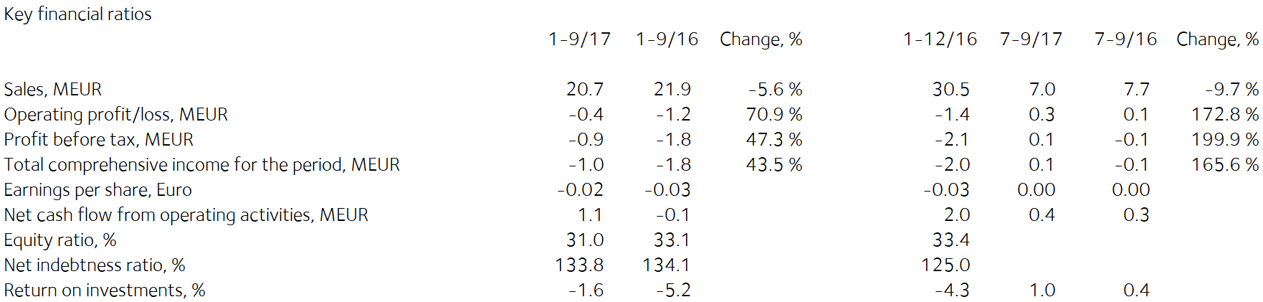

Comments by Heikki Vauhkonen, Managing Director:

Exports of Tulikivi products continued to increase in the third quarter. The new Karelia collection has substantially increased dealers’ and consumers' interest towards Tulikivi products in Central Europe. Thanks to the Karelia fireplace collection, the sales outlook for the second half of the year is better than it was in 2016 in all main export markets.
In Russia, the biggest export country, the order intake and net sales grew on the previous year as a result of the active development of the distribution channel and the favourable market conditions.
In Finland sales of fireplaces to new-home builders increased but demand in the renovation market declined.
In the third quarter the company’s incoming orders totalled EUR 7.2 (7.6) million. The order intake grew in fireplace exports and sauna heaters. The order intake in stove liner stones, interior stone products and sales of fireplaces to renovators in Finland declined.
Tulikivi’s order books at the end of the review period amounted to EUR 3.4 (3.2) million.
Profitability has improved as a result of demand for the new Karelia fireplace collection and the measures taken to boost efficiency. Due to better profitability, decreased fixed costs and lower depreciation, the company’s operating result improved in the review period by EUR 0.8 million compared with the previous year.

The new Karelia fireplace collection has been very well received in Finland and abroad. The marked improvement in Finnish consumer confidence in the first half of the year is estimated to increase low-rise construction and home renovation in upcoming months. Sales boosting measures are being targeted at Finland during the remainder of the year to increase sales in the renovation market.

The emphasis on export sales together with successful measures to boost efficiency will enable a further improvement in profitability during the remainder of 2017.

Interim Report, 1-9/2017

Operating environment

The recovery of low-rise housing construction and renovation projects, and the improvement in consumer confidence compared with 2016 have energised construction in Finland. Low-rise housing construction has begun to increase in the EU, which will boost the performance of the fireplace market in the near future. In Russia, demand for Tulikivi products is growing but it is dependent on changes in the exchange rate of the rouble and the development of the Russian economy.

Net sales and result

The Tulikivi Group’s third-quarter net sales totalled EUR 7.0 million (Q3/2016: EUR 7.7 million), the operating result was EUR 0.3 (0.1) million and the result before taxes was EUR 0.1 (-0.1) million.

For the review period as a whole, the Tulikivi Group’s net sales were EUR 20.7 million (1 Jan – 30 Sept 2016: EUR 21.9 million), the operating result was EUR -0.4 (-1.2) million and the result before taxes was EUR -0.9 (-1.8) million. Profitability has improved as a result of demand for the new Karelia fireplace collection and the measures taken to boost efficiency. Due to better profitability, decreased fixed costs and lower depreciation, the company’s operating result improved in the review period by EUR 0.8 million compared with the previous year.

Tulikivi’s order books at the end of the review period amounted to EUR 3.4 (3.2) million. In the third quarter the company’s incoming orders totalled EUR 7.2 (7.6) million. The order intake grew in fireplace exports and sauna heaters. The order intake in stove liner stones, interior stone products and sales of fireplaces to renovators in Finland declined.
Net sales in Finland in the review period were EUR 10.0 (11.1) million, or 48.3% (50.5%) of total net sales. In Finland sales of fireplaces to new-home builders increased but demand in the renovation market declined.

Net sales from exports amounted to EUR 10.7 (10.9) million in the review period. The principal export countries were Russia, Germany, France, Sweden and Denmark. Exports of Tulikivi products continued to increase in the third quarter. The new Karelia collection has substantially increased dealers’ and consumers' interest towards Tulikivi products in Central Europe. Thanks to the Karelia fireplace collection, the sales outlook has improved on 2016 in all main export markets.
In Russia, the biggest export country, the order intake and net sales grew on the previous year as a result of the active development of the distribution channel and the favourable market conditions.
The new Karelia fireplace collection has been very well received in Finland and abroad. In addition, the marked improvement in Finnish consumer confidence in the first half of the year is estimated to increase low-rise construction and home renovation in upcoming months. Sales boosting measures are being targeted at Finland during the remainder of the year to increase sales in the renovation market.

The emphasis on export sales together with successful measures to boost efficiency will enable a further improvement in profitability during the remainder of 2017.

Financing

Net cash flow from operating activities was EUR 0.4 (0.3) million in the third quarter and EUR 1.1 (-0.1) million in the review period. Working capital decreased by EUR 0.8 (-0.3) million during the review period. Working capital totalled EUR 3.0 (5.8) million at the end of the review period.

Loan repayments totalled EUR 0.6 (0.1) million in the review period. Interest-bearing debt was EUR 15.8 (17.6) million at the end of the review period and net financial expenses were EUR 0.6 (0.6) million in the review period. The Group’s equity ratio at the end of the review period was 31.0% (33.1%). The ratio of interest-bearing net debt to equity, or gearing, was 133.8% (134.1%). The current ratio was 0.8 (1.5) and equity per share was EUR 0.19 (0.21). At the end of the review period, the Group’s cash and other liquid assets came to EUR 0.5 (0.7) million.

The company concluded an agreement with its finance providers on a new repayment programme for the final quarter of 2017 and for 2018 and on new covenant limits for the conditions at 31 December 2017. The financing agreement includes covenants concerning EBITDA, the equity ratio and the ratio of debt to EBITDA. According to the estimate of the company’s management, the company will meet all covenants at the next date of examination, which is 31 December 2017 if the current sales forecasts are met.

Investments and product development

The Group’s investments totalled EUR 1.1 (0.5) million during the review period. The company introduced its new soapstone collection at the Batibouw fair in Belgium in the beginning of this year. The Karelia fireplace collection is based on a new kind of soapstone surface finish and high-quality design. In conjunction with the renewal of the collection, the company invested in changes to production lines and new surface finishing technology.
Research and development expenditure was EUR 0.8 (0.7) million, or 4.1% (3.2%) of net sales. EUR 0.3 (0.3) million of this was capitalised on the balance sheet.

The company’s soapstone reserves increased by 1.6 million cubic meters when the Finnish Safety and Chemicals Agency granted permission on 27 March 2017 to expand the Vaaralampi mining patent in Juuka. The added reserves correspond to more than 10 years of stone consumption.
On 20 April 2017 Tulikivi announced its decision to study opportunities to exploit talc reserves in the Suomussalmi deposit. Tulikivi Corporation’s soapstone deposit in Suomussalmi has talc reserves that are believed to be suitable for talc production. On 13 June 2017 Tulikivi announced the results of the studies into the talc reserves. According to a sample analysis conducted by the Geological Survey of Finland, the talc grades of the reserves correspond to talc projects carried out previously in Finland in terms of talc content, yield and brightness. Based on the earlier drilling tests that Tulikivi carried out for the purpose of soapstone production and the new test results, Tulikivi estimates that there are approximately 20 million tonnes of talc ore in Suomussalmi. On 24 August 2017 Tulikivi announced that during the summer it had looked into whether potential partners were interested in exploiting the Suomussalmi talc deposit based on the results of the Geological Survey of Finland’s sample analysis and the earlier drilling tests. Based on the feedback received, Tulikivi's Board of Directors launched preparations for the sale of the talc deposit. The sale process was launched in September 2017. It is too early to estimate whether a sale will take place or the financial impact of a sale.

Personnel

The Group employed an average of 208 (214) people during the review period. Salaries and bonuses during the period totalled EUR 6.3 (6.4) million. The number of personnel is adjusted through lay-offs in accordance with the level of demand. In addition to temporary lay-offs, 2 (3) members of the office staff have been laid off for the time being. The Tulikivi Group has an incentive pay scheme for all personnel. The company also has a stock option scheme for management that was launched in 2013.

Annual General Meeting

Tulikivi Corporation’s Annual General Meeting, held on 20 April 2017, resolved not to distribute a dividend for the 2016 financial year. Jaakko Aspara, Markku Rönkkö, Paula Salastie, Reijo Svanborg, Jyrki Tähtinen and Heikki Vauhkonen were elected as members of the Board of Directors. The Board elected Jyrki Tähtinen as its Chairman. The auditor appointed was KPMG Oy Ab, Authorised Public Accountants, with Kirsi Jantunen, APA, as chief auditor.

The Annual General Meeting authorised the Board of Directors to decide on issuing new shares and on the transfer of Tulikivi Corporation shares held by the company in accordance with the proposals of the Board. Tulikivi can issue new shares or transfer treasury shares held by the company as follows: a maximum of 10,437,748 Series A shares and a maximum of 1,536,500 Series K shares.

The authorisation includes the right to decide on a directed rights issue, deviating from the shareholders’ right of pre-emption, provided that there is compelling financial reason for the company. The authorisation also includes the right to decide on a bonus issue to the company itself, where the number of shares issued to the company is no more than one tenth of the total number of the company’s shares.

The authorisation also includes the right to issue special rights referred to in Chapter 10, section 1, of the Limited Liability Companies Act, which would give entitlement to Tulikivi shares against payment or by setting off the receivable. The authorisation includes the right to pay the company’s share rewards. The Board is authorised to decide on other matters concerning share issues. The authorisation is valid until the 2018 Annual General Meeting.

Treasury shares

The company did not purchase or assign any treasury shares during the reporting period. The number of shares in the company’s possession at the end of the review period was 124 200 A shares which corresponds to 0.2% of the company’s share capital and 0.1% of all voting rights.

Near-term risks and uncertainties

The Group’s most significant risk is the potential continuation of the decline in net sales in the principal market areas. The potential halt of the increase in new construction and renovation projects would impact the demand for Tulikivi products in Finland. The slower-than-predicted recovery of the markets in Central Europe and the uncertain economic situation in Russia also have an impact on the demand for fireplaces.

Maintaining the Group’s financing position at the present level and securing the continuation of financing will depend on an improvement in profitability in the future. If the company’s business operations and result do not develop as planned, the repayment of its debts may create a greater burden on the company’s cash flow than anticipated.

As regards the company’s foreign currency risk, the most significant currencies are the Russian rouble and the U.S. dollar. About 90% of the company’s cash flow is in euros, which means that the company’s exposure to foreign currency risks is low. A weakening of currencies may have an adverse effect on the sales margin.

The risks are described in more detail on page 82 of the Tulikivi Annual Report for 2016.

Future outlook
Net sales in 2017 are expected to be at the previous year’s level, and the operating result is expected to improve year-on-year.

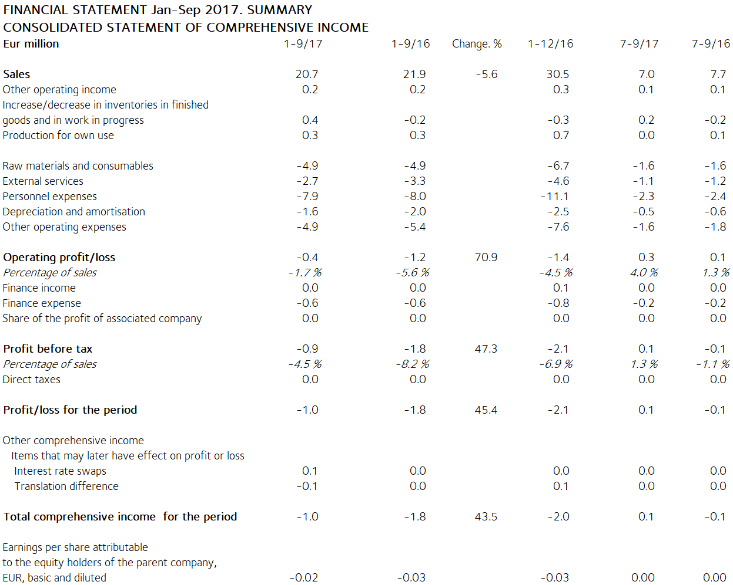

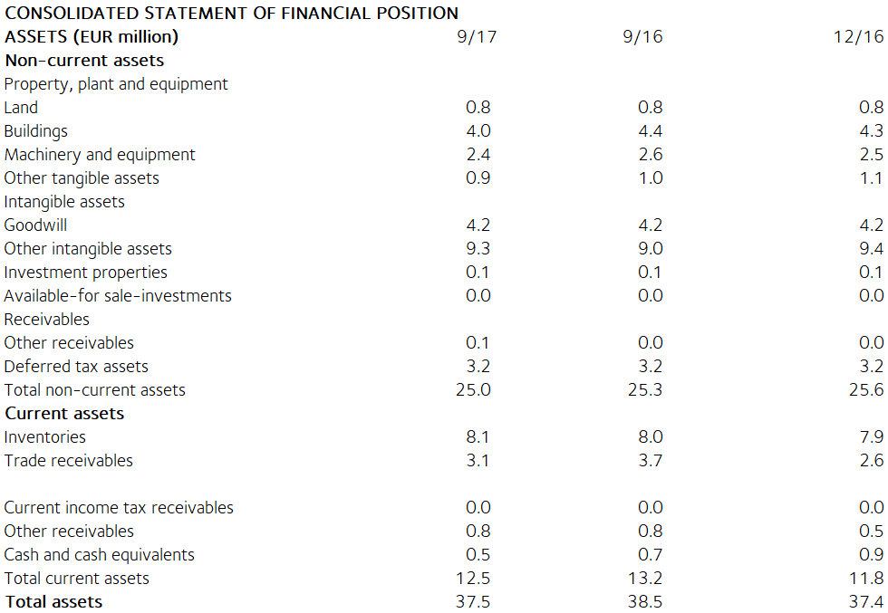

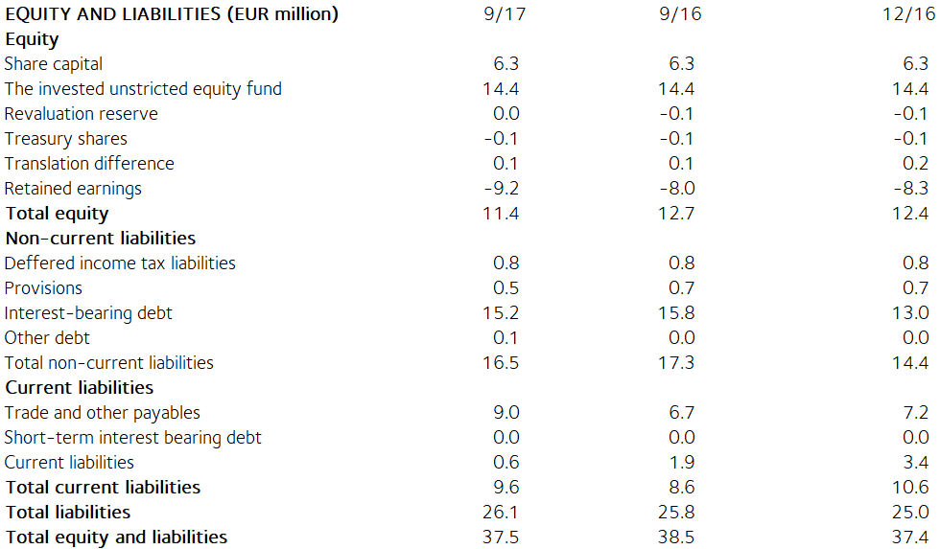

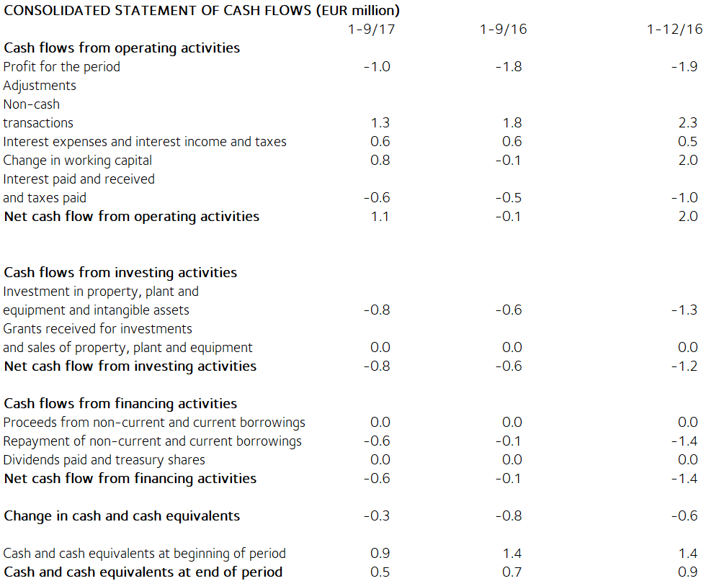

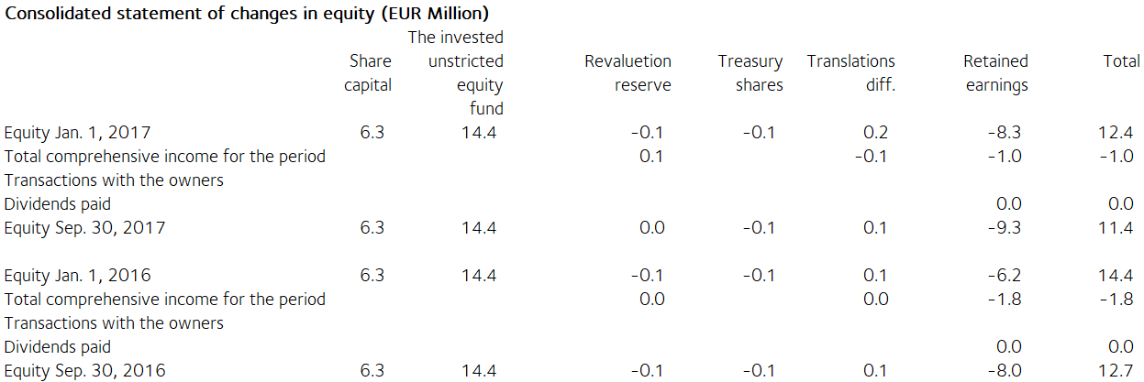

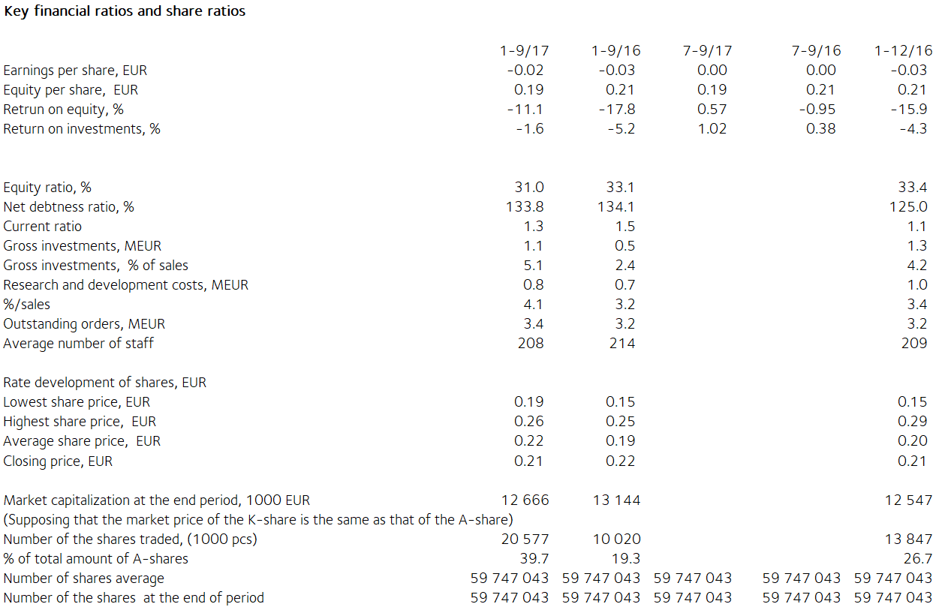

Notes on the financial statements

The information presented in the interim report release has not been audited.

This interim report release has been prepared in accordance with the IAS 34 Interim Financial Reporting standard. Tulikivi has applied the same IFRS accounting principles in this interim report release as in the previous consolidated financial statements. The key figures presented in the interim report release have been calculated using the same formulas as in the 2016 financial statements. As there are no non-recurring expenses in this or the preceding financial year, no key figures based on non-recurring expenses are presented. The formulas can be found on page 86 of the Annual Report 2016.

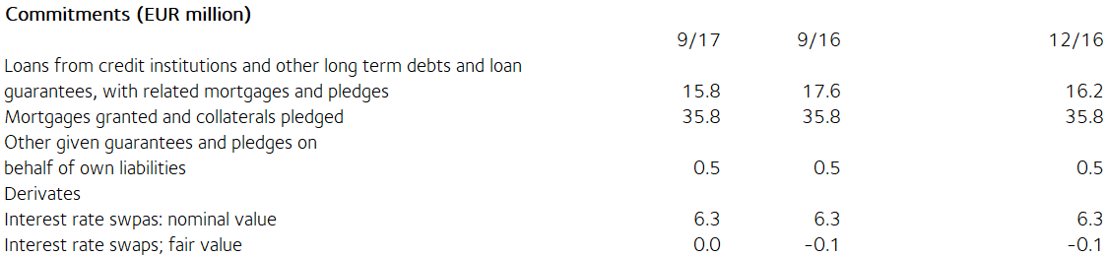

The fair value of derivatives is the gain or loss for closing the contract based on market rates on the interim report date. Derivatives are classified as level 2 in the fair value hierarchy. Available-for-sale financial assets are investments in unlisted companies. They are valued at acquisition cost because their fair value cannot be reliably determined.

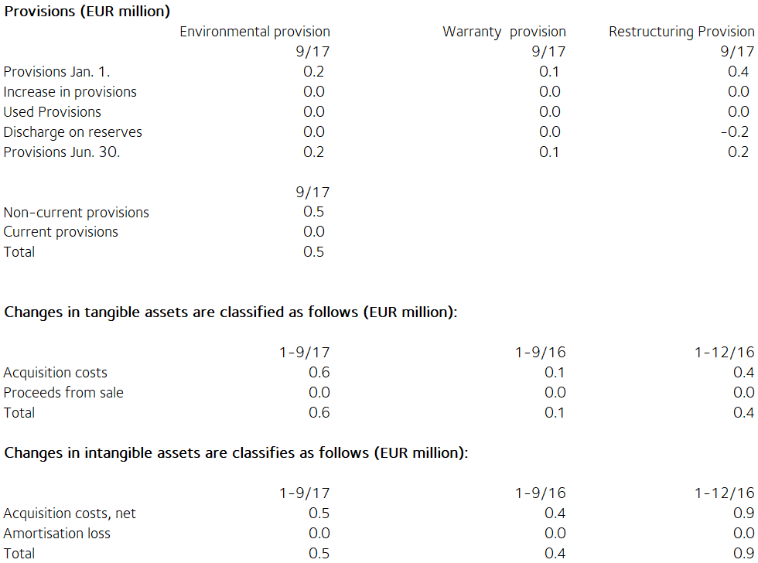

Share capital
Share capital by share series
Shares, Percentage, Percentage, Percentage,
number % % EUR
shares votes share
. capital
Series K shares (10 votes) 7 682 500 12.8 59.5 810 255
Series A shares (1 vote) 52 188 743 87.2 40.5 5 504 220
Total 30 September 2017 59 871 243 100.0 100.0 6 314 475

There have been no changes in Tulikivi Corporation´s share capital during the review period. According to the Articles of Association, the dividend paid on Series A shares shall be EUR 0.0017 higher than the dividend paid on Series K shares. The A share is listed on NASDAQ OMX Helsinki. At the end of the review period, the company held 124,200 series A shares.

Related party transactions (EUR 1 000)
There are no transactions with associated companies.

Transactions with other related parties
Tulikivi Corporation is a founder member of the Finnish Stone Research Foundation. The company has leased offices and storage facilities from a property owned by the Foundation and the North Karelia Educational Federation of Municipalities. The rent paid for these facilities was EUR 24 thousand (32 thousand) in the review period. The rent corresponds to market rents. The company's sales of services and land leases from the Foundation came to EUR 2 (6) thousand.

Management benefits (EUR 1 000)
1-9/17 1-9/16
Salaries and other short-term employee
benefits of the Board of Directors’
members and the Managing Director " 196 197

Principal shareholders on 30 September 2017

Name of shareholder Shares Percentage
of votes
Vauhkonen Heikki 6 873 839 45.9%
Elo Mutual Pension Insurance Company 4 545 454 3.5%
Ilmarinen Mutual Pension Insurance Company 3 720 562 2.9%
Elo Eliisa 3 108 536 5.7%
Toivanen Jouko 2 531 259 2.7%
Finnish Cultural Foundation 2 258 181 2.4%
Mutanen Susanna 1 643 800 6.8%
Fennia Mutual Insurance Company 1 515 151 1.2%
Nikkola Jarkko 1 301 100 1.0%
EVK-Capital Oy 1 000 000 0.8%
Others 31 373 361 27.1%

The companies included in the Group are the parent company Tulikivi Corporation, Tulikivi U.S. Inc. and OOO Tulikivi. Group companies also include Tulikivi GmbH and The New Alberene Stone Company, Inc., which are dormant.

TULIKIVI CORPORATION

Board of Directors

Distribution: NASDAQ Helsinki

Key media

www.tulikivi.com

Further information: Heikki Vauhkonen, Managing Director, tel. +358 (0)207 636 555

