Half-year financial report 1-6/2017


Tulikivi Corporation
Half-year financial report 1-6/2017: Positive market outlook and profitable April–June

11 August 2017 at 1 p.m.

- The Tulikivi Group’s second-quarter net sales were EUR 7.8 million (Q2/2016: EUR 7.9 million), the operating result was EUR 0.3 (0.0) million and the result before taxes was EUR 0.1 (-0.2) million.
- For the review period as a whole, the Tulikivi Group’s net sales were EUR 13.7 million (EUR 14.2 million in H1/2016), the operating result was EUR -0.6 (-1.3) million and the result before taxes EUR -1.0 (-1.7) million.
- Net cash flow from operating activities in the second quarter was EUR 0.6 (0.1) million and EUR 0.7 (-0.4) million in the review period.
- Order books at the end of the review period amounted to EUR 4.0 (3.9) million.
- Sales of the new Karelia fireplace collection are developing well, both in exports and domestically.
- Future outlook: Net sales in 2017 are expected to be at the previous year’s level, and the operating result is expected to improve year-on-year.

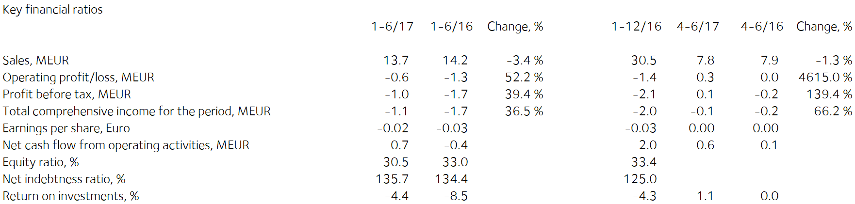

Comments by Heikki Vauhkonen, Managing Director:

Exports of Tulikivi products continued to grow in the second quarter. In Central Europe, the new Karelia collection has substantially increased dealers’ and consumers' interest towards Tulikivi products. The sales outlook for the second half of the year is better than in 2016 in all main export markets. Consumer marketing of the Karelia fireplace collection will be launched in the autumn season.
In addition to the new collection, measures to boost the effectiveness of sales have strengthened Tulikivi’s position in Central Europe in the range offered by existing dealers and attracted new dealers.
In Russia the order intake and net sales increased year-on-year mostly because of better economic growth than in 2016.
In Finland sales of fireplaces to new-home builders increased but demand in the renovation market was weaker than a year earlier, resulting in a decline in domestic sales in the second quarter. The Karelia collection has received a very warm welcome from consumers at this summer’s Finnish Housing Fair in Mikkeli, which is likely to have a positive impact on fireplace sales in the autumn in Finland.
In the second quarter the company’s incoming orders totalled EUR 7.9 (7.6) million. The order intake grew in fireplace exports, interior stone products and sauna heaters. The order intake of stove liner stones and sales of fireplaces to renovators in Finland declined.
Tulikivi’s order books at the end of the review period amounted to EUR 4.0 (3.9) million.
As a result of the measures taken last year to boost efficiency, the company’s profitability improved on the previous year. Due to better profitability, decreased fixed costs and lower depreciation, the company’s operating result for the review period improved by EUR 0.7 million compared to the previous year.

The new Karelia fireplace collection has been very well received in Finland and abroad. In addition, the marked improvement in Finnish consumer confidence in the first half of the year is estimated to increase low-rise construction and home renovation in upcoming months. Together with the improved export environment, they form a solid basis for sales growth in the second half of 2017. Cost efficiency is estimated to continue to improve in the second half of 2017.

Half-year financial report 1-6/2017

Operating environment

The recovery of low-rise housing construction and renovation projects, and the improvement in consumer confidence compared with 2016 have energised construction in Finland. Low-rise housing construction has begun to increase in the EU, which will boost the performance of the fireplace market in the near future. In Russia, demand for Tulikivi products is growing but dependent on changes in the exchange rate of the rouble and on economic developments.

Net sales and result

The Tulikivi Group’s second-quarter net sales totalled EUR 7.8 million (Q2/2016: EUR 7.9 million), the operating result was EUR 0.3 (0.0) million and the result before taxes was EUR 0.1 (-0.2) million.

For the review period as a whole, the Tulikivi Group’s net sales were EUR 13.7 million (H1/2016: EUR 14.2 million), the operating result was EUR -0.6 (-1.3) million and the result before taxes was EUR -1.0 (-1.7) million. As a result of the measures taken last year to improve efficiency, the company’s profitability improved on the previous year. Due to improved profitability, decreased fixed costs and lower depreciation, the company’s operating result for the review period improved by EUR 0.7 million compared with the previous year.

Tulikivi’s order books at the end of the review period amounted to EUR 4.0 (3.9) million. In the second quarter the company’s flow of orders was EUR 7.9 (7.6) million. The order intake grew thanks to fireplace exports, interior stone products and sauna heaters. The order intake from standard room-heating stoves and fireplace renovation sales in Finland decreased.
Net sales in Finland in the review period were EUR 6.4 (7.3) million, or 46.9% (51.6%) of total net sales. In Finland sales to customers building new homes increased but demand in the renovation market declined on the previous year, leading to a decline in domestic sales in the second quarter. The Karelia collection has been very well received by consumers at this summer’s Finnish Housing Fair in Mikkeli, which is likely to have a positive impact on fireplace sales in the autumn in Finland.
Net sales from exports amounted to EUR 7.3 (6.9) million in the review period. The principal export countries were Russia, Germany, France, Sweden and Denmark. Export sales of Tulikivi products continued to increase in the second quarter. In Central Europe, the new Karelia collection has substantially increased dealers’ and consumers' interest towards Tulikivi products. The sales outlook for the second half of the year is better than in 2016 in all main export markets. Consumer marketing of the Karelia fireplace collection will be launched in the autumn season.

In addition to the new collection, measures to boost the effectiveness of sales have strengthened Tulikivi’s position in Central Europe in the range offered by existing dealers and attracted new dealers.
In Russia the order intake and net sales increased strongly year-on-year mostly because of better economic growth than in 2016.
The new Karelia fireplace collection has been very well received in Finland and abroad. In addition, the markedly improved confidence of Finnish consumers in the first half of the year is estimated to increase low-rise construction and home renovation in the upcoming months. Together with the improved export environment, they form a solid basis for sales improvement in the second half of 2017. Cost efficiency is estimated to continue improving in the second half of 2017.

Financing

Net cash flow from operating activities was EUR 0.6 (0.1) million in the second quarter and EUR 0.7 (-0.4) million in the review period. Working capital decreased by EUR 1.0 (0.0) million during the review period. Working capital totalled EUR 2.7 (5.5) million at the end of June. The company is continuing to reduce working capital.

Loan repayments totalled EUR 0.4 (0.2) million in the review period. Interest-bearing debt was EUR 16.0 (17.6) million at the end of the review period and net financial expenses were EUR 0.4 (0.4) million in the review period. The Group’s equity ratio at the end of the review period was 30.5% (33.0%). The ratio of interest-bearing net debt to equity, or gearing, was 135.7% (134.4%). The current ratio was 1.0 (1.5) and equity per share was EUR 0.19 (0.21). At the end of the review period, the Group’s cash and other liquid assets came to EUR 0.6 (0.5) million. The financing agreement includes covenants concerning EBITDA, the equity ratio and the ratio of debt to EBITDA. The company met the covenant that concerns the equity ratio and the finance providers granted Tulikivi Corporation a waiver from compliance with the EBITDA and debt-to-EBITDA covenant conditions at 30 June 2017. According to the estimate of the company’s management, the company will meet all covenants at the next date of examination which is 31 December 2017 if the current sales forecasts are met.

Investments and product development

The Group’s investments totalled EUR 1.0 (0.4) million during the review period. The company introduced its new soapstone collection at the Batibouw fair in Belgium at the beginning of this year. The collection is based on a new kind of surface finish of soapstone and a high quality of design. In conjunction with the renewal of the collection, the company invested EUR 0.5 million in a new surface finisher.
Research and development expenditure was EUR 0.6 (0.5) million, or 4.3% (3.6%) of net sales. EUR 0.2 (0.1) million of this was capitalised on the balance sheet. In product development, the focus was on developing the soapstone fireplace collection, making good use of the advantages of soapstone as a material for fireplaces and interior design.

The company’s soapstone reserves increased by 1.6 million cubic meters when the Finnish Safety and Chemicals Agency granted permission on 27 March 2017 to expand the Vaaralampi mining patent in Juuka. The added reserves correspond to more than 10 years of stone consumption.
On 20 April 2017 Tulikivi announced its decision to study opportunities to exploit talc reserves in the Suomussalmi deposit. Tulikivi Corporation’s soapstone deposit in Suomussalmi has talc reserves that are believed to be suitable for talc production. On 13 June 2017 Tulikivi announced the results of the studies into the talc reserves. According to a sample analysis conducted by the Geological Survey of Finland, the talc grades of the reserves correspond to talc projects carried out in Finland in terms of talc content, yield and brightness. Based on earlier drilling tests that Tulikivi carried out for the purpose of soapstone production and the new test results, Tulikivi estimates that there are approximately 20 million tonnes of talc ore in Suomussalmi. The company continued to explore opportunities for collaboration in the project with a potential partner.

Personnel

The Group employed an average of 205 (205) people during the review period. Salaries and bonuses during the period totalled EUR 4.4 (4.4) million. The number of personnel will be adjusted through lay-offs in accordance with the level of demand. In addition to temporary lay-offs, 2 (3) members of the office staff have been laid off for the time being. The Tulikivi Group has an incentive pay scheme for all personnel. The company also has a stock option scheme for management that was launched in 2013.

Annual General Meeting

Tulikivi Corporation’s Annual General Meeting, held on 20 April 2017, resolved not to distribute a dividend for the 2016 financial year. Jaakko Aspara, Markku Rönkkö, Paula Salastie, Reijo Svanborg, Jyrki Tähtinen and Heikki Vauhkonen were elected as members of the Board of Directors. The Board elected Jyrki Tähtinen as its Chairman. The auditor appointed was KPMG Oy Ab, Authorised Public Accountants, with Kirsi Jantunen, APA, as chief auditor.

The Annual General Meeting authorised the Board of Directors to decide on issuing new shares and on the transfer of Tulikivi Corporation shares held by the company in accordance with the proposals of the Board. Tulikivi can issue new shares or transfer treasury shares held by the company as follows: a maximum of 10,437,748 Series A shares and a maximum of 1,536,500 Series K shares.

The authorisation includes the right to decide on a directed rights issue, deviating from the shareholders’ right of pre-emption, provided that there is a compelling financial reason for the company. The authorisation also includes the right to decide on a bonus issue to the company itself, where the number of shares issued to the company is no more than one tenth of the total number of the company’s shares.

The authorisation also includes the right to issue special rights referred to in Chapter 10, section 1, of the Limited Liability Companies Act, which would give entitlement to Tulikivi shares against payment or by setting off the receivable. The authorisation includes the right to pay the company’s share rewards. The Board is authorised to decide on other matters concerning share issues. The authorisation is valid until the 2018 Annual General Meeting.

Treasury shares

The company did not purchase or assign any treasury shares during the reporting period. The number of shares in the company’s possession at the end of the review period was 124,200 A shares which corresponds to 0.2% of the company’s share capital and 0.1% of all voting rights.

Near-term risks and uncertainties

The Group’s most significant risk is the potential continuation of the decline in net sales in the principal market areas. The potential halt of the increase in new construction and renovation projects would impact the demand for Tulikivi products in Finland. The slower-than-predicted recovery of the markets in Central Europe and the uncertain economic situation in Russia also have an impact on the demand for Tulikivi’s products.

Maintaining the Group’s financing position at the present level and securing the continuation of financing will depend on an improvement in profitability in the future. If the company’s business operations and result do not develop as planned, the repayment of its debts may create a greater burden on the company’s cash flow than anticipated.

As regards the company’s foreign currency risk, the most significant currencies are the Russian rouble and the U.S. dollar. About 90% of the company’s cash flow is in euros, which means that the company’s exposure to foreign currency risks is low. A weakening of currencies may have an adverse effect on the sales margin.

The risks are described in more detail on page 82 of the Tulikivi Annual Report for 2016.

Future outlook
Net sales in 2017 are expected to be at the previous year’s level, and the operating result is expected to improve year-on-year.

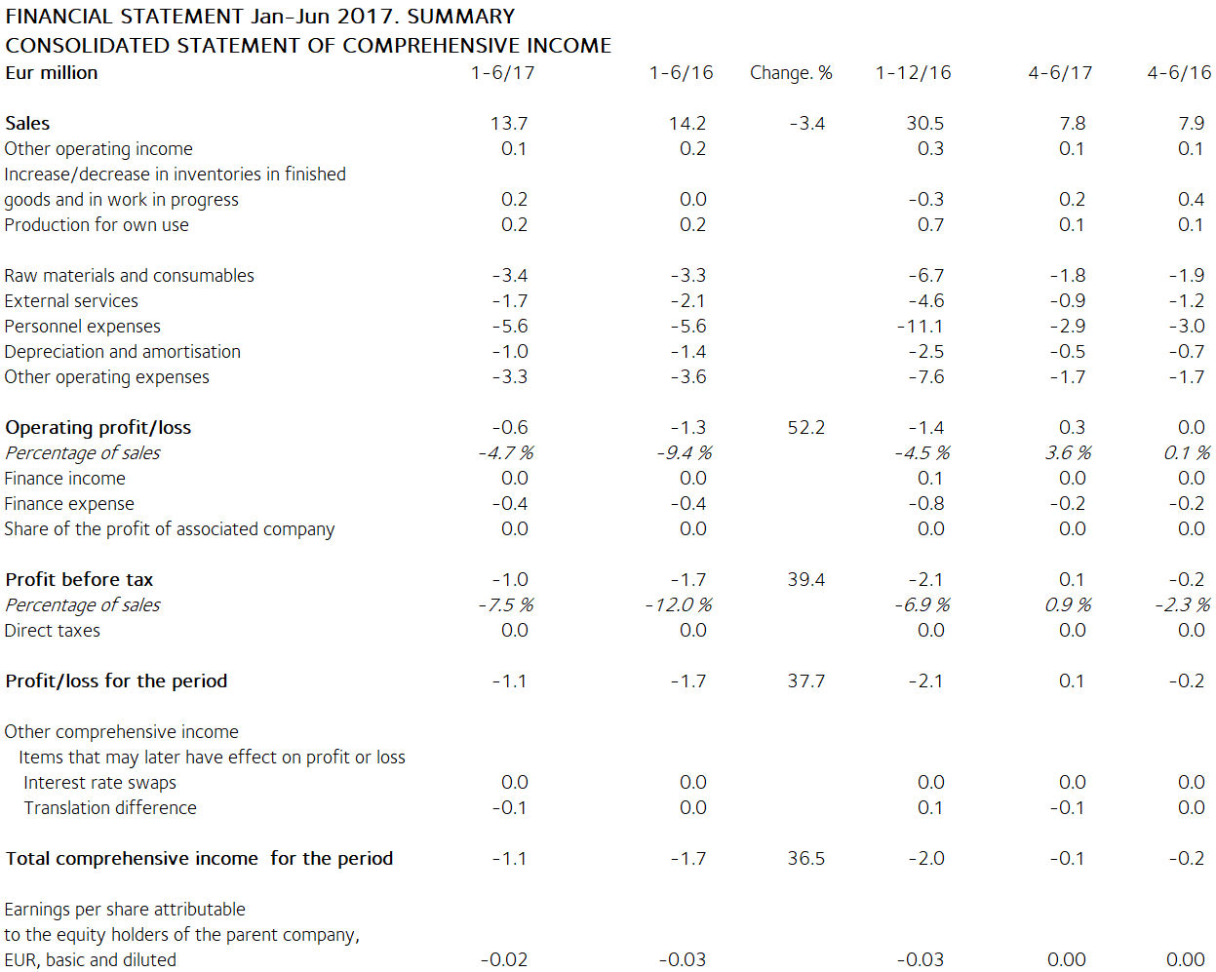

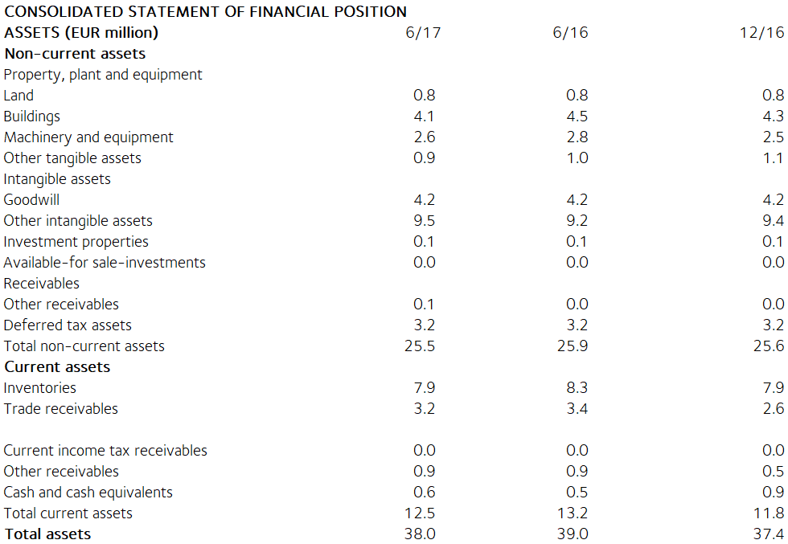

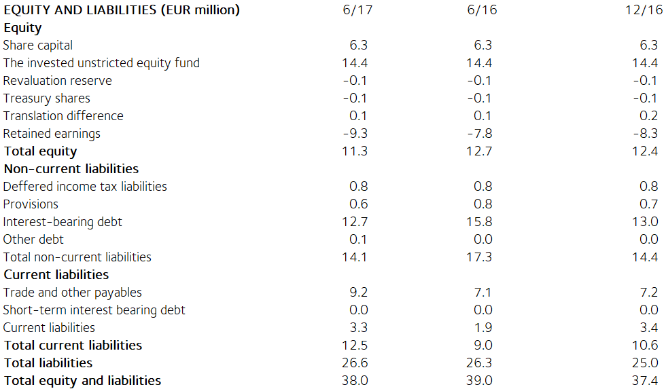

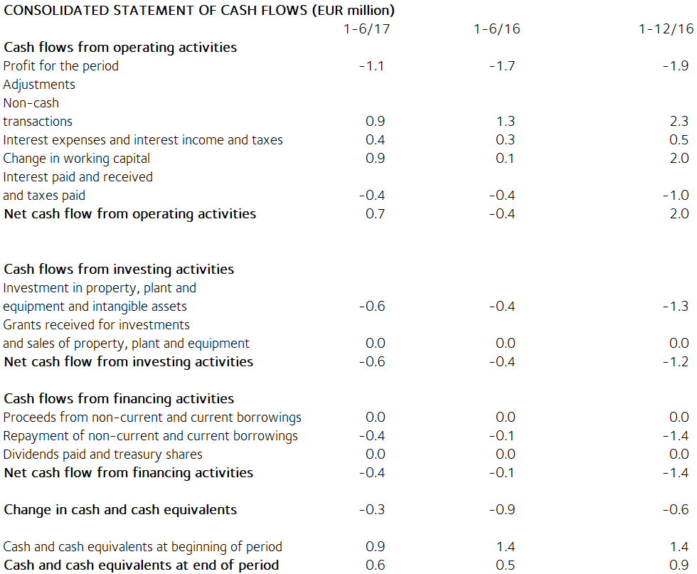

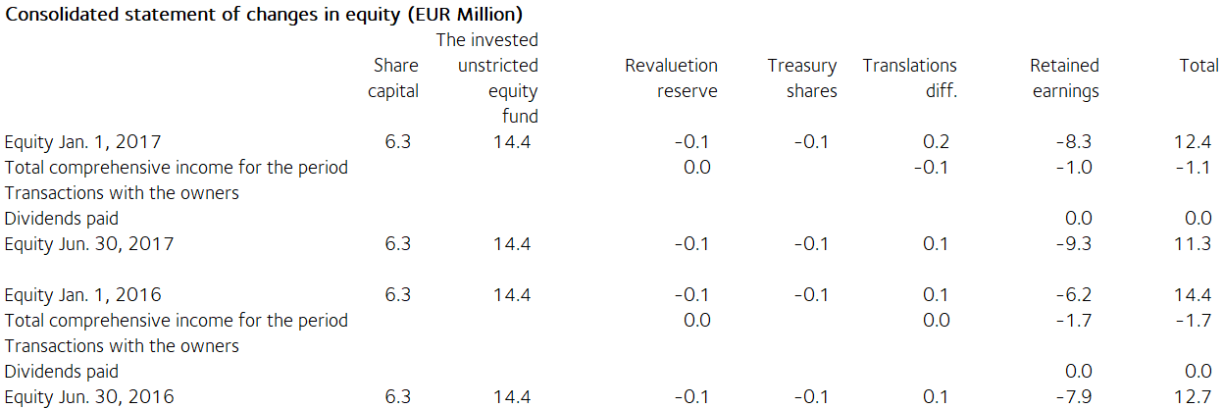

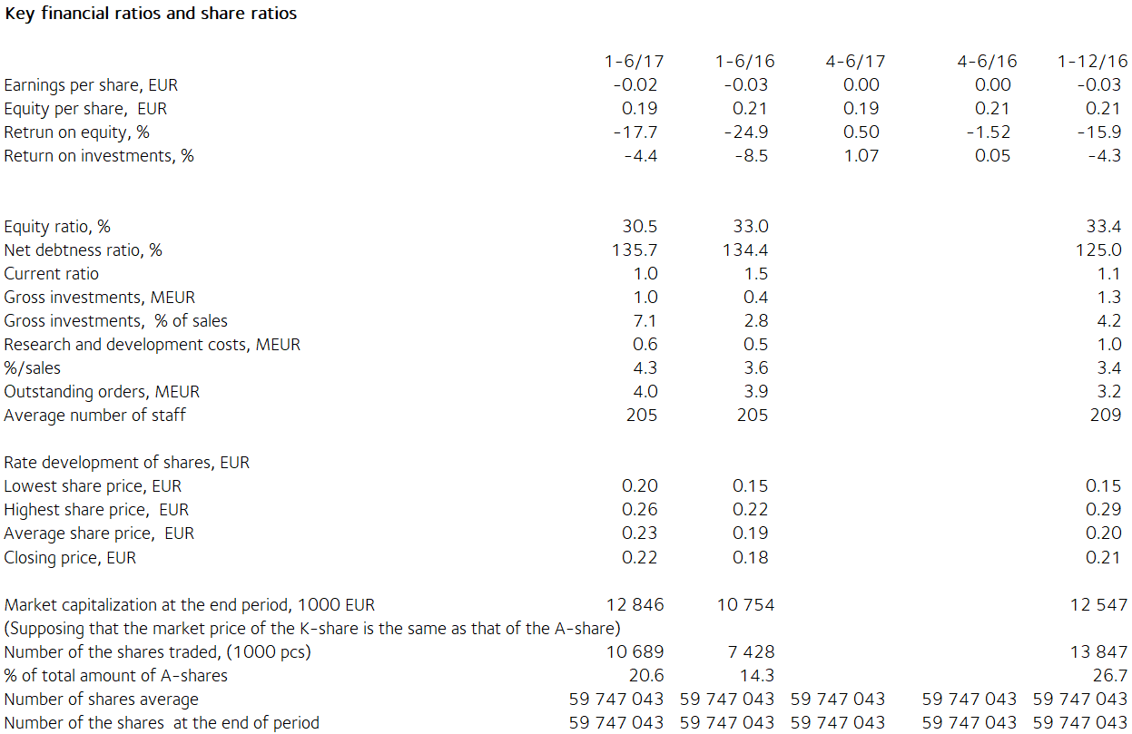

Notes on the financial statements

The information presented in this half-year report release has not been audited.

This half-year report release has been prepared in accordance with the IAS 34 Interim Financial Reporting standard. Tulikivi has applied the same IFRS accounting principles in this release as in the previous consolidated financial statements. The key figures presented in the half-year report release have been calculated using the same formulas as the 2016 financial statements. As there are no non-recurring expenses in this or the preceding review period, no figures based on non-recurring expenses are presented. The formulas can be found on page 86 of the Annual Report 2016.

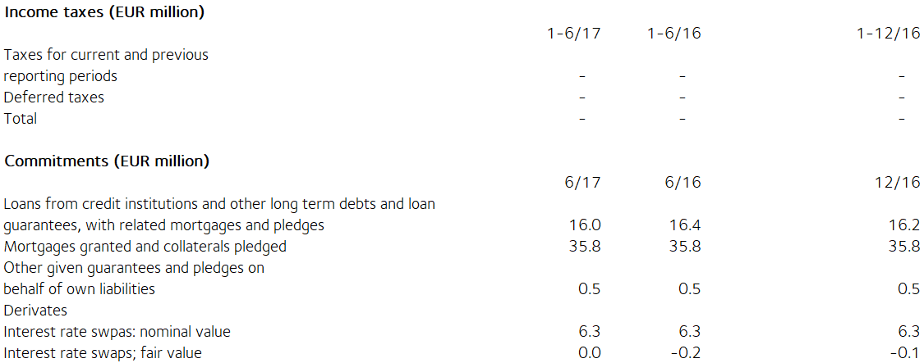

The fair value of derivatives is the gain or loss for closing the contract based on market rates at the balance sheet date. Derivatives are classified as level 2 in the fair value hierarchy. Available-for-sale financial assets are investments in unlisted companies. They are valued at acquisition cost because their fair value cannot be reliably determined.

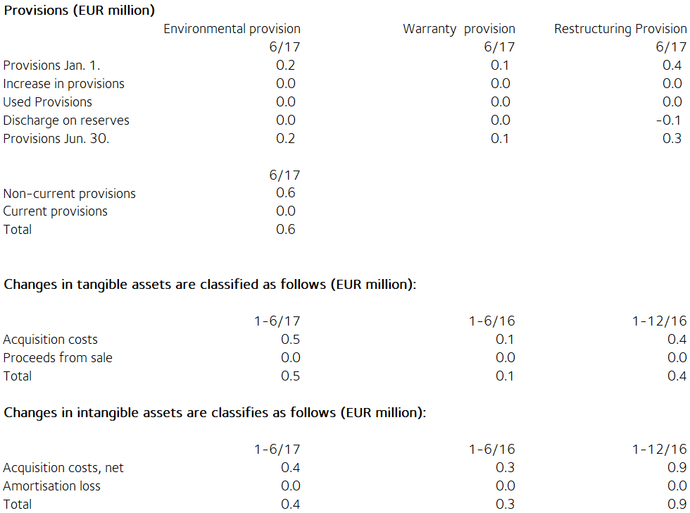

Share capital
Share capital by share series
Osakkeita, Osuus, Osuus, Osuus,
kpl % % euroa
osak- äänistä osakepää-
keista omasta
K-osakkeet (10 ääntä) 7 682 500 12,8 59,5 810 255
A-osakkeet (1 ääni) 52 188 743 87,2 40,5 5 504 220
Yhteensä 30.6.2017 59 871 243 100,0 100,0 6 314 475

There have been no changes in Tulikivi Corporation´s share capital during the review period. According to the Articles of Association, the dividend paid on Series A shares shall be EUR 0.0017 higher than the dividend paid on Series K shares. The A share is listed on NASDAQ OMX Helsinki. At the end of the review period, the company held 124,200 Series A shares.

Related party transactions (EUR 1,000)
There are no transactions with associated companies.

Transactions with other related parties
Tulikivi Corporation is a founder member of the Finnish Stone Research Foundation. The company has leased offices and storage facilities from a property owned by the Foundation and the North Karelia Educational Federation of Municipalities. The rent paid for these facilities was EUR 18 thousand (23 thousand) in the review period. The rent corresponds to market rents. The company's sales of services and land leases from the Foundation came to EUR 2 (3) thousand.

Management benefits (EUR 1 000)
1-6/17 1-6/16
Salaries and other short-term employee
benefits of the Board of Directors’
members and the Managing Director 134 135

Principal shareholders on 30 June 2017

Name of shareholder Shares Percentage
of votes
Vauhkonen Heikki 6 873 839 45.9%
Elo Mutual Pension Insurance Company 4 545 454 3.5%
Ilmarinen Mutual Pension Insurance Company 3 720 562 2.9%
Elo Eliisa 3 108 536 5.7%
Varma Mutual Pension Insurance Company 2 813 948 2.2%
Toivanen Jouko 2 531 259 2.7%
Finnish Cultural Foundation 2 258 181 2.4%
Mutanen Susanna 1 643 800 6.8%
Fennia Mutual Insurance Company 1 515 151 1.2%
Nikkola Jarkko 1 301 100 1.0%
Others 29 559 413 25.7%

The companies included in the Group are the parent company Tulikivi Corporation, Tulikivi U.S. Inc. and OOO Tulikivi. Group companies also include Tulikivi GmbH and The New Alberene Stone Company, Inc., which are dormant.

TULIKIVI CORPORATION

Board of Directors

Distribution: NASDAQ Helsinki

Key media

www.tulikivi.com

Further information: Heikki Vauhkonen, Managing Director, tel. +358 (0)207 636 555

