Financial statements release, Jan–Dec 2017


Tulikivi Corporation
Financial statements release, Jan–Dec 2017: Profitability improves, higher export net sales, parent company’s equity less than half of share capital

9 February 2018 at 1 p.m.

- The Tulikivi Group’s fourth-quarter net sales totalled EUR 8.6 million (EUR 8.5 million Q4/2016), the fourth-quarter operating result was EUR 0.0 (-0.1) million and the profit before taxes was EUR -0.2 (-0.3) million.
- The 2017 net sales of the Tulikivi Group were EUR 29.3 million (EUR 30.5 million Jan-Dec/2016), the operating result
was EUR -0.4 (-1.4) million and the result before taxes was EUR -1.2 (-2.1) million.
- Net cash flow from operating activities was EUR 0.9 (2.1) million in the fourth quarter and EUR 1.9 (2.0) million in the review period.
- The year-end order books stood at EUR 2.9 (3.2) million.
- Sales of the new Karelia fire place collection are developing well both in exports and domestically
- The parent company’s equity was EUR 2.4 million in the financial statements, while share capital is EUR 6.3 million, which means that parent company equity is less than 50% of share capital. The matter will be considered at the Annual General Meeting.
- Future outlook: Net sales are expected to increase in 2018, and the operating profit is expected to be positive.

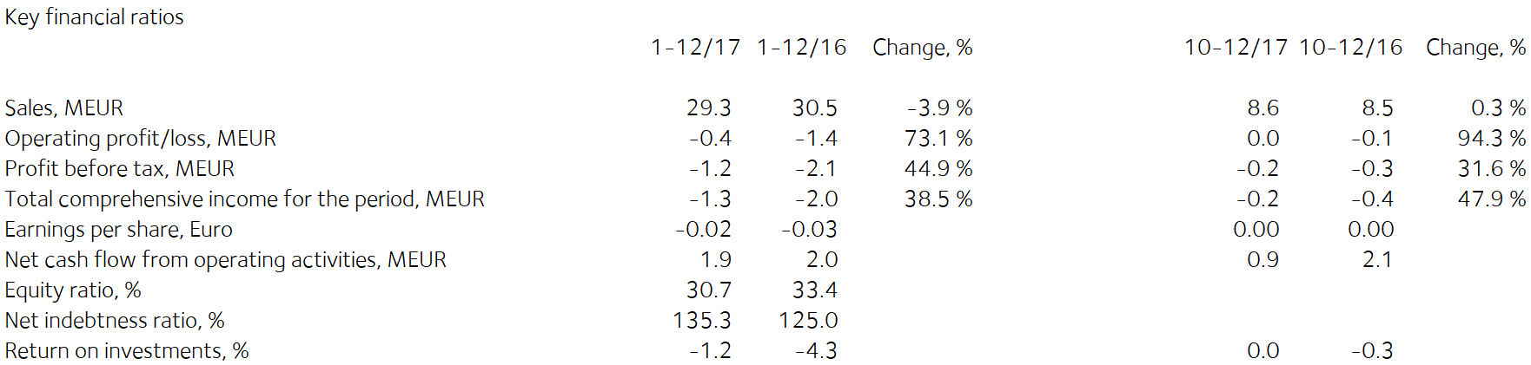

Comments by Heikki Vauhkonen, Managing Director:

Export sales of Tulikivi products continued to increase in the final quarter of 2017. In Central Europe, the new Karelia collection has substantially increased dealers’ and consumers' interest towards Tulikivi products. The sales outlook for early 2018 is better than a year ago in all the main export markets thanks to the Karelia collection.
The new Pielinen collection, launched in October, has also received a good welcome. The products in the collection are also modern Scandinavian design with a new technique for soapstone surface finish. The Pielinen products are compact and easy to install. They are especially well suited for the Central European market as well as markets where there is no expertise in installing heat-retaining fireplaces.
The order intake and net sales from Russia, our largest export country, increases thanks to active development of distribution channels and market environment that was more positive than in 2016.
In Finland the increase in sales of fireplaces to customers building new homes slowed down after the first half of the year but was nevertheless positive overall. Domestic sales decreases in the renovation market and as a result, the Finnish distribution channel was renewed. The goal is to increase the number of active service points.
In the fourth quarter, the company’s order intake was EUR 8.3 (8.4) million. Order intake for fireplaces and saunas increased. Order intake of stove liner stones and interior stone products, and fireplaces in Finland, declined.
The company’s order books at the end of the year amounted to EUR 2.9 (3.2) million.
In addition to efficiency measures, the focus of demand on the new Karelia collection has improved profitability. Due to improved productivity, decreased fixed costs and lower depreciation, the company’s operating result for the review period improved by EUR 1.0 million compared to the previous year.

The new Karelia fireplace collection has been very well received in Finland and abroad. The significantly improved confidence of Finnish consumers is expected to increase small house construction. We are continuing our efforts to enhance sales efficiency to increase renovation sales.

The highly successful development work of the Karelia and Pielinen collections provides an opportunity to increase net sales and profitability in 2018 in both Finland and exports.

Financial statements Jan–Dec 2017

Operating environment

The recovery of low-rise housing construction and renovation projects, and the improvement in consumer confidence compared with 2016, have energised demand for construction in Finland. Low-rise housing construction has begun to increase in the EU, which will boost the performance of the fireplace market in the near future. In Russia, demand for Tulikivi products is growing but dependent on the exchange rate of the rouble and the performance of the Russian economy.

Net sales and result

The Tulikivi Group’s fourth-quarter net sales totalled EUR 8.6 million (EUR 8.5 million for Q4/2016). The operating result was EUR 0.0 (-0.1) million, and the profit before taxes was EUR -0.2 (-0.3) million.

The Tulikivi Group’s net sales in 2017 totalled EUR 29.3 million (EUR 30.5 million in 2016). The operating result was EUR -0.4 (-1.4) million, and the result before taxes was EUR -1.2 (-2.1) million. In addition to efficiency measures, the focus of demand on the new Karelia collection has improved profitability. Due to improved productivity, decreased fixed costs and lower depreciation, the company’s operating result for the review period improved by EUR 1.0 million compared to the previous year.

The company’s order books at the end of the year amounted to EUR 2.9 (3.2) million. In the fourth quarter, the company’s order intake was EUR 8.3 (8.4) million. Order intake for fireplaces and saunas increased. Order intake of stove liner stones and interior stone products, and fireplaces in Finland, declined.
Net sales in Finland increased in the financial year and were EUR 13.4 (15.5) million, or 45.6% (50.9%) of total net sales. In Finland the increase in sales of fireplaces to customers building new homes slowed down after the first half of the year but was nevertheless positive overall. Domestic sales decreased in the renovation market and as a result, the Finnish distribution channel was renewed at the end of 2017. The goal is to increase the number of active service points.
Net sales from exports amounted to EUR 15.9 (15.0) million in the financial year. The principal export countries were Russia, Germany, France, Sweden and Denmark. Export sales of Tulikivi products continued to increase in the final quarter of 2017. In Central Europe, the new Karelia collection has substantially increased dealers’ and consumers' interest towards Tulikivi products. The sales outlook for early 2018 is better than a year ago in all the main export markets thanks to the Karelia collection.
The order intake and net sales from Russia, our largest export country, increases thanks to active development of distribution channels and market environment that was more positive than in 2016.
The new Karelia fireplace collection has been very well received in Finland and abroad. The significantly improved confidence of Finnish consumers is expected to increase small house construction. We are continuing our efforts to enhance sales efficiency to increase renovation sales.

The highly successful development work of the Karelia and Pielinen collections provides an opportunity to increase net sales and profitability in 2018 in both Finland and exports.

Financing

In the fourth quarter, net cash flow from operating activities was EUR 0.9 (2.1) million and EUR 1.9 (2.0) million during the financial year. Working capital decreased by EUR 1.5 (-1.8) million during the financial year. At the end of 2016, working capital stood at EUR 2.2 (3.7) million.

Loan repayments totalled EUR 0.7 (1.4) million in the financial year. Interest-bearing debt stood at EUR 15.7 (16.4) million at the end of the financial year, and net financial expenses for the financial year were EUR 0.8 (0.8) million. The equity ratio at the end of the financial year was 30.7% (33.4%). The ratio of interest-bearing net debt to equity, or gearing, was 135.3% (125.0%). The current ratio was 0.5 (1.1). Equity per share was EUR 0.19 (0.21). At the end of the financial year, the Group’s cash and other liquid assets totalled EUR 0.6 (0.9) million.

The financing agreement includes covenants concerning EBITDA, the equity ratio and the ratio of debt to EBITDA.
The company has concluded a new agreement with its finance providers on the 2018 repayment programme and negotiated a waiver on its covenants concerning EBITDA and the ratio of net debt to EBITDA at 31 December 2017. In the company management’s opinion the company will not meets its covenants concerning EBITDA and the ratio of net debt to EBITDA at 30 June 2018, as a result of which long-term financial liabilities have been classified and short-term financial liabilities in these financial statements in accordance with the IFRS standard. The management does believe, however, that it will receive wavers from its financing providers on said covenants at 30 June 2018 and that as a result, they will not demand the repayment of debt. The company has already agreed with its financing providers that it will commence negotiations on a new repayment programme and its terms no later than 1 September 2018.

As a result of posting a loss, the parent company’s equity has fallen to less than 50% of share capital. The parent company’s equity was EUR 2.4 million (consolidated equity EUR 11.2 million) in the financial statements, while share capital is EUR 6.3 million (consolidated share capital EUR 6.3 million). As a result, the company’s Board of Directors has taken action as referred to in Chapter 20, section 23, subsection 1, of the Limited Liability Companies Act. The financial statements referred to in the Limited Liability Companies Act will be for the period January-December 2017. As required in the Limited Liability Companies Act, the annual general meeting that will decide on the Board’s proposal concerning measures required by the company’s financial situation will be the company’s Annual General Meeting to be held on 19 April 2018. The Board of Directors’ proposal to the Annual General Meeting will consider, among other things, the company’s positive performance budgeted for 2018 and what is stated under Investments and product development in this financial statements release.

Investments and product development

The Group’s investments for the financial year totalled EUR 1.5 (1.3) million. The company introduced its new soapstone collection at the Batibouw fair in Belgium at the beginning of 2017. The Karelia fireplace collection is based on a new kind of surface finish of soapstone and a high quality of design. In conjunction with the renewal of the collection, the company invested in changes to production lines and a new surface finishing technology.
A new collection named Pielinen was launched in October 2017. The products in the collection are also modern Scandinavian design with a new technique for soapstone surface finish. The Pielinen products are compact and easy to install. They are especially well suited for the Central European market as well as markets where there is no expertise in installing heat-retaining fireplaces.
Research and development expenditure was EUR 1.0 (1.0) million, or 3.6% (3.4%) of net sales. EUR 0.5 (0.5) million of this was capitalised in the balance sheet.

The company’s soapstone reserves increased by 1.6 million cubic meters when the Finnish Safety and Chemicals Agency granted permission on 27 March 2017 to expand the Vaaralampi mining patent in Juuka. The added reserves are equal to the stone demand of more than 10 years.
On 20 April 2017 Tulikivi announced its decision to study opportunities to exploit the talc reserves in the Suomussalmi deposit. Tulikivi Corporation’s soapstone reserves in Suomussalmi have talc reserves that are believed to be suitable for talc production. On 13 June 2017 Tulikivi announced that according to analyses conducted by the Geological Survey of Finland, the talc grades of the deposit correspond to previous talc projects carried out in Finland in terms of talc content, yield and brightness. Based on the earlier drilling tests that Tulikivi carried out for the purpose of soapstone production and the new test results, Tulikivi estimates that there are approximately 20 million tonnes of talc ore in Suomussalmi. On 24 August 2017 Tulikivi announced that during summer, it had explored potential partners’ interest in exploiting the Suomussalmi talc deposit on the basis of the Geological Survey of Finland’s analysis and the earlier drilling tests. In September 2017, based on the feedback received, Tulikivi's Board of Directors launched preparations for the sale of the talc deposit. As a part of this process, the company ordered an official ore study that meets the international JORC code of a part of the Haaponen deposit in Suomussalmi from the Geological Survey of Finland. The initial stage of the study will cover a roughly 6-million-tonne part of the talc deposit. The purpose of the study is to verify the concentration capacity of the deposit for the purposes of talc production. Other studies will also be conducted concerning talc quarrying and concentration. The studies will be conducted in collaboration with the Kainuu ELY Centre. The goal is to complete this work during spring 2018. Evaluation of the success of sales or its financial impact is premature.

Personnel

The Group employed an average of 208 (209) people during the financial year. Salaries and bonuses during the financial year totalled EUR 9.1 (8.9) million. The number of personnel will be adjusted through lay-offs in accordance with the level of demand. In addition to temporary lay-offs, no members of the office staff are currently laid off. The Tulikivi Group has an incentive pay scheme for all personnel. The company also has a stock option scheme for the management that was launched in 2013.

Annual General Meeting

Tulikivi Corporation’s Annual General Meeting, held on 20 April 2017, resolved not to distribute a dividend on the 2016 financial year. Jaakko Aspara, Markku Rönkkö, Paula Salastie, Reijo Svanborg, Jyrki Tähtinen and Heikki Vauhkonen were elected as members of the Board of Directors The Board elected Jyrki Tähtinen as its Chairman. The auditor appointed was KPMG Oy Ab, Authorised Public Accountants, with Kirsi Jantunen, APA, as chief auditor.

The Annual General Meeting authorised the Board of Directors to decide on issuing new shares and on the transfer of Tulikivi Corporation shares held by the company in accordance with the proposals of the Board. Tulikivi can issue new shares or transfer treasury shares held by the company as follows: a maximum of 10,437,748 Series A shares and a maximum of 1,536,500 Series K shares.

The authorisation includes the right to decide on a directed rights issue, deviating from the shareholders’ right of pre-emption, provided that there is compelling financial reason for the company. The authorisation also includes the right to decide on a bonus issue to the company itself, where the number of shares issued to the company is no more than one tenth of the total number of the company’s shares.

The authorisation also includes the right to issue special rights referred to in Chapter 10, section 1, of the Limited Liability Companies Act, which would give entitlement to Tulikivi shares against payment or by setting off the receivable. The authorisation includes the right to pay the company’s share rewards. The Board is authorised to decide on other matters concerning share issues. The authorisation is valid until the 2018 Annual General Meeting.

Treasury shares

The company did not purchase or assign any treasury shares during the reporting period. At the end of the period, the total number of Tulikivi shares held by the company was 124,200 Series A shares, corresponding to 0.2 per cent of the company’s share capital and 0.1 per cent of all voting rights.

Board of Directors’ proposal on use of distributable equity

The parent company has no distributable equity. The Board will propose to the Annual General Meeting that no dividend be paid out for 2017.

Near-term risks and uncertainties

The Group’s most significant risk is the decline in net sales in the principal market areas. A potential halt in the restarted growth in new construction and renovation projects would affect the demand for Tulikivi products in Finland. The slower-than-predicted recovery of the markets in Central Europe and the uncertain economic situation in Russia also have an impact on the demand for fireplaces.

Improving the Group’s financing position and securing the continuation of financing require an improvement in profitability. If the company’s business operations and result do not develop as planned, the repayment of its debts may create a greater burden on the company’s cash flow than anticipated. A further risk is that the company will not succeed in negotiating a sufficient repayment programme and terms with the financing providers.

As regards the company’s foreign currency risk, the most significant currencies are the Russian rouble and the U.S. dollar. About 90 per cent of the company’s cash flow is in euros, which means the company’s exposure to foreign currency risks is very low. A weakening of currencies may have an adverse effect on the sales margin.

The risks are described in more detail on page 82 of the 2016 annual report and in the 2017 annual report that will be published during the week beginning on 19 March 2018 (week 12).

Future outlook
Net sales are expected to increase in 2018, and the operating profit is expected to be positive.

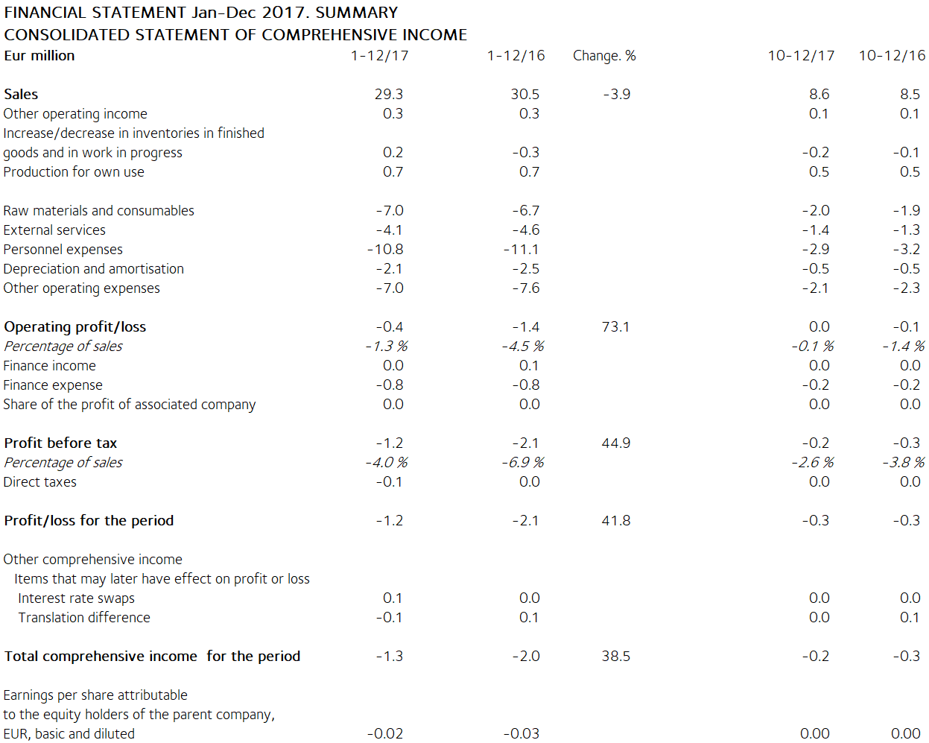

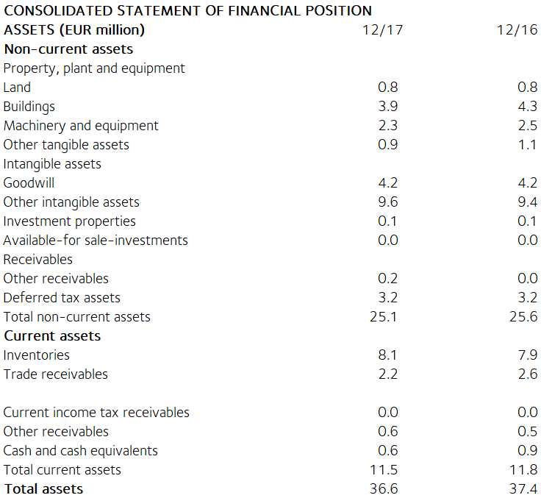

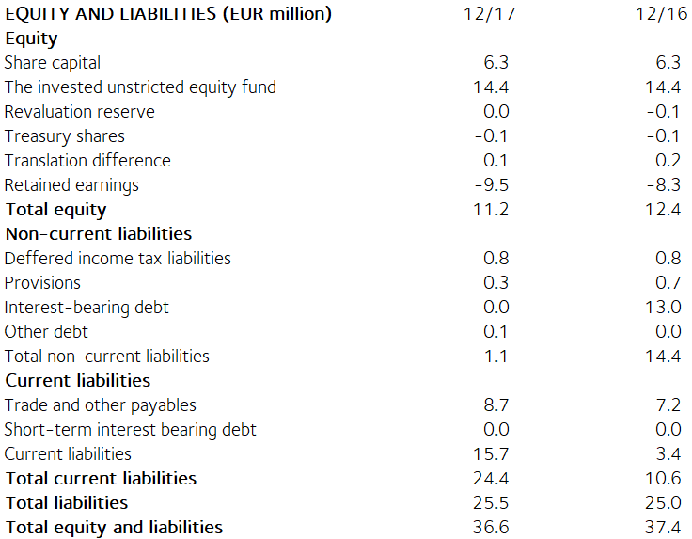

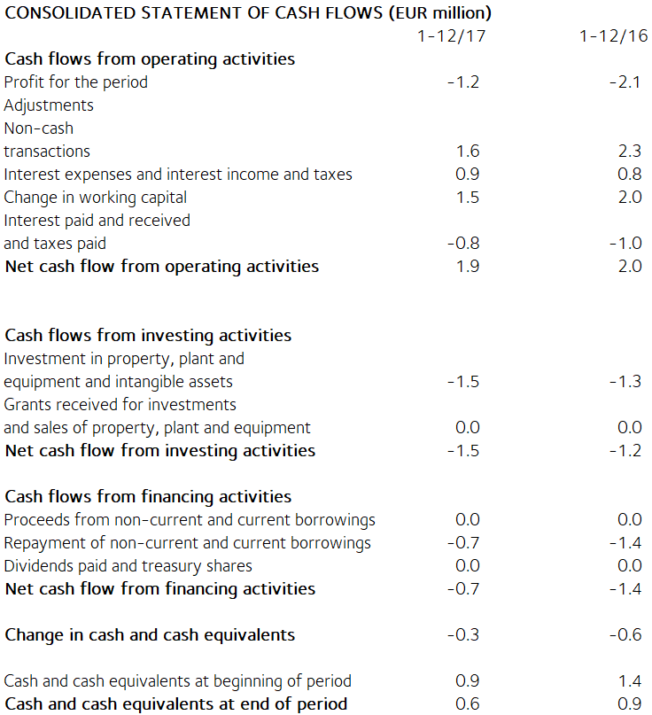
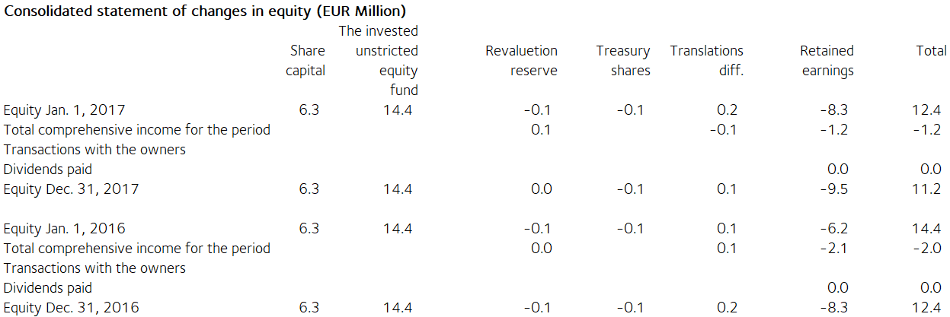

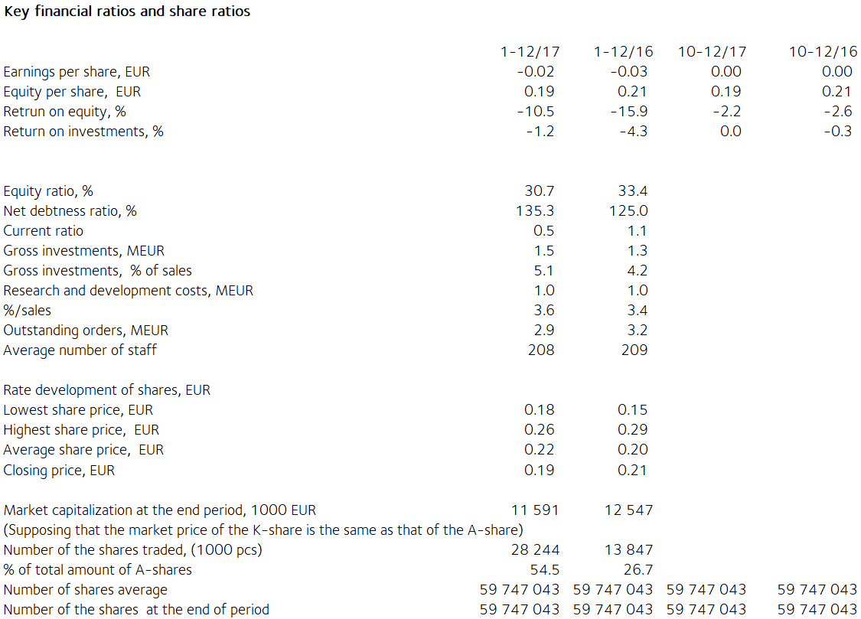

Notes to the financial statements

The information presented in the financial statements release has not been audited.

This financial statements release has been prepared in accordance with the IAS 34 Interim Financial Reporting standard. Tulikivi has applied the same IFRS accounting principles in this financial statements release as in the previous consolidated financial statements. The key figures presented in the financial statements release have been calculated using the same formulas as the latest financial statements for 2016. As there are no non-recurring expenses in this or the preceding review period, no figures based on non-recurring expenses are presented. The formulas can be found on page 86 of the Annual Report 2016.

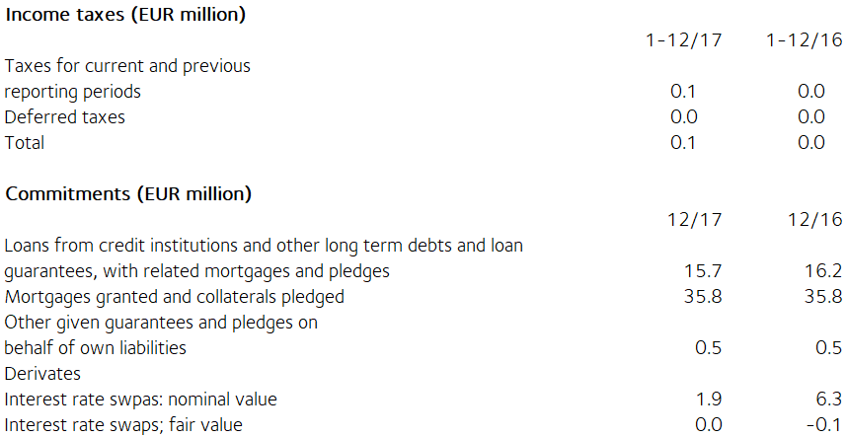

The fair value of derivatives is the gain or loss for closing the contract based on market rates at the balance sheet date. Derivatives contracts belong to level 2 of the fair value hierarchy. Available-for-sale financial assets are investments in unlisted shares They are valued at acquisition cost because their fair value cannot be reliably determined.

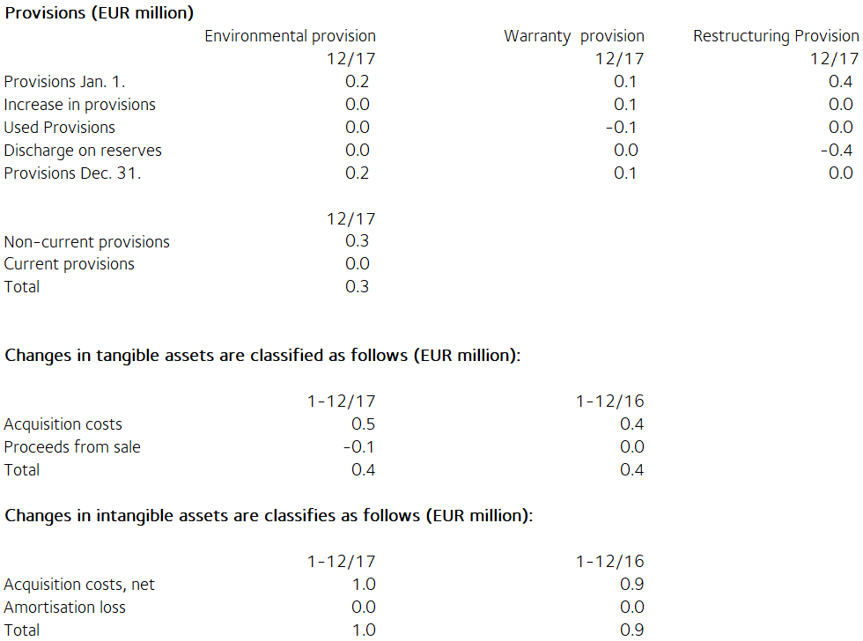

Share capital
Share capital by share series
Shares Percentage, Percentage, Percentage,
% % EUR
shares votes share
capital capital
Series K shares (10 votes) 7 682 500 12.8 59.5 810 255
Series A shares (1 vote) 52 188 743 87.2 40.5 5 504 220
Total, 31 December 2017 59 871 243 100.0 100.0 6 314 475

There have been no changes in Tulikivi Corporation´s share capital during the financial year. According to the Articles of Association, the dividend paid on Series A shares shall be EUR 0.0017 higher than the dividend paid on Series K shares. The A share is listed on NASDAQ OMX Helsinki. At the end of the review period, the company held 124,200 series A shares.

Related party transactions (EUR 1 000)
There are no transactions with associated companies.

Transactions with other related parties
Tulikivi Corporation is a founder member of the Finnish Stone Research Foundation. The company has leased offices and storage facilities from a property owned by the Foundation and the North Karelia Educational Federation of Municipalities. The rent paid for these facilities was EUR 36 (41) thousand in the financial year. The rent corresponds to market rents. The company's sales of services and land leases from the Foundation came to EUR 2 (2) thousand.

Management benefits (EUR 1 000)
1-12/17 1-12/16
Salaries and other short-term employee
benefits of the members of the Board of Directors and the Managing Director
374 351

Principal shareholders on 31 December 2017

Name of shareholder Shares Percentage
of votes
- Vauhkonen Heikki 6 873 839 45.9%
- Elo Mutual Pension Insurance Company 4 545 454 3.5%
- Ilmarinen Mutual Pension Insurance Company 3 720 562 2.9%
- Elo Eliisa 3 108 536 5.7%
- Toivanen Jouko 2 531 259 2.7%
- Finnish Cultural Foundation 2 258 181 2.4%
- Mutanen Susanna 1 643 800 6.8%
- Fennia Mutual Insurance Company 1 515 151 1.2%
- Nikkola Jarkko 1 320 200 1.0%
- EVK-Capital Oy 1 000 000 0.8%
Others 31 355 761 27.1%

The companies included in the Group are the parent company Tulikivi Corporation, Tulikivi U.S. Inc. and OOO Tulikivi. Group companies also include Tulikivi GmbH and The New Alberene Stone Company, Inc., which are dormant.

TULIKIVI CORPORATION

Board of Directors

Distribution: NASDAQ OMX Helsinki

Key media

www.tulikivi.com

Further information: Heikki Vauhkonen, Managing Director, tel. +358 (0)207 636 555

