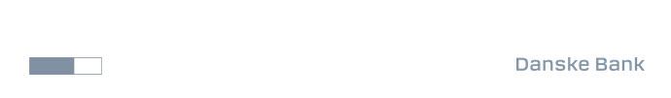

Company announcement no. 47 2025
Danske Bank
Bernstorffsgade 40
DK-1577 København V
Tel. + 45 33 44 00 00

20 October 2025

Page 1 of 1

Danske Bank share buy-back programme: transactions in week 42

On 7 February 2025, Danske Bank A/S announced a share buy-back programme for a total of DKK 5 billion, with a maximum of 45,000,000 shares, in the period from 10 February 2025 to 30 January 2026, at the latest, as described in company announcement no. 6 2025.

The Programme is carried out in accordance with Article 5 of Regulation (EU) No 596/2014 of the European Parliament and Council of 16 April 2014 (the "Market Abuse Regulation") and the Commission Delegated Regulation (EU) 2016/1052 of 8 March 2016 (together with the Market Abuse Regulation, the "Safe Harbour Rules").

The following transactions on Nasdaq Copenhagen A/S were made under the share buy-back programme in week 42:

 | Number of shares | VWAP DKK | Gross value DKK
Accumulated, last announcement | 13,841,531 | 245.9195 | 3,403,901,926
13 October 2025 | 50,000 | 272.4208 | 13,621,040
14 October 2025 | 52,000 | 270.5582 | 14,069,026
15 October 2025 | 139,208 | 274.7045 | 38,241,064
16 October 2025 | 35,000 | 273.6223 | 9,576,781
17 October 2025 | 200,996 | 271.5417 | 54,578,796
Total accumulated over week 42 | 477,204 | 272.6019 | 130,086,706
Total accumulated during the share buyback programme | 14,318,735 | 246.8087 | 3,533,988,632

With the transactions stated above, the total accumulated number of own shares under the share buy-back programme corresponds to 1.715% of Danske Bank A/S' share capital.

Danske Bank
Contact: Claus Ingar Jensen, Head of Group Investor Relations, tel. +45 25 42 43 70

