Ahold Delhaize will publish its first quarter 2026 results on May 6, 2026
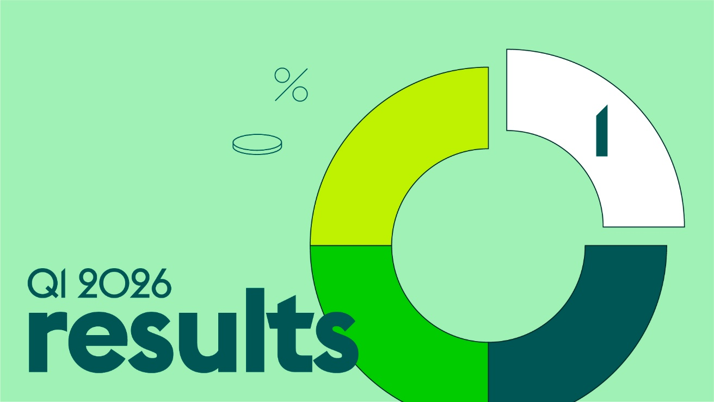
Zaandam, the Netherlands, April 15, 2026 – On Wednesday, May 6 at 7:30 AM CET Ahold Delhaize will publish its first quarter 2026 results.
Follow our conference call and webcast that starts at 10 AM CET which will be available on this website.
If you have questions or would like further information, please contact:
Ahold Delhaize Investor Relations at investor.relations@aholddelhaize.com or +31 (0)88 659 5213.
Webcast: https://streams.nfgd.nl/s/ahold-delhaize-q1-2026-results/register

- Ends -

About Ahold Delhaize
Ahold Delhaize’s family of great local brands serves over 77 million customers each week in Europe, the United States and Indonesia. Together, these 17 brands employ 384,000 associates, and operate more than 9,500 supermarkets, convenience stores and specialty stores. Our group includes the top online retailer in the Benelux, bol, and the food retail brands in the U.S. and the Benelux lead in online grocery. Ahold Delhaize brands are at the forefront of sustainable retailing, supporting local communities and helping customers make healthier choices. Headquartered in Zaandam, the Netherlands, Ahold Delhaize is listed on the Euronext Amsterdam and Brussels stock exchanges (ticker: AD). Its American Depositary Receipts are traded on the over-the-counter market in the U.S. and quoted on the OTCQX International marketplace (ticker: ADRNY).
