PRESS RELEASE
HOLLAND COLOURS HALF-YEAR RESULTS 2025/2026

- Revenues of € 56.8 million, unchanged from previous year, with an unfavorable translation from USD to EUR of € 1.5 million (-2.6%).
- Operating result of € 2.7 million versus € 4.8 million in the same period previous year.
- Net result was € 2.1 million compared to € 3.5 million in the same period last year, resulting in net earnings per share of € 2.44 compared to € 4.02 in the same period previous year.

Our key markets were stagnant in the first half of this financial year, primarily as a result of economic uncertainty. We continued to advance on our strategic growth initiatives, achieving solid progress despite a slower and fluctuating pace due to prevailing uncertainties.

Division EMEIA increased revenue in the first half-year by 4% versus the same period last year. Building and Construction, and Packaging both saw a slight increase in revenue, while Coatings & Sealants underperformed.

Division Americas saw revenue in USD increase by 2% where Packaging was the biggest contributor, while Coatings & Sealants underperformed versus the same period last year.

Division Asia revenue in USD remained flat (0%) where Building and Construction and Packaging both saw increased revenue with a stronger contribution from export sales, while Coatings & Sealants saw a decrease.

The contribution margin for the Group was € 26.8 million, a decrease of € 1.1 million compared to the same period last year including an unfavorable USD to EUR translation of € 0.7 million. The margin for the Group as a percentage of revenue decreased to 47%, versus 49% in the same period last year, partly due to an unfavorable sales mix.

Operating expenses were € 24.0 million, up by € 0.9 million (5%) compared to the same period previous year. This increase was in line with our strategic roadmap and included higher costs related to business development, marketing, and IT.

Net cash flow amounted to € 10.1 million (negative) versus a net cash flow in the same period last year of € 2.7 million (negative), a decrease of € 7.4 million. This was primarily due to a lower operating result, a higher level of investments related to new manufacturing equipment for the Americas and the EMEIA division and the higher dividend that has been paid versus the same period last year.

OUTLOOK 2025/2026

2025/2026 continues to be defined by a challenging global economic environment. Persistent inflationary pressures, ongoing trade tensions, and geopolitical uncertainty remain key concerns. Therefore, we remain cautious in our business expectations for the remainder of 2025/2026.

Despite current market conditions, Holland Colours remains committed to its strategy, mission, and vision. Our strategy includes specific initiatives to accelerate the growth of our core business, and we are committed to developing new, innovative opportunities in the area of recycling and circularity. Our strategy continues to reflect our commitment to solidifying our position as an independent supplier of pigment and additive concentrates.

Apeldoorn, October 31, 2025

Board of Management
Coen Vinke (CEO)
Martijn Klomp (CFO)
Eelco van Hamersveld (CTO)

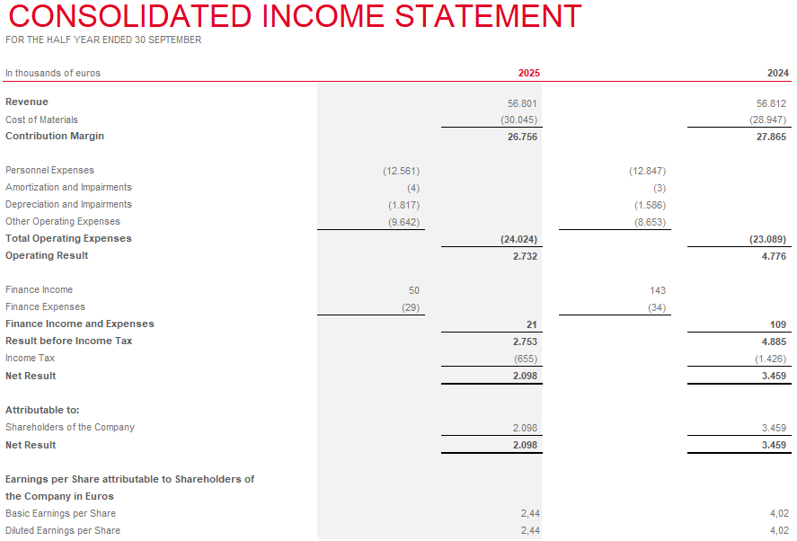

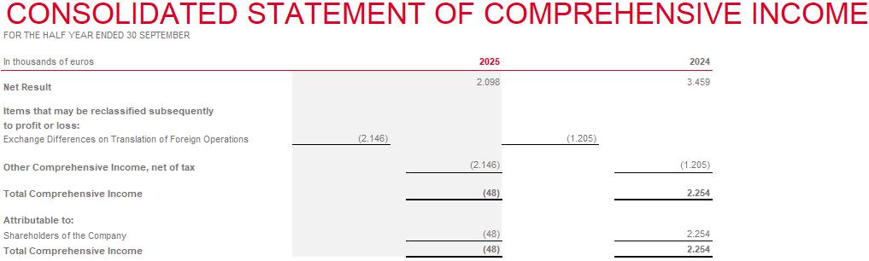
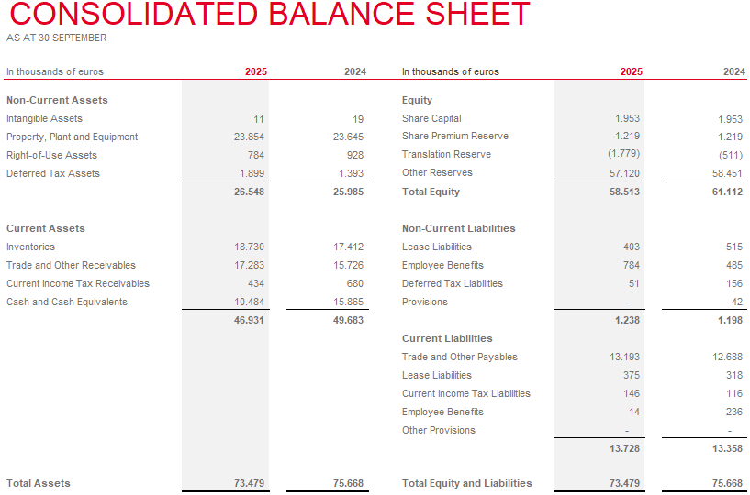

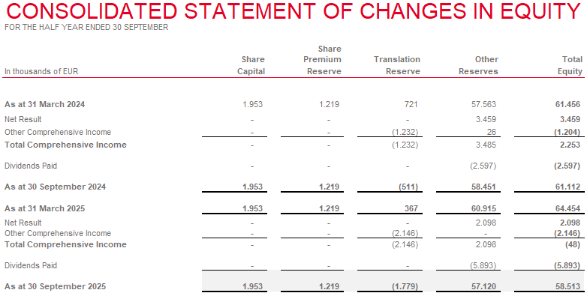
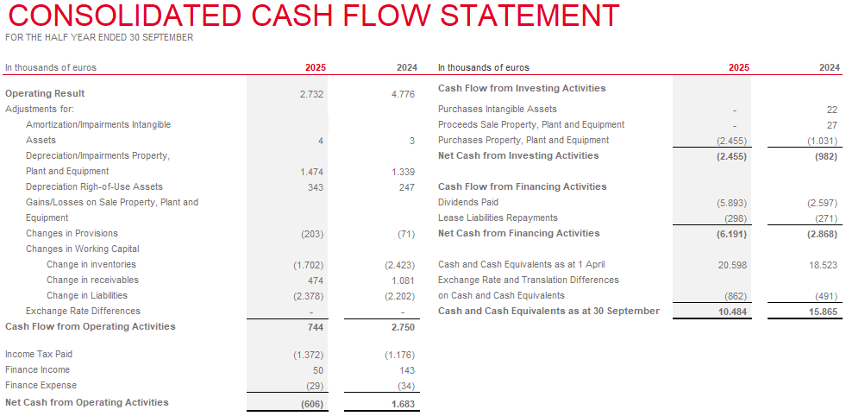
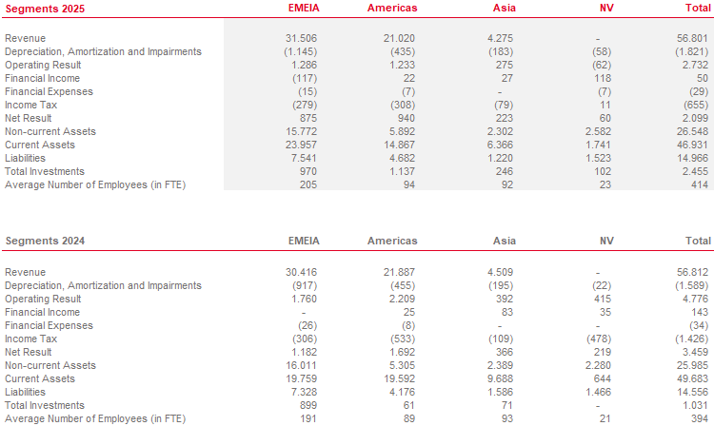
NOTES
Basis of preparation
The interim financial information covering the period ending September 30, 2025 has been prepared in accordance with the principles for consolidation and financial reporting, as described in the annual report of Holland Colours NV for the year 2024/2025 and does not include all information and disclosures required for the annual financial statements. Accordingly, the interim financial information should be read in conjunction with the financial statements for the year ending March 31, 2025, which have been prepared in accordance with EU-IFRS. Comparison numbers may have been reclassified or adjusted for comparability purposes and are in line with the annual report 2024/2025.

Audit
The half- year results of 2025/2026 are unaudited.

PROFILE
Holland Colours develops and manufactures groundbreaking solid and liquid color concentrates, plus masterbatches and additive concentrates for rigid and flexible PVC for the building & construction industry, and for the production of PET and polyolefin-based packaging. We also produce color concentrates for use in coatings, sealants & adhesives, and other applications.

As a company, we set out to deliver customer peace of mind through superior product performance, world-leading product stewardship, and outstanding technical service. Our experts co-design color and functional solutions with our customers, develop solutions to support recycling and actively contribute to creating a more sustainable industry overall.

Holland Colours is a Dutch company, founded in 1979 and listed on the Euronext Amsterdam Stock Exchange. With committed employee shareholders and production locations in the Americas, Europe, and Asia, we serve customers on every continent. To find out more, visit us at hollandcolours.com.

KEY DATES (provisional)
May 28, 2026 Publication of 2025/2026 financial statements
July 9, 2026 Annual General Meeting of Shareholders

Holland Colours NV
PO Box 720 | 7300 AS Apeldoorn | Netherlands
Tel + 31 (0)55 368 07 00 |
ir@hollandcolours.com | www.hollandcolours.com |
 |  |  |  | 

