

Press Information

April 3, 2014

Philips showcases locally relevant innovations in India

Bangalore, India – Royal Philips (NYSE: PHG, AEX: PHIA) today showcased a range of innovations at the Philips Innovation Center (PIC) in Bangalore, India, specially developed for South Asia and other growth geographies. At an international media event, Philips underlined its commitment to developing and investing in innovations in the area of healthcare, energy-efficient LED lighting solutions, and locally relevant consumer appliances and services.

“India and other growth geographies are increasingly important, not just as markets, but as centers of innovation excellence for Philips.” said Jim Andrew, Chief Strategy & Innovation Officer “We believe that to be meaningful, innovation must be locally relevant. That requires innovating close to and often directly alongside, our customers, wherever they are in the world. This is a fundamental part of our innovation strategy, and why we continue to invest in centers of innovation excellence that have impact locally and also expertise that we can leverage globally.”

The PIC and is one of the 59 Philips R&D centers in the world, of which 13 are in Asia and 3 in Latin America. In 2013 Philips invested more than EUR 1.7 billion in research and development globally.
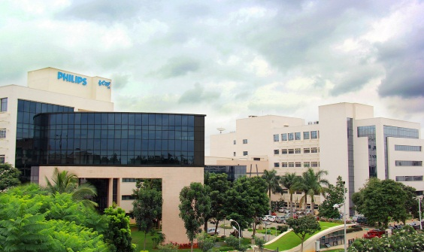
The Center focuses on building complete products for India and growth geographies, in addition to developing solutions and products for global markets, across the three sectors Philips operates in, Healthcare, Lighting and Consumer Lifestyle. Products include, ultrasound devices, Mother and Child Care products like Warmers and Incubators, the Intellispace Consultative Critical Care Solution and a whole host of solutions for India. It also contributes to Global solutions in MR, CT and Component development for connected consumer devices, connected Lighting solutions and renewable energy.

Products and solutions unveiled at the event include:

Mobile Obstetrical Monitoring (MOM) is a prototype scalable telehealth solution for early high-risk pregnancy detection in regions where increasing maternal mortality is a concern. Using a mobile phone* application, midwives can easily collect data from physical examinations and tests at local nursing clinics or even at the soon-to-be-mother’s home. Obstetricians or gynecologists in a different location are enabled to determine if a pregnancy might be high- risk, anywhere and anytime. Based on initial testing in India, Philips Indonesia is currently running a one-year pilot project.

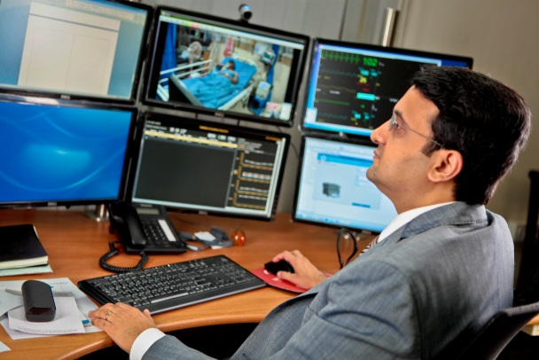
IntelliSpace Consultative Critical Care (ICCC) is a telehealth solution for remote intensive care delivery (tele-ICU) in rural and urban areas of India, where specialist care is not always available. Designed by the PIC team in India and already used by a total of thirteen regional hospitals in the country, it enables patients who suffer from a serious injury or illness to be monitored and evaluated by an intensive care specialist from a central hospital command center through the latest audio-visual technology.


Air Purifier- As part of Philips’ commitment to deliver meaningful innovation in personal health and well-being, Philips introduced in the India market a new category in its Consumer Lifestyle portfolio – Air Purification – with the launch of three variants of Air Purifiers designed to manage indoor air quality. These products can help to improve the lives of those suffering from allergies or respiratory problems – good indoor air quality can help prevent such issues from occurring or worsening.

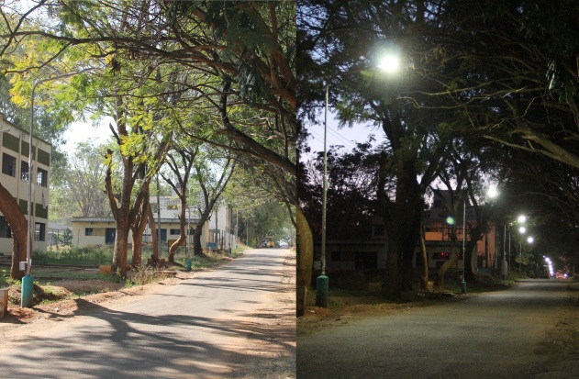
Solar Energy -The DC Grid
The Philips Solar DC grid is a new LED-based solution that realizes an efficient link between a renewable energy source and an efficient luminaire. The development of affordable, inexhaustible and clean solar energy technologies will have huge longer-term benefits, especially in growth geographies where there is an increasing gap between supply and demand.

This has driven Government agencies to look out for sustainable sources of energy. The Philips Solar DC grid will demand less energy from the source to produce the same amount of light and this reduced energy can be supplied from smaller photovoltaic (PV) panels due to the efficient DC grid infrastructure.


Connected LED lighting powered over Ethernet-Philips launched the world’s first complete Power over Ethernet connected lighting system for offices that gives workers smartphone control of their office lighting and building managers new insights into building usage. The intelligent lighting system can incorporate sensors to provide anonymous occupancy and climate data for more efficient facilities management and energy savings. At the same time it gives office workers more control of their open plan environment, aiding comfort and productivity.

For further information, please contact:
Elena Calamo Specchia
Philips Group Communications
Tel: +31 6 25004735
Email: elena.calamo.specchia@philips.com

Moushumi Dutt
Corporate Communications, Philips India Limited
Tel: +91-9899101579
Email: moushumi.dutt@philips.com

Sumathi Rao
Corporate Communications, Philips India Limited
Tel: +91-9845210362
Email: sumathi.rao@philips.com

About Royal Philips:
Royal Philips (NYSE: PHG, AEX: PHIA) is a diversified health and well-being company, focused on improving people’s lives through meaningful innovation in the areas of Healthcare, Consumer Lifestyle and Lighting. Headquartered in the Netherlands, Philips posted 2013 sales of EUR 23.3 billion and employs approximately 115,000 employees with sales and services in more than 100 countries. The company is a leader in cardiac care, acute care and home healthcare, energy efficient lighting solutions and new lighting applications, as well as male shaving and grooming and oral healthcare. News from Philips is located at www.philips.com/newscenter.

