PRESS RELEASE

Zwolle – October 20th 2016

RoodMicrotec Appoints New CFO

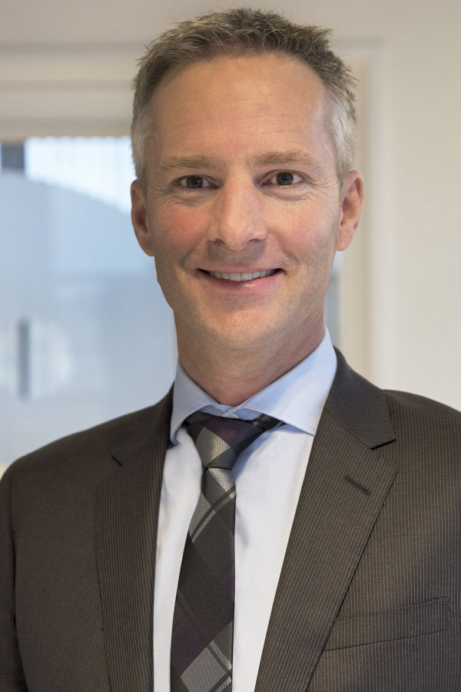
RoodMicrotec, the Dutch semiconductor supplier of advanced microchips critical to communication in the rapidly expanding electric automotive, industrial and medical sectors, has appointed Arvid Ladega as its new CFO from November 1st 2016. Erwin Vrielink, the current CFO, will stay on as a financial advisor to the company.
Martin Sallenhag, CEO of RoodMicrotec said: “Arvid brings with him a wealth of experience from his functions as CFO and financial controller in industrial engineering. We are also ensuring continuity in the role with Erwin staying on as an advisor.”
Arvid Ladega has extensive experience as CFO in the industrial sector, having served in that capacity for almost seven years at Turn Key Pipeline Services B.V. and five years at Bartels Engineering, both in the Netherlands. He also held a senior financial position at Wasco Coatings Europe, subsidiary to its Malaysian listed holder.
Erwin Vrielink, who has served as RoodMicrotec CFO since November 2015, is making a speedy recovery from a recent eye operation. He has decided to further his career as an independent financial advisor.
ENDS

About RoodMicrotec
With more than 45 years’ experience as an independent value-added service provider in the area of micro and optoelectronics, RoodMicrotec offers Fabless Companies, OEMs and other companies a one-stop shop proposition. With its powerful solutions RoodMicrotec has built up a strong position in Europe.
Our services comply with the industrial and quality requirements of the high reliability/space, automotive, telecommunications, medical, industrial and electronics sectors.
Certified by RoodMicrotec concerns inter alia certification of products to the stringent ISO/TS 16949 standard that applies to suppliers to the automotive industry. The company also has an accredited laboratory for test activities and qualification to the ISO/IEC 17025 standard.
Its value-added services include (eXtended) supply chain management and total manufacturing solutions with partners, failure & technology analysis, qualification & burn-in, test & product engineering, production test (including device programming and end-of-line service), ESD/ESDFOS assessment & training and quality & reliability consulting.
RoodMicrotec has branches in Germany (Dresden, Nördlingen, Stuttgart), United Kingdom (Bath) and the Netherlands (Zwolle).
For more information visit http://www.roodmicrotec.com

Further information
Martin Sallenhag CEO; Reinhard Pusch COO; Vic Tee chairman of the Supervisory Board; Philip Nijenhuis member of Supervisory Board; Erwin Vrielink CFO.
Telephone: +31 38 4215216
Postal address:
RoodMicrotec N.V., PO Box 1042, 8001 BA Zwolle
Email: investor-relations@roodmicrotec.com Web: www.roodmicrotec.com

This press release is published in English, Dutch and German. In case of conflict between these versions the English version shall prevail.

