
RoodMicrotec takes over leading role in APPLAUSE, a large European funding project on advanced packaging for photonics and electronics
- leader of work package “Testing, Reliability, Failure Analysis & Metrology”
- national coordinator for the nine German partners
- EUR 750,000 of funding in the next three years
Deventer, 29th October 2019 – RoodMicrotec, a leading independent company for semiconductors supply and quality services, today announces the start of the large European funding project APPLAUSE. A consortium of 31 key players for packaging of electronics, optics and photonics, leading equipment suppliers and testing experts from 11 countries launched a new project, “Advanced packaging for photonics, optics and electronics for low cost manufacturing in Europe,” simply called APPLAUSE. The project fosters the European semiconductor value chain by building new tools, methods and processes for high volume manufacturing. As a part of the Electronics Components and Systems for European Leadership Joint Undertaking (ECSEL JU), the 34M€ total budget for the three-year project is co-funded by Horizon 2020 and national funding agencies and industries.
Being the leader of work package 6 (Testing, Reliability, Failure Analysis & Metrology) for all six industrial use cases, RoodMicrotec will contribute with its core competence in quality and reliability. As national coordinator for the nine German partners, RoodMicrotec also is the main contact for the German funding agency. In total, RoodMicrotec will receive about 750,000€ of funding from the EU and the BMBF (German Federal Ministry of Education and Research) within the next three years.
“APPLAUSE is a great chance to develop new technologies for the next generation of advanced packaging for the ever growing photonics industry with regards to testing and qualification. With our finger on the pulse of the time, we will strengthen our future market position”, says Martin Sallenhag, CEO of RoodMicrotec.
The six use cases include a substantially smaller 3D integrated ambient light sensor for mobile and wearable applications (ams AG, Austria), a high performance, low cost, uncooled thermal IR sensor for automotive and surveillance applications (IDEAS, Norway), high speed datacom transceivers with reduced manufacturing costs (DustPhotonics, Israel), a flexible cardiac monitoring patch (Precordior, Finland), miniaturized cardiac implants with advanced monitoring capabilities (Cardiaccs, Norway), and an optical water measurement module with cost-effective packaging of components (Vaisala, FinIand).

For more information, please contact Dr. Björn Hoffmann, Manager Optoelectronics & Innovation at RoodMicrotec (bjoern.hoffmann@roodmicrotec.com) or visit the website at www.applause-ecsel.eu .

Project partners:

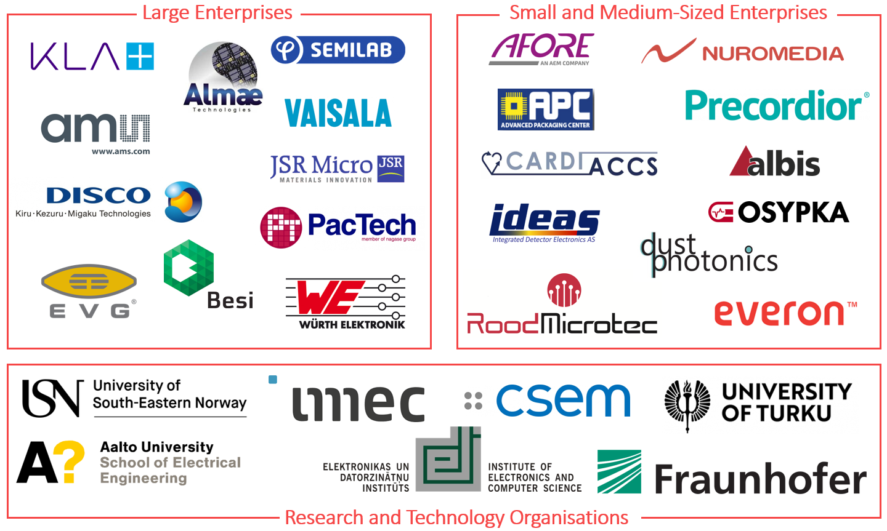




APPLAUSE has received funding from the ECSEL JU under grant agreement No 826588. The JU receives support from the European Union’s Horizon 2020 research and innovation programme as well as Belgium, Germany, Netherlands, Finland, Austria, France, Hungary, Latvia, Norway, Switzerland and Israel.

About ECSEL JU
The “Electronic Components and Systems for European Leadership” (ECSEL) is a Joint Undertaking established in June 2014 by the European Union Council Regulation No 561/2014. The ECSEL Joint Undertaking - the Public-Private Partnership for Electronic Components and Systems – funds Research, Development and Innovation projects for world-class expertise in these key enabling technologies, essential for Europe's competitive leadership in the era of the digital economy. Through the ECSEL JU, the European industry, SMEs and Research and Technology Organisations are supported and co-financed by 30 ECSEL Participating States and the European Union. A total of approximately 346M€ European and national grants have been awarded to proposals with total eligible costs of about 748M€ arising from the ECSEL JU, making another step forward in the 5B€ programme to be supported by ECSEL JU.
Read more about the ECSEL JU programme.

About RoodMicrotec
RoodMicrotec is a leading independent company for semiconductor supply and quality services. With 50 years of experience in the semiconductor and electronics industry, RoodMicrotec is well-established as a highly valued partner for many companies worldwide. The company provides full-turnkey ASIC services for complex microchips that are customized to handle specific applications for individual customers. In cooperation with strong partners, RoodMicrotec manages the entire development and production flow of ASICs in the target volume, ranging from low quantities up to multiple millions per year. The turnkey solution includes project management, wafer test, assembly, final test, qualification, failure analysis and logistics. All services comply with the industrial and quality requirements of the high reliability, aerospace, automotive, healthcare and industrial sectors. RoodMicrotec’s headquarter is located in Deventer, Netherlands, with operational units in Nördlingen and Stuttgart, Germany.
For more information visit https://www.roodmicrotec.com

Further information beside Dr. Björn Hoffmann
Martin Sallenhag - CEO, Arvid Ladega - CFO
Telephone: +31 570 745623 Email: investor-relations@roodmicrotec.com Web: www.roodmicrotec.com

This press release was published in English, Dutch and German. In case of conflict between these versions, the English version shall prevail.

