
Universal Music Group N.V. Reports Financial Results for the Third Quarter and Nine Months Ended September 30, 2022

Summary Q3 Results
- Revenue of €2,664 million increased 13.3% year-over-year in constant currency driven by growth across all segments.
- Recorded Music revenue grew 10.1% year-over-year in constant currency, Music Publishing revenue grew 6.9% year-over-year in constant currency and Merchandising and Other revenue grew 101.1% year-over-year in constant currency.
- Top sellers for the quarter included BTS, BLACKPINK, Ado, INI and Morgan Wallen.
- Adjusted EBITDA increased 9.1% year-over-year in constant currency driven by the revenue growth.

Summary YTD Results
- Revenue of €7,398 million increased 15.6% year-over-year in constant currency with strong growth across all segments.
- Recorded Music revenue grew 10.1% year-over-year in constant currency, Music Publishing revenue grew 28.2% year-over-year in constant currency and Merchandising and Other revenue grew 80.6% year-over-year in constant currency.
- Adjusted EBITDA increased 10.2% year-over-year in constant currency driven by the revenue
growth.
Hilversum, The Netherlands, October 27, 2022 -- Universal Music Group N.V. (“UMG” or “the
Company”) today announced its financial results for the third quarter and nine months ended September 30, 2022.

“More than ever, we are delivering a diverse and growing range of business and creative opportunities to our recording artists and songwriters,” said Sir Lucian Grainge, UMG’s Chairman and CEO. “Through our innovation, global reach, and unique understanding of the evolution of the market, we are continually improving the monetization of music and music-related content, generating high-quality revenue and recurring income from more sources than ever before.”
Boyd Muir, UMG’s EVP, CFO and President of Operations, said, “Our vision of success is about maximizing the long-term value of the business. That requires not only growing revenues but also growing a broad diversity of revenue streams that help drive greater absolute EBITDA and greater value for shareholders.”

UMG Results
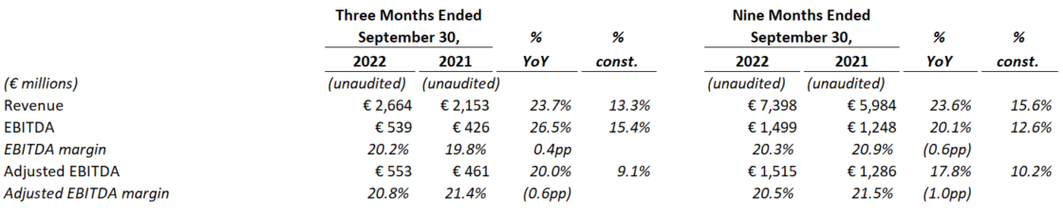
Note: % YoY indicates % change year-over-year; % const. indicates % change year-over-year adjusted for constant currency. Constant currency change is calculated by taking current year results and comparing against prior year results restated at current year rates.
Q3 2022 Results
Revenue for the third quarter of 2022 was €2,664 million, an increase of 23.7% year-over-year, or 13.3% in constant currency. Revenue includes a €71 million benefit in Recorded Music from the settlement of a copyright infringement lawsuit with an internet service provider (the “Legal Settlement”), as well as a €21 million negative impact in Music Publishing from a previously announced change in accounting policy.
As disclosed in the UMG Annual Consolidated Financial Statements for the year ended December 31, 2021, UMG adjusted its accounting policy in relation to certain revenues that are collected through societies (the “Change in Society Accounting”). In prior years, these revenues were recognized when the relevant collection society notified UMG of the usage by the end customer and collectability was assured. Recognition of that revenue is now based on an accrual for the best available estimate of when the usage occurs and the amount of consideration which is probable to be collected. This has affected the timing of the recognition of certain revenues across financial reporting quarters.
UMG’s Recorded Music, Music Publishing and Merchandising and Other segments all contributed to the revenue growth in the quarter, as discussed further below.
EBITDA for the quarter grew 26.5% year-over-year, or 15.4% in constant currency, to €539 million, driven by the revenue growth and the Legal Settlement. EBITDA margin was 20.2%, compared to 19.8% in the third quarter of 2021. EBITDA and EBITDA margin were impacted by share-based compensation of €14 million during the third quarter of 2022, and by €20 million of share-based compensation as well as €15 million of expenses related to UMG’s listing on Euronext Amsterdam during the third quarter of 2021. Excluding these items, Adjusted EBITDA for the quarter was €553 million, up 20.0% year-over-year, or 9.1% in constant currency, driven by the revenue growth and the Legal Settlement. Adjusted EBITDA margin was 20.8%, compared to 21.4% in the third quarter of 2021.
EBITDA and Adjusted EBITDA in the third quarter of 2022 included a €52 million benefit from the Legal Settlement, partially offset by the negative €7 million impact from the Change in Society Accounting.
EBITDA and Adjusted EBITDA were also impacted by the timing of certain A&R expenses, which increased in the quarter but remain down year-to-date, and by revenue mix, as revenues were more heavily weighted towards Merchandising and Other revenues, which carry a significantly lower EBITDA margin than the Company’s other revenues. Excluding these items, Adjusted EBITDA margin was flat versus the prior-year quarter.

YTD 2022 Results
In the nine months ended September 30, 2022, UMG’s revenues of €7,398 million increased by 23.6%, or 15.6% in constant currency, compared to the nine months ended September 30, 2021. This increase was driven by double-digit improvements across all segments, as discussed further below.
Revenue for the nine months ended September 30, 2022 includes a €123 million benefit from the Change in Society Accounting, and a €71 million benefit from the Legal Settlement, both discussed above. Revenue for the nine months ended September 30, 2021 included a €41 million benefit from a catch up payment from a digital service provider “DSP Catch-Up Payment”, previously disclosed and booked in Q2 2021. Excluding these items, revenue increased 21.2% year-over-year, or 13.3% in constant currency.
For the nine months ended September 30, 2022, EBITDA of €1,499 million grew 20.1% year-over-year, or 12.6% in constant currency, and EBITDA margin was 20.3% compared to 20.9% in the prior year period. EBITDA and EBITDA margin were impacted by share-based compensation of €16 million during the nine months through Q3 2022, and by €20 million of share-based compensation as well as €18 million of expenses related to UMG’s listing on Euronext Amsterdam during the nine months through Q3 2021. Excluding these amounts, Adjusted EBITDA for the nine months through Q3 2022 was €1,515 million, up 17.8% compared to the comparable period in 2021, or up 10.2% in constant currency, driven by the revenue growth. Adjusted EBITDA margin contracted 1.0pp year-over-year to 20.5%.
EBITDA and Adjusted EBITDA for the nine months through Q3 2022 benefitted from the Change in Society Accounting (€27 million) and the Legal Settlement (€52 million). EBITDA and Adjusted EBITDA for the nine months ended Q3 2021 benefitted from the DSP Catch-Up Payment (€26 million), as well as from a previously disclosed recovery of an advance provision and release of historic royalties (the “Exceptional Recovery and Release”, €20 million) in the first quarter of 2021. Excluding these items, Adjusted EBITDA grew 15.8% year-over-year, or 8.0% in constant currency, and Adjusted EBITDA margin was 19.9%, compared to 20.9% for the nine months ended Q3 2021. The contraction in Adjusted EBITDA margin was driven by revenue mix, as revenues were more heavily weighted towards lower-margin Merchandising revenues in the first nine months of 2022.

Recorded Music
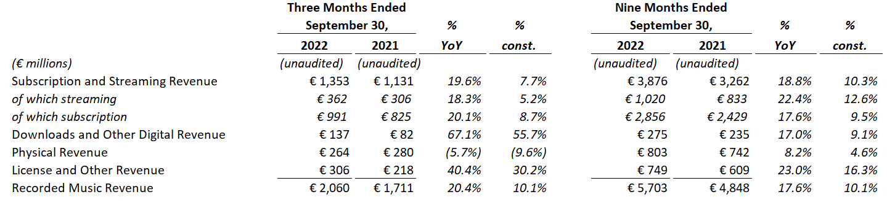
Note: % YoY indicates % change year-over-year; % const. indicates % change year-over-year adjusted for constant currency.
Q3 2022 Results
Recorded Music revenues for the third quarter of 2022 were €2,060 million, up 20.4% compared to the third quarter of 2021, or 10.1% in constant currency. Subscription and streaming revenue grew 19.6% year-over-year, or 7.7% in constant currency, with subscription revenue up 20.1% year-over-year, or 8.7% in constant currency, driven by the continued healthy growth in music subscribers. Ad-supported streaming revenue grew 18.3% year-over-year, or 5.2% in constant currency, reflecting ongoing improvement in ad-based monetization, despite industry-wide ad-market pressure as a result of the uncertain macro-economic environment. Physical revenue declined 5.7% year-over-year, or 9.6% in constant currency, driven by the industry transition to digital consumption and a difficult comparison against strong physical sellers in the prior-year quarter. Downloads and other digital revenue were up 67.1% year-over-year, or 55.7% in constant currency due to the Legal Settlement. License and other revenue improved 40.4% year-over-year, or 30.2% in constant currency, driven by the strong recovery in live touring, where the Company participates in certain markets. Top sellers for the quarter included BTS, BLACKPINK, Ado, INI and Morgan Wallen, while top sellers in the prior-year quarter included Olivia Rodrigo, BTS, Billie Eilish, Drake and King & Prince.
YTD 2022 Results
In the nine months through Q3 2022, Recorded Music revenues were €5,703 million, up 17.6% year-over-year, or 10.1% in constant currency. Subscription revenue of €2,856 million grew 17.6% year-over-year, or 9.5% in constant currency. Subscription revenue in the first nine months of 2021 benefited from the DSP Catch-Up Payment. Excluding this item, subscription revenue grew 19.6% year-over-year, or 11.3% in constant currency. Ad-supported streaming revenue of €1,020 million grew 22.4% year-over-year, or 12.6% in constant currency.
Physical revenue grew 8.2% year-over-year, or 4.6% in constant currency, driven by strong vinyl demand as well as continued CD sales, particularly from BTS and King & Prince. Downloads and other digital revenue increased 17.0% year-over-year, or 9.1% in constant currency, due to the Legal Settlement. License and other revenue improved 23.0% year-over-year, or 16.3% in constant currency as a result of improvements in synchronisation, live and brand deals. Top sellers included BTS, the Encanto soundtrack, Olivia Rodrigo, Morgan Wallen and The Weeknd while top sellers in the prior year included Olivia Rodrigo, BTS, Justin Bieber, The Weeknd and Morgan Wallen.

Music Publishing
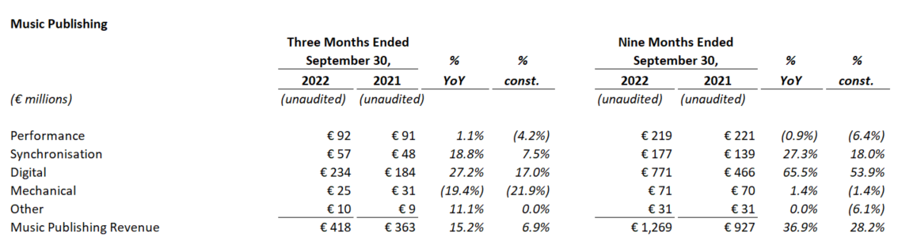
Note: % YoY indicates % change year-over-year; % const. indicates % change year-over-year adjusted for constant currency.
Q3 2022 Results
Music Publishing revenue amounted to €418 million in the third quarter of 2022, up 15.2% year-over-year, or 6.9% in constant currency, despite a €21 million negative impact in the quarter from the Change in Society Accounting discussed above. Excluding the Change in Society Accounting, Music Publishing revenue was up 20.9% year-over-year, or 12.3% in constant currency.
Within Music Publishing, digital revenue grew 27.2% year-over-year, or 17.0% in constant currency, reflecting the continued growth of streaming and subscription, partially offset by the Change in Society Accounting. Performance revenue grew 1.1% year-over-year, but fell 4.2% in constant currency, reflecting the Change in Society Accounting. Synchronisation revenue improved 18.8% year-over-year, or 7.5% in constant currency, as a result of increased income from advertising and film. Mechanical revenue fell 19.4% year-over-year, or 21.9% in constant currency, driven by a decline in industry-wide physical sales, as well as the Change in Society Accounting.
YTD 2022 Results
Music Publishing revenue amounted to €1,269 million, up 36.9% year-over-year, or 28.2% in constant currency and included a €123 million benefit from the Change in Society Accounting discussed above. Excluding the Change in Society Accounting, Music Publishing revenue grew 23.6% year-over-year, or 15.8% in constant currency, as a result of organic growth trends and initial contributions from catalogue acquisitions made in prior years.
Within Music Publishing, digital revenue grew 65.5% year-over-year, or 53.9% in constant currency, reflecting the Change in Society Accounting, as well as continued healthy growth in streaming and subscription. Synchronisation revenue grew 27.3% year-over-year, or 18.0% in constant currency, as a result of increased income from advertising, TV and film. Performance revenue declined 0.9% year-over-year, or 6.4% in constant currency, reflecting the Change in Society Accounting. Mechanical revenue grew 1.4% year-over-year, but fell 1.4% in constant currency.

Merchandising and Other
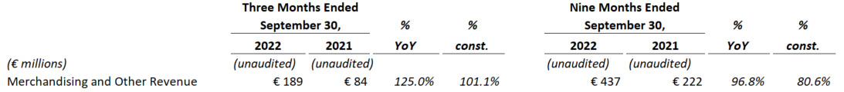
Note: % YoY indicates % change year-over-year; % const. indicates % change year-over-year adjusted for constant currency.
Q3 2022 Results
Merchandising and Other revenue of €189 million was up 125.0% year-over-year, or 101.1% in constant currency, as touring-related merchandising revenue rebounded following a COVID related slow-down in live touring in the prior year period.
YTD 2022 Results
Merchandising and Other revenue of €437 million was up 96.8% year-over-year, or 80.6% in constant currency, as touring-related merchandising revenue rebounded following a COVID related slow-down in live touring in the prior year period.

Conference Call Details
The Company will host a conference call to discuss these results on October 27, 2022 at 6:15PM CET. A link to the live audio webcast will be available on investors.universalmusic.com and a link to the replay will be available after the call.
While listeners may use the webcast, a dial-in telephone number is required for investors and analysts to ask questions. Investors and analysts interested in asking questions can pre-register for a dial-in line at investors.universalmusic.com under the "Financial Reports" tab.

Cautionary Notice
This press release is published by Universal Music Group N.V. and contains inside information within the meaning of article 7(1) of Regulation (EU) No. 596/2014 (Market Abuse Regulation).

Forward-looking statements
This press release may contain statements that constitute forward-looking statements with respect to UMG’s financial condition, results of operations, business, strategy and plans. Such forward-looking statements may be identified by the use of words such as ‘profit forecast’, ‘expect’, ‘estimate’, ‘project’, ‘anticipate’, ‘should’, ‘intend’, ‘plan’, ‘probability’, ‘risk’, ‘target’, ‘goal’, ‘objective’, ‘will’, ‘endeavour’, ‘optimistic’, ‘prospects’ and similar expressions or variations on such expressions. Although UMG believes that such forward-looking statements are based on reasonable assumptions, they are not guarantees of future performance. Actual results may differ materially from such forward-looking statements as a result of a number of risks and uncertainties, many of which are related to factors that are outside UMG’s control, including, but not limited to, UMG’s inability to compete successfully and to identify, attract, sign and retain successful recording artists and songwriters, failure of streaming and subscription adoption or revenue to grow or to grow less rapidly than anticipated, UMG’s reliance on digital service providers, UMG’s inability to execute its business strategy, the global nature of UMG’s operations, UMG’s inability to protect its intellectual property and against piracy, UMG’s inability to attract and retain key personnel, changes in laws and regulations and the other risks that have been described in UMG’s 2021 annual report. Accordingly, UMG cautions readers against placing undue reliance on such forward-looking statements. Such forward-looking statements are made as of the date of this press release. UMG disclaims any intention or obligation to provide, update or revise any such forward-looking statements, whether as a result of new information, future events or otherwise.

Alternative Performance Indicators
This press release includes certain alternative performance indicators which are not defined in IFRS issued by the International Accounting Standards Board as endorsed by the EU. The descriptions of these alternative performance indicators and reconciliations of non-IFRS to IFRS measures are included in the Appendix to this press release.

About Universal Music Group
At Universal Music Group (EURONEXT: UMG), we exist to shape culture through the power of artistry. UMG is the world leader in music-based entertainment, with a broad array of businesses engaged in recorded music, music publishing, merchandising and audiovisual content. Featuring the most comprehensive catalogue of recordings and songs across every musical genre, UMG identifies and develops artists and produces and distributes the most critically acclaimed and commercially successful music in the world. Committed to artistry, innovation and entrepreneurship, UMG fosters the development of services, platforms and business models in order to broaden artistic and commercial opportunities for our artists and create new experiences for fans. For more information on Universal Music Group N.V. visit www.universalmusic.com

Contacts
Media
James Murtagh-Hopkins - communicationsnl@umusic.com

Investors
Erika Begun - investorrelations@umusic.com

Appendix

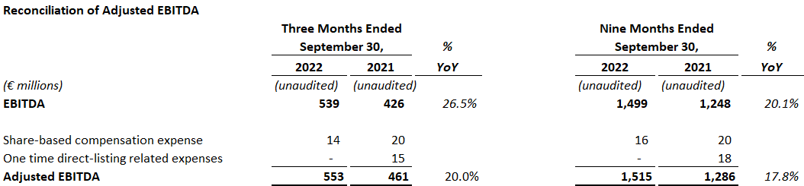

DEFINITIONS
In this press release, UMG presents certain financial measures when discussing UMG’s performance that are not measures of financial performance or liquidity under IFRS (“non-IFRS”). These non-IFRS measures (also known as alternative performance measures or indicators) are presented because management considers them important supplemental measures of UMG’s performance and believes that they are widely used in the industry in which UMG operates as a means of evaluating a company’s operating performance and liquidity. UMG believes that an understanding of its sales performance, profitability, financial strength and funding requirements is enhanced by reporting the following non-IFRS measures. All non-IFRS measures should be considered in addition to, and not as a substitute for, other IFRS measures of operating and financial performance as described in this press release. In addition, it should be noted that other companies may have definitions and calculations for these non-IFRS measures that differ from those used by UMG, thereby affecting comparability.
EBITDA and EBITDA margin
UMG considers EBITDA and EBITDA margin, non-IFRS measures, to be relevant measures to assess the performance of its operating segments as reported in the segment data. It enables UMG to compare the operating performance of operating segments regardless of whether their performance is driven by the operating segment’s organic growth or by acquisitions. EBITDA margin is EBITDA divided by revenue. To calculate EBITDA, the accounting impact of the following items is excluded from the income from Operating Profit:
- amortization of intangible assets;
- impairment losses on goodwill and other intangibles;
- other income and expenses related to transactions with shareowners (except when directly recognized in equity);
- depreciation of tangible assets including right of use assets;
- (gains)/losses on the sale of tangible assets, including right of use assets and intangible assets;
- (income)/losses from equity affiliates;
- restructuring expenses; and
- other non-recurring items.

Adjusted EBITDA and Adjusted EBITDA margin
The difference between EBITDA and Adjusted EBITDA consists of share-based compensation expenses and certain one-time items that are deemed by management to be significant and incidental to normal business activity, including but not limited to professional fees and listing fees related to UMG’s listing on Euronext Amsterdam. Adjusted EBITDA margin is Adjusted EBITDA divided by revenue. UMG considers Adjusted EBITDA and Adjusted EBITDA margin, non-IFRS measures, to be relevant measures to assess performance of its operating activities excluding items that may be incidental to normal business activity.

This press release includes certain alternative performance indicators which are not defined in the International Financial Reporting Standards (“IFRS”) issued by the International Accounting Standards Board as endorsed by the EU. The descriptions of these alternative performance indicators and reconciliations of non-IFRS to IFRS measures are included in the Appendix to this press release.

