No. 32965
The Companies Act 2006
PUBLIC COMPANY LIMITED BY SHARES

SPECIAL RESOLUTION

OF
AVON PROTECTION p.l.c.
Passed 27 January 2023
At the Annual General Meeting of the above-named company duly convened and held on 27 January 2023 the following resolution was passed as a SPECIAL RESOLUTION: -
That a general meeting of the Company (other than an AGM) may be called on not less than 14 clear days’ notice. By order of the Board

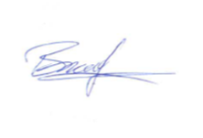
BRUCE THOMPSON
Chairman of the Meeting

