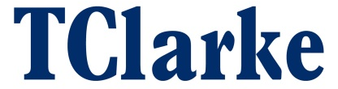

TClarke plc
Directorate Change

TClarke plc (“TClarke" or the “Company”), announces today that Mike Robson, the Senior Independent Director, has decided not to offer himself for re-election as a Director of the Company at the next Annual General Meeting of the Company to be held on 5th May 2021. Mike will remain a Director until that time.

The Board would like to thank Mike for his commitment and invaluable input to TClarke since his appointment in 2015 and wish him well for the future.

Date: 24th March 2021

For further information contact:

TClarke plc
Mark Lawrence
Group Chief Executive
Trevor Mitchell
Finance Director
Tel: 020 7997 7400
www.tclarke.co.uk

Cenkos Securities plc (Corporate Broker)
Max Hartley (Corporate Finance)
Nick Searle (Sales)
Tel: 020 7397 8900
www.cenkos.com

RMS Partners
Simon Courtenay
Tel: 020 3735 6551

