Company Number 119351 The Companies Act 2006
Public Company Limited by Shares Resolutions of TClarke Plc ("the Company") Passed on 24 July 2023

At the General Meeting of the Company duly convened and held at 30 St Mary Axe, London EC3A 8BF at 9.00am on Monday 24 July 2023 the following Ordinary Resolutions and Special Resolution of the Company were duly passed:

Ordinary Resolutions

1. THAT, the allotment and issue of 4,000,000 ordinary shares of 10 pence each in the capital of the Company (“Ordinary Shares”) in aggregate to Regent Gas, in connection with the Placing, being a related party transaction for the purposes of the Listing Rules, be and is hereby approved.

2. THAT, in addition to all existing authorities given to them pursuant to section 551 of the Companies Act 2006 (the “Act”), the directors of the Company be and are generally and unconditionally authorised under section 551 of the Act to exercise all powers of the Company to allot shares in the Company and to grant rights to subscribe for or to convert any security into, shares of the Company (such shares, and rights to subscribe for or to convert any security into shares of the Company being (“relevant securities”)) up to a maximum aggregate nominal amount of £874,933.70 (being equal to 8,749,337 Ordinary Shares) in connection with the Placing provided that (unless previously renewed, revoked, varied or extended by the Company at a general meeting), this authority shall expire on 15 October 2024, save that the Company may at any time before such expiry make an offer or agreement which would or might require relevant securities to be allotted after such expiry and the directors may allot relevant securities under such an offer or agreement as if the authority granted by this Resolution had not expired.

Special Resolution

3. THAT, conditional on the passing of Resolution 2, and in addition to any existing authorities and powers given to the directors under section 570 of the Act, the directors of the Company be empowered under section 571(1) of the Act, to allot equity securities (as defined in section 560 of the Act) of the Company for cash pursuant to the authority conferred by Resolution 2, as if section 561(1) of the Act did not apply to such allotment up to a maximum nominal amount of £874,933.70 (being approximately 19.84 percent. of the Shares in issue as at 5 July 2023, being the latest practicable date prior to the publication of this document) pursuant to the Placing, provided that (unless previously renewed, revoked varied or extended by the Company at a general meeting), this authority shall expire on 15 October 2024, save that the Company may at any time before such expiry make an offer or agreement which would or might require equity securities to be allotted after such expiry and the Directors may allot equity securities in pursuance of such an offer or agreement as if the authority granted by this Resolution had not expired.

Ordinary Resolution

4. THAT subject to and conditional upon the passing of Resolutions 2 and 3, the issue of up to 8,749,337 Ordinary Shares for cash at a price of 122 pence per share (which represents a discount of greater than 10 percent. to the middle market price of the Ordinary Shares as at 5 July 2023, being the last closing price prior to announcement of the Placing) and otherwise on the terms set out in the Circular published by the Company, be and is hereby approved.
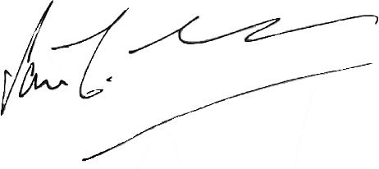

Iain McCusker Chairman

