Form 52-109FV2
Certification of Interim Filings
Venture Issuer Basic Certificate
I, Bennett Kurtz, the Chief Financial Officer of First Phosphate Corp. (the “Issuer”), certify the following:
1. Review: I have reviewed the interim financial report and interim MD&A (together, the “interim filings”) of the Issuer for the interim period ended August 31, 2023.
2. No misrepresentations: Based on my knowledge, having exercised reasonable diligence, the interim filings do not contain any untrue statement of a material fact or omit to state a material fact required to be stated or that is necessary to make a statement not misleading in light of the circumstances under which it was made, with respect to the period covered by the interim filings.
3. Fair presentation: Based on my knowledge, having exercised reasonable diligence, the interim financial report together with the other financial information included in the interim filings fairly present in all material respects the financial condition, financial performance and cash flows of the issuer, as of the date of and for the periods presented in the interim filings.
Date: October 30, 2023
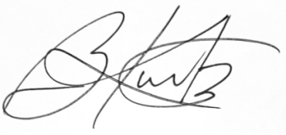

Bennett Kurtz
Chief Financial Officer
NOTE TO READER
In contrast to the certificate required for non-venture issuers under National Instrument 52-109 Certification of Disclosure in Issuers’ Annual and Interim Filings (NI 52-109), this Venture Issuer Basic Certificate does not include representations relating to the establishment and maintenance of disclosure controls and procedures (DC&P) and internal control over financial reporting (ICFR), as defined in NI 52-109. In particular, the certifying officers filing this certificate are not making any representations relating to the establishment and maintenance of
i) controls and other procedures designed to provide reasonable assurance that information required to be disclosed by the issuer in its annual filings, interim filings or other reports filed or submitted under securities legislation is recorded, processed, summarized and reported within the time periods specified in securities legislation; and
ii) a process to provide reasonable assurance regarding the reliability of financial reporting and the preparation of financial statements for external purposes in accordance with the issuer’s GAAP.
The issuer’s certifying officers are responsible for ensuring that processes are in place to provide them with sufficient knowledge to support the representations they are making in this certificate. Investors should be aware that inherent limitations on the ability of certifying officers of a venture issuer to design and implement on a cost effective basis DC&P and ICFR as defined in NI 52- 109 may result in additional risks to the quality, reliability, transparency and timeliness of interim and annual filings and other reports provided under securities legislation.

