Company number: 00125575

THE COMPANIES ACT 2006
PUBLIC COMPANY LIMITED BY SHARES
RESOLUTION
OF
Grainger plc (Grainger)
Passed on 1 September 2025

At the General Meeting of the above-named Company, duly convened and held on 1 September 2025, the following resolution was duly passed:

Special Resolution

THAT the articles of association produced to the meeting and initialed by the Chair of the meeting for the purposes of identification containing, inter alia, amendments recommended for the purposes of the Company’s entry into the REIT Regime, be adopted as the articles of association in substitution for and to the exclusion of all existing articles of association.

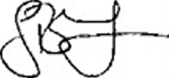

……………………………………..……
Company Secretary

