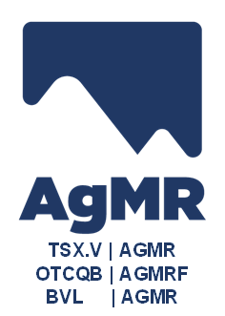

Silver MOUNTAIN REPORTS HIGH GRADE SILVER IN UNDERGROUND Channel Sampling PROGRAM AND PROVIDES UPDATE ON Stockpiling at ITS Reliquias Project, peru

Key Highlights – Channel sampling at Reliquias

Ayayay vein: 1.07m @ 336 g/t Ag, 10.7 % Pb, 11.7 % Zn, 2.7 % Cu and 0.34 g/t Au

Ayayay vein: 1.04m @ 414 g/t Ag, 17.3 % Pb, 8.5 % Zn, 3.1 % Cu and 0.28 g/t Au

Tensional Ayayay vein: 0.82m @ 510 g/t Ag, 7.4% Pb, 13.3% Zn, 1.0% Cu and 0.31 g/t Au

Tensional Ayayay vein: 1.17m @ 168 g/t Ag, 5.3% Pb, 10.1% Zn, 0.4% Cu and 0.15 g/t Au

TORONTO, CANADA, Tuesday, November 27, 2025 – Silver Mountain Resources Inc. ("Silver Mountain" or the "Company") (TSXV: AGMR; OTCQB: AGMRF) is pleased to provide an update on ongoing underground channel sampling and early-stage stockpiling of mineralized material at its Reliquias Project, located in Huancavelica, Peru. These activities are part of the Company's planned mine-readiness work aimed at starting commercial production at its Reliquias Project during Q3 of 2026.

Alvaro Espinoza, President and CEO of Silver Mountain, said: "We are encouraged by the consistent strong grades from the Ayayay vein and associated structures – reinforcing the high-grade quality of the Reliquias deposit. The commencement of stockpiling adds to the substantial progress that we have been making at Reliquias, now visible on site. We are advancing the project with purpose as we work toward our targeted commercial production in Q3 2026. Our shareholders can expect continued delivery on the milestones that support that timeline. I am proud to highlight the outstanding performance of our team underground."

Recent channel samples collected by the Company's technical team from the Ayayay and Matacaballo vein systems, which include conjugate – or "Tensional" – veins, on Level 340 have returned high grades of silver, lead, zinc, and copper. The silver equivalent grades obtained during this round of sampling often exceed those reported in the mineral resource estimate (see https://agmr.ca/wp-content/uploads/2025/01/Final_-_7_-_AR_Tech_Report.pdf), confirming the existence of readily accessible high grade polymetallic veins at various mine levels. All samples were collected perpendicular to the veins using portable rock saws. Table 1 shows a summary of the results from the eight recently sampled channels.

Table 1: Underground channel samples reported in this news release

Level | Vein | Channel | Sample | Type | Width | Silver | Lead | Zinc | Copper | Gold | Ag_Eq¹
 |  |  |  |  | m | g/t | % | % | % | g/t | Oz/t
340 | Ayayay | CN-07 | SMR-025269 | Vein | 1.07 | 336 | 10.70 | 11.70 | 2.70 | 0.34 | 27.34
340 | Ayayay | CN-08 | SMR-025272 | Vein | 1.04 | 414 | 17.30 | 8.50 | 3.06 | 0.28 | 32.08
340 | Tensional Ayay_1 | CN-05 | SMR-025262 | Vein | 0.82 | 510 | 7.40 | 13.30 | 0.98 | 0.31 | 30.11
340 | Tensional Ayay_1 | CN-06 | SMR-025265 | Vein | 1.17 | 168 | 5.30 | 10.10 | 0.38 | 0.15 | 15.07
340 | Tensional Ayay_2 | CN-01 | SMR-025248 | Vein | 0.65 | 82 | 3.20 | 4.10 | 0.24 | 0.26 | 7.69
340 | Tensional Ayay_2 | CN-04 | SMR-025259 | Vein | 0.97 | 114 | 2.43 | 4.10 | 0.32 | 0.09 | 8.00
340 | Matacaballo | CN-02 | SMR-025251 | Vein | 0.90 | 16 | 0.33 | 0.53 | 0.03 | 0.04 | 1.13
340 | Matacaballo | CN-03 | SMR-025255 | Vein | 0.44 | 29 | 0.11 | 0.75 | 0.04 | 0.07 | 1.61
Note:
^{1.} Silver equivalent (Ag_Eq) grades are calculated using metal prices of: Ag US$32.40/oz., Au US$3,188/oz, Cu US$9,502/tm, Pb US$1,984/tm and Zn US$2,756/tm. Silver equivalent grade is calculated as Ag_Eq (oz/t) = (Ag (oz/t) + (Au (g/t) * 2.15) + (Cu (%) * 1.03) + (Pb (%) * 0.58) + (Zn (%) * 0.58), using metallurgical recoveries of 94.5% Ag, 81.2% Au, 89.6% Pb, 85% Zn, and 93.6% Cu.

Figure 1 below presents a level plan of Level 340 at the Reliquias mine, where Company crews are continuing to upgrade underground workings in preparation for upcoming commercial production.
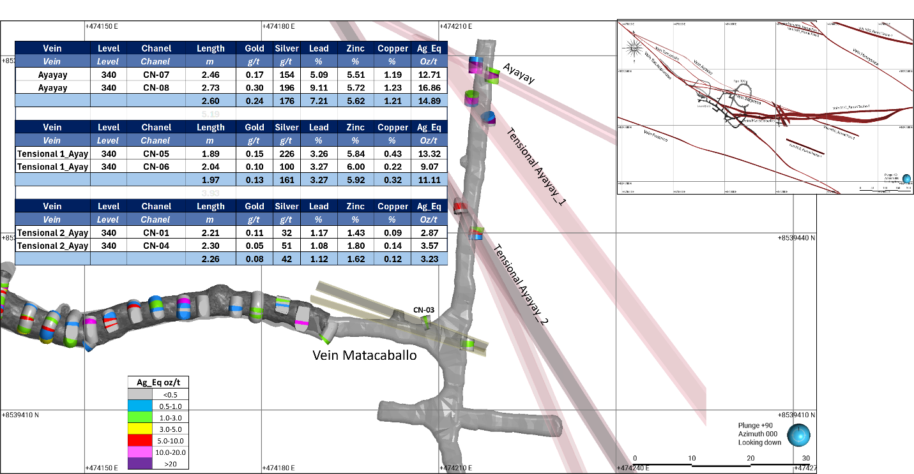
Figure 1: Detail plan at 340 level showing sections of the Ayayay and Matacaballo vein systems

The Company also announces that it has now stockpiled approximately 525 metric tonnes of strongly mineralized material from ongoing rehabilitation and development activities at Reliquias, sourced entirely from the Ayayay vein system. This material was collected from 22 metres of new underground development, with initial extraction focused on levels 340 and 390, contributing roughly 150 and 375 tonnes respectively, all of which have been transported to the stockpile at the nearby Caudalosa plant. Building this stockpile is a key step in ensuring a smooth and efficient ramp-up once commercial mining operations begin. With underground work advancing steadily, the Company remains on track to meet its commitment to commence commercial production at the Reliquias mine in Q3 2026.

On Behalf of the Board of Directors of Silver Mountain Resources Inc.

Alvaro Espinoza, Chief Executive Officer

Qualified Person

The scientific and technical content in this news release has been reviewed and approved by Antonio Cruz Bermudez, P. Geo. and Registered Member FAIG, who is a "qualified person" (as defined in National Instrument 43-101 – Standards of Disclosure for Mineral Projects) and independent of the Company for purposes of Section 1.5 of National Instrument 43-101 – Standards of Disclosure for Mineral Projects.

About Silver Mountain

Silver Mountain Resources Inc. is a Canadian mining company focused on the exploration and development of silver projects in Peru. The Company's principal asset is the Reliquias Project, a past-producing silver mine located in the Castrovirreyna district of Huancavelica. Silver Mountain is committed to creating long-term value for its shareholders through responsible mining, strong community engagement, and sustainable development practices.

For additional information on the Reliquias Project, please refer to the technical report titled "Amended and Restated NI 43-101 Technical Report: Preliminary Economic Assessment, Reliquias Mine, Department of Huancavelica, Peru" dated October 28, 2024 (with an effective date of May 15, 2024), which was prepared for the Company by Steven L. Park, Antonio Cruz Bermudez and Gerardo Acuña (the "Reliquias PEA"). Readers are encouraged to read the Reliquias PEA in its entirety, including all assumptions, parameters, qualifications, limitations and methods therein. The Reliquias PEA is intended to be read as a whole, and sections should not be read or relied upon out of context. The Reliquias PEA was prepared in accordance with NI 43-101 and is available electronically on SEDAR+ (www.sedarplus.ca) under Silver Mountain's issuer profile.

For further information about our drill program, including cross sections of the main veins with drill hole locations, please refer to our corporate presentation, available on our website at www.agmr.ca.

For Further Information Contact:

Alvaro Espinoza
Chief Executive Officer
aespinoza@agmr.ca
Silver Mountain Resources Inc
82 Richmond Street East
Toronto, ON M5C 1P1
+51 997 903 576

info@agmr.ca
www.agmr.ca

Sampling, QA/QC, and Analytical Procedures

Silver Mountain follows systematic and rigorous sampling and analytical protocols which meet industry standards. These protocols are summarized below.

Rock channel samples were collected with an electric percussion hammer and do not exceed 1.0 m in length. Channels are broken at obvious geologic boundaries to correctly separate rock types and mineralization styles. The sample bags were sealed with a plastic zip tie and identified with a unique sample number, pending shipment to a certified laboratory sample preparation facility.

Samples are sent by batch to the ALS and Certimin laboratories in Lima, Peru for assaying. Silver Mountain independently inserts certified control standards, fine and coarse blanks, and duplicates into the sample stream to monitor data quality. These standards are inserted "blindly" to the laboratory in the sample sequence prior to departure from the core storage facilities. At the laboratory, samples are dried, crushed, and pulverized and then analyzed using a fire assay-AA finish analysis for gold and a full multi-acid digestion with ICP-AES analysis for other elements. Samples with results that exceed maximum detection values for the main elements of interest (Ag, Zn, Pb, Cu) are re-analyzed using precise ore-grade ICP analytical techniques, while high gold values are re-analyzed by fire assay with a gravimetric finish.

Caution Regarding Forward-Looking Statements

This news release contains "forward-looking statements" and "forward-looking information" within the meaning of applicable Canadian securities legislation (together, "forward-looking statements").These forward-looking statements, by their nature, require Silver Mountain to make certain assumptions and necessarily involve known and unknown risks and uncertainties that could cause actual results to differ materially from those expressed or implied in these forward-looking statements. Forward-looking statements are not guarantees of performance. Words such as "may", "will", "would", "could", "expect", "believe", "plan", "anticipate", "intend", "estimate", "continue", "objective", "strategy", variants of these words or the negative or comparable terminology, as well as terms usually used in the future and the conditional, are intended to identify forward-looking statements. In this news release, forward-looking statements include statements pertaining to: the significance of the channel sampling at Reliquias and early-stage stockpiling of mineralized material; the Company's planned mine readiness work; the timing and ability of the Company to recommence commercial production at its Reliquias Project during Q3 of 2026 (if at all); management's belief of the strong grade from the Ayayay vein; the ability of the Company to achieve stated milestones; expectations regarding having access to sufficient funding to achieve stated milestones; the assumptions, qualifications and limitations in the Reliquias PEA; the capital resources available to the Company; the ability of the Company to access capital as and when required and on terms acceptable to the Company; the ability of the Company to execute its planned activities; management's perceptions of historical trends, current conditions and expected future developments; future mining activities.

Forward-looking statements are based on a number of assumptions and are subject to a number of risks and uncertainties, many of which are beyond Silver Mountain's control, which could cause actual results and events to differ materially from those that are disclosed in or implied by such forward-looking statements. Such risks and uncertainties include, but are not limited to, the factors identified in the Company's continuous disclosure record on SEDAR+ (www.sedarplus.ca) under Silver Mountain's issuer profile, including under the headings (i) "Caution Regarding Forward-Looking Statements" and "Risk Factors" in the Annual Information Form of the Company dated July 17, 2025 for the year ended December 31, 2024; (ii) "Risk Factors" in the final base shelf prospectus of the Company dated October 16, 2025; and (iii) "Risk Factors" in the prospectus supplement of the Company dated November 12, 2025. Silver Mountain undertakes no obligation to update or revise any forward-looking statements, whether as a result of new information, future events or otherwise, except as may be required by law. New factors emerge from time to time, and it is not possible for Silver Mountain to predict all of them or assess the impact of each such factor or the extent to which any factor, or combination of factors, may cause results to differ materially from those contained in any forward-looking statement. Any forward-looking statements contained in this news release are expressly qualified in their entirety by this cautionary statement.

Neither TSX Venture Exchange nor its Regulation Services Provider (as that term is defined in policies of the TSX Venture Exchange) accepts responsibility for the adequacy or accuracy of this news release.

