Company Number: 09268016

The Companies Act 2006

PUBLIC COMPANY LIMITED BY SHARES

RESOLUTIONS

OF

MJ GLEESON PLC
(“the Company”)

At an annual general meeting of the Company duly convened and held at Grocers’ Hall, Princes Street, London EC2R 8AD at 11:30 a.m. on Friday 18 November 2022, the following resolutions were duly passed:

Ordinary Resolution:

14. That for the purposes of section 551 of the Companies Act 2006 the Directors be generally and unconditionally authorised in accordance with Article 8 of the articles of association of the Company to allot shares in the Company or grant rights to subscribe for or convert any security into shares in the Company (“relevant securities”) up to a maximum nominal amount of £388,949 (being the “Section 551 Amount” for the purposes of such Article 8) for a period expiring at the conclusion of the Company’s next Annual General Meeting or 15 months from the date of the passing of this Resolution, if earlier (being the “prescribed period” for the purposes of such Article 8), upon the terms set out in such Article 8, and that all previous unutilised authorities under section 551 of the Companies Act 2006 shall cease to have effect (save to the extent that the same are exercisable under section 551(7) of the Companies Act 2006 by reason of any offer or agreement made prior to the date of this resolution which would or might require shares to be allotted or right to be granted to subscribe for or convert any securities into shares in the Company on or after that date).

Special Resolutions:

15. That, if Resolution 14 is passed, the Board be authorised to allot equity securities (as defined in section 560 of the Companies Act 2006) for cash under the authority given by that resolution and/or to sell ordinary shares held by the Company as treasury shares for cash as if section 561 of the Companies Act 2006 did not apply to any such allotment or sale; such authority to be limited to:
a) the allotment of equity securities and the sale of treasury shares for cash in connection with an offer of, or invitation to apply for, equity securities:
(i) to ordinary shareholders in proportion (as nearly as may be practicable) to their existing holdings; and
(ii) to holders of other equity securities as required by the rights of those securities or as the Board otherwise considers necessary,
and so that the Board may impose any limits, exclusions or restrictions and make any arrangements which they consider necessary or appropriate to deal with any treasury shares, fractional entitlements, record dates, legal, regulatory or practical problems in, or under the laws of, any territory or any other matter whatsoever; and
b) the allotment of equity securities or sale of treasury shares (otherwise than under paragraph (a) above) up to a maximum nominal amount of £58,342, such authority to expire at the end of the next Annual General Meeting of the Company (or, if earlier, at the close of business on 17 February 2024) but, in each case, prior to its expiry the Company may make offers, and enter into agreements, which would, or might, require equity securities to be allotted (and treasury shares to be sold) after the authority expires and the Board may allot equity securities (and sell treasury shares) under any such offer or agreement as if the authority had not expired.

16. That, if Resolution 14 is passed, the Board be authorised, in addition, to any authority granted under Resolution 15, to allot equity securities (as defined in section 560 of the Companies Act 2006) for cash under the authority given by that resolution and/or to sell ordinary shares held by the Company as treasury shares for cash as if section 561 of the Companies Act 2006 did not apply to any such allotment or sale; such authority to be:
a) limited to the allotment of equity securities or sale of treasury shares up to a maximum nominal amount of £58,342; and
b) used only for the purposes of financing (or refinancing, if the authority is to be used within six months after the original transaction) a transaction which the Board of the Company determines to be an acquisition or other capital investment of a kind contemplated by the Statement of Principles on Dis-applying Pre-Emption Rights most recently published by the Pre-Emption Group prior to the date of this notice,
such authority to expire at the end of the next Annual General Meeting of the Company (or, if earlier, at the close of business on 17 February 2024) but, in each case, prior to its expiry the Company may make offers, and enter into agreements, which would, or might, require equity securities to be allotted (and treasury shares to be sold) after the authority expires and the Board may allot equity securities (and sell treasury shares) under any such offer or agreement as if the authority had not expired.

17. That the Company be generally and unconditionally authorised for the purposes of section 701 of the Companies Act 2006 to make one or more market purchases (as defined in section 693 (4) of the Companies Act 2006) on the London Stock Exchange of any of its own ordinary shares provided that:
(i) the maximum number of ordinary shares which may be acquired pursuant to this authority is £116,684 ordinary shares in the capital of the Company;
(ii) the minimum price (exclusive of expenses) which may be paid for each ordinary share is an amount equal to the nominal value of each ordinary share;
(iii) the maximum price (exclusive of expenses) which may be paid for each ordinary share is the highest of:
(a) an amount equal to 5% above the average of the middle market quotations for an ordinary share as derived from the London Stock Exchange Daily Official List for the five business days immediately preceding the date on which the ordinary share is contracted to be purchased; and
(b) an amount equal to the higher of the price of the last independent trade of an ordinary share and the highest current independent bid for an ordinary share on the trading venues where the purchase is carried out;
(iv) unless previously revoked or varied, this authority expires on whichever is the earlier of:
(a) the date 15 months from the date of the passing of this Resolution; or
(b) the conclusion of the next Annual General Meeting of the Company; and
(v) the Company may make a contract or contracts to purchase its own ordinary shares under this authority prior to the expiry of such authority which will or may be executed by the Directors wholly or partly after the expiry date of such authority, and may make a purchase of its own ordinary shares in pursuance of any such contract or contracts.

18. That a general meeting other than an Annual General Meeting may be called on not less than 14 clear days’ notice.
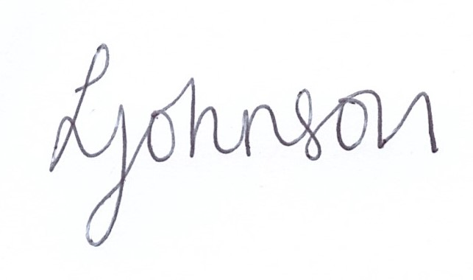

______________________
Leanne Johnson
Company Secretary

