Company number: 09777975

THE COMPANIES ACT 2006
PUBLIC COMPANY LIMITED BY SHARES
RESOLUTIONS
of
ARIX BIOSCIENCE PLC
Passed 23 May 2023

At the Annual General Meeting of the Company held on Tuesday 23 May 2023, the following ONE ORDINARY resolution and FOUR SPECIAL resolutions were duly passed as Special Business at the meeting:

ORDINARY RESOLUTION

RESOLUTION 11 – AUTHORITY TO ALLOT SHARES

THAT, in substitution for all existing authorities, the Board of Directors be generally and unconditionally authorised in accordance with section 551 of the Companies Act 2006 (the “2006 Act”) to exercise all the power of the Company to allot shares or grant rights to subscribe for or to convert any security into shares in the Company:

- up to an aggregate nominal amount of £426.29; and

- comprising equity securities (as defined in Section 560(1) of the 2006 Act) up to a further aggregate nominal amount of £426.29 in connection with an offer by way of a rights issue;

such authorities to apply in substitution for all previous authorities pursuant to Section 551 of the Companies Act 2006 and to expire at the end of the next Annual General Meeting or on 23 August 2024, whichever is the earlier, but in each case so that the Company may make offers and enter into agreements during the relevant period which would, or might, require shares to be allotted or rights to subscribe for or to convert any security into shares to be granted after the authority ends.

SPECIAL RESOLUTIONS

RESOLUTION 12 – DISAPPLICATION OF PRE-EMPTION RIGHTS

THAT, in substitution of all existing powers, the Board be authorised to allot equity securities (as defined in the Companies Act 2006) for cash under the authority given by that resolution and/or to sell ordinary shares held by the Company as treasury shares for cash as if section 561 of the Companies Act 2006 did not apply to any such allotment or sale, such authority to be limited:

- to allotments for rights issues and other pre-emptive issues; and

- to the allotment of equity securities or sale of treasury shares (otherwise than under paragraph (a) above) up to a nominal amount of £64.59,

such authority to expire at the end of the next AGM of the Company or, if earlier, at the close of business on 23 August 2024 but, in each case, prior to its expiry the Company may make offers, and enter into agreements, which would, or might, require equity securities to be allotted (and treasury shares to be sold) after the authority expires and the Board may allot equity securities (and sell treasury shares) under any such offer or agreement as if the authority had not expired.

RESOLUTION 13 – ADDITIONAL AUTHORITY TO DISAPPLY PRE-EMPTION RIGHTS

THAT, in substitution of all existing powers, the Board be authorised in addition to any authority granted under Resolution 12 to allot equity securities (as defined in the Companies Act 2006) for cash under the authority given by that resolution and/or to sell ordinary shares held by the Company as treasury shares for cash as if section 561 of the Companies Act 2006 did not apply to any such allotment or sale, such authority to be:

- limited to the allotment of equity securities or sale of treasury shares up to a nominal amount of £64.59; and

- used only for the purposes of financing (or refinancing, if the authority is to be used within six months after the original transaction) a transaction which the Board of the Company determines to be an acquisition or other capital investment of a kind contemplated by the Statement of Principles on Disapplying Pre-Emption Rights most recently published by the Pre-Emption Group prior to the date of this notice,

such authority to expire at the end of the next AGM of the Company or, if earlier, at the close of business on 23 August 2024 but, in each case, prior to its expiry the Company may make offers, and enter into agreements, which would, or might, require equity securities to be allotted (and treasury shares to be sold) after the authority expires and the Board may allot equity securities (and sell treasury shares) under any such offer or agreement as if the authority had not expired.

RESOLUTION 14 – TO AUTHORISE THE COMPANY TO MAKE MARKET PURCHASES OF ITS OWN ORDINARY SHARES.

THAT the Company be authorised for the purposes of section 701 of the Companies Act 2006 to make market purchases (as defined in Section 693(4) of the Companies Act 2006) of ordinary shares of £0.00001 each in the capital of the Company provided that:

- the maximum number of ordinary shares which may be purchased is 12,918,080;

- the minimum price which may be paid for each share is £0.00001;

- the maximum price which may be paid for an ordinary share is an amount equal to the higher of (i) 105% of the average of the closing price of the Company’s ordinary shares as derived from the London Stock Exchange Daily Official List for the five business days immediately preceding the day on which such ordinary share is contracted to be purchased and (ii) an amount equal to the higher of the price of the last independent trade of an ordinary share and the highest current independent bid for an ordinary share as derived from the London Stock Exchange Trading System; and

- this authority shall expire at the conclusion of the Company’s next Annual General Meeting or, if earlier, 2 August 2024 (except in relation to the purchase of ordinary shares the contract for which was concluded before the expiry of such authority and which might be executed wholly or partly after such expiry) unless such authority is renewed prior to such time.

RESOLUTION 15 – NOTICE OF MEETINGS

THAT a general meeting other than an AGM may be called on not less than 14 clear days’ notice.

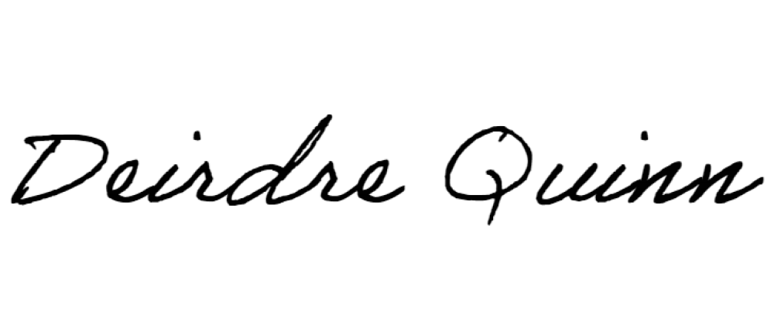
_____________________________
For and on behalf of Kin Company Secretarial Limited
Company Secretary, Arix Bioscience plc

