16 March 2023
WILDCAT Petroleum Plc
(“Wildcat” or the “Company”)
Interim results for the period from 1 July 2022 to 31 December 2022
Wildcat Petroleum Plc (“WCAT” or “the Company”) a company targeting investment opportunities in businesses and assets within the upstream sector of the petroleum industry, announces its interim results for the six-month period ended 31 December 2022.

Results for the period
For the period 1 July 2022 to 31 December 2022, the results include the on-going running costs in connection with being a listed company.
In October 2022, the Company signed a memorandum of understanding over four oil blocks with the Sudanese government. It is the Company’s main aim in 2023 to sign a production sharing agreement (PSA) over at least one of these four blocks. The deadline for the licence round in Sierra Leone has been extended from the 27th January 2023 to the 29th September 2023. All activities relating to Sierra Leone have been put on hold while all resources are concentrated on signing a PSA in Sudan.
In October 2022, the company raised at a price of 1.25p per share, £225,500 (net £211,970). Also during the month Waterford Finance & Investment Ltd took a nominal stake in Wildcat (£50,000) and the owner of the fund Mr Mikhail Kroupeev joined Wildcat as a strategic advisor. Once the first PSA is signed, Wildcat intends to use Waterford and its network of natural resource investors as a possible source of funds.
In November 2022, the company changed auditors from Jeffreys Henry LLP to Shipleys LLP.
Risks and uncertainties
The prime objective of the Company is to work and invest in the upstream sector of the petroleum industry – namely exploration, appraisal, development and production of oil and gas.
The Company’s stated objectives were outlined in its IPO Prospectus – Namely:
“The Company’s intention is to either take a minority stake or acquire control of a business, either of which may constitute a Reverse Takeover under the Listing Rules.”
In the event that an Acquisition presents itself which would require the raising of additional capital (i.e., as the consideration payable will likely be greater than the amount of available funds remaining).
In assessing any potential acquisition, the Board will pay particular attention to the following factors when making the acquisition:
• Businesses which are profitable or potentially profitable within the period of 1-2 years from acquisition;
• Assets which don’t require a large capital expenditure;
• Assets with low cost of acquisition and potentially significant up-side.
The Board will seek to draw on its experience in both the petroleum industry and the financial industry in order to access suitable targets and fund an Acquisition.
The Director’s objective is to create long term value for shareholders by building WCAT, through its targeted investments, into a successful Company within the upstream sector of the petroleum industry.
Development and performance
In the reporting period (1 July 2022 to 31 December 2022) the Company has incurred costs of £159,117. At the balance sheet date, the Company had net assets totalling £224,394 including a cash balance totalling £235,083.
Key performance indicators
The Company recognises that the oil and gas business is in a transitional period to net zero carbon emissions by the middle of the century; and that an increasing number of traditional oil companies (e.g. BP, Shell, Equinor) are embracing this and have started to move their activities away from oil and gas to renewables. However, this does not alter the importance of oil and gas in the energy mix and the need to develop these resources to meet global demand and enable transition – allowing developing countries, in Africa for example, to benefit from the revenue generated and their need for reliable power.
Now, more than ever oil and gas development must be done in a responsible way.
With major companies disposing of their oil and gas assets, the Company sees an opportunity to selectively acquire assets. We believe that money will still be available for projects which can be operated in a responsible way (e.g. associated gas is captured for re-injection or use rather than flared into the atmosphere).
The Company has summarised the Risks and Uncertainties in its IPO Prospectus and in its first year’s accounts – both of which can be found on the website: www.wildcatpetroleum.co.uk.
Going Concern

As stated in the notes to the condensed financial statements, the directors are satisfied that the Company has sufficient resources (including plans for a mini fund raise in Q2/Q3) to continue in operation for the foreseeable future, a period of not less than twelve months from the date of this report.

Responsibility statement
We confirm that to the best of our knowledge:
- the condensed set of financial statements has been prepared in accordance with IAS 34 ‘Interim Financial Reporting’;
- the interim management report includes a fair review of the information required by DTR 4.2.7R (indication of important events and description of principal risks and uncertainties); and,
- the interim management report includes a fair review of the information required by DTR 4.2.8R (disclosure of related parties’ transactions and changes therein).

Cautionary statement
This Interim Management Report (IMR) has been prepared solely to provide additional information to shareholders to assess the Company’s strategies and the potential for those strategies to succeed. The IMR should not be relied on by any other party or for any other purpose.
The condensed accounts have not been reviewed by the auditors.
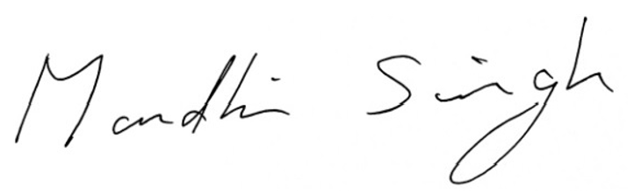
Mandhir Singh
Chairman
16 March 2023

WILDCAT PETROLEUM PLC
INTERIM CONDENSED STATEMENT OF CHANGES IN EQUITY
FROM 1 JUL 2022 TO 31 DEC 2022
 | Share Capital | Share Premium | Other reserves | Retained earnings |  | Total
 | GBP | GBP | GBP | GBP |  | GBP
 | (‘000) | (‘000) | (‘000) | (‘000) |  | (‘000)
Balance at 30 June 2022 | 67 | 550 | 256 | -765 |  | 108
Loss and total comprehensive income for the period | - | - | - | -159 |  | -159
Issue of share capital | 1 | 275 |  | - |  | 276
 | - | - | - | - |  | -
Balance at 31 Dec 2022 | 68 | 825 | 256 | -924 |  | 225

NOTES TO THE UNAUDITED INTERIM MANAGEMENT REPORT

General Information

Wildcat Petroleum Plc is a company incorporated in the United Kingdom. The address of the registered office is Belmont House, 3rd Floor, Suite ASCO-303, Belmont Road, Uxbridge, London UB8 1HE. The Company was incorporated and registered in England and Wales on 8 January 2020 as a public limited company.

1. Basis of preparation
This announcement was approved and authorised to issue by the Board of directors on 30 March 2023.
The financial information in this interim report have been prepared in accordance with the International Financial Reporting Standards (IFRS) and International Financial Reporting Interpretations Committee (IFRIC) interpretations issued by the International Accounting Standards Board (IASB) as adopted by the United Kingdom and with those parts of the Companies Act 2006 applicable to companies reporting under IFRS.

There are no IFRS, or IFRIC interpretations that are effective in this period that would be expected to have a material impact on the company.

The financial information has been prepared under the historical cost convention, as modified by the accounting standard for financial instruments at fair value.

The Directors are of the opinion that the financial information should be prepared on a going concern basis, in the light of the Company's financial resources.

These condensed interim financial statements for the period from 1 July 2022 to 31 December 2022 are unaudited and do not constitute full accounts. The comparative figures for the period 1 July 2021 to 30 June 2022 are extracted from the statutory financial statements which have been filed with the Registrar of Companies and which contact an unqualified audit report and did not contact a statement under sections 494(2) or 498(3) of the Companies Act 2006.

No taxation charge has arisen for the period and the Directors have not declared an interim dividend.

Copies of the interim report can be found on the Company’s website at www.wildcat petroleum.co.uk

Going concern

The directors are satisfied that the Company has sufficient resources to continue in operation for the foreseeable future, a period of not less than 12 months from the date of this report. Accordingly, they continue to adopt the going concern basis in preparing the condensed financial statements.

2. Loss Per Share

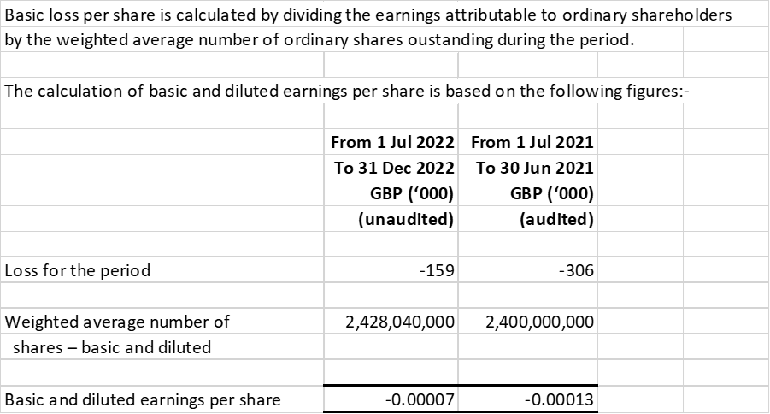

3. Trade and other receivables

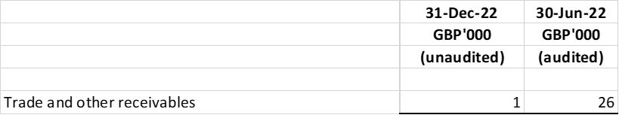

4. Share Capital

5. Events Subsequent to 31 December 2022
There were no events subsequent to the balance sheet date.

6. Reports

A copy of this announcement will be put on the Wildcat Petroleum website and submitted to the relevant authorities. Copies will be available for members of the public at the Company's Registered Office, Belmont House, 3rd Floor, Suite ASCO-303, Belmont Road, Uxbridge, London UB8 1HE.

Enquiries:
Wildcat Petroleum plc: Mandhir Singh msingh@wildcatpetroleum.co.uk
Guild Financial Advisory: Ross Andrews ross.andrews@guildfin.co.uk

