THIS DOCUMENT IS IMPORTANT AND REQUIRES YOUR IMMEDIATE ATTENTION. If you are in any doubt about the contents of this Document or the action you should take, you are recommended to seek your own financial advice immediately from an appropriately authorised stockbroker, bank manager, solicitor, accountant or other independent financial adviser who, if you are taking advice in the United Kingdom, is duly authorised under the Financial Services and Markets Act 2000 (as amended) (“FSMA”).
This document comprises a Prospectus relating to Sivota PLC prepared in accordance with the Prospectus Regulation Rules of the FCA made under Section 73A of the FSMA. This Prospectus has been approved by the FCA (as competent authority under the UK Prospectus Regulation), and will be made available to the public and has been filed in accordance with the Prospectus Regulation Rules. The FCA only approves this Prospectus as meeting the standards of completeness, comprehensibility and consistency imposed by the UK Prospectus Regulation, and such approval should not be considered as an endorsement of the Company or the quality of the Ordinary Shares that are the subject of this Prospectus. Investors should make their own assessment as to the suitability of investing in the Ordinary Shares.
Applications will be made to the FCA in its capacity as competent authority under FSMA for all of the issued and to be issued Ordinary Shares of the Company to be admitted to the standard listing segment of the Official List of the FCA (the “Official List”) and to the London Stock Exchange plc (the “London Stock Exchange”) for such Ordinary Shares to be admitted to trading on the London Stock Exchange’s main market for listed securities (the “Main Market”) (together, “Readmission”). It is expected that Readmission will become effective at 8.00 a.m. on 26 September 2022. Readmission to trading on the Main Market constitutes admission to trading on a regulated market. The Ordinary Shares have an ISIN of GB00BMH30492.
THE WHOLE OF THE TEXT OF THIS DOCUMENT SHOULD BE READ BY PROSPECTIVE INVESTORS. YOUR ATTENTION IS SPECIFICALLY DRAWN TO THE DISCUSSION OF CERTAIN RISKS AND OTHER FACTORS THAT SHOULD BE CONSIDERED IN CONNECTION WITH AN INVESTMENT IN THE ORDINARY SHARES AS SET OUT IN THE SECTION ENTITLED ‘RISK FACTORS’ BEGINNING ON PAGE 11 OF THIS DOCUMENT.
The Directors whose names appear on page 34, and the Company accept responsibility for the information contained in this Document. As at the date of this Document, to the best of the knowledge of the Directors and the Company the information contained in this Document is in accordance with the facts and the Document makes no omission likely to affect its import.
Certain information in relation to the Company has been incorporated by reference into this Document. You should refer to the part of this Document entitled Documents Incorporated by Reference, which can be found at page 32.
SIVOTA PLC

(Incorporated in England and Wales with Registered No. 12897590)

Readmission of the Enlarged Share Capital to the Official List (by way of Standard Listing under Chapter 14 of the Listing Rules) and to trading on the London Stock Exchange’s Main Market for listed securities

Financial Adviser & Joint Broker


Canaccord Genuity Limited (“Canaccord”) is authorised and regulated by the FCA in the United Kingdom in the conduct of investment business, is acting exclusively for the Company and for no-one else in connection with the Fundraising and Readmission and will not be responsible to anyone other than the Company for providing the protections afforded to customers of Canaccord or for providing advice in relation to the contents of this Document or any matter referred to in it.
Canaccord makes no representation, express or implied, as to the contents of this Document, for which the Company, the Directors are solely responsible. Apart from the responsibilities and liabilities, if any, which may be imposed on Canaccord in its respective capacities as a broker by FMSA or the regulatory regime established thereunder and without limiting the statutory rights of any person to whom this Document is issued, no liability whatsoever is accepted by Canaccord for the accuracy of any information or opinions contained in this Document or for any omission of information, for which the Company and the Directors are solely responsible. The information contained in this Document has been prepared solely for the purpose of the Fundraising and Readmission and is not intended to be relied upon by any subsequent purchasers of Ordinary Shares (whether on or off exchange) and accordingly no duty of care is accepted in relation to them.
The New Ordinary Shares will rank in full for all dividends or other distributions hereafter declared, made or paid on the ordinary share capital of the Company and will rank pari passu in all other respects with all Existing Ordinary Shares.
This Document does not constitute an offer to sell or an invitation to subscribe for, or the solicitation of an offer or invitation to buy or subscribe for, Ordinary Shares in any jurisdiction where such an offer or solicitation is unlawful or would impose any unfulfilled registration, publication or approval requirements on the Company.
The Ordinary Shares have not been and will not be registered under the Securities Act, or the securities laws of any state or other jurisdiction of the United States or under applicable securities laws of Australia, Canada, Japan or the Republic of South Africa (or their respective territories). Subject to certain exceptions, the Ordinary Shares may not be offered, sold, resold, transferred or distributed directly or indirectly, within, into or in the United States or to or for the account or benefit of persons in the United States, Australia, Canada, Japan or the Republic of South Africa (or their respective territories) or any other jurisdiction where such offer or sale would violate the relevant securities laws of such jurisdiction. This Document does not constitute an offer to sell or a solicitation of an offer to purchase or subscribe for Ordinary Shares in any jurisdiction in which such offer or solicitation is unlawful or would impose any unfulfilled registration, publication or approval requirements on the Company. The Ordinary Shares may not be taken up, offered, sold, resold, transferred or distributed, directly or indirectly within, into or in the United States except pursuant to an exemption from, or in a transaction that is not subject to, the registration requirements of the Securities Act. There will be no public offer in the United States. The Company has not been and will not be registered under the United States Investment Company Act pursuant to the exemption provided by Section 3(c)(7) thereof, and investors will not be entitled to the benefits of that Act.
The distribution of this Document in or into jurisdictions other than the United Kingdom may be restricted by law and therefore persons into whose possessions this Document comes should inform themselves about and observe any such restrictions. Any failure to comply with these restrictions may constitute a violation of the securities laws of any such jurisdiction.
None of the Ordinary Shares have been approved or disapproved by the SEC, any state securities commission in the United States or any other regulatory authority in the United States, nor have any of the foregoing authorities passed comment upon or endorsed the merit of the offer of the Ordinary Shares or the accuracy or the adequacy of this Document. Any representation to the contrary is a criminal offence in the United States.
Application will be made for the Enlarged Share Capital to be readmitted to a Standard Listing on the Official List. A Standard Listing will afford investors in the Company a lower level of regulatory protection than that afforded to investors in companies with Premium Listings on the Official List, which are subject to additional obligations under the Listing Rules.
This Document is dated 21 September 2022.

CONTENTS
Page
SUMMARY 4
RISK FACTORS 11
NOTICE TO INVESTORS 23
CONSEQUENCES OF A STANDARD LISTING 27
IMPORTANT INFORMATION 28
DOCUMENTS INCORPORATED BY REFERENCE 32
EXPECTED TIMETABLE OF PRINCIPAL EVENTS 33
DIRECTORS, SECRETARY AND ADVISERS 34
PART I LETTER FROM THE CHAIRMAN OF THE COMPANY 35
PART II INFORMATION ON APESTER 39

PART III THE COMPANY, THE BOARD AND CORPORATE GOVERNANCE 47
PART IV THE FUNDRAISING AND USE OF PROCEEDS 51
PART V OPERATING AND FINANCIAL REVIEW OF APESTER 54
PART VI FINANCIAL INFORMATION OF THE COMPANY 60
PART VII FINANCIAL INFORMATION OF APESTER 71
PART VIII UNAUDITED PRO FORMA FINANCIAL INFORMATION OF THE GROUP 217
PART IX TAXATION 225
PART X ADDITIONAL INFORMATION 227
PART XI DEFINITIONS 252
PART XII GLOSSARY OF TECHNICAL TERMS 257
SUMMARY

This summary is made up of four sections and contains all the sections required to be included in a summary for this type of securities and issuer. Even though a sub-section may be required to be inserted in the summary because of the type of securities and issuer, it is possible that no relevant information can be given regarding the sub-section. In this case, a short description of the sub-section is included in the summary with the mention of “not applicable”.

INTRODUCTION AND WARNINGS
Name and ISIN of the securities |  | The securities subject to Readmission are Ordinary Shares of £0.01 each which are registered with ISIN number GB00BMH30492 and SEDOL number BMH3049.
Identity and contact details of the issuer |  | The issuer is Sivota PLC, its registered address is at New London House, 172 Drury Lane, London, United Kingdom, WC2B 5QR and its telephone number is + 44 207 484 9770.  The Company’s legal entity identifier is: 213800X6JMYWKEPLSE77.  The Company’s website is: https://sivotacapital.com/.
Identity and contact details of the issuer or of the person asking for admission to trading on a regulated market |  | The Company is the offeror and the person asking for readmission to trading of the Enlarged Share Capital on the Main Market, which is a regulated market.
Identity and contact details of the competent authority approving the prospectus |  | The competent authority approving the Prospectus is the FCA.  The FCA’s registered address is at 12 Endeavour Square, London E20 1JN, United Kingdom and telephone number is +44 (0)20 7066 1000.
Date of approval of the prospectus |  | The Prospectus was approved on 21 September 2022.
Warnings |  | This summary should be read as an introduction to the Prospectus.  Any decision to invest in the Ordinary Shares should be based on a consideration of the Prospectus as a whole by the investor.  The investor could lose all or part of the invested capital.  Civil liability attaches only to those persons who have tabled this summary, but only where the summary is misleading, inaccurate or inconsistent, when read together with the other parts of the Prospectus, or where it does not provide, when read together with the other parts of the Prospectus, key information in order to aid investors when considering whether to invest in such securities.
KEY INFORMATION ON THE ISSUER
Who is the issuer of the securities?
Domicile and legal form |  | The legal and commercial name of the issuer is Sivota PLC (Sivota or the Company). Sivota is a public company limited by shares incorporated in England and Wales on 22 September 2020. Sivota operates in accordance with the Companies Act 2006. Sivota’s LEI is 213800X6JMYWKEPLSE77.
Principal activities |  | Sivota was established in order to acquire controlling stakes and then act as a holding company for various target businesses operating or founded in Israel, predominantly in the technology sector. Sivota may acquire controlling holdings, full control, or minority holdings. In addition, it may elect to do so in connection with a target which is not operating or founded in Israel.  The Company has a controlling holding in Apester, a digital experience software platform that enables brands, publishers and e-commerce to create and distribute interactive digital experiences and collect the resultant data to better understand their customers and to accelerate the monetisation of their assets.  The Company has a wholly owned subsidiary, Sivota IL Ltd incorporated in Israel with registered number 516637881 the purpose of which is to provide financial and administrative services for the Company. Sivota IL Ltd is currently non-trading.  The Company is continuing to seek further acquisition targets which may complement Apester’s technologies and business or which may be companies unrelated to the activities of Apester but still within the technology sector.
Major shareholders |  | So far as the Company is aware, as at the LPD and on Readmission, the following persons, directly or indirectly, will have a direct interest in the Company’s capital and Voting Rights which is notifiable under the Disclosure Guidance and Transparency Rules:  All of the Ordinary Shares shall rank pari passu in all respects.
  Shareholder | Number of Ordinary Shares | Percentage of issued share capital on Readmission
  Prytek Investment Holdings PTE Ltd | 1,787,950 | 14.2%
  Ophir Yahalom | 1,670,020 | 13.3%
  Ronen Kirsch | 1,418,728 | 11.3%
  Schroders (held via Chase Nominees Limited) | 1,247,750 | 9.9%
  Trico Fuchs Ltd (Yishai Fuchs) (held via Vidacos Nominees Limited) | 1,213,392 | 9.6%
  Ehud Levy (held via Vidacos Nominees Limited) | 1,023,167 | 8.1%
  Hagai Tal (held via Vidacos Nominees Limited) | 606,207 | 4.8%
  Ziv Ben Barouch | 531,396 | 4.2%
Directors |  | The Directors of the Company as at the date of this Document are Tim Weller, Ziv Ben-Barouch and Neil Jones.
Statutory auditors |  | Sivota’s statutory auditors are Crowe UK LLP.
What is the key financial information regarding the issuer?
Selection of historical key financial information |  | Company  The tables below set out a summary of the key financial information of the Company for the period from incorporation on 22 September 2020 to 31 December 2021 as extracted from the audited historical financial information of the Company for this period:  Summary Statement of Financial Position:  Summary Statement of Comprehensive Income:  Summary Statement of Cash Flows:  Apester  The tables below set out a summary of the audited financial information of Apester for each of the years ended 31 December 2019, 31 December 2020 and 31 December 2021, as extracted from the audited historical financial information of Apester for these periods  Summary Statement of Financial Position:  Summary Statement of Comprehensive Income:  Summary Statement of Cash Flows:
  Audited
  As at
  31 December 2021
  £
  Total Assets | 790,005
  Total Equity | 616,897
  Audited
  The period from 22 September 2020 to 31 December
  2021
  £
  Revenue | -
  Operating loss | (375,691)
  Loss after tax and comprehensive loss | (365,285)
  Cash (outflows)/inflows from: | Audited  The period from 22 September 2020 to 31 December  2021  £
  Operating activities | (233,044)
  Financing activities | 982,182
   | Audited  As at  31 December  2019  $ thousands | Audited  As at  31 December  2020  $ thousands | Audited  As at  31 December  2021  $ thousands
  Total Assets | 4,118 | 3,478 | 3,327
  Total Equity | (1,792) | (1,100) | (6,317)
   | Audited  Year ended  31 December  2019  $  thousands | Audited  Year ended  31 December  2020  $ thousands | Audited  Year ended  31  December 2021  $ thousands
  Revenue | 7,993 | 7,288 | 9,233
  Operating Loss | (3,176) | (2,068) | (7,160)
  Loss after tax and comprehensive loss | (3,812) | (1,808) | (7,758)
  Net cash flows from: | Audited  Year ended  31 December  2019  $  thousands | Audited  Year ended  31 December  2020  $ thousands | Audited  Year ended  31  December  2021  $ thousands
  Operating activities | (5,096) | (2,294) | (5,116)
  Investing activities | (7) | (25) | (104)
  Financing activities | 5,557 | 2,242 | 5,495
Pro forma financial information |  | The unaudited consolidated pro forma financial information (the “Pro Forma Financial Information”) has been prepared on the basis described, for illustrative purposes only, to provide financial information about how 1) the acquisition of Apester, 2) the assignment and settlement of $1,600,000 of Convertible Loans, 3) the issue of the New Ordinary Shares and 4) settlement of the Transaction Costs might have affected the income, expenses and net assets presented on the basis of accounting policies adopted by the Company in preparing the audited financial information for the period ended 31 December 2021, as if these events had occurred on 31 December 2021 with respect to the pro forma Statement of Financial Position and on 1 January 2021 with respect to the pro forma Statement of Comprehensive Income.  The Pro Forma Financial Information has been prepared on the basis set out therein and in accordance with the requirement of item 18.4 of Annex 1 and in accordance with Annex 20 of the Prospectus Regulation Rules and is given for the purpose of complying with that requirement and for no other purposes.  Unaudited pro forma Statement of Financial Position  Unaudited pro forma Statement of Comprehensive Income  Notes  - Represents the Company’s audited assets and equity as at 31 December 2021 and the audited results for the period from 22 September 2020 to 31 December 2021.  Represents Apester’s unaudited assets and equity as at 30 June 2021 and the unaudited results for the six-month period then ended.  - Represents Apester’s audited assets and equity as at 31 December 2021 and the audited results for the year ended 31 December 2021  - Represents the acquisition and consolidation of Apester, together with the assignment from Apester to the Company of $1,600,000 of Convertible Loans.  - Represents the receipt of the Gross Proceeds and settlement of the Transaction Costs.
   | Company  As at  31 December  2021  (Note 1)  $’000 | Adjustment  Apester  As at  31 December  2021  (Note 2)  $’000 | Adjustment  Acquisition and  consolidation  of Apester  (Note 2)  $’000 | Adjustment  Fundraising and  settlement of Transaction Costs  (Note 3)  $’000 | Pro forma  balances  as at  31 December  2021  $’000$’000
  Total assets | 1,067 | 3,327 | 10,921 | 14,797 | 30,112
  Equity | 833 | (6,317) | 12,521 | 14,797 | 21,834
   | Company  the period from 22 September 2020 to 31 ded  December 2021  (Note 1)  $’000 | Adjustment  Apester  the year ended d  31 December  2021  (Note 2)  $’000 | Adjustment  Acquisition and  consolidation  of Apester  (Note 3)  $’000 | Adjustment  Fundraising and  settlement of Transaction Costs  (Note 4)  $’000 | Pro forma  results  $’000
  Revenue | - | 9,233 | - | - | 9,233
  Operating loss | (516) | (7,119) | (1,783) | (240) | (9,658)
  Loss after taxation | (502) | (7,747) | (1,732) | (240) | (10,221)
Brief description of any qualifications in the audit report |  | There are no qualifications in the audit reports relating to the historical financial information of the Company for the period since incorporation.  There are no qualifications in the audit reports relating to the historical financial information of Apester for the period ended 31 December 2021.
What are the key risks that are specific to the issuer?

Brief description of the most material risk factors specific to the issuer contained in the prospectus |  | Key risks that are specific to the Company and industry in which it operates are as follows:  - Concentration risk: The Company’s sole undertaking is Apester, in which it has a controlling holding on the basis of its equity shareholding and its control of the board of Apester. The Company is therefore reliant on the performance of Apester, and the ability of Apester to declare and pay dividends in order to drive growth of the Company.  - Keeping pace with technological developments: Apester’s ability to attract new customers and increase revenue from existing customers depends in large part on its ability to enhance and improve its existing solutions and to introduce compelling new products and features. The success of any enhancement to its solutions depends on several factors, including timely completion and delivery, competitive pricing, adequate quality testing, integration with other technologies and the Apester platform, and overall market acceptance. Any new solution that Apester develops may not be introduced in a timely or cost-effective manner, may contain errors, vulnerabilities or bugs, or may not achieve the market acceptance necessary to generate significant revenue. If Apester is unable to successfully develop new products, enhance its existing solutions to meet customer requirements, or otherwise gain market acceptance, its reputation, business, results of operations, and financial condition would be harmed.  - The Company will be subject to foreign investment and exchange risks. Company’s functional and presentational currency is pounds sterling. Following the transaction, the Company's functional currency will change to US Dollars. As a result, the Company’s consolidated financial statements will carry the Company’s assets in US Dollars. Apester’s financial information is denominated US Dollars and it incurs expenses in Euro and Pounds Sterling. Therefore, changes in exchange rates between pounds sterling and the Euro and US Dollar could lead to significant changes in the Company’s reported financial results between financial periods.  - Ability to generate revenues and profits: Given Apester’s relatively limited trading history to date, there is no certainty that it will be able to expand its share of its current markets to the extent that it intends to. Failure to do so and/or slower demand for Apester’s products may result in revenues growing more slowly than anticipated.  - Security, political and economic instability in the Middle East and Israel in particular may harm Apester’s business.  - There is currently a limited market for the Ordinary Shares, notwithstanding the Company’s intention to be readmitted to trading on the London Stock Exchange. A market for the Ordinary Shares may not develop, which would adversely affect the liquidity and price of the Ordinary Shares.
KEY INFORMATION ON THE SECURITIES

What are the main features of the securities?

Type, class and ISIN |  | The securities subject to Readmission are Ordinary Shares of £0.01 each which will be registered with ISIN number GB00BMH30492 and SEDOL number BMH3049.
Currency, denomination, par value, number of securities issued and the term of the securities |  | The Ordinary Shares are denominated in UK Sterling and the Issue Price paid in UK Sterling.  The issued share capital of the Company on Readmission will consist of 12,585,000 Ordinary Shares.
Rights attached to the securities |  | Each Ordinary Share ranks pari passu for voting rights, dividends and return of capital on winding up. Each Ordinary Share confers the right to receive notice of and attend all meetings of Shareholders. Subject to the Act and articles of association of the Company (Articles), each holder of Ordinary Shares present at a general meeting in person, by proxy or by its authorised corporate representative has one vote, and, on a poll, one vote for every Ordinary Share of which he is a holder. All members who are entitled to receive notice under the Articles must be given notice of each general meeting. The Ordinary Shares are eligible for dividends.
Relative seniority of the securities in the issuer’s capital structure in the event of insolvency |  | The Ordinary Shares rank pari passu with each other.  On a winding-up of the Company, the balance of the assets available for distribution will, subject to any sanction required by the Act, be divided amongst the members.
Restrictions on the free transferability of the securities |  | The Articles contain no restrictions on the free transferability of fully paid Ordinary Shares, provided that, for shares in certificated form, the transfer is in favour of not more than four transferees, the Company has no lien over the shares in question, the transfer is in respect of only one class of share, it is duly stamped or shown to the Board to be exempt from stamp duty and the provisions in the Articles relating to registration of transfers have been complied with. For shares in uncertificated form, the transfer must be permitted by the uncertificated securities rules.
Dividend or pay-out policy |  | Dividends will be paid at such times (if any) and in such amounts (if any) as the Board may determine. The Company will consider future payments of dividends, subject to sufficient distributable profits being available.
Where will the securities be traded?

Application for admission to trading |  | An application will be made for the Enlarged Share Capital to be admitted to a Standard Listing on the Official List of the FCA and to trading on the London Stock Exchange’s Main Market for listed securities. It is expected that Readmission will become effective and that unconditional dealings will commence on the London Stock Exchange at 8.00am on 26 September 2022.
Identity of other markets where the securities are or are to be traded |  | The Ordinary Shares will not be listed on any other stock exchange.
What are the key risks specific to the securities?

 | Brief description of the most material risk factors specific to the securities contained in the prospectus | - A Standard Listing affords Shareholders less regulatory protection than a Premium Listing, which may have an adverse effect on the liquidity of the Ordinary Shares.  - The Company’s share price will fluctuate and may decline as a result of a number of factors, some of which are outside of the Company’s control.  - The ability of the Company to pay dividends is a function of its profitability and the extent to which, as a matter of law, it will have available to it sufficient distributable reserves out of which any proposed dividend may be paid.
KEY INFORMATION ON THE OFFER OF SECURITIES TO THE PUBLIC AND/OR THE
ADMISSION TO TRADING ON THE LONDON STOCK EXCHANGE
 | Under which conditions and timetable can I invest in this security?
 | General terms and conditions | Not applicable. There is no offer for securities.
 | Expected timetable of the offer | Publication of this Document 21 September 2022  Readmission and commencement of dealings in Ordinary Shares 26 September 2022
 | Details of admission to trading on a regulated market | Application will be made for the Ordinary Shares to be readmitted to a Standard Listing on the Official List and to trading on the Main Market of the London Stock Exchange. It is expected that Readmission will become effective and that dealings in the Enlarged Share Capital will commence at 8:00 a.m. on 26 September 2022.
 | Plan for distribution | Not applicable. There are no shares or other securities being issued conditional upon Readmission.
 | Amount and percentage of immediate dilution resulting from the offer | Not applicable. There are no shares or other securities being issued conditional upon Readmission.
 | Estimate of total expenses of the issue and/or offer | The Transaction costs will be borne by the Company. The total expenses of Readmission are £550,000.
 | Why is this prospectus being produced?
Reasons for the offer or for the admission to trading on a regulated market |  | The Fundraise raised £11,500,000 (before expenses) to enable the Company to acquire a controlling stake in Apester Limited. The acquisition of the controlling stake constitutes a reverse takeover under the Listing Rules and, as the Company wishes to be readmitted to trading on the Main Market, it is required to publish a prospectus.
Use and estimated net amount of the proceeds |  | The Gross Proceeds from the issue were $14,200,000, (£11,500,000). The total associated expenses of the Fundraising and Readmission were $680,000 (£550,000), $155,000 (£125,000) of which has been paid separately and not out of the Proceeds. The Proceeds has been and will be used by the Company as follows:  - $12,000,000 pursuant to the Apester SPA ($6,000,000 of which was paid on 13 May 2022 and US$6,000,000 of which is due to be paid on or before the date 90 days following Completion).  - $1,650,000 to acquire the Convertible Loans.  - $525,000 to pay the remaining expenses of the Fundraising and Readmission.
Indication of whether the offer is subject to an underwriting agreement |  | Not applicable.
Indication of the most material conflicts of interests pertaining to the offer or admission to trading |  | None

RISK FACTORS
Any investment in the Ordinary Shares carries a significant degree of risk, including risks in relation to the Company’s business strategy, potential conflicts of interest, risks relating to taxation and risks relating to the Ordinary Shares.

Prospective investors should note that the risks relating to the Ordinary Shares, the Company and the sector in which it operates summarised in the section of this Document headed “Summary” are the risks that the Directors believe to be the most essential to an assessment by a prospective investor of whether to consider an investment in the Ordinary Shares. However, as the risks which the Company faces relate to events and depend on circumstances that may or may not occur in the future, prospective investors should consider not only the information on the key risks summarised in the section of this Document headed “Summary” but also, among other things, the risks and uncertainties described below.
The risks referred to below are those risks the Directors consider to be the material risks at the date of this Document. However, there may be additional risks that the Directors do not currently consider to be material or of which the Directors are not currently aware, that may adversely affect the Company’s business, financial condition, results of operations or prospects. Investors should review this Document carefully and in its entirety and consult with their professional advisers before acquiring any Ordinary Shares. If any of the risks referred to in this Document were to occur, the results of operations, financial condition and prospects of the Company could be materially adversely affected. If that were to be the case, the trading price of the Ordinary Shares and/or the level of dividends or distributions (if any) received from the Ordinary Shares could decline significantly. Furthermore, investors could lose all or part of their investment.
RISKS RELATING TO THE COMPANY’S BUSINESS AND STRATEGY IN RELATION TO, AND FOLLOWING, THE INVESTMENT
Concentration risk
The Company’s sole undertaking is Apester of which it has a controlling holding in on the basis of its equity shareholding and its control of the board of Apester. The Company is therefore reliant on the performance of Apester, and the ability of Apester to declare and pay dividends in order to drive growth of the Company. In the event of Apester failing to perform as expected, the Company may be required to provide further funding as Apester’s major shareholder and may not receive dividends from Apester.
In the event that the Company makes any further Acquisitions or investments, any underperformance of Apester may have a negative effect on such other group undertakings in the event that the Company is forced to divert funds and/or management time required by other undertakings to address such underperformance.
The Company’s holding in Apester may be diluted if it does not participate in future funding rounds
The Company does not own the entire issued share capital of Apester. Therefore, if Apester’s board decides to raise money by way of equity finance and the Company does not participate or does participate but on a less than pro-rata basis, its holding will be reduced. Although the Company controls the Apester Board, it may be in the best interests of Apester to undertake such an equity raise. If the Company’s shareholding is reduced it may not be able to maintain its control of the Apester Board and may not be able to exert as much influence as it otherwise would have been able to do. If the Company’s holding in Apester is reduced then, to the extent that Apester pays dividends to its shareholders, the Company will receive less than from such dividends than it would have done had it maintained its shareholding. This will have an adverse impact on the Company’s results of operations.
The Company will be subject to foreign investment and exchange risks
The Company’s functional and presentational currency is pounds sterling. Following the Transaction, the Company's functional currency will be changed to US Dollars. As a result, the Company’s consolidated financial statements will carry the Company’s assets in US Dollars. Apester’s financial information is denominated US Dollars, and it incurs expenses in Euro and pounds sterling. Therefore, changes in exchange rates between pounds sterling and the Euro and US Dollar could lead to significant changes in the Company’s reported financial results between financial periods. Among the factors that may affect currency values are trade balances, levels of short-term interest rates, differences in relative values of similar assets in different currencies, long-term opportunities for investment and capital appreciation and political or regulatory developments. Although the Company may seek to manage its foreign exchange exposure, including by active use of hedging and derivative instruments, there is no assurance that such arrangements will be entered into or available at all times when the Company wishes to use them, or that they will be sufficient to cover the risk.
Limited operating history
The Company has very limited operating history and the Investment is its first transaction. Therefore, investors have no basis on which to evaluate the Company’s ability to achieve its objectives of executing a transaction and ensuring that the investment is a success for Shareholders.
Although the Company has control of the Apester board, this does not guarantee that it can ensure that the Company’s Investment meets the Directors’ growth expectations. Furthermore, no assurance can be made that an investment in Ordinary Shares will ultimately prove to be more favourable to investors than a direct investment in Apester, were such opportunity available.
Due diligence risk
- The Company has conducted appropriate commercial, financial and legal due diligence processes in relation to the Investment. There can be no assurance however that any due diligence undertaken has revealed or highlighted all relevant facts that may be necessary or helpful in evaluating Apester and/or formulating post-acquisition business strategies. If issues become known or arise only after completion, the shares in Apester may become worth less than Company paid for them and the Company may not have any recourse against Apester or any of Apester’s shareholders. In such an event, the Company’s results of operations will be adversely affected.
- As Shareholder approval was not directly required in connection with the Investment, Shareholders have relied on the Directors’ ability to evaluate Apester and undertake appropriate due diligence.
Although the Company has sought to evaluate the risks inherent in Apester (in particular, the sector in which it operates), it cannot offer any assurance that such an exercise has made a proper discovery or assessment of all of the significant risks.
Tax risk in Israel
- As the Company has acquired a holding in an entity incorporated in Israel, in order to pay dividends, the Company will be reliant on the ability of Apester to advance funds to it either by way of intra-group loans or dividends. Tax law and practice in Israel, as well as accounting and legal restrictions on the abilities of group companies to declare and pay dividends free of taxes or other deductions, may restrict the ability of the Company to receive sufficient funds to pay dividends to Shareholders.
RISKS RELATING TO THE INVESTMENT
The Company has not acquired the full voting control of Apester
- The Company has acquired 57.5 per cent. of the voting rights in Apester and has taken control of Apester’s Board. The remaining ownership interest of Apester is held by third party shareholders, some of whom are directors and employees of Apester, others of whom have no such connection with Apester. Accordingly, the Company’s decision-making authority in relation to Apester may be limited particularly if shareholder approval is required for certain proposed actions under Israeli law. However, at the point of Readmission, in accordance with Apester’s articles of association (Apester Articles) and the provisions of Exhibit A to the Apester Articles, the Company has the right to appoint the majority of the Apester board. This right is not dependent on the Issuer's holding of voting rights or shares in Apester and was negotiated along with the other commercial terms of the transaction. In addition, until the closing of an IPO or a Deemed Liquidation Event (as defined in the Apester Articles), the Company’s approval is required in order for Apester to approve certain resolutions.
- Third party shareholders in Apester may be unable or unwilling to fund additional investments into Apester so if the Company is required to put further equity investment into Apester it may be required to do so by more than its pro-rata shareholding. Such third party shareholders may also have interests which are inconsistent or are in conflict with the Company’s interests, or they may obstruct the Company’s strategy for Apester propose an alternative strategy.
- In addition, disputes between the Company and any such third parties connected to Apester could result in litigation or arbitration and any inappropriate behaviour on the part of such third parties (including the making of unsubstantiated allegations) could have a negative impact on the reputation of the Company and Apester. Any of these events could impair the Company’s objectives and strategy in relation to the Investment, which could have a material adverse effect on the continued development or growth of Apester, and therefore a material adverse effect on the Company itself.
There is no assurance as to Apester’s future financial performance
Whilst the Company will has undertaken a financial assessment of Apester, Apester may underperform against historical or expected financial performance. In this event, the Company may need to spend unanticipated management time and potentially further costs to try to improve the financial performance of Apester and this may have an adverse impact on its own financial performance.
This may also require taking on debt which may have adverse effects on the Company and Apester. If debt financing is utilised, there will be additional unanticipated servicing costs. Furthermore, while the terms of any such financing cannot be predicted, such terms may subject the Company or the relevant group company to financial and operating covenants or other restrictions, including restrictions that might limit the Company’s ability to make distributions to Shareholders.
Ability to generate revenues and profits
Given Apester’s limited track record to date, there is no certainty that it will be able to expand its share of its current markets to the extent that it intends to. Failure to do so and/or slower demand for Apester’s products may result in revenues growing more slowly than anticipated. In addition, there is no certainty that existing customers will renew their contracts on expiry, or that the fees payable to Apester are sustainable in the long term with new competitive pressures, all of which may lead to a decline in Apester’s customer numbers and therefore a decline in revenue and profits. Such declines would have a material impact on the Company’s own business, financial condition, results of operations and future prospects.
Apester’s ability to broaden its customer base, particularly its business customer base, and achieve broader market penetration will depend to a significant extent on the ability of its sales and marketing functions to drive its sales pipeline and cultivate customer and partner relationships to drive revenue growth.
With the proceeds from the Investment, Apester intends to expand its sales and marketing efforts. Identifying, recruiting, and training sales personnel will require significant time, expense, and attention. If Apester is unable to recruit, hire, develop, and retain talented sales or marketing personnel, if Apester’s new sales or marketing personnel and partners are unable to achieve desired productivity levels in a reasonable period of time, or if Apester’s sales and marketing programs are not effective, its ability to widen its customer base and achieve broader market penetration could be harmed.

Keeping pace with technological developments
Apester’s ability to attract new customers and increase revenue from existing customers depends in large part on its ability to enhance and improve its existing solutions and to introduce compelling new technology products. The success of any enhancement to its solutions depends on several factors, including timely completion and delivery, competitive pricing, adequate quality testing, integration with other technologies and the Apester platform, and overall market acceptance. Any new solution that Apester develops may not be introduced in a timely or cost-effective manner, may contain errors, vulnerabilities or bugs, or may not achieve the market acceptance necessary to generate significant revenue. If Apester is unable to successfully develop new products, enhance its existing solutions to meet customer requirements, or otherwise gain market acceptance, its reputation, business, results of operations, and financial condition would be harmed.
Apester’s ability to attract new customers and increase revenue from existing customers also depends on its ability to deliver technology enhancements and new solutions to its customers in a format where they can be easily and consistently deployed by most or all users without significant customer support. If Apester customers believe that deploying Apester’s technology enhancements and new solutions would be overly time-consuming, confusing, or too technically challenging, then Apester’s ability to grow its business would be substantially harmed. Apester needs to deliver a repeatable, user-friendly, prescriptive approach to deployment that allows users of all kinds to effectively and easily deploy Apester’s solutions, and if it fails to do so, Apester’s business and results of operations would be harmed.
Concentration of key clients
Apester has significant contracts and relationships with a number of key customers. Although the Company knows of no reason why such contracts should be terminated or will not be renewed on the same or more favourable terms, the Directors cannot guarantee that such relevant parties’ commercial position or market conditions will not alter their position. Should any of these contracts be terminated or not be renewed, it could have a material adverse effect on the financial position and future prospects of the Company. Any deterioration of Apester’s relationship with its key customers, or the loss of a contract (or a reduction in the gross or net margin in respect of the contract) from key customers, could have a material adverse effect on its business, financial condition, results of operations and future prospects and, as a result, the Company’s own business, financial condition, results of operations and future prospects may also be negatively affected.
Changes to the digital advertising landscape
Apester's current revenues are derived partly from revenue sharing agreements for advertising space sold through its platform. Such revenues are dependent on the worldwide demand and ask prices for advertising, which are mainly controlled by large market participants, such as search engines. If a search engine decides to reduce its pricing or demand for advertising space is depressed, this will adversely affect Apester’s revenues. Although Apester is seeking to reduce the proportion of revenues derived from advertising space sold, there remains a risk that any such change to prices and/or demand would adversely affect Apester and, in turn, the Company’s own financial condition.
Changes to data protection legislation could impact the digital marketing landscape and impact how Apester can use the data it gathers from its clients and customers
The Apester platform allows its customers to use it in order to collect data on their audience and analyse this data to better understand their users. The technology has the advantage that it does not use third party cookies and therefore is compliant with current market practices and data protection regulation. However, there is a risk that Apester will not be able not be able to maintain this advantage if either current regulation changes or if its technology does not meet new standards. In such an event, Apester may be required to make significant investment in order to bring its technology up to date. This could have a material adverse effect on its business, financial condition, results of operations and future prospects and, in turn, the Company’s own financial condition.
Disruption or failure of networks and information systems, the internet or other technology
Apester’s business is dependent on the availability of network and information systems, the internet and the cloud. Shutdowns or service disruptions caused by events such as criminal activity, sabotage or espionage, computer viruses, hacking and other cyber-security attacks, router disruption, automated attacks such as denial of service attacks, power outages, natural disasters, accidents, terrorism, equipment failure or other events within or outside Apester’s control could adversely affect it and its customers. Furthermore, such attacks cannot always be immediately detected, which means that Apester may not be in a position to promptly address the issue or to implement adequate preventative measures. Such events could result in large expenditures necessary to recover data, or repair or replace such networks or information systems or to protect them from similar events in the future. Significant incidents could result in a disruption of parts of Apester’s business, consumer dissatisfaction, damage to the platform, legal costs or liability, and a loss of customers or revenues and affect Apester’s financial performance and prospects. In such circumstances, the Company’s own business, financial condition, results of operations and future prospects may also be negatively affected.
In particular, loss of personal data resulting from a systems breach could result in Apester breaching the provisions of the General Data Protection Regulation in the European Union and/or equivalent legislation in other jurisdictions (in particular in the United Kingdom and the United States). Breaches of such legislation could result in significant fines and/or reputational damage to Apester and could affect its relationships with key customers.
In the event of such loss of personal data occurring, the Company, as the holder of a controlling interest in Apester, may also suffer reputational damage even if such breaches occurred before the Company invested in Apester and any fines which have a material impact on Apester will, in turn, have an impact on the Company’s expected financial performance.
Failure by Apester to maintain sufficient levels of high-quality customer support could have a material adverse effect on its financial condition, operating results and prospects
Apester’s customers rely on its customer support teams to resolve technical and operational issues if and when they arise. Apester may be unable to respond quickly enough to accommodate short-term increases in customer demand for customer support. Apester may also be unable to modify the nature, scope, and delivery of its customer support to compete with changes in customer support services provided by competitors or to adapt to product and industry developments. Increased customer demand for customer support, without corresponding revenue, could increase costs and harm Apester’s results of operations. Such increased costs negative impact may, in turn, result in a material impact on the Company’s own business, financial condition, results of operations and future prospects.
In addition, as Apester continues to grow its operations and reach a large global customer base, it will need to be able to provide efficient customer support to meet customers’ needs globally and at scale. The number of Apester’s customers could grow significantly, and that growth could continue to put additional pressure on Apester’s internal support function. High quality customer support is important for the renewal and expansion of Apester’s agreements with existing customers and any failure to maintain such standards of customer support, or a market perception that Apester does not maintain high quality customer support, could harm Apester’s reputation, its ability to sell to existing and prospective customers, its business, results of operations, and financial condition. In such circumstances, the Company’s own business, financial condition, results of operations and future prospects may also be negatively affected.
Apester may be unable to adequately protect its intellectual property proprietary rights and prevent others from making unauthorised use of its technology
Apester’s success and ability to compete depends in part upon its intellectual property and other proprietary rights. In order to protect its intellectual property rights, Apester uses a combination of copyright and trademark laws, as well as confidentiality and/or license agreements with its employees, contractors, customers, partners and suppliers.
However, any steps taken to protect Apester’s intellectual property rights may be insufficient, and its intellectual property may still be challenged, invalidated, disclosed, or subject to other attacks from competitors or former employees. Apester cannot guarantee that its existing and future intellectual property rights will be sufficiently broad to protect its proprietary technology. Others, including Apester’s competitors, may independently develop similar technology, duplicate Apester’s services or design around its intellectual property and, in such cases, it may not be able assert its intellectual property rights against such parties. Further, Apester’s contractual arrangements may not effectively prevent disclosure of its confidential information or provide an adequate remedy in the event of unauthorised disclosure of its confidential information, and Apester may be unable to detect the unauthorised use of, or take appropriate steps to enforce, its intellectual property rights. In such circumstances, the Company’s own business, financial condition, results of operations and future prospects may also be negatively affected.
Employee knowhow risks
As a technology company with significant research and development expenditure, Apester’s key employees are aware of, and hold, very sensitive and specific information. Losing any such employees represents a risk to Apester’s capability to properly function. In order to address such risk, Apester holds monthly knowledge sharing meetings and operates an “open book” environment around every technical aspect of its system from algorithms to architecture in order that information is shared internally.
Apester generally enters into confidentiality, invention assignment or license agreements with employees, consultants and customers, and generally limits access to distribution of its proprietary information. However, Apester cannot guarantee that it has entered into such agreements with all parties who may have or have had access to confidential information or that the agreements entered into will not be breached.
Apester’s platform is built on technology specifically created by key personnel within its development team. Should Apester’s competitors hire any former key personnel, and it is unable to protect its proprietary rights, Apester may incur a competitive disadvantage compared to those hiring former employees who need not incur the additional expense, time, and effort required to establish the “know-how” used in creating the platform that has enabled Apester to build its business to date. Any of these events could materially adversely affect Apester’s business, results of operations, financial condition and/or prospects. In turn, the Company’s business, results of operations, financial condition and/or prospects could be materially adversely affected.
Digital experience platforms are relatively new and rapidly changing, and if Apester does not compete effectively, its business, results of operations, and financial condition could be harmed.
Digital experience platforms are relatively new and rapidly changing and have relatively low barriers to entry compared to some other categories. While Apester does not believe that any of its competitors currently offer a full suite of digital experience solutions that directly competes with the Apester platform, there are competitors who offer products and services that compete with certain features of the platform. Whilst Apester believes it competes favourably against these competitors, some of its existing competitors and potential future competitors are larger and have greater brand name recognition, longer operating histories, larger marketing budgets, established marketing relationships, access to larger customer bases, and significantly greater resources for the development of their offerings. These competitors may be able to respond more quickly and effectively than Apester can to new or changing opportunities, technologies, standards, or customer requirements.
With the introduction of new technologies, the evolution of Apester’s solutions, and new market entrants, the Company expects competition may intensify in the future. Pricing pressures from competitors, and increased competition generally could result in reduced sales, reduced margins, losses, or the failure of Apester’s solutions to achieve or maintain more widespread market acceptance, any of which could harm the business, results of operations, and financial condition. Furthermore, Apester’s actual and potential competitors may establish cooperative relationships among themselves, with third parties, or consolidate through acquisitions or be sold to its competitors with greater resources than Apester currently has, such occurrence may further enhance their resources and offerings in the market and may increase the likelihood of its competitors offering bundled or integrated products with which Apester cannot compete effectively. Additionally, some current and potential customers and partners, particularly large organisations may in the future elect to develop or acquire their own internal digital experience platform that would reduce or eliminate the demand for Apester’s solutions. Therefore, Apester cannot anticipate that it will be able to compete successfully in the future against current and future competitors, and any such inability to maintain or increases its position in the markets in which it operates could harm its business, results of operations, and financial condition, and therefore of the Company.
Apester’s sales and marketing efforts to date have been minimal
Since its incorporation, Apester has focused its resources on developing its platform and technology offering. Apester is now at a stage where it intends to focus its attention on winning new business and attracting new customers. To date, sales and marketing efforts have been minimal and while Apester will endeavour to ensure that its new strategy is well executed, there can be no guarantee that the application of funds raised from the Investment deployed in such areas will be successful.
Dependence on key executives and personnel
Apester’s future development and prospects depends to a significant degree on the experience, performance and continued service of its senior management team including the Apester Board. Apester has invested in its management team at all levels and believes that the senior management team is appropriately structured for its size. Apester has also entered into contractual arrangements with these individuals with the aim of securing the services of each of them. However, retention of these services or the identification of suitable replacements cannot be guaranteed. The loss of the services of any of the Apester Board or other members of the senior management team of Apester and the costs of recruiting replacements may have a material adverse effect on Apester’s business, revenue, financial condition, profitability, results, prospects and/or future operations. In turn, the Company’s financial condition, profitability, results, prospects and/or future operations may be adversely affected.
COVID-19
The outbreak of COVID-19 (commonly referred to as coronavirus) negatively impacted economic conditions globally and had an adverse and disruptive effect on economies. Apester’s way of operating has adapted and is likely to need to continue to adapt over the coming months in response to the developments relating to the COVID-19 outbreak. In particular, whilst Israel was one of the first countries to ensure a wide rollout of vaccinations which seemed to have the result of materially reducing the impact of the COVID-19 pandemic, the country has been affected by further outbreaks of COVID-19 and the government has been forced to impose new travel bans and nationwide lockdowns.
If the COVID-19 pandemic continues for a prolonged period of time, this may result in delays to the execution of Apester’s strategy and Apester failing to secure new business. The COVID-19 pandemic may therefore have an adverse effect on Apester’s business, cash flows, profitability, results of operation and financial condition. In such an event, the Company’s financial performance will also be negatively affected.
The Company’s operations may be subject to global economic, financial, political, social and government policies, developments and conditions
Apester’s financial performance and business could be adversely affected by a deterioration in macroeconomic and geopolitical conditions, in Europe or in other jurisdictions, which could result in an adverse impact on global economic, financial, political, social or government conditions to which the Company is subject. Specifically, the conflict in Ukraine has resulted in severe sanctions being imposed by the United States, the United Kingdom, the European Union, against Russia, the Russian financial sector and certain Russian individuals. If the situation in Ukraine escalates further, there may be further sanctions, the extent and scope of such sanctions are currently unknown. This could result in increases to inflation, increases to interest rates, negative interest rates, decreasing access to credit, adverse impacts to wages, rises in unemployment, adverse impacts to the housing and property markets, changes in government regulatory, fiscal or tax policies, including changes in applicable tax rates and the modification of existing or adoption of new tax legislation with or without retrospective effect, sanctions regimes, removal of subsidies, reduced public spending, increases in fuel prices, declines in energy markets or a loss of consumer confidence. The consequence of such may have an adverse effect on Apester’s business, cash flows, profitability, results of operation and financial condition. In such an event, the Company’s financial performance will also be negatively affected.
RISK FACTORS RELATING TO APESTER’S DOMICILE AND OPERATIONS IN ISRAEL
Security, political and economic instability in the Middle East and Israel in particular may harm Apester’s business
Apester is incorporated under the laws of the State of Israel, and its principal offices and research and development facilities are located in Israel. Accordingly, security, political and economic conditions in the Middle East in general, and in Israel in particular, directly affect its business. Any armed conflicts or political instability in the region, including acts of terrorism or any other hostilities involving or threatening Israel, would be likely to have a negative effect on business conditions and could make it more difficult for the Company to conduct its operations in Israel and/or increase its costs and adversely affect its financial results.
Furthermore, some neighbouring countries, as well as certain companies and organisations, continue to participate in a boycott of Israeli firms and others doing business with Israel or with Israeli companies. Restrictive laws, policies or practices directed towards Israel or Israeli businesses could have an adverse impact on the expansion of Apester’s business.
Apester’s operations could be disrupted by the absence for significant periods of one or more of its executive officers, key employees or a significant number of other employees because of military service. A number of Apester’s executive officers and the majority of its employees in Israel are obliged to perform military reserve duty, which accumulates annually from several days to up to two months in special cases and circumstances. The length of such reserve duty depends, among other factors, on an individual’s age and prior position in the military. In addition, if a military conflict occurs, these persons could be required to serve in the military for extended periods of time. Any disruption in Apester’s operations as the result of military service by key personnel could harm its business.
The rights and responsibilities of Apester’s shareholders are governed by Israeli law and differ in some respects from the rights and responsibilities of shareholders under English law
Apester is incorporated under Israeli law. The rights and responsibilities of the Company as a holder of shares in Apester will be governed by Apester’s articles of association and by Israeli law. These rights and responsibilities differ in some respects from the rights and responsibilities of shareholders in typical English incorporated companies.
In particular, a shareholder of an Israeli company has a duty to act in good faith toward the company and other shareholders and to refrain from abusing his power in the company, including, among other things, in voting at a general meeting of shareholders on certain matters. Israeli law provides that these duties are applicable in shareholder votes on, among other things, amendments to a company’s articles of association, increases in a company’s authorised share capital, mergers and interested party transactions requiring shareholder approval. In addition, a controlling shareholder, a shareholder who knows that it possesses the power to determine the outcome of a shareholder vote, and a shareholder that possesses the power to appoint or prevent the appointment of a director or executive officer of a company, has a general duty of fairness toward the company. The Company may therefore be required to vote the shares which it holds in Apester in way which does not necessarily align with the Company’s commercial interests.
RISKS RELATING TO SUBSEQUENT ACQUISITIONS AND INVESTMENTS BY THE COMPANY
Difficulties in acquiring suitable targets
The Company’s strategy and future success is dependent to a significant extent on its ability to identify sufficient suitable Acquisition opportunities and to execute these transactions on terms consistent with the Company’s strategy. If the Company cannot identify suitable Acquisitions, or successfully execute any such transactions, this will have an adverse effect on its financial and operational performance.
Reliance on key personnel
The Company is dependent upon the Directors to manage the Company’s business and on the Directors to source potential Acquisitions and investments. The non-executive Directors are not required to devote all of their time to the Company’s affairs and, accordingly, they may have conflicts of interest in allocating time among their business activities. The Company does not have key-man insurance on the lives of the Directors. The unexpected loss of the services of any of the Directors could have a material adverse effect on the Company’s ability to identify and acquire targets, particularly given the strong connections that the Directors have within Israel.
If the Directors’ other commitments require them to devote more substantial amounts of time to such affairs, it could limit their ability to devote time to the Company’s affairs and could have a negative impact on the Company. In addition, although the Directors must act in the Company’s best interests and owe certain fiduciary duties to the Company, they are not necessarily obligated to present business opportunities to the Company.
Due diligence performed in connection with potential acquisitions
- The Company will conduct appropriate commercial, financial and legal due diligence processes in relation to potential Acquisitions, based on the facts and circumstances applicable to each potential Acquisition. When conducting due diligence and making an assessment regarding an Acquisition, the Company will be required to rely on resources available to them, including public information and information provided by the vendor(s). Whilst the Company will retain third party advisers to assist it in such due diligence investigations, there can be no assurance that any due diligence undertaken will reveal or highlight all relevant facts that may be necessary or helpful in evaluating an acquisition or formulating post-acquisition business strategies. Where issues become known or arise only after completion of an Acquisition, the assets which are adversely affected by such issues could fall to be worth less than the Company paid for them and the Company may not have any recourse against the vendor(s). In such an event, the Company’s results of operations will be adversely affected.
- As Shareholder approval will not be required in connection with an Acquisition, investors will be relying on the Directors’ ability to identify potential targets, evaluate their merits, conduct or monitor due diligence and conduct negotiations.
- Due diligence may reveal or highlight material facts that were not known prior to the commencement of the review process that will cause the Company to terminate the Acquisition process or to materially amend the terms on which it is willing to invest, which may not be acceptable to the shareholders of the target. In such circumstances, the Company may need to look to alternative targets and may suffer wasted due diligence and other transaction costs undertaken in looking at the failed deal.
The Company could use Ordinary Shares as consideration for Acquisition targets
- The Company may issue Ordinary Shares as consideration. There is no guarantee that consideration shares will be an attractive offer for the shareholders of any company or business which the Company identifies as a suitable opportunity. If the Company does use its Ordinary Shares as consideration, Shareholders are likely to see their interests in the Company significantly diluted, unless the Company also undertakes an open offer or similar equity transaction, of which there is no guarantee.
- The Company may face significant competition for Acquisition opportunities
- The Company is dependent upon the Directors to select targets for Acquisitions. Whilst they have a wide network, that does not mitigate the risk of losing out to competitors offering more favourable terms to potential targets. The Company will be competing for targets against both larger listed and private equity backed entities who may have greater cash resources than the Company.
- The Company may be unable to complete Acquisitions if it does not obtain additional funding
- There is a risk that failure to raise funding in circumstances where a potential seller requires cash consideration, or where a seller is based in a jurisdiction in which the Company is unable to make an offer of its ordinary shares or where due diligence investigations reveal that additional unanticipated working capital will be needed to support a business post-acquisition this may jeopardise the Company’s ability or desire to acquire that target. In such circumstances, the Company may need to look to alternative targets and may suffer wasted due diligence and other transaction costs undertaken in looking at the failed deal. The working capital available to the Company (as a result of Readmission) will not support any additional Acquisitions.
Future taxation risks
The Company may, if it is viewed as having material operations in Israel, be considered an Israeli entity for tax purposes and so be required to pay applicable taxes in Israel. In such circumstances the Company may be able to benefit from the double taxation treaty between Israel and the United Kingdom but there is no guarantee that the Company will be able do so.
The taxation position of UK resident Shareholders who sell Ordinary Shares or who receive dividends paid on the Company’s Ordinary Shares in the event that the Company is considered to be an Israeli entity for tax purposes may change and the Company will at the relevant time provide an update to the general taxation summary set out at Part IX of this Document.
Litigation risks
With any technology product there is a risk that defects may arise which give rise to litigation from customers, and which could be undertaken on a class action basis. Companies which sell products into the United States face a heightened risk of such litigation. Whilst a company acquired by the Company may seek to fight such litigation, there is no guarantee that any claims would be successfully defended and there may be irrecoverable significant legal costs in any event. Even if litigation is successfully defended, there may be reputational loss. Whilst the Company will seek to undertake commercial due diligence on proposed targets, there is no guarantee that such exercise will uncover specific issues with technology products. In the event of any such issues arising, there could be a material impact on the group’s finances.
Redundancy risk
If the Company invests in an entity which at that time has a unique or market-leading product, there is no guarantee that better or cheaper products will not be produced by competitors which make the product redundant. In addition, changing customer preferences could result in a reduction in sales of a previously popular product. In such an event, the Company’s financial assessments of that target company could prove to be materially incorrect which would have a material adverse effect on the Company’s results.
Intellectual Property risks
Companies seek to protect their intellectual property and litigation over intellectual property (IP) is commonplace. If the Company acquires an entity, it may find that a commercial rival later claims ownership over certain IP in products produced by that entity. Such litigation may be costly and take significant management time. Likewise, third parties may infringe IP rights enjoyed by a group company and the cost and time in pursuing such infringements may be significant, with no guarantee of success. Any IP litigation is likely therefore to have an adverse effect on the Company.
Dependency on key personnel
If the Company invests in an entity that is dependent on key personnel, the success and growth of that entity will be dependent on retaining those key personnel. The loss of a key individual from an acquired entity could have an adverse effect on the future of the acquired entity as it may reduce that entity’s ability to generate profits. This could in turn have an adverse effect on the profitability of the Company.
Dependency on key partners
Technology companies are often reliant on key partners, such as suppliers of parts they require. If the Company invests in an entity that is dependent on key partners, that entity’s business will be dependent on retaining those key partners. The loss of a key partner of an acquired entity could have an adverse effect on the future of the acquired entity as it may reduce that entity’s ability to generate profits or it may be unable to replace that partner without incurring additional costs. This could in turn have an adverse effect on the profitability of the Company and its group.
The Company may invest in an entity whose market segment loses its valuation or attractiveness to investors
In the event that the Company acquires holdings in entities in a particular market segment or niche, if that market segment, or other listed companies in such segment or niche, become generally viewed as unattractive to investors or see a general reduction in their valuation on the stock exchange, this may have an adverse consequence on the Company’s share price and liquidity, irrespective of the actual performance of any underlying entity.

A Director may enter into related party transactions with the Company, which may give rise to conflicts of interest between the Company and the relevant Director

The Directors and one or more of their affiliates may enter into agreements with the Company (which may be non-binding or binding) in connection with a potential Acquisition. Whilst the Company will not enter into any such related party transaction without the approval of the Acquisitions Committee, it is possible that the entering into of such an agreement might raise conflicts of interest between the Company and the relevant Director.

Historical results of prior investments made by, or businesses associated with, the Directors and their affiliates may not be indicative of future performance of an investment in the Company

Investors are cautioned that historical results of prior businesses which the Directors founded and/or managed may not be indicative of the future performance of an investment in the Company or the returns the Company will, or is likely to, generate going forward.
In particular, the Company and any companies in which it acquires a holding may be adversely affected by changes in economic, political, judicial, administrative, taxation or other regulatory factors, which did not impact on any of those prior investments.

Increase in the minimum market capitalisation threshold
The FCA has increased the minimum market capitalisation threshold for both premium and standard listings segments for shares in ordinary commercial companies from £700,000 to £30,000,000. The Company is currently able to take advantage of the transitional arrangements, however, it may be that when the Company intends to make its next or subsequent acquisitions that it will not satisfy the requirements for the minimum market capitalisation threshold. This would restrict the Company’s ability to make further acquisitions which would adversely impact its growth strategy and financial prospects.
RISKS RELATING TO THE ORDINARY SHARES
The proposed Standard Listing of the Ordinary Shares will afford investors a lower level of regulatory protection than a Premium Listing.
Application will be made for the Ordinary Shares to be readmitted to a Standard Listing on the Official List. A Standard Listing will afford investors in the Company a lower level of regulatory protection than that afforded to investors in a company with a Premium Listing, which is subject to additional obligations under the Listing Rules. A Standard Listing will not permit the Company to gain a FTSE indexation, which may have an adverse effect on the liquidity of the Ordinary Shares.
While the Company has a Standard Listing, it is not required to comply with the provisions of, among other things:
- Chapter 8 of the Listing Rules regarding the appointment of a sponsor to guide the Company in understanding and meeting its responsibilities under the Listing Rules in connection with certain matters. The Company has not and does not intend to appoint such a sponsor on Readmission;
- Chapter 9 of the Listing Rules regarding continuous obligations for a company with a Premium Listing;
- Chapter 10 of the Listing Rules relating to significant transactions;
- Chapter 11 of the Listing Rules regarding related party transactions;
- Chapter 12 of the Listing Rules regarding purchases by the Company of its Ordinary Shares; and
- Chapter 13 of the Listing Rules regarding the form and content of circulars to be sent to Shareholders.
The Company may be unable to transfer to a Premium Listing or other appropriate listing venue.
The Company is not currently eligible for a Premium Listing under Chapter 6 of the Listing Rules and does not currently intend to seek to transfer to either a Premium Listing or other listing venue. Even if the Company did determine to seek a transfer to a Premium Listing, there is no guarantee that it would be able to fulfil the relevant eligibility criteria.
The Company will therefore not be obliged to comply with the higher standards of corporate governance or other requirements which it would be subject to upon achieving a Premium Listing and, for as long as the Company continues to have a Standard Listing, it will be required to continue to comply with the lesser standards applicable to a company with a Standard Listing.
There is currently a limited market for the Ordinary Shares, notwithstanding the Company’s intention to be readmitted to trading on the London Stock Exchange. A market for the Ordinary Shares may not develop, which would adversely affect the liquidity and price of the Ordinary Shares.
The price of the Ordinary Shares after Readmission may also vary due to a number of factors, including but not limited to, general economic conditions and forecasts, and the Company’s financial results. Although the Company’s current intention is that its securities should continue to trade on the London Stock Exchange, it cannot assure investors that they will always do so. In addition, an active trading market for the Shares may not develop or, if developed, may not be maintained. Investors may be unable to sell their Ordinary Shares unless a market can be established and maintained, and if the Company subsequently obtains a listing on an exchange in addition to, or in lieu of, the London Stock Exchange, the level of liquidity of the Ordinary Shares may decline.
Investors may not be able to realise returns on their investment in Ordinary Shares within a period that they would consider to be reasonable.
Investments in the Ordinary Shares may be relatively illiquid. There may be a limited number of Shareholders and this factor may contribute both to infrequent trading in the Ordinary Shares on the London Stock Exchange and to volatile share price movements. Investors should not expect that they will necessarily be able to realise their investment in the Ordinary Shares within a period that they would regard as reasonable. Accordingly, the Ordinary Shares may not be suitable for short-term investment. Readmission should not be taken as implying that there will be an active trading market for the Ordinary Shares. Even if an active trading market develops, the market price for the Ordinary Shares may fall below the issue price.
Dividend payments on the Ordinary Shares are not guaranteed.

To the extent the Company intends to pay dividends on the Ordinary Shares, it will pay such dividends at such times (if any) and in such amounts (if any) as the Board may determine. The Company will consider future payments of dividends, subject to sufficient distributable profits being available and will only pay dividends to the extent that doing so is in accordance with all applicable laws.
Dilution
If the Company elects to offer additional Ordinary Shares in the future, for example to raise additional funds or to fund an Acquisition, this could dilute the interests of investors and/or have an adverse effect on the market price of the Ordinary Shares.
RISKS RELATING TO TAXATION
Taxation of returns from assets located outside of the UK may reduce any net return to Shareholders.
It is possible that any return the Company receives from assets located outside of the UK might be reduced by irrecoverable foreign withholding or other local taxes and this may reduce any net return derived by Shareholders from an investment in the Company.
Changes in tax law may reduce any net returns for Shareholders.
The tax treatment of Shareholders holding Ordinary Shares issued by the Company will be subject to changes in tax laws or practices in the UK or any other relevant jurisdiction. Any change may reduce any net return derived by Shareholders from an investment in the Company.
There can be no assurance that the Company will be able to make returns for Shareholders in a tax-efficient manner.
The Company has made certain assumptions regarding taxation. However, if these assumptions are not borne out in practice, taxes may be imposed with respect to any of the Company’s assets, or the Company may be subject to tax on its income, profits, gains or distributions in a particular jurisdiction or jurisdictions in excess of taxes that were anticipated. This could alter the post-tax returns for Shareholders (or Shareholders in certain jurisdictions). The level of return for Shareholders may also be adversely affected. Any change in laws or tax authority practices could also adversely affect any post-tax returns of capital to Shareholders or payments of dividends (if any). In addition, the Company may incur costs in taking steps to mitigate any such adverse effect on the post-tax returns for Shareholders.
THE RISKS NOTED ABOVE DO NOT NECESSARILY COMPRISE ALL THOSE FACED BY THE COMPANY AND ITS GROUP.
THE INVESTMENT DESCRIBED IN THIS DOCUMENT IS SPECULATIVE AND MAY NOT BE SUITABLE FOR ALL RECIPIENTS OF THIS DOCUMENT. POTENTIAL INVESTORS ARE ACCORDINGLY ADVISED TO CONSULT A PERSON AUTHORISED UNDER FSMA WHO SPECIALISES IN ADVISING ON INVESTMENTS OF THIS KIND BEFORE MAKING ANY INVESTMENT DECISIONS. A PROSPECTIVE INVESTOR SHOULD CONSIDER CAREFULLY WHETHER AN INVESTMENT IN THE COMPANY IS SUITABLE IN THE LIGHT OF HIS PERSONAL CIRCUMSTANCES AND THE FINANCIAL RESOURCES AVAILABLE TO THEM.

NOTICE TO INVESTORS
The distribution of this Document may be restricted by law in certain jurisdictions and therefore persons into whose possession this Document comes should inform themselves about and observe any restrictions, including those set out below. Any failure to comply with these restrictions may constitute a violation of the securities laws of any such jurisdiction.
No action has been or will be taken in any jurisdiction that would permit a public offering of the Ordinary Shares, or possession or distribution of this Document or any other offering material in any country or jurisdiction where action for that purpose is required. Accordingly, the Ordinary Shares may not be offered or sold, directly or indirectly, and neither this Document nor any other offering material or advertisement in connection with the Ordinary Shares may be distributed or published in or from any country or jurisdiction except under circumstances that will result in compliance with any and all applicable rules and regulations of any such country or jurisdiction. Any failure to comply with these restrictions may constitute a violation of the securities laws of any such jurisdiction. This Document does not constitute an offer to subscribe for any of the Ordinary Shares offered hereby to any person in any jurisdiction to whom it is unlawful to make such offer or solicitation in such jurisdiction.
This Prospectus does not constitute an offer of, or the solicitation of an offer to subscribe for or buy, any Ordinary Shares to any person in any jurisdiction to whom or in which jurisdiction such offer or solicitation is unlawful and, in particular, is not for distribution in the United States, Australia, Canada, the Republic of South Africa, or Japan. None of the Company, nor Canaccord accepts any legal responsibility for any violation by any person, whether or not a prospective investor, of any such restrictions. No action has been or will be taken to permit a public offering of the new Ordinary Shares or to permit the possession or distribution of this Prospectus (or any other offering or publicity materials relating to the new Ordinary Shares) in any jurisdiction where action for that purpose may be required or doing so may be restricted by law or would give rise to an obligation to obtain any consent, approval or permission or to make any application, filing or registration. The offer, sale and/or issue of Ordinary Shares has not been, and will not be, qualified for sale under any applicable securities laws of Australia, Canada, Japan or the United States of America. Subject to certain exceptions, the new Ordinary Shares may not be offered, sold or delivered within the United States, Australia, Canada, the Republic of South Africa, or Japan, or to, or for the benefit of, any national, resident or citizen of the United States, Australia, Canada, the Republic of South Africa, or Japan.
For the attention of UK investors
In relation to the United Kingdom, no new Ordinary Shares have been offered or will be offered pursuant to the Fundraising to the public in the United Kingdom prior to the publication of the Prospectus that has been approved by the FCA, except that Ordinary Shares may be made to the public in the United Kingdom at any time:
- to any legal entity which is a qualified investor as defined under Article 2 of the UK Prospectus Regulation;
- to fewer than 150 natural or legal persons (other than qualified investors as defined under the UK Prospectus Regulation), subject to obtaining the prior consent of Canaccord for any such offer; or
- in any other circumstances falling within Section 86 of FSMA,
provided that no such offer of the new Ordinary Shares shall require the Company or any Underwriter to publish a prospectus pursuant to Section 85 of FSMA or supplement a prospectus pursuant to Article 23 of the UK Prospectus Regulation.
Each person in the United Kingdom who acquires any new Ordinary Shares in the Fundraising or to whom any offer is made will be deemed to have represented, acknowledged and agreed to and with the Company and to Canaccord that it is a qualified investor within the meaning of the UK Prospectus Regulation. In the case of any new Ordinary Shares being offered to a financial intermediary as that term is used in Article 5(1) of the UK Prospectus Regulation, each such financial intermediary will be deemed to have represented, acknowledged and agreed to and with the Company and to Canaccord that the new Ordinary Shares acquired by it in the offer have not been acquired on a non-discretionary basis on behalf of, nor have they been acquired with a view to their offer or resale to, persons in circumstances which may give rise to an offer to the public other than their offer or resale in the United Kingdom to qualified investors, in circumstances in which the prior consent of Canaccord has been obtained to each such proposed offer or resale. Neither the Company nor Canaccord have authorised, nor do they authorise, the making of any offer of new Ordinary Shares through any financial intermediary, other than offers made by Canaccord which constitute the final placement of new Ordinary Shares contemplated in this Prospectus. The Company, Canaccord and their respective affiliates will rely upon the truth and accuracy of the foregoing representations, acknowledgements and agreements. For the purposes of this provision, the expression an “offer to the public” in relation to the Ordinary Shares in the United Kingdom means the communication in any form and by any means of sufficient information on the terms of the offer and any Ordinary Shares to be offered so as to enable an investor to decide to purchase or subscribe for any Shares and the expression “UK Prospectus Regulation” means Regulation (EU) 2017/1129 as it forms part of retained EU law by virtue of EUWA.
In relation to each member state of the European Economic Area (each, a “Relevant Member State”), an offer to the public of the Ordinary Shares may only be made once the Prospectus has been passported in such Relevant Member State in accordance with the Prospectus Regulation. For any other Relevant Member State, an offer to the public in that Relevant Member State of any Ordinary Shares may only be made at any time under the following exemptions under the Prospectus Regulation and, subject to Article 3 of the Prospectus Regulation:
- to any legal person or entity which is a qualified investor, within the meaning of article 2(e) of the Prospectus Regulation;
- to fewer than 150 natural or legal persons (other than qualified investors within the meaning of article 2(e) of the Prospectus Regulation) in such Relevant Member State subject to obtaining prior consent of the Company for any such offer; or
- in any other circumstances falling within Article 1(4) of the Prospectus Regulation.
For the purposes of this provision, the expression an ‘offer to the public’ in relation to any offer of Ordinary Shares in any Relevant Member State means the communication in any form and by any means of sufficient information on the terms of the offer and any Ordinary Shares to be offered so as to enable an investor to decide to purchase or subscribe for the Ordinary Shares.
For the attention of any US investors
The Ordinary Shares have not been and will not be registered under the Securities Act, as amended, or the securities laws of any state or jurisdiction of the United States, and may not be offered, sold, resold, transferred or distributed, directly or indirectly, within, into or in the United States, except pursuant to an exemption from, or in a transaction that is not subject to, the registration requirements of the Securities Act and in compliance with the securities laws of any state or jurisdiction of the United States.

Information to Distributors
Solely for the purposes of the product governance requirements of Chapter 3 of the FCA Handbook Product Intervention and Product Governance Sourcebook (the “UK Product Governance Requirements”), and disclaiming all and any liability, whether arising in tort, contract or otherwise, which any “manufacturer” (for the purposes of the UK Product Governance Requirements) may otherwise have with respect thereto, the new Ordinary Shares have been subject to a product approval process, which has determined that such new Ordinary Shares are: (i) compatible with an end target market of retail investors and investors who meet the criteria of professional clients and eligible counterparties, each defined in paragraph 3 of the FCA Handbook Conduct of Business Sourcebook; and (ii) eligible for distribution through all permitted distribution channels (the “Target Market Assessment”). Notwithstanding the Target Market Assessment, “distributors” should note that: the price of the new Ordinary Shares may decline and investors could lose all or part of their investment; the new Ordinary Shares offer no guaranteed income and no capital protection; and an investment in the new Ordinary Shares is compatible only with investors who do not need a guaranteed income or capital protection, who (either alone or in conjunction with an appropriate financial or other adviser) are capable of evaluating the merits and risks of such an investment and who have sufficient resources to be able to bear any losses that may result therefrom. The Target Market Assessment is without prejudice to any contractual, legal or regulatory selling restrictions in relation to the Fundraising. Furthermore, it is noted that, notwithstanding the Target Market Assessment, the Underwriters will only procure investors who meet the criteria of professional clients and eligible counterparties.

For the avoidance of doubt, the Target Market Assessment does not constitute: (a) an assessment of suitability or appropriateness for the purposes of Chapter 9A or 10A respectively of the FCA Handbook Conduct of Business Sourcebook; or (b) a recommendation to any investor or group of investors to invest in, or purchase, or take any other action whatsoever with respect to the new Ordinary Shares. Each distributor is responsible for undertaking its own target market assessment in respect of the new Ordinary Shares and determining appropriate distribution channels.

Presentation of financial information
The reports on historical financial information included in Part VI to VIII of this Document has been prepared in accordance with the Standards for Investment Reporting issued by the Auditing Practices Board in the United Kingdom and the related consent to its inclusion in this Document appearing in Part VI of this Document has been included as required by the Prospectus Regulation Rules and solely for that purpose.
Unless otherwise indicated, financial information in this Document, including the Company's audited consolidated financial statements for the period from incorporation on 22 September 2020 to 31 December 2021 and Apester’s audited consolidated financial information for the years ended 31 December 2019, 31 December 2020 and 31 December 2021 and the notes to those financial statements, have been prepared in accordance with IFRS.
Financial information in this Document relating to the financial year commencing 1 January 2022 has been extracted from internal financial records of the Company and Apester and has not been audited.
Non-IFRS information
This Document contains certain financial measures that are not defined or recognised under IFRS, including EBITDA and Adjusted EBITDA. EBITDA and Adjusted EBITDA result from Company operating profit adjusted for depreciation and amortisation, share-based payments and exceptional items. Information regarding EBITDA, Adjusted EBITDA or similar measures is sometimes used by investors to evaluate the efficiency of a company’s operations and its ability to employ its earnings toward repayment of debt, capital expenditures and working capital requirements. There are no generally accepted principles governing the calculation of EBITDA, Adjusted EBITDA or similar measures and the criteria upon which EBITDA, Adjusted EBITDA or similar measures are based can vary from company to company. EBITDA and Adjusted EBITDA, alone, do not provide a sufficient basis to compare the Company's performance with that of other companies and should not be considered in isolation or as a substitute for operating profit, revenue or any other measure as an indicator of operating performance, or as an alternative to cash generated from operating activities as a measure of liquidity.
Presentation of market, economic and industry data
This Document contains information regarding the Group’s business and the industry in which it operates and competes, which the Company has obtained from various third party sources. Such third party information has been accurately reproduced and, so far as the Company is aware and is able to ascertain from information published by the relevant third party, no facts have been omitted which would render the reproduced information inaccurate or misleading.
Rounding
Certain data in this Document, including financial, statistical and operational information has been rounded. As a result of the rounding, the totals of data presented in this Document may vary slightly from the actual arithmetical totals of such data. Percentages in tables have been rounded and, accordingly, may not add up to 100 per cent.
Cautionary note regarding forward-looking statements
This Document includes statements that are, or may be deemed to be, "forward-looking statements". These forward-looking statements can be identified by the use of forward-looking terminology, including the terms "believes", "estimates", "plans", "projects", "anticipates", "expects", "intends", "may", "will", or "should" or, in each case, their negative or other variations or comparable terminology. These forward-looking statements include matters that are not historical facts. They appear in a number of places throughout this Document and include statements regarding the Directors' current intentions, beliefs or expectations concerning, among other things, the Company's results of operations, financial condition, liquidity, prospects, growth, strategies and the Company's markets.
By their nature, forward-looking statements involve risk and uncertainty because they relate to future events and circumstances. Actual results and developments could differ materially from those expressed or implied by the forward-looking statements. Factors that might cause such a difference, include, but are not limited to the risk factors set out on pages 11 to 22 this Document.

Website

Save for the documents listed in Paragraph 22.9 of Part X: “Additional Information — Documents available for inspection” that are extracts from this Prospectus and will be available for inspection for a period of 12 months following Readmission on the Company’s website at https://sivotacapital.com/, information contained on the Company’s website, or the contents of any website accessible from hyperlinks on the Company’s website do not form part of this Prospectus. The information on such websites has not been scrutinised or approved by the FCA and investors should not rely on such information.

The date of this Prospectus is 21 September 2022.

CONSEQUENCES OF A STANDARD LISTING
Application will be made for the Enlarged Share Capital to be Admitted to trading on the Main Market for listed securities pursuant to Chapter 14 of the Listing Rules, which sets out the requirements for Standard Listings. The Company is required to and will comply with the Listing Principles set out in Chapter 7 of the Listing Rules at Listing Rule 7.2.1, which apply to all companies with securities admitted to the Official List, being Listing Principle 1 and Listing Principle 2.
A Standard Listing will afford investors in the Company a lower level of regulatory protection than that afforded to investors in a company with a Premium Listing, which is subject to additional obligations under the Listing Rules. While the Company has a Standard Listing, it is not required to comply with the provisions of, among other things:
- Chapter 8 of the Listing Rules regarding the appointment of a sponsor to guide the Company in understanding and meeting its responsibilities under the Listing Rules in connection with certain matters. The Company has not and does not intend to appoint such a sponsor on Readmission;
- Chapter 9 of the Listing Rules regarding continuous obligations for a company with a Premium Listing;
- Chapter 10 of the Listing Rules relating to significant transactions;
- Chapter 11 of the Listing Rules regarding related party transactions;
- Chapter 12 of the Listing Rules regarding purchases by the Company of its Ordinary Shares; and
- Chapter 13 of the Listing Rules regarding the form and content of circulars to be sent to Shareholders.

IMPORTANT INFORMATION
Without prejudice to the Company’s obligations under FSMA, the Prospectus Regulation Rules, the Listing Rules and the Disclosure Guidance and Transparency Rules, neither the delivery of this Document nor any subscription made under this Document shall, under any circumstances, create any implication that there has been no change in the affairs of the Company since the date of this Document or that the information contained herein is correct as at any time after its date.
Prospective investors must not treat the contents of this Document or any subsequent communications from the Company, the Directors, or any of their respective affiliates, officers, directors, employees or agents as advice relating to legal, taxation, accounting, regulatory, investment or any other matters.
The section headed “Summary” should be read as an introduction to this Document. Any decision to invest in the Ordinary Shares should be based on consideration of this Document as a whole by the investor. In particular, investors must read the sections relating to risks contained in the Summary together with the risks set out in the section headed “Risk Factors” beginning on page 11 of this Document.
Any reproduction or distribution of this Document, in whole or in part, and any disclosure of its contents or use of any information herein is prohibited.
This Document does not constitute, and may not be used for the purposes of, an offer to sell or an invitation or solicitation of an offer or invitation to subscribe for or buy, any Ordinary Shares by any person in any jurisdiction: (i) in which such offer or invitation is not authorised; or (ii) in which the person making such offer or invitation is not qualified to do so; or (iii) in which, or to any person to whom, it is unlawful to make such offer, solicitation or invitation. The distribution of this Document and the offering of Ordinary Shares in certain jurisdictions may be restricted. Accordingly, persons outside the United Kingdom who obtain possession of this Document are required by the Company and the Directors to inform themselves about, and to observe any restrictions as to the offer or sale of the Ordinary Shares and the distribution of this Document under the laws and regulations of any territory in connection with any applications for Ordinary Shares, including obtaining any requisite governmental or other consent and observing any other formality prescribed in such territory. No action has been taken or will be taken in any jurisdiction by the Company or the Directors that would permit a public offering of the Ordinary Shares in any jurisdiction where action for that purpose is required, nor has any such action been taken with respect to the possession or distribution of this Document other than in any jurisdiction where action for that purpose is required. Neither the Company nor the Directors accept any responsibility for any violation of any of these restrictions by any person.
The Ordinary Shares have not been and will not be registered under the Securities Act, or under any relevant securities laws of any state or other jurisdiction in the United States, or under the applicable securities laws of Australia, Canada, the Republic of South Africa or Japan. Subject to certain exceptions, the Ordinary Shares may not be offered, sold, resold, reoffered, pledged, transferred, distributed or delivered, directly or indirectly, within, into or in the United States, Australia, Canada, the Republic of South Africa, or Japan or to any national, resident or citizen of Australia, Canada, the Republic of South Africa or Japan.
The Ordinary Shares have not been approved or disapproved by the SEC, any federal or state securities commission in the United States or any other regulatory authority in the United States, nor have any of the foregoing authorities passed upon or endorsed the merits of the offering of the Ordinary Shares or confirmed the accuracy or determined the adequacy of the information contained in this Document. Any representation to the contrary is a criminal offence in the United States.
Investors may be required to bear the financial risk of an investment in the Ordinary Shares for an indefinite period.
Neither Canaccord, nor any person acting on its behalf, makes any representation or warranty, express or implied, with regard to the completeness or accuracy of this Document, nor does any such person authorise the contents of this Document. No such person accepts any responsibility or liability whatsoever for the contents of this Document or for any other statement made or purported to be made by it or on its behalf in connection with the Ordinary Shares or Readmission. Apart from the responsibilities and liabilities, if any, which may be imposed on Canaccord, in its capacity as financial adviser and broker and placing agent to the Company by FMSA or the regulatory regime established thereunder, Canaccord disclaim all and any liability whether arising in tort or contract or otherwise which they might otherwise have in respect of this Document or any such statement. Neither Canaccord, nor any person acting on its behalf accepts any responsibility or obligation to update, review or revise the information in this Document or to publish or distribute any information which comes to their attention after the date of this Document, and the distribution of this Document shall not constitute a representation by Canaccord or any such person that this Document will be updated, reviewed, revised or that any such information will be published or distributed after the date hereof.
Data protection
The Company may delegate certain administrative functions to third parties and will require such third parties to comply with data protection and regulatory requirements of any jurisdiction in which data processing occurs. Such information will be held and processed by the Company (or any third party, functionary or agent appointed by the Company) for the following purposes:
- verifying the identity of the prospective investor to comply with statutory and regulatory requirements in relation to anti-money laundering procedures;
- carrying out the business of the Company and the administering of interests in the Company;
- meeting the legal, regulatory, reporting and/or financial obligations of the Company and its group in the United Kingdom or elsewhere; and
- disclosing personal data to other functionaries of, or advisers to, the Company to operate and/or administer the Company.
Where appropriate it may be necessary for the Company (or any third party, functionary or agent appointed by the Company) to:
- disclose personal data to third party service providers, agents or functionaries appointed by the Company to provide services to prospective investors; and
- transfer personal data outside of the United Kingdom to countries or territories which do not offer the same level of protection for the rights and freedoms of prospective investors as the United Kingdom.
If the Company (or any third party, functionary or agent appointed by the Company) discloses personal data to such a third party, agent or functionary and/or makes such a transfer of personal data, it will use reasonable endeavours to ensure that any third party, agent or functionary to whom the relevant personal data is disclosed or transferred is contractually bound to provide an adequate level of protection in respect of such personal data.
In providing such personal data, prospective investors will be deemed to have agreed to the processing of such personal data in the manner described above. Prospective investors are responsible for informing any third-party individual to whom the personal data relates of the disclosure and use of such data in accordance with these provisions.
Investment considerations
In making an investment decision, prospective investors must rely on their own examination, analysis and enquiry of the Company, this Document and the terms of the Readmission, including the merits and risks involved. The contents of this Document are not to be construed as advice relating to legal, financial, taxation, investment decisions or any other matter. Investors should inform themselves as to:
- the legal requirements within their own countries for the purchase, holding, transfer or other disposal of the Ordinary Shares;
- any foreign exchange restrictions applicable to the purchase, holding, transfer or other disposal of the Ordinary Shares which they might encounter; and
- the income and other tax consequences which may apply in their own countries as a result of the purchase, holding, transfer or other disposal of the Ordinary Shares or distributions by the Company, either on a liquidation or distribution, or otherwise. Prospective investors must rely upon their own representatives, including their own legal advisers and accountants, as to legal, tax, investment or any other related matters concerning the Company and an investment therein.
An investment in the Company should be regarded as a long-term investment. There can be no assurance that the Company’s objectives will be achieved.
It should be remembered that the price of the Ordinary Shares and any income from such Ordinary Shares can go down as well as up.
This Document should be read in its entirety before making any investment in the Ordinary Shares. All Shareholders are entitled to the benefit of, are bound by, and are deemed to have notice of, the provisions of the Articles, which investors should review.
Forward-looking statements
This Document and any document incorporated herein by reference include statements that are, or may be deemed to be, “forward-looking statements”. In some cases, these forward-looking statements can be identified by the use of forward-looking terminology, including the terms “targets”, “believes”, “estimates”, “anticipates”, “expects”, “intends”, “may”, “will”, “should” or, in each case, their negative or other variations or comparable terminology. They appear in a number of places throughout the Document and any document incorporated herein by reference and include statements regarding the intentions, beliefs or current expectations of the Company and the Directors concerning, among other things: (i) the Company’s objectives, acquisition and financing strategies, results of operations, financial condition, capital resources, prospects, capital appreciation of the Ordinary Shares; and (ii) implementation of active management strategies. By their nature, forward-looking statements involve risks and uncertainties because they relate to events and depend on circumstances that may or may not occur in the future. Forward-looking statements are not guaranteeing future performances. The Company’s actual performance, results of operations, financial condition, distributions to Shareholders and the development of its financing strategies may differ materially from the forward-looking statements contained in this Document and any document incorporated herein by reference. In addition, even if the Company’s actual performance, results of operations, financial condition, distributions to Shareholders and the development of its strategies are consistent with the forward-looking statements contained in this Document and any document incorporated herein by reference, those results or developments may not be indicative of results or developments in subsequent periods. Important factors that may cause these differences include, but are not limited to:
- the availability and cost of equity or debt capital for future transactions (please note that this does not relate to the working capital period);
- currency exchange rate fluctuations, as well as the success of the Company’s hedging strategies in relation to such fluctuations (if such strategies are in fact used);
- changes in the economic environment; and
- legislative and/or regulatory changes, including changes in taxation regimes.
Prospective investors should carefully review the ‘Risk Factors’ set out on pages 11 to 22 this Document for a discussion of additional factors that could cause the Company’s or the Company’s actual results to differ materially before making an investment decision. For the avoidance of doubt, nothing in this paragraph constitutes a qualification of the working capital statement contained in paragraph 9 of Part X of this Document.
Forward-looking statements contained in this Document and any document incorporated herein by reference apply only as at the date of this Document. Subject to any obligations under the Listing Rules, the Disclosure Guidance and Transparency Rules, the Prospectus Regulation Rules, and MAR, the Company undertakes no obligation to update or review any forward-looking statement, whether as a result of new information, future developments or otherwise.
After Readmission, the Company shall continue to provide updates to investors, as required pursuant to the Listing Rules, the Disclosure Guidance and Transparency Rules, the Prospectus Regulation Rules and MAR.
Third party data
This Document includes certain market, economic and industry data, which was obtained by the Company from industry publications, data and reports, compiled by professional organisations and analysts’ data from other external sources conducted by or on behalf of the Company. Where information contained in this Document originates from a third party source, it is identified where it appears in this Document together with the name of its source. The Company confirms that data sourced from third parties used to prepare the disclosures in this Document has been accurately reproduced and, so far as the Company and the Directors are aware, and able to ascertain from information published by that third party, no facts have been omitted that would render the reproduced information inaccurate or misleading. All third-party information is identified alongside where it is used.

Certain of the aforementioned third-party sources may state that the information they contain has been obtained from sources believed to be reliable. However, such third-party sources may also state that the accuracy and completeness of such information is not guaranteed and that the projections they contain are based on significant assumptions. As the Company does not have access to the facts and assumptions underlying such market data, statistical information and economic indicators included in these third-party sources, the Company is unable to verify such information.
Currency presentation
Unless otherwise indicated, all references in this Document to “UK Sterling”, “pound sterling”, “sterling”, “£”, or “pounds” or “pence” are to the lawful currency of the UK, all references to “EUR”, “Euro”, “€” or “euro cents” are to the lawful currency of the EU, all references to “USD”,“$”, “US Dollar” or “cents” are to the lawful currency of the United States and all references to “NIS” are to New Israeli Shekels, the lawful currency of Israel.
No incorporation of website
The contents of any website of the Company, any member of the Group, or any other person do not form part of this Document, unless stated to be incorporated by reference.

Definitions
A list of defined terms used in this Document is set out in Part XI “Definitions”. A list of technical terms in this Document is set out in Part XII “Glossary”.
Governing law
Unless otherwise stated, statements made in this Document or documents incorporated herein by reference are based on the law and practice currently in force in England and Wales and are subject to changes therein.

DOCUMENTS INCORPORATED BY REFERENCE
The table below sets out the various sections of such documents which are incorporated by reference into this Document, so as to provide the information required pursuant to the Prospectus Regulation Rules and to ensure that this Document contains the relevant reduced information which is necessary to enable investors to understand the prospects of the Company. The parts of the document noted below which are not being incorporated by reference are either not relevant for an investor or are covered elsewhere in this Document. Information that is itself incorporated by reference or referred or cross-referred to in the documents below is not incorporated by reference into this Document. Except as set forth above, no other portion of these documents is incorporated by reference into this Document. The following information is available free of charge from the Company’s registered office and the Company’s website at https://sivotacapital.com/.

Information that is itself incorporated by reference or referred or cross-referenced to in these documents is not incorporated by reference into this Document.

Information incorporated by reference into this Document | Description of incorporation | Page numbers within those documents
Historical financial information for the Company | Audited financial results for the period ended 31 December 2021, which includes financial statements for the period from incorporation 22 September 2020 to 31 December 2021 | All
Historical financial information for the Company | Audited financial results for the period from incorporation on 22 September 2020 to 30 September 2020 contained within the Company’s IPO Prospectus | 39 - 46

EXPECTED TIMETABLE OF PRINCIPAL EVENTS
Publication of this Document 21 September 2022
Readmission and of dealings on the London Stock Exchange of the Enlarged Share Capital commence 26 September 2022

All references to time in this Document are to London time unless otherwise stated

FUNDRAISING AND ADMISSION STATISTICS

Number of Placing Shares issued pursuant to the Placing | 2,181,850
Number of Subscription Shares issued pursuant to the Subscription | 9,318,150
Number of Ordinary Shares in issue on Readmission | 11,500,000
New Ordinary Shares as a percentage of the Enlarged Share Capital | 91.38%
Issue Price | £1.00
Gross Proceeds | £11,500,000
Net Proceeds | £10,950,000
Market capitalisation of the Company at the Issue Price on Readmission | £12,585,000

DEALING CODES

ISIN | GB00BMH30492
SEDOL | BMH3049
EPIC/TIDM | SIV
LEI | 213800X6JMYWKEPLSE77

DIRECTORS, SECRETARY AND ADVISERS

Directors | Timothy (Tim) Grainger Weller (non-executive Chairman)  Ziv Ben-Barouch (Chief Executive Officer)  Neil Jones (non-executive Director)
Company Secretary | Neil Jones
Broker and Financial Adviser | Canaccord Genuity Limited  88 Wood Street  London  EC2V 7QR
Legal advisers to the Company as to Israeli law | Naschitz, Brandes, Amir & Co.  5 Tuval Street  Tel-Aviv 6789717  Israel
Legal advisers to the Company as to English law | Charles Russell Speechlys LLP  5 Fleet Place  London  EC4M 7RD
Legal advisers to the Broker and Financial Adviser | Howard Kennedy LLP  No. 1 London Bridge  London  SE1 9BG
Reporting Accountants | KPMG LLP  15 Canada Square  London  E14 5GL
Auditors | Crowe UK LLP  55 Ludgate Hill  London  EC4M 7JW
Registrars | Computershare Investor Services PLC  The Pavilions  Bridgwater Rd  Bristol  BS13 8AE
Company website | https://sivotacapital.com/

PART I

LETTER FROM THE CHAIRMAN OF THE COMPANY

To the holders of Ordinary Shares

21 September 2022

Dear Shareholder,

Proposed Controlling Investment into Apester Limited

Introduction

The Company announced on 7 December 2021 that it had conditionally agreed to make a significant investment into Apester Limited (Apester) by way of an acquisition of new shares in Apester for $12,000,000. In addition, the Company is intending to acquire certain convertible loans in Apester for an aggregate of $1,650,000 (the acquisition of new shares and the convertible loans being, together, the Investment). As per the Company’s announcement on 13 May 2022, the Company acquired a majority stake in Apester, acquiring 57.5 per cent. of Apester’s voting rights.

The funding for the Investment came from the net proceeds of a placing and subscription of Ordinary Shares which closed on 12 May 2022. From its readmission, the Company will no longer be a cash shell for the purposes of the Listing Rules and is now the holding company for Apester.

The Investment constitutes a Reverse Takeover under the Listing Rules as it has resulted in a fundamental change in the business and management of the Company. Therefore, trading in the Existing Ordinary Shares was suspended with effect from 7 December 2021 pending the publication of this Document.
To fund the Investment, the Company undertook a cash placing and direct subscription and raised £11,500,000 by the issue of Placing Shares and Subscription Shares at £1.00 per share. The resolutions relating to the Placing and Subscription were passed at the General Meeting of the Company held on 21 February 2022.
The purpose of this Document is to explain the background to and reasons for the Investment and to demonstrate how it aligns with the Company’s strategy and why the Directors believe that the Investment and the Fundraising was in the best interests of the Company and its Shareholders as a whole.

Overview and reasons for the Investment

The Company was formed and listed on the Main Market of the London Stock Exchange for the purpose of undertaking Acquisitions of a controlling stake in later stage Israeli-related technology companies.
The Directors have undertaken the necessary legal, financial and commercial due diligence on Apester and its business and operations and, following completion of the due diligence review, the Directors believe that Apester represents a suitable target opportunity for the Company.
The Directors consider that the Investment was in the best interests of Shareholders for the following reasons:
- Apester is a mature, Israeli-related technology company.
- Apester's technology has a proven track record of strong performance with its customers.
- With the Company's advice and input Apester will be better positioned to define its strategic goals and achieve such goals.
- The Transaction will allow the formation of a sales and marketing team focused on its defined goals.
- Apester's technology is valuable for brands and e-commerce companies, which will become the strategic focus for Apester. E-commerce is continuing to grow rapidly and engagement tools, such as those developed by Apester are seeing an increase in demand, which the Company considers, will continue to increase.
- Apester is in a strong position to capitalise on its data capabilities, using publishers' own data without any reliance on cookies, which is in accordance with the latest evolution of online data collection methods and privacy regulations.
In summary, the Company believes that Apester has a ready to market technology which is attractive to brands and e-commerce companies. The current investment funds together with the added values provided by the Company as mentioned above will allow Apester to achieve its strategic goals.
Apester SPA
The Apester SPA was entered into between the Company and Apester on 24 January 2022 and was amended by a deed of amendment on 12 May 2022. Pursuant to the Apester SPA the Company was issued 14,947,409 new Preferred Seed Shares in the capital of Apester for an aggregate consideration of $12,000,000 of which $6,000,000 was paid on 13 May 2022 and the further $6,000,000 is to be paid on or before the date 90 days following Completion. As of completion of the Apester SPA the Company holds 57.5 per cent. of Apester’s voting rights.
Pursuant to the articles of association of Apester, the Company also has certain veto and consent rights, including the right to appoint a majority of directors to the Apester Board, which it exercised following completion of the Apester SPA.
In addition, amongst other customary provisions, the Apester SPA contained various warranties typical in a transaction of this nature from Apester in favour of the Company, regarding the operations, employees and the business and assets of Apester.
The Apester SPA is further detailed at paragraph 19.1.1 of Part X (Additional Information).

Strategy and Future Growth

Company Strategy

Following Readmission, the Company will continue to seek out further suitable Acquisition targets. Such targets may be complimentary to Apester but may also be in unrelated businesses.

The Company’s strategy comprises the following elements:
- utilising its Israeli network and connections to identify the right target companies for Acquisition. These are Israeli technology companies that already generate revenues but are "underfollowed" and which the Company believes have the potential, when utilising the Company’s team and experience, to provide attractive returns over time;
- conducting due diligence and other reviews on potential target companies at the outset and until closing of Acquisitions to ensure it acquires suitable targets;
- aiming to secure a controlling interest in the target companies in most cases; and
- members of the Company's team and individuals from its network of business experts will join a target company's board and will provide advice to such companies to increase their growth where there is potential to do so.
Apester's strategy

Apester is an innovative digital software platform that enables brands, publishers and e-commerce to create and distribute interactive digital experiences and collect the resultant data to better understand their customers and engage with them.
Online customer engagement is important for brands and publishers. Generating high quality and sustained customer interaction throughout the customer journey is therefore central to driving performance and ensuring enterprises remain competitive. Apester’s end-to-end platform facilitates conversational marketing, providing an open stream of communication between customers and enterprises that can that result in brand uplift and higher conversion rates.
Apester's future strategy is to focus on brands and the e-commerce sector, which is fast growing, looking to engage its customers in a competitive marketplace. Apester's platform enables businesses to better engage with their audience simultaneously via different platforms, creating an improved experience for customers. Apester's platform further enables businesses to analyse engagement and performance for business optimisation.

In order to accelerate growth in this sector, Apester plans to invest in the following areas:
- continued development of the platform so that it becomes the most prominent self-serve engagement platform for SMBs;
- recruitment and training of a sales and marketing team, focusing on brands and the e-commerce sector, identifying SME businesses that could benefit from Apester’s engagement capabilities;
- continued development of Apester's DMP. Ensuring compliance with the evolution of online data collection methods and privacy regulations.
The Board believes that this strategy will reposition Apester’s business and will increase its growth.

The Placing and the Subscription

The Company raised Gross Proceeds of £11,500,000 through the issue of 2,181,850 Placing Shares and 9,318,150 Subscription Shares at the Issue Price.
The Net Proceeds of £10,950,000 comprising the Gross Proceeds less transaction costs of £550,000, were used to fund the Investment (including costs) and the remainder will be used for the Enlarged Group’s ongoing working capital requirements. Further details of the Placing and the Subscription, as well as the use of the proceeds, are set out in Part IV of this Document.

Summary financial information
Audited historical financial information of the Company for the financial period from incorporation on 22 September 2020 to 31 December 2021, is incorporated into this Document by reference. Such financial information and the report on the audited financial information may be found on the Company’s website https://sivotacapital.com/.
Audited consolidated historical financial information for Apester for the three years ended 31 December 2021 is set out in Part VII of this Document.
Unaudited pro forma financial information for the Group immediately following Completion is set out in Part VIII of this Document.
Dividend policy
To the extent the Company intends to pay dividends on the Ordinary Shares, it will pay such dividends at such times (if any) and in such amounts (if any) as the Board may determine. The Company will be reliant on the performance of Apester, and on Apester being able to pay dividends on its ordinary shares in order to pay dividends to Shareholders.

Option scheme

As at the date of this Document, the Company does not have an option scheme.

Lock in arrangements

Each of the Directors has entered into a lock-in agreement pursuant to which they have agreed not to dispose of Ordinary Shares for 12 months from Readmission and for a further 12 months to only make any disposals through Canaccord as the Company’s broker. Further details of the lock-in agreements are set out at paragraph 12.1.6 of Part X (Additional Information). In addition to these contractual agreements, any dealings in shares by Directors will be subject to the Company’s share dealing code and other internal policies in force from time to time.

Minimum market capitalisation
On 2 December 2021 the FCA published Policy Statement PS21/22 (Primary Market effectiveness Review: Feedback and final changes to the Listing Rules) which confirmed an increase to the minimum market capitalisation threshold for both the premium and standard listing segments for shares in ordinary commercial companies from £700,000 to £30,000,000.
The Company is able to take advantage of the transitional provisions as it is a shell company that had existing listed shares on 2 December 2021 and Readmission will be based on a minimum market capitalisation threshold of £700,000.

Readmission
As the Investment constitutes a Reverse Takeover under the Listing Rules, the London Stock Exchange will cancel trading in the Ordinary Shares on the Main Market for listed securities, and the FCA will cancel the listing of the Ordinary Shares on the standard segment of the Official List by 8.00 a.m. on 26 September 2022. Applications will be made for all of the Ordinary Shares to be readmitted to the Official List of the FCA by way of a Standard Listing and to trading on the Main Market. Readmission is expected to occur at 8.00 a.m. on 26 September 2022 and in addition to the Document being available on the Company’s website at: https://sivotacapital.com/ copies of this Document will be available to the public, free of charge, from the Company’s registered office until the expiry of one month from the date of Readmission.

Yours faithfully

Tim Weller

PART II

INFORMATION ON APESTER

1. Overview
Apester is an innovative digital experience software platform that enables brands, publishers and e-commerce businesses to create and distribute interactive digital experiences and collect the resultant data to better understand their customers and to accelerate their business performance.
Apester provides enterprises interactive engagement with customers. Apester’s software platform enables a number of engagement tools, including customer surveys, mobile landing pages, onboarding forms, interactive videos, polls and quizzes. Apester allows publishers and brands to create an authentic, visual, interactive experience to engage with their customers.
Apester’s technology optimises customer experiences and applications to ensure compatibility with a number of digital media platforms, allowing clients to publish engaging experiences and distribute them across multiple digital assets in a consistent format.
Apester’s platform also includes a Data Management Platform that allows clients to collect, store and ‘own’ Zero-Party and First-Party engagement data generated from experiences and applications created by Apester. AI-driven analytics deliver valuable insight into customer segmentations - trends, sentiments and preferences, empowering brands and publishers to personalise their offering, target their messaging, and convert engagement into sales.
Apester's platform consists of the following elements:
- Engagement Studio - clients can create personalised interactive experiences for multiple purposes with no coding or design skills required. These include quizzes, surveys, sweepstakes, countdowns and landing pages and custom applications. Apester also offers a large template library and selection of ready-to-use applications, with functionality such as drag and drop features making the creation process even easier.

- Experience Player - Apester’s interactive experience offering is available in a HTML web player. The Experience Player optimises clients’ applications and experiences into formats compatible with a broad range of digital media channels. This functionality enables clients to publish all applications and experiences created in Studio to their various digital assets, including their websites, blogs, native apps and social media, directly from the Apester platform.
- Data Management Platform - following the launch of an experience, Apester’s DMP collects Zero-Party and First-Party data for clients. The DMP stores and analyses this engagement data, enabling clients to gain valuable insight to better understand their audiences, and seek to increase ROI. Zero-Party and First-Party data collected from Apester-built applications and experiences can be truly ‘owned’ by clients and saved into their own CRM systems, releasing them from their dependency on third-party cookie data.
The combination of this end-to-end software suite enables clients to increase their customer engagement and digital interaction. In doing so, they are able to lower customer churn and gather valuable First-Party data, which results in the increased personalization, user retention and increased LTV of their customers.
Apester’s customers include businesses such as CNN, RollingStone, The Independent, IKEA and the Australian Football League.
2. History
- Apester was founded in 2011 by Moti Cohen, and to date has received aggregated investments of $36m which were utilised to develop Apester's platform.
- The Apester platform was launched in 2015.
- In 2015 Apester established its US subsidiary and in 2016 it established its UK subsidiary.
- In 2016 Apester integrated with WordPress CMS.
- In 2018, it won the DigiDay award for “Best Interactive Platform”.
- In 2019 Apester launched its SaaS solution for enterprises.
- In 2020 Apester launched its SaaS self-serve platform allowing SMBs to independently create experiences and engage their customers using Apester's tools and platform.
- In 2021 Apester released automated stories generation in scale leading to integrations with Shopify and Wix.

Apester's platform currently services over 140 customers, generating c. 700,000,000 monthly views.

3. Business overview
Market positioning
The Apester Board believe that services offered by platforms such as Typeform and Jebbit, provide the most compelling competition to the Apester offering. However, they do not offer the full breadth of solutions provided by Apester. Typeform, for example, focuses on online interactive content in the form of quizzes, online forms, and surveys.
Customers who have implemented Apester's engagement solutions on either desktop or mobile reported significantly improved engagement of their users, measured through multiple KPIs such as time on site, click-through rate (CTR), registrations, deposits and others.
Apester believes that its platform has a competitive technological advantage. Apester's DMP allows its clients to collect, store and ‘own’ Zero-Party and First-Party engagement data which is generated from experiences and applications created on Apester. This gives Apester’s clients valuable insights into customer segmentations such as trends, sentiment and preferences, empowering brands and publishers to engage audiences in scale with a personalised offering, target their messaging, and convert engagement into sales.
Apester’s consolidated solution, all-inclusive, digital engagement platform provides a genuine ‘one stop shop’ for brands and publishers supporting mobile and desktop on web and social platforms carries its offering with a streamlined creation, distribution and analysis benefiting its customers with community’s engagement growth and audience segmentation at a granular level with information provided by actual users’ indications and actions.
In addition, Apester is focused on providing advanced functionality through a flexible, self-serve platform, which clients can quickly start using without a convoluted sales process or extensive training. Apester provides its customers a social experience outside of the closed Facebook, Snapchat and Tiktok ecosystems with stories and social interactions, therefore returning control to brands, website owners and creators with users’ engagement and data collection. It is therefore well-suited to SME clients who are typically less well-resourced than larger enterprises, and for self-serve integrations with partners such as Wordpress, Wix and Shopify.
In summary, the Company believes that Apester’s platform is a simple, cost effective and scalable technology, built for the next phase of digital business. Code free, it allows untrained users to create interactive experiences in a matter of minutes through Apester Studio. This personalised content can then be distributed across multiple digital media channels, at scale and through a single cloud-based, self-serve platform, and later gather data and analyse it to improve performance.
Revenue Model
Apester operates a blended SaaS revenue model based on subscription fees, usage, self-serve and prepackaged models. Historically Apester also operated revenue share models and therefore past years' contracts mainly reflect that model.
Apester also offers a subscription-based model for its self-serve Studio, which provides an initial usage package based on Apester’s Experience Player. This can then be progressed to a metered usage model, in which clients are offered a range of subscription packages that incorporate a combination of subscription fees and a usage component priced to reflect the volume of interactive experiences produced, with additional customisation services that may be offered. Users are encouraged to use the platform with the opportunity to scale up activity or broaden the level of customer engagement. The revenue model will therefore flex according to customer activity enabling Apester to align usage with revenue.
The model enables users to respond to positive outcomes and scale their existing subscription to accommodate increased customer response, usage, and page views. Additionally, the self-serve Studio enables Apester to deliver a predictable baseline of trading volume, whilst also creating a working environment within which the client can experience Apester’s platform. The platform is designed to encourage clients to broaden their customer experiences through a wide range of digital experiences and, in turn, create opportunities to upsell or ‘land and expand’.
Cash flow
 |  | Year ended December 31,
 |  | 2021 | 2020 | 2019
Net cash used in operating activities |  | (5,116) | (2,294) | (5,096)
Net cash provided by (used in) investing activities |  | (104) | (25) | (7)
Net cash provided by financing activities |  | 5,495 | 2,242 | 5,557
Effect of foreign exchange rate changes |  | (123) | (104) | (94)
Increase/(Decrease) in cash and cash equivalents |  | 152 | (181) | 360
Cash and cash equivalents at beginning of the period |  | 389 | 570 | 210
Cash and cash equivalents at end of year |  | 541 | 389 | 570

- CLIENTS AND CUSTOMERS
From its incorporation, Apester has largely focused on acquiring clients and customers from within the publishing sector based on the principle that media companies generate large volumes of content and therefore have a significant number of digital assets from which data can be harvested. The creation of a continuous stream of immersive, high-quality digital experiences is therefore crucial in order for media companies to monetise their services effectively.
Apester has since evolved and expanded its offering to become more accessible and relevant to a wider range of sectors and industries, most notably: publishers, brands and e-commerce businesses.
As of 31 October 2021, Apester had 141 customers, 61 publishers, 12 SaaS-based customers, and 68 self-serve clients, compared to 80 publishers, 7 SaaS-based customers, and 5 self-serve clients at 31 December 2019. Apester benefits from a robust client and customer list, which includes enterprises such as Bundesliga, The Independent, Trusted Reviews, Kicker, Dumont, G+J Electronic media, LadBible, Rangers Football Club and BandLab.
- MARKET OVERVIEW
Apester operates within the digital experience platform market, which is expected to grow at a CAGR of c. 13.4 per cent. per annum to reach $43 billion by 2028. Apester aims to increase its market share and therefore has the potential to deliver very high growth rates from the $9,200,000 of revenue generated in 2021.

The COVID-19 pandemic has undoubtedly accelerated digital transformation globally, and the digital experience market is no exception. Online businesses continue to seek out tools that improve their customer experience whilst increasing engagement and delivering meaningful ROI. In addition, with greater emphasis on consumer privacy and the growing momentum for greater levels of compliance, the Company believes that Apester’s ability to generate First-Party data has never been more critical in the marketplace.
6. GROWTH STRATEGY
Online customer engagement is now a necessity for brands and publishers in what is a highly crowded digital space. Generating high-quality and sustained customer interaction across the customer journey is therefore central to driving performance and ultimately ensuring enterprises remain competitive. Apester’s end-to-end platform facilitates conversational marketing, providing an open stream of communication between customers and marketers that results in brand uplift and higher conversion rates.

Apester's future strategy is to focus on brands and the e-commerce sector, which is fast growing, looking to engage its customers in a competitive marketplace. Apester's platform enables businesses to better engage with their audience simultaneously via different platforms, creating an improved experience for customers. Apester's platform further enables businesses to analyse engagement and performance for business optimisation.

In order to accelerate growth in this sector, Apester plans to invest in the following areas:
- continued development of the platform so that it becomes the most prominent self-serve engagement platform for SMBs;
- recruitment and training of a sales and marketing team, focusing on brands and the e-commerce sector, identifying SME businesses that could benefit from Apester's engagement capabilities;
- continued development of Apester's DMP. Ensuring compliance with the evolution of online data collection methods and privacy regulations.
Further leverage the Self-Serve Platform
Apester's opinion is that the self-serve customer base is a relatively high margin revenue stream, and thus a key priority for investment.
Improving self-serve customers’ experience and stickiness to Apester is a key strategy of Apester going forward. Apester plans to further develop the self-serve platform, offering an improved user experience through increased functionality, ease of integration and a greater level of intuitiveness to users.
Leveraging the self-serve platform will involve channeling a greater number of users to Apester’s website through direct marketing strategies which will come as the result of increasing the awareness of the Apester brand across target demographics through the use strategically placed advertising on platforms including but not limited to: news sites, online retail outlets, music sites and social media channels, all of which will be designed to drive traffic to Apester’s landing page. Potential users are offered a free trial of Apester’s platform, with the aim of them becoming permanent, self-serve customers once the trial period has elapsed. Apester monitors self-serve users’ activity in order to identify those which can potentially be upgraded.
Implementing this strategy will involve Apester operating with an increased marketing budget and function. The Company’s intention is that the proceeds of its investment into Apester will be, in part, used to fuel the expansion of Apester’s sales team, with the prime objective being to boost lead generation and deliver an increased rate of client acquisition.
Focus on brands and e-commerce sector
Apester's future strategy is to focus on the e-commerce sector, which is fast growing, looking to engage its customers in a competitive marketplace. Apester's platform enables e-commerce businesses to better engage with their audience simultaneously via different platforms, creating an improved experience for customers. Apester's platform further enables e-commerce businesses to analyse engagement and performance for business optimization.
Continue to develop Apester's DMP - unique offering for data and analytics
An important technological competitive advantage is Apester's DMP which allows clients to collect, store and ‘own’ Zero-Party and First-Party engagement data which is generated from experiences and applications created on Apester. This gives Apester’s clients and get valuable insights into customer segmentations such as trends, sentiment and preferences, empowering brands and publishers to personalise their offering, target their messaging, and convert engagement into sales. Apester's DMP data capabilities are a key competitive factor, allowing clients to use publishers' own data without any reliance on cookies, which is in accordance with the latest evolution of online data collection methods and privacy regulations.
Apester plans to continue to develop these capabilities to integrate with complementary data collection tools and CRMs which will provide customers a full suite of data and CRM capabilities which will provide Apester's customers with tools for improving their performance and enabling them to better interact with their own customers.
- PRODUCT DEVELOPMENT ROADMAP
In line with Apester's future strategy, the product development roadmap includes the following elements:
- Further development of the self-serve platform, offering an improved user experience through increased functionality, ease of integration and a greater level of intuitiveness to users.
- Continuing to develop the DMP to integrate with complementary data collection tools and CRMs. This will provide customers with end-to-end support to engage with their customers, analyse their experience and to use the data to further interact with their customers and drive increased performance.
- In relation to data collection and analysis, Apester intends to invest resources on developing AI technology to automatically harvest both First-Party and Zero-Party data which will then be stored on a secure platform before analysing such data using an algorithmic (machine learning) approach to provide valuable insights to users such as benchmarking analysis.
- APESTER KEY DIRECTORS AND EMPLOYEES
Brief biographies of Apester’s key directors and employees are set out below.
Arnon Sobol, Chief Business Officer
Arnon joined Apester in 2021 prior to which he has held a number of board and senior positions at a number of tech companies. He was Co-Founder at ScaleUP NY a company which provides a platform for operations professionals from startups and tech companies to learn and collaborate on scale up and business growth topics, Chief Operating Officer at Cinch Technologies Inc. a platform designed to assist smaller local business with e commerce and Head of Global Business Strategy and Data Solutions at Outbrain, an online recommendation platform designed to help users discover new digital content. Prior to joining Outbrain, Arnon spent 11 years at Retalix, a provider of retail and POS trading solutions with his time there culminating with the role of VP of Operations. Arnon also served for 6 years as a Lieutenant Commander in the Israeli Navy and studied Engineering at Coventry University before completing an MBA at the University of Texas.
Niv Shochat Stermer Finance Director
Niv joined Apester in 2019 as Vice President of Finance and currently serves as Finance Director where he oversees the Group’s financial strategy and reporting procedures. Prior to joining Apester, Niv was the Financial Controller of the Essence Group, a global provider of IoT connected-living and cybersecurity solutions for communication, security, and healthcare service providers. Post his University Studies of Accounting and Business/Management Niv went on to train as a qualified accountant (CPA) at EY having gained experience in US/Israeli GAAP and IFRS and holds an MBA from Tel Aviv University’s Coller School of Management.
Andrey Yashunsky, Non-Executive Director and Prytek board representative
Andrey is the Founder and CEO of Prytek, a multinational technology corporation, with 50 companies in the portfolio, focused on banking and educational technologies. Andrey’s previous roles include acting as Managing Partner at FMF Capital, a Mezzanine Fund focused on investments in Russia and CIS, and also HI Capital, a Mezzanine Fund of Credit Bank of Moscow, where he acted as Managing Partner. Andrey holds a BA in Economics & Management from Bar-Ilan University, Israel.
As at 31 March 2022, Apester had a total of 32 employees as follows:
7 | Office and management | 7
14 | Technical | 14
11 | Sales and marketing | 11
32 | Total | 32
9. SUMMARY FINANCIAL INFORMATION
The following summary of financial information relating to Apester’s activities for the three years to 31 December 2021 has been extracted, without material adjustment, from the financial information on Apester set out in Part VII of this Document.
In order to make a proper assessment of the financial performance of Apester’s business, prospective investors should read this Document as a whole and not rely solely on the key or summarised information in this section.
Summary Historical Statement of Comprehensive Income
 | 12 months ended  31 December 2021  $'000 | 12 months ended  31 December 2020  $'000 | 12 months ended  31 December 2019  $'000
Revenues | 9,233 | 7,288 | 7,993
Gross profit | 2,073 | 2,467 | 2,663
Net loss | 7,758 | 1,808 | 3,812
Loss per ordinary share | 0.71 | 0.42 | 1.4

- CURRENT TRADING, OPERATIONAL TRENDS AND PROSPECTS
Apester has invested in developing a highly scalable, self-serve, cloud-based platform. It is now focused on accelerating its growth through investment in sales and marketing, so that it can achieve economies of scale, and deliver strong growth in revenue and profitability. In 2021, Apester developed a range of sales channels, including direct integrations (already completed with Wix and Shopify), which are intended to be transformational as they will enable Apester to sell into Wix’s 200,000,000 users, and the 1,700,000 businesses on Shopify’s platform.
A key part of the technology architecture of Apester (which is API based) enables an easy and scalable integration process to third party platforms and ecosystems. Apester’s approach is to become an extension and augmentation of this platform around customer engagement technology, therefore the Directors have begun to integrate Apester with all the leading tech marketplaces from CRM (for example Salesforce, Hubspot) to CMS for example Wordpress, where the Company’s products are already integrated.
In 2021 the Company delivered $9,200,000 revenue, compared to $7,300,000 revenues delivered in 2020, representing 21 per cent. growth.
The table below shows the Company’s current position in terms of client and customer numbers:

 | As at 31 December 2019 | As at 31 December 2020 | As at 31 December 2021
SaaS SME | 7 | 17 | 18
SaaS SMB | 5 | 68 | 72
Usage model SME | 45 | 47 | 48
Usage model SMB | 56 | 20 | 18
Total | 113 | 152 | 156

The following table shows the geographic breakdown of Apester’s revenues:
 | Year ended 31 December,
 | 2021 | 2020
 | USD in thousands
North America | 3,224 | 3,291
UK and Ireland | 2,046 | 1,393
European countries | 2,706 | 1,254
Other countries | 1,257 | 1,350
 | 9,233 | 7,288
- SHAREHOLDER STRUCTURE
Following Readmission and the issue to the Company of the Preferred Seed Shares it is expected that the shareholder base of Apester will be as follows:
Shareholder | Percentage share holdings
Sivota PLC | 57.5%
Prytek Investment Holdings PTE Ltd. | 33.4%
Other shareholders | 9.1%
- OPTIONS
Apester has options over its share capital representing 12 per cent. of its issued share capital (if exercised in full) following the issue to the Company of the Preferred Seed Shares.
Option holder | Number of options over Ordinary Shares
Moti Cohen | 1,244,420
Edi Dubinin | 1,288
Daniel Zadok | 708,500
Gal Sivan | 3,000
Profito Real Estate Ltd. | 1,000
Tal Simantov | 10,062
Lior Boker | 5,218
Employee Stock Ownership Plan (allocated) | 404,527
Employee Stock Ownership Plan (pool) | 121,451
Niv Shochat Stermer | 36,000
Arnon Sobol | 320,000

PART III
THE COMPANY, BOARD AND CORPORATE GOVERNANCE
- The Company

The Company was incorporated England and Wales on 22 September 2020 with registration numberr 12897590 as a public company limited by shares.
Following Completion and Readmission, the objective of the Company will be to continue to seek out suitable Acquisition targets. Such targets may be complimentary to Apester but may be in unrelated businesses. The Company will also, through its shareholder and majority board representation seek to drive and implement the strategy of Apester, with a view to generating value for its Shareholders through development and growth.

- The Directors

The Directors of the Company as at the date of this Document are as set out below. Details of their letters of appointment are set out at paragraph 8 of Part X (Additional Information) of this Document.
The Directors will guide the Company’s strategy. In particular, Ziv Ben-Barouch (who has held and holds executive and investment management positions in high-tech businesses) and Tim Weller are well-recognised entrepreneurs in the Israeli and European markets and the Company will leverage their connections and network in order to create and maintain market credibility and deal flow.
The Directors are not required to devote all, or substantially all, of their time to the Company’s business. Therefore, there may be occasions where a Director’s other interests’ conflict with the Company’s interests.
Tim Weller (non-executive Chairman)
Tim Weller is a successful entrepreneur. He is the founder of Incisive Media and was Chairman until its successful sale to Eagletree Private Equity in March 2022. He successfully floated Incisive on the Main Market of the London Stock Exchange in 2000 and in 2006 he led the £275,000,000 management buyout which took the company private again. Tim has more than 15 years’ experience chairing and investing in public and private equity backed businesses. He was Non-Executive director and Chairman of RDF Media from 2005-2010 and was also Non-Executive Chairman of Polestar from 2009-2011 until its sale to Sun European Partners LLP. Tim was Independent Non-Executive Director and Chairman of Tremor International between 2014 and August 2020. He was Chairman of TI Media, one of the largest consumer magazine and digital publishers in the UK from April 2019 to May 2020 following its sale to Future Plc. He is also Chairman of Trustpilot, a leading provider of trusted company reviews and led its $1,400,000 IPO in March 2021. Tim was Chairman of Superawesome, a leading technology company that powers the global kids’ digital media ecosystem until its sale to Epic Games in September 2020. Tim was a member of the Shadow Cabinet New Enterprise Council, which advised the then Shadow Chancellor of the Exchequer, George Osborne, on business and enterprise prior to the 2010 General Election, and was voted Ernst & Young Entrepreneur of the Year – London in 2001. In 2005, he received the publishing industry's top honour – the Marcus Morris award

Ziv Ben-Barouch –CEO
Ziv Ben-Barouch is an experienced operator and leader with decades of experience in finance and investments within technology companies. He has a proven track record of leading corporate turnarounds, M&A, IPOs, and strategically guiding companies as they build their business. Ziv is the co-founder and managing partner of Pereg Ventures, a US-Israeli Venture Capital Firm focused on B2B data companies which is backed by investments from Nielsen, a world leader in marketing intelligence, the Tata Group, and other leading financial institutions. At Pereg, Ziv has led and participated in the direct investment of 13 early stage technology companies that have raised in combined excess of $250,000,000 in follow-on investments from leading investors and lead on the disposal of two portfolio companies to NYSE listed counterparties. Prior to founding Pereg, he was Senior Principal and CFO at Viola, a technology-focused investment group with over $3 billion assets under management. Before joining Viola, Ziv was the CFO of SpaceNet Inc, a specialty telecommunications company providing managed network solutions by satellite and terrestrial technologies for business, government and residential users in North America. He led SpaceNet’s turnaround and participated in SpaceNet’s parent company’s $70,000,000 NASDAQ listing. Ziv has key relationships with Israeli and international investment firms in the technology space which he will be able to leverage to assist Sivota. Ziv is an Israeli Certified Public Accountant.
Neil Jones (non-executive director)
Neil has held Board positions in UK multi-national public and private companies for over 20 years. He has a deep understanding of the UK Corporate Governance code and board procedures from these and other NED positions. He is currently Group Corporate Development Director at Inizio an international healthcare and communications group formed by the combination of Huntsworth PLC and UDG PLC both of which were taken private by Private Equity Group Clayton, Dubilier & Rice in 2020 and 2021, having previously held the position of COO and CFO at Huntsworth since February 2016. Prior to Huntsworth, Neil was was CFO of ITE Group plc (Now Hyve plc), a FTSE listed international organiser of exhibitions and conferences and before that Neil was Group Finance Director of Tarsus Group plc, another international trade exhibition organiser. Neil is also the Senior Independent Director of Tremor International, a dual listed (Nasdaq and AIM) Ad-Tech company. Neil is a member of the ICAEW, qualifying with PWC in 1990.

- Directors’ fees

Neil Jones agreed not to be paid any fees until the Company had undertaken a fundraise of at least £8,000,000. As the Company has raised more than £8,000,000, from Readmission he will be paid £22,500 per annum to act as a non-executive director of the Company.

Tim Weller agreed not to be paid any fees until the Company had undertaken a fundraise of at least £8,000,000. As the Company has raised more than £8,000,000, from Readmission he will be paid £70,000 per annum to act as a non-executive director of the Company.

As at the date of this Document, Ziv Ben-Barouch is paid £18,000 per annum to act as chief executive officer. Following Readmission, he will be paid £70,000 per annum.

- share options
As at the date of this Document, there are no options over the Company’s Ordinary Shares.
- corporate governance
  - Corporate governance regime

The Board supports high standards of corporate governance. The Company complies with the Quoted Companies Alliance Corporate Governance Code (the “QCA Code”) and will continue to do so from Readmission.

The QCA Code applies the key elements of good corporate governance in a manner that is consistent with the different needs of growing companies and therefore is suitable to the Company’s current status. The QCA Code contains ten broad principles, including that the Company should: (i) establish a strategy and business model which promote long-term value for shareholders; (ii) embed effective risk management, considering both opportunities and threats, throughout the organisation; (iii) maintain the board as a well-functioning, balanced team led by the chair; (iv) ensure that between them the directors have the necessary up-to-date experience, skills and capabilities; (v) promote a corporate culture that is based on ethical values and behaviours; and (vi) maintain governance structures and processes that are fit for purpose and support good decision-making by the Board.
  - Committees

The Board established an Audit Committee and a Remuneration and Nomination Committee with effect from the Company’s admission to trading on the Main Market. In addition, the Board established an Acquisitions Committee which will consider potential targets where a Director has a potential conflict and, following completion of the Investment, will establish a risk committee which will monitor the financial and commercial performance of Apester.

Audit Committee
The Audit Committee consists of Neil Jones and Tim Weller, each of whom have recent and relevant financial experience. The Audit Committee will normally meet at least twice a year at the appropriate times in the reporting and audit cycle. The committee has responsibility for, amongst other things, the monitoring of the financial integrity of the financial statements of the Group and the involvement of the Group’s auditors in that process. It will focus in particular on compliance with accounting policies and ensuring that an effective system of internal financial control is maintained. The ultimate responsibility for reviewing and approving the annual report and accounts and the half-yearly reports, remains with the Board.
The terms of reference of the Audit Committee cover such issues as membership and the frequency of meetings, as mentioned above, together with requirements of any quorum for and the right to attend meetings. The duties of the Audit Committee covered in the terms of reference are: financial reporting, internal controls, internal audit, external audit and reserving. The terms of reference also set out the authority of the committee to carry out its duties.

Remuneration and Nomination Committee
The Remuneration and Nomination Committee consists of Tim Weller and Neil Jones. The Remuneration and Nomination Committee will meet at least once a year. It will have responsibility for the determination of specific remuneration packages for executive directors and any senior executives or managers of the Group, including pension rights and any compensation payments, and recommending and monitoring the level and structure of remuneration for senior management, and the implementation of share option, or other performance-related, schemes.

The Remuneration and Nomination Committee will also be responsible for considering and making recommendations to the Board in respect of appointments to the Board, the board committees and the chairmanship of the board committees. It is also responsible for keeping the structure, size and composition of the Board under regular review, and for making recommendations to the Board with regard to any changes necessary. The Remuneration and Nomination Committee also considers succession planning, taking into account the skills and expertise that will be needed on the Board in the future.
The terms of reference of the Remuneration and Nomination Committee cover such issues as membership and frequency of meetings, as mentioned above, together with the requirements for quorum for and the right to attend meetings. The duties of the Remuneration and Nomination Committee covered in the terms of reference relate to the following: determining and monitoring policy on and setting level of remuneration, early termination, performance-related pay, pension arrangements, authorising claims for expenses from the chief executive officer and chairman, reporting and disclosure, share schemes and appointment of remuneration consultants. The terms of reference also set out the reporting responsibilities and the authority of the committee to carry out its duties.
Acquisitions Committee
The Acquisitions Committee consists of all Independent Directors, in the event of a potential acquisition target being introduced to the Company by a Director where that Director has an interest or other conflict of interest. In such circumstances, the Acquisitions Committee will have a full remit to negotiate the terms of such transaction (including engaging and liaising with professional advisers) and the conflicted or interested Director will not be invited to join or attend any meetings of the committee.
  - Share dealings
The Board has adopted a share dealing code that complies with the requirements of the Market Abuse Regulation and which shall continue to apply from Readmission. All persons discharging management responsibilities and their persons closely associated shall be required to comply with the provisions of the share dealing code at all times.
The Company will also adopt a share dealing policy which will, following the completion of the Investment, also apply to all employees of its enlarged group.

- City Code on Takeovers and Mergers
The Company is incorporated in England and Wales and its Ordinary Shares are admitted to trading on the Standard List of the Main Market. Accordingly, the City Code applies to the Company and as such its Shareholders are entitled to the protections afforded by the City Code.

Under Rule 9 of the City Code (Rule 9), any person who acquires an interest in shares (as defined in the City Code), whether by a series of transactions over a period of time or not, which (taken together with any interest in shares held or acquired by persons acting in concert (as defined in the City Code) with him) in aggregate, carry 30 per cent. or more of the voting rights of a company which is subject to the City Code, that person is normally required by the Panel to make a general offer, in cash, to all of the remaining shareholders to acquire their shares.

Similarly, when any person, together with persons acting in concert with him, is interested in shares which in aggregate carry not less than 30 per cent. of the voting rights of such a company but does not hold shares carrying more than 50 per cent. of such voting rights, a general offer will normally be required if any further interests in shares are acquired by any such person which increases the percentage of shares carrying voting rights in which he is interested.

An offer under Rule 9 must be in cash or be accompanied by a cash alternative and at the highest price paid by the person required to make the offer, or any person acting in concert with him, for any interest in shares of the company during the 12 months prior to the announcement of the offer. Under the City Code, a concert party arises where persons who, pursuant to an agreement or understanding (whether formal or informal), co-operate to obtain or consolidate control (as defined below) of a company or to frustrate the successful outcome of an offer for a company. “Control” means holding, or aggregate holdings, of shares carrying 30 per cent. or more of the voting rights of the company, irrespective of whether the holding or holdings give de facto control.

Taxation
The attention of investors is drawn to the information regarding taxation set out in Part IX of this Document. This information is intended only as a general guide to the current tax position under UK law for certain types of investor. Investors who are in any doubt as to their tax position or who are subject to tax in jurisdictions other than the UK are strongly advised to consult their professional advisers.
Further information
Prospective investors should read the whole of this Document, which provides additional information on the Company and should not rely on summaries or individual parts only. The attention of prospective investors is drawn to the financial and other information set out in Parts V, VI, VII, VIII and X of this Document, which provide additional information on the Company. In particular, prospective investors are advised to consider carefully the risk factors relating to any investment in Ordinary Shares in this Document.
PART IV
THE FUNDRAISING AND USE OF PROCEEDS

Under the Placing, 2,181,350 Placing Shares were subscribed for, and under the Subscription, 9,318,150 Subscription Shares were subscribed for, and were issued to investors on 12 May 2022, in each case, at the Issue Price of £1.00 per share.

The Gross Proceeds from the issue were $14,200,000, (£11,500,000). The total associated expenses of the Fundraising and Readmission were $680,000 (£550,000), $155,000 (£125,000) of which has been paid separately and not out of the Proceeds. The Proceeds has been and will be used by the Company as follows:
- $12,000,000 pursuant to the Apester SPA ($6,000,000 of which was paid on 13 May 2022 and US$6,000,000 of which is due to be paid on or before the date 90 days following Completion).
- $1,650,000 to acquire the Convertible Loans.
- $525,000 to pay the remaining expenses of the Fundraising and Readmission.

The $12,000,000 to be invested in Apester by the Company will be used by Apester as follows:
- $3,000,000 to repay Apester’s outstanding loans at Readmission
- $1,000,000 to repay Apester’s outstanding liabilities at Readmission
- $420,000 to pay deal costs
- $6,500,000 for on-going working capital costs over the next 2 years, predominantly to develop a sales and marketing infrastructure that will support growth as well as into R&D
The Placing

The Company, Directors and Canaccord entered into a Placing Agreement dated 12 May 2022, pursuant to which Canaccord agreed to act as agent for the Company for the purposes of procuring subscribers for the Placing Shares. Further details of this agreement are set out in Part X of this Document.
The Subscription

The Company and each of the Subscribers entered into Subscription Agreements dated 12 May 2022, pursuant to which certain investors and qualified investors (of the type specified in the First Appendix to the Israeli Securities Law, 5728-1968) have agreed to subscribe for a total of 8,977,165 Subscription Shares at the Issue Price. Further details of the Subscription Agreements are set out in Part X of this Document.
In accordance with Listing Rule 14.3, on Readmission at least 10 per cent. of the Company’s Ordinary Shares will be in public hands. Readmission is expected to take place at 8.00 a.m. on 26 September 2022.

Readmission
Readmission is expected to take place and dealings in the Ordinary Shares are expected to commence on the London Stock Exchange at 8.00 a.m. on 26 September 2022. The Company is not making any arrangements for dealing prior to Readmission.

No application has been made, or is currently intended to be made, for the Ordinary Shares to be admitted to listing or dealt on any other stock exchange.
Where applicable, definitive share certificates in respect of the Ordinary Shares to be issued pursuant to the Fundraising by post at the risk of the recipients, to the relevant holders, not later than seven days following Readmission. The Ordinary Shares are in registered form and can also be held in uncertificated form. Prior to the dispatch of definitive share certificates in respect of any Ordinary Shares which are held in certificated form, transfers of those Ordinary Shares will be certified against the register of members of the Company. No temporary documents of title will be issued.

Fundraising and pricing
The Company raised £11,500,000 ($14,200,000) by the issue of:

- 2,181,850 Placing Shares which were placed at the Issue Price by Canaccord, on behalf of the Company with institutional and other investors through the Placing; and

- 9,318,150 Subscription Shares which were subscribed for by the Subscribers who are all “Qualified Investors” of the type specified in the First Appendix to the Israeli Securities Law, 5728-1968.
The Placing Shares and Subscriber Shares represent approximately 91.38 per cent. of the Enlarged Share Capital. The Placing Shares and Subscriber Shares rank pari passu in all respects with Existing Ordinary Shares, including all rights to dividends and other distributions declared, made or paid following Readmission and will be issued as fully paid.
No expenses of the Fundraising were charged to any investor by the Company.

Further details of the Placing Agreement and the Subscription Agreements are set out in Part X of this Document.
Transferability

The Articles contain no restrictions on the free transferability of fully paid Ordinary Shares, provided that the transfer is permitted by the uncertificated securities rules or, for shares in certificated form, the transfer is in favour of not more than four transferees, the Company has no lien over the shares in question, the transfer is in respect of only one class of share, it is duly stamped or shown to the Board to be exempt from stamp duty and the provisions in the Articles relating to registration of transfers have been complied with.

Dealing Arrangements
Application has been made to the FCA for all the Ordinary Shares to be listed on the Official List and application has been made to the London Stock Exchange for the same to be admitted to trading on the London Stock Exchange’s Main Market for listed securities as a Standard Listing.
It is expected that Readmission will take place and unconditional dealings in the Ordinary Shares will commence on the London Stock Exchange at 8.00 a.m. on 26 September2022. This date and time may change. It is intended that settlement of Placing Shares allocated to Placees and Subscriber Shares to Subscribers will take place by means of crediting relevant CREST stock accounts on Readmission. Dealings in advance of crediting of the relevant CREST stock account shall be at the risk of the person concerned. When readmitted to trading, the Ordinary Shares will be registered with the ISIN of the Ordinary Shares is GB00BMH30492. The SEDOL of the Ordinary Shares is BMH3049.
CREST
CREST is a paperless settlement procedure enabling securities to be evidenced otherwise than by a certificate and transferred otherwise than by written instrument. The Articles permit the holding of Ordinary Shares under the CREST system. Accordingly, settlement of transactions in the Ordinary Shares following Readmission may take place within the CREST system if any Shareholder so wishes.
CREST is a voluntary system and investors who wish to receive and retain certificates for their securities will be able to do so. Except as otherwise described herein, the Placees may elect to receive Ordinary Shares in uncertificated form if such Shareholder is a member (as defined in the CREST Regulations) in relation to CREST.
Overseas Shareholders
The Ordinary Shares have not been and will not be registered under the Securities Act or under the securities laws of any state or other jurisdiction of the United States or under applicable securities laws of Canada, Australia, Japan or the Republic of South Africa. Subject to certain exceptions, the Ordinary Shares may not be offered, sold, resold, transferred or distributed directly or indirectly, and this Document may not be distributed by any means including electronic transmission within, into, in or from the United States or to or for the account or benefit of persons in the United States, Canada, Australia, Japan, the Republic of South Africa or any other jurisdiction where such offer or sale would violate the relevant securities laws of such jurisdiction. This Document does not constitute an offer to sell or a solicitation of an offer to purchase or subscribe for Ordinary Shares in any jurisdiction in which such offer or solicitation is unlawful or would impose any unfulfilled registration, publication or approval requirements on the Company. The Ordinary Shares may not be taken up, offered, sold, resold, transferred or distributed, directly or indirectly within, into or in the United States except pursuant to an exemption from, or in a transaction that is not subject to, the registration requirements of the Securities Act. There will be no public offer in the United States, although the Company may sell the Ordinary Shares in a private placement transaction in the United States pursuant to an exemption from registration.

PART V

SECTION A: OPERATING AND FINANCIAL REVIEW OF APESTER

The following operating and financial review contains financial information that has been extracted or derived without material adjustment from Apester’s audited financial information included in Part VII “Financial Information of Apester” of this Document, prepared in accordance with IFRS.

The following discussion should be read in conjunction with the other information in this Document and the historical financial information of Apester in the Financial Information of Apester in Part VII “Financial Information of Apester” of this Document. This discussion contains forward-looking statements, which, although based on assumptions that the Directors consider reasonable, are subject to risks and uncertainties which could cause actual events or conditions to differ materially from those expressed or implied by the forward-looking statements. Investors should read the notice in relation to forward-looking statements contained on page 26 of this Document.

The key risks and uncertainties include but are not limited to those described in the section of this Document entitled “Risk Factors” on pages 11 to 22 of this Document.

Summary Statements of Comprehensive Income
Summarised below are the audited consolidated Statements of Comprehensive Income of Apester for the three years ended 31 December 2019, 31 December 2020 and 31 December 2021:
 | Year ended December 31,
 | 2021 | 2020 | 2019
Revenues | 9,233 | 7,288 | 7,993
Cost of revenues | 7,160 | 4,821 | 5,330
Gross Profit | 2,073 | 2,467 | 2,663
Operating expenses:
Research and development | 2,265 | 1,779 | 1,950
Sales and marketing | 3,224 | 1,975 | 2,454
General and administrative | 3,719 | 1,503 | 1,424
Other income | (16) | (722) | 11
Total operating expenses | 9,192 | 4,535 | 5,839
Operating loss | (7,119) | (2,068) | (3,176)
Financial income | - | 889 | 97
Financial expenses | 628 | 629 | 733
Financial expenses, net | (628) | (260) | 636
Loss before taxes | (7,747) | (1,808) | (3,812)
Taxes on income | (11) | - | -
Net loss | (7,758) | (1,808) | (3,812)
Net comprehensive loss | (7,758) | (1,808) | (3,812)

Summary Statements of Financial Position
Summarised below are the audited consolidated Statements of Financial Position of the Company as at 31 December 2019, 31 December 2020 and 31 December 2021:
 | As at December 31,
 | 2021 | 2020 | 2019
ASSETS
CURRENT ASSETS
Cash and cash equivalents | 541 | 389 | 570
Short-term restricted deposit | 76 | 30 | 31
Trade receivables | 2,307 | 2,481 | 2,848
Prepaid expenses and other current assets | 338 | 421 | 413
Total current assets | 3,262 | 3,420 | 3,961
NON-CURRENT ASSETS
Property and equipment, net | 58 | 29 | 110
Right of use assets | 7 | 29 | 47
Total non-current assets | 65 | 58 | 157
Total assets | 3,327 | 3,478 | 4,118

CURRENT LIABILITIES
Short term loans | 646 | 797 | 1,067
Trade payables | 2,872 | 2,288 | 3,100
Current maturities of lease liabilities | 7 | 21 | 20
Warrants | 23 | 22 | 263
Employees and payroll accruals | 966 | 668 | 484
Accrued expenses and other current liabilities | 529 | 167 | 139
Total current liabilities | 5,043 | 3,963 | 5,073
NON-CURRENT LIABILITIES
Long term loans | 4,540 | 586 | 793
Lease liability | - | 8 | 25
Employee benefits | 61 | 21 | 19
Total non-current liabilities | 4,601 | 615 | 837
Total liabilities | 9,644 | 4,578 | 5,910
SHAREHOLDERS' EQUITY
Share capital | 27 | 26 | 9
Capital reserve from share-based transactions | 1,260 | 566 | 455
Additional paid-in capital | 35,965 | 34,341 | 31,969
Other capital reserves | 222 | - | -
Accumulated deficit | (43,791) | (36,033) | (34,225)
Total shareholders' equity | (6,317) | (1,100) | (1,792)
Total liabilities and shareholders' equity | 3,327 | 3,478 | 4,118

Summary Statements of Cash Flow

Summarised below are the audited consolidated Statements of Cash Flows of the Company for the three years ended 31 December 2019, 31 December 2020 and 31 December 2021:

 | Year ended December 31,
 | 2021 | 2020 | 2019
Cash flows from operating activities:
Net loss | (7,758) | (1,808) | (3,812)
Adjustments to reconcile net loss to net cash used in operating activities:
Depreciation | 39 | 43 | 221
Share-based transactions | 694 | 156 | 50
Gain from termination of lease contract | - | - | (26)
Gain from settlement of loan by issuing ordinary shares | - | (649) | -
Change in warrants fair value | - | (241) | (71)
Loss from impairment of fixed assets | 4 | 80 | 11
Interest expense (income) | 381 | 339 | 56
Decrease (increase) in trade receivables | 174 | 367 | (1,016)
Decrease (increase) in prepaid expenses and other current | 66 | (72) | 134
Increase (decrease) in trade payables | 584 | (812) | (509)
Increase (decrease) in employees and payroll accruals | 298 | 248 | (254)
Increase (decrease) in accrued expenses and other liabilities | 362 | 53 | 120
Increase (decrease) in long term employee benefits | 40 | 2 | -
Net cash used in operating activities | (5,116) | (2,294) | (5,096)
Cash flows from investing activities:
Decrease (increase) in short and long-term restricted deposits | 1 | 1 | (6)
Proceeds from selling property and equipment | - | - | 12
Purchase of property and equipment | (61) | (26) | (13)
Net cash provided by (used in) investing activities | (104) | (25) | (7)
Cash flows from financing activities:
Decrease in credit due to bank | - | - | (658)
Proceeds from issuance of Preferred Seed Shares and options | - | - | 6,712
Proceeds from issuance of ordinary shares and options | 1,641 | 651 | -
Issuance of SAFE agreement | - | 100 | -
Proceeds from Loans | 4,575 | 1,880 | 404
Loan Repayments | (707) | (373) | (762)
Exercise of options | - | - | 7
Repayment of lease liability | (14) | (16) | (146)
Net cash provided by financing activities | 5,495 | 2,242 | 5,557
Effect of foreign exchange rate changes | (123) | (104) | (94)
Increase/(Decrease) in cash and cash equivalents | 152 | (181) | 360
Cash and cash equivalents at beginning of the period | 389 | 570 | 210
Cash and cash equivalents at end of year | 541 | 389 | 570

Results for the year ended 31 December 2021
(All numbers in $ thousands)
Trading results
Apester recorded revenues of $ 9,233 during the year ended 31 December 2021. During that period Apester incurred a loss before taxes of $7,747 mainly as a result of the costs of revenue for the period which were $7,160 as well as the operating expenses which included $2,265 for research and development, $3,224 for sales and marketing and $3,719 for general and administrative expenses.
Cash flows, financing and capital reserves
Net cash inflow for the year ended 31 December 2021, was $152 which resulted in a closing cash balance of $541 as of 31 December 2021.
Net cash used in operating activities for the year ended 31 December 2021 was $5,116 which reflects mainly the net loss of $7,758 and the net decrease in working capital.
Net cash provided by financing activities for this period was $5,495 and consisted primarily of proceeds from loans of $3,868 net of repayments, and proceeds from issuance of ordinary shares and options of $1,641.
Assets
Assets of Apester as of 31 December 2021 amounted to $3,327 and comprised mainly of cash and short term deposits of $617, trade receivables of $2,307 and other current assets of $338.
Liabilities
Current Liabilities
Current liabilities as of 31 December 2021 were $5,043 and consisted primarily of trade payables of $2,872, short term loans $646 and employee and payroll accruals $966.
Non-Current Liabilities
Non-Current liabilities as of 31 December 2021 were $4,601 and consisted primarily of long-term loans.

Results for the year ended 31 December 2020
(All numbers in $ thousands)
Trading results
Apester recorded revenues of $7,288 during the year ended 31 December 2020. During that period Apester incurred a loss before taxes of $1,808 mainly as a result of the costs of revenue for the period which were $4,821 as well as the operating expenses which included $1,779 for research and development, $1,975 for sales and marketing and $1,503 for general and administrative expenses.
Cash flows, financing and capital reserves
Net cash outflow for the year ended 31 December 2020, was $181 which resulted in a closing cash balance of $389 as of 31 December 2020.
Net cash used in operating activities for the year ended 31 December 2020 was $2,294 which reflects the operating loss of $1,808, gain from settlement of loan by issuing ordinary shares of $649 as well as some changes to working capital.
Net cash provided by financing activities for this period was $2,242 and consisted primarily of proceeds from issuance of ordinary shares and options of $751 as well as loans granted of $1,507 net of repayments.
Assets
Assets of Apester as of 31 December 2020 amounted to $3,478 and comprised mainly of cash and short term deposits of $419, trade receivables of $2,481 and other current assets of $520.
Liabilities
Current Liabilities
Current liabilities as of 31 December 2020 were $3,963 and consisted primarily of trade payables of $2,288, short term loans $797 and employee and payroll accruals $668.
Non-Current Liabilities
Non-Current liabilities as of 31 December 2020 were $615 and consisted primarily of long-term loans.
Results for the year ended 31 December 2019
(All numbers in $ thousands)
Trading results
Apester recorded revenues of $ 7,993 during the year ended 31 December 2019. During that period Apester incurred a loss before taxes of $3,812 mainly as a result of the costs of revenue for the period which were $5,330 as well as the operating expenses which included $1,950 for research and development, $2,454 for sales and marketing and $1,424 for general and administrative expenses.
Cash flows, financing and capital reserves
Net cash generated in the year ended 31 December 2019, was $360 which resulted in a closing cash balance of $570 as of 31 December 2019.
Net cash used in operating activities for the year ended 31 December 2019 was $5,096 which mainly reflects the operating loss of $3,812, an increase in trade receivables of $1,016 as well as some smaller changes to the working capital.
Net cash provided by financing activities for this period was $5,557 and consisted primarily of proceeds from issuance of Preferred Seed Shares and options of $6,712 as well as loans granted of $404 offset by repayments of loans, lease and bank credit of $1,566.
Assets
Assets of Apester as of 31 December 2019 amounted to $4,118 and comprised mainly of cash and short term deposits of $601, Trade receivables of $2,848 and other current assets of $413.
Liabilities
Current Liabilities
Current liabilities as of 31 December 2019 were $5,073 and consisted primarily of trade payables of $3,100, short term loans $1,067 and employee and payroll accruals $484.
Non-Current Liabilities
Non-Current liabilities as of 31 December 2019 were $837 and consisted primarily of long-term loans.

PART VI

FINANCIAL INFORMATION OF THE COMPANY

SECTION A: – ACCOUNTANT’S REPORT ON THE HISTORICAL FINANCIAL INFORMATION OF THE COMPANY


Crowe U.K. LLP
Chartered Accountants
Member of Crowe Global
55 Ludgate Hill
London EC4M 7JW, UK
Tel +44 (0)20 7842 7100
Fax +44 (0)20 7583 1720
DX: 0014 London Chancery Lane
www.crowe.co.uk

21 September 2022

The Directors
Sivota PLC
New London House
172 Drury Lane
London WC2B 5QR

Dear Sirs and Madams,

We report on the audited financial information of Sivota PLC (the “Company”) for the period ended from 22 September 2020 to 31 December 2021.

Opinion on financial information

In our opinion, the Company Financial Information gives, for the purpose of the Company’s prospectus dated 21 September 2022 (the “Document”), a true and fair view of the state of affairs of the Company as at 31 December 2021 and of its profits, cash flows, statements of comprehensive income and changes in equity for the period from 22 September 2020 to 31 December 2021, in accordance with UK-adopted international accounting standards (“UK IFRS”).

Responsibilities

The directors of the Company (the “Directors”) are responsible for preparing the Company Financial Information in accordance with UK IFRS.

It is our responsibility to form an opinion on the Company Financial Information, and to report our opinion to you.

Basis of preparation

The Company Financial Information has been prepared for inclusion in Section C “Financial Information of the Company” of Part VIII “Financial Information of the Company” of the Document, on the basis of the accounting policies set out in Note 3 to the Company Financial Information. This report is required by item 18.3.1 of Annex 1 to the UK version of Regulation number 2019/980 of the European Commission, supplementing Regulation (EU) 2017/1129, which is part of UK law by virtue of the European Union (Withdrawal) Act 2018 (together, the “Prospectus Regulation”) and is given for the purpose of complying with that requirement and for no other purpose.

Basis of opinion

We conducted our work in accordance with the Standards for Investment Reporting issued by the Financial Reporting Council (the “FRC”) in the United Kingdom. We are independent of the Company in accordance with the FRC’s Ethical Standard as applied to Investment Circular Reporting Engagements, and we have fulfilled our other ethical responsibilities in accordance with these requirements.

Our work included an assessment of evidence relevant to the amounts and disclosures in the Company Financial Information. It also included an assessment of significant estimates and judgments made by those responsible for the preparation of the Company Financial Information and whether the accounting policies are appropriate to the Company’s circumstances, consistently applied and adequately disclosed.

We planned and performed our work so as to obtain all the information and explanations which we considered necessary in order to provide us with sufficient evidence to give reasonable assurance that the Company Financial Information is free from material misstatement whether caused by fraud or other irregularity or error.

Conclusions relating to going concern

We have not identified a material uncertainty related to events or conditions that, individually or collectively, may cast doubt on the ability of the Company to continue as a going concern for a period of at least 12 months from the date of this report. We therefore conclude that the Directors’ use of the going concern basis of accounting in the preparation of the Company Financial Information is appropriate.

Declaration

For the purposes of Prospectus Regulation Rule PRR 5.3.2 R (2)(f), we are responsible for this report as part of this Document and we declare that, to the best of our knowledge, the information contained in this report is in accordance with the facts and that this report makes no omission likely to affect its import. This declaration is included in the Document in compliance with item 1.2 of Annex 1 to the Prospectus Regulation.

Yours faithfully,

Crowe U.K. LLP
Chartered Accountants

SECTION B: –HISTORICAL FINANCIAL INFORMATION OF THE COMPANY

Statement of Financial Position as at 31 December 2021

ASSETS | Note | Audited  As at  31 December  2021  £

Current assets
Other receivables | 6 | 40,867
Cash and cash equivalents |  | 749,138
Total current assets |  | 790,005

EQUITY AND LIABILITIES
Equity attributable to owners | 8
Share capital |  | 10,850
Deferred shares |  | 49,500
Share premium |  | 921,832
Accumulated Losses |  | (365,285)
Total equity attributable to Shareholders |  | 616,897
Current liabilities | 7
Accruals |  | 170,893
Other payables |  | 2,215
Total current liabilities |  | 173,108
 |  | 790,005

Statement of Comprehensive Income for the period starting 22 September 2020 to 31 December 2021

 | Note | Audited  For the period starting  22 September 2020 to  31 December  2021  £
Revenue |  | -
Administrative expenses |  | 375,691
Operating loss |  | (375,691)
Finance income |  | 10,406
Loss before taxation |  | (365,285)
Income tax |  | -
Loss and total comprehensive loss for period |  | (365,285)
Loss per share | 8 | (0.27)

Statement of Changes in Equity
for the period starting 22 September 2020 to 31 December 2021 - Audited

 |  | Ordinary Share capital | Deferred  Shares | Share Premium | Accumulated losses | Total equity
 |  |  | £
Balance as at 22 September 2020 | - |  | - | - | - | -
Loss for the period starting 22 September 2020 to 31 December 2021 | - |  | - | - | (365,285) | (365,285)
Total comprehensive loss for the period | - |  | - | - | (365,285) | (365,285)
Transactions with owners:  Share capital issuance on incorporation | 50,000 |  | - | - | - | 50,000
Deferred shares | (49,500) |  | 49,500 | - | - | -
Share capital issuance on admission | 10,350 |  | - | 1,024,650 | - | 1,035,000
Share issue cost | - |  | - | (102,818) | - | (102,818)
Total transactions with the owners | 10,850 |  | 49,500 | 921,832 | - | 982,182
Balance as at 31 December 2021 | 10,850 |  | 49,500 | 921,832 | (365,285) | 616,897

Statement of Cash Flow for the period starting 22 September 2020 to 31 December 2021

Audited

For the period starting

22 September 2020 to

31 December

2021

£
Cash generated used in operating activities
Loss for the period | (365,285)
Working capital adjustments:
Increase in other receivables | (40,867)
Increase in accruals | 170,893
Increase in other payables | 2,215
Net cash used in operating activities | (233,044)
Cash flows from financing activities
Proceeds from the issue of Ordinary Shares, net of issuance costs | 982,182
Net cash flow from financing activities | 982,182
Net increase in cash and cash equivalents | 749,138
Cash and cash equivalents at beginning of period | -
Cash and cash equivalents at end of period | 749,138

Notes to the Financial Statements
for the Period starting 22 September 2022 to 31 December 2021

- General information

The Company is a public limited company incorporated and registered in England and Wales on 22 September 2020 with registered company number 12897590 and its registered office situated in England and Wales with its registered office at New London House, 172 Drury Lane, London WC2B 5QR.

On 22 July 2021 the company completed a placing and listed on the Main Market of the London Stock Exchange - see Note 8 below.

- Basis of preparation

The principal accounting policies applied in the preparation of the Company Financial Information are set out below. These policies have been consistently applied throughout the period presented, unless otherwise stated.

The Company Financial Statements have been prepared in accordance with International Accounting Standards in conformity with the requirements of the UK Companies Act 2006.

The Company Financial Information of the Company is presented in Great British Pounds Sterling (“£”); also the Company’s functional currency.

Standards and interpretations issued but not yet applied

New standards, interpretations and amendments effective from 22 September 2020

There were no new standards or interpretations effective for the first time for periods beginning on or after 22 September 2020 that had a significant effect on the Company’s Financial Statements.
New standards, interpretations and amendments not yet effective
At the date of authorisation of these Financial Statements, a number of amendments to existing standards and interpretations, which have not been applied in these Financial Statements, were in issue but not yet effective for the year presented. The Directors do not expect that the adoption of these standards will have a material impact on the financial information of the Company in future periods.

At the date of authorisation of the Company Financial Information, the Directors have reviewed the standards in issue by the International Accounting Standards Board and the International Financial Reporting Interpretations Committee, which are effective for the accounting periods ending on or after the stated effective date. In their view, none of these standards would have a material impact on the financial reporting of the Company.

Going concern
As at 31 December 2021 the Company had cash and cash equivalents in amount of £749,138. Subsequent to the year-end the Company raised additional £11,500,000 to fund Apester’s investment – see Note 15.
As part of their going concern assessment, the Board of Directors have reviewed cash flow forecasts consolidated with Apester for the 12 months from the date these financial statements were signed.
The Directors are satisfied that the Company has adequate resources to continue in operation for at least 12 months from the date of approval of the financial statements and that it is appropriate to prepare financial statements on the going concern basis.

- Accounting policies

Cash and cash equivalents

Cash and short-term deposits in the balance sheet comprise cash at bank and in hand and short-term deposits with original maturities of three months or less that are readily convertible to known amounts of cash and which are subject to an insignificant risk of changes in value.
- Financial assets and liabilities

Financial assets and financial liabilities are recognised when the Company becomes a party to the contractual provisions of a financial instrument. Financial assets and financial liabilities are offset if there is a legally enforceable right to set off the recognised amounts and interests and it is intended to settle on a net basis.

- Use of assumptions and estimates

In preparing the Company Financial Information, the Directors have to make judgments on how to apply the Company’s accounting policies and make estimates about the future.
The Directors do not consider there to be any critical judgments that have been made in arriving at the amounts recognised in the Company Financial Information.
Cost of new shares and cost of listing
The cost of new shares issued is deducted from share premium while the cost of the Initial Public Offering is record as administrative expense. In arriving at the split of the common costs a rational and appropriate basis has been applied in order to estimate the allocation.
- Other receivables

As at

31 December

2021

£
Vat receivable | 38,939
Other receivables | 1,929
 | 40,867

- Current Liabilities

As at

31 December 2021

£
Accruals (*) | 170,893
Other payables | 2,215
 | 173,108

(*) includes £119,810 accruals related the Apester’s Transaction - see Note 15.

- Equity

a. Composition of share capital:
Class of Shares |  |  | Issued and Outstanding Number of Shares
Ordinary Shares of £0.01 par value |  |  | 1,085,000
Deferred Shares of £0.01 par value |  |  | 4,950,000

The company has no authorised share capital limit.

b. Movement in Ordinary Shares’ capital:

Date | Movement | Number of Ordinary Shares | Par value £ | Price per share  £ | Total proceeds, net of issuance costs  £
Incorporation on 22 September 2020 | Issuance of Ordinary Shares to the original subscriber - Mr. Hagai Tal | 5,000,000 | 0.01 | 0.01 | 50,000
18 December 2020 | Redesignation of Ordinary Shares to Deferred Shares (*) | (4,950,000) | 0.01 | 1.00 | -
22 July 2021 | Issuance of Ordinary shares on the Admission | 1,035,000 | 0.01 | 1.00 | 932,182
Total as at 31 December 2021 |  | 1,085,000 |  |  | 982,182

(*) The Deferred Shares carry no voting rights, no rights to dividends and on a return of capital are only entitled to a return once a sum of £1,000,000 has been paid on each Ordinary Share. The entire class of Deferred Share can be acquired by the Company at any time for no consideration.

c. Loss per share

The weighted average number of shares – 1,336,710
Loss for the period - (365,285)
Loss per share – (0.27)

Diluted earnings per share has not been disclosed on the basis the company was loss making and therefore the impact of any potentially dilutive ordinary shares would be anti-dilutive. In addition, the company does not have any potentially dilutive instruments.

- Capital management policy

The Directors’ objectives when managing the Company’s capital are to safeguard the Company's ability to continue as a going concern in order to provide returns for Shareholders and benefits for other stakeholders and to maintain an optimal capital structure to reduce the cost of capital. The capital structure of the Company consists of equity attributable to equity holders of the Company, comprising issued share capital and reserves.

- Financial instruments

The Company’s principal financial instruments comprise other payables. The Company’s accounting policies and method adopted, including the criteria for recognition, the basis on which income and expenses are recognised in respect of each class of financial asset and equity instrument are set out in Note 3 “Accounting policies” to the Company Financial Information. The Company does not use financial instruments for speculative purposes.

Financial risk management

The Directors use a limited number of financial instruments, comprising mainly cash and other payables, which arise directly from the Company’s initial operations. The Company does not trade in financial instruments.

Financial risk factors

The Company’s activities expose it to a variety of financial risks, being currency risk, credit risk, liquidity risk and cash flow interest rate risk. The Directors’ overall risk management programme focuses on the unpredictability of financial markets and seeks to minimise potential adverse effects on the Company’s financial performance.

Currency risk

The Company does not currently operate internationally and its exposure to foreign exchange risk is limited to transactions and balances that are denominated in currencies other than £.

Credit risk

Credit risk is the risk of financial loss to the Company if a counterparty to a financial instrument fails to meet its contractual obligations. As at 31 December 2021 the company’s exposure to credit risk is immaterial.

Liquidity risk

Prudent liquidity risk management implies maintaining sufficient cash and available funding through an adequate amount of committed credit facilities. The Directors ensure that the Company has adequate resource to discharge all its liabilities. The Directors have considered the liquidity risk as part of their going concern assessment.

Cash flow interest rate risk

The Company has no significant interest-bearing liabilities and assets.

Fair values

The Directors assessed that the fair values of cash, other receivables and trade payables approximate their carrying amounts.

- Related Party Transactions

On 8 December 2020 the sole shareholder, Mr. Hagai Tal, transferred £50,000 to the bank account at the nominal value of 100 per cent. of the share capital on incorporation.

In January 2021, the Company received $1,010,000 from Mr. Hagai Tal and £125,000 cash from Mr. Tim Weller, in advance of the issue of Ordinary Shares. On 9 April 2021, all amounts owed to Mr. Hagai Tal were repaid in full, without any issue of shares.

- Ultimate controlling party

From the incorporation to 22 July 2021 Mr. Hagai Tal was the ultimate controlling party. Following listing and placing on the Main Market (Standard Segment) of the LSE, see Note 1 above, there ceased to be any controlling party.

- Key management personnel compensation

There were no staff costs on the basis that no staff were employed by the Company during the period ended 31 December 2021. The only key management compensation incurred during the reporting period was Ziv Ben Barouch’s director fees in amount of £9,400.
- Auditors remuneration

The auditors’ remuneration for the reported period was as follows:

Audit fees £27,000

Non-audit fees £50,250

- Subsequent events

Apester’s Share Purchase Agreement
On 24 January 2022 the Company entered into a Share Purchase Agreement (“SPA”) with Apester Ltd, a digital marketing engagement platform, that was completed on 12 May 2022. Under the terms of SPA Apester will issue to the Company Preferred Seed Shares for an aggregate consideration of $12.0 million (£9.8 million) of which $6.0 million was paid on 13 May 2022 and the further $6.0 million is to be paid within 90 days. The issue of the Preferred Seed Shares will provide the Company with 57.5% of Apester's voting rights. The purchase price to be allocated mainly to net tangible assets of Apester (after the investment) in the amount of approximately $4.0 million (£3.3 million) and the intangible assets in the total of amount of approximately $14.6 million (£11.9 million).
Pursuant to the articles of association of Apester, that were exercised following SPA’s completion, the Company also has certain veto and consent rights, including the right to appoint a majority of directors to the Apester’s Board.
In addition, amongst other customary provisions, SPA contains various warranties typical in a transaction of this nature from Apester in favour of the Company, regarding the operations, employees and the business and assets of Apester.

Apester’s Convertible loans
In addition to the acquisition of Apester’s shares, the Company entered into two convertible loan assignment agreements with lenders to Apester, pursuant to which $1.6 million (£1.3 million) in convertible loans (plus interest) were assigned to the Company, for consideration equal to the aggregate outstanding principal and interest accrued until the date of SPA’s completion. The convertible loans bear interest at a rate of 6% per annum and will be capable of conversion by the Company into Preferred Seed Shares in Apester. If converted in full, the Preferred Seed Shares immediately after the SPA’s completion represent approximately 5.6% of Apester's share capital on a fully diluted basis. If the convertible loans are not so converted, Apester will be required to repay all outstanding principal and interest on the loans in full in 24 monthly instalments starting February 2024.
Fundraising
The cash consideration for the acquisition of Apester’s shares and convertible loans was funded through a £11.5 million (gross) placing and direct subscription of 11,500,000 new ordinary shares of one pence each in the Company from existing and new investors in the Company. The issue price is 100 pence per new ordinary share. As a result of the acquisition and the fundraising the Company will bear additional transaction costs at the amount of approximately £490,000.
Management agreement
With the completion of SPA, the Company and Apester also entered into a Management Services Agreement, according to which the Company will provide certain management services to Apester in consideration of the annual management fee, calculated as 2% of the total investment made by the Company into Apester. The agreement will continue for up to five years from the SPA’s completion.

PART VII

FINANCIAL INFORMATION OF APESTER

APESTER LTD.

CONSOLIDATED FINANCIAL STATEMENTS
AS OF DECEMBER 31, 2021

APESTER LTD.

CONSOLIDATED FINANCIAL STATEMENTS
AS OF DECEMBER 31, 2021

IN U.S. DOLLARS

INDEX

 | Page
Report of Independent Auditors | 2-6
Consolidated Statements of Financial Position | 7-8
Consolidated Statements of Comprehensive Income | 9
Consolidated statements of Changes in Equity | 10
Consolidated Statements of Cash Flows | 11-12
Notes to Consolidated Financial Statements | 13 – 62

Independent Auditor’s Report
To the Shareholders of

APESTER LTD.

Report on the audit of the consolidated financial statements

Opinion

We have audited the consolidated financial statements of APESTER Ltd and its subsidiaries (the Group), which comprise the consolidated statements of financial position as of 31 December 2021,2020 and 2019 and the consolidated statements of comprehensive income, consolidated statements of changes in equity and consolidated statements of cash flows for each of the three years ended as of 31 December 2021, and notes to the consolidated financial statements, including a summary of significant accounting policies.
In our opinion, the accompanying consolidated financial statements present fairly, in all material respects, the financial position of the Group as of 31 December 2021,2020 and 2019 and its financial performance and its cash flows for each of the three years ended as of 31 December 2021 in accordance with International Financial Reporting Standards (IFRS).

Basis for opinion

We conducted our audit in accordance with International Standards on Auditing (ISAs). Our responsibilities under those standards are further described in the Auditor’s responsibilities for the audit of the consolidated financial statements section of our report. We are independent of the Group in accordance with the International Code of Ethics for Professional Accountants (including International Independence Standards) (IESBA Code), and we have fulfilled our other ethical responsibilities in accordance with the IESBA Code. We believe that the audit evidence we have obtained is sufficient and appropriate to provide a basis for our opinion.

Key audit matters

Key audit matters are those matters that, in our professional judgment, were of most significance in our audit of the consolidated financial statements of the year ended 31 December 2021. These matters were addressed in the context of our audit of the consolidated financial statements as a whole, and in forming our opinion thereon, and we do not provide a separate opinion on these matters. For each matter below, our description of how our audit addressed the matter is provided in that context.
We have fulfilled the responsibilities described in the Auditor’s responsibilities for the audit of the consolidated financial statements section of our report, including in relation to these matters. Accordingly, our audit included the performance of procedures designed to respond to our assessment of the risks of material misstatement of the consolidated financial statements. The results of our audit procedures, including the procedures performed to address the matters below, provide the basis for our audit opinion on the accompanying consolidated financial statements.

Key Audit Matter | Description of Key Audit Matter and why a matter of most significance in the audit | Description of Auditor’s Response
Revenue  recognition | Revenues which amounted to USD 9,233 thousand in 2021, USD 7,288 thousand in 2020 and USD 7,993 thousand in 2019 are significant to the consolidated financial statements based on their quantitative materiality. As such, there is inherent risk that revenues may be improperly recognised, inflated or misstated. | In order to gain the required level of assurance, we performed substantive audit procedures relating to the recognition and recording of revenues, including reconciliations from underlying data to the financial accounts, reading agreements with customers, and testing collection.  We also evaluated the appropriateness of revenues accounting policies and the adequacy of the disclosures provided in relation to revenues in Notes 2H and 20 to the consolidated financial statements.
Going Concern | Since inception, the Group has suffered continuous losses from its business operations and has generated negative cash flows from operating activities. As of December 31, 2021, the Company had a cash balance of USD 541 thousand, and an accumulated deficit of USD 43,791 thousand and total negative working capital in the amount of USD 1,781 thousand.  As noted in note 1C, the Company's Board of Directors and Management have conclude that there are factors that raise significant doubts regarding the Group's ability to continue as a going concern. The financial statements did not include adjustments regarding the values of the assets and liabilities and their classification that may be necessary if the Group is not able to continue operating as a going concern. | To conclude on the appropriateness of management’s use of the going concern basis in preparation of the financial statements, and in order to conclude whether a material uncertainty exists related to events or conditions that may cast significant doubts on the Group’s ability to continue as a going concern, and the appropriateness of the financial position disclosure, we performed substantive and analytical audit procedures, which included among other:  - Review and evaluation of the management forecasts, examining their reasonableness, and examining whether the forecasts are sufficient for Group's continued operation beyond a period of at least 12 months from the date of approval of the financial statements.  - Obtaining substantive evidence for the Group's forecast key assumptions.  - Confirming the existence, legality and enforceability of arrangements to provide or maintain financial support with related parties.  - Performing audit procedures regarding subsequent events to identify those that either mitigate or otherwise affect the entity’s ability to continue as a going concern.  - We have examined the adequacy of the disclosure regarding the Group financial position.

Other information included in the Group’s 2021 Annual Report

Other information consists of the information included in the Group’s 2021 Annual Report other than the consolidated financial statements and our auditor’s report thereon. Management is responsible for the other information. The Group’s 2021 Annual Report is expected to be made available to us after the date of this auditor’s report.
Our opinion on the consolidated financial statements does not cover the other information and we will not express any form of assurance conclusion thereon.
In connection with our audit of the consolidated financial statements, our responsibility is to read the other information identified above when it becomes available and, in doing so, consider whether the other information is materially inconsistent with the consolidated financial statements or our knowledge obtained in the audit or otherwise appears to be materially misstated.

Responsibilities of management and the board of directors for the consolidated financial statements

Management is responsible for the preparation and fair presentation of the consolidated financial statements in accordance with IFRS, and for such internal control as management determines is necessary to enable the preparation of consolidated financial statements that are free from material misstatement, whether due to fraud or error.
In preparing the consolidated financial statements, management is responsible for assessing the Group’s ability to continue as a going concern, disclosing, as applicable, matters related to going concern and using the going concern basis of accounting unless management either intends to liquidate the Group or to cease operations, or has no realistic alternative but to do so.
The board of directors is responsible for overseeing the Group’s financial reporting process.

Auditor’s responsibilities for the audit of the consolidated financial statements

Our objectives are to obtain reasonable assurance about whether the consolidated financial statements as a whole are free from material misstatement, whether due to fraud or error, and to issue an auditor’s report that includes our opinion. Reasonable assurance is a high level
of assurance but is not a guarantee that an audit conducted in accordance with ISAs will always detect a material misstatement when it exists. Misstatements can arise from fraud or error and are considered material if, individually or in the aggregate, they could reasonably be expected to influence the economic decisions of users taken on the basis of these consolidated financial statements.
As part of an audit in accordance with ISAs, we exercise professional judgment and maintain professional skepticism throughout the audit. We also:
- Identify and assess the risks of material misstatement of the consolidated financial statements, whether due to fraud or error, design and perform audit procedures responsive to those risks, and obtain audit evidence that is sufficient and appropriate to provide a basis for our opinion. The risk of not detecting a material misstatement resulting from fraud is higher than for one resulting from error, as fraud may involve collusion, forgery, intentional omissions, misrepresentations, or the override of internal control.
- Obtain an understanding of internal control relevant to the audit in order to design audit procedures that are appropriate in the circumstances, but not for the purpose of expressing an opinion on the effectiveness of the Group’s internal control.
- Evaluate the appropriateness of accounting policies used and the reasonableness of accounting estimates and related disclosures made by management.
- Conclude on the appropriateness of management’s use of the going concern basis of accounting and, based on the audit evidence obtained, whether a material uncertainty exists related to events or conditions that may cast significant doubt on the Group’s ability to continue as a going concern. If we conclude that a material uncertainty exists, we are required to draw attention in our auditor’s report to the related disclosures in the consolidated financial statements or, if such disclosures are inadequate, to modify our opinion. Our conclusions are based on the audit evidence obtained up to the date of our auditors’ report. However, future events or conditions may cause the Group to cease to continue as a going concern.
- Evaluate the overall presentation, structure and content of the consolidated financial statements, including the disclosures, and whether the consolidated financial statements represent the underlying transactions and events in a manner that achieves fair presentation.
- Obtain sufficient appropriate audit evidence regarding the financial information of the entities or business activities within the Group to express an opinion on the consolidated financial statements. We are responsible for the direction, supervision and performance of the group audit. We remain solely responsible for our audit opinion.

We communicate with the board of directors regarding, among other matters, the planned scope and timing of the audit and significant audit findings, including any significant deficiencies in internal control that we identify during our audit.
We also provide the board of directors with a statement that we have complied with relevant ethical requirements regarding independence, and to communicate with them all relationships and other matters that may reasonably be thought to bear on our independence, and where applicable, related safeguards.
From the matters communicated with the board of directors, we determine those matters that were of most significance in the audit of the consolidated financial statements of the year ended 31 December 2021 and are therefore the key audit matters. We describe these matters in our auditor’s report unless law or regulation precludes public disclosure about the matter or when, in extremely rare circumstances, we determine that a matter should not be communicated in our report because the adverse consequences of doing so would reasonably be expected to outweigh the public interest benefits of such communication.

Material Uncertainty Related to Going Concern

We draw attention to Note 1C in the consolidated financial statements, regarding the Group's financial position and results of operations and that the Group is dependent on raising funds from existing and new investors for the purpose of continuing its operations in the foreseeable future, and to the Group's management and board of directors conclusion that these factors raise significant doubts regarding the Group's ability to continue as a going concern. The financial statements did not include adjustments regarding the values of the assets and liabilities and their classification that may be necessary if the Group is not able to continue operating as a going concern.

July 07, 2022 Mohamed Hibi
Nazareth, Israel For and on behalf of
Brightman Almagor Zohar & Co.
Certified Public Accountants
A Firm in the Deloitte Global Network

CONSOLIDATED STATEMENTS OF FINANCIAL POSITION
U.S. dollars in thousands

 |  | As of December 31,
 | Notes | 2021 | 2020 | 2019
ASSETS
CURRENT ASSETS
Cash and cash equivalents | 3 | 541 | 389 | 570
Short-term restricted deposit | 4 | 175 | 129 | 130
Trade receivables | 5A | 2,307 | 2,481 | 2,848
Prepaid expenses and other current assets | 5C | 239 | 421 | 413
Total current assets |  | 3,262 | 3,420 | 3,961
NON-CURRENT ASSETS
Property and equipment, net | 6 | 58 | 29 | 110
Right of use assets | 10 | 7 | 29 | 47
Total non-current assets |  | 65 | 58 | 157
Total assets |  | 3,327 | 3,478 | 4,118

The accompanying notes are an integral part of the consolidated financial statements.

CONSOLIDATED STATEMENTS OF FINANCIAL POSITION
U.S. dollars in thousands

 |  | As of December 31,
 | Notes | 2021 | 2020 | 2019
CURRENT LIABILITIES
Short term loans | 9 | 646 | 797 | 1,067
Trade payables | 7 | 2,872 | 2,288 | 3,100
Current maturities of lease liabilities | 10 | 7 | 21 | 20
Warrants |  | 23 | 22 | 263
Employees and payroll accruals |  | 966 | 668 | 484
Accrued expenses and other current liabilities | 8 | 529 | 167 | 139
Total current liabilities |  | 5,043 | 3,963 | 5,073
NON-CURRENT LIABILITIES
Long term loans | 9 | 4,540 | 586 | 793
Lease liability | 10 |  | 8 | 25
Employee benefits |  | 61 | 21 | 19
Total non-current liabilities |  | 4,601 | 615 | 837
Total liabilities |  | 9,644 | 4,578 | 5,910
SHAREHOLDERS' EQUITY | 12
Share capital |  | 27 | 26 | 9
Capital reserve from share-based transactions |  | 1,260 | 566 | 455
Additional paid-in capital |  | 35,965 | 34,341 | 31,969
Other capital reserves |  | 222
Accumulated deficit |  | (43,791) | (36,033) | (34,225)
Total shareholders' equity |  | (6,317) | (1,100) | (1,792)
Total liabilities and shareholders' equity |  | 3,327 | 3,478 | 4,118

The accompanying notes are an integral part of the consolidated financial statements.

July 7, 2022
Date of approval of the |  | Niv Shochat |  | Ziv Ben Barouch
consolidated financial statements |  | Chief Finance Officer |  | Board Chairman

CONSOLIDATED STATEMENTS OF COMPREHENSIVE INCOME
U.S. dollars in thousands

 |  | Year ended December 31,
 | Notes | 2021 | 2020 | 2019
Revenues | 20 | 9,233 | 7,288 | 7,993
Cost of revenues | 14 | 7,160 | 4,821 | 5,330
Gross Profit |  | 2,073 | 2,467 | 2,663
Operating expenses:
Research and development | 15 | 2,265 | 1,779 | 1,950
Sales and marketing | 16 | 3,224 | 1,975 | 2,454
General and administrative | 17 | 3,719 | 1,503 | 1,424
Other expenses (income) | 18 | (16) | (722) | 11
Total operating expenses |  | 9,192 | 4,535 | 5,839
Operating loss |  | (7,119) | (2,068) | (3,176)
Financial income |  | - | 889 | 97
Financial expenses |  | 628 | 629 | 733
Financial income/(expenses) |  | (628) | 260 | (636)
Loss before taxes |  | (7,747) | (1,808) | (3,812)
Taxes on income | 11 | (11) | - | -
Net loss |  | (7,758) | (1,808) | (3,812)
Net comprehensive loss |  | (7,758) | (1,808) | (3,812)
Earnings per share:
Basic loss per ordinary share |  | 0.71 | 0.42 | 1.4
Diluted loss per ordinary share |  | 0.71 | 0.42 | 1.4
Weighted average number of ordinary shares for basic earnings per share |  | 10,862,156 | 4,322,303 | 2,721,884
Weighted average number of ordinary shares for diluted earnings per share |  | 10,862,156 | 4,322,303 | 2,721,884

The accompanying notes are an integral part of the consolidated financial statements.

STATEMENTS OF CHANGES IN SHAREHOLDERS' EQUITY
U.S. dollars in thousands (except share data)

 | Preferred shares |  | Ordinary shares |  | Capital reserve from share-based transactions | Additional paid-in capital | Other capital reserves | Accumulated deficit | Total equity
 | Number | Amount | Number | Amount
Balance as of January 1, 2019 | 1,189,132 | 4 | 163,150 | (*) - | 497 | 23,207 | - | (30,413) | (6,705)
Issuance of preferred D shares, net | 1,896,456 | 5 | - | - | - | 8,663 | - | - | 8,668
Exercise of options | - | - | 7,400 | - |  | 7 | - | - | 7
Share-based compensation | - | - | - | - | (42) | 92 | - |  | 50
Net loss | - | - | - | - | - | - | - | (3,812) | (3,812)
Balance as of January 1, 2020 | 3,085,588 | 9 | 170,550 | (*) - | 455 | 31,969 | - | (34,225) | (1,792)
Issuance of ordinary shares, net | - | (9) | 836,407 | 12 |  | 668 | - | - | 671
Conversion of preferred shares to ordinary shares | (3,085,588) | - | 3,512,461 | - | - | - | - | - | -
Exercise of options | - | - | 3,655 | (*) - | - | (*) - | - | - | (*) -
Exercise of warrants | - | - | 2,094,935 | 5 | - | - | - | - | 5
Issuance of shares upon loan settlement | - | - | 2,859,844 | 9 | - | 1,659 | - | - | 1,668
Share-based compensation | - | - | - | - | 111 | 45 | - | - | 156
Net loss | - | - | - | - | - | - | - | (1,808) | (1,808)
Balance as of December 31, 2020 | - | - | 9,477,852 | 26 | 566 | 34,341 | - | (36,033) | (1,100)
Issuance of ordinary shares, net | - | - | 1,328,705 | 1 | - | 1,640 | - | - | 1,641
Exercise of options | - | - | 11,717 | (*) - | - | - | - | -
Conversion of SAFE | - | - | 247,824 | (*) - | - | 99 | - | - | 99
Convertible loan | - | - | - | - | - | - | 222 | - | 222
Share-based compensation | - | - | - | - | 694 | - | - | - | 694
Forfeiture of shares | - | - | - | - | - | (115) | - | - | (115)
Net loss | - | - | - | - | - | - | - | (7,758) | (7,758)
Balance as of December 31, 2021 | - | - | 11,066,098 | 27 | 1,260 | 35,965 | 222 | (43,791) | (6,317)
(*) Represent an amount lower than 1 USD.
The accompanying notes are an integral part of the consolidated financial statements.

CONSOLIDATED STATEMENTS OF CASH FLOW
U.S. dollars in thousands

 |  | Year ended December 31,
 |  | 2021 | 2020 | 2019
Cash flows from operating activities:
Net loss |  | (7,758) | (1,808) | (3,812)
Adjustments to reconcile net loss to net cash used in operating activities:
Depreciation |  | 39 | 43 | 221
Share-based transactions |  | 694 | 156 | 50
Gain from termination of lease contract |  | - | - | (26)
Gain from settlement of loan by issuing ordinary shares |  | - | (649)
Change in warrants fair value |  | - | (241) | (71)
Loss from impairment of fixed assets |  | 4 | 80 | 11
Interest expense (income) |  | 381 | 339 | 56
Decrease (increase) in trade receivables |  | 174 | 367 | (1,016)
Decrease (increase) in prepaid expenses and other current assets |  | 66 | (72) | 134
Increase (decrease) in trade payables |  | 584 | (812) | (509)
Increase (decrease) in employees and payroll accruals |  | 298 | 248 | (254)
Increase (decrease) in accrued expenses and other liabilities |  | 362 | 53 | 120
Increase (decrease) in long term employee benefits |  | 40 | 2 | -
Net cash used in operating activities |  | (5,116) | (2,294) | (5,096)
Cash flows from investing activities:
Decrease (increase) in short and long-term restricted deposits |  | 1 | 1 | (6)
Proceeds from selling property and equipment |  | - | - | 12
Investment in short-term deposit |  | (44) | - | -
Purchase of property and equipment |  | (61) | (26) | (13)
Net cash used in investing activities |  | (104) | (25) | (7)
Cash flows from financing activities:
Decrease in credit due to bank |  | - | - | (658)
Proceeds from issuance of preferred shares and options |  | - | - | 6,712
Proceeds from issuance of ordinary shares and options |  | 1,641 | 651 | -
Issuance of SAFE agreement |  | - | 100 | -
Proceeds from Loans |  | 4,575 | 1,880 | 404
Loan Repayments |  | (707) | (373) | (762)
Exercise of options |  | - | - | 7
Repayment of lease liability |  | (14) | (16) | (146)
Net cash provided by financing activities |  | 5,495 | 2,242 | 5,557
Effect of foreign exchange rate changes |  | (123) | (104) | (94)
Increase/(Decrease) in cash and cash equivalents |  | 152 | (181) | 360
Cash and cash equivalents at beginning of the period |  | 389 | 570 | 210
Cash and cash equivalents at end of year |  | 541 | 389 | 570

The accompanying notes are an integral part of the consolidated financial statements.

CONSOLIDATED STATEMENTS OF CASH FLOW
U.S. dollars in thousands

(a) | Investing and Financing non-cash transactions:
 |  | Year ended December 31,
 |  | 2021 | 2020 | 2019
 |  | US dollars in thousands
 | Right-of-use asset recognized with corresponding lease liability | - | - | 236
 | Loan settlement by issuing ordinary shares | - | 1,668 | 2,000
 | Conversion of SAFE into ordinary shares | 99 | - | -
 | Forfeiture of shares | 115 | - | -
 | Equity features of convertible loan | 222 | - | -

(*) All changes in liabilities arising from financing activities, other than described above, were in cash.

The accompanying notes are an integral part of the consolidated financial statements.

NOTE 1 - GENERAL

- General description of the Group and its operations:

Apester Ltd. Hereafter: “the Company” was incorporated and commenced operations in Israel in June 2011.
The Company has a wholly owned subsidiary in the U.S., Apester Inc. (the "U.S. Subsidiary"), which was incorporated in 2015, and the Company has a wholly owned subsidiary in the UK (the "U.K. Subsidiary"), which was incorporated in 2016, all together hereafter: “the Group”.

Apester has developed a cloud-based marketing software for content creation platform that offers publishers, brands, agencies, marketeers, and large content entities improve their content performance through the implementation of interactive content. The Company has developed digital tools that make it possible to create interactive content that can be embedded in websites or mobile applications, as well as publish on them.

Already in 2015, the new platform was launched, which won a new set of products, design, branding, and business model, including rebuilding the Company's overall team.

As of December 31, 2021, the controlling shareholder of the Company was Prytek Investment Holdings PTE Ltd.

As of the approval date of the consolidated financial statements, the controlling shareholder of the Company is Sivota PLC ("Sivota").

- Definitions:

In these financial statements:
Related parties – as defined in IAS 24
Dollar/USD – U.S. dollar

- Financial position:

Since inception, the Company has incurred continuous losses from its business operations and has generated negative cash flows from operating activities. The Company has so far financed its operations mainly through equity resulting from capital raising, loans received and through revenues that generated through the years. As of December 31, 2021, and 2020, the Company had a cash balance of USD 541 and USD 389, respectively, and an accumulated deficit of USD 43,791 and USD 36,033, respectively.

NOTE 1 - GENERAL (Cont.)

- Financial position (Cont.):

in 2021 the company signed an investment agreement with Sivota PLC for a further investment of $12 million. The transaction was completed in 2022 and a first installment of the investment amount was received in May 2022. For further details see note 21A.
As part of their ongoing responsibilities, the Company's Board of Directors and Management have recently undertaken a thorough review of the Group’s cash flow forecast and potential liquidity risks. Forecasts of operating results and cash flow projections have been prepared for the remainder of year 2022 and until the end of year 2023. According to such projections, unless the proceeds from the investment agreement with Sivota occur as planned, the Company will not have sufficient resources for the continuation of its activities and it will not be able to meet its obligations in the next 12 months without additional fundraising. Therefore, the Company's management and Board acknowledge the above factors raise significant doubts regarding the Company's continued operation as a going concern. The financial statements did not include adjustments regarding the values of the assets and liabilities and their classification that may be necessary if the Company is not able to continue operating as a going concern.

NOTE 2 - SIGNIFICANT ACCOUNTING POLICIES

The following accounting policies have been applied consistently in the financial statements for all periods presented, unless otherwise stated.

A. Basis of accounting

The financial statements have been prepared in accordance with International Financial
Reporting Standards (IFRS Standards).

The financial statements have been prepared on the historical cost basis, except for the
Revaluation of financial instruments that are measured at fair values at the end of each reporting period, as explained in the accounting policies below. Historical cost is generally based on the fair value of the consideration given in exchange for goods and services.

NOTE 2 - SIGNIFICANT ACCOUNTING POLICIES (Cont.)

A. Basis of accounting (Cont.)

Fair value is the price that would be received to sell an asset or paid to transfer a liability in an orderly transaction between market participants at the measurement date, regardless of whether that price is directly observable or estimated using another
valuation technique. In estimating the fair value of an asset or a liability, the Group takes into account the characteristics of the asset or liability if market participants would take those characteristics into account when pricing the asset or liability at the measurement date. Fair value for measurement and/or disclosure purposes in these consolidated financial statements is determined on such a basis, except for share-based payment transactions that are within the scope of IFRS 2.
The principal accounting policies adopted are set out below.

B Basis of consolidation

The consolidated financial statements incorporate the financial statements of the Company and entities controlled by the Company (its subsidiaries) made up to 31 December each year. Control is achieved when the Company:

- has the power over the investee;
- is exposed, or has rights, to variable returns from its involvement with the investee;
and
- has the ability to use its power to affects its returns.

The Company reassesses whether or not it controls an investee if facts and circumstances indicate that there are changes to one or more of the three elements of control listed above.

Consolidation of a subsidiary begins when the Company obtains control over the subsidiary and ceases when the Company loses control of the subsidiary. Specifically, the results of subsidiaries acquired or disposed of during the year are included in profit or loss from the date the Company gains control until the date when the Company ceases to control the subsidiary.

Where necessary, adjustments are made to the financial statements of subsidiaries to bring the accounting policies used into line with the Group’s accounting policies.

All intragroup assets and liabilities, equity, income, expenses and cash flows relating to transactions between the members of the group are eliminated on consolidation.

Non-controlling interests in subsidiaries are identified separately from the Group’s equity therein. Those interests of non-controlling shareholders that are present ownership interests entitling their holders to a proportionate share of net assets upon liquidation may initially be measured at fair value or at the non-controlling interests’ proportionate share of the fair value of the acquiree’s identifiable net assets. The choice of measurement is made on an acquisition-by-acquisition basis. Other non-controlling interests are initially measured at fair value. Subsequent to acquisition, the carrying amount of non-controlling interests is the amount of those interests at initial recognition plus the non-controlling interests’ share of subsequent changes in equity.

NOTE 2 - SIGNIFICANT ACCOUNTING POLICIES (Cont.)

B Basis of consolidation (Cont.)

Profit or loss and each component of other comprehensive income are attributed to the owners of the Company and to the non-controlling interests. Total comprehensive income of the subsidiaries is attributed to the owners of the Company and to the non-controlling interests even if this results in the non-controlling interests having a deficit balance.

Changes in the Group’s interests in subsidiaries that do not result in a loss of control are accounted for as equity transactions. The carrying amount of the Group’s interests and the non-controlling interests are adjusted to reflect the changes in their relative interests in the subsidiaries. Any difference between the amount by which the noncontrolling interests are adjusted and the fair value of the consideration paid or received is recognized directly in equity and attributed to the owners of the Company.

When the Group loses control of a subsidiary, the gain or loss on disposal recognized in profit or loss is calculated as the difference between (i) the aggregate of the fair value of the consideration received and the fair value of any retained interest and (ii) the previous carrying amount of the assets (including goodwill), less liabilities of the subsidiary and any non-controlling interests. All amounts previously recognized in other comprehensive income in relation to that subsidiary are accounted for as if the Group had directly disposed of the related assets or liabilities of the subsidiary (i.e. reclassified to profit or loss or transferred to another category of equity as required/permitted by applicable IFRS Standards). The fair value of any investment retained in the former subsidiary at the date when control is lost is regarded as the fair value on initial recognition for subsequent accounting under IFRS 9 when applicable, or the cost on initial recognition of an investment in an associate or a joint venture.

C. Cash and cash equivalents

Cash equivalents are considered as highly liquid investments, including unrestricted
short-term bank deposits with an original maturity of three months or less from the date
of acquisition or with a maturity of more than three months, but which are redeemable on demand without penalty and which form part of the Group’s cash management.

D. Impairment of non-financial assets

The Group evaluates the need to record an impairment of the carrying amount of nonfinancial assets whenever events or changes in circumstances indicate that the carrying amount is not recoverable.
If the carrying amount of non-financial assets exceeds their recoverable amount, the assets are reduced to their recoverable amount. The recoverable amount is the higher of fair value less costs of sale and value in use. In measuring value in use, the expected future cash flows are discounted using a pre-tax discount rate that reflects the risks specific to the asset. The recoverable amount of an asset that does not generate independent cash flows is determined for the cash-generating unit to which the asset belongs. Impairment losses are recognized in profit or loss.

NOTE 2 - SIGNIFICANT ACCOUNTING POLICIES (Cont.)

D. Impairment of non-financial assets (Cont.)

An impairment loss of an asset, other than goodwill, is reversed only if there have been
changes in the estimates used to determine the asset’s recoverable amount since the last impairment loss was recognized. Reversal of an impairment loss, as above, shall not be increased above the lower of the carrying amount that would have been determined (net of depreciation or amortization) had no impairment loss been recognized for the asset in prior years, and its recoverable amount. The reversal of impairment loss of an asset presented at cost is recognized in profit or loss.
The following criteria are applied in assessing impairment of these specific assets:
Domains and websites - Intangible assets with an indefinite useful life that are not systematically amortized.
The impairment test is performed annually, on 31 December, or more frequently if events or changes in circumstances indicate that there is an impairment.

E. Fair value measurement

Fair value is the price to sell an asset or paid to transfer a liability in an orderly transaction between market participants at the measurement date.
Fair value measurement is based on the assumption that the transaction will take place in the asset’s or the liability’s principal market, or in the absence of a principal market, in the most advantageous market.
The fair value of an asset or a liability is measured using the assumptions that market
participants would use when pricing the asset or liability, assuming that market participants act in their economic best interest.
The Group uses valuation techniques that are appropriate in the circumstances and for which sufficient data are available to measure fair value, maximizing the use of relevant observable inputs and minimizing the use of unobservable inputs.
All assets and liabilities measured at fair value or for which fair value is disclosed are
categorized into levels within the fair value hierarchy based on the lowest level input that is significant to the entire fair value measurement:
Level 1 – quoted prices (unadjusted) in active markets for identical assets or liabilities.
Level 2 – inputs other than quoted prices included within Level 1 that are observable
either directly or indirectly.
Level 3 – inputs that are not based on observable market data (valuation techniques
which use inputs that are not based on observable market data).

F. Intangible assets

Separately acquired intangible assets are measured on initial recognition at cost including directly attributable costs. Intangible assets acquired in a business combination are measured at fair value at the acquisition date. Expenditures relating to internally generated intangible assets, excluding capitalized development costs, are recognized in profit or loss when incurred.
Intangible assets with a finite useful life are amortized over their useful life and reviewed for impairment whenever there is an indication that the asset may be impaired. The amortizations period and the amortization method for an intangible asset are reviewed at least at each year end.

NOTE 2 - SIGNIFICANT ACCOUNTING POLICIES (Cont.)

F. Intangible assets (Cont.)

Intangible assets with indefinite useful lives are not systematically amortized and are tested for impairment annually or whenever there is an indication that the intangible asset may be impaired. Since the content of the domains and websites is being updated on a current basis management believes that these assets have indefinite useful lives. The useful life of these assets is reviewed annually to determine whether their indefinite life assessment continues to be supportable. If the events and circumstances do not continue to support the assessment, the change in the useful life assessment from indefinite to finite is accounted for prospectively as a change in accounting estimate and on that date the asset is tested for impairment. Commencing from that date, the asset is amortized systematically over its useful life.

Research and development expenditures:

Research expenditures are recognized in profit or loss when incurred. An intangible asset arising from a development project or from the development phase of an internal project is recognized if the Group can demonstrate: the technical feasibility of completing the intangible asset so that it will be available for use or sale; the Company’s intention to complete the intangible asset and use or sell it; the Company’s ability to use or sell the intangible asset; how the intangible asset will generate future economic benefits; the availability of adequate technical, financial and other resources to complete the intangible asset; and the Company’s ability to measure reliably the expenditure attributable to the intangible asset during its development.
The asset is measured at cost less any accumulated amortization and any accumulated
impairment losses. Amortization of the asset begins when development is completed, and the asset is available for use. The asset is amortized over its useful life. Testing of impairment is performed annually over the period of the development project.

G. Earnings per share

Earnings per share are calculated by dividing the net income (loss) attributable to equity
holders of the Company by the weighted average number of Ordinary Shares outstanding during the period. The Company’s share of earnings of investees is included based on the earnings per share of the investees multiplied by the number of shares held by the Company.
If the number of Ordinary Shares outstanding increases as a result of a capitalization, bonus issue, or share split, the calculation of earnings per share for all periods presented are adjusted retrospectively.
Potential Ordinary shares are included in the computation of diluted earnings per share when their conversion decreases earnings per share from continuing operations. Potential Ordinary shares that are converted during the period are included in diluted

Earnings per share only until the conversion date and from that date in basic earnings per share.

NOTE 2 - SIGNIFICANT ACCOUNTING POLICIES (Cont.)

H. Revenue recognition

Revenue from contracts with customers is recognized when the control over the services is transferred to the customer. The transaction price is the amount of the consideration that is expected to be received based on the contract terms.

Revenue from rendering of services is recognized over time, during the period the customer simultaneously receives and consumes the benefits provided by the Company’s performance. The Company charges its customers based on payment terms agreed upon in specific agreements, most of them are net 60 – net 75.

The Company generates revenues from two different models:

- Revenues from revenue share business model (hereafter: “rev-share model”) are based on the Company’s installed software platform at Publisher’s site. When an end-customer is using the Company’s platform, the Company generates revenue from the rev-share model, with whom it has contracted, and split the revenues with the Publishers, such 50% to 80% of the revenues collected are passed through to the Publisher.
- Revenues from SAAS (software as a service) model - the Company recognized revenue from rendering SAAS over time.

In determining the amount of revenue from contracts with customers, the Group evaluates whether it is a principal or an agent in the arrangement. The Group is principal when the Group controls the promised services before transferring them to the customer. In these circumstances, the Group recognizes revenue for the gross amount of the consideration. Revenues from rev-share model are presented on a gross basis as the group acts as a principal and is exposed to the risks associated with the transaction.

I. Leases

The Group as lessee

The Group assesses whether a contract is or contains a lease, at inception of the contract. The Group recognizes a right-of-use asset and a corresponding lease liability with respect to all lease arrangements in which it is the lessee, except for short-term leases (defined as leases with a lease term of 12 months or less).
The lease liability is initially measured at the present value of the lease payments that are not paid at the commencement date, discounted by using the rate implicit in the lease. If this rate cannot be readily determined, the Group uses its incremental borrowing rate.

NOTE 2 - SIGNIFICANT ACCOUNTING POLICIES (Cont.)

I. Leases (Cont.)

Lease payments included in the measurement of the lease liability comprise:
    - Fixed lease payments (including in-substance fixed payments), less any lease incentives receivable;
    - Variable lease payments that depend on an index or rate, initially measured using the index or rate at the commencement date;
    - The amount expected to be payable by the lessee under residual value guarantees;
    - The exercise price of purchase options, if the lessee is reasonably certain to exercise the options; and
    - Payments of penalties for terminating the lease, if the lease term reflects the exercise of an option to terminate the lease.

The lease liability is presented as a separate line in the consolidated statement of financial position. The lease liability is subsequently measured by increasing the carrying amount to reflect interest on the lease liability (using the effective interest method) and by reducing the carrying amount to reflect the lease payments made.
The Group remeasures the lease liability (and makes a corresponding adjustment to the related right-of-use asset) whenever:

- The lease term has changed or there is a significant event or change in circumstances resulting in a change in the assessment of exercise of a purchase option, in which case the lease liability is remeasured by discounting the revised lease payments using a revised discount rate.
- The lease payments change due to changes in an index or rate or a change in expected payment under a guaranteed residual value, in which cases the lease liability is remeasured by discounting the revised lease payments using an unchanged discount rate (unless the lease payments change is due to a change in a floating interest rate, in which case a revised discount rate is used).
- A lease contract is modified and the lease modification is not accounted for as a separate lease, in which case the lease liability is remeasured based on the lease term of the modified lease by discounting the revised lease payments using a revised discount rate at the effective date of the modification.

The Group did not make any such adjustments during the periods presented.

The right-of-use assets comprise the initial measurement of the corresponding lease liability, lease payments made at or before the commencement day, less any lease incentives received and any initial direct costs. They are subsequently measured at cost less accumulated depreciation and impairment losses Whenever the Group incurs an obligation for costs to dismantle and remove a leased asset, restore the site on which it is located or restore the underlying asset to the condition required by the terms and conditions of the lease, a provision is recognized and measured under IAS 37. To the extent that the costs relate to a right-of use asset, the costs are included in the related right-of-use asset, unless those costs are incurred to produce inventories.

NOTE 2 - SIGNIFICANT ACCOUNTING POLICIES (Cont.)

I. Leases (Cont.)

Right-of-use assets are depreciated over the shorter period of lease term and useful life of the right-of-use asset. If a lease transfers ownership of the underlying asset or the cost of the right-of-use asset reflects that the Group expects to exercise a purchase option, the related right-of-use asset is depreciated over the useful life of the underlying asset. The depreciation starts at the commencement date of the lease.

The right-of-use assets are presented as a separate line in the consolidated statement of financial position.

The Group applies IAS 36 to determine whether a right-of-use asset is impaired and accounts for any identified impairment loss as described in the ‘Property, Plant and Equipment’ policy. Variable rents that do not depend on an index or rate are not included in the measurement the lease liability and the right-of-use asset.

The related payments are recognized as an expense in the period in which the event or condition that triggers those payments occurs and are included in the line “Other expenses” in profit or loss.
As a practical expedient, IFRS 16 permits a lessee not to separate non-lease components, and instead account for any lease and associated non-lease components as a single arrangement. The Group has not used this practical expedient. For a contract that contain a lease component and one or more additional lease or non-lease
components, the Group allocates the consideration in the contract to each lease component on the basis of the relative stand-alone price of the lease component and the aggregate stand-alone price of the non-lease components.

J. Foreign currencies

The functional currency of the Company and all of its subsidiaries is the US dollar (“USD” or “U.S. dollar”), as the dollar is the primary currency of the economic environment in which the Company and its subsidiaries have operated and expects to continue to operate in the foreseeable future
In preparing the financial statements of the Group entities, transactions in currencies other than the entity’s functional currency (foreign currencies) are recognized at the rates of exchange prevailing on the dates of the transactions. At each reporting date, monetary assets and liabilities that are denominated in foreign currencies are retranslated at the rates prevailing at that date. Non-monetary items carried at fair value that are denominated in foreign currencies are translated at the rates prevailing at the date when the fair value was determined. Nonmonetary items that are measured in terms of historical cost in a foreign currency are not retranslated.

Exchange differences are recognized in profit or loss in the period in which they arise except for exchange differences on monetary items receivable from or payable to a foreign operation for which settlement is neither planned nor likely to occur in the foreseeable future (therefore forming part of the net investment in the foreign operation), which are recognized initially in other comprehensive income and reclassified from equity to profit or loss on disposal or partial disposal of the net investment.

NOTE 2 - SIGNIFICANT ACCOUNTING POLICIES (Cont.)

K. Retirement and termination benefit costs

Payments to defined contribution retirement benefit plans are recognized as an expense when employees have rendered service entitling them to the contributions. Payments made to state-managed retirement benefit plans are accounted for as payments to defined contribution plans where the Group’s obligations under the plans are equivalent to those arising in a defined contribution retirement benefit plan.

All of the Company's employees have subscribed to Section 14 of Israel's Severance Pay Law, 5723-1963 ("Section 14"). Pursuant to Section 14, the Company's employees, covered by this section, are entitled only to monthly deposits, at a rate of 8.33% of their monthly salary, made on their behalf by the Company.

Payments in accordance with Section 14 release the Company from any future severance liabilities in respect of those employees. Neither severance pay liabilities nor severance pay funds under Article 14 for such employees are recorded in the Company's balance sheet. For the years, 2021, 2020 and 2019, the Company recognize USD 379 and USD 371, and USD 363 respectively related to defined contribution retirement benefit plans.

L. Short-term and other long-term employee benefits

A liability is recognized for benefits accruing to employees in respect of wages and salaries, annual leave and sick leave in the period the related service is rendered at the undiscounted amount of the benefits expected to be paid in exchange for that service.

Liabilities recognized in respect of short-term employee benefits are measured at the undiscounted amount of the benefits expected to be paid in exchange for the related service.

Liabilities recognized in respect of other long-term employee benefits are measured at the present value of the estimated future cash outflows expected to be made by the Group in respect of services provided by employees up to the reporting date.

M. Taxation

The income tax expense represents the sum of the tax currently payable and deferred tax.

Current tax

The tax currently payable is based on taxable profit for the year. Taxable profit differs from net profit as reported in profit or loss because it excludes items of income or expense that are taxable or deductible in other years and it further excludes items that are never taxable or deductible. The Group’s liability for current tax is calculated using
Tax rates that have been enacted or substantively enacted by the end of the reporting period.

NOTE 2 - SIGNIFICANT ACCOUNTING POLICIES (Cont.)

M. Taxation (Cont.)

A provision is recognized for those matters for which the tax determination is uncertain, but it is considered probable that there will be a future outflow of funds to a tax authority. The provisions are measured at the best estimate of the amount expected to become payable. The assessment is based on the judgement of tax professionals within the Company supported by previous experience in respect of such activities and in certain cases based on specialist independent tax advice.

Deferred tax
Deferred tax is the tax expected to be payable or recoverable on differences between the carrying amounts of assets and liabilities in the financial statements and the corresponding tax bases used in the computation of taxable profit, and is accounted for using the liability method. Deferred tax liabilities are generally recognized for all taxable temporary differences and deferred tax assets are recognized to the extent that it is probable that taxable profits will be available against which deductible temporary differences can be utilized. Such assets and liabilities are not recognized if the temporary difference arises from the initial recognition (other than in a business combination) of other assets and liabilities in a transaction that affects neither the taxable profit nor the accounting profit. In addition, a deferred tax liability is not recognized if the temporary difference arises from the initial recognition of goodwill.

Deferred tax liabilities are recognized for taxable temporary differences arising on investments in subsidiaries and associates, and interests in joint ventures, except where the Group is able to control the reversal of the temporary difference and it is probable that the temporary difference will not reverse in the foreseeable future. Deferred tax assets arising from deductible temporary differences associated with such investments and interests are only recognized to the extent that it is probable that there will be sufficient taxable profits against which to utilize the benefits of the temporary differences and they are expected to reverse in the foreseeable future.

The carrying amount of deferred tax assets is reviewed at each reporting date and reduced to the extent that it is no longer probable that sufficient taxable profits will be available to allow all or part of the asset to be recovered.
Deferred tax is calculated at the tax rates that are expected to apply in the period when the liability is settled or the asset is realized based on tax laws and rates that have been enacted or substantively enacted at the reporting date.

The measurement of deferred tax liabilities and assets reflects the tax consequences that would follow from the manner in which the Group expects, at the end of the reporting period, to recover or settle the carrying amount of its assets and liabilities.

Deferred tax assets and liabilities are offset when there is a legally enforceable right to set off current tax assets against current tax liabilities and when they relate to income taxes levied by the same taxation authority and the Group intends to settle its current tax assets and liabilities on a net basis.

NOTE 2 - SIGNIFICANT ACCOUNTING POLICIES (Cont.)

M. Taxation (Cont.)

Current and deferred tax are recognized in profit or loss, except when they relate to items that are recognized in other comprehensive income or directly in equity, in which case, the current and deferred tax are also recognized in other comprehensive income or directly in equity respectively. Where current tax or deferred tax arises from the initial accounting for a business combination, the tax effect is included in the accounting for the business combination.

N. Property, plant and equipment

Property and equipment are measured at cost, including directly attributable costs, less
accumulated depreciation.
Depreciation is calculated on a straight-line basis over the useful life of the assets at annual rates as follows:
 | Number of years
Computer and electronic equipment | 3-7
Office furniture and equipment | 15
Leasehold improvements | 10

The useful life, depreciation method and residual value of an asset are reviewed at least
each year-end and any changes are accounted for prospectively as a change in accounting estimate.
Depreciation of an asset ceases at the earlier of the date that the asset is classified as held for sale and the date that the asset is derecognized. An asset is derecognized on disposal or when no further economic benefits are expected from its use.

O. Financial instruments

Financial assets and financial liabilities are recognized in the Group’s statement of financial position when the Group becomes a party to the contractual provisions of the instrument.
Financial assets and financial liabilities are initially measured at fair value, except for trade receivables that do not have a significant financing component which are measured at transaction price. Transaction costs that are directly attributable to the acquisition or issue of financial assets and financial liabilities (other than financial assets and financial liabilities at fair value through profit or loss) are added to or deducted from the fair value of the financial assets or financial liabilities, as appropriate, on initial recognition. Transaction costs directly attributable to the acquisition of financial assets or financial liabilities at fair value through profit or loss are recognized immediately in profit or loss.

NOTE 2 - SIGNIFICANT ACCOUNTING POLICIES (Cont.)

O. Financial instruments (Cont.)

Financial assets
All financial assets are recognized and derecognized on a trade date where the purchase or sale of a financial asset is under a contract whose terms require delivery within the timeframe established by the market concerned, and are initially measured at fair value, plus transaction costs, except for those financial assets classified as at fair value through profit or loss, which are initially measured at fair value.
Financial assets are classified into the following specified categories: financial assets "at fair value through profit or loss", or FVTPL, "at fair value through other comprehensive income" or at amortized cost on the basis of the Company’s business model for managing financial assets and the contractual cash flow characteristics of the financial asset.
Income is recognized on an effective interest basis for debt instruments other than those financial assets classified as at FVTPL.
Financial assets at amortized cost
Financial assets are measured at amortized cost if both of the following conditions are met:
- the financial asset is held within a business model whose objective is to hold financial assets in order to collect contractual cash flows; and
- the contractual terms of the financial asset give rise on specified dates to cash flows that are solely payments of principal and interest on the principal amount outstanding.
Financial assets at fair value through other comprehensive income
Financial assets are measured at fair value through other comprehensive income if both of the following conditions are met:
- the financial asset is held within a business model whose objective is achieved by both collecting contractual cash flows and selling financial assets; and
- the contractual terms of the financial asset give rise on specified dates to cash flows that are solely payments of principal and interest on the principal amount outstanding.
Financial assets at FVTPL
Financial assets are classified as at FVTPL where the financial asset is held for trading.
A financial asset is classified as held for trading if:
- it has been acquired principally for the purpose of selling in the near future; or
- it is a part of an identified portfolio of financial instruments that we manage together and has a recent actual pattern of short-term profit-taking; or
- it is a derivative that is not designated and effective as a hedging instrument.
Financial assets at FVTPL are stated at fair value, with any resultant gain or loss recognized in the statement of income or loss. The net gain or loss recognized in income or loss incorporates any dividend or interest earned on the financial asset. Fair value is determined in the manner described in Note 19.

NOTE 2 - SIGNIFICANT ACCOUNTING POLICIES (Cont.)

O. Financial instruments (Cont.)
Derecognition of Financial Assets
The Company derecognizes a financial asset only when the contractual rights to cash flows from the asset expire, or when it transfers the financial asset and substantially all the risks and rewards of ownership of the asset to another entity. If the Company neither transfers nor retains substantially all the risks and rewards of ownership and continues to control the transferred asset, the Company recognizes its retained interest in the asset and an associated liability for amounts it may have to pay. If the Company retains substantially all the risks and rewards of ownership of a transferred financial asset, the Company continues to recognize the financial asset and also recognizes a collateralized borrowing for the proceeds received.

Financial liabilities and equity

Financial liabilities are initially measured at fair value when the group becomes a party to their contractual arrangements. Transaction costs are included in the initial measurement of financial liabilities, with the exception of financial liabilities classified at fair value through profit or loss. The subsequent measurement of financial liabilities is discussed below. A financial liability is derecognized when the obligation under the liability is discharged, cancelled or expires.
Classification as debt or equity:
Debt and equity instruments are classified as either financial liabilities or as equity in accordance with the substance of the contractual arrangements and the definitions of a financial liability and an equity instrument.

Equity instruments:
An equity instrument is any contract that evidences a residual interest in the assets of an entity after deducting all of its liabilities. Equity instruments issued by the Group are recognized at the proceeds received, net of direct issue costs.

Repurchase of the Company’s own equity instruments is recognized and deducted directly in equity. No gain or loss is recognized in profit or loss on the purchase, sale, issue or cancellation of the Company’s own equity instruments.

The Company applies IFRIC 19, Extinguishing Financial Liabilities with Equity Instruments (“IFRIC 19”) to account for financial liabilities that are extinguished either fully, or partially by issuing equity instruments. This interpretation provides guidance on how to account for the extinguishment of a financial liability by the issue of equity instruments. IFRIC 19 clarifies that the entity’s equity instruments issued to a creditor, which are part of the consideration paid to extinguish the financial liability, are measured at their fair value. Differences between the carrying amount of the financial liability extinguished and the initial measurement amount of the equity instruments issued are included in the Company’s consolidated statements of operating results

NOTE 2 - SIGNIFICANT ACCOUNTING POLICIES (Cont.)

O. Financial instruments (Cont.)

Financial liabilities
All financial liabilities are measured subsequently at amortized cost using the effective interest method or at FVTPL.
However, financial liabilities that arise when a transfer of a financial asset does not qualify for derecognition or when the continuing involvement approach applies, and financial guarantee contracts issued by the Group, are measured in accordance with the specific accounting policies set out below.

Financial liabilities at FVTPL are measured at fair value, with any gains or losses arising on changes in fair value recognized in profit or loss to the extent that they are not part of a designated hedging relationship. Warrants issued by the Company that have cashless or net share settlement mechanism is classified as derivative and measured at fair value, with any gains or losses arising on changes in fair value recognized in profit or loss.

P. Provisions

Provisions are recognized when the Group has a present obligation (legal or constructive) as a result of a past event, it is probable that the Group will be required to settle that obligation and a reliable estimate can be made of the amount of the obligation.
The amount recognized as a provision is the best estimate of the consideration required to settle the present obligation at the reporting date, taking into account the risks and uncertainties surrounding the obligation. Where a provision is measured using the cash flows estimated to settle the present obligation, its carrying amount is the present value of those cash flows (when the effect of the time value of money is material).
When some or all of the economic benefits required to settle a provision are expected to be recovered from a third party, a receivable is recognized as an asset if it is virtually certain that reimbursement will be received and the amount of the receivable can be measured reliably.
Onerous contracts
Present obligations arising under onerous contracts are recognized and measured as provisions. An onerous contract is considered to exist where the Group has a contract under which the unavoidable costs of meeting the obligations under the contract exceed the economic benefits expected to be received under it.

Q. Share-based payments

Share-based payment transactions of the Company Equity-settled share-based payments to employees and others providing similar services are measured at the fair value of the equity instruments at the grant date. The fair value excludes the effect of non-market-based vesting conditions. Details regarding the determination of the fair value of equity-settled share-based transactions are set out in note 13.

NOTE 2 - SIGNIFICANT ACCOUNTING POLICIES (Cont.)

Q. Share-based payments (Cont.)

The fair value determined at the grant date of the equity-settled share-based payments is expensed on a straight-line basis over the vesting period, based on the Group’s estimate of the number of equity instruments that will eventually vest. At each reporting date, the Group revises its estimate of the number of equity instruments expected to vest as a result of the effect of non-market-based vesting conditions. The impact of the revision of the original estimates, if any, is recognized in profit or loss such that the cumulative expense reflects the revised estimate, with a corresponding adjustment to reserves.

Equity-settled share-based payment transactions with parties other than employees are measured at the fair value of the goods or services received, except where that fair value cannot be estimated reliably, in which case they are measured at the fair value of the equity instruments granted, measured at the date the entity obtains the goods or the counterparty renders the service.

R. Classification of Interest paid / received in the statement of cash flows:

The Group classifies cash flows in respect of interest received by it as cash flows from investing activities, as well as cash flows in respect of interest paid as cash flows used in financing activities.

S. Critical accounting judgements and key sources of estimation uncertainty

In applying the Group’s accounting policies, which are described in note 2, the directors are required to make judgements (other than those involving estimations) that have a significant impact on the amounts recognized and to make estimates and assumptions about the carrying amounts of assets and liabilities that are not readily apparent from other sources. The estimates and associated assumptions are based on historical experience and other factors that are considered to be relevant. Actual results may differ from these estimates.

The estimates and underlying assumptions are reviewed on an ongoing basis. Revisions to accounting estimates are recognized in the period in which the estimate is revised if the revision affects only that period, or in the period of the revision and future periods if the revision affects both current and future periods.

- Research and Development expenses

According to the accounting treatment, as described above, the Group's management examined whether the conditions for recognizing development costs as intangible assets are met. The Group conclude that, development costs relating to the group software platform did not meet the conditions for recognition of as an intangible asset.

NOTE 2 - SIGNIFICANT ACCOUNTING POLICIES (Cont.)

S. Critical accounting judgements and key sources of estimation uncertainty (Cont.)
- Share-based payment.

The fair value of share-based payment transactions is calculated using the fair value of Company's ordinary shares at the date of granting the options, this fair value is estimated by using valuation techniques that are based on actual purchasing price when applicable and measurement of the share's price by valuation technique of discounting future cash flows or other valuation techniques.

For more information, see Note 13.

T. ADOPTION OF NEW AND REVISED STANDARDS AND INTERPRETATIONS

IAS 1 Amendment "Presentation of Financial Statements" (Regarding the Classification of Liabilities as Current or Non-Current)

The amendment clarifies the existing requirements for classifying liabilities as current or non-current in the statement of financial position as follows:

- Clarification has been added to sections 69 and 73 of the standard, which emphasizes that in order for a liability to be classified as non-current, the right to defer settlement must exist at the end of the reporting period.
- The words "unconditional" have been removed from section 69 of the Standard and a new paragraph has been added clarifying that if the right to defer settlement is conditional on compliance with financial criteria, the right exists if the entity meets the criteria set at the end of the reporting period.
- It was clarified that the examination of the classification of the liability as non-current will be carried out with regard to the right that the entity has and not in accordance with its expectations of whether this right will be exercised.

A definition has been added to the term "disposal". According to the definition, "for the purpose of classifying an obligation as current or non-current, settlement refers to a transfer to the opposite party, the result of which is the extinguishment of the obligation." Transfer can be cash, goods and services or equity instruments of the entity itself. In this context, it was clarified that if under the terms of the liability, the other party has an option to demand liquidation of the entity's equity instruments, this condition does not affect the classification of the liability as current or non-current, if the option is classified as a separate equity component in accordance with IAS 32.

NOTE 2 - SIGNIFICANT ACCOUNTING POLICIES (Cont.)

T. ADOPTION OF NEW AND REVISED STANDARDS AND INTERPRETATIONS (Cont.)

The amendment will be applied retrospectively for annual reporting periods beginning on or after January 1, 2023. Early adoption is possible. The Company estimates that the adoption of the Standard for the first time will not be material to its financial statements.

NOTE 3 - Cash and Cash equivalents

 | As of December 31,
 | 2021 | 2020 | 2019
 | USD in thousands
In ILS | 255 | 198 | 7
In USD | 204 | 135 | 440
In Euro | 35 | - | 1
In GBP | 47 | 56 | 122
 | 541 | 389 | 570

NOTE 4 - Short-Term Investments

 | Annual interest rate | As of December 31,
 | Annual interest rate | 2021 | 2020 | 2019
 | Annual interest rate | USD in thousands
Short-term deposits
bank deposits (*) | 0.01 | 76 | 30 | 31
Others |  | 99 | 99 | 99
 |  | 175 | 129 | 130

(*) The deposit includes a fixed lien recorded as security for credit cards

NOTE 5 - Trade and Other Receivables

- Trade receivables
 | As of December 31,
 | 2021 | 2020 | 2019
 | USD in thousands
Trade receivables from contracts with customers | 2,307 | 2,481 | 2,881
Less – provision for doubtful accounts | - | - | 33
Trade receivables, net | 2,307 | 2,481 | 2,848

B. Additional information of trade receivables
Balances of major Customers, which each account for 10% or more of the total balance of trade receivables:

 | As of December 31,
 | 2021 | 2020 | 2019
 | USD in thousands
Customer A | 301 | - | -
Customer B | - | - | 349
Customer C | - | - | 323

- As of December 31, 2021, the Group has no material amounts that are past due and not impaired.

- Doubtful accounts expenses are included in general and administrative expenses.

- See Note 18 (b) (2) regarding credit risk of trade receivables.

C. Prepaid expenses and other current assets

 | As of December 31,
 | 2021 | 2020 | 2019
 | USD in thousands
Prepaid expenses | 30 | 65 | 7
Government authorities | 177 | 202 | 298
Advance and loan to employees | 11 | 135 | 64
Security deposits | 20 | 19 | 39
Other | 1 | - | 5
Total | 239 | 421 | 413

NOTE 6 - PROPERTY AND EQUIPMENT

 | Computer and electronic equipment | Office furniture and equipment | Leasehold improvements | Total
Cost:
As of January 1, 2019 | 186 | 69 | 124 | 379
Additions | 13 | 6 | 5 | 24
Loss from impairment | (11) |  |  | (11)
Sale of property and equipment | (12) |  |  | (12)
As of December 31, 2019 | 176 | 75 | 129 | 380
Additions | 26 |  |  | 26
Loss from impairment |  | (73) | (129) | (202)
As of December 31, 2020 | 202 | 2 | - | 204
Additions | 61 | - | - | 61
Loss from impairment | (15) | - | - | (15)
As of December 31, 2021 | 248 | 2 | - | 250
Accumulated depreciation:
As of January 1, 2019 | 124 | 14 | 71 | 209
Additions | 35 | 13 | 24 | 72
Loss from impairment | (11) | - | - | (11)
As of December 31, 2019 | 148 | 27 | 95 | 270
Additions | 27 | - | - | 27
Loss from impairment | - | (*) (27) | (*) (95) | (122)
As of December 31, 2020 | 175 | - | - | 175
Additions | 27 | 1 | - | 28
Loss from impairment | (11) |  | - | (11)
As of December 31, 2021 | 191 | 1 | - | 192
Carrying amount as of December 31, 2019 | 28 | 48 | 34 | 110
Carrying amount as of December 31, 2020 | 27 | 2 | - | 29
Carrying amount as of December 31, 2021 | 57 | 1 |  | 58

NOTE 7 - Trade payables

Balances of major vendors, which each account for 10% or more of the total
balance of trade payables:

 | As of December 31,
 | 2021 | 2020 | 2019
 | USD in thousands
Vendor A | 402 | 391 | -
Vendor B | - | - | 707
Vendor C | - | - | 433

NOTE 8 - Accrued expenses and other current liabilities

 | As of December 31,
 | 2021 | 2020 | 2019
 | USD in thousands
Accrued expenses | 418 | 89 | 35
Other liabilities | 111 | 78 | 104
Total | 529 | 167 | 139

NOTE 9 - Loans

A. Composition:
 | As of December 31,
 | 2021 | 2020 | 2019
 | USD in thousands
Long-term bank loans | 18 | 60 | 119
Less-current maturities | 18 | 32 | 119
 | - | 28 | -
Long Term loans from others | 5,168 | 1,323 | 1,741
Less-current maturities | 628 | 765 | 948
 | 4,540 | 558 | 793
Total Long-term loans | 4,540 | 586 | 793
Total Short-term loans | 646 | 797 | 1,067
Total Loans | 5,186 | 1,383 | 1,860

B. Loan terms:

- In April 2017, the Company entered into agreement with Kreos Capital VL.P. (the "Kreos loan"), as subsequently amended in July 2018, March 2019 and January 2021, pursuant to which Kreos advanced US $3,000 to Apester at an interest rate of 11.75 per cent, to be fully repaid in February 2022. As of December 31, 2021, 2020 and 2019, the Loan balance is USD 633, USD 1,299 and USD 1,552, respectively.
A pledge on the Company’s assets was registered accordingly.
The Company has a security deposit as collateral for the monthly payment in the amount of USD 98.
The loan is expected to be fully repaid during July 2022.

NOTE 9 - Loans (Cont.)

B. Loan terms (Cont.):

- In May 2020, a subsidiary of the Company received a loan from a bank for the amount of USD 60. The loan is repayable in 13 equal instalments starting April 2020.

- In May 2021, the Company signed a convertible loan agreement ("CLA") with a lender in the amount of USD 700, bearing an interest rate of 3.2% per year. The lender has an option to convert prior to an event of IPO.
In case the loan is converted into shares, no interest will be due or paid or converted into shares. In the event of an IPO prior to the repayment of the loan, the outstanding loan amount will be converted into 539,106 ordinary shares of the Company. In case the loan is not converted into shares the loan and interest will be paid after 21 months of the loan date.
In addition, the lender received 2 options to invest additional amounts in the company: under option one the investor can receive 616,122 ordinary shares for an investment in the amount of USD 800 (In July 2021 the Company received an amount of USD 450 from the lender, and an additional USD 350 in October 2021). The option expires 12 months after the loan date. Option two provides the investor an option to invest another amount, for a period of up to 12 months following an IPO, in exchange for ordinary shares.
with an exercise price per share, equal to the price per share of an ordinary share that will be determined in the IPO and subject to the following terms: the number of shares will be determined prior to the closing of an IPO and that the lender will hold an aggregate of 9.9% of the share capital of the company on a fully diluted basis. The option expires 24 months after the loan date.

In August 2021 the Company signed an amendment to the CLA described above. Pursuant to the amendment, the lender has extended the company with an additional principal amount of USD 800, so that the total principal amount of the convertible loan will be USD 1,500. Accordingly, upon conversion of the principal amount (as amended herein), in the events set forth in the CLA, the lender shall be issued an aggregate amount of 1,155,228 ordinary shares of the company. Furthermore, under the terms of this amendment, the first option, as described above, is extinguished.

In January 2022 the Company signed an amendment to the convertible loan agreement that is subject to the share purchase agreement with Sivota as described in Note 21(A) (“SPA”). According to the amendment, the loan will bear interest at an annual rate of 6% from the funding date, when the lender may at any time, by written notice, elect to convert the loan into such number of Preferred Seed Shares of the Company, par value NIS 0.01 each, at a conversion price per share of US$0.8028147, as may be adjusted from time to time, in accordance with the Articles. If the loan is not converted on an IPO or deemed liquidation event (as defined in Apester’s articles of association), Apester will be required to repay all outstanding principal and interest on the loans in full in 24 monthly instalments starting February 2024.

With the completion of the SPA in May 2022, the convertible loan, including all interest accrued thereon, was assigned from the lender to Sivota.

NOTE 9 - Loans (Cont.)

B. Loan terms (Cont.):

- In June 2021, the Company signed a convertible loan agreement (CLA no.2") with a lender in the amount of USD 75, bearing an interest rate of 3.2% per year. The lender has an option to convert prior to an event IPO.
In case the loan is converted into shares, no interest will be due or paid or converted into shares. In the event of an IPO prior to the repayment of the loan, the outstanding loan amount will be converted into 57,761 ordinary shares of the Company. In case the loan is not converted into shares the loan and interest will be paid after 21 months of the loan date.

In addition, the investor received 2 options to invest additional amounts in the company: under option one the investor can receive 57,761 ordinary shares for an investment in the amount of USD 75. The option expires 12 months after the loan date. Option two provides the investor an option to invest another amount, for a period of up to 12 months following an IPO, in exchange for ordinary shares with an exercise price per share, equal to the price per share of an ordinary share that will be determined in the IPO and subject to the following terms: the number of shares will be determined prior to the closing of an IPO and that the lender will hold an aggregate of 1% of the share capital of the company on a fully diluted basis. The option expires 24 months after the loan date.

In January 2022 the Company signed an amendment to the CLA no.2 that is subject to the share purchase agreement with Sivota as described in Note 21A (“SPA”). According to the amendment the loan will bear interest at an annual rate of 6% from the funding date, when the lender may at any time, by written notice, elect to convert the loan into such number of Preferred Seed Shares of the Company, par value NIS 0.01 each, at a conversion price per share of US$0.8028147, as may be adjusted from time to time, in accordance with the Articles. If the loan is not converted on an IPO or deemed liquidation event (as defined in Apester’s articles of association), Apester will be required to repay all outstanding principal and interest on the loans in full in 24 monthly instalments starting February 2024.

In May 2022, the first option to the CLA no.2 expired, since no further investment was made by the investor.

With the completion of the SPA in May 2022, the CLA no.2, including all interest accrued thereon, was assigned from the lender to Sivota.

NOTE 9 - Loans (Cont.)

B. Loan terms (Cont.):

- On July 1, 2021, the company signed a funding agreement with Prytek for financing of its business and operations for the period commencing from the date hereof through December 31, 2022 (the “Funding Period”).
The Funding shall be provided by Prytek during the Funding Period according to the following terms: (I) The Funding shall be extended in the form of a loan (the “Loan”), to be withdrawn by the Company in up to 6 (Six) equal installments, subject to and at the request of the Company.
Prytek shall wire to the Company’s bank account any Installment called for by the Company; (II) The term of the Loan shall be 3 (Three) years; (III) The principal amount of the Loan shall be repaid from and after January 2023, provided, however, that the repayment of any outstanding Loan (if any) shall become accelerated and the Loan shall become immediately due and payable, in the event that the Company consummates prior to the abovementioned date, an initial public offering of its shares on the Alternative Investment Market of the London Stock Exchange (AIM) or any alternative stock exchange (the “IPO”); (IV) The Loan shall bear interest at the rate of 12% (Twelve percent) per annum.

On July 1, 2021, as part of the funding agreement described above, the Company, Prytek and ESOP Management and Trust Services Ltd. ("Escrow agent") signed an Escrow agreement as a security for Prytek's compliance with its obligations to provide the funding pursuant to the Loan Agreement, the controlling shareholder shall deposit with the Escrow Agent the Loan Amount in an aggregate amount of USD 3,000 (the “Escrowed Amount”). Prytek and the Company have requested that the Escrow Agent hold the Escrowed Amount in escrow, pursuant with the provisions as set forth in the Escrow agreement.

Pursuant to this financial support commitment letter and as of the financial statements’ date, an amount of USD 2 million was received.

On October 18, 2021, the company and Prytek signed an addendum to the funding agreement dated July 1, 2021, the outstanding amount of USD 2,000 (including all interest accrued thereon) shall be accelerated and become immediately due within 7 days from the share purchase agreement with Sivota as described in Note 22A (“Closing”).

On December 14, 2021, the company and Prytek signed a second addendum to the funding agreement, pursuant to which the company will borrow additional USD 1,500 from Prytek that will be wired to the company in two installments: USD 1,000 no later than December 17, 2021 and USD 500 no later than January 31, 2022. The additional loan shall bear interest at the rate of 12% per annum. Each Installment of the Additional Loan shall be repaid following 2 years from the date such Installment was made, in a manner to be mutually agreed upon by the Company and Prytek.

As of December 31, 2021 the loan balance is USD 3,116, with a principal amount of USD 3,000 and accrued interest of USD 116.

NOTE 9 - Loans (Cont.)

B. Loan terms (Cont.):

(5) (Cont.)

On January 24, 2022 the Company signed a third amendment, which entered into force upon the closing of the SPA, according to which-
effective as of the Closing the first funding in the amount of USD 2,000 together with the accrued interest shall be repaid within 7 days from the Closing and contingent upon the Closing. The remaining amount of USD 1,500 shall bear an interest at the rate of 6% per annum, accrued from the actual funding date, and Prytek may elect to convert the amount including the interest into Preferred Seed Shares of the Company, par value NIS 0.01 each, at a conversion price per share of US$0.8028147 as may be adjusted from time to time, in accordance with the Articles (as defined below) (the “Shares”). If the loan is not converted on an IPO or deemed liquidation event (as defined in the Company’s articles of association), the Company will be required to repay all outstanding principal and interest on the loans in full in 24 monthly instalments starting February 2024.

With the completion of the SPA in May 2022, the first funding in the amount USD 2,000 including accrued interest was fully repaid.

NOTE 10 - Leases

A. Right-of-use assets

 | Buildings | Motor vehicles | Total
 | USD in thousands
Cost:
Balance as of January 1, 2019 | 585 | 28 | 613
Additions | - | 55 | 55
Lease termination | (585) | - | -
Balance as of December 31, 2019 | - | 83 | 83
Additions | - | - | -
Balance as of December 31, 2020 | - | 83 | 83
Additions | - | - | -
Lease termination | - | (25) | (25)
Balance as of December 31, 2021 | - | 58 | 58
Accumulated depreciation:
Balance as of January 1, 2019 | 156 | 19 | 175
Additions | 143 | 17 | 160
Lease termination | (299) | - | (299)
Balance as of December 31, 2019 | - | 36 | 36
Additions | - | 18 | 18
Balance as of December 31, 2020 | - | 54 | 54
Additions | - | 13 | 13
Lease termination |  | (16) | (16)
Balance as of December 31, 2021 | - | 51 | 51
Carrying amount at December 31, 2019 | - | 47 | 47
Carrying amount at December 31, 2020 | - | 29 | 29
Carrying amount at December 31, 2021 | - | 7 | 7

B. The Group leases several assets including buildings and motor vehicles. The average lease term is 3 years.
The leases for buildings in UK and in Israel are renewed every year. For the Israeli lease there is a deposit of USD 20 as of December 31, 2021. The USA lease for building was signed in October 5, 2016 for 5 years with an option to terminate the agreement after 3 years anniversary. On November 30, 2019 the Company's subsidiary in the USA terminated the lease agreement and started to work from home due to Covid-19. For this lease there was a deposit for USD 89 which was released to the Company in February 2020.

NOTE 10 - Leases (Cont.)

B. (Cont.)

The Company leases 2 motor vehicles for 2 Company employees. One lease agreement ends in May 2019 and the second ends in June 2019. The expired contracts were replaced by new leases for identical underlying assets. One lease agreement ends in November 2022 and the second ends in May 2022.
In April 2021, one of the employees had left the company. As a result, the company canceled the lease agreement for the vehicle of this employee.
The Company has a security deposit as collateral for the lease in the amount of USD 3.

C. Amounts recognized in profit and loss

 | As of December 31,
 | 2021 | 2020 | 2019
 | USD in thousands
Depreciation expense on right-of-use assets | 13 | 18 | 160
Interest expense on lease liabilities | 2 | 4 | 29
Income from sub-leasing right-of-use assets | - | (36) | (123)
- As of December 31, 2021 and December 31, 2020, the Group is committed to USD 7 and USD 21 respectively, for short-term leases.
- During 2021 and 2020 the recognized in profit and loss short- term lease expenses in the amount of USD 94 and USD 87, respectively

Lease rights of use assets and liabilities are presented in the statement of financial position as follows:

 | As of December 31,
 | 2021 | 2020 | 2019
 | USD in thousands
Non-current asset | 7 | 29 | 47
Current liabilities | 7 | 21 | 20
Non-current liabilities | - | 8 | 25

NOTE 11 - TAXES ON INCOME

A. Carryforward net operating losses:

As of December 31, 2021, the Company has accumulated net operating losses, amounting to USD 42,937 which may be carried forward and offset against taxable income in the future for an indefinite period.

As of December 31, 2021, the U.K. subsidiary has net operating loss carry forward for income tax purposes of USD 405, which may be carried forward and offset against taxable income in the future for an indefinite period.

As of December 31, 2021, the U.S. subsidiary has no accumulated loss for tax purposes.

B. Tax rates:

1) The Israeli corporate income tax rate was 23% in 2021 and 2020.

2) The principal tax rates applicable to the subsidiaries whose place of incorporation is outside Israel are:

Company incorporated in the U.S. - tax rate of approximately 21%.
Company incorporated in England - tax rate of approximately 19%.

C. Tax assessments:

The Company has tax assessments considered as final up to and including the year
2015.
The subsidiaries of the Company have not received final tax assessments since their incorporation.

NOTE 12 - SHAREHOLDERS' EQUITY

A. Composition of share capital:

 | December 31, 2021 |  |  | December 31, 2020 |  |  | December 31, 2019
 | Authorized | Issued | Outstanding | Authorized | Issued | Outstanding | Authorized | Issued | Outstanding
 | Number of shares |  |  | Number of shares |  |  | Number of shares
Ordinary shares (1) | 100,000,000 | 11,066,098 | 11,066,098 | 100,000,000 | 9,483,852 | 9,477,852 | 93,637,156 | 170,550 | 164,650
Treasury Ordinary shares |  |  |  | - | - | ** 5,900 | - |  | 5,900
Series A Preferred share* |  |  |  | - |  |  | 43,859 | 43,859 | 43,859
Series A-1 Preferred shares* |  |  |  | - | * | * | 108,619 | 108,619 | 108,619
Series A-2 Preferred shares* |  |  |  | - | * | * | 190,184 | 190,184 | 190,184
Series B Preferred shares* |  |  |  | - | * | * | 167,234 | 159,286 | 159,286
Series B -1 Preferred shares* |  |  |  | - | * | * | 92,766 | 92,766 | 92,766
Series C Preferred shares* |  |  |  | - | * | * | 760,182 | 594,418 | 594,418
Series D Preferred shares* |  |  |  | - | * | * | 5,000,000 | 1,896,456 | 1,896,456
Total | 100,000,000 | 11,066,098 | 11,066,098 | 100,000,000 | 9,483,852 | 9,483,752 | 100,000,000 | 3,256,138 | 3,256,138

* In November 2020 all of the preferred shares were converted to ordinary shares.
** In February 2021 the treasury shares were canceled.

NOTE 12 - SHAREHOLDERS' EQUITY (Cont.)

B. Classes of shares:

Ordinary shares:

The ordinary shares confer upon the holders the right to receive notice to participate and vote in general meetings of the Company, and the right to receive dividends, if declared and to participate in the distribution of the surplus assets of the Company upon liquidation of the Company.

C. Issuance of shares:

- In January 2019, the Company entered into a Series D Preferred shares purchase agreement with investors according to which 1,896,456 shares of Preferred D shares were issued in consideration for the SAFE that the Company received in October 2018, see Note 10 C (2) above and USD 6,625 that was received in 2019

- In November 2019, the Company signed a loan agreement of USD 300 with a shareholder. In January 2020, another agreement for USD 700 was signed and in May 2020 another agreement was signed for USD 1,000. In May 2020, 2 more convertible loans were signed for a total of USD 120. All of the loan's principal and interest were converted to 2,859,844 ordinary shares in December 2020. The shareholders received 2,323,000 warrants that can be converted to 2,323,000 ordinary shares with an exercise price of 0.01 NIS. In august 2020 2,094,935 warrants were exercised.

- In November 2020, the Company signed a shares purchase agreement with investors according to which up to 1,239,122 Ordinary shares will be issued in consideration for up to USD 1,000. As of December 31, 2020, the Company issued 836,407 ordinary shares for USD 675.

- In November 2020 all of the preferred shares were converted to 3,512,461 ordinary shares.

- In 2020 the Company issued 3,655 ordinary shares upon the exercise of options by former employees.

- In January 2021 the company issued 247,824 ordinary shares in accordance with a SAFE agreement signed in August 2020.

- In February 2021 the company entered into a shares purchase agreement with a shareholder according to which 1,155,228 ordinary shares were issued in consideration for USD 1,500.

- In February 2021 existing shareholders signed a joinder agreement and invested an additional USD 140 for 173,477 ordinary shares that were issued.

- The Company issued 11,717 ordinary shares upon the exercise of options by former employees during the six months period ended December 31, 2021.

NOTE 12 - SHAREHOLDERS' EQUITY (Cont.)

D. Net loss per share:

Details of the number of shares and loss used in the computation of loss per share:

 | Year ended 31 December
 | 2021 |  | 2020 |  | 2019
 | Weighted number of shares | Net loss from continuing operating attributable to equity holders of the Company | Weighted number of shares | Net loss from continuing operating attributable to equity holders of the Company | Weighted number of shares | Net loss from continuing operating attributable to equity holders of the Company
 | In thousands | USD in thousands | In thousands | USD in thousands | In thousands | USD in thousands
Number of shares and loss for the computation of basic net earnings | 10,862 | 7,758 | 4,322 | 1,808 | 2,722 | 3,812
Effect of potential dilutive Ordinary shares (*) | - | - | - | - | - | -
For the computation of diluted net earnings | 10,862 | 7,758 | 4,322 | 1,808 | 2,722 | 3,812

(*) Share based payment options, convertible loan and warrants have been excluded because their effect on loss per share is antidilutive.

NOTE 13 - Share-based compensation

The expense recognized in the financial statements for services received is shown in the following table:

 | Year ended December 31,
 | 2021 | 2020 | 2019
 | USD in thousands
Total expense arising from share-based payment transactions | 694 | 156 | 50

A. Under the Company's 2015 Global Share Incentive Plan (the "Plan"), options may be granted to directors, employees and consultants of the Company or its subsidiaries.

Each option granted under the Plan is exercisable until the earlier of ten years from the date of the grant of the option or the expiration date of the Plan. The options vest primarily over four years. Any options, which are forfeited before expiration, become available for future grants.

2019 grants

In May 2019, the Company granted the Group’s CEO and the Group's COO, respectively, 283,000 and 70,500 options exercisable to 283,000 and 70,500 Ordinary shares with an exercise price of USD 0.13.
The options will vest in equal quarterly installments over a period of 36 months (with each installment vesting at the end of the applicable 3 months period). Notwithstanding anything to the contrary in the Plan, and as further set forth in the Option Agreement executed between the Participant and the Company, in the event that the Company consummates an M&A Event or an IPO (as such terms are defined in the Articles of Association) during the term of the Participant’s employment with or service to the Company, all of the then outstanding unvested Options shall be deemed to have become fully vested and exercisable, immediately prior to the closing of the M&A Event or the IPO (as applicable).

The total fair value of the options granted was USD 23 in thousands at the grant date.

The following table specifies the inputs used for the fair value measurement of the grant:

Option pricing model | Black & Scholes
Exercise price USD | 0.13
Dividend yield | 0%
Expected volatility of the share price (%) | 52.49%
Risk- free interest rate | 2.3%
Expected life of share options (years) | 5.83
Share price USD | 0.13

NOTE 13 - Share-based compensation (Cont.)

A. (Cont.)

2019 grants (Cont.)

In July 2019, the Company granted 157,400 options to employees, exercisable to 157,400 Ordinary shares at an exercise price of USD 0.13. 15,400 options will vest over a period of 4 years from the grant date (25% on the anniversary of the vesting commencement date and the rest in quarterly instalments over an additional period of 36 months, with each installment vesting at the end of the 3 months period). and 142,000 options will vest over a period of 36 months (with each installment vesting at the end of the 3 months period). The options are exercisable for a period of up to 10 years.

The following table specifies the inputs used for the fair value measurement of the grant:

Option pricing model | Black –Scholes –Merton formula
Exercise price USD | 0.13
Dividend yield | 0%
Expected volatility of the share price (%) | 51.47%
Risk- free interest rate | 1.89%
Expected life of share options (years) | 6
Share price USD | 0.13

The total fair value of the options granted was USD 123 at the grant date.

In July 2019, the Company decided to reprice the exercise price of 73,970 options of employees to USD 0.13.
The total fair value of the repricing of options was USD 12 in thousands at that date

In September 2019 the Company granted 6,300 options to employees, exercisable to 6,300 Ordinary shares at an exercise price of USD 0.13. the options will vest over a period of 4 years from the grant date (25% on the anniversary of the vesting commencement date and the rest in quarterly instalments over an additional period of 36 months, with each installment vesting at the end of the 3 months period). The options are exercisable for a period of up to 10 years.

The following table specifies the inputs used for the fair value measurement of the grant:

Option pricing model | Black – Scholes – Merton formula
Exercise price USD | 0.13
Dividend yield | 0%
Expected volatility of the share price (%) | 53.58%
Risk- free interest rate | 1.42%
Expected life of share options (years) | 6.14
Share price USD | 0.13

NOTE 13 - Share-based compensation (Cont.)

A. (Cont.)

2020 grants

In February 2020, the Company granted 15,900 options to employees.
The options are exercisable to 15,900 Ordinary shares at an exercise price of USD 0.13. The options will vest over a period of 4 years from the grant date (25% on the anniversary of the vesting commencement date and the rest in quarterly instalments over an additional period of 36 months, with each installment vesting at the end of the 3 months period). The options are exercisable for a period of up to 10 years.

The following table specifies the inputs used for the fair value measurement of the grant:

Option pricing model | Black –Scholes –Merton formula
Exercise price USD | 0.13
Dividend yield | 0%
Expected volatility of the share price (%) | 53.08%
Risk- free interest rate | 1.48%
Expected life of share options (years) | 6.23
Share price USD | 0.13

The total fair value of the options granted was USD 1 in thousands at the grant date.

In June 2020, the Company granted the Group’s CEO and the Group's COO, respectively, 320,000 and 320,000 options exercisable to 320,000 and 320,000 Ordinary shares with an exercise price of NIS 0.01.
The Ordinary Shares subject to the Option Grant shall vest in equal quarterly installments over a period of 36 months (with each installment vesting at the end of the applicable 3 months period). Acceleration: (i) In the event that the Company consummates an M&A Event or an IPO (as such terms are defined in the Articles of Association) during the term of the Participant’s employment with or service to the Company, all of the then outstanding unvested Options shall be deemed to have become fully vested and exercisable, immediately prior to the closing of the M&A Event or the IPO (as applicable). (ii) Upon the termination of Participant’s employment or service with the Company without Cause (as defined below), or resignation by the Participant with Good Reason (as defined below), all of the then outstanding unvested Options shall be deemed to have immediately and fully vested and become exercisable.

NOTE 13 - Share-based compensation (Cont.)

A. (Cont.)

2020 grants (Cont.)

For purposes of this resolution, the term “Cause” means a termination due to (i) Participant’s embezzlement of funds of the Company and/or theft from the Company; or (ii) a breach by Participant of his fiduciary duties towards the Company; or (iii) an act involving moral turpitude, as shall be determined by a competent court; or (iv) a breach of Participant’s confidentiality and/or non-competition and/or non-solicitation and/or assignment of inventions provisions according to participant’s employment agreement and/or any other document or agreement under which Participant is obligated by towards the Company, and/or a fundamental breach of his employment agreement as shall be determined by a competent court; or (v) circumstances that do not entitle Participant to entire and/or partial severance payments under any applicable law and/or under any judicial decision of a competent tribunal.

The total fair value of the options granted was USD 287 in thousands at the grant date.

The following table specifies the inputs used for the fair value measurement of the grant:

Option pricing model | Black – Scholes – Merton formula
Exercise price USD | 0.13
Dividend yield | -
Expected volatility of the share price (%) | -
Risk- free interest rate | -
Expected life of share options (years) | -
Share price USD | 0.45

In August 2020, the Company granted 132,450 options to employees.
The options are exercisable to 132,450 Ordinary shares at an exercise price of USD 0.13. In which 33,000 options will vest over a period of 4 years from the grant date (25% on the anniversary of the vesting commencement date and the rest in quarterly instalments over an additional period of 36 months, with each installment vesting at the end of the 3 months period), and 99,450 options will vest over a period of 48 months (with each installment vesting at the end of the 3 months period). The options are exercisable for a period of up to 10 years.

The following table specifies the inputs used for the fair value measurement of the grant:

Option pricing model | Black – Scholes – Merton formula
Exercise price USD | 0.13
Dividend yield | 0%
Expected volatility of the share price (%) | 57.02%
Risk- free interest rate | 0.41%
Expected life of share options (years) | 6.08
Share price USD | 0.49

NOTE 13 - Share-based compensation (Cont.)

A. (Cont.)

2020 grants (Cont.)

The total fair value of the options granted was calculated at USD 52 in thousands at the grant date.

In February 2020 the Company granted 20,000 options to a consultant exercisable to 20,000 Ordinary shares at an exercise price of USD 0.13. The options were fully vested on the grant date. The options are exercisable for a period of up to 10 years.
The following table specifies the inputs used for the fair value measurement of the grant:

Option pricing model | Black – Scholes – Merton formula
Exercise price USD | 0.13
Dividend yield | 0%
Expected volatility of the share price (%) | 53.08%
Risk- free interest rate | 1.61%
Expected life of share options (years) | 10
Share price USD | 0.13

The total fair value of the options granted was USD 2 in thousands at the grant date.

2021 grants

On February 9, 2021 the Company granted 920,000 options to employees exercisable to 920,000 Ordinary shares at an exercise price of NIS 0.01. The Options shall vest in equal quarterly installments over a period of 36 months (with each installment vesting at the end of the applicable 3 months period). The options are exercisable for a period of up to 10 years.

The following table specifies the inputs used for the fair value measurement of the grant:

Option pricing model | Black – Scholes – Merton formula
Exercise price USD | 0.00
Dividend yield | 0%
Expected volatility of the share price (%) | 60.73%
Risk- free interest rate | 0.66%
Expected life of share options (years) | 5.81
Share price USD | 0.77

The total fair value of the options granted was USD 706 in thousands at the grant date

NOTE 13 - Share-based compensation (Cont.)

On June 24, 2021 the Company granted 8,000 options to consultants exercisable to 8,000 Ordinary shares at an exercise price of USD 0.13. The Options shall vest in equal quarterly installments over a period of 36 months (with each installment vesting at the end of the applicable 3 months period). The options are exercisable for a period of up to 10 years.

The following table specifies the inputs used for the fair value measurement of the grant:

Option pricing model | Black – Scholes – Merton formula
Exercise price USD | 0.13
Dividend yield | 0%
Expected volatility of the share price (%) | 60.73%
Risk- free interest rate | 1.08%
Expected life of share options (years) | 6
Share price USD | 0.77

The total fair value of the options granted was USD 5 in thousands at the grant date.

On June 24, 2021 the Company granted 9,000 options to consultants exercisable to 9,000 Ordinary shares at an exercise price of USD 0.13. The options were fully vested on the grant date. The options are exercisable for a period of up to 10 years.

The following table specifies the inputs used for the fair value measurement of the grant:

Option pricing model | Black – Scholes – Merton formula
Exercise price USD | 0.13
Dividend yield | 0%
Expected volatility of the share price (%) | 60.73%
Risk- free interest rate | 0.9%
Expected life of share options (years) | 5
Share price USD | 0.77

The total fair value of the options granted was USD 6 in thousands at the grant date.

On June 24, 2021 the Company granted 232,000 options to employees exercisable to 58,000 Ordinary shares at an exercise price of USD 0.13. In which 118,000 options will vest over a period of 4 years from the grant date (25% on the anniversary of the vesting commencement date and the rest in quarterly instalments over an additional period of 36 months, with each installment vesting at the end of the 3 months period), and 114,000 options will vest over a period of 48 months (with each installment vesting at the end of the 3 months period). The options are exercisable for a period of up to 10 years.

NOTE 13 - Share-based compensation (cont.)

The following table specifies the inputs used for the fair value measurement of the grant:

Option pricing model | Black – Scholes – Merton formula
Exercise price USD | 0.13
Dividend yield | 0%
Expected volatility of the share price (%) | 60.73%
Risk- free interest rate | 1.13%
Expected life of share options (years) | 6.25
Share price USD | 0.77

The total fair value of the options granted was USD 154 in thousands at the grant date.

On June 24, 2021 the Company granted 19,000 options to employees exercisable to 19,000 Ordinary shares at an exercise price of USD 1.3. In which 7,000 options will vest over a period of 4 years from the grant date (25% on the anniversary of the vesting commencement date and the rest in quarterly instalments over an additional period of 36 months, with each installment vesting at the end of the 3 months period), and 12,000 options will vest over a period of 48 months (with each installment vesting at the end of the 3 months period). The options are exercisable for a period of up to 10 years.

The following table specifies the inputs used for the fair value measurement of the grant:

Option pricing model | Black – Scholes – Merton formula
Exercise price USD | 1.3
Dividend yield | 0%
Expected volatility of the share price (%) | 60.73%
Risk- free interest rate | 1.13%
Expected life of share options (years) | 6.25
Share price USD | 0.77

The total fair value of the options granted was USD 6 in thousands at the grant date.

On June 24, 2021 the Company granted 320,000 options to an employee exercisable to 320,000 Ordinary shares at an exercise price of USD 1.3. The Options shall vest in equal quarterly installments over a period of 36 months (with each installment vesting at the end of the applicable 3 months period) and up to 1/3 acceleration on IPO exercise period of 2 years. The options are exercisable for a period of up to 10 years.

NOTE 13 - Share-based compensation (cont.)

The following table specifies the inputs used for the fair value measurement of the grant:

Option pricing model | Black – Scholes – Merton formula
Exercise price USD | 1.3
Dividend yield | 0%
Expected volatility of the share price (%) | 60.73%
Risk- free interest rate | 1.08%
Expected life of share options (years) | 6
Share price USD | 0.77

The total fair value of the options granted was USD 96 in thousands.

NOTE 13 - Share-based compensation (Cont.)

B. Changes during the year:

 | 2021 |  | 2020 |  | 2019
 | Number of options | Weighted Average exercise price | Number of options | Weighted Average exercise price | Number of options | Weighted Average exercise price
 |  | USD |  | USD |  | USD
Share options outstanding at beginning of year | 1,409,576 | 0.21 | 661,515 | 0.41 | 189,872 | 3
Share options granted during the year | 1,508,000 | 0.80 | 813,050 | 0.03 | 528,200 | 0.13
Share options forfeited during the year | 163,743 | 2.10 | 61,334 | 0.2 | 49,157 | 4.08
Share options exercised during the year | 11,717 | 0.13 | 3,655 | 0.13 | 7,400 | 0.01
Share options outstanding at end of year (1) (2) | 2,742,116 | 0.34 | 1,409,576 | 0.21 | 661,515 | 0.41
Share options exercisable at end of year | 1,278,846 | 0.37 | 520,543 | 0.01 | 228,617 | 0.01

- The weighted average remaining contractual life for the options outstanding as of 31 December 2021 was 7.5 years (2020- 5.8 years).
- The range of exercise prices for options outstanding as of 31 December 2021 was mainly NIS 0.01 - USD 1.3 (2020 - USD 0.01- USD 1.3).

NOTE 13 - Share-based compensation (Cont.)

C. The following table sets forth the total share-based payment expenses resulting from options granted, included in the statements of operation:

 | Year ended December 31,
 | 2021 | 2020 | 2019
 | USD in thousands
Research and development | 17 | 17 | 16
Sales and Marketing | 92 | 12 | 18
General and administrative | 585 | 127 | 16
 | 694 | 156 | 50

NOTE 14 - COST OF REVENUES

 | Year ended December 31,
 | 2021 | 2020 | 2019
 | USD in thousands
Publishers' costs | 6,147 | 3,994 | 4,494
Servers | 548 | 421 | 517
Sub-contractors and others | 465 | 406 | 319
 | 7,160 | 4,821 | 5,330

NOTE 15 - RESEARCH AND DEVELOPMENT EXPENSES

 | Year ended December 31,
 | 2021 | 2020 | 2019
 | USD in thousands
Payroll and related expenses | 1,735 | 1,576 | 1,684
Share Based Compensation | 17 | 17 | 16
Consultants | 157 | 50 | 22
Depreciation | 10 | 8 | 15
Servers and IT | 26 | 10 | 20
Rent and office maintenance | 44 | 102 | 115
Outsourcing and subcontractors | 220 | - | -
Others | 56 | 16 | 78
 | 2,265 | 1,779 | 1,950

NOTE 16 - SALES AND MARKETING EXPENSES

 | Year ended December 31,
 | 2021 | 2020 | 2019
 | USD in thousands
Payroll and related expenses | 2,258 | 1,518 | 1,843
Share Based Compensation | 92 | 12 | 18
Consultants | 236 | 119 | 294
Outsourcing and subcontractors | 371 | - | -
Advertising | 41 | 134 | 16
Travel | 1 | 11 | 42
Communication and IT | 111 | 53 | 126
Depreciation | 10 | 8 | 10
Rent and office maintenance | 59 | 81 | 79
Others | 45 | 39 | 26
 | 3,224 | 1,975 | 2,454

NOTE 17 - GENERAL AND ADMINISTRATIVE EXPENSES

 | Year ended December 31,
 | 2021 | 2020 | 2019
 | USD in thousands
Payroll and related expenses | 1,368 | 762 | 710
Share Based Compensation | 585 | 127 | 16
Professional services | 1,513 | 425 | 370
Communication and IT | 47 | 32 | 41
Depreciation | 28 | 30 | 163
Rent and office maintenance | 25 | 12 | -
Travel | 2 | 20 | 33
Others | 151 | 95 | 91
 | 3,719 | 1,503 | 1,424

NOTE 18 - Other expenses (income)

 | Year ended December 31,
 | 2021 | 2020 | 2019
 | USD in thousands
Loss from impairment of fixed assets | 1 | 80 | 11
Revenues from government grants | (17) | (157) | -
Settlement agreement |  | (645) | -
 | (16) | (722) | 11

NOTE 19 - Financial instruments

The following table combines information about:
• classes of financial instruments based on their nature and characteristics;
• the carrying amounts of financial instruments;
• fair values of financial instruments (except financial instruments when carrying amount approximates their fair value); and
• fair value hierarchy levels of financial assets and financial liabilities for which fair value was disclosed.

Fair value hierarchy levels 1 to 3 are based on the degree to which the fair value is observable:
• Level 1 fair value measurements are those derived from quoted prices (unadjusted) in active markets for Identical assets or liabilities;
• Level 2 fair value measurements are those derived from inputs other than quoted prices included within Level 1 that are observable for the asset or liability, either directly (i.e. as prices) or indirectly (i.e. derived from prices); and
• Level 3 fair value measurements are those derived from valuation techniques that include inputs for the asset or liability that are not based on observable market data (unobservable inputs).

A. Classification of financial assets and liabilities:

The financial assets and financial liabilities in the statement of financial position are classified by groups of financial instruments as follows:

 | As of December 31,
 | 2021 | 2020 | 2019
 | USD in thousands
Financial assets
Financial assets measured at amortized cost:
Cash and cash equivalents | 541 | 389 | 570
Restricted cash | 46
Short-term restricted deposit | 175 | 129 | 130
Trade receivables | 2,307 | 2,481 | 2,848
Total financial assets measured at amortized cost | 3,069 | 2,999 | 3,548
Total current | 3,069 | 2,999 | 3,548

NOTE 19 - Financial instruments (Cont.)

A. Classification of financial assets and liabilities (Cont.):

 | As of December 31,
 | 2021 | 2020 | 2019
 | USD in thousands
Financial liabilities
Financial liabilities measured at amortized cost:
Short term loans | 646 | 797 | 1,067
Trade payables | 2,872 | 2,288 | 3,100
Current maturities of lease liabilities | 7 | 21 | 20
Long term loans | 4,541 | 586 | 793
Lease liabilities | - | 8 | 25
Total financial liabilities measured at amortized cost | 8,066 | 3,700 | 5,005
FVTPL – Warrants (see note C below) | 23 | 22 | 263
Total current | 3,548 | 3,128 | 4,450
Total non-current | 4,541 | 594 | 818

B. Financial risks factors:

The Group’s activities expose it to various financial risks.

1. Market risk - Foreign exchange risk:

A significant portion of the Group’s revenues are received in USD. The Group also has revenues that are received in GBP, EURO and NIS. A significant portion of the Company's expenses are paid in New Israeli Shekels (“NIS”) and a significant portion of the Company's subsidiaries expenses are paid in Euro and GBP. Therefore, the Group is exposed to fluctuations in the foreign exchange rates in EURO, and USD against the NIS and GBP.

For the years ended December 31, 2021, December 31, 2020 and December 31, 2019 the Group recorded foreign exchange rate differences loss in the amount of USD 153, USD 158 and USD 197 respectively.

2. Credit risk:

The Group usually extends 30-60-day term to its customers. The Group regularly monitors the credit extended to its customers and their general financial condition but does not require collateral as security for these receivables.

The Group always recognises lifetime expected credit losses (ECL) for trade receivables. The expected credit losses on these financial assets are estimated based on the Group’s historical credit loss experience, adjusted for factors that are specific to the debtors, general economic conditions and an assessment of both the current as well as the forecast direction of conditions at the reporting date, including time value of money where appropriate.

NOTE 19 - Financial instruments (Cont.)

B. Financial risks factors (Cont.):

2. Credit risk (Cont.):

The Group considers the following as constituting an event of default for internal credit risk management purposes if information developed internally or obtained from external sources indicates that the debtor is unlikely to pay its creditors, including the Group, in full (without taking into account any collateral held by the Group).
Irrespective of the above analysis, the Group considers that default has occurred when a financial asset is more than 90 days past due unless the Group has reasonable and supportable information to demonstrate that a more lagging default criterion is more appropriate.

Given the payment history of the Company's customers, the ECL provision amounted, if any, to immaterial amounts.

The Group maintains cash and cash equivalents and restricted deposits in various financial institutions. These financial institutions are located in the UK, Israel, and US.

3. Liquidity risk:

The table below summarizes the maturity profile of the Group’s financial liabilities based on contractual undiscounted payments (including interest payments):

As of 31 December 2021:
 | Less than one year | From one to three years
Trade payables | 2,872
Short term loans | 646
Warrants | 23
Lease liabilities | 7
Long Term Loans | - | 4,541
 | 3,548 | 4,541

As of 31 December 2020:
 | Less than one year | One to two years
Trade payables | 2,288 | -
Short term loans | 797 | -
Warrants | 22 | -
Lease liabilities | 21 | 8
Long Term Loans | - | 586
 | 3,128 | 594

NOTE 19 - Financial instruments (Cont.)

B. Financial risks factors (Cont.):

3. Liquidity risk (Cont.):

As of 31 December 2019:
 | Less than one year | One to two years
Trade payables | 3,100 | -
Short term loans | 1,067 | -
Warrants | 263 | -
Lease liabilities | 20 | 25
Long Term Loans | - | 793
 | 4,450 | 818

C. Fair value:

The carrying amounts of the Group’s financial assets and liabilities approximate their fair value, except of warrants derivative financial liability that are measured in fair value through profit and loss category (FVTPL). The warrants fair value is classified as level 3. The Company used the Black-Scholes option pricing model to estimate the fair value of the warrants, while the Company's shares fair value, used in this model, is estimated by using valuation techniques based on actual purchasing price when applicable or measurement of the shares price by valuation technique of discounting future cash flows or other techniques.

D. Sensitivity tests relating to changes in market factors:

 | As of December 31,
 | 2021 | 2020 | 2019
 | USD in thousands
Sensitivity test to changes in Euro to Dollar exchange rate:
Gain (loss) from the change:
Increase of 10% in exchange rate | (9) | (7) | 34
Decrease of 10% in exchange rate | 9 | 7 | (34)
Sensitivity test to changes in NIS to Dollar exchange rate:
Gain (loss) from the change:
Increase of 10% in exchange rate | (16) | (48) | (35)
Decrease of 10% in exchange rate | 16 | 48 | 35
Sensitivity test to changes in GBP to Dollar exchange rate:
Gain (loss) from the change:
Increase of 10% in exchange rate | - | (14) | 25
Decrease of 10% in exchange rate | - | 14 | (25)

NOTE 20 - Operating Segments

A. General:

The operating segments are identified on the basis of information that is reviewed by the chief operating decision maker (“CODM”) to make decisions about resources to be allocated and assess its performance.
The Group has one operating segment – Publishing, which consists the operation of over 2,300 owned informational websites in 18 languages. These websites refer potential customers to online businesses. The sites’ content, written by professional writers, is designed to attract online traffic which the Group then directs to its customers online businesses.

B. Geographic information:

Revenues classified by geographical areas based on client location:

 | Year ended 31 December,
 | 2021 | 2020 | 2019
 | USD in thousands
North America | 3,224 | 3,291 | 3,897
UK and Ireland | 2,046 | 1,393 | 1,271
European countries | 2,706 | 1,254 | 1,749
Other countries | 1,257 | 1,350 | 1,076
 | 9,233 | 7,288 | 7,993

C. Product information:

Revenues classified by product type based on client location:

 | Year ended 31 December,
 | 2021 | 2020 | 2019
 | USD in thousands
Media publishers | 8,318 | 6,581 | 7,551
SAAS | 915 | 586 | 201
Others | - | 121 | 241
 | 9,233 | 7,288 | 7,993

NOTE 20 - Operating Segments

D. Additional information on revenues:

Revenues from major customers, which each account for 10% or more of total revenues reported in the financial statements:

 | Year ended 31 December,
 | 2021 | 2020 | 2019
 | USD in thousands
Customer A | 1,658 | - | -
Customer B | 1,080 | - | -
Customer C | - | 859 | -
Customer D | - | 761 | -
Customer E | - | - | 1,139
Customer F | - | - | 978
Customer G | - | - | 953

NOTE 21 - Balances and Transactions with Related Parties

A. Balances
 | As of December 31,
 | 2021 | 2020 | 2019
 | USD in thousands
Current receivables:
Advance and loan to employees(*) | 1 | 106 | 59
Current liabilities:
Management fees and other short–term payables | 47 | 28 | 33
Non–current liability (**) | 3,116 | 89 | (*) 380

(*) The loan closed in 2021 with an interest according to the Israeli law.

(**) see Note 9 (5).

B. Transactions:
 | As of December 31,
 | 2021 | 2020 | 2019
 | USD in thousands
Short–term benefits | 694 | 569 | 426
Cost of share–based payments (*) | 589 | 120 | 14
Interest expenses on loan from related party | 141 | - | -
 | 1,424 | 689 | 440
(*) The number of options granted to the CEO during the years 2019, 2020 and 2021 were
36,790 , 320,000 and 620,000 , respectively.
(*) The number of options granted to the COO during the years 2019, 2020 and 2021 were
9,165 , 320,000 and 300,000 , respectively.

NOTE 22 - SUBSEQUENT EVENTS

- Investment of USD 12 million in the Company

- On January 24, 2022 the Company entered into a share purchase agreement (the "SPA") with Sivota PLC ("Sivota"), according to which Sivota will invest an aggregated amount of USD 12,000 in return for newly created 14,949,409 preferred seed shares of the company, at a price per share of USD 0.8028147.

On May 12, 2022 the company and Sivota signed an amendment to the SPA, according to which the investment amount shall be payable in installments as follows: an aggregate amount of USD 6,000 (the “First Installment”) shall be payable in several increments in the discretion of the Investor within 14 days after May 13, 2022 (the "Closing Date"), provided that the entire First Installment shall be paid to the Company at the end of such 14 days, and the remaining Investment Amount in the amount of USD 6,000 (the “Second Installment”) in one or more installments until the Second Installment Date (as defined below). The “Second Installment Date” means the date which is 90 days following the Closing date, which may be extended by the written request of the Investor by additional 90 days thereafter.

- An amount of USD 420 will be deducted will be deducted from the First Installment to reimburse the investor's legal expenses and other fees.

- In May 2022 the SPA was closed, and subsequently Sivota has paid in full the First Installment of $6 million.

- In the event that Sivota did not invest the Second Installment since the condition precedent as set forth in SPA was not satisfied, the Company’s sole remedy will be to forfeit such number of Shares reflecting the unpaid portion of the Second Installment, and the Company nor anyone on its behalf shall have further claims or demands against Sivota or any of its shareholders, directors, officers, employees and agents, except that the Company and Sivota agree to discuss in good faith the amendment of the rights of Sivota under the Company’s articles of association granted to it assuming investment of the entire amount.

- As part of the SPA the Company also entered into a management agreement, an investor rights agreement, and has made changes to its articles of association and changes to its share capital (see also note 22 B).

- In connection with the SPA, as described above, the board of directors has approved on January 24, 2022 a reclassification of the company's shares, so that following such reclassification,

- the authorized share capital of the company shall be NIS 1,000,000, divided into 80,000,000 ordinary shares and 20,000,000 preferred seed shares.

- In January 2022 the Company signed an amendment to the convertible loan agreements, see notes 9B(3) and 8B(4).

NOTE 22 - SUBSEQUENT EVENTS (Cont.)

- On January 24, 2022 the Company signed a third amendment to the funding agreement with Prytek, see note 9B(5).

- In April 2022, the Company entered into a loan agreement with Bank Leumi in the amount of USD 400, bearing an interest of 3.8%, for a period of up to 3 months.
Pursuant to the loan agreement, in order to secure the repayment of any and all obligations of the Company to the Bank, An investor of the Company has agreed to guarantee all the Company’s obligations under this Loan Agreement. The loan was fully repaid and investor’s guarantee was terminated in June 2022.

* * *

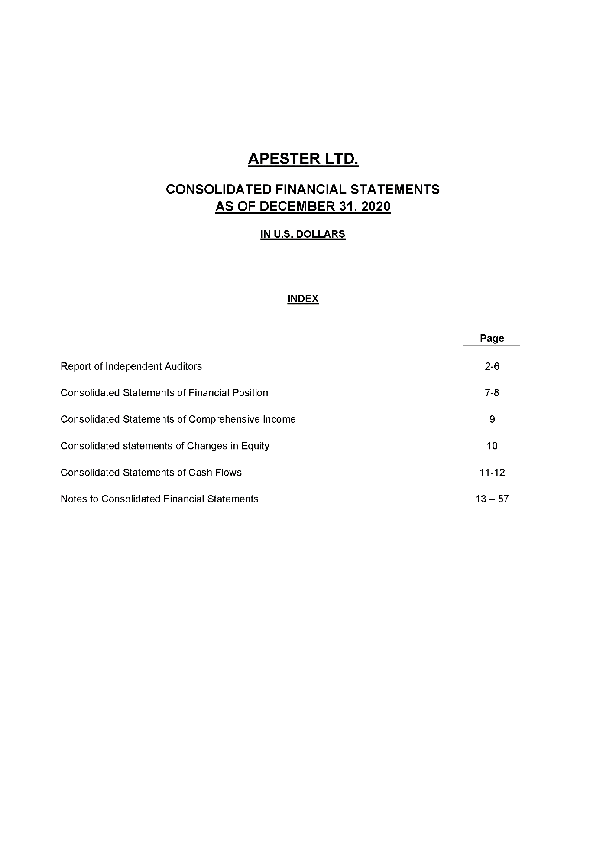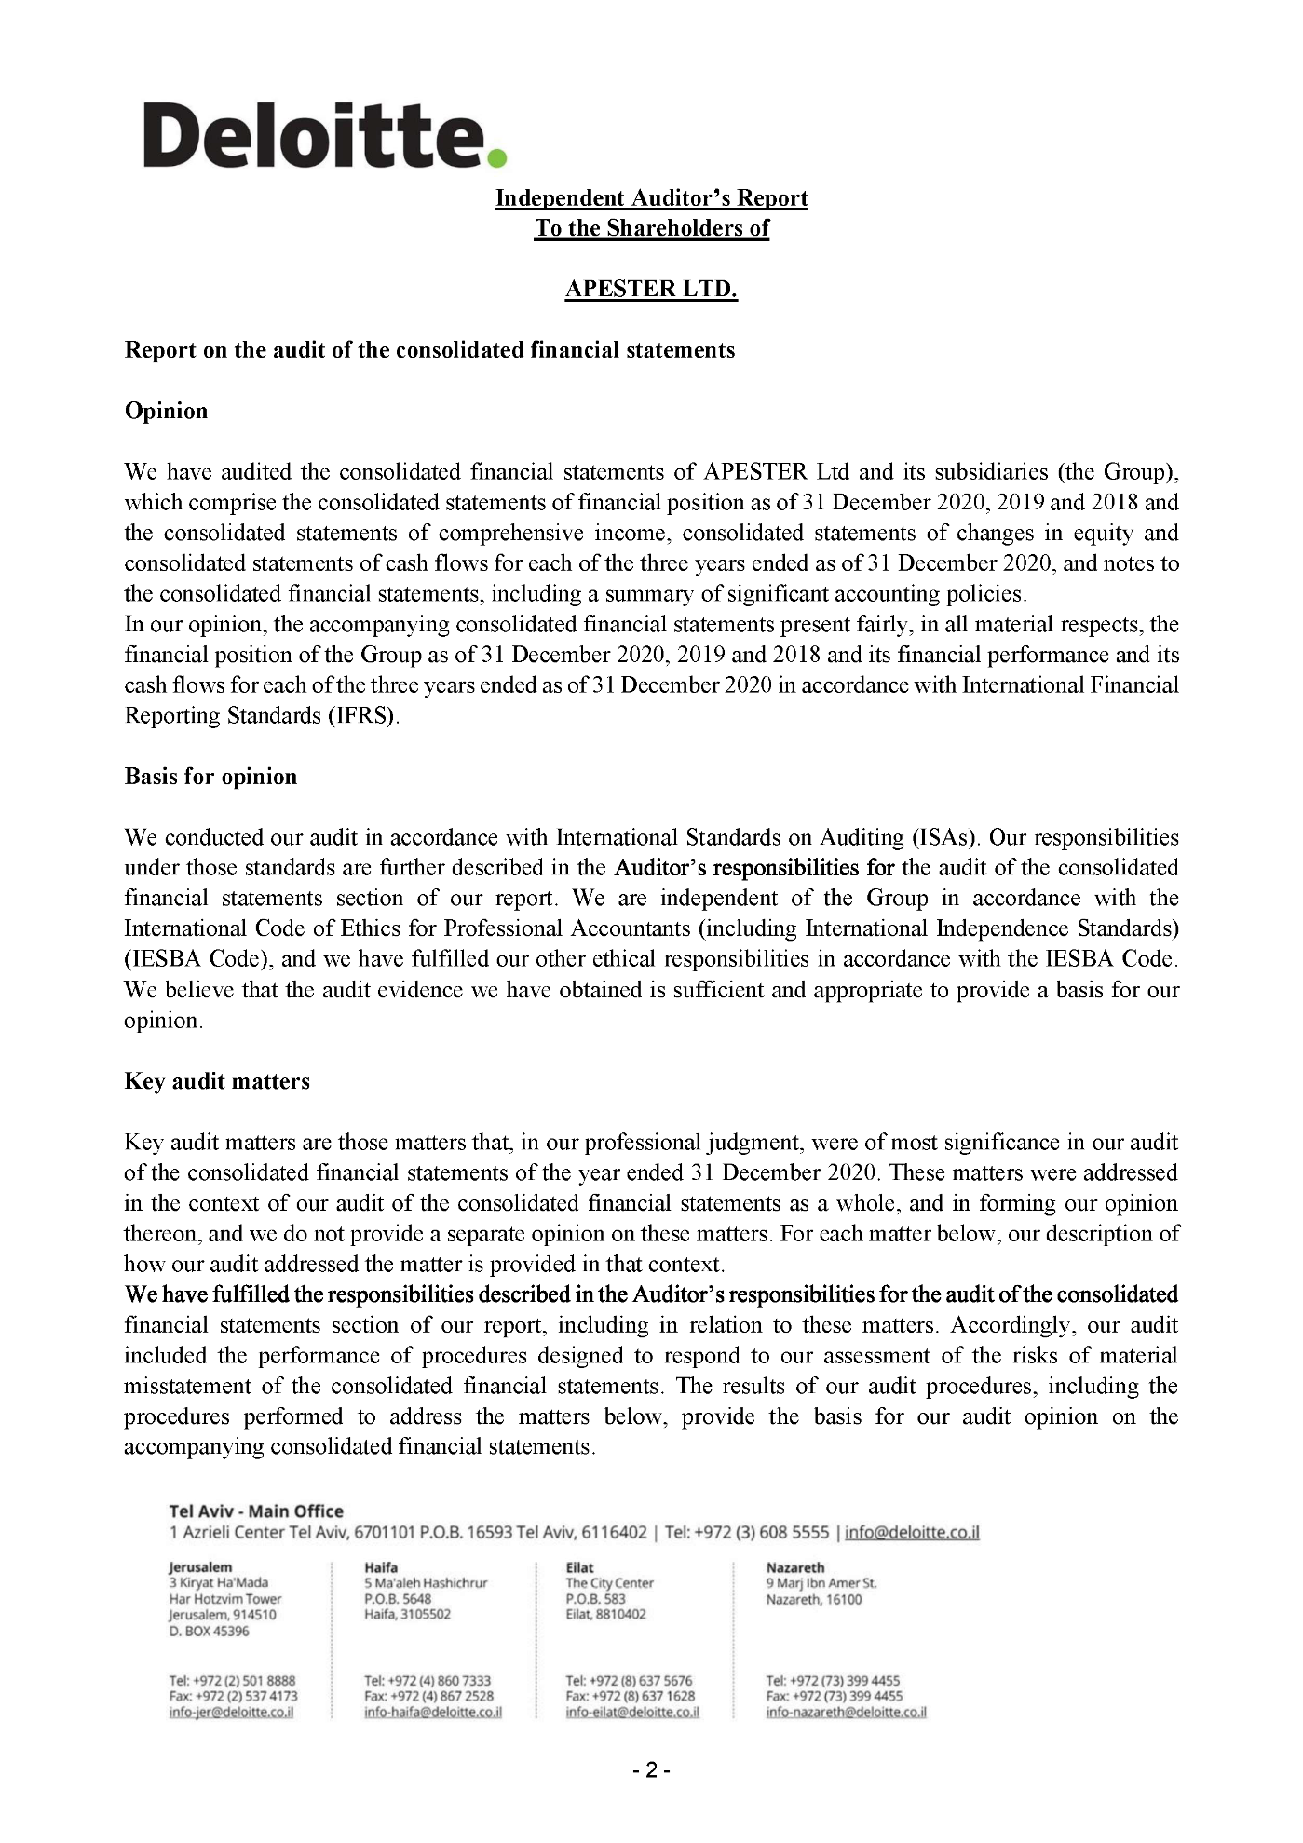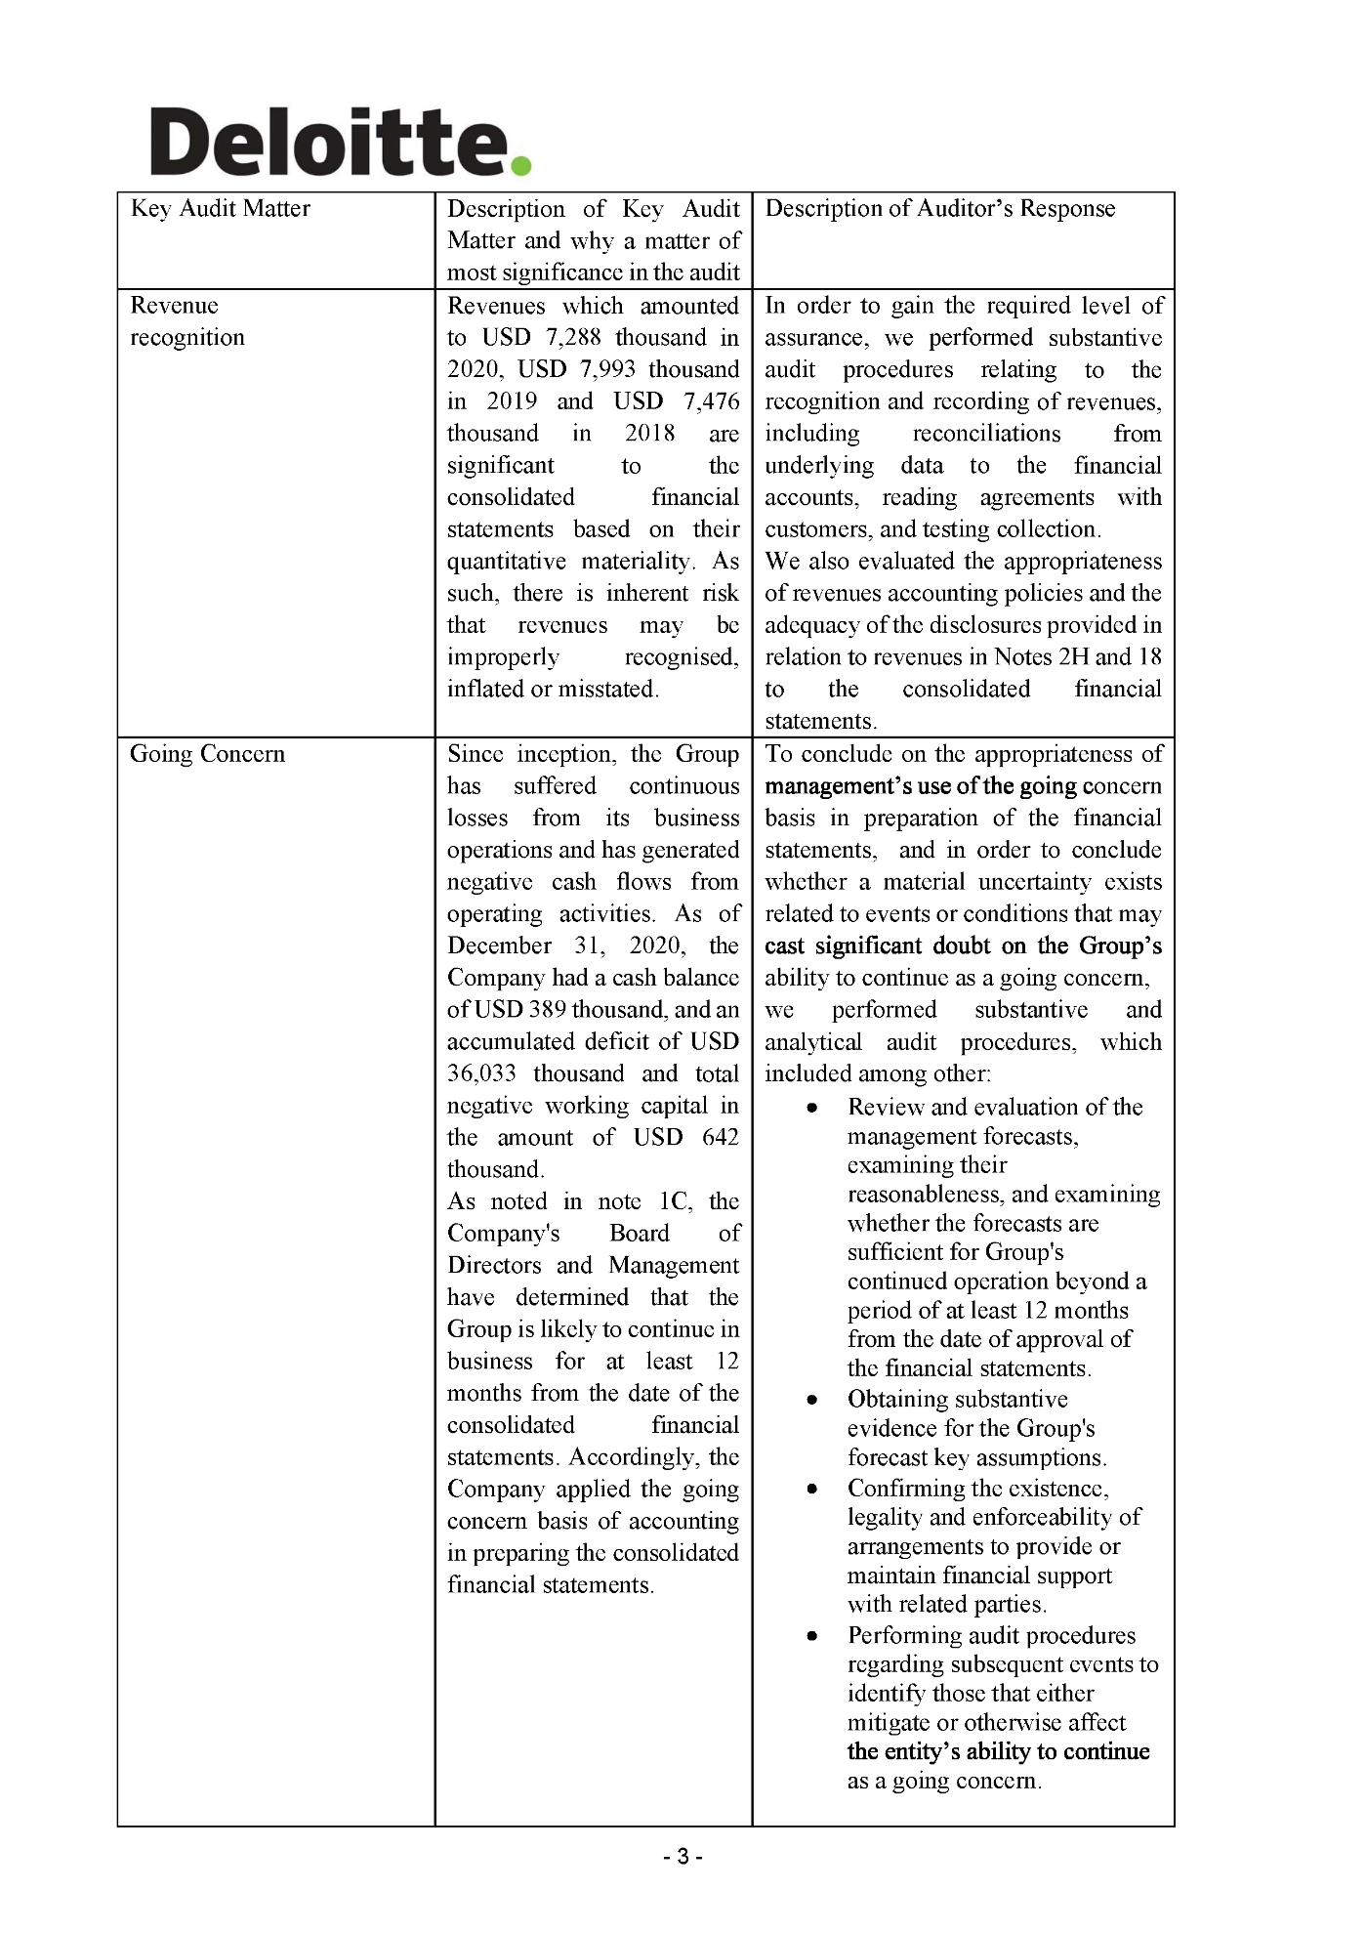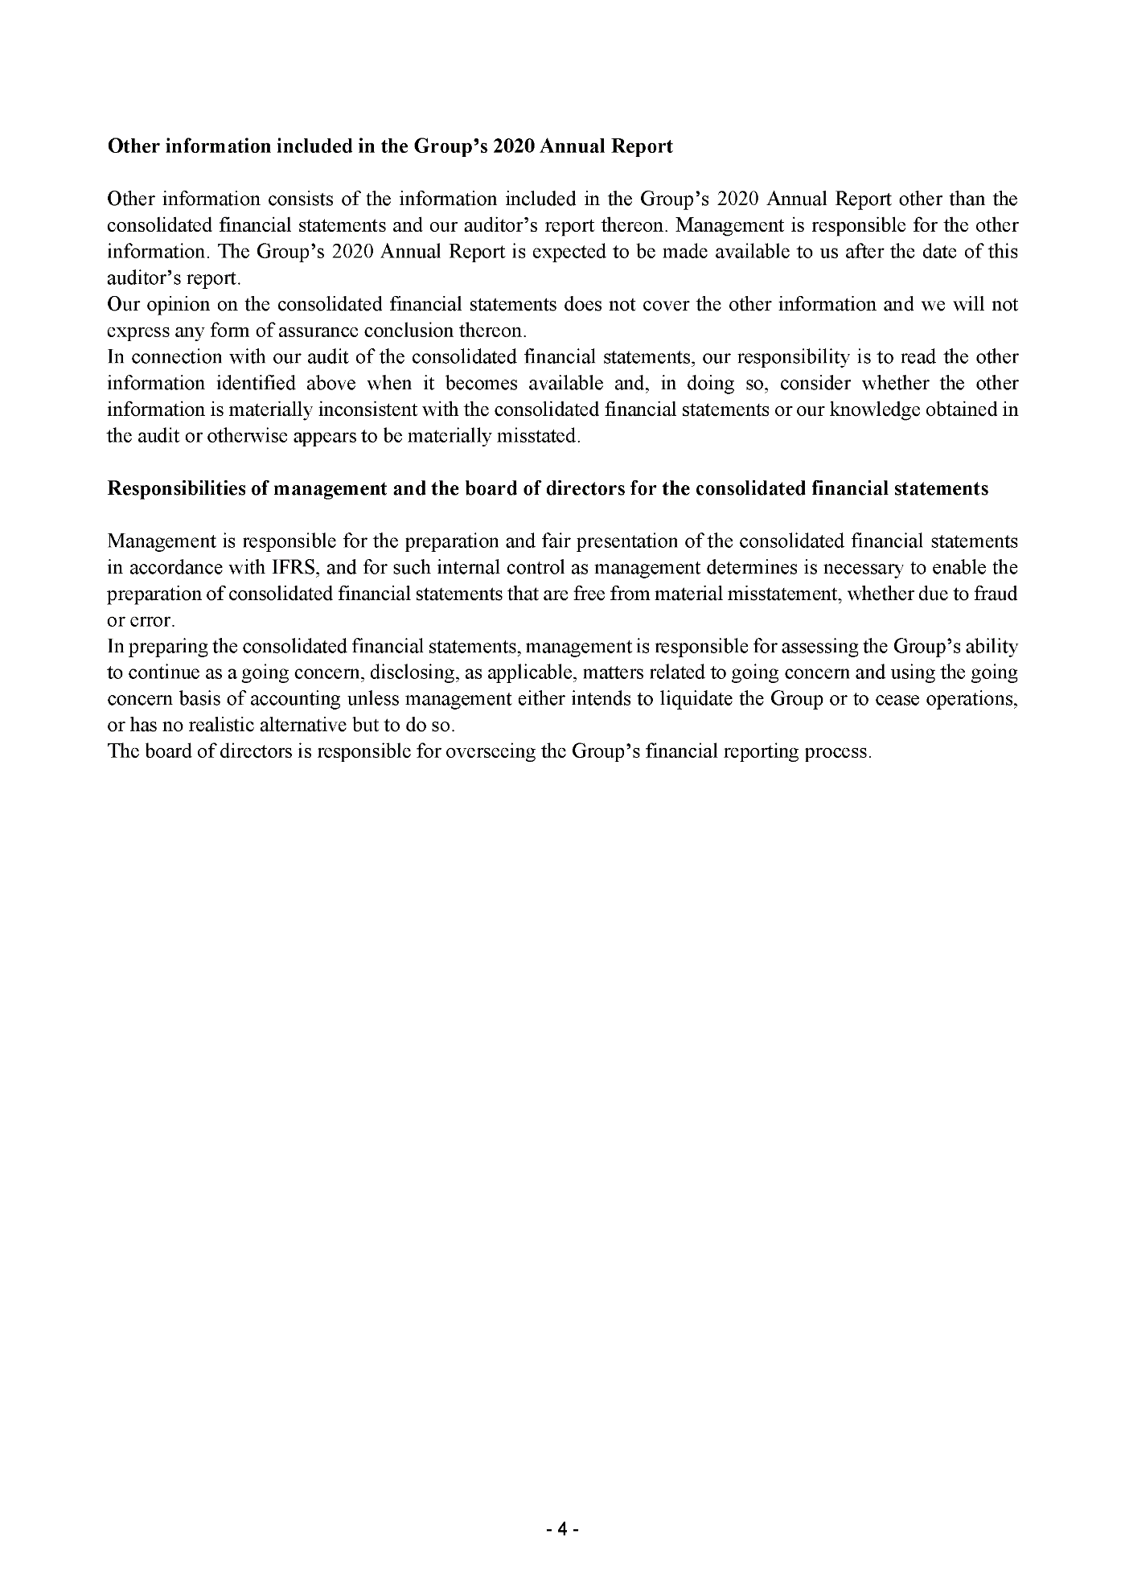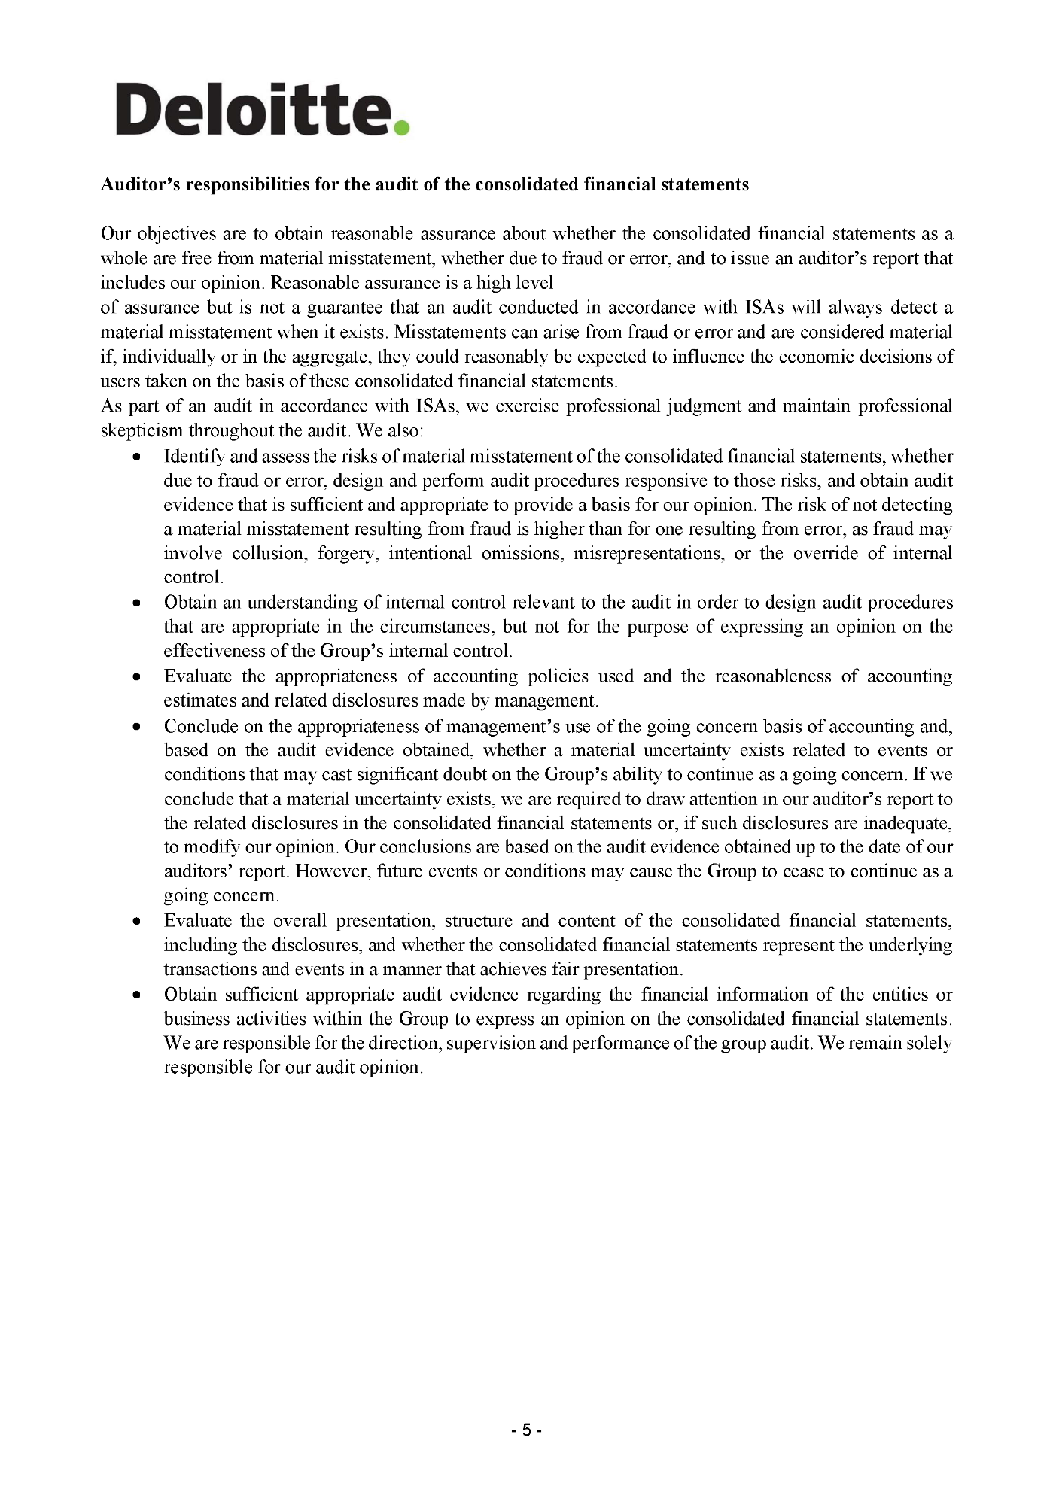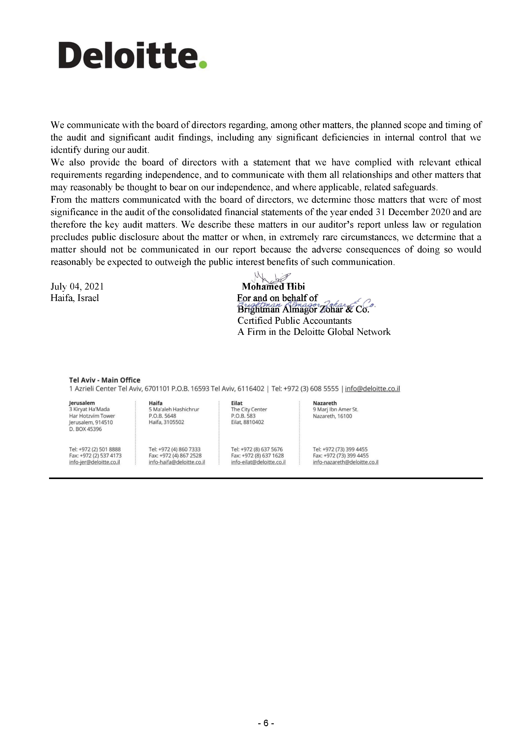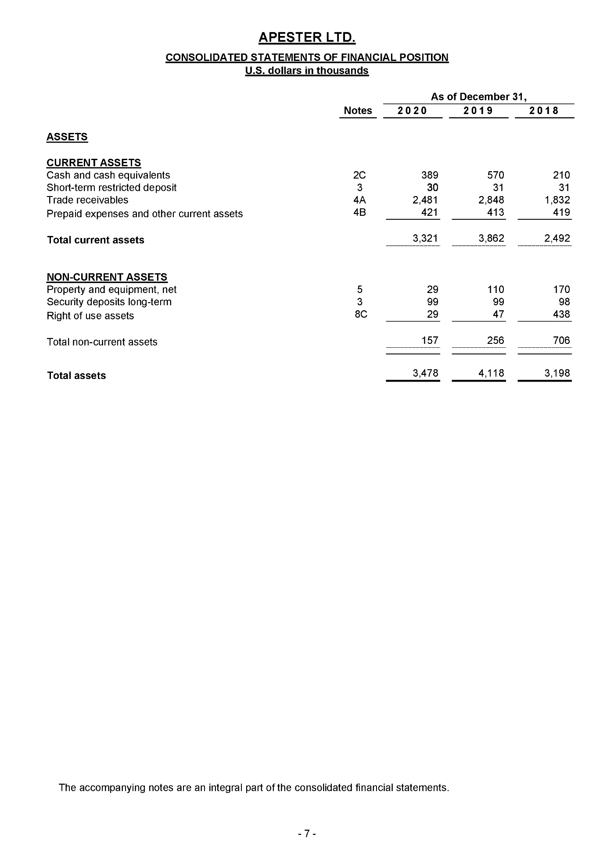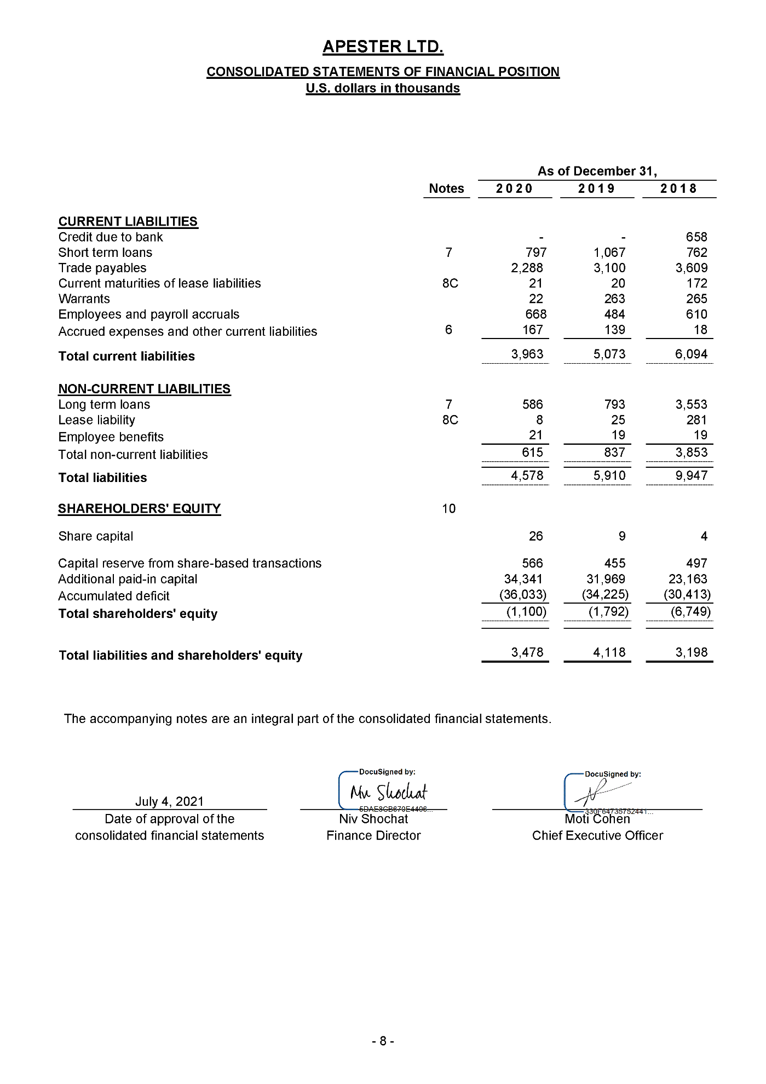
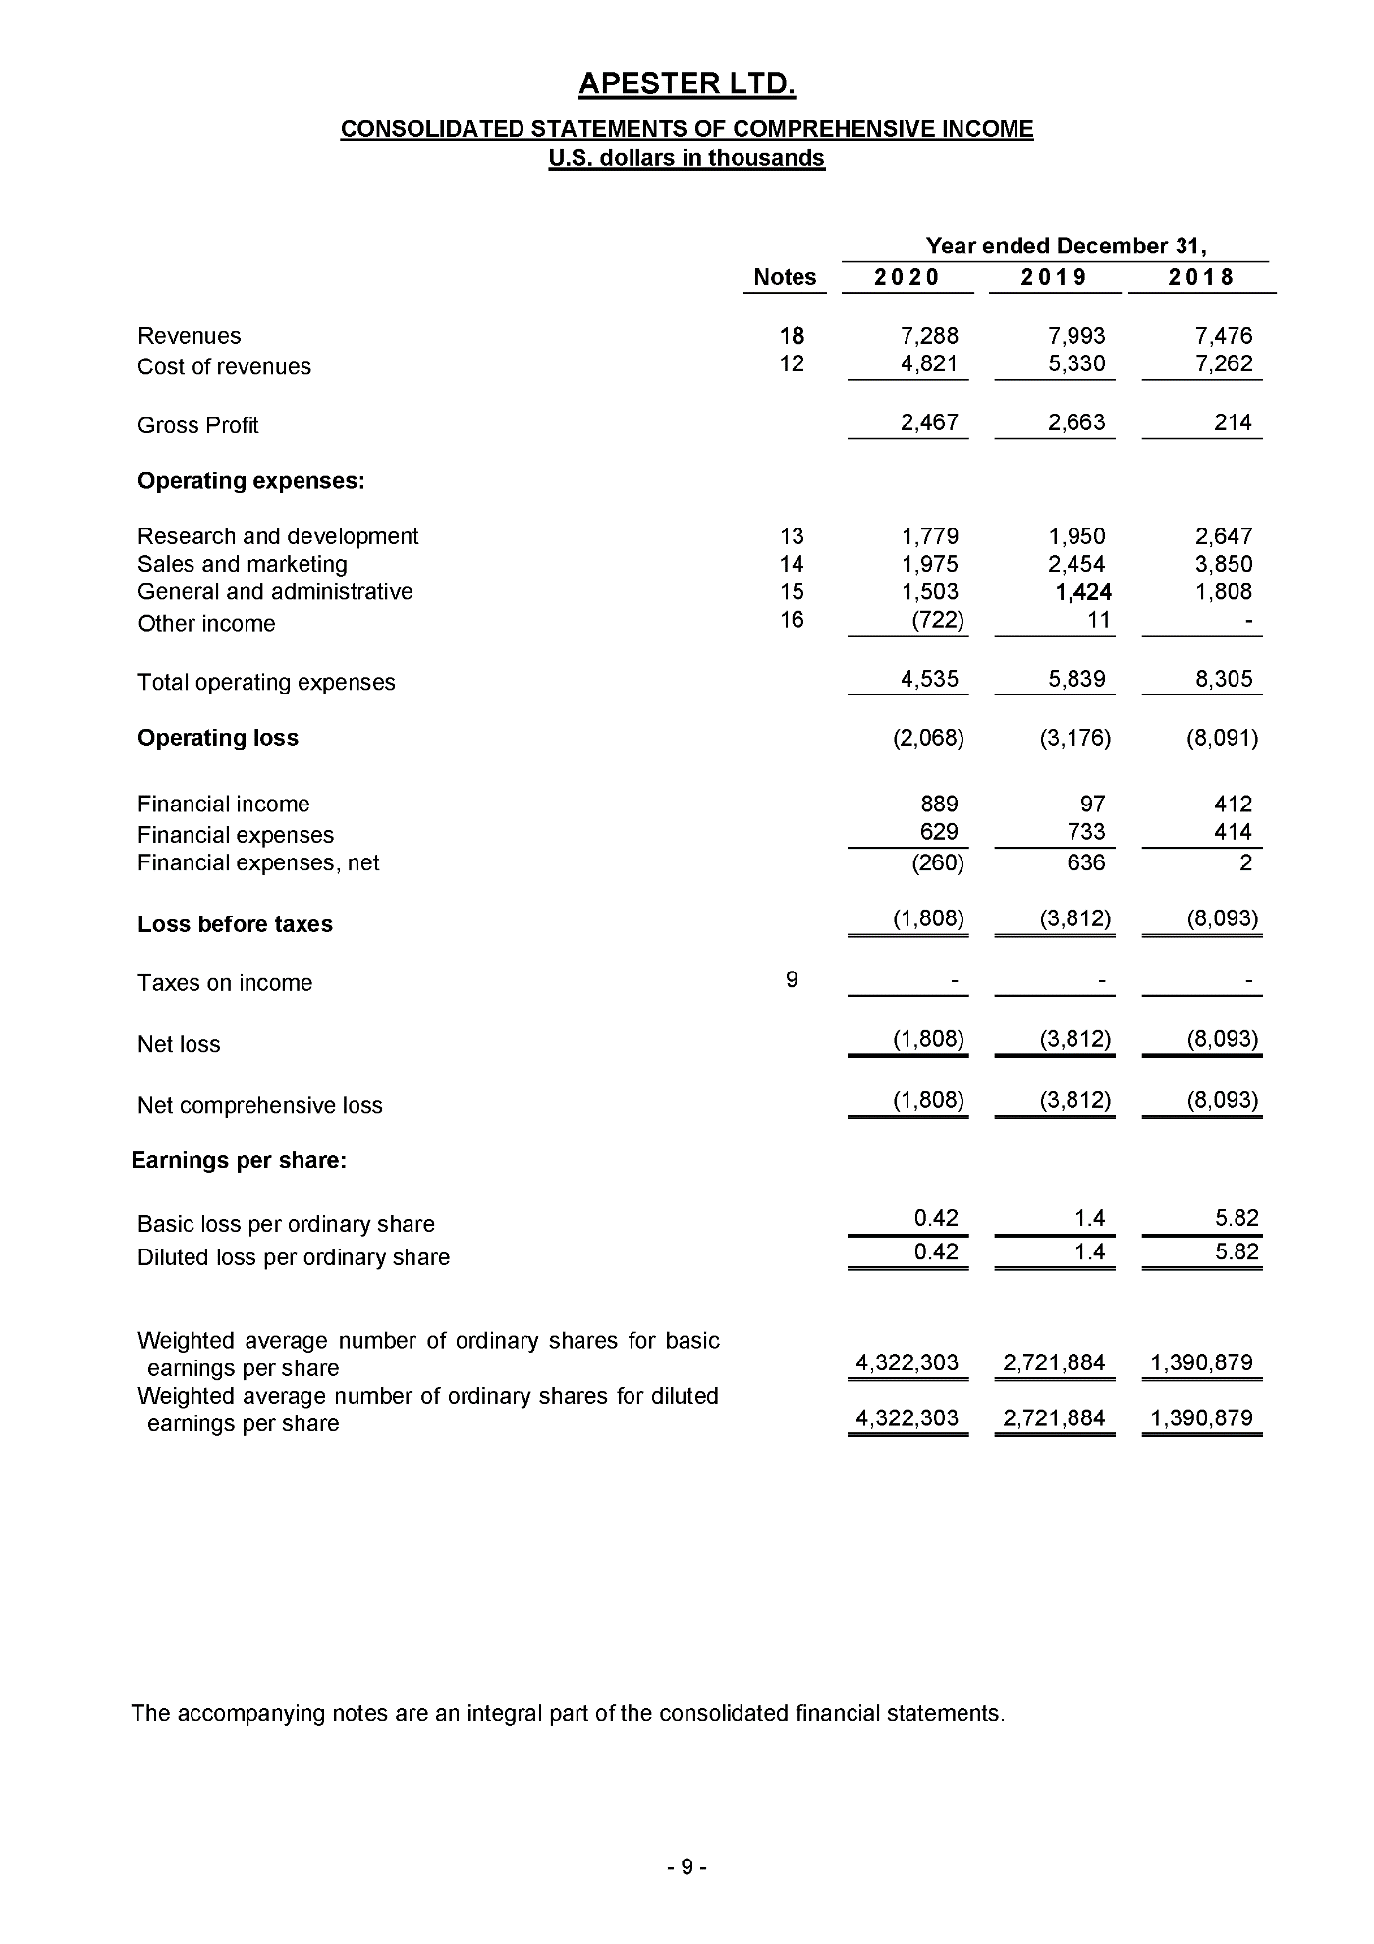
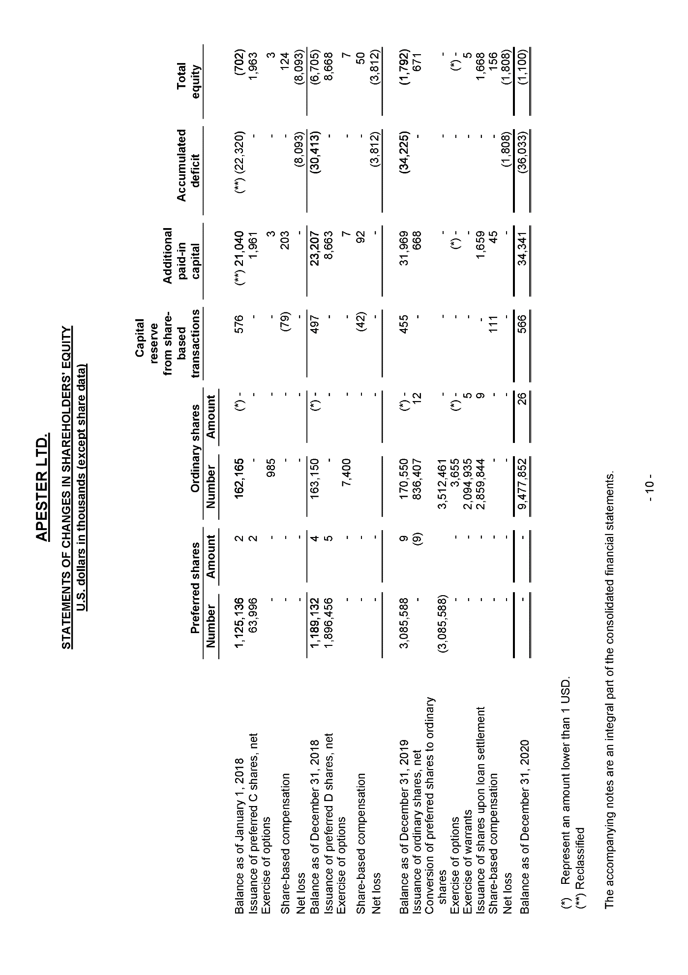
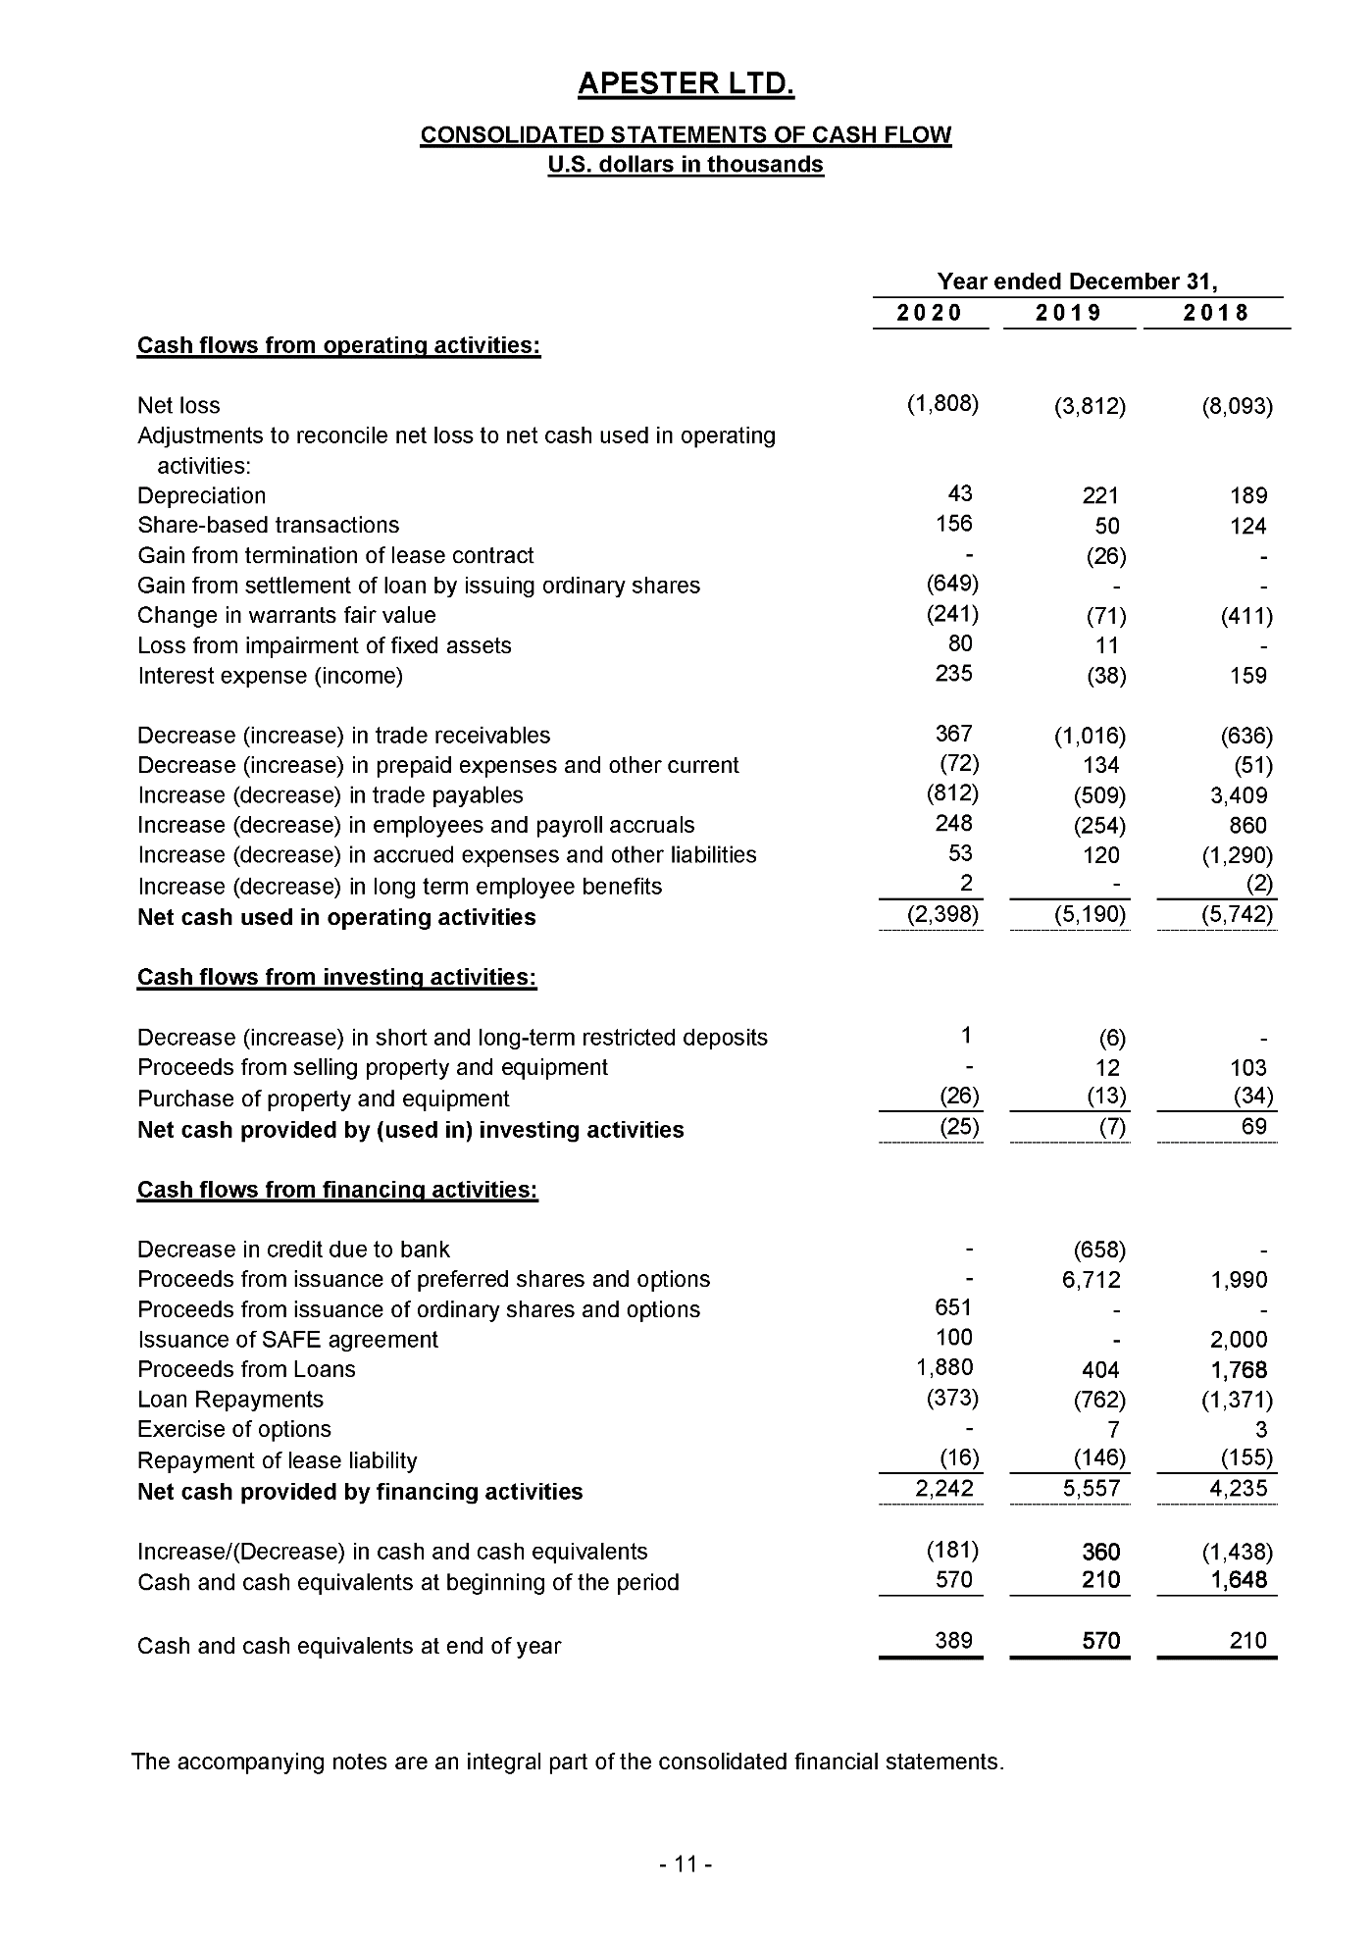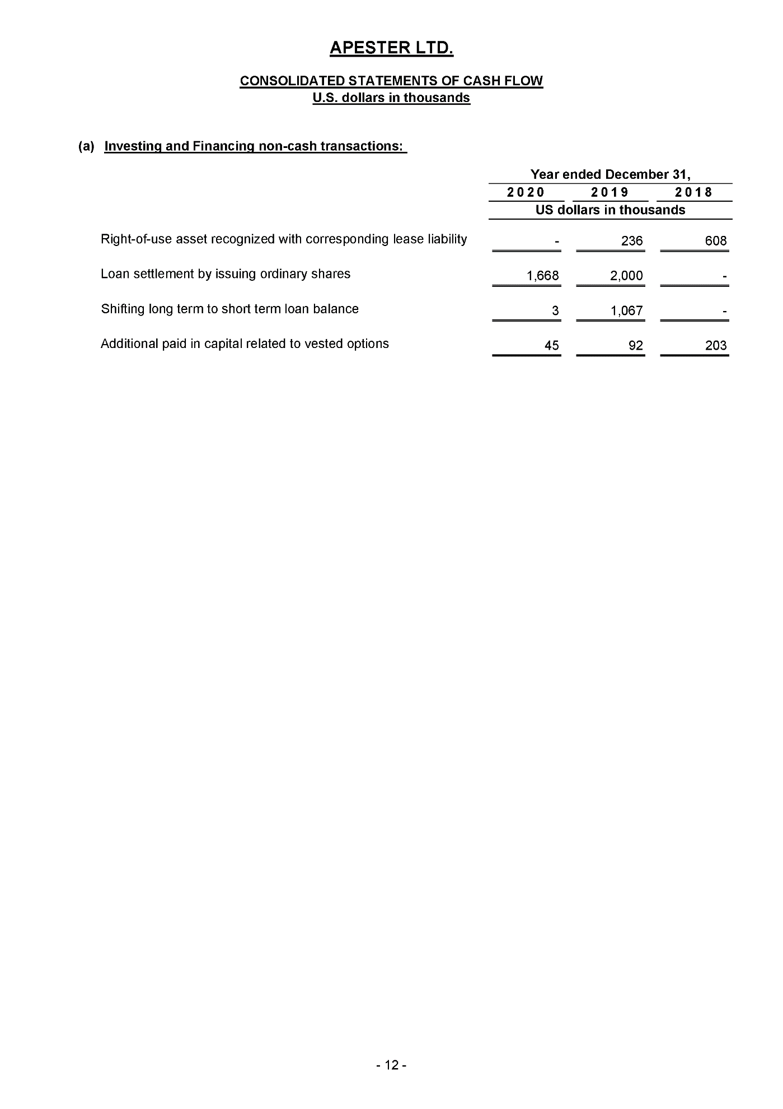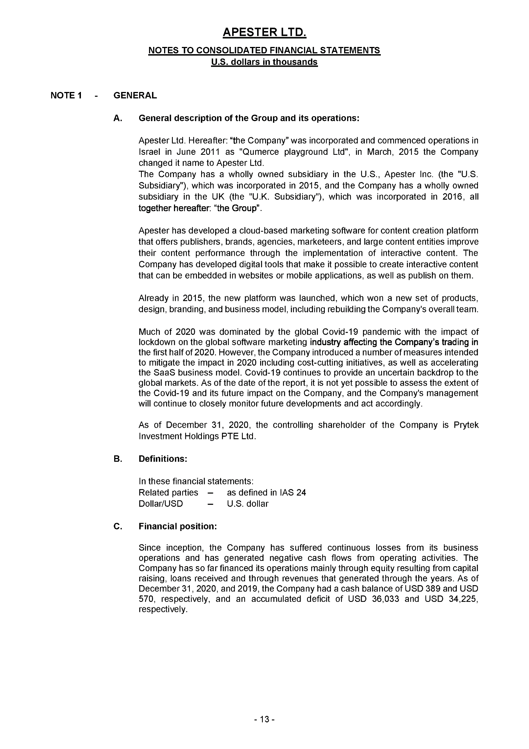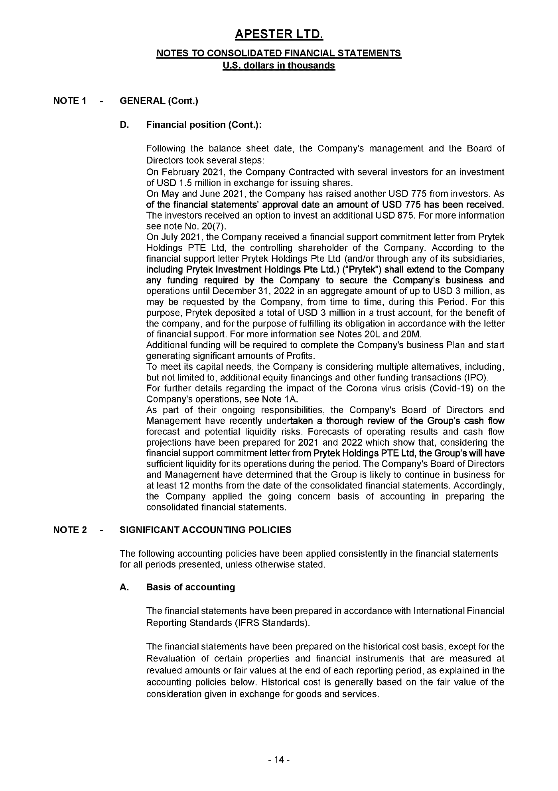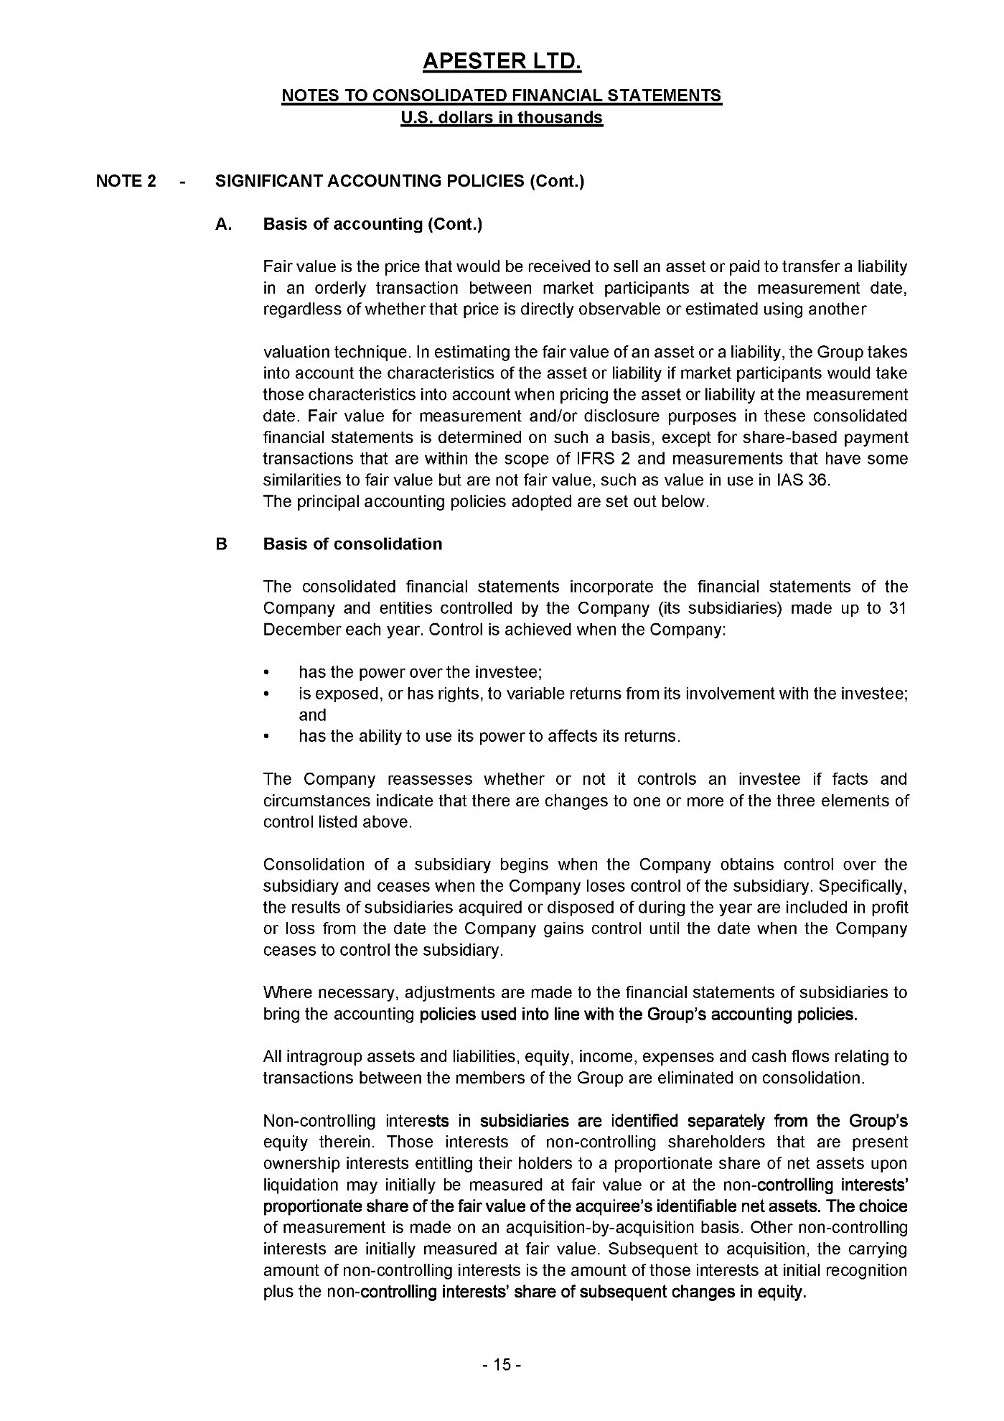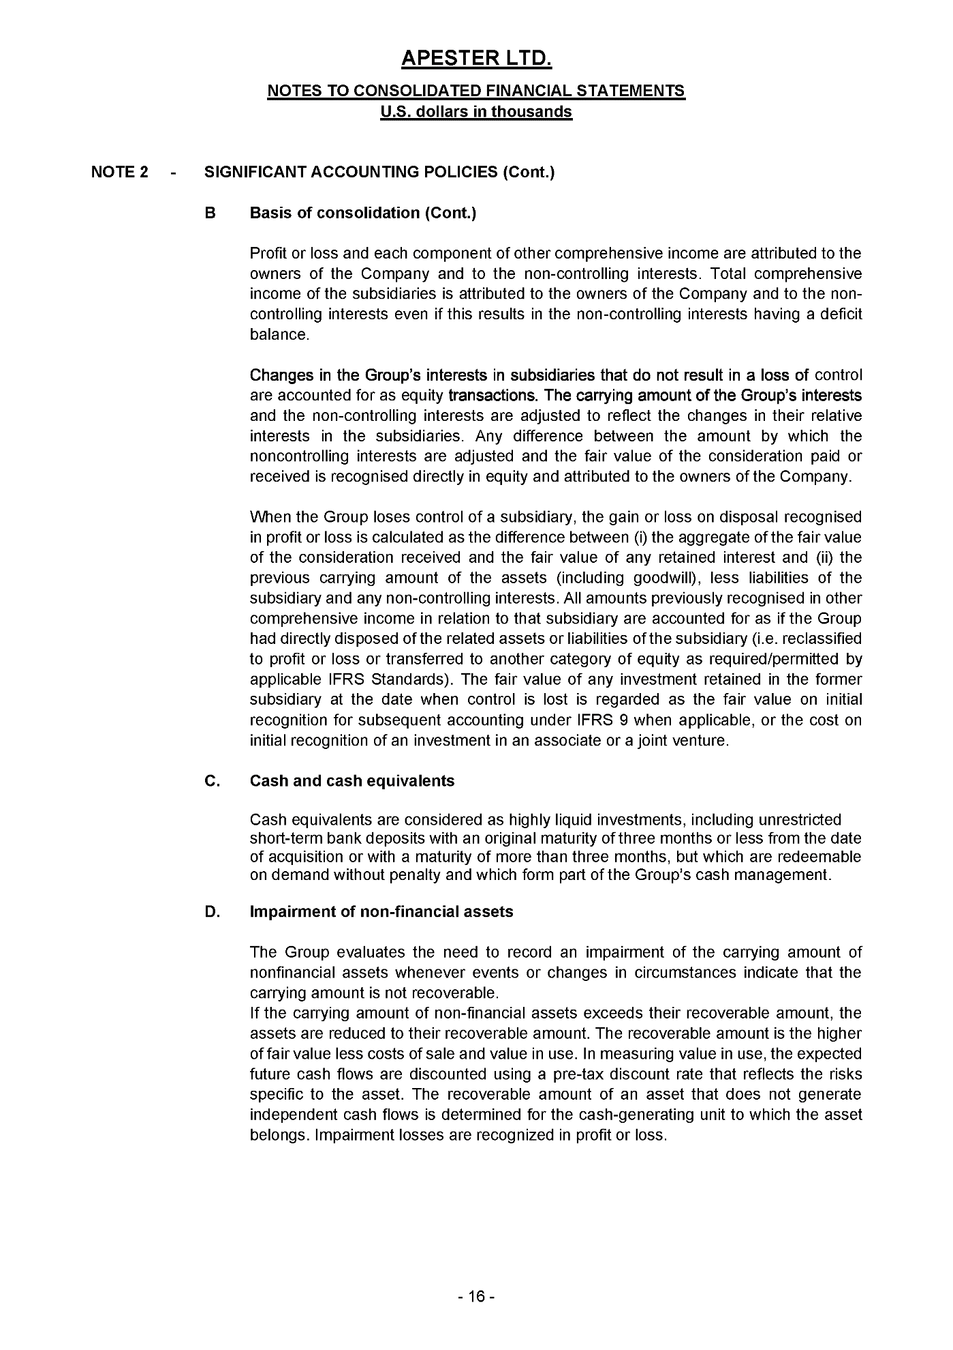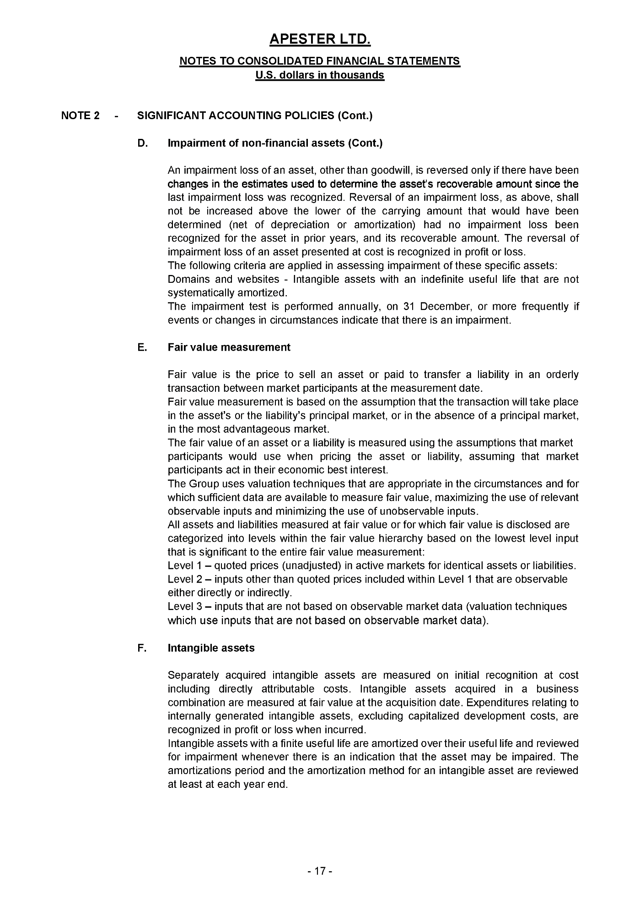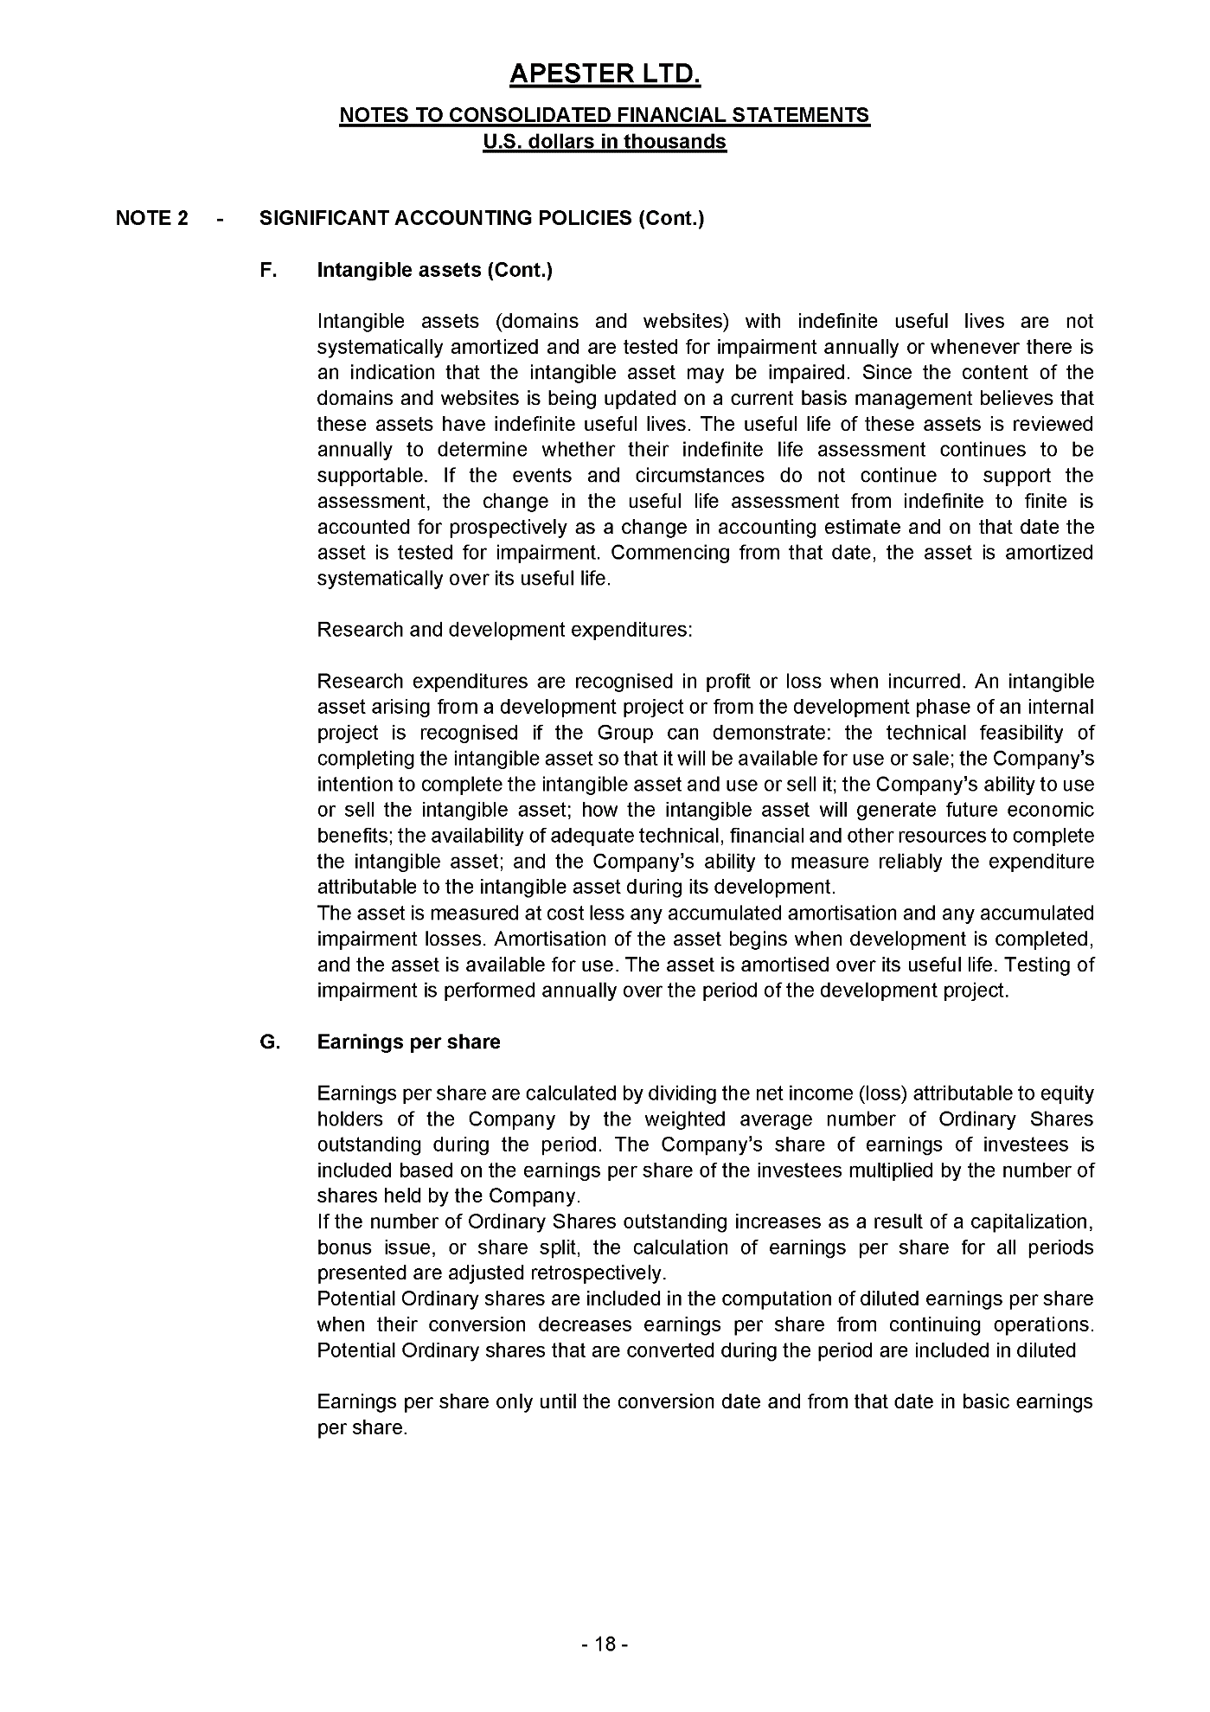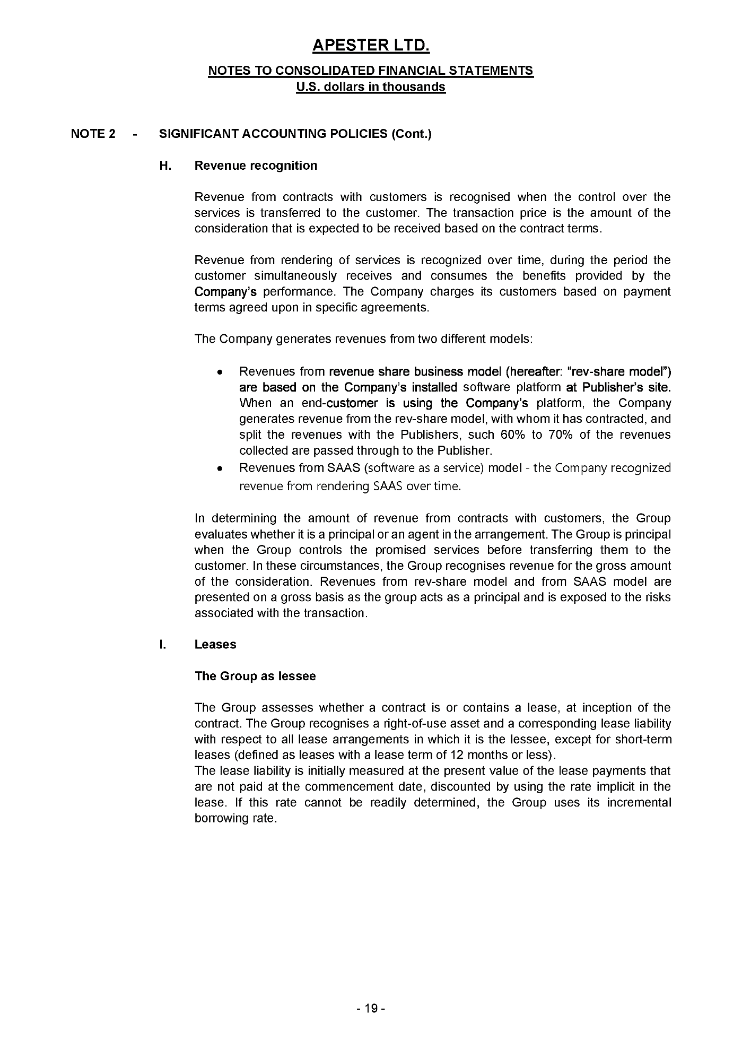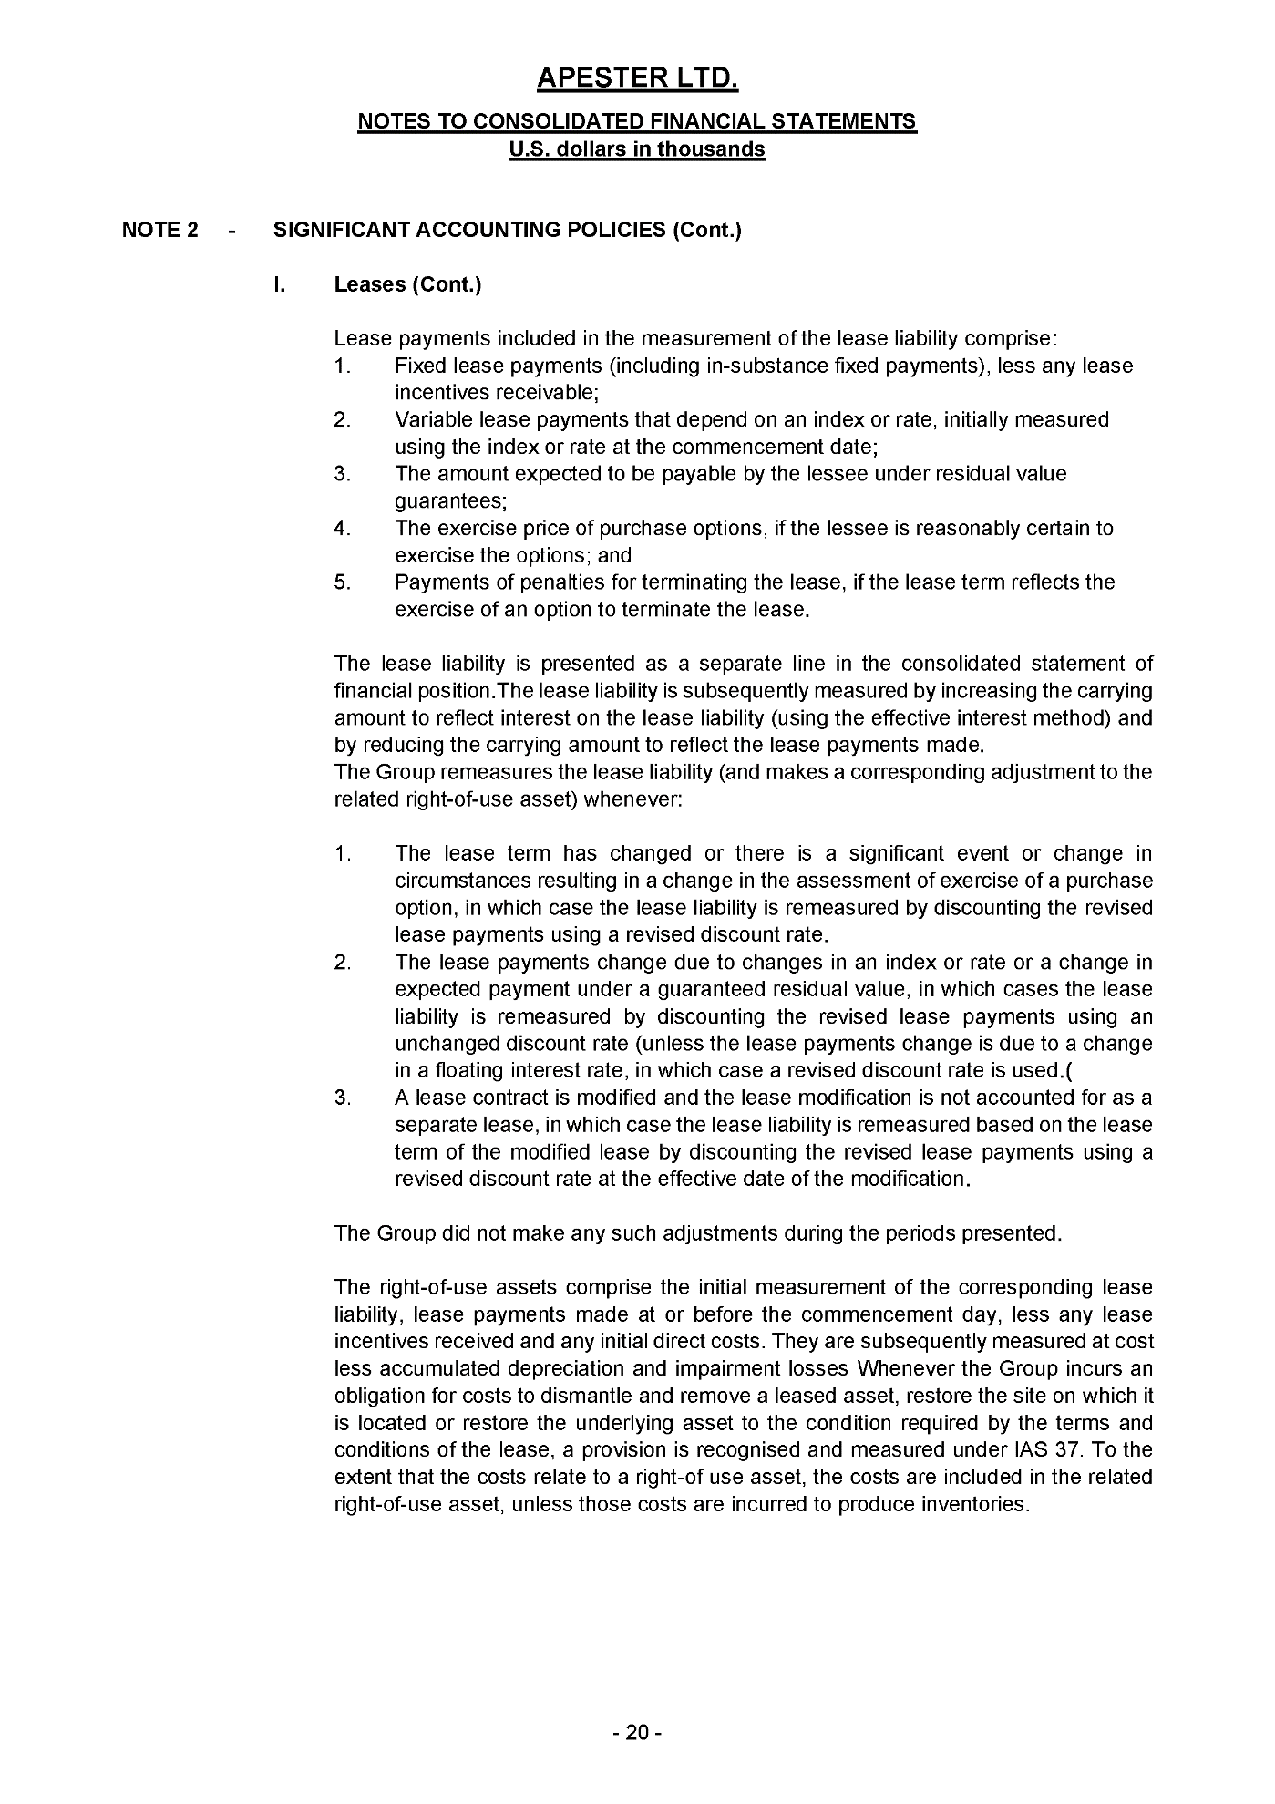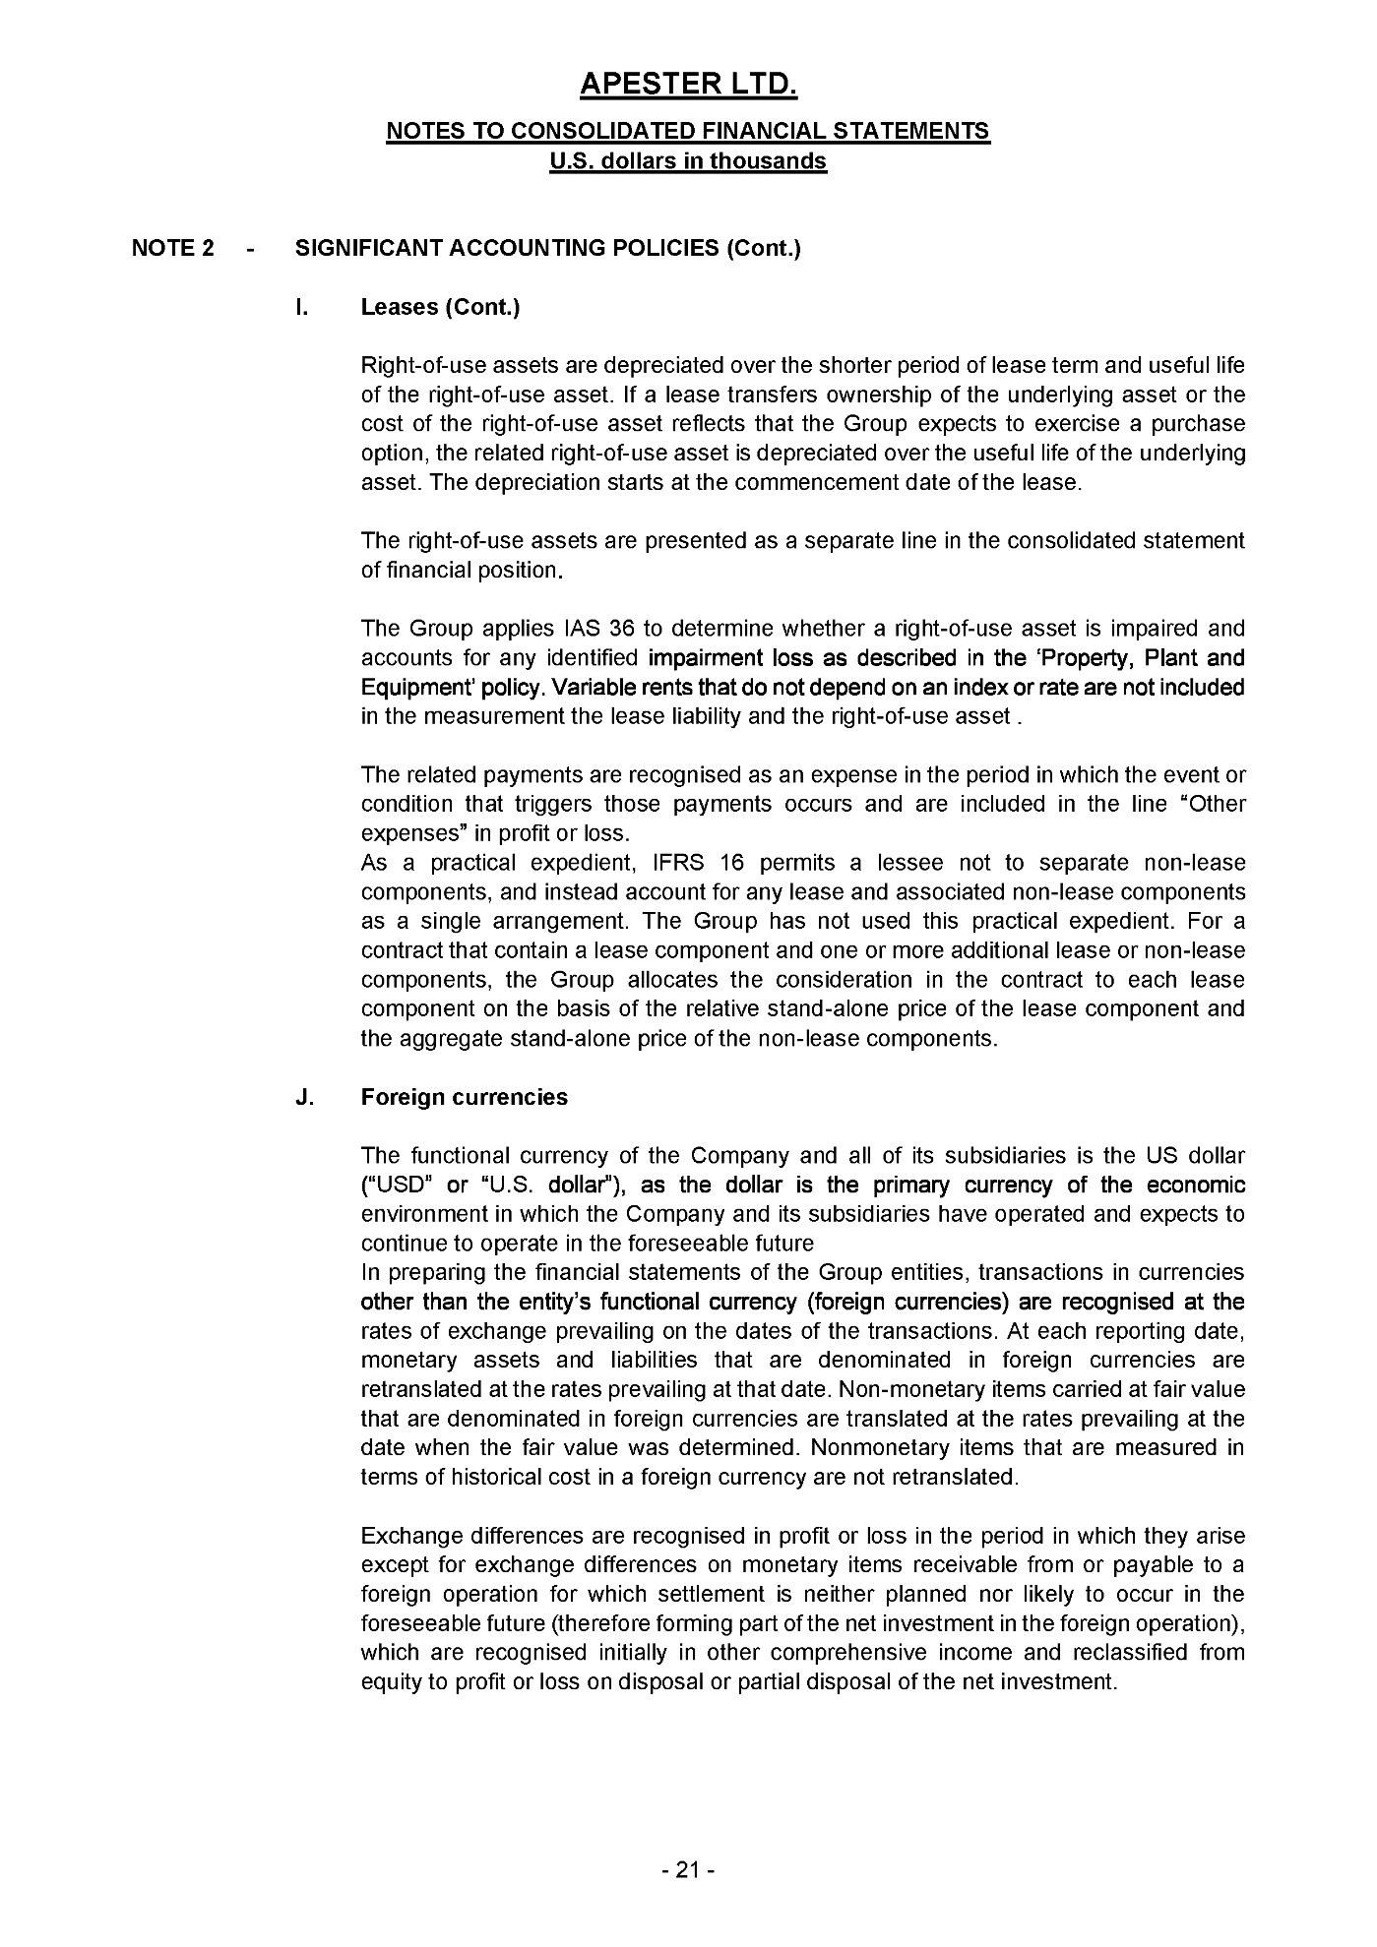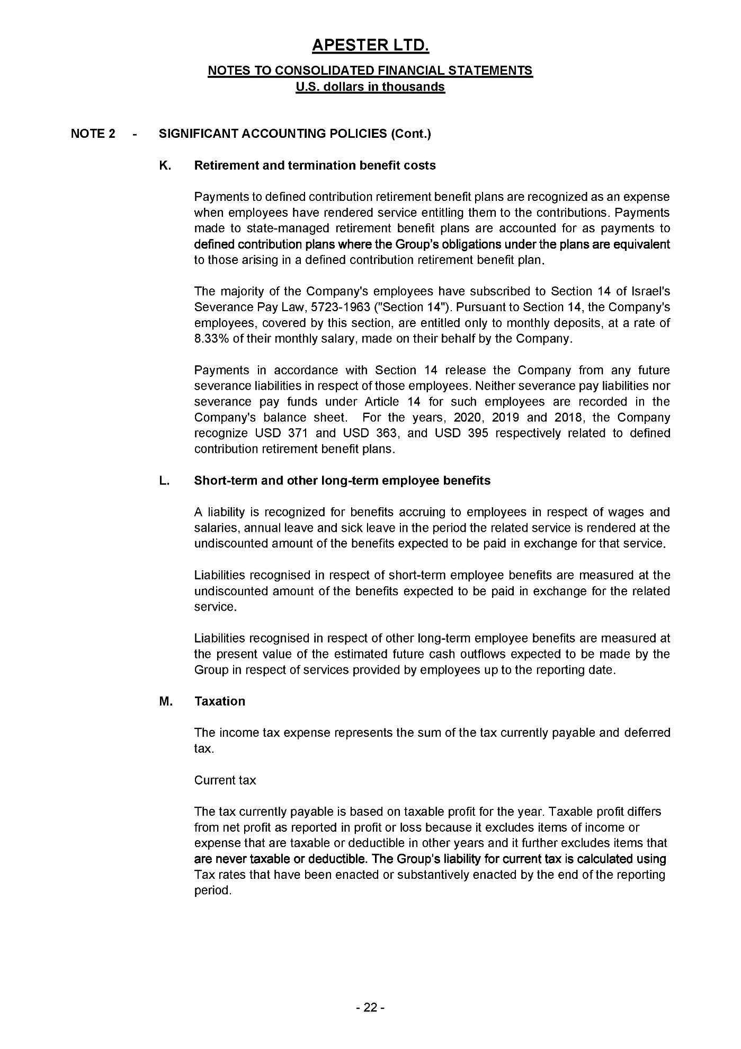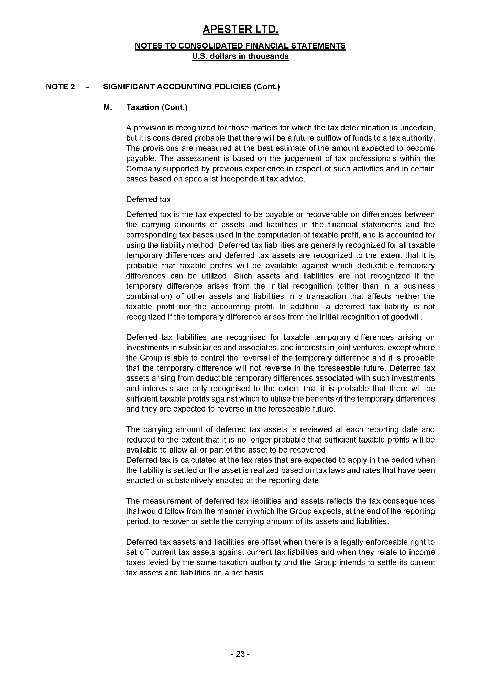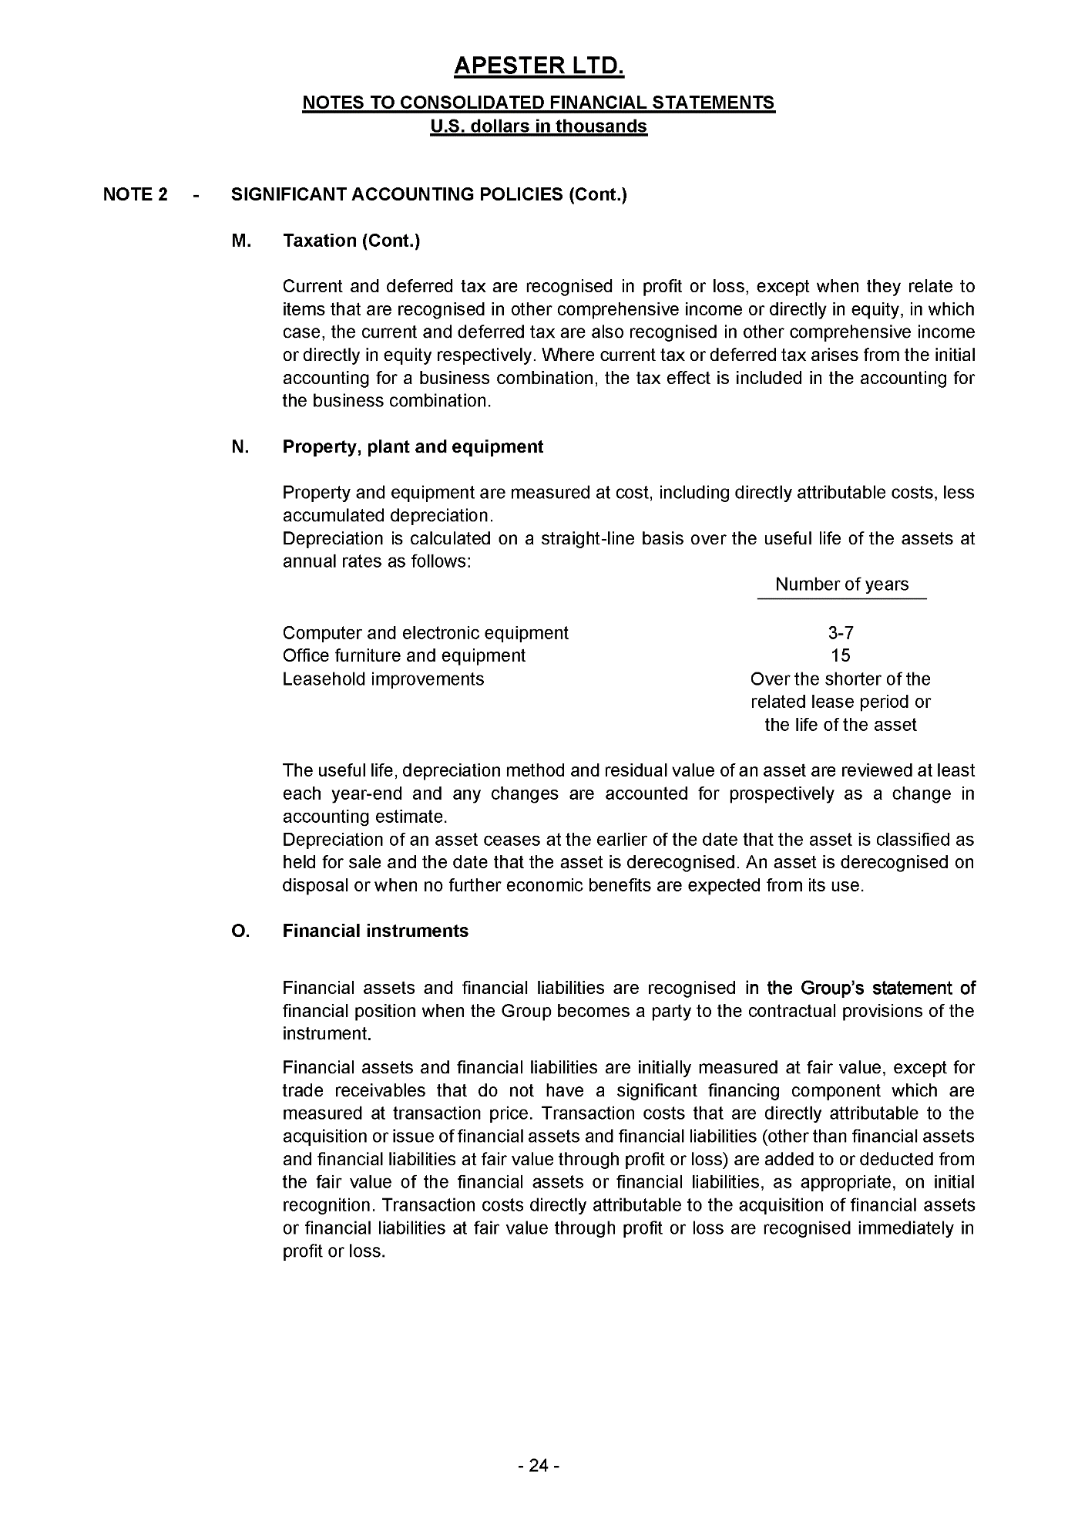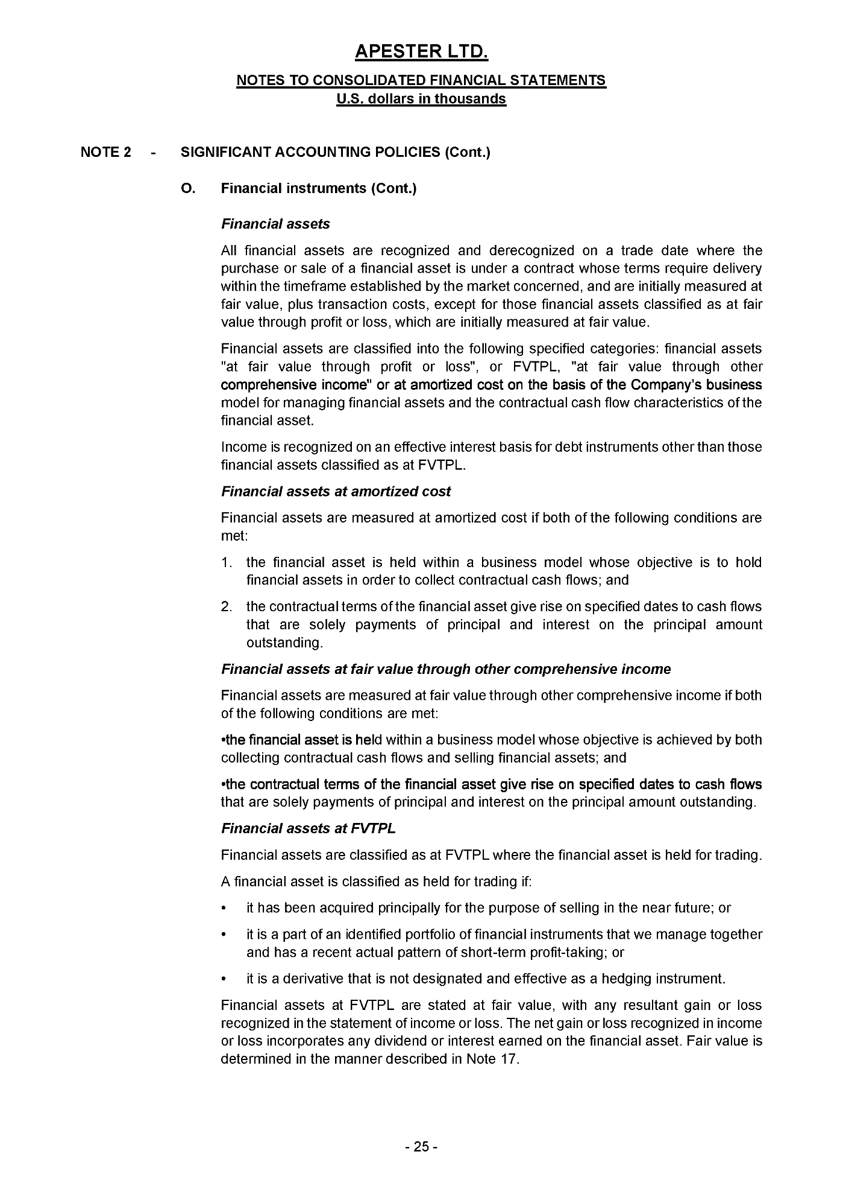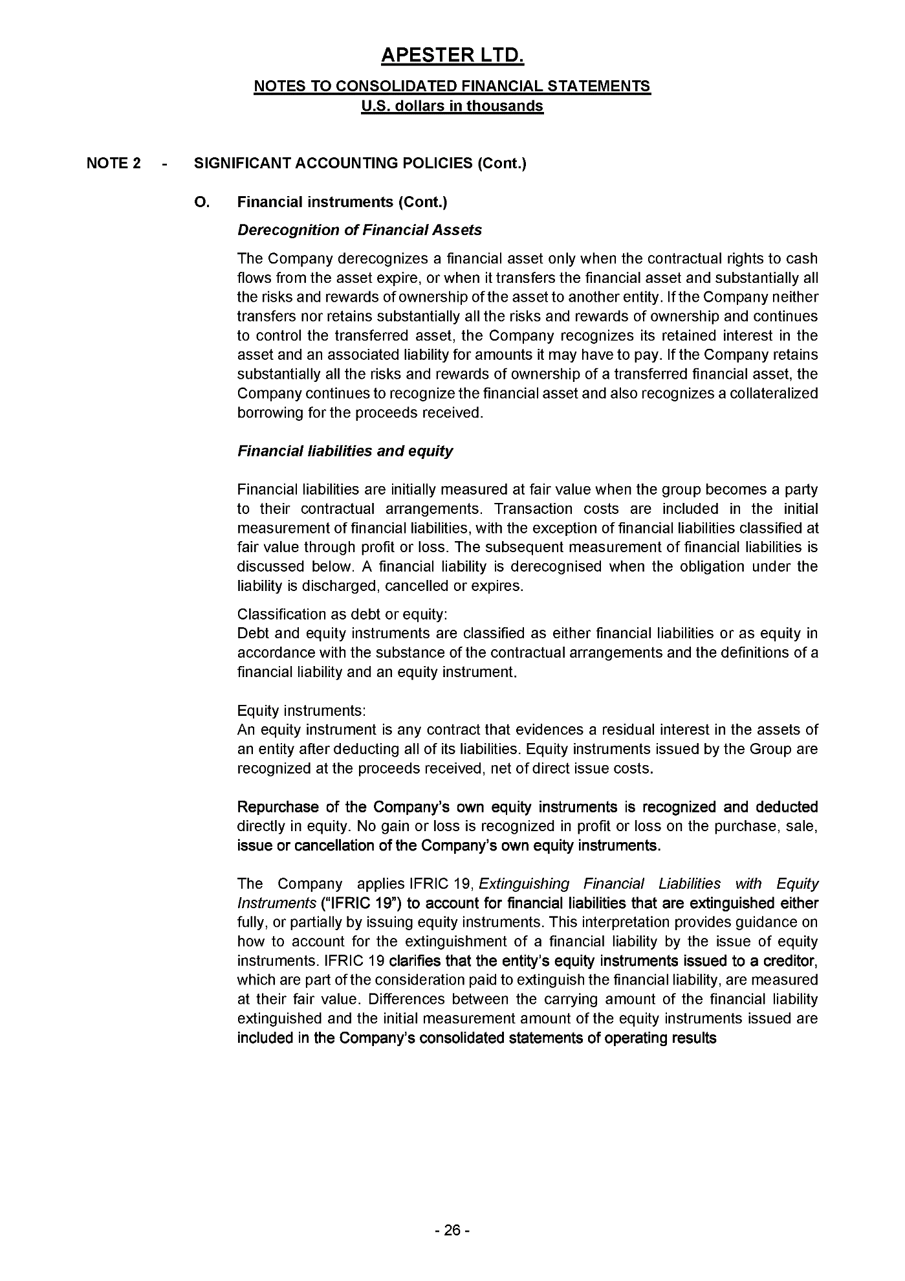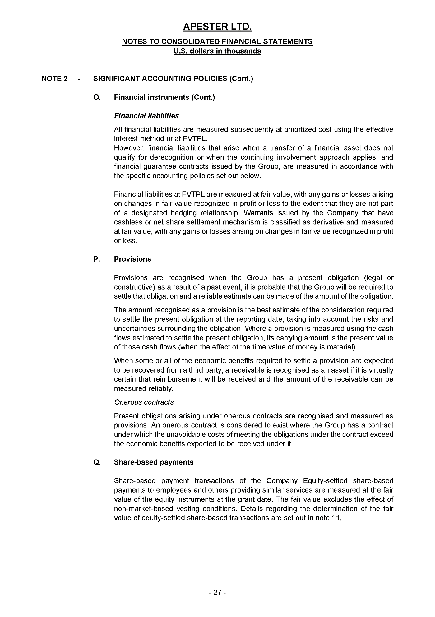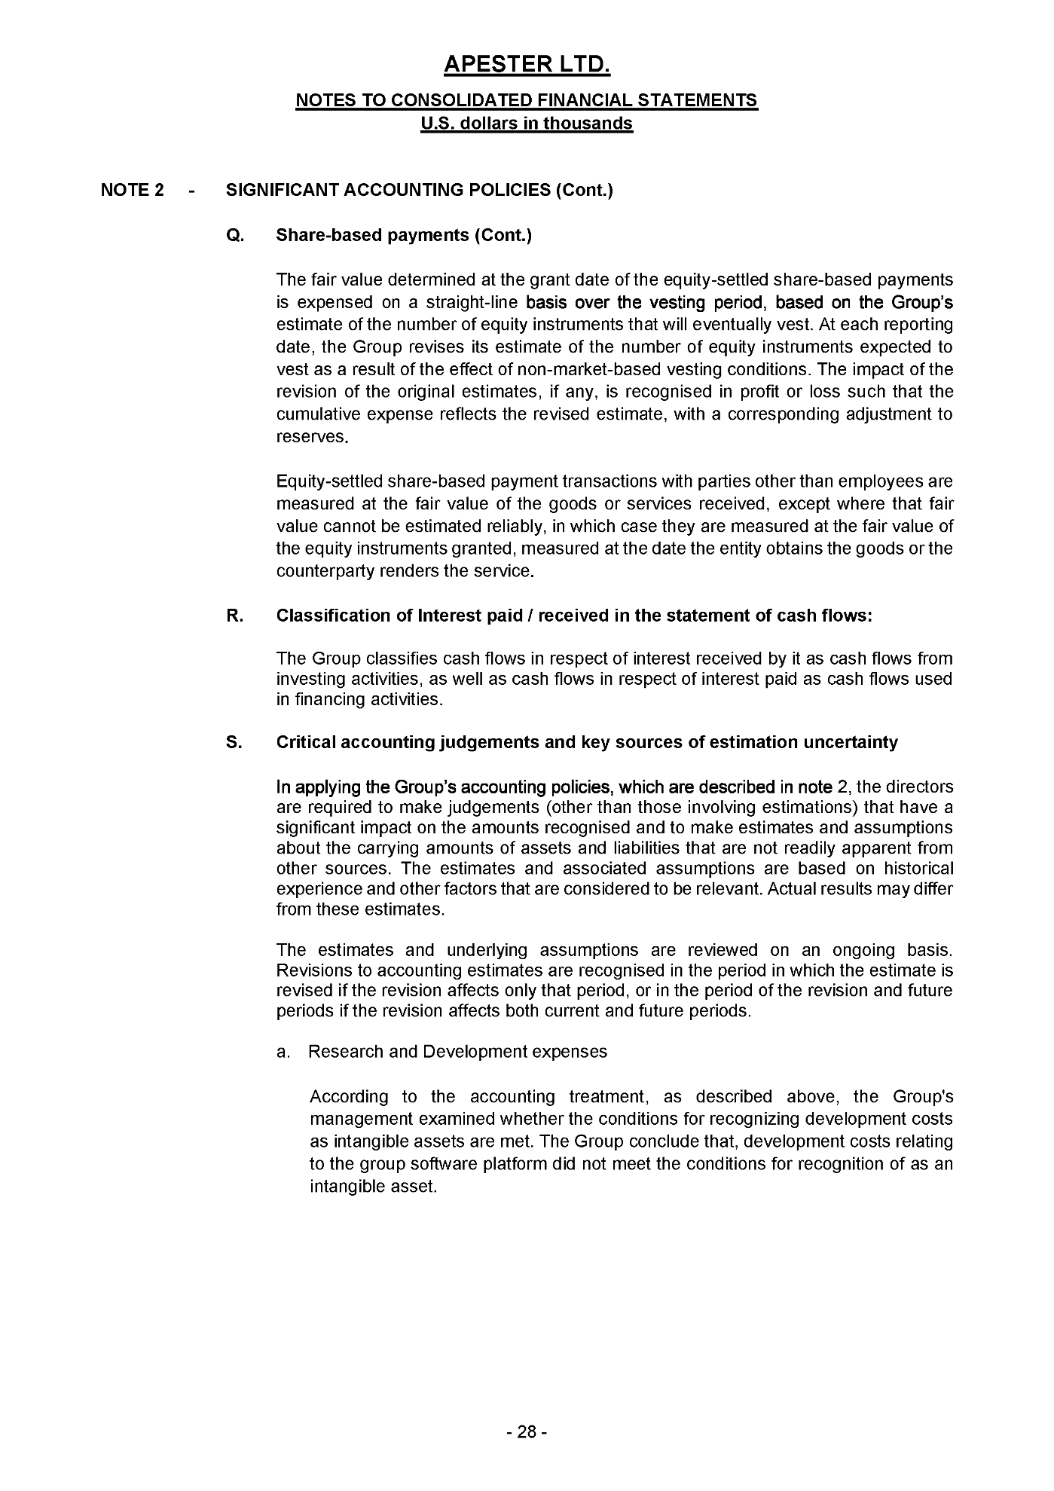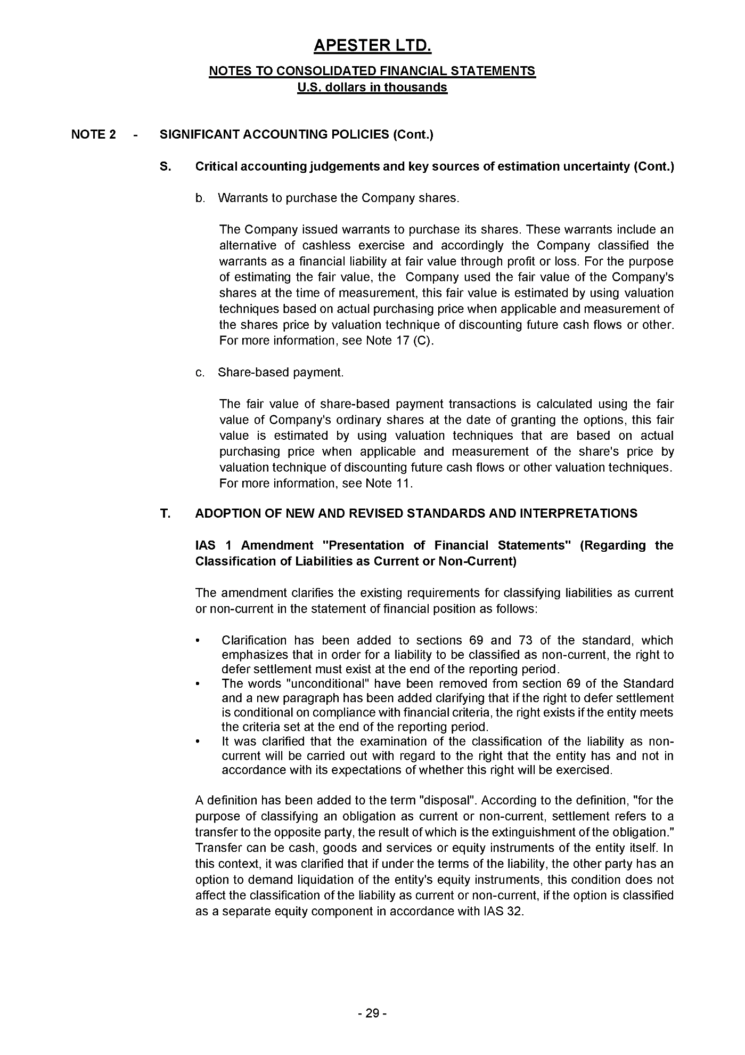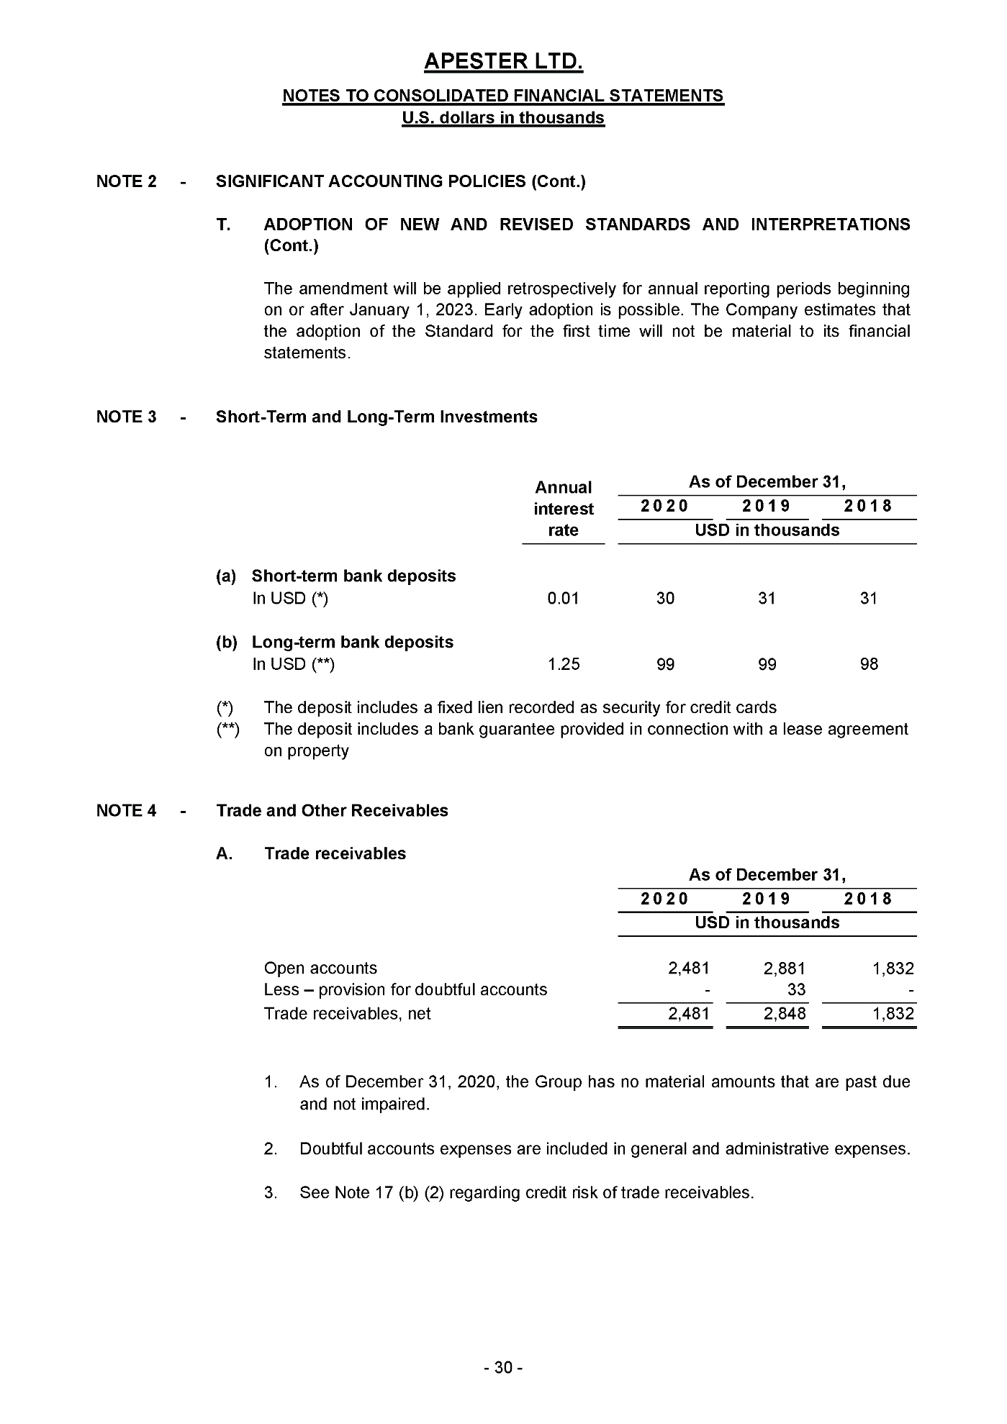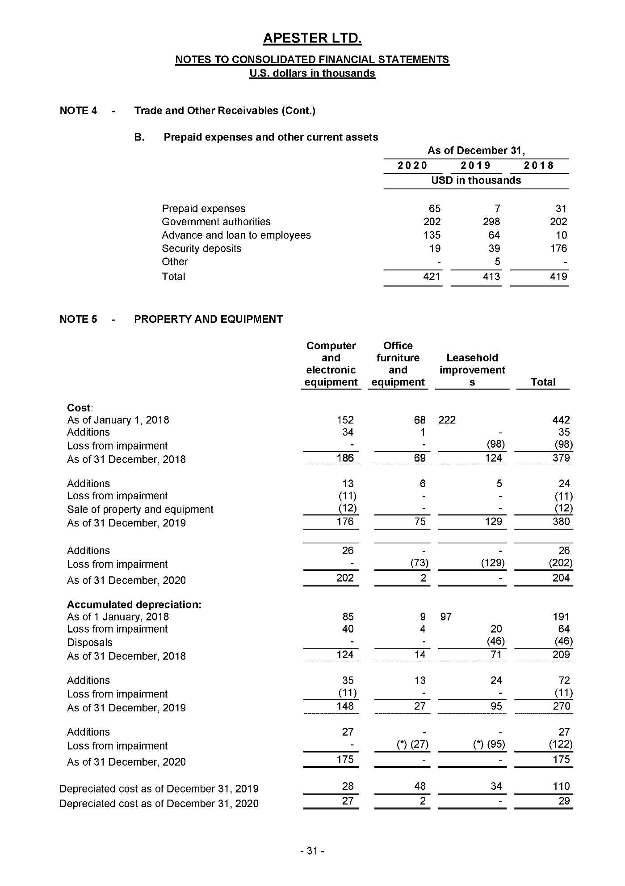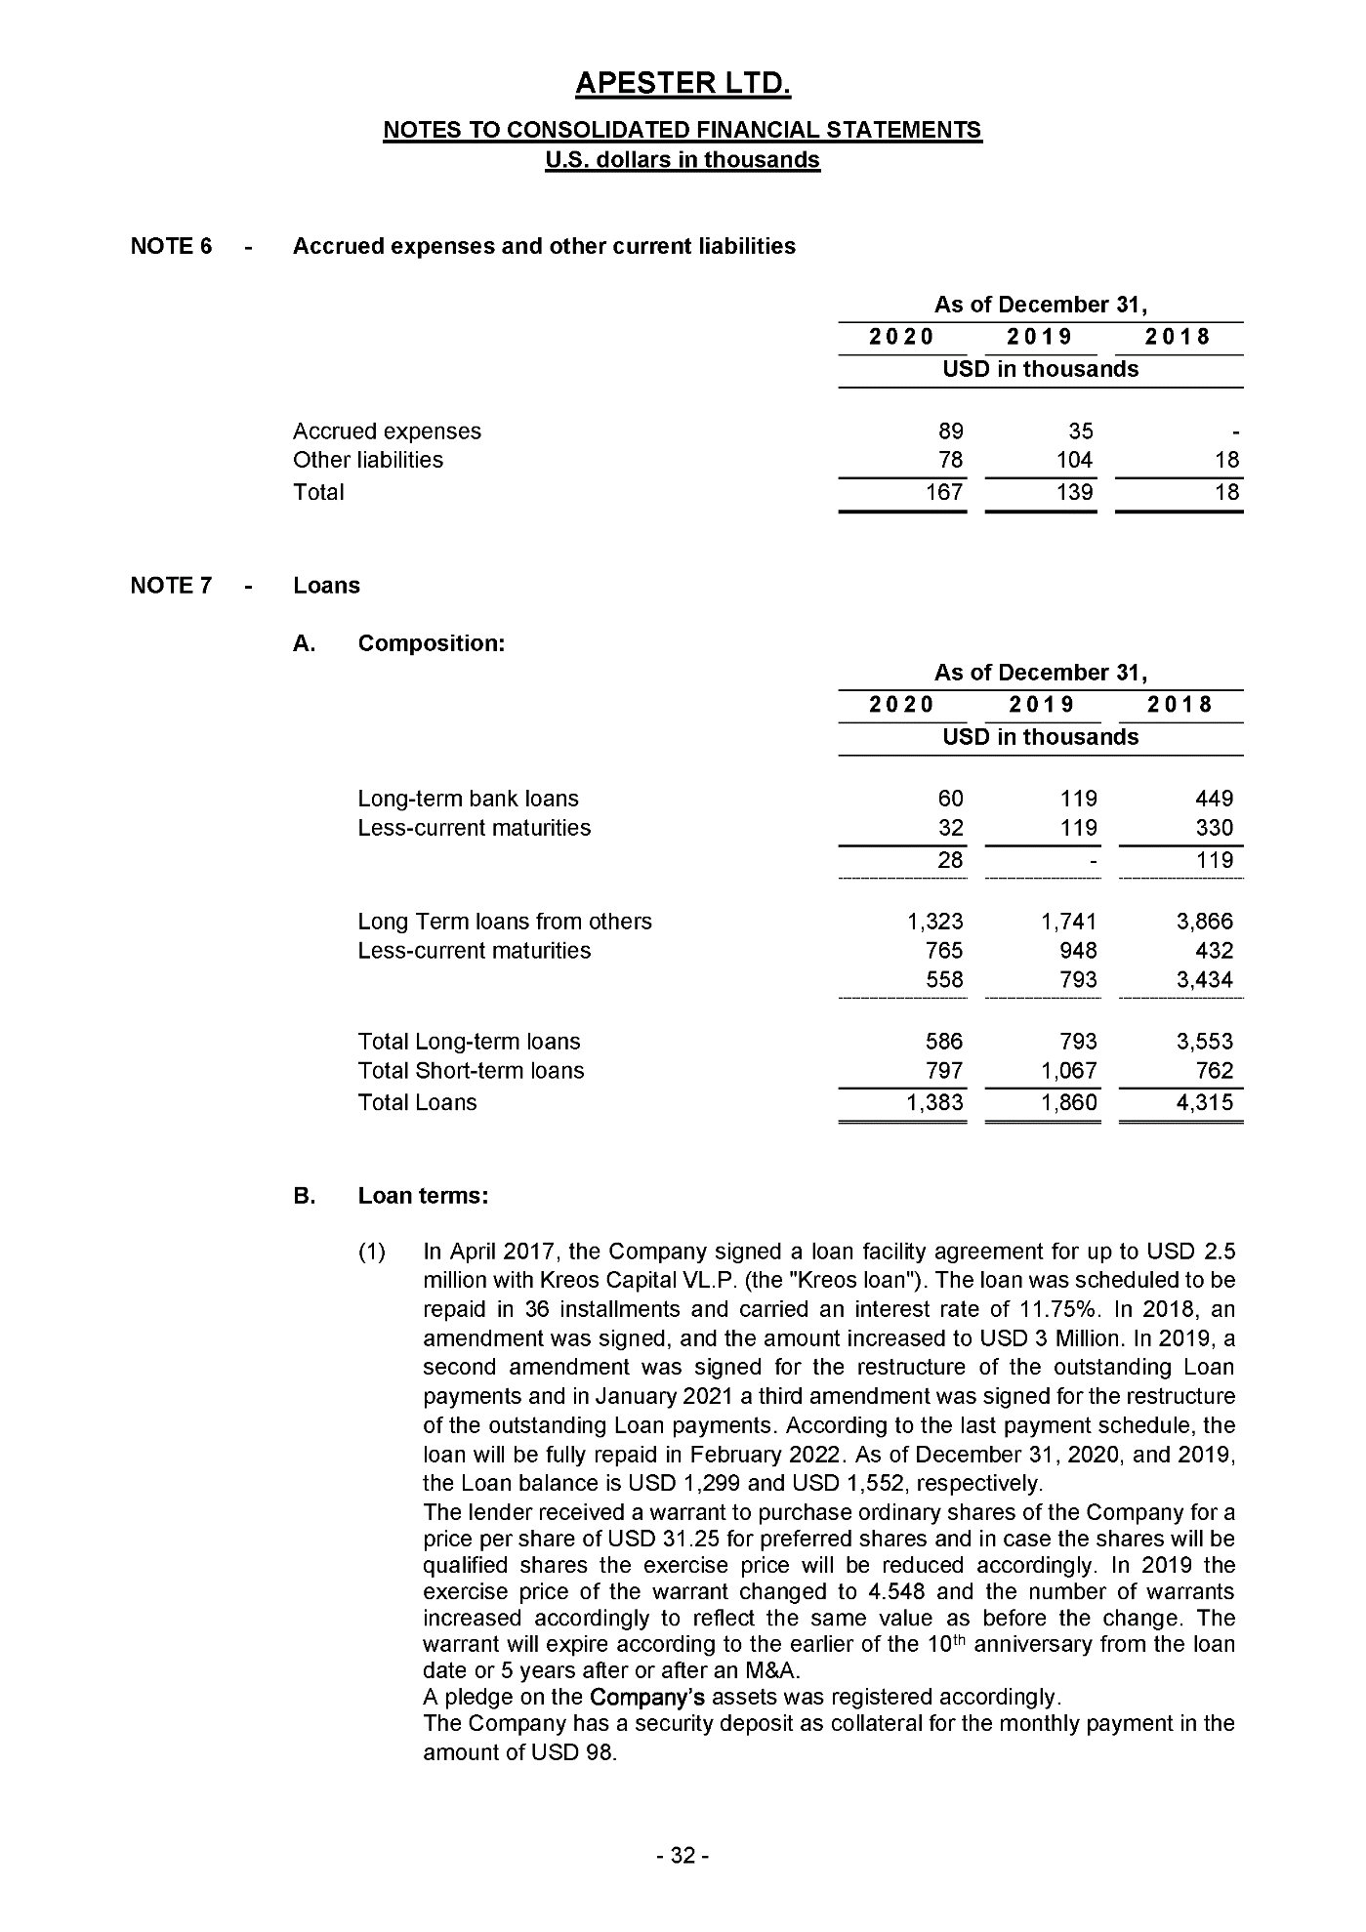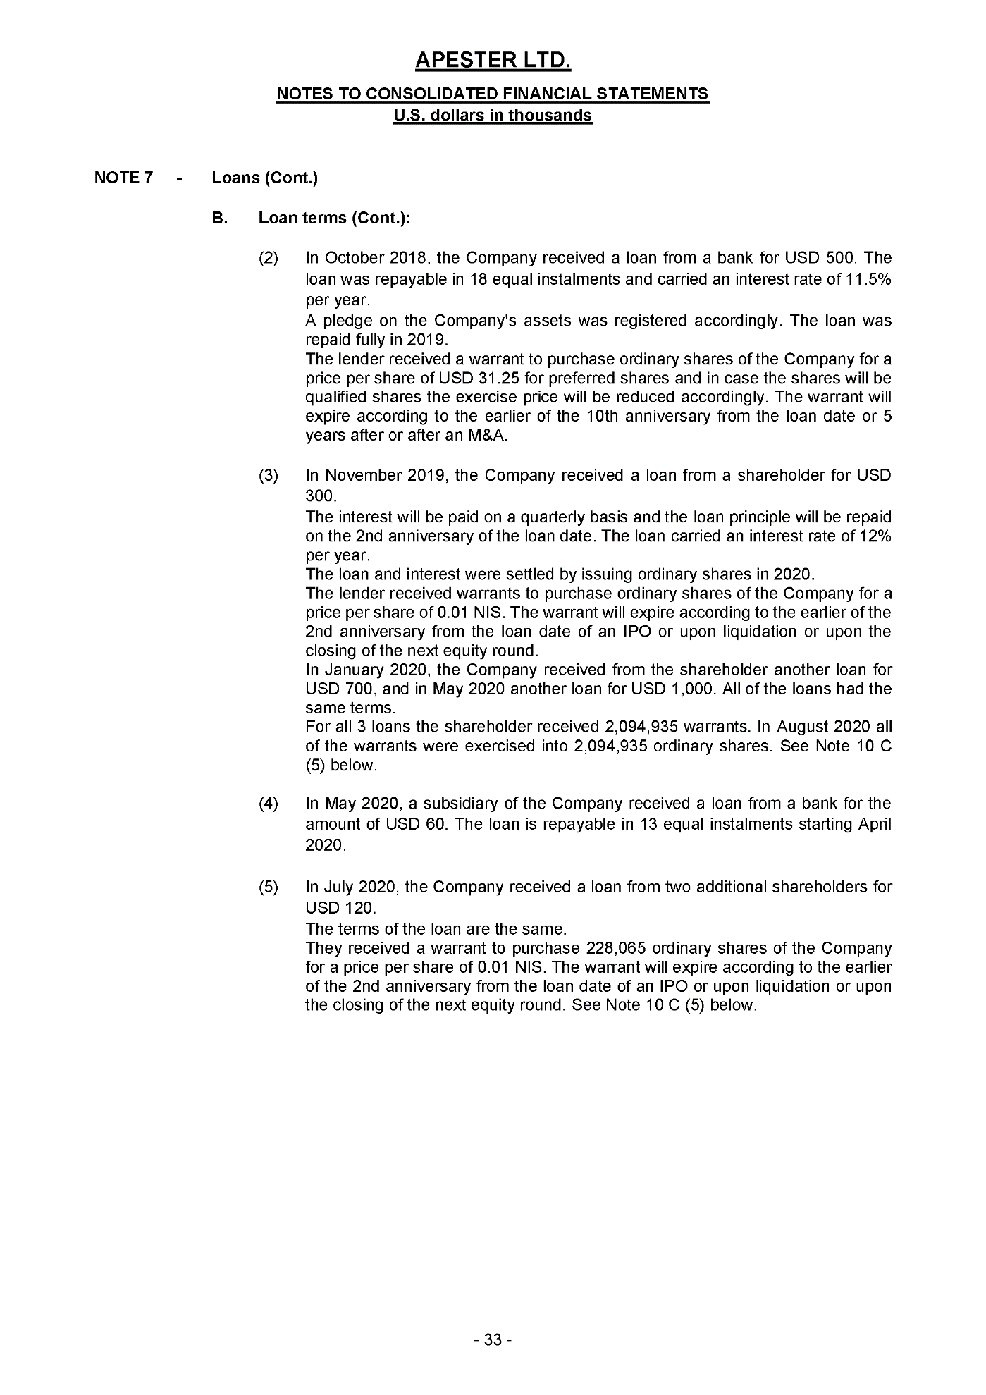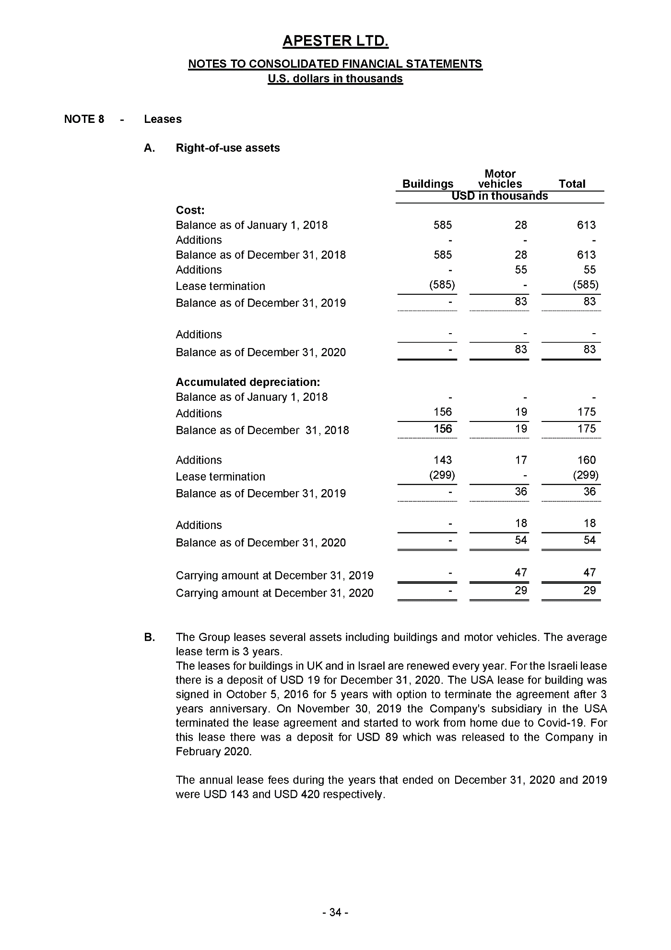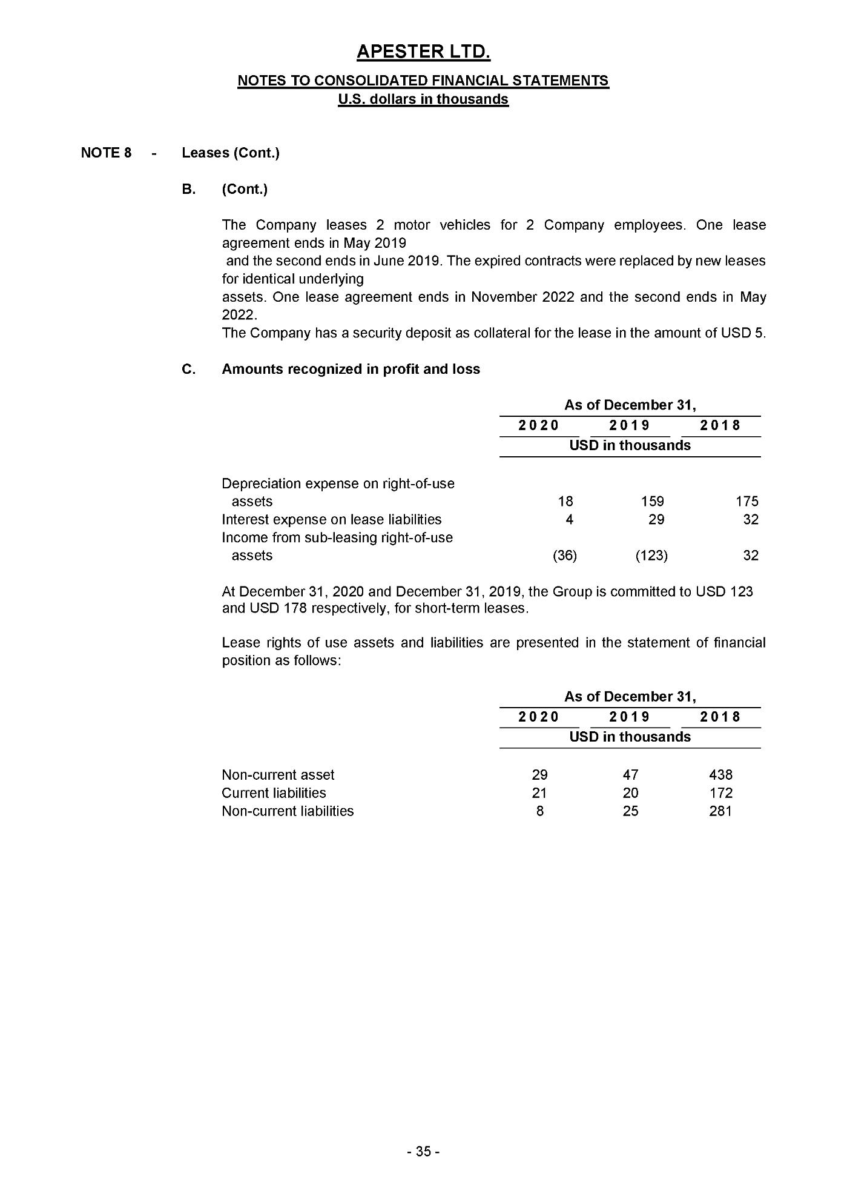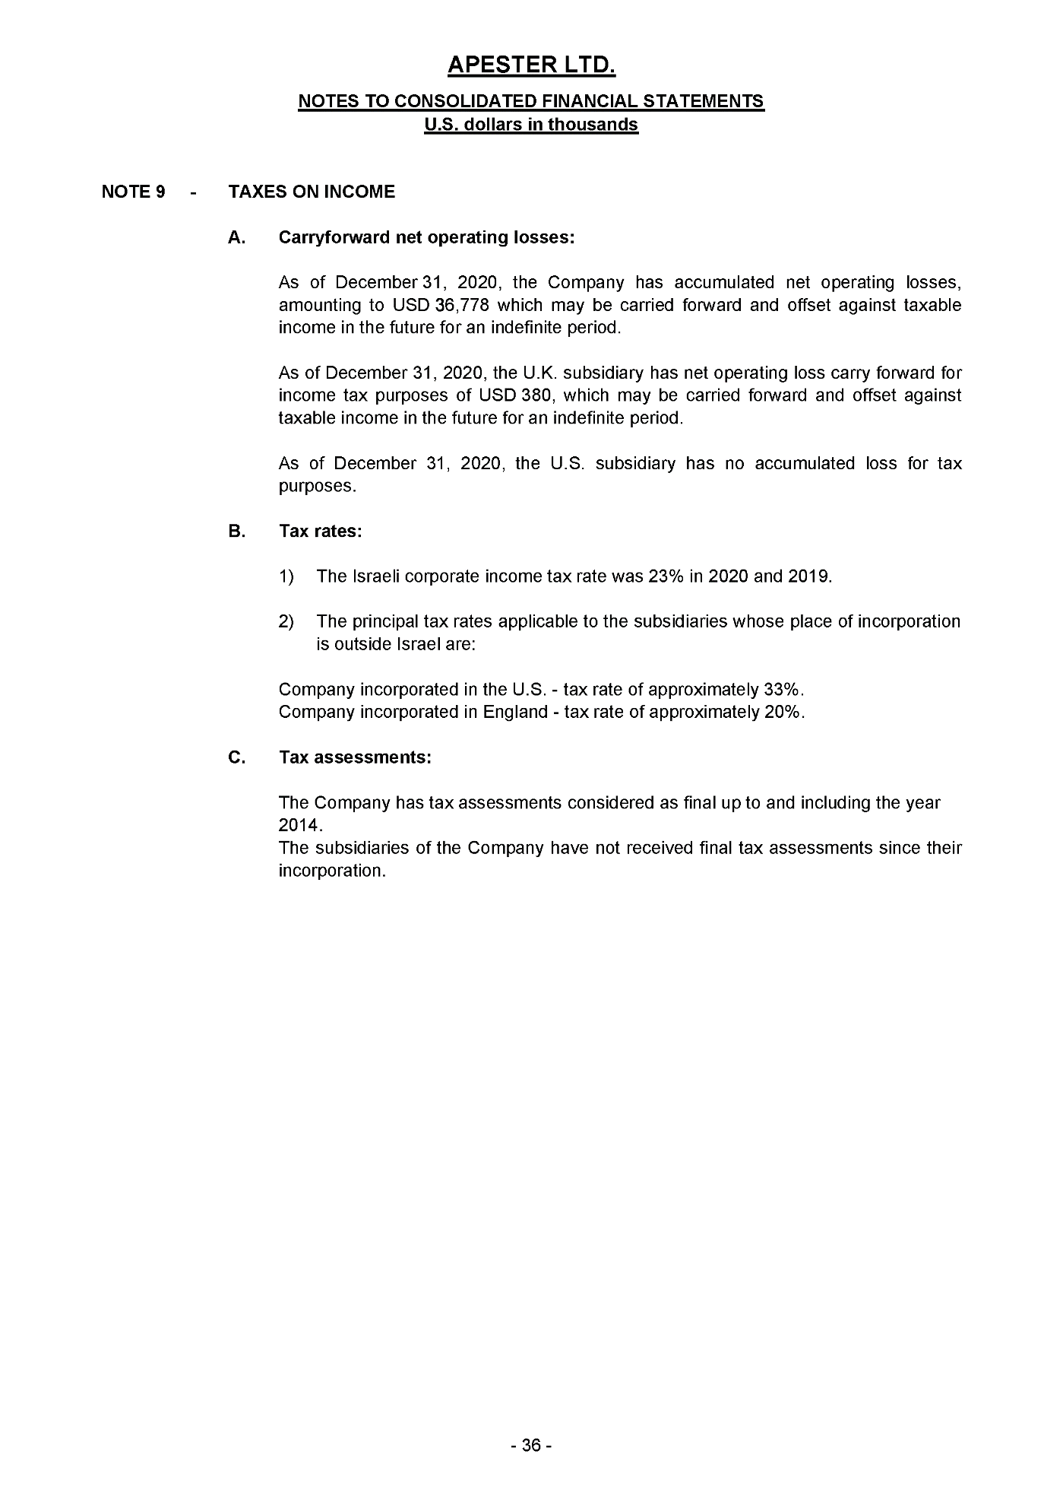
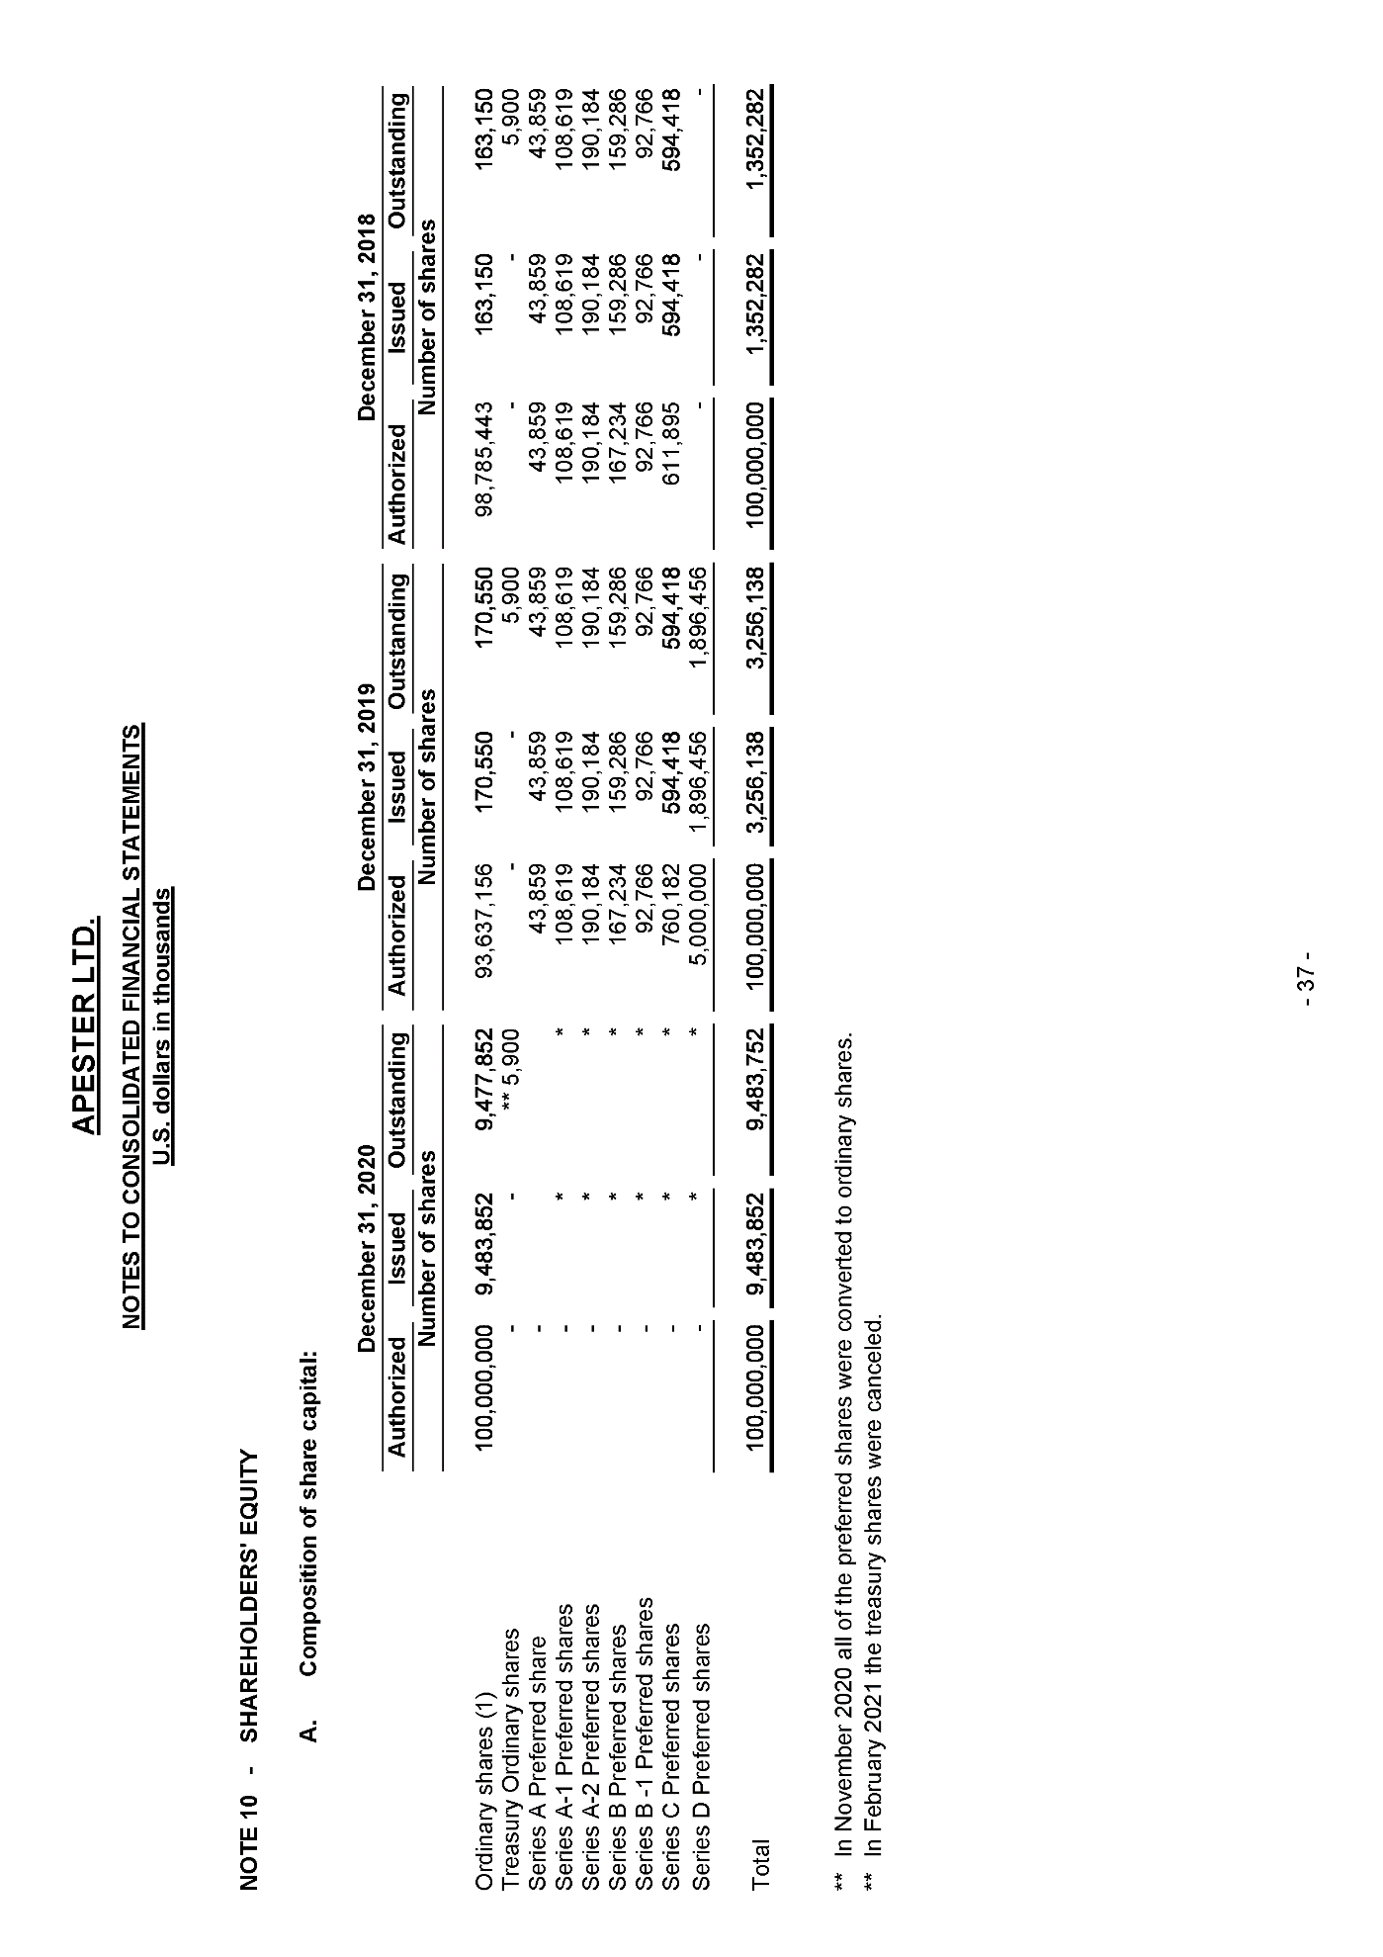
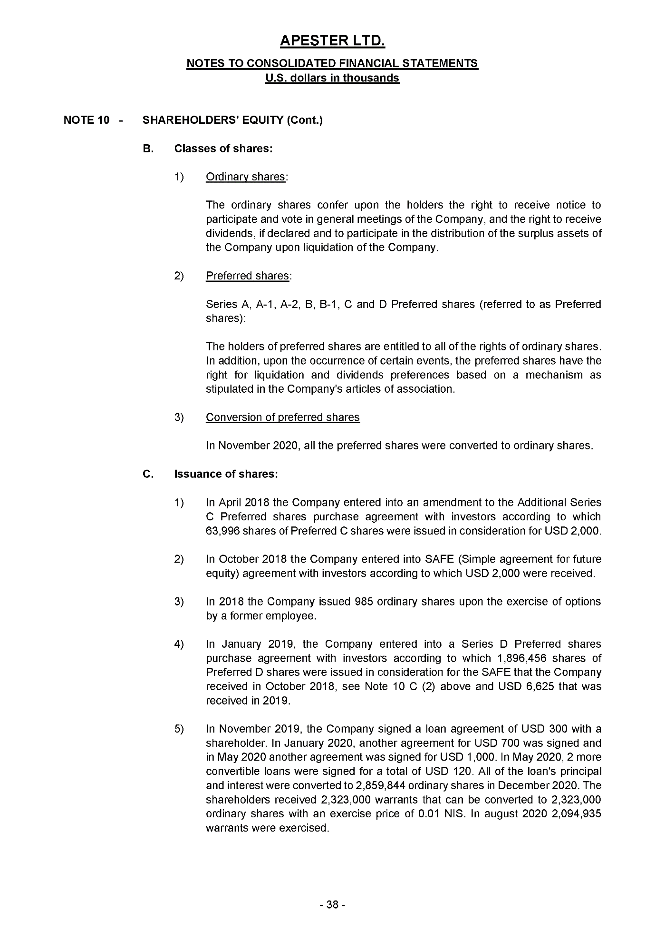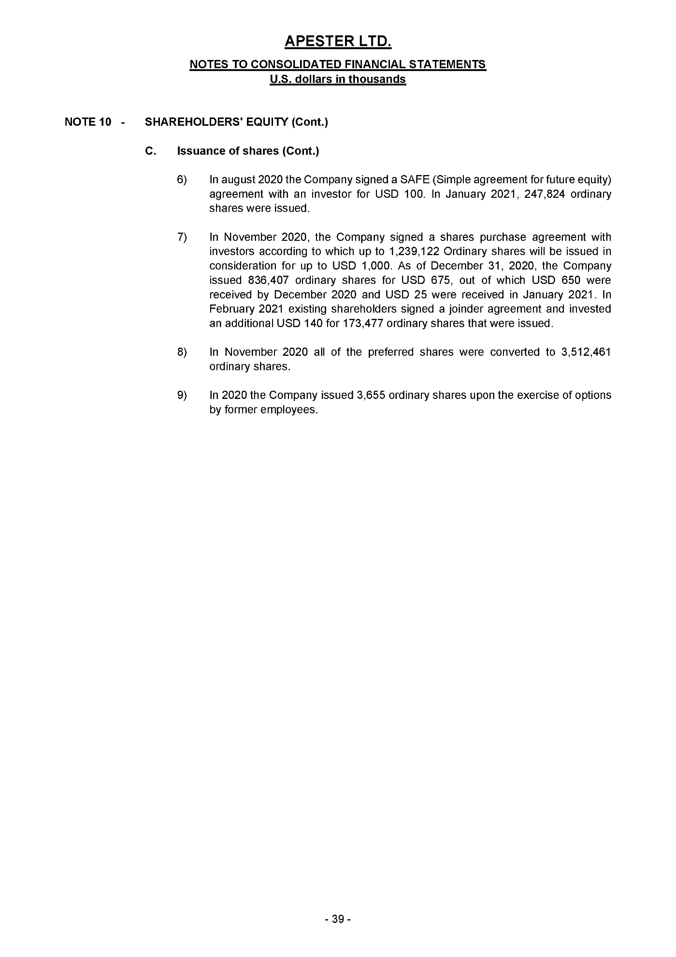
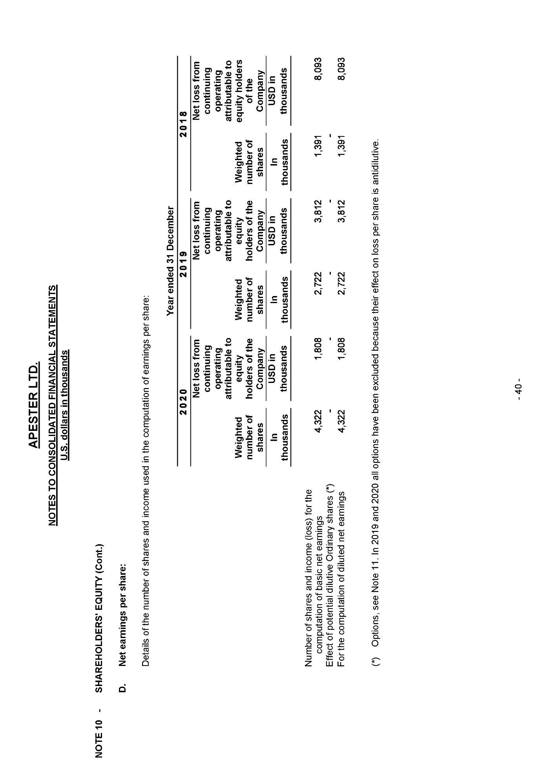
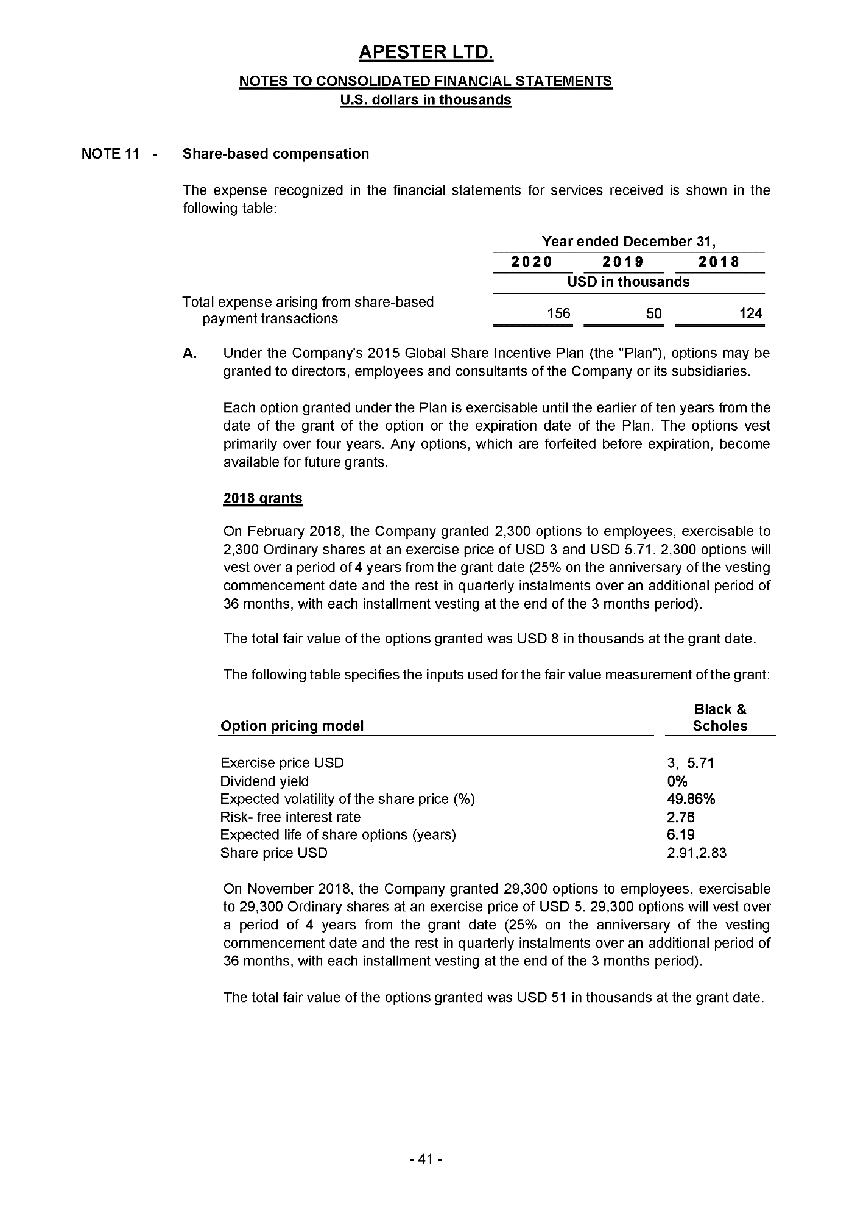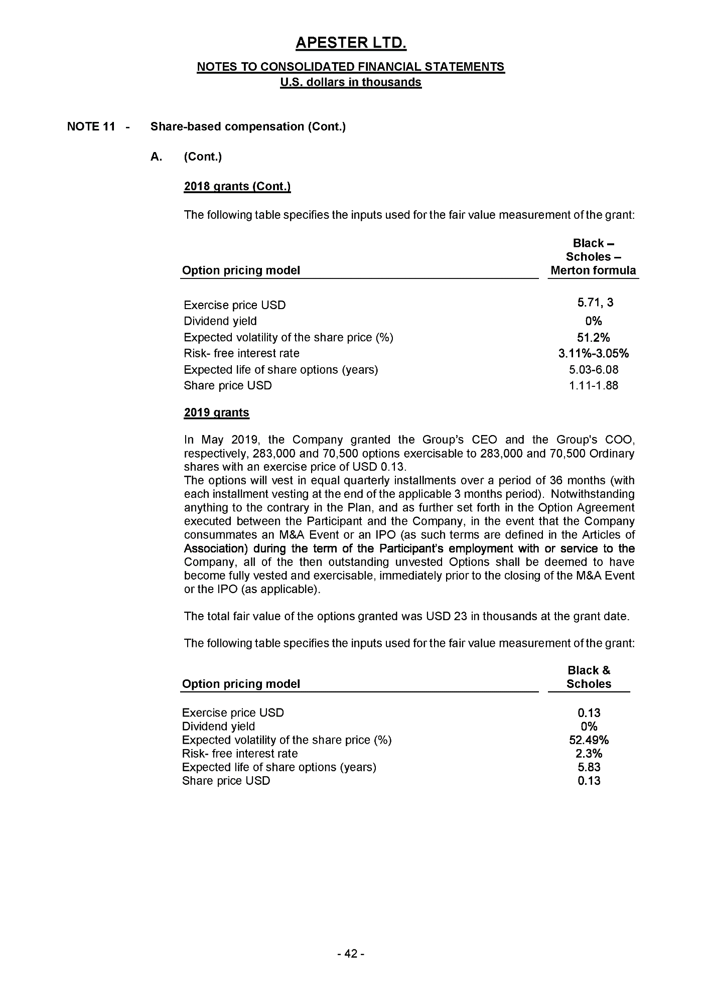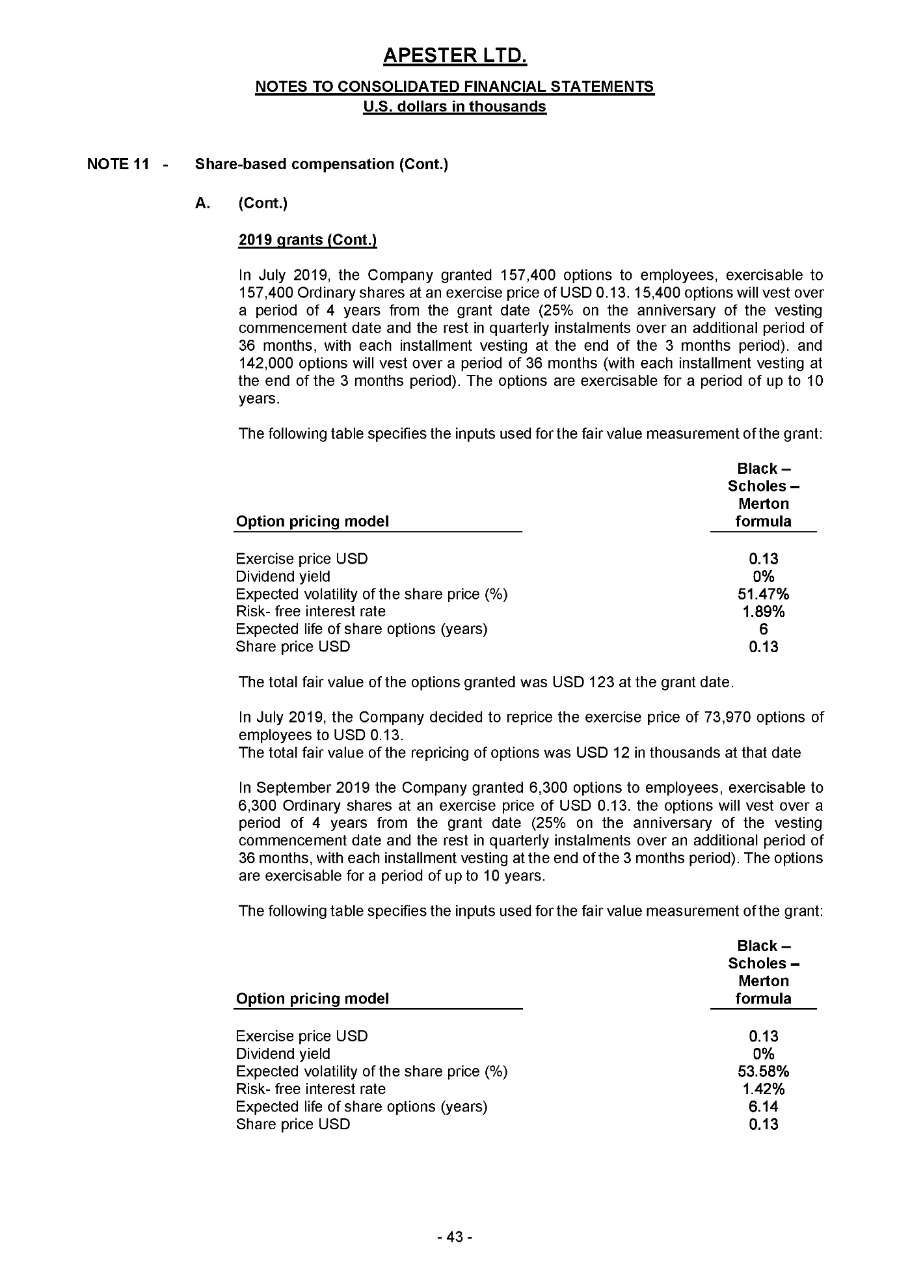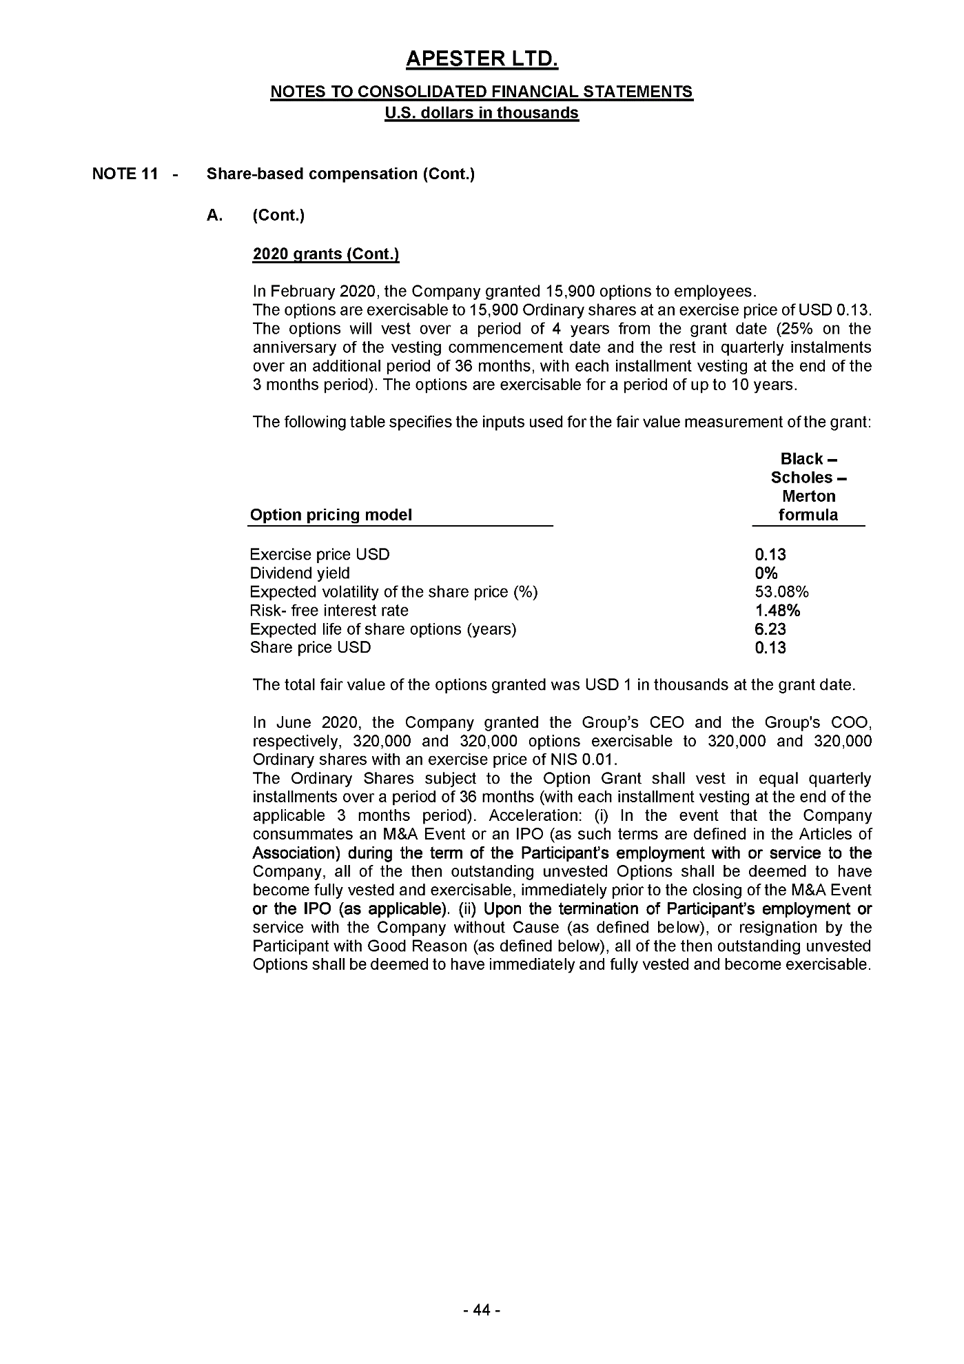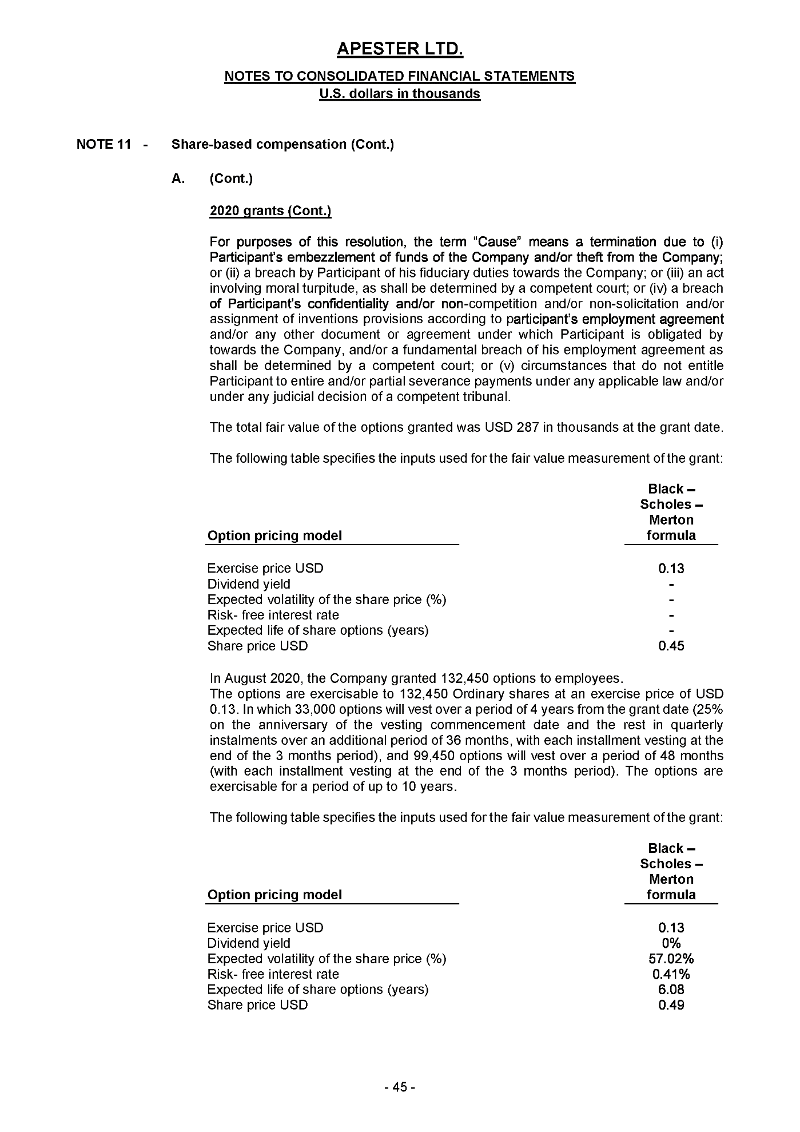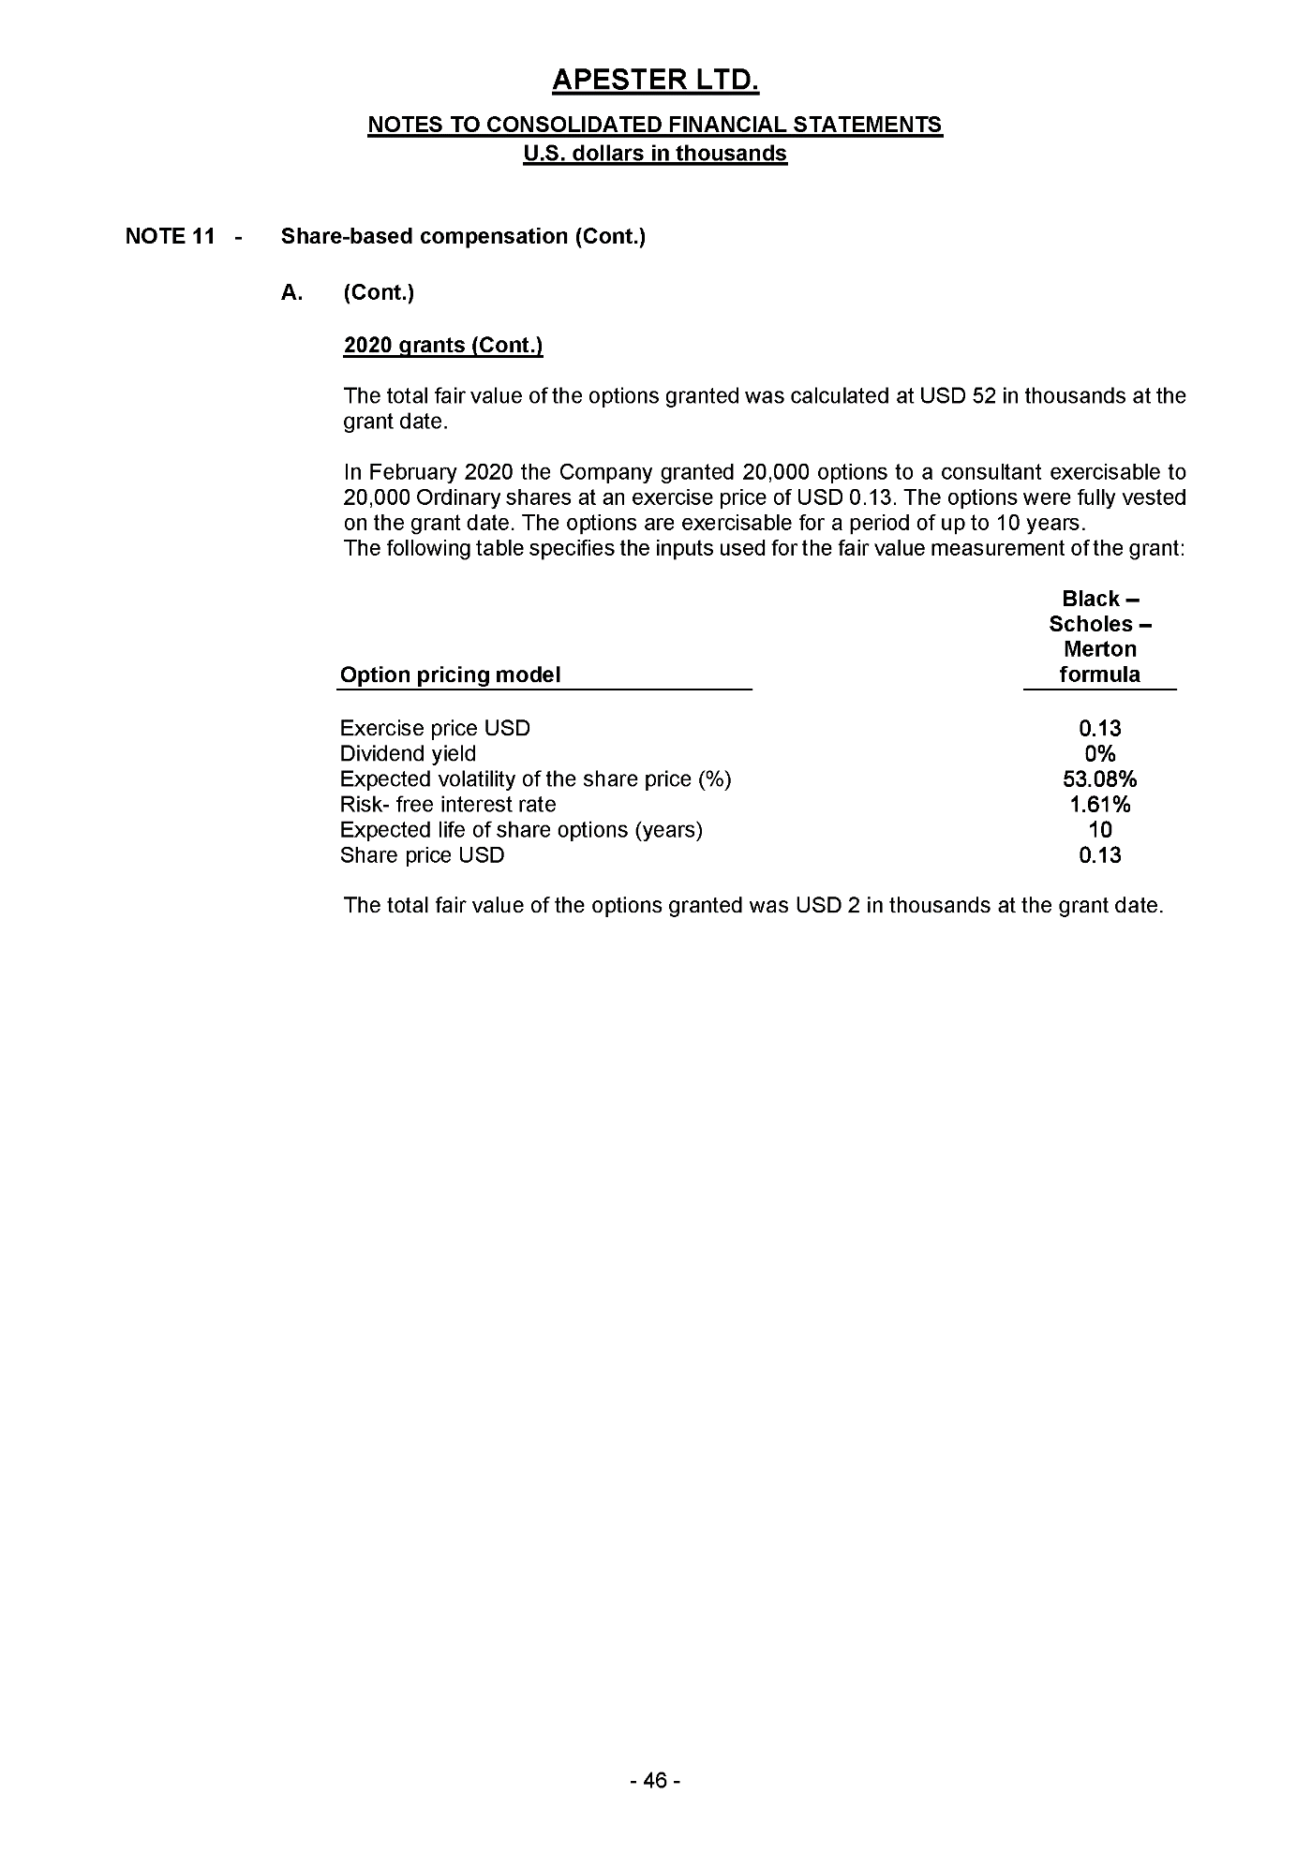
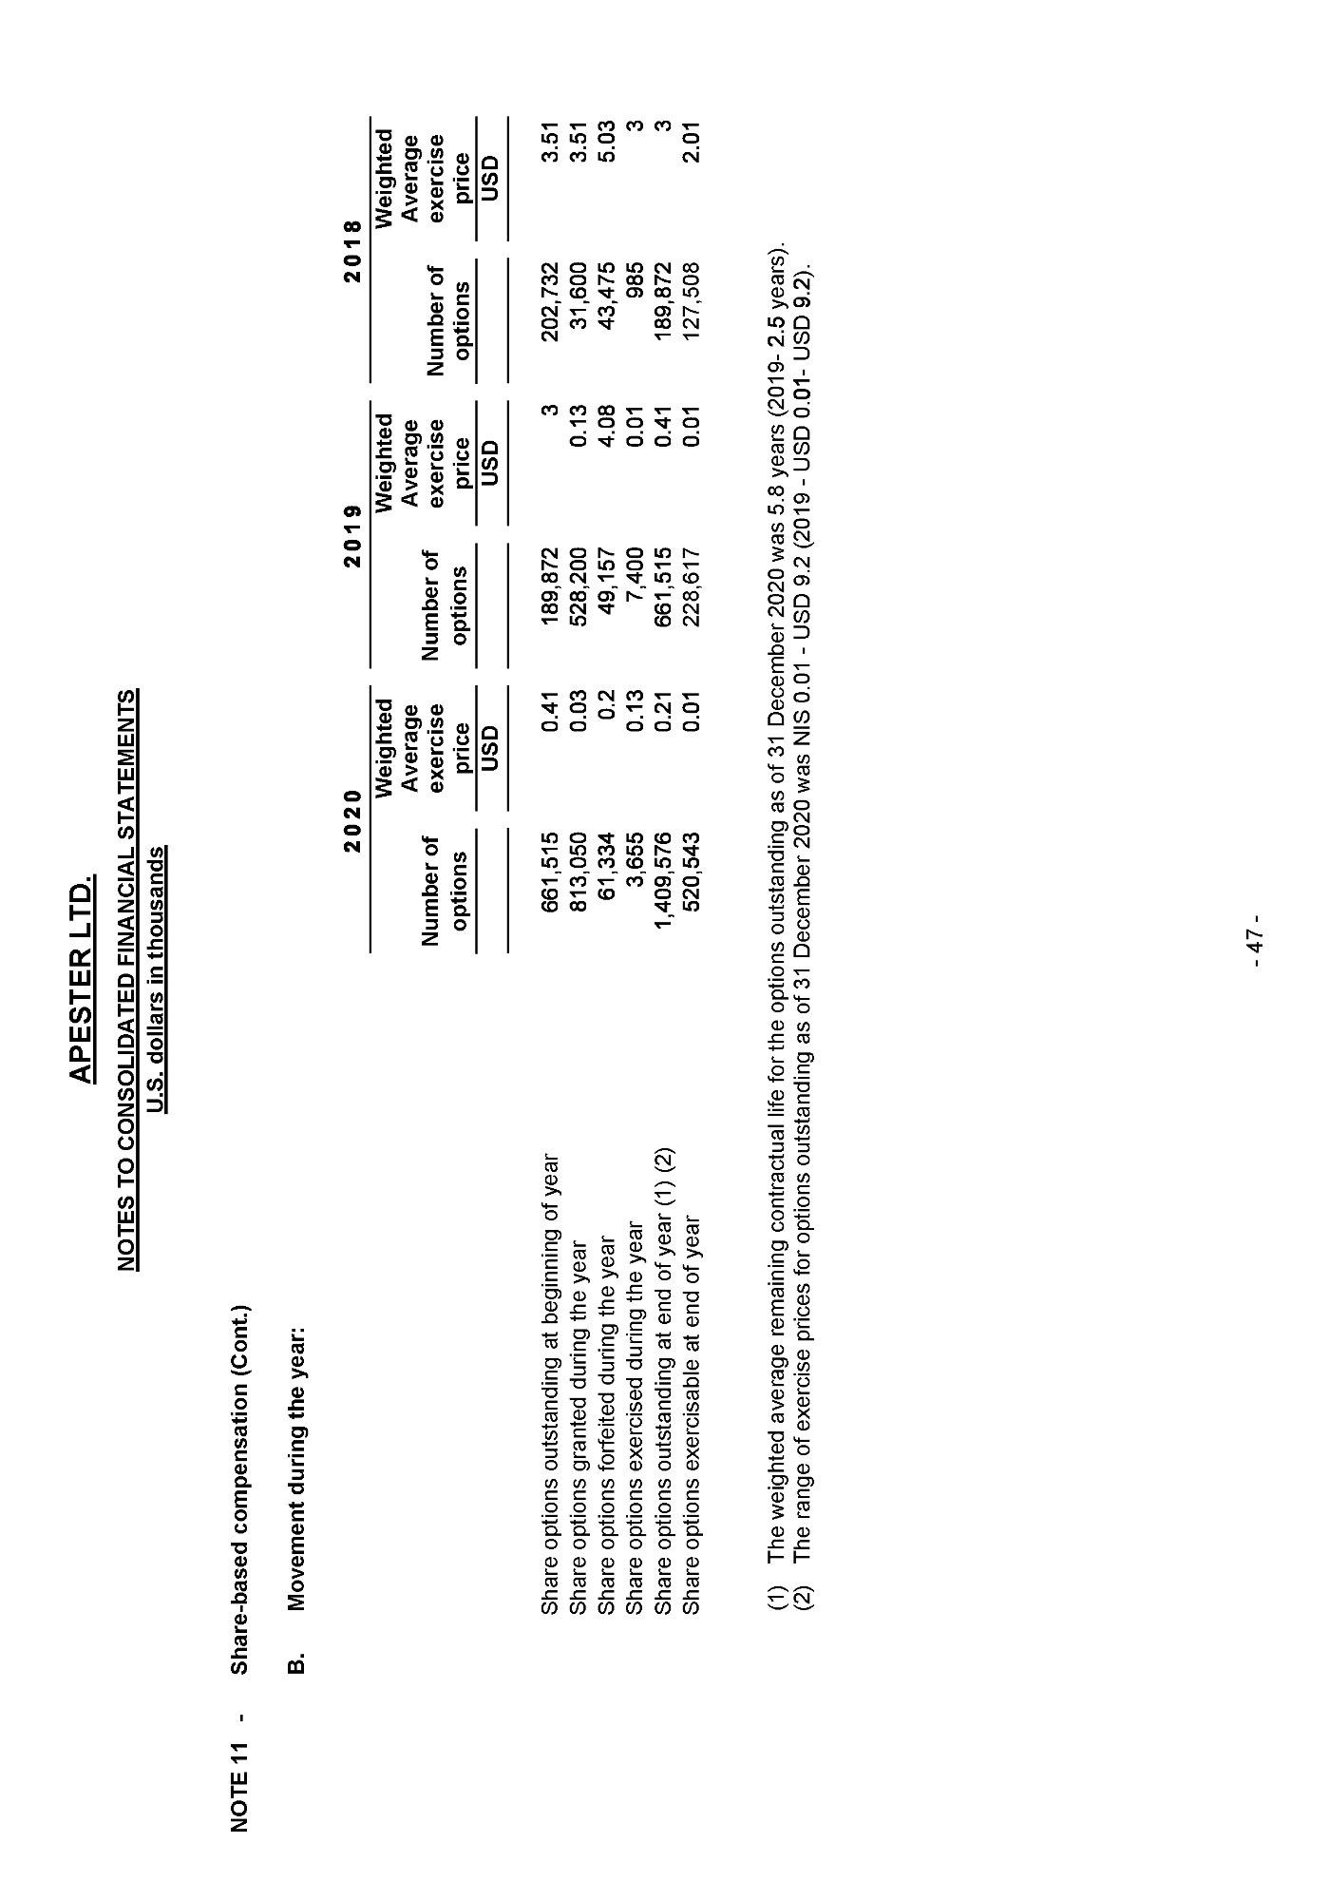
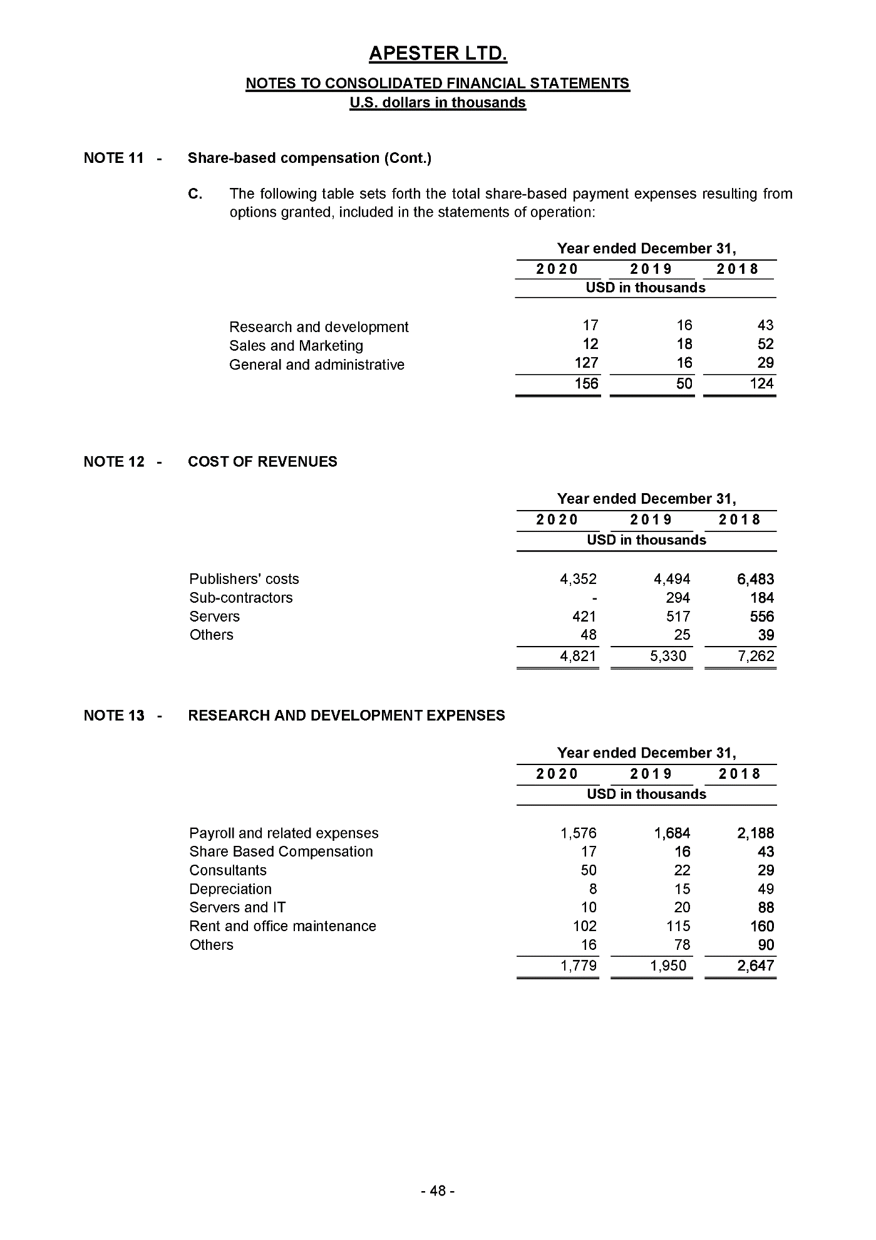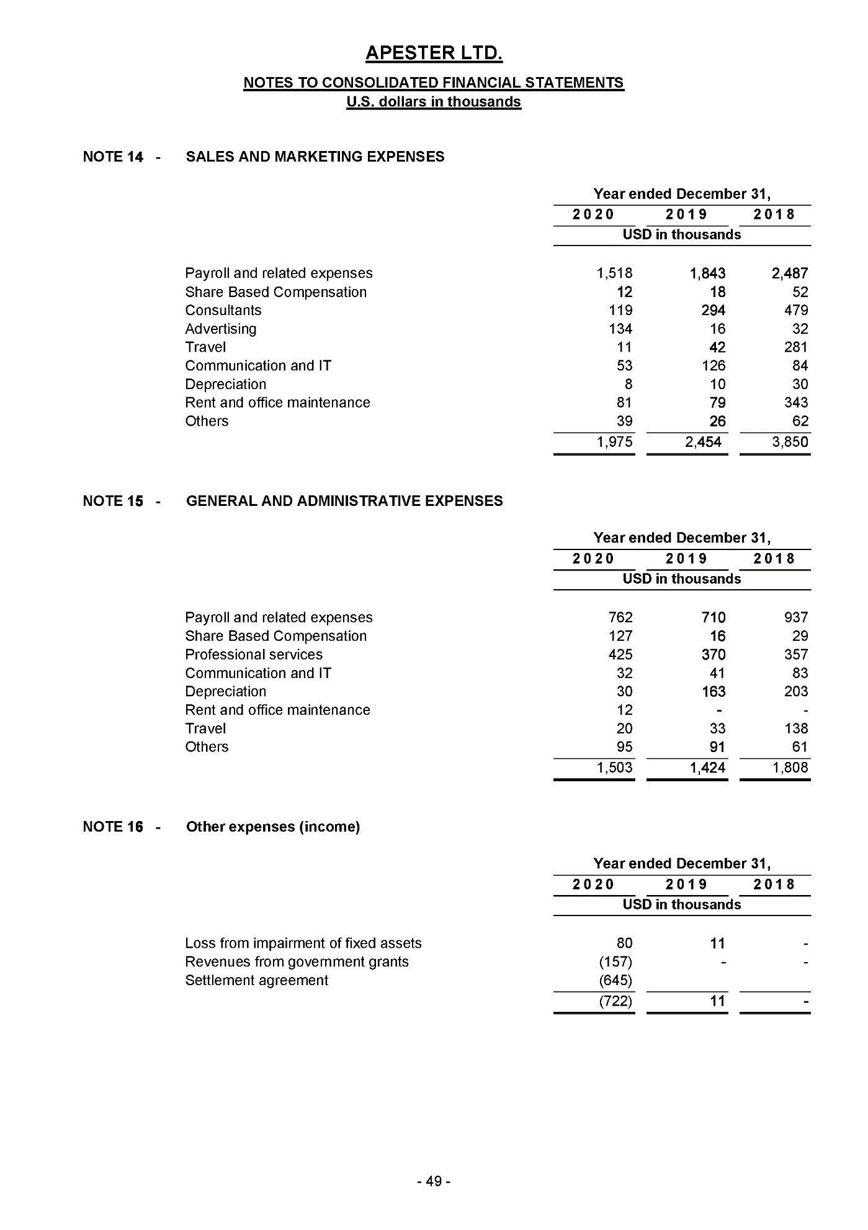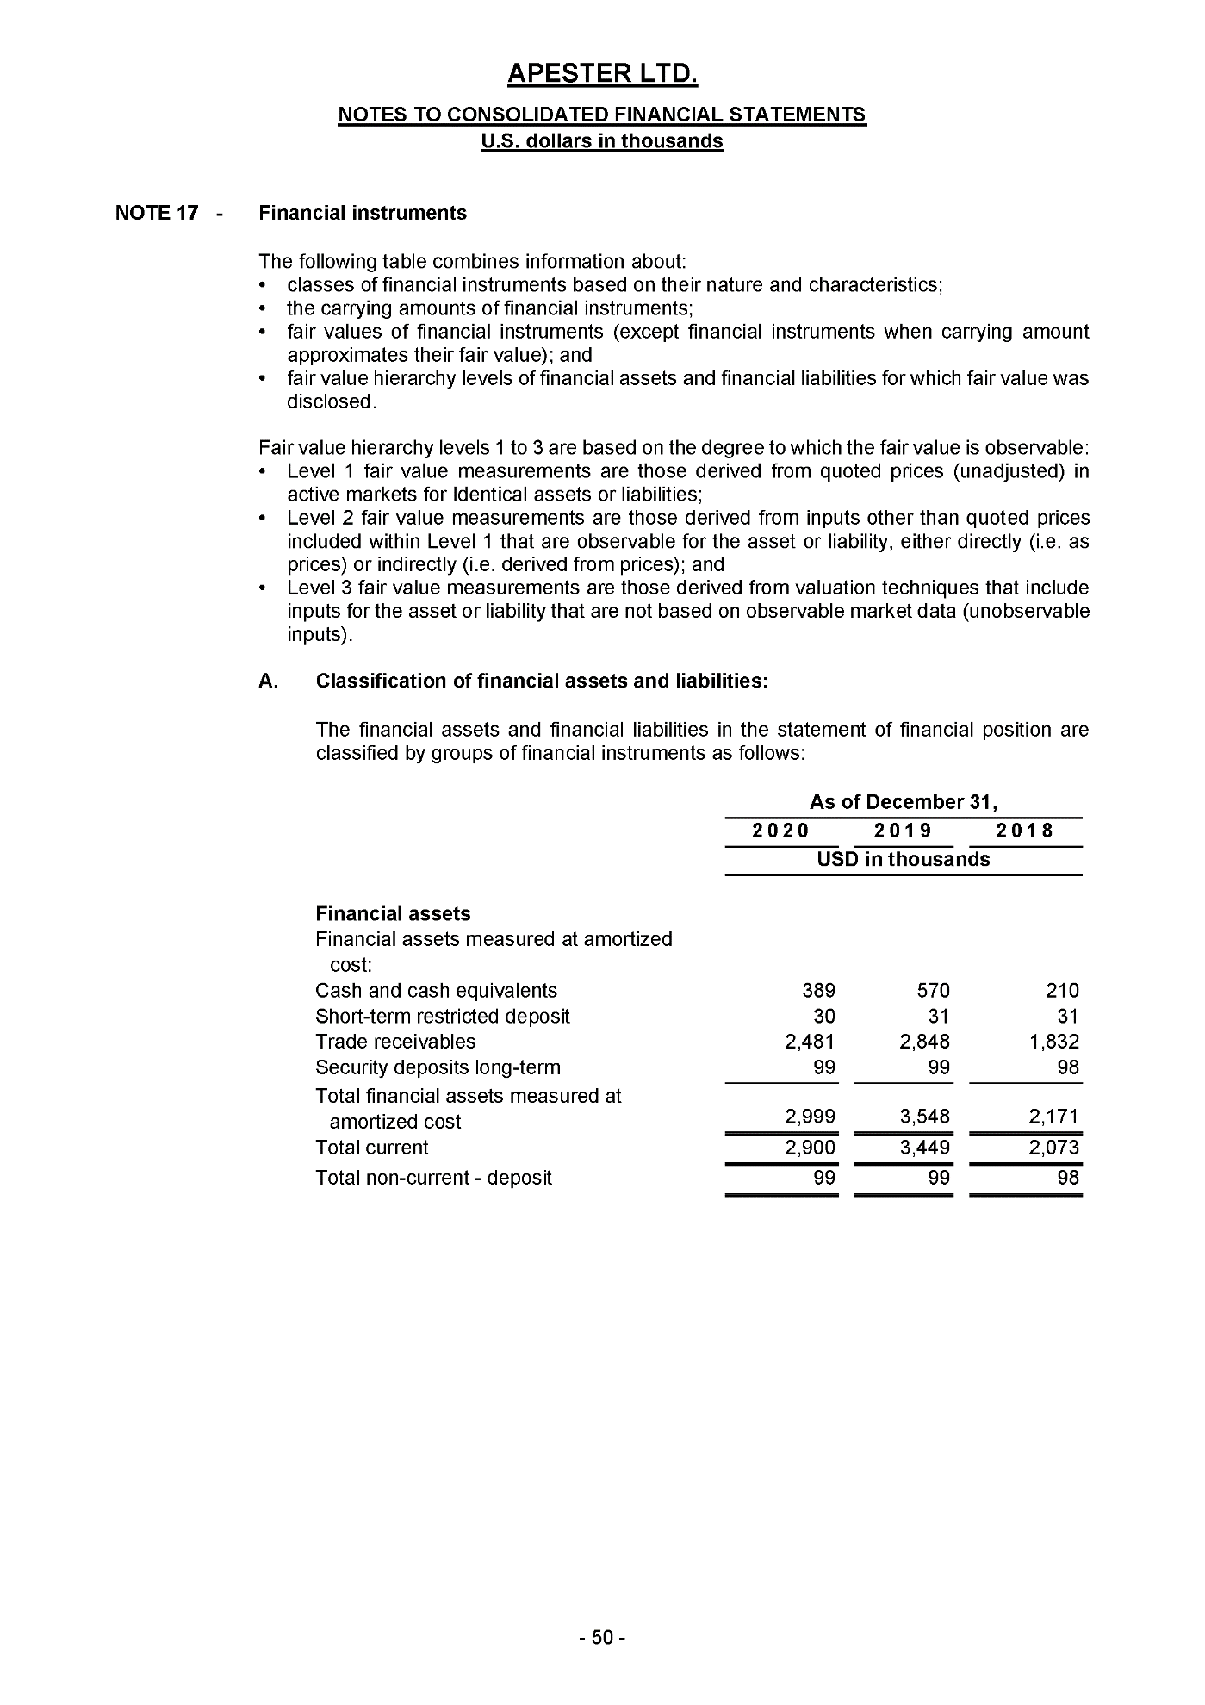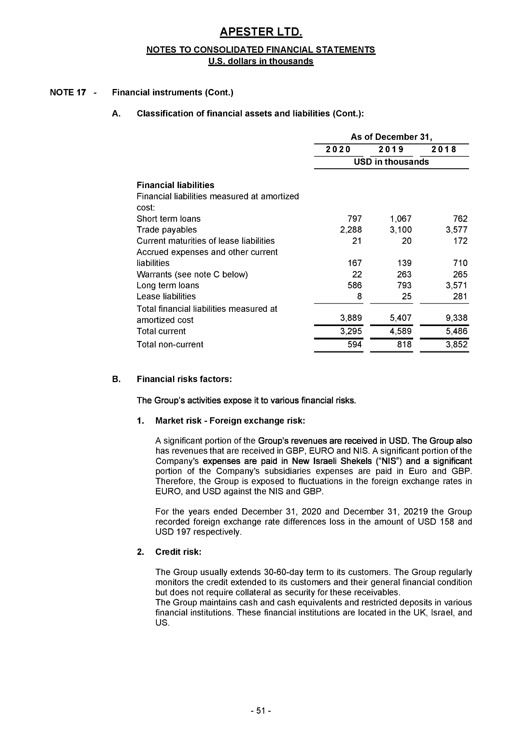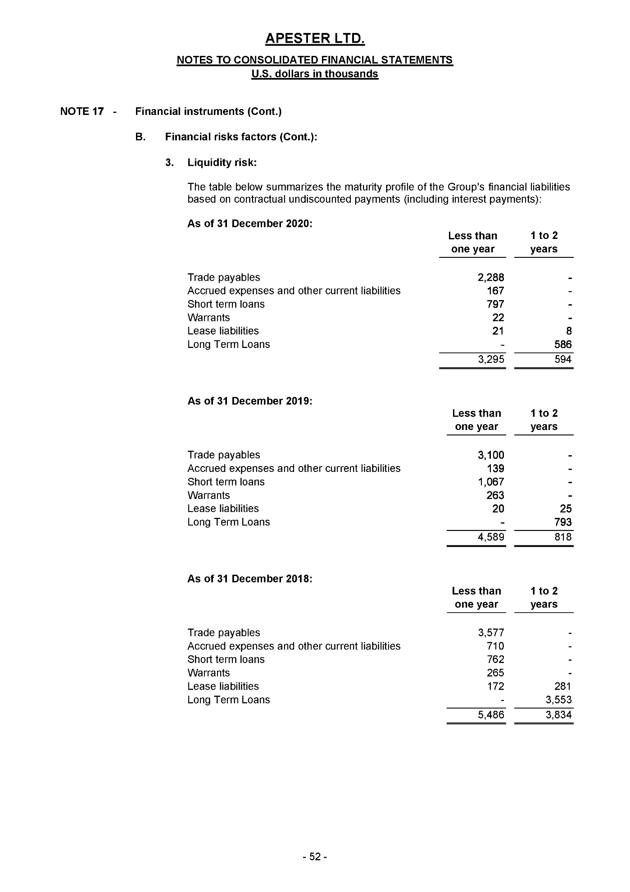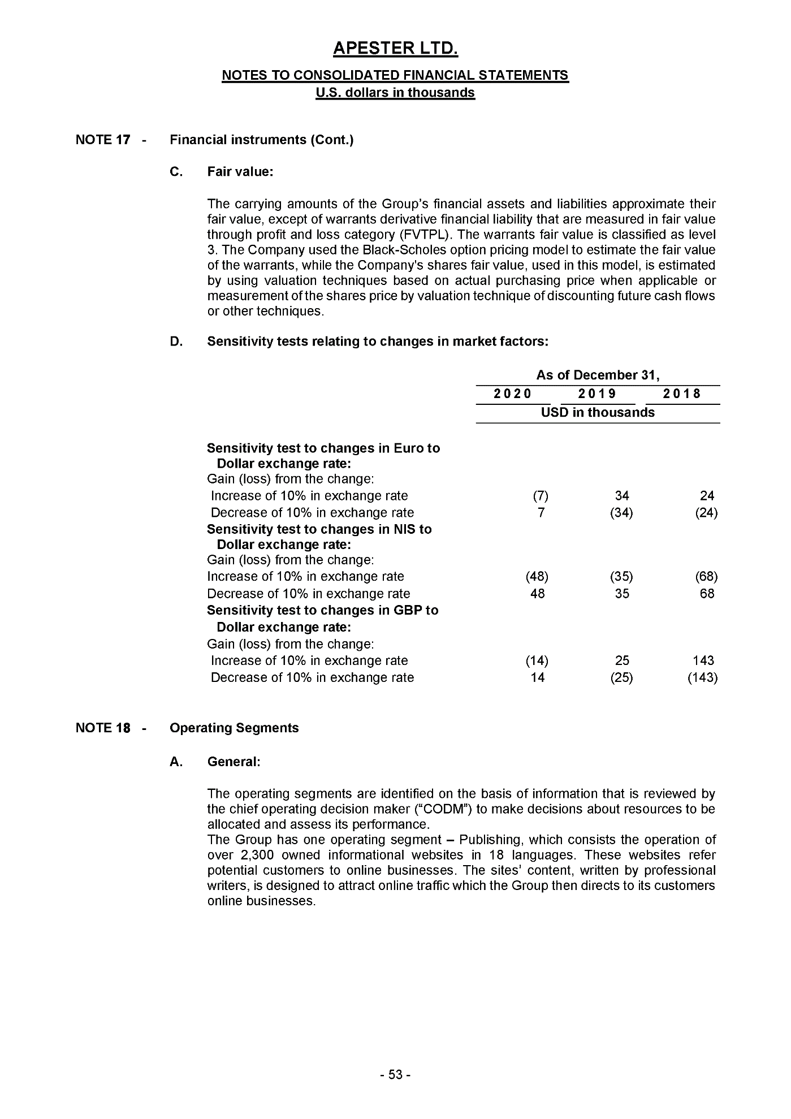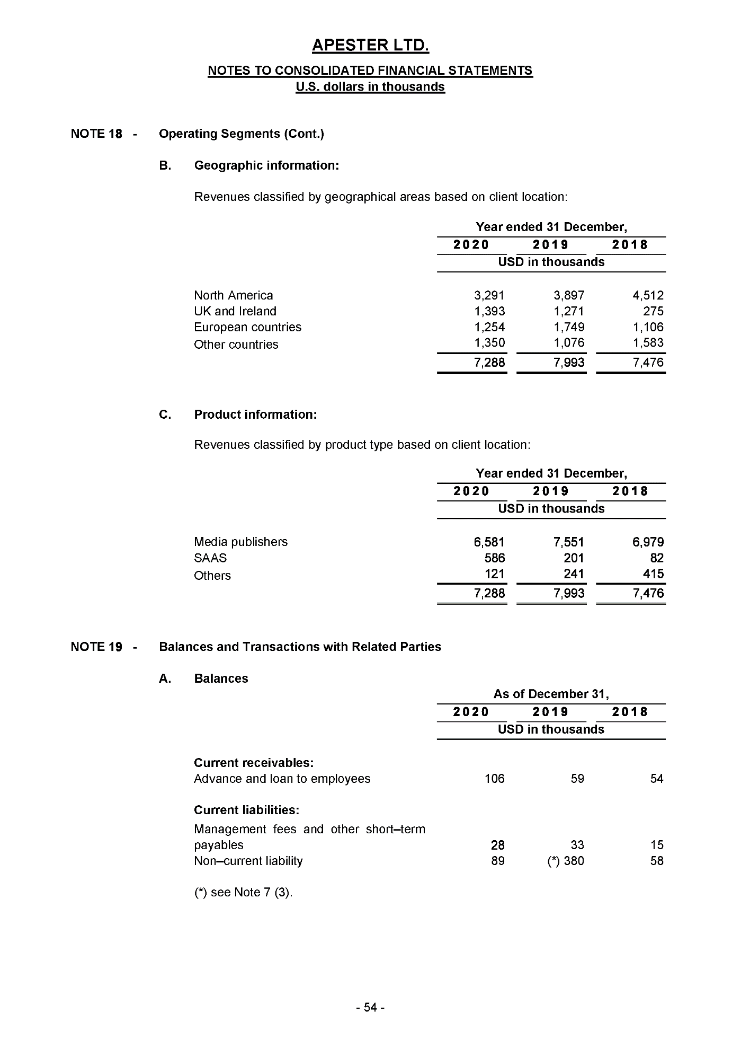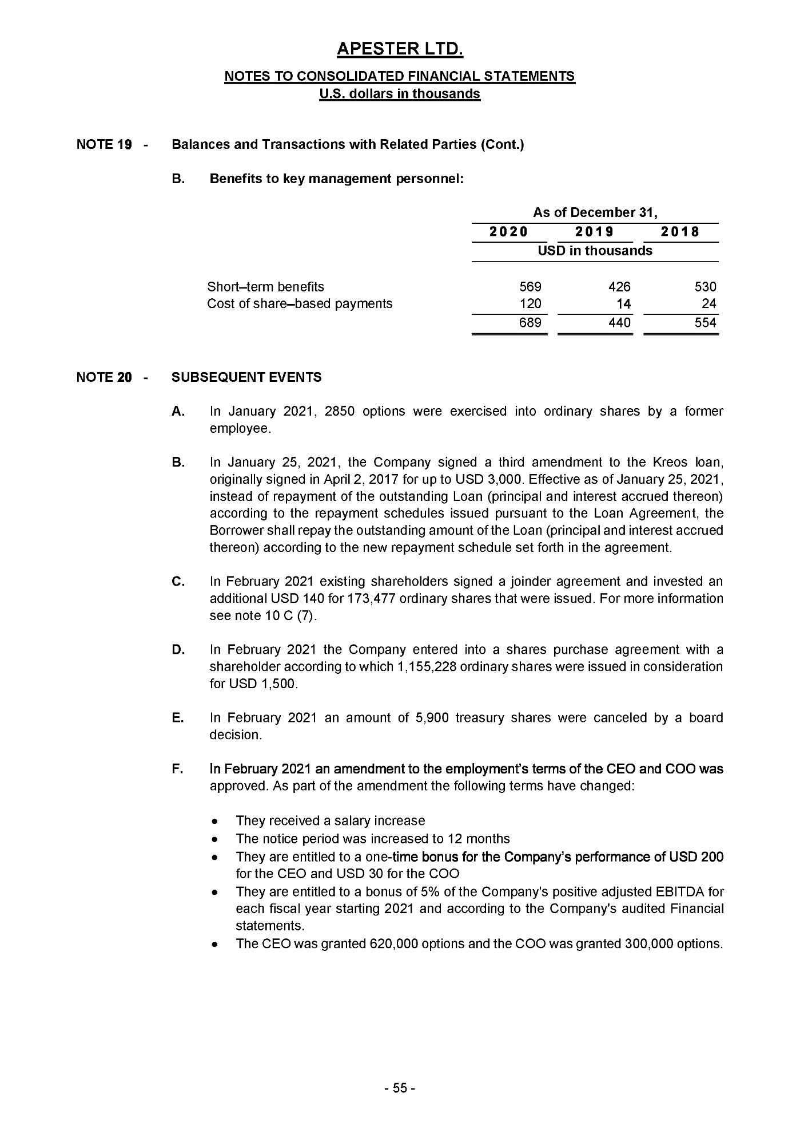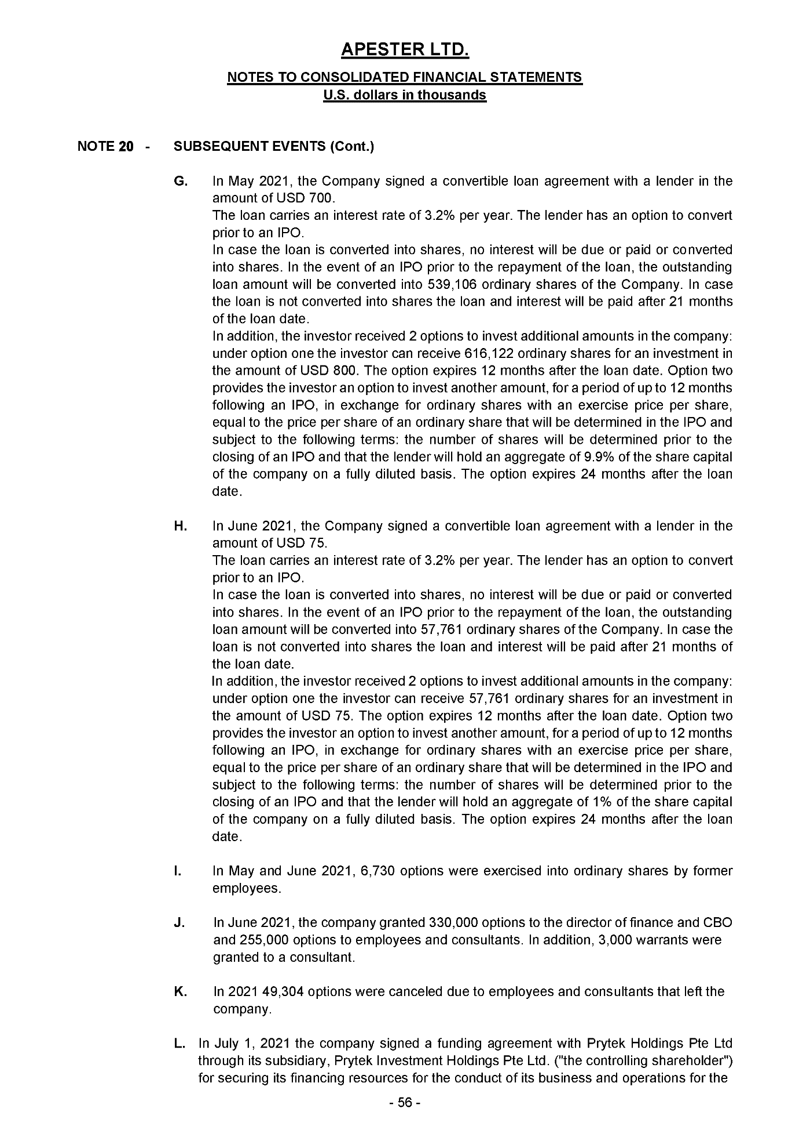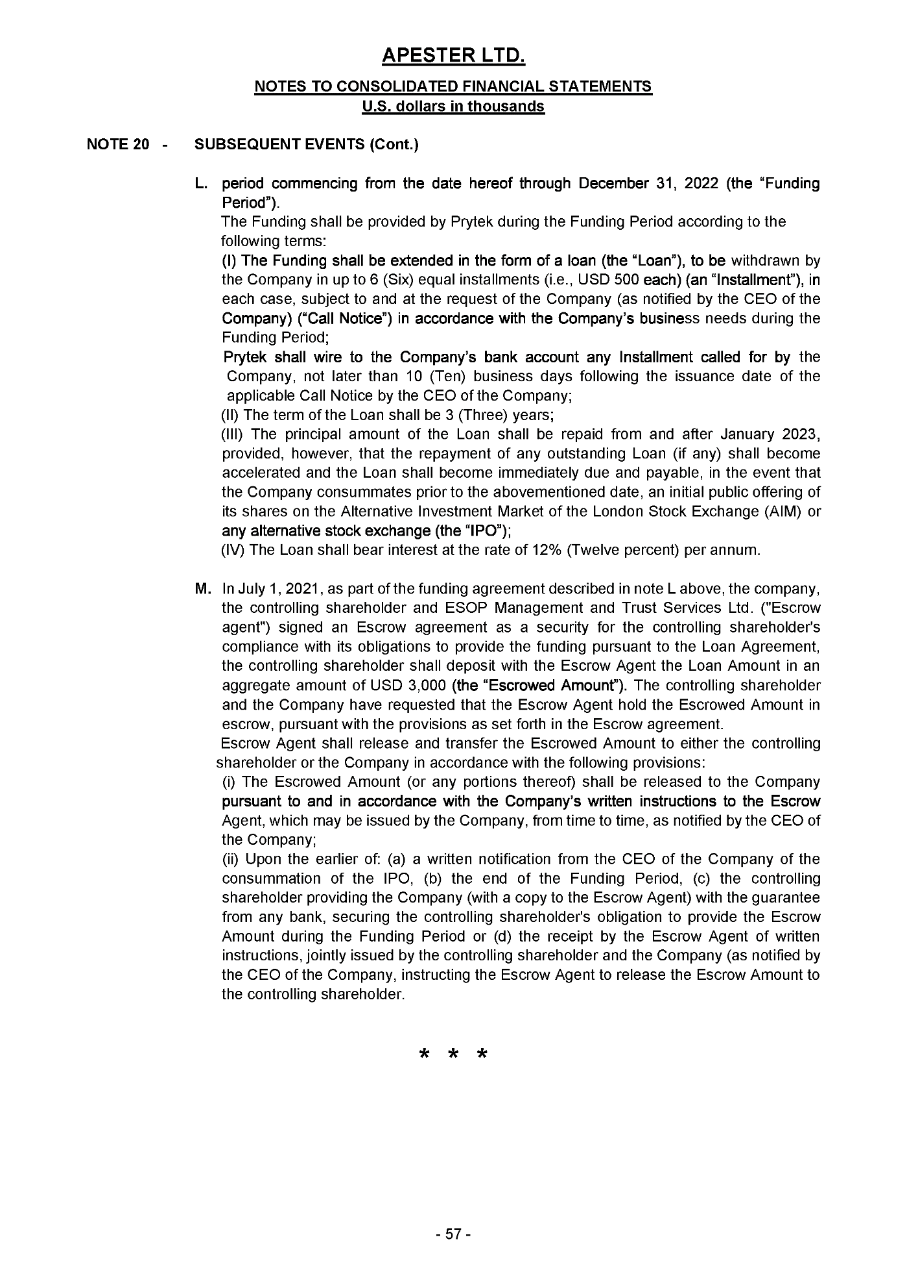
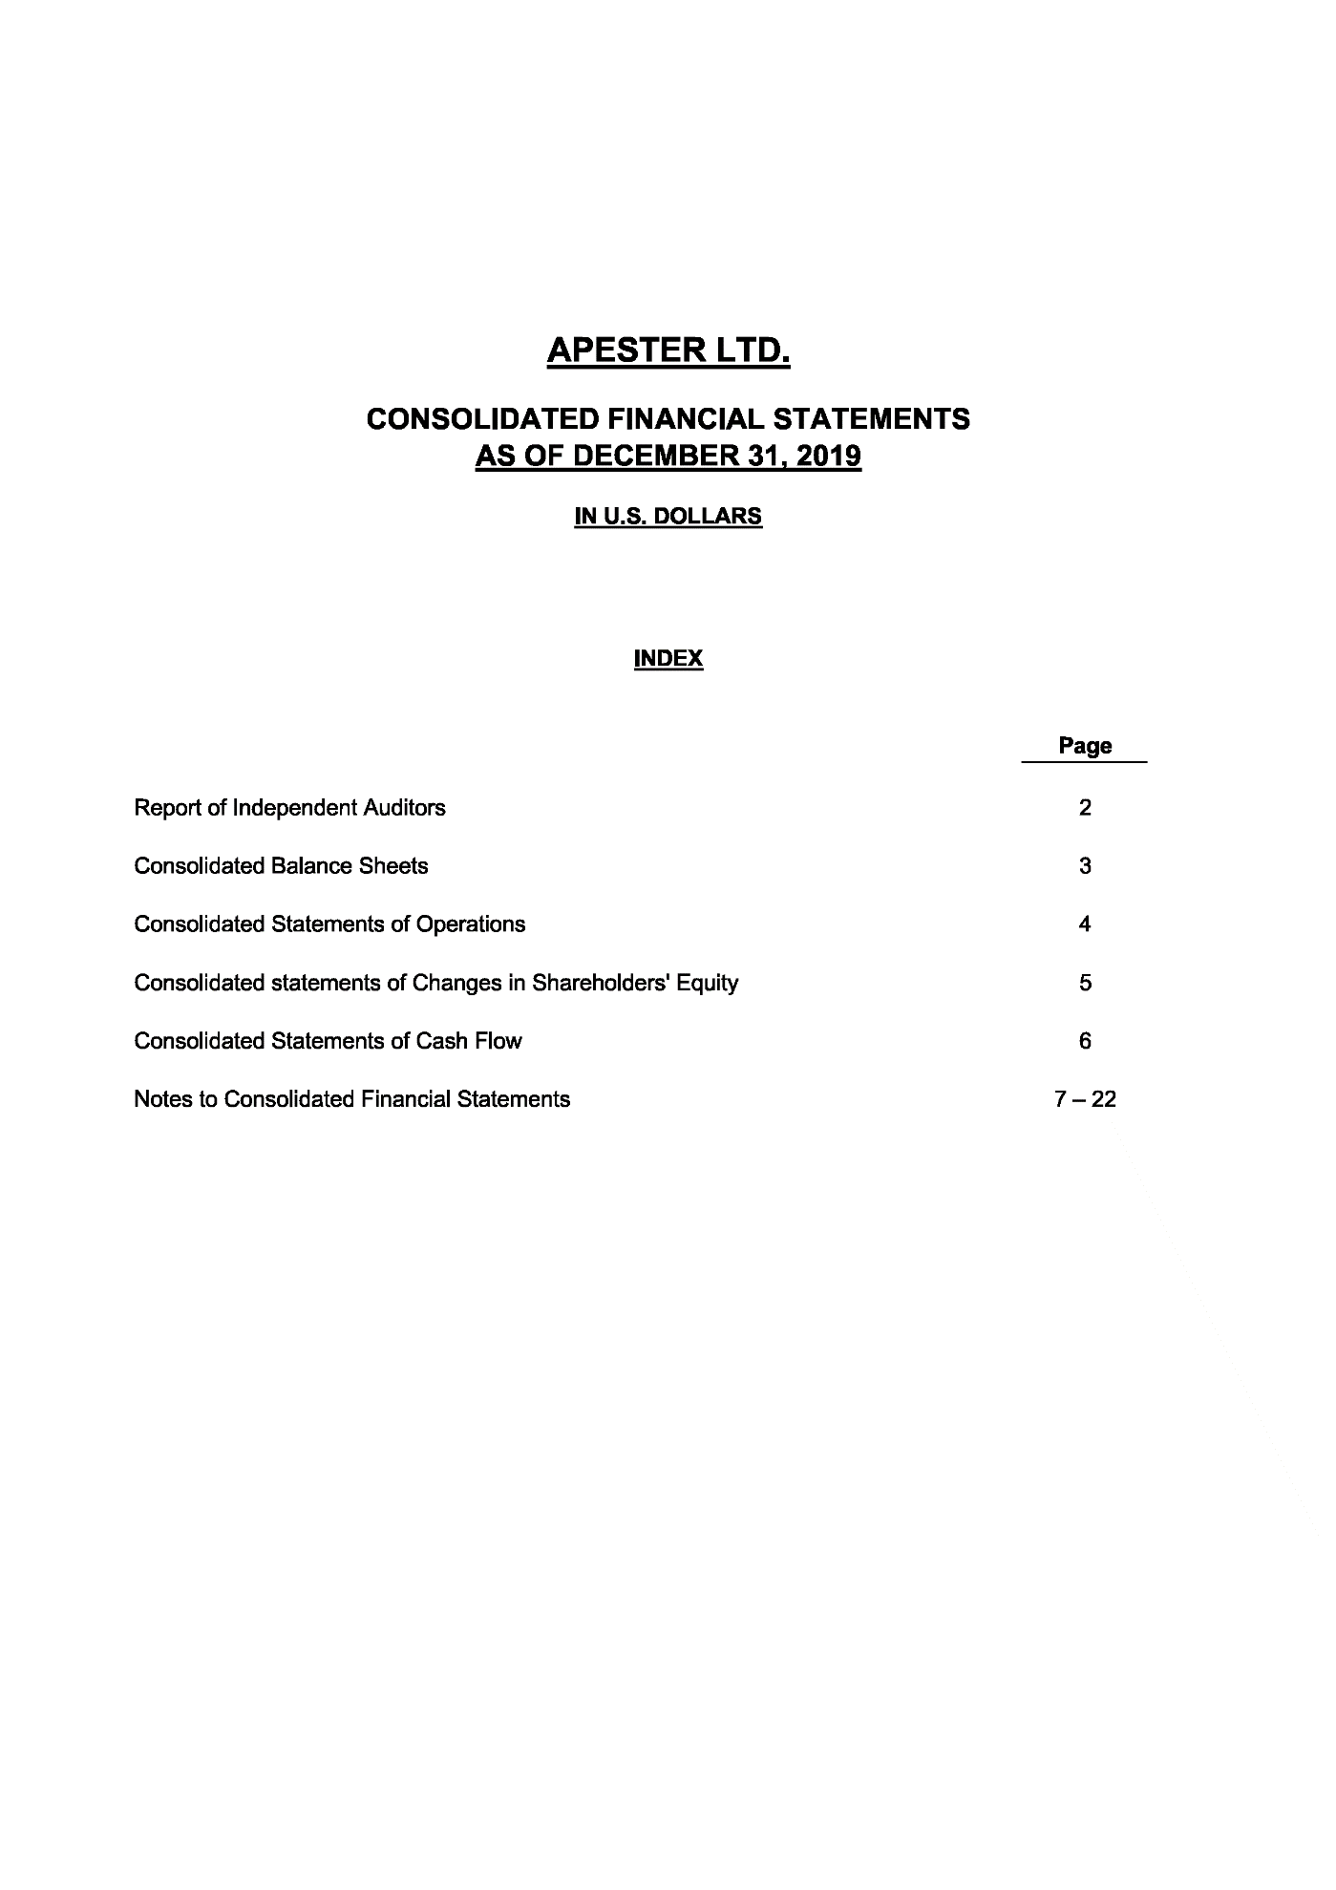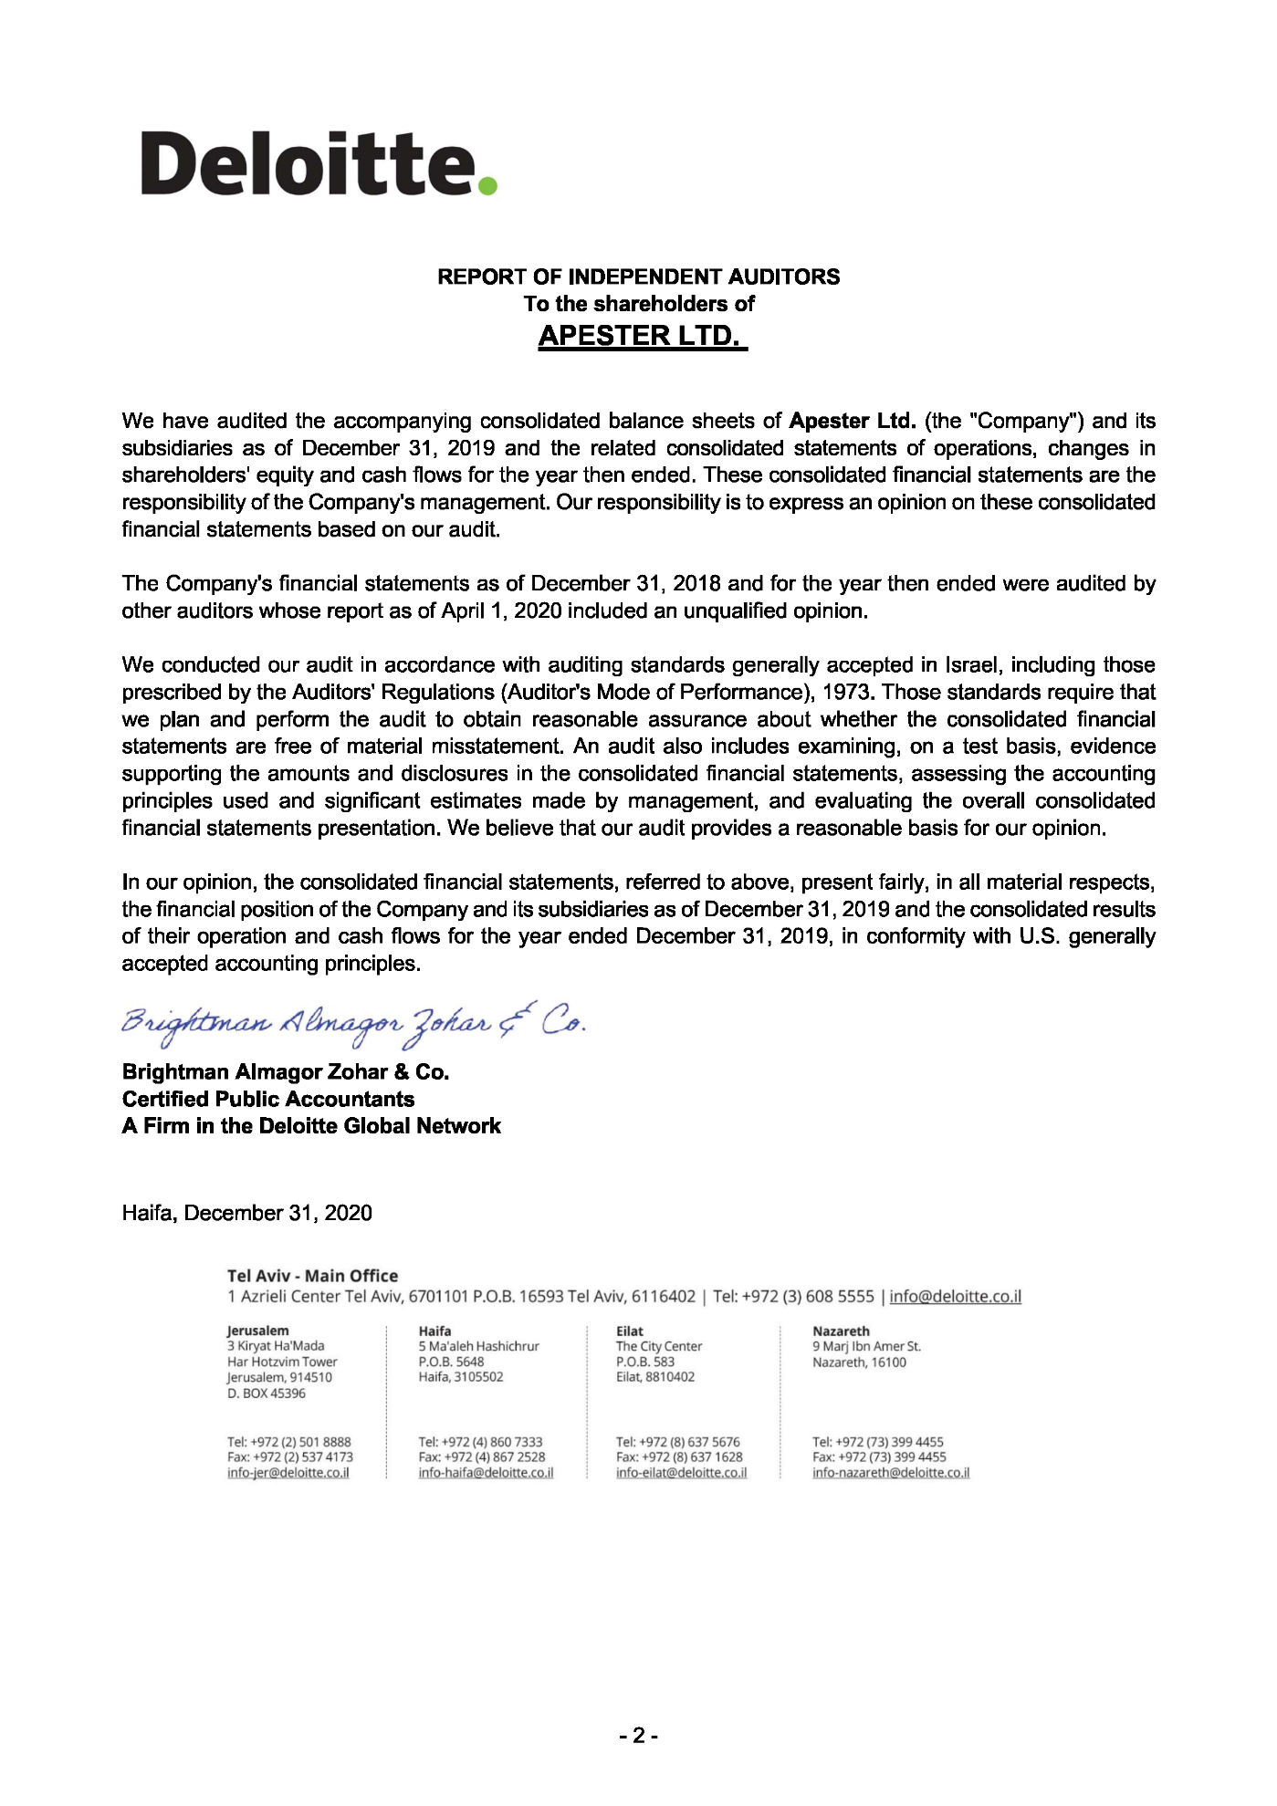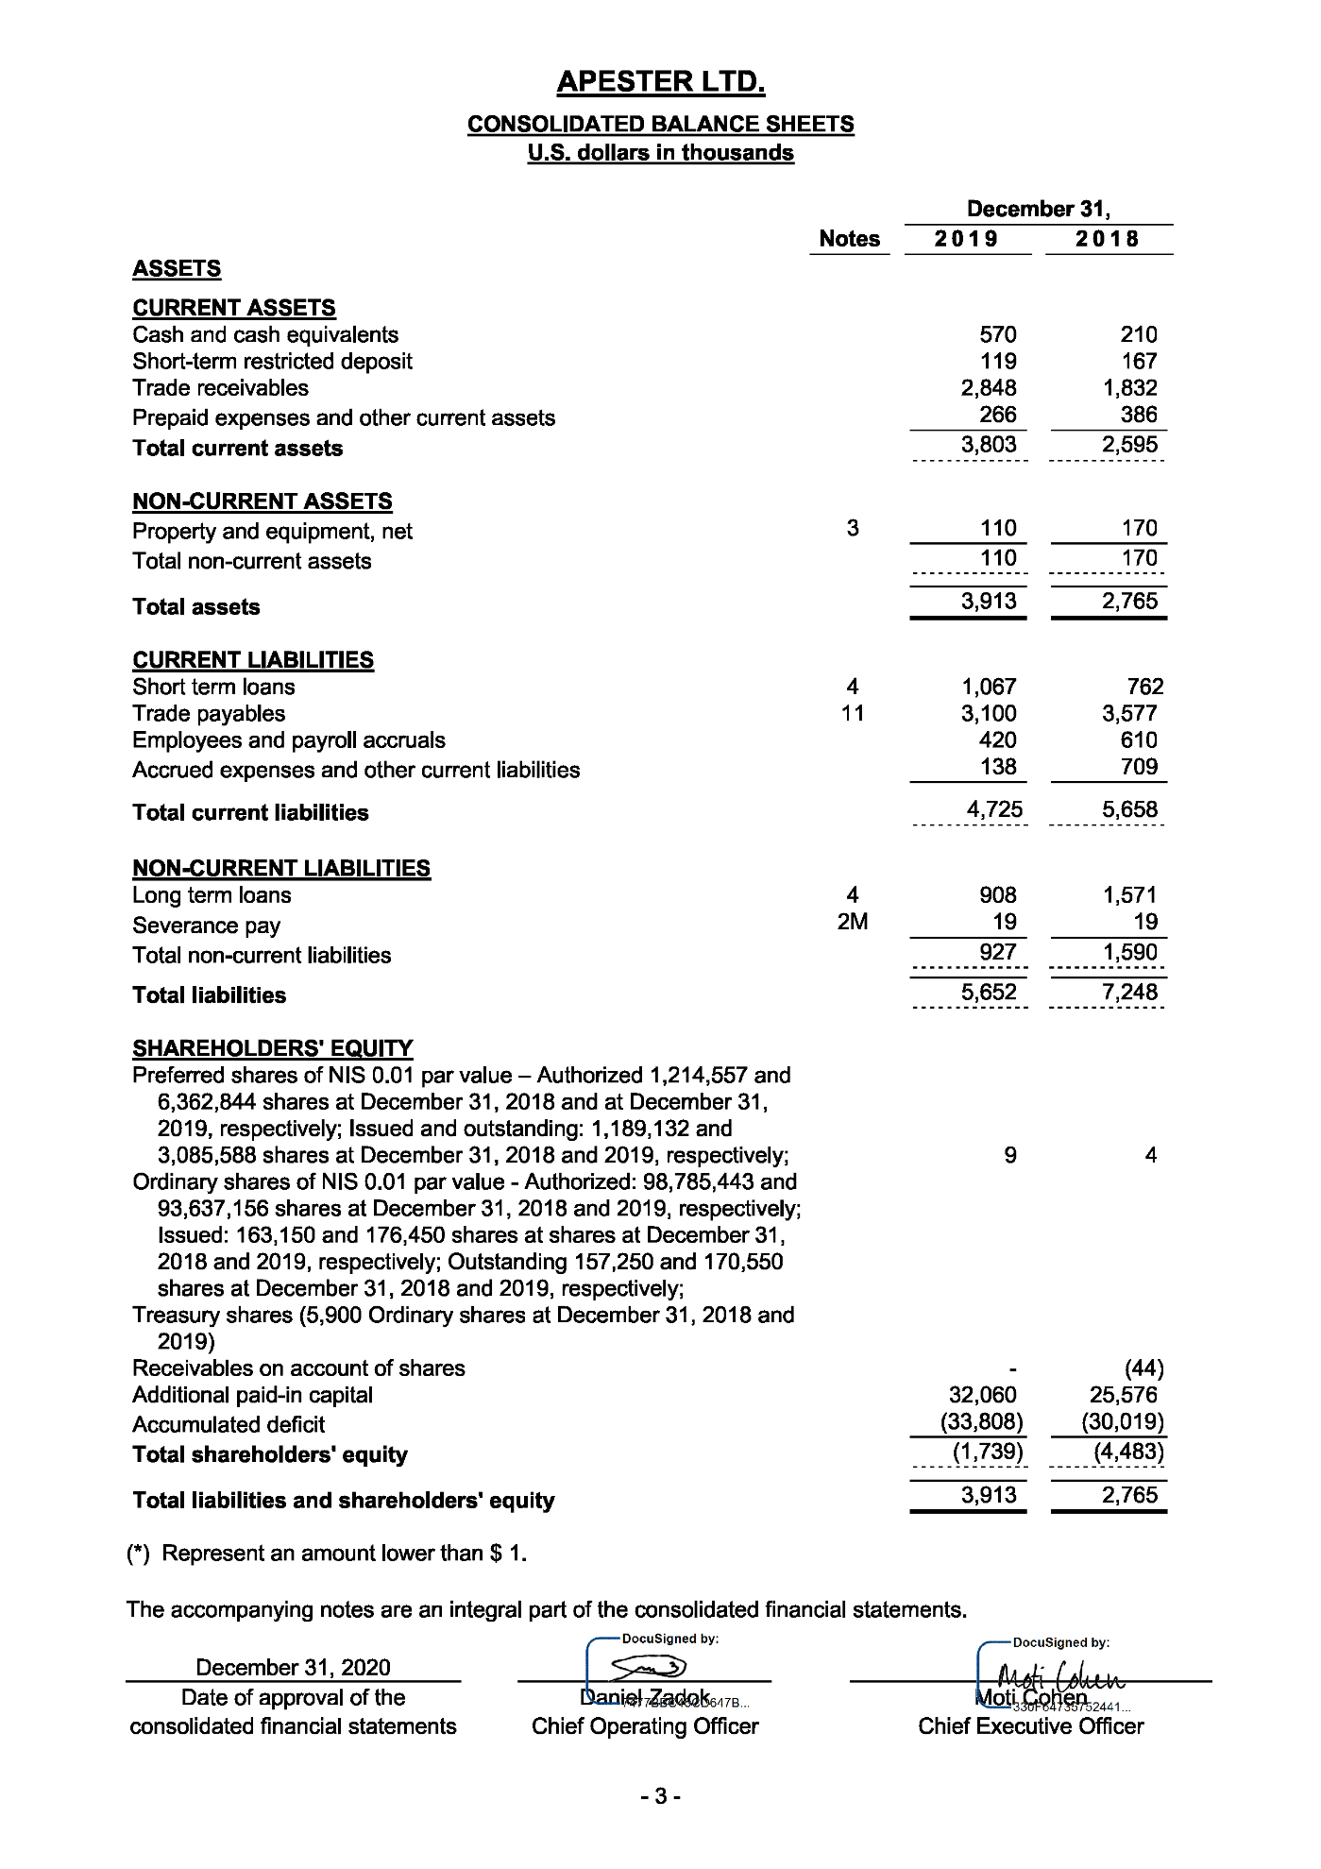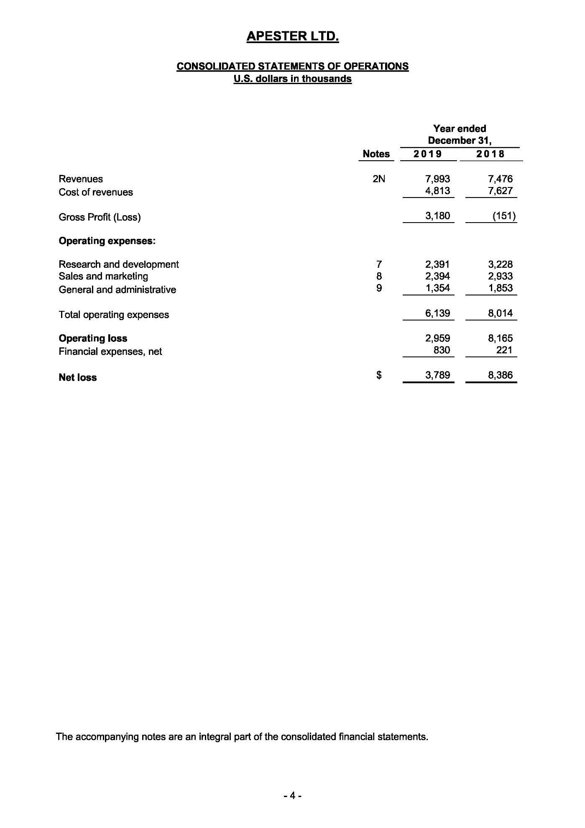
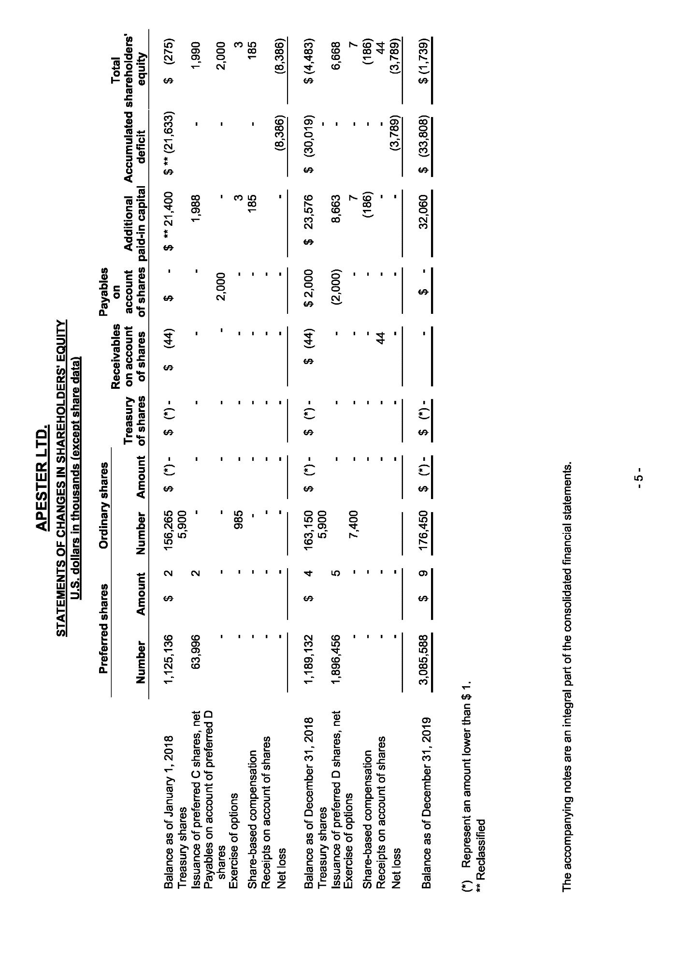
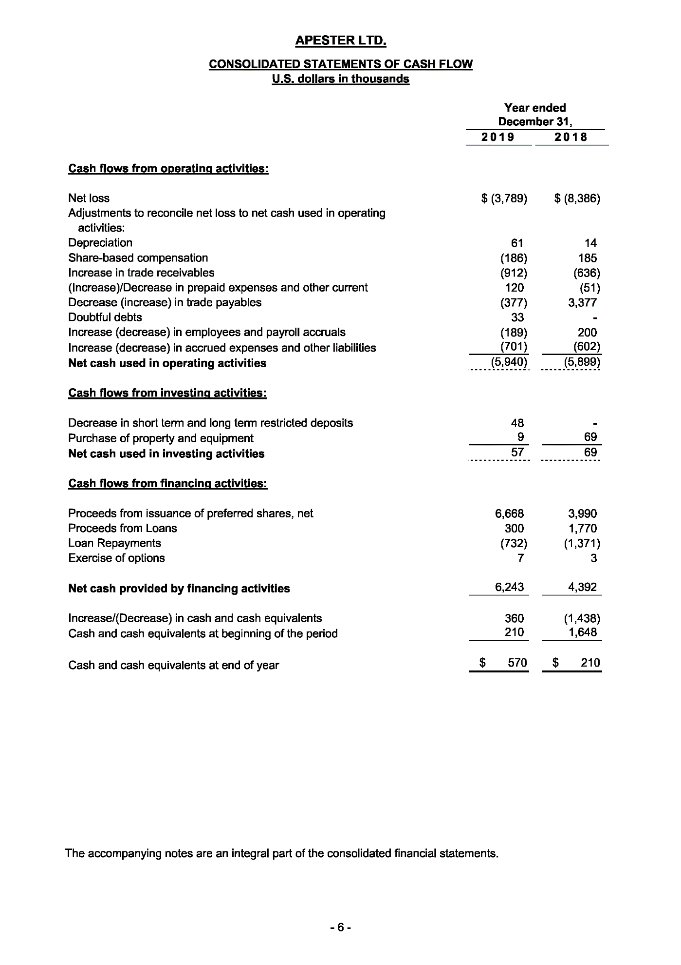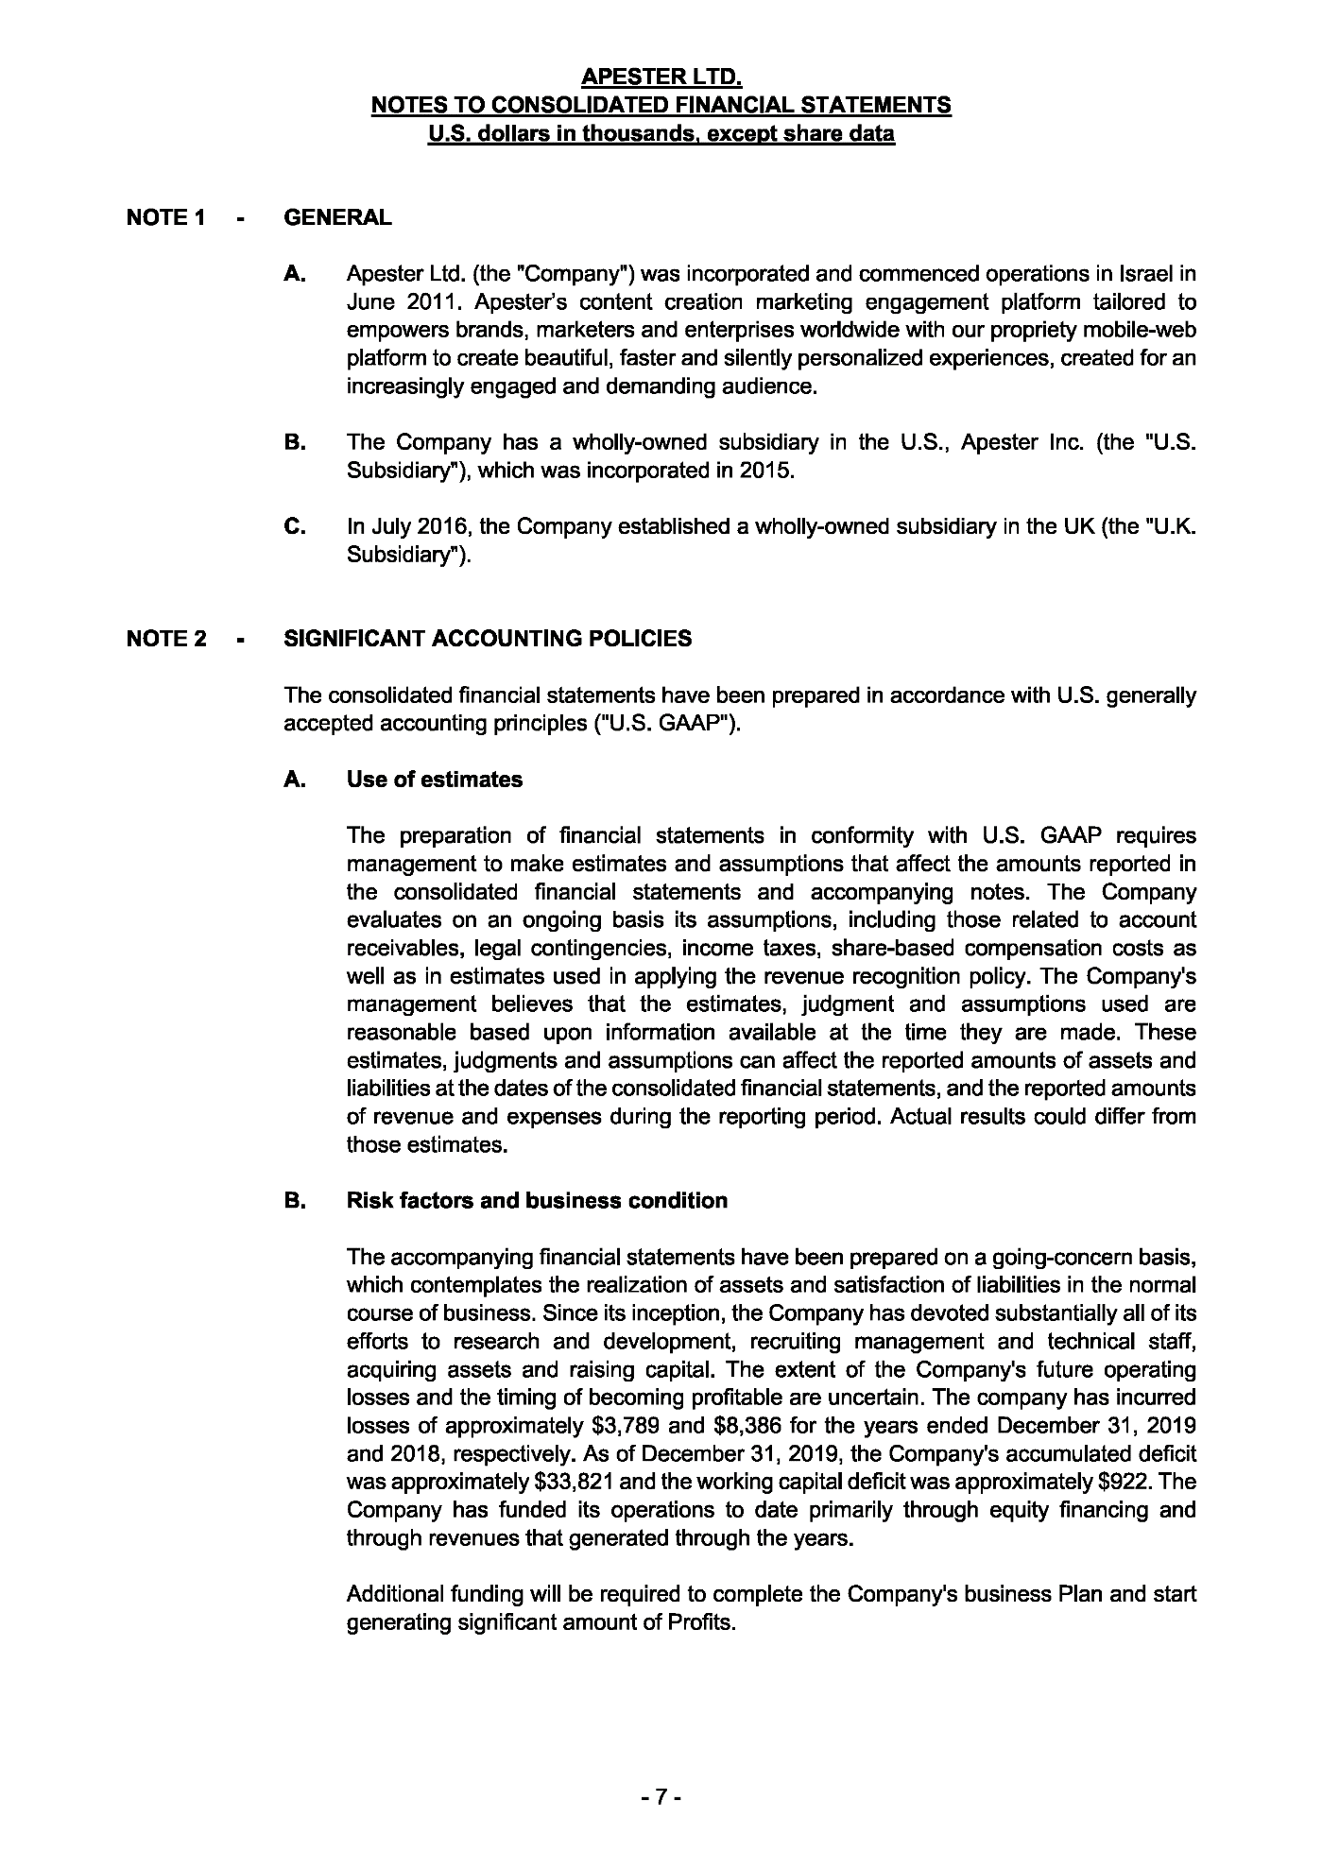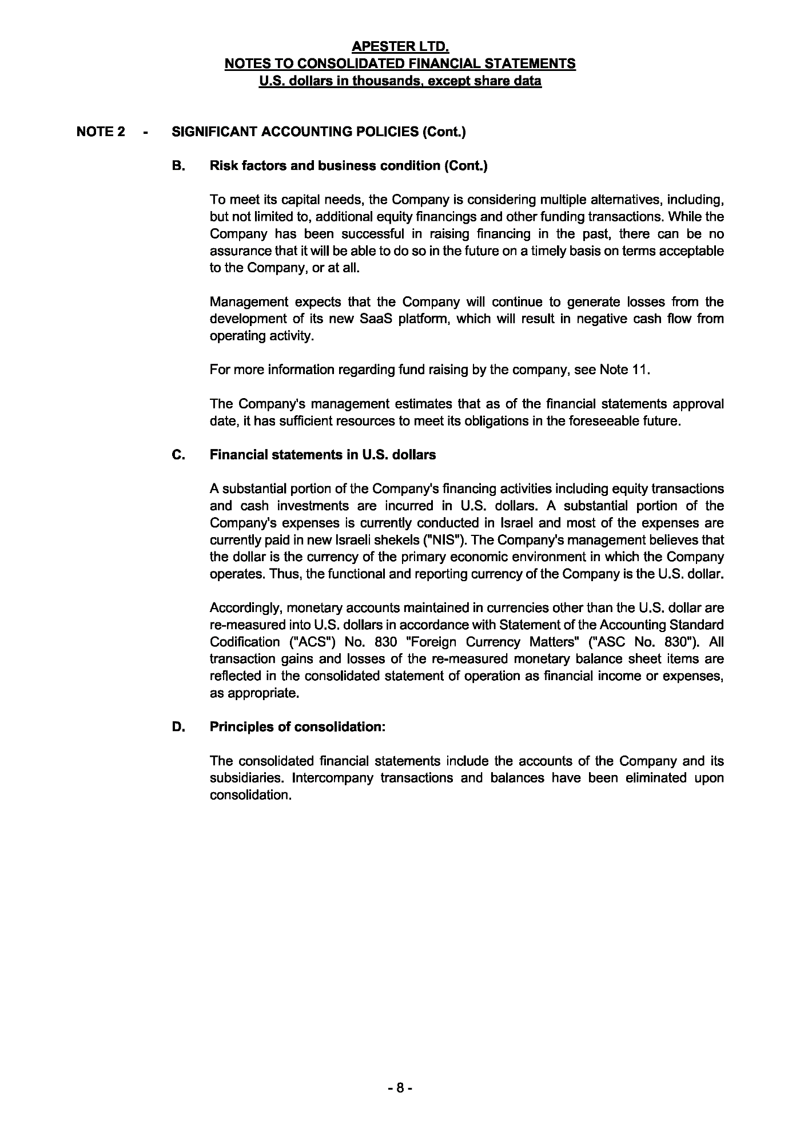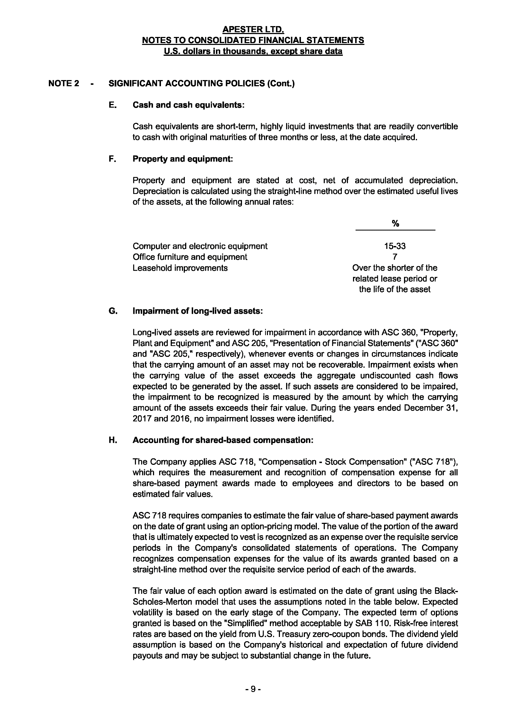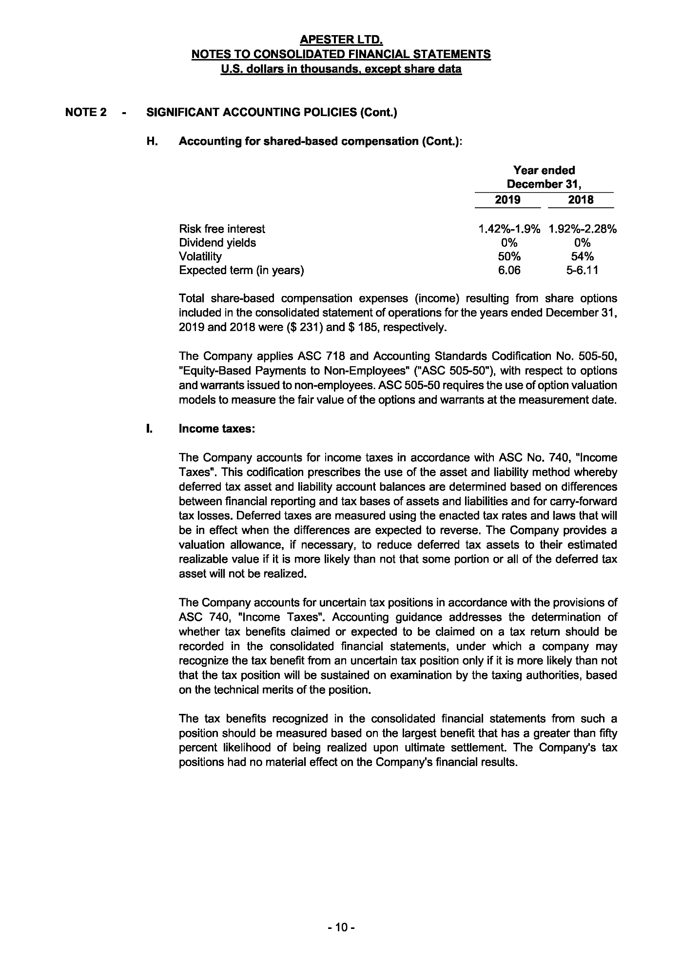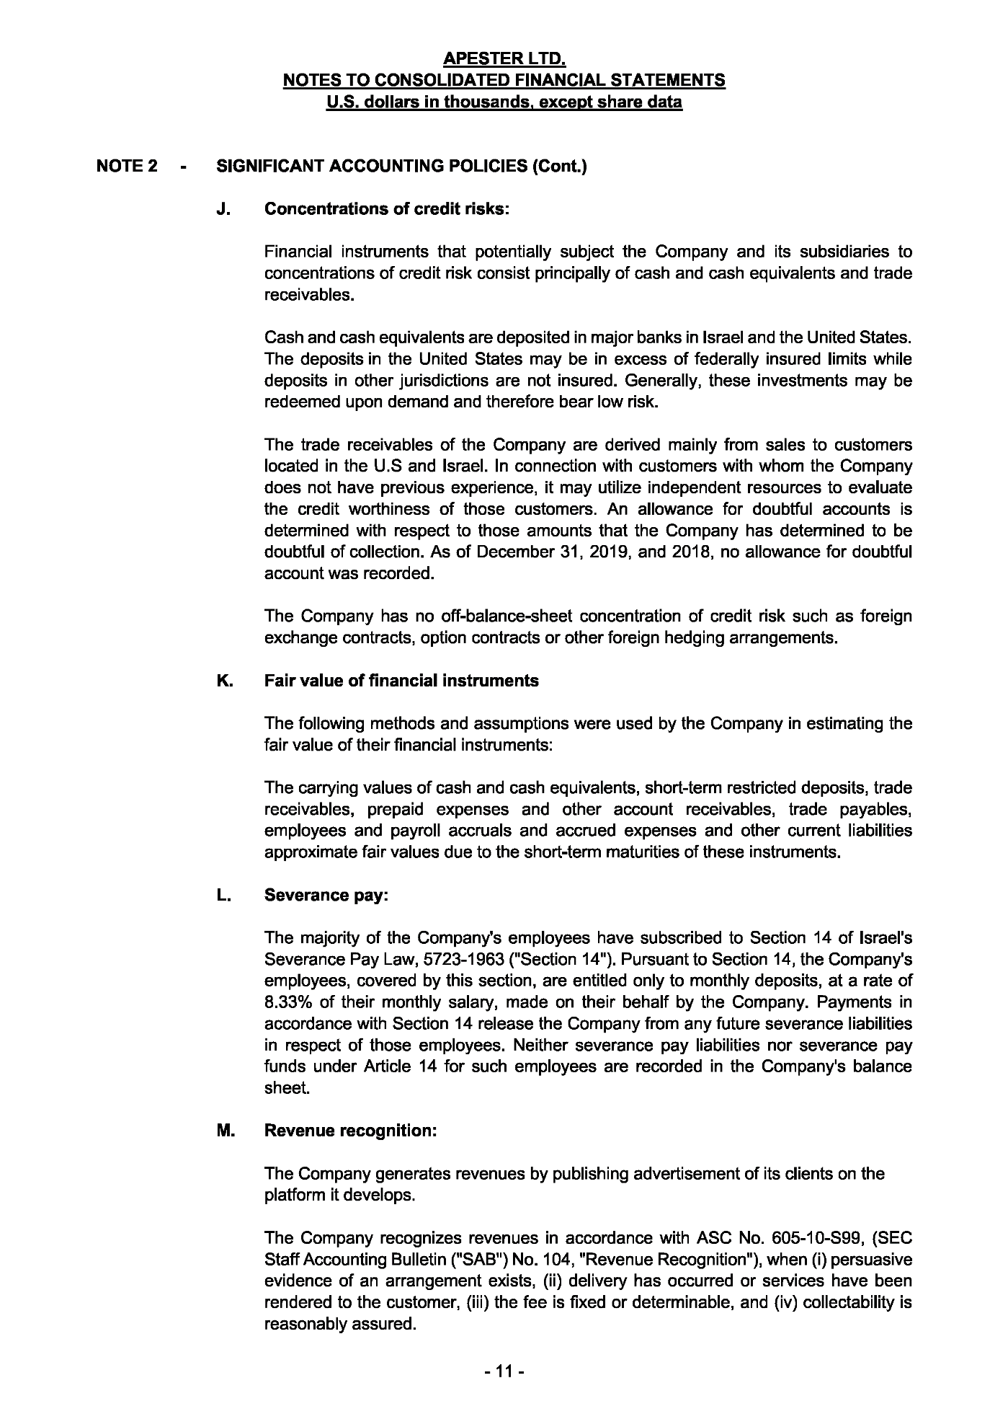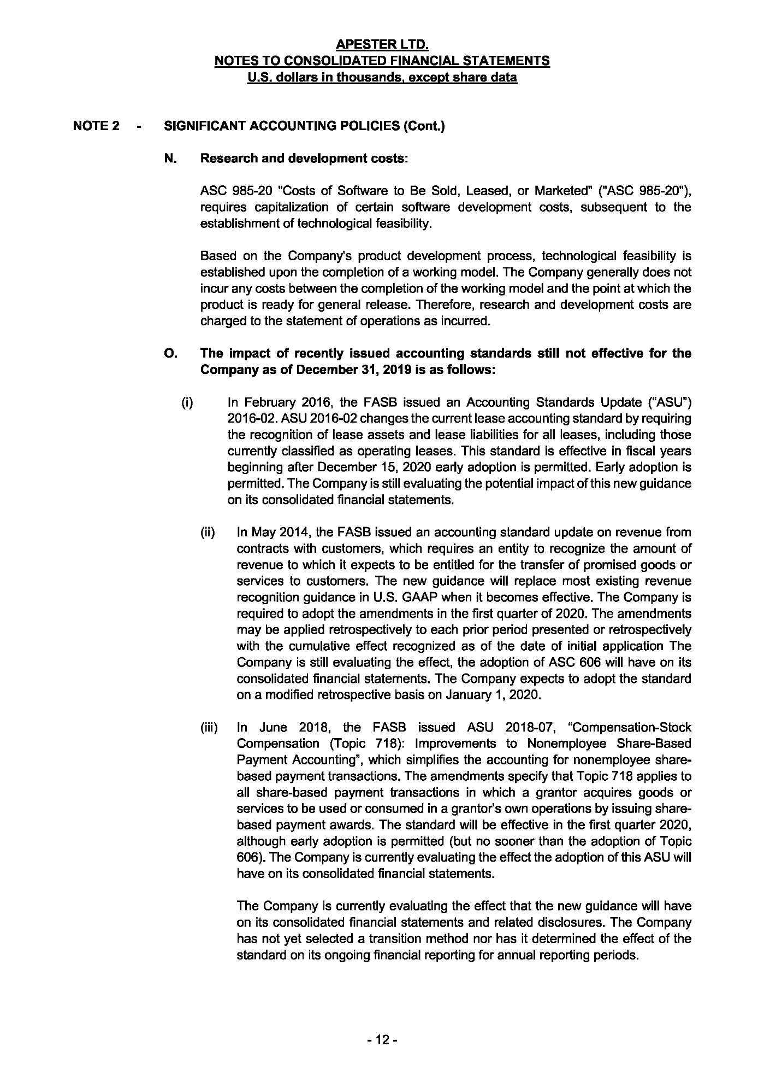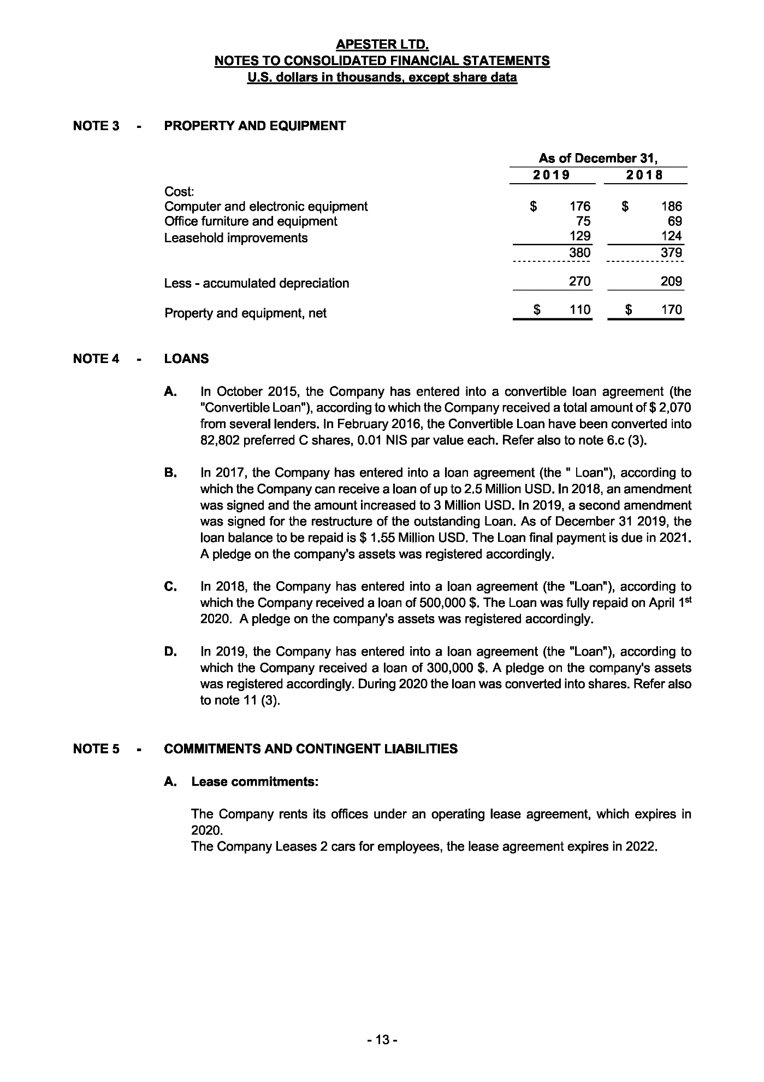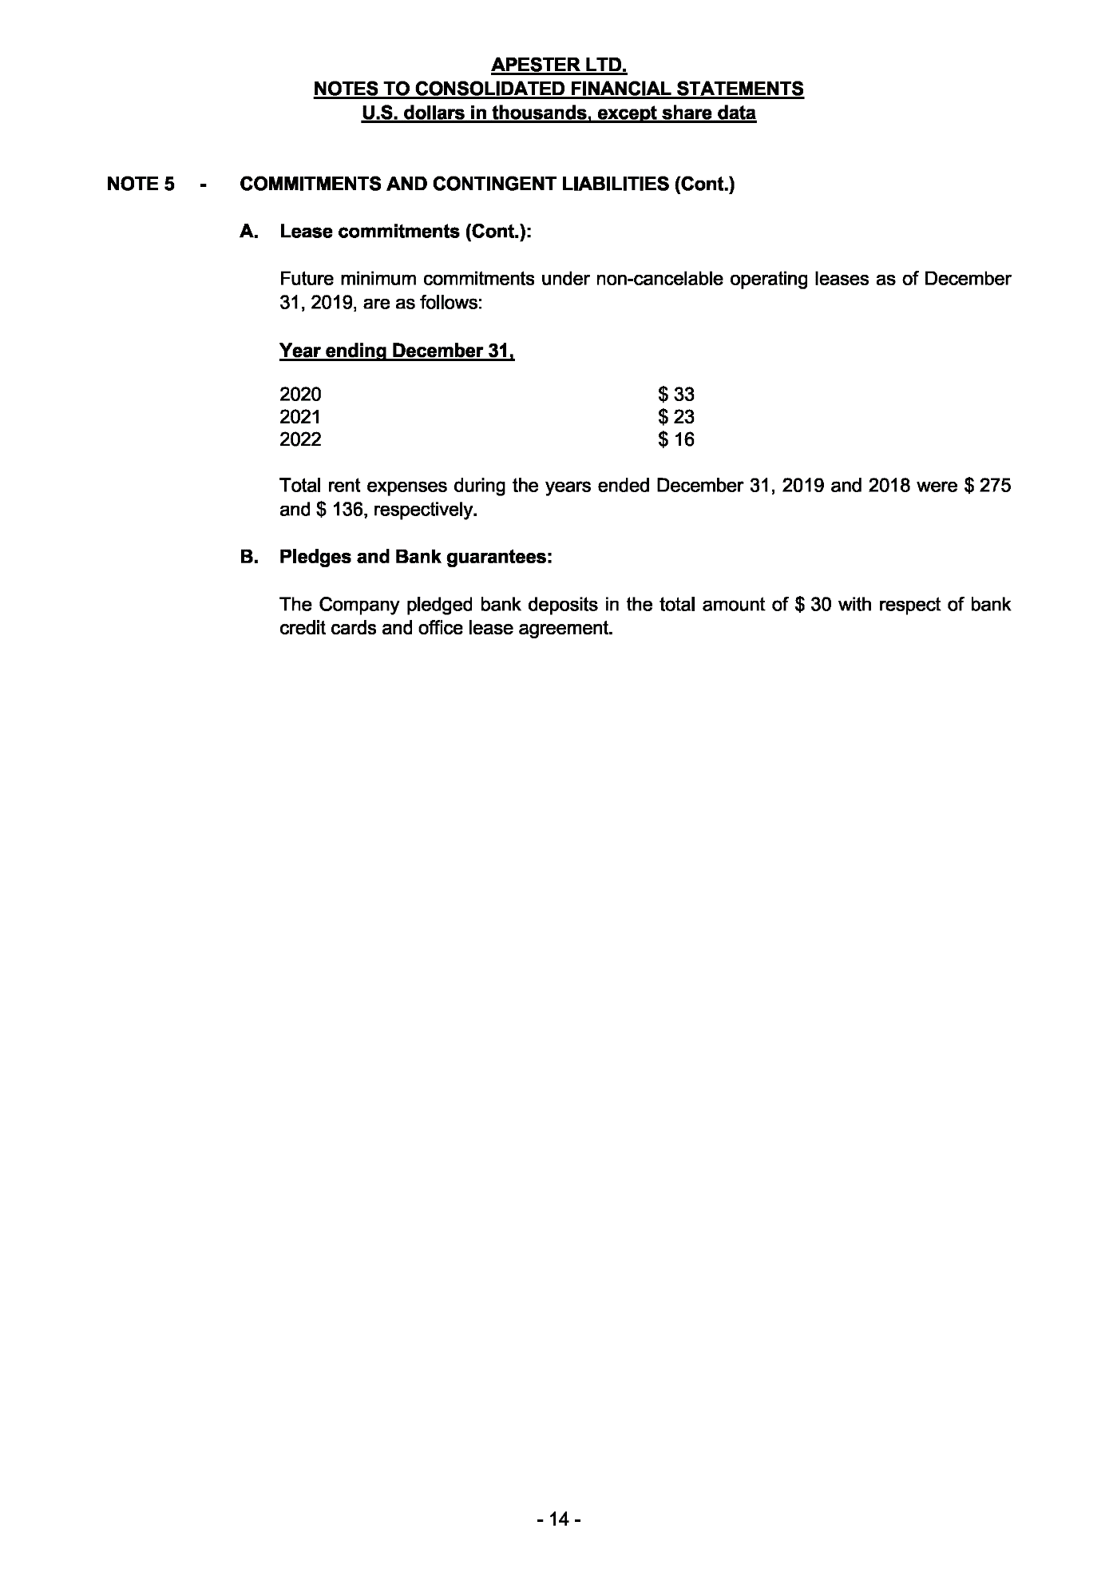
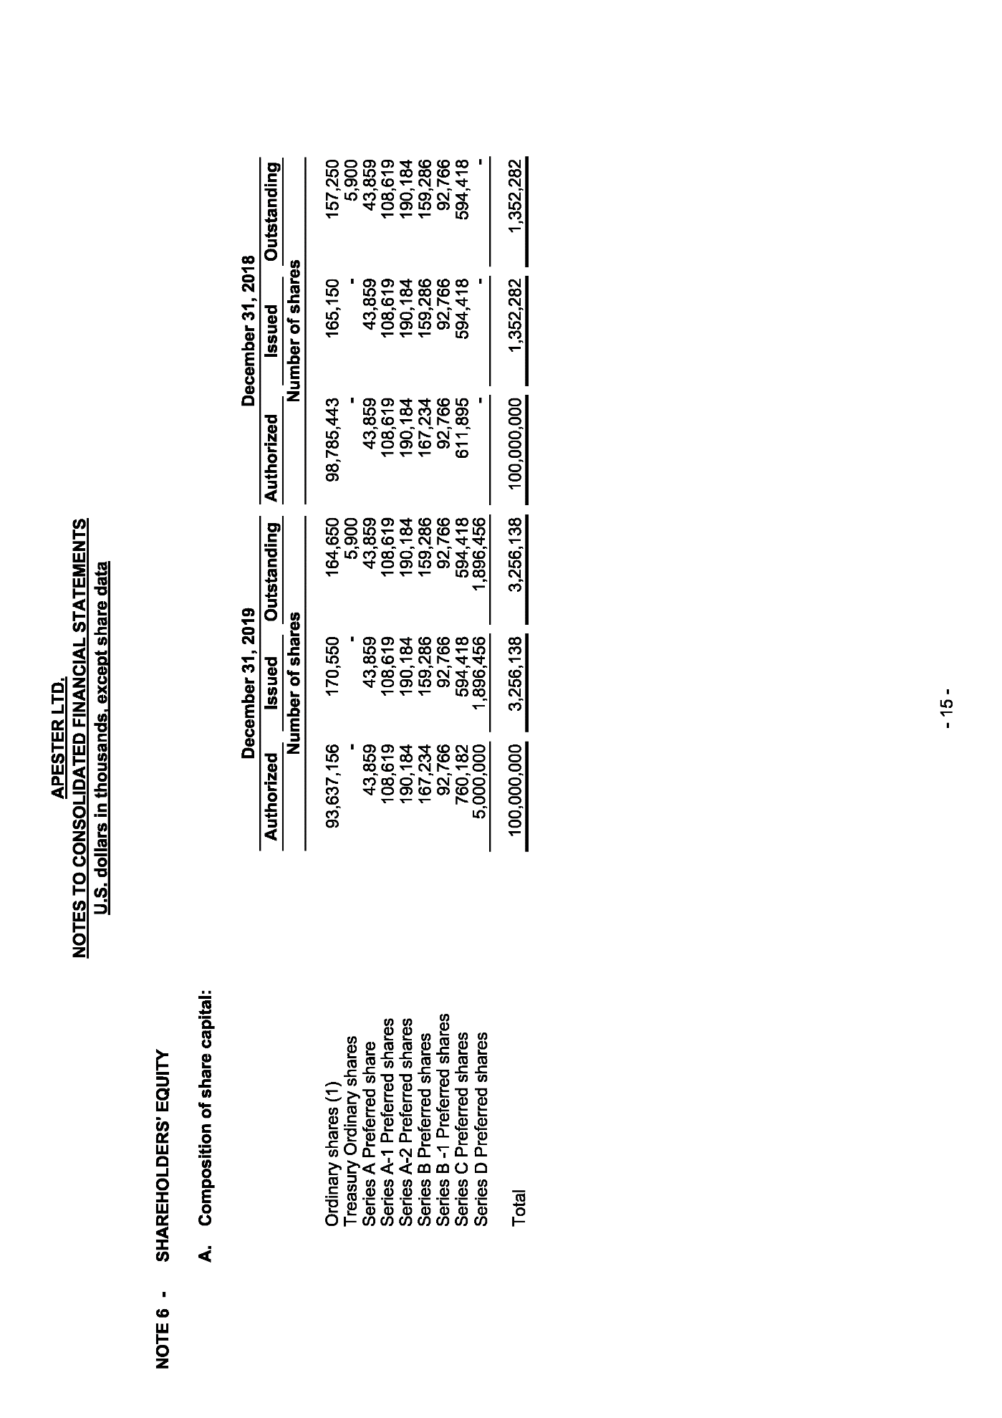
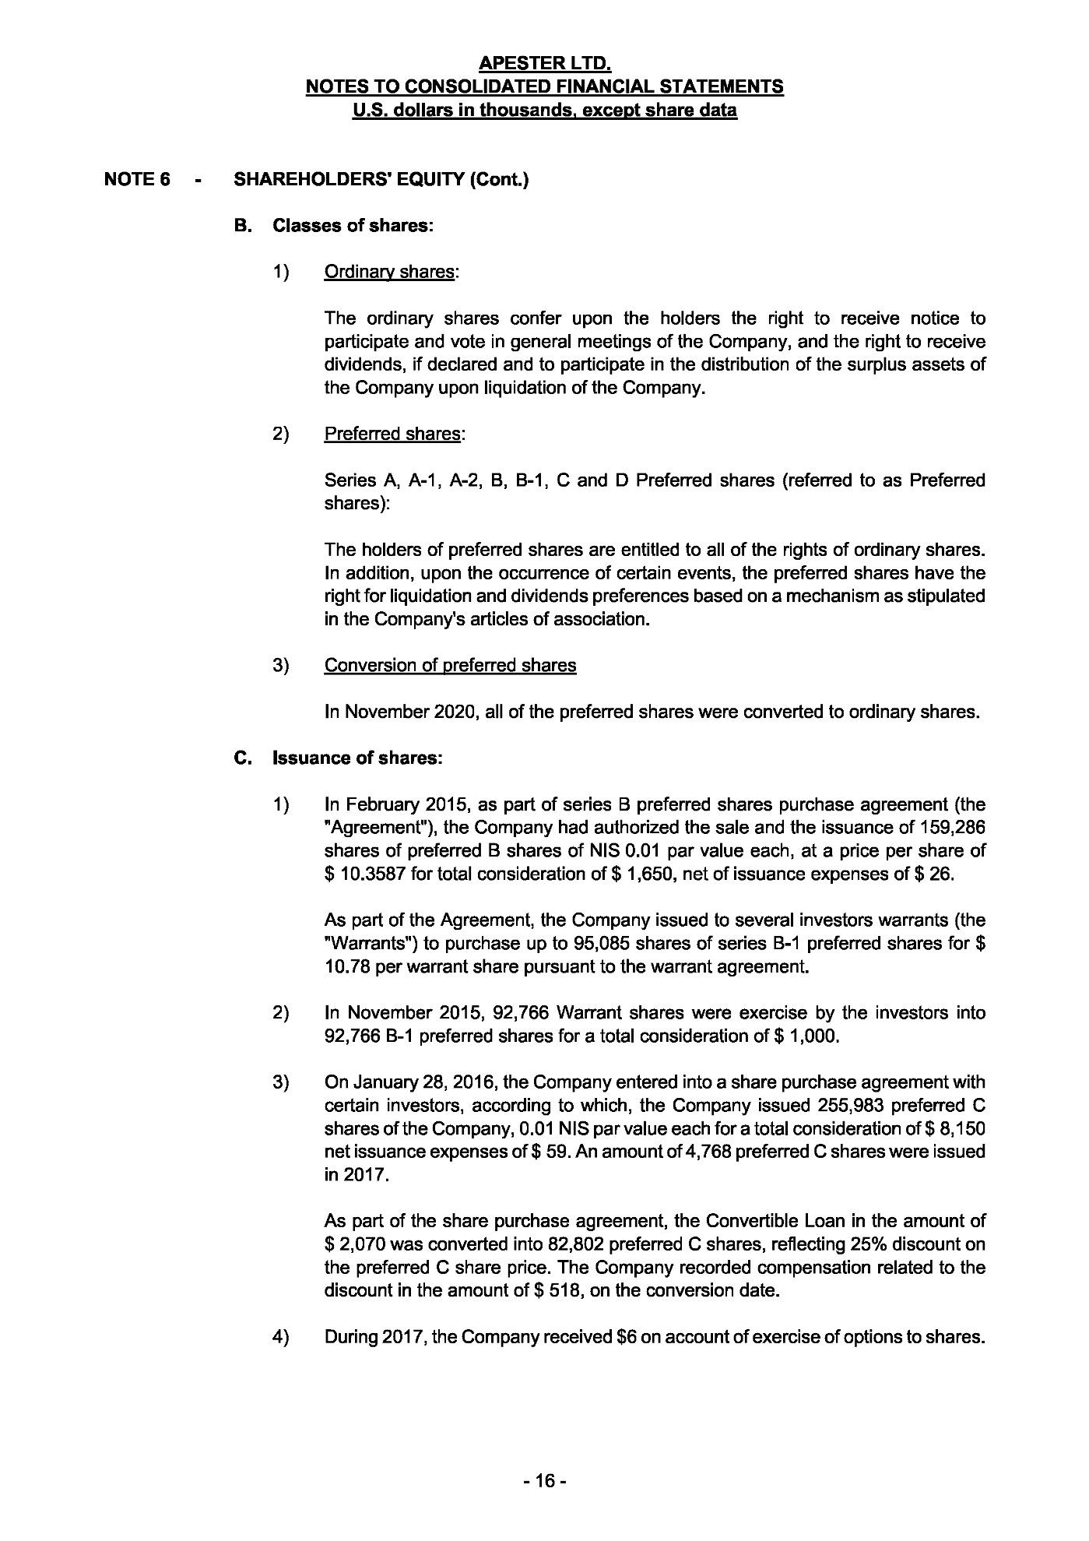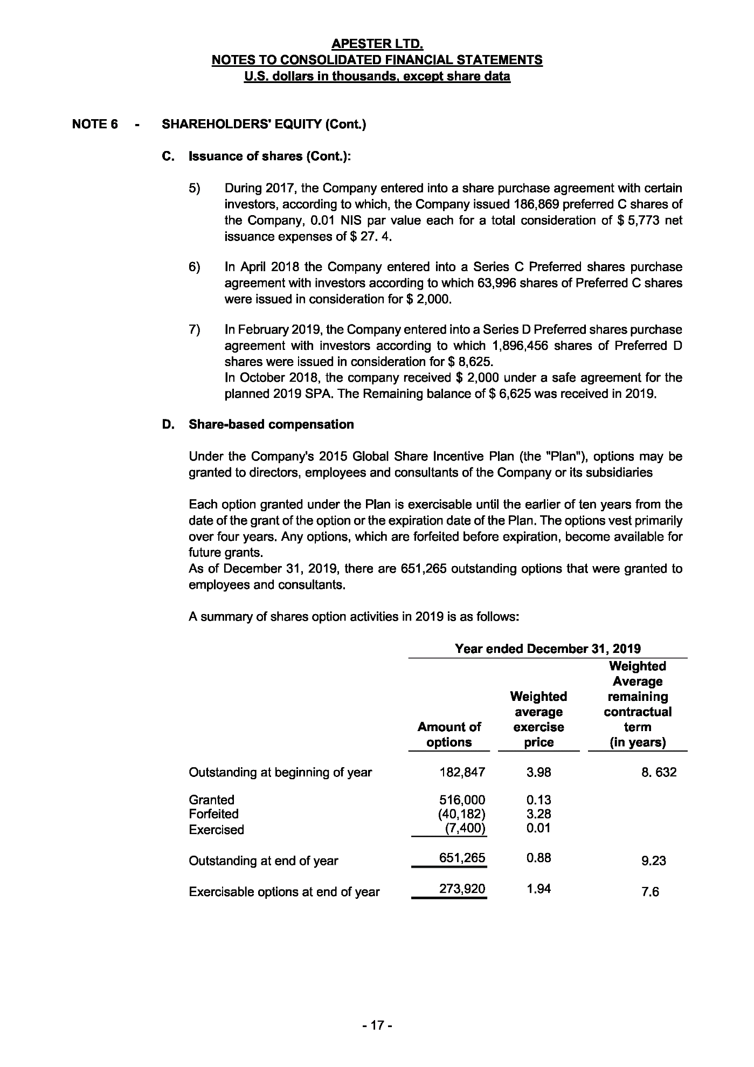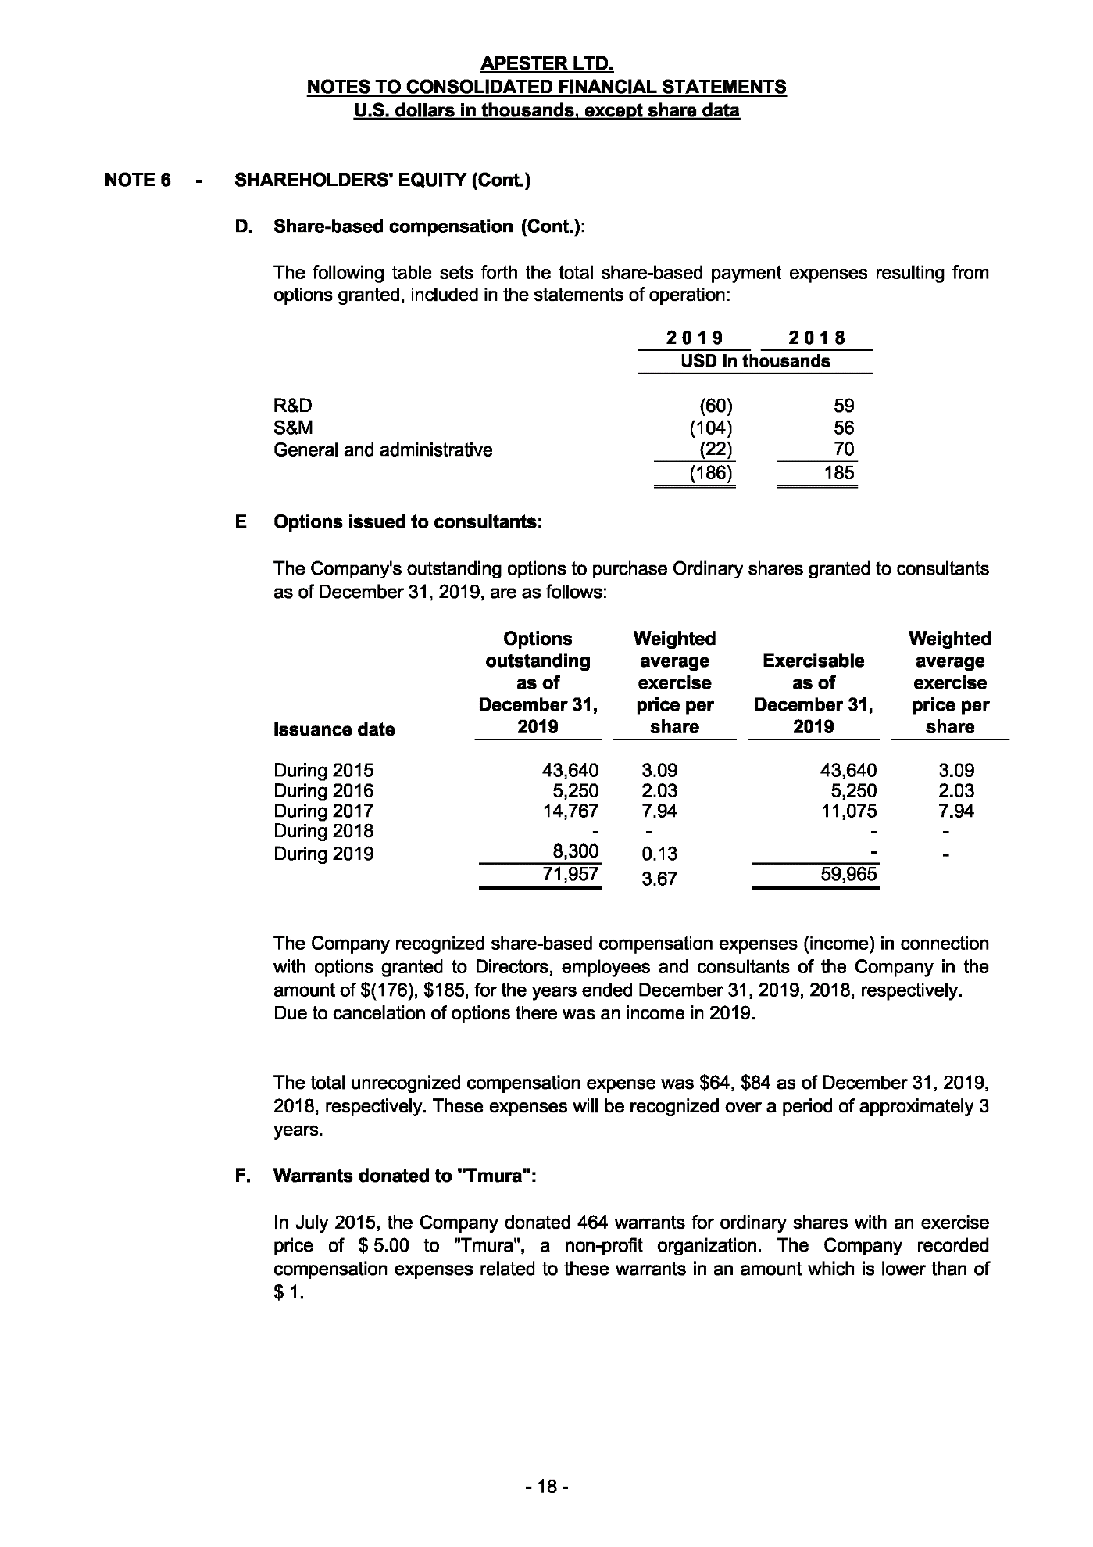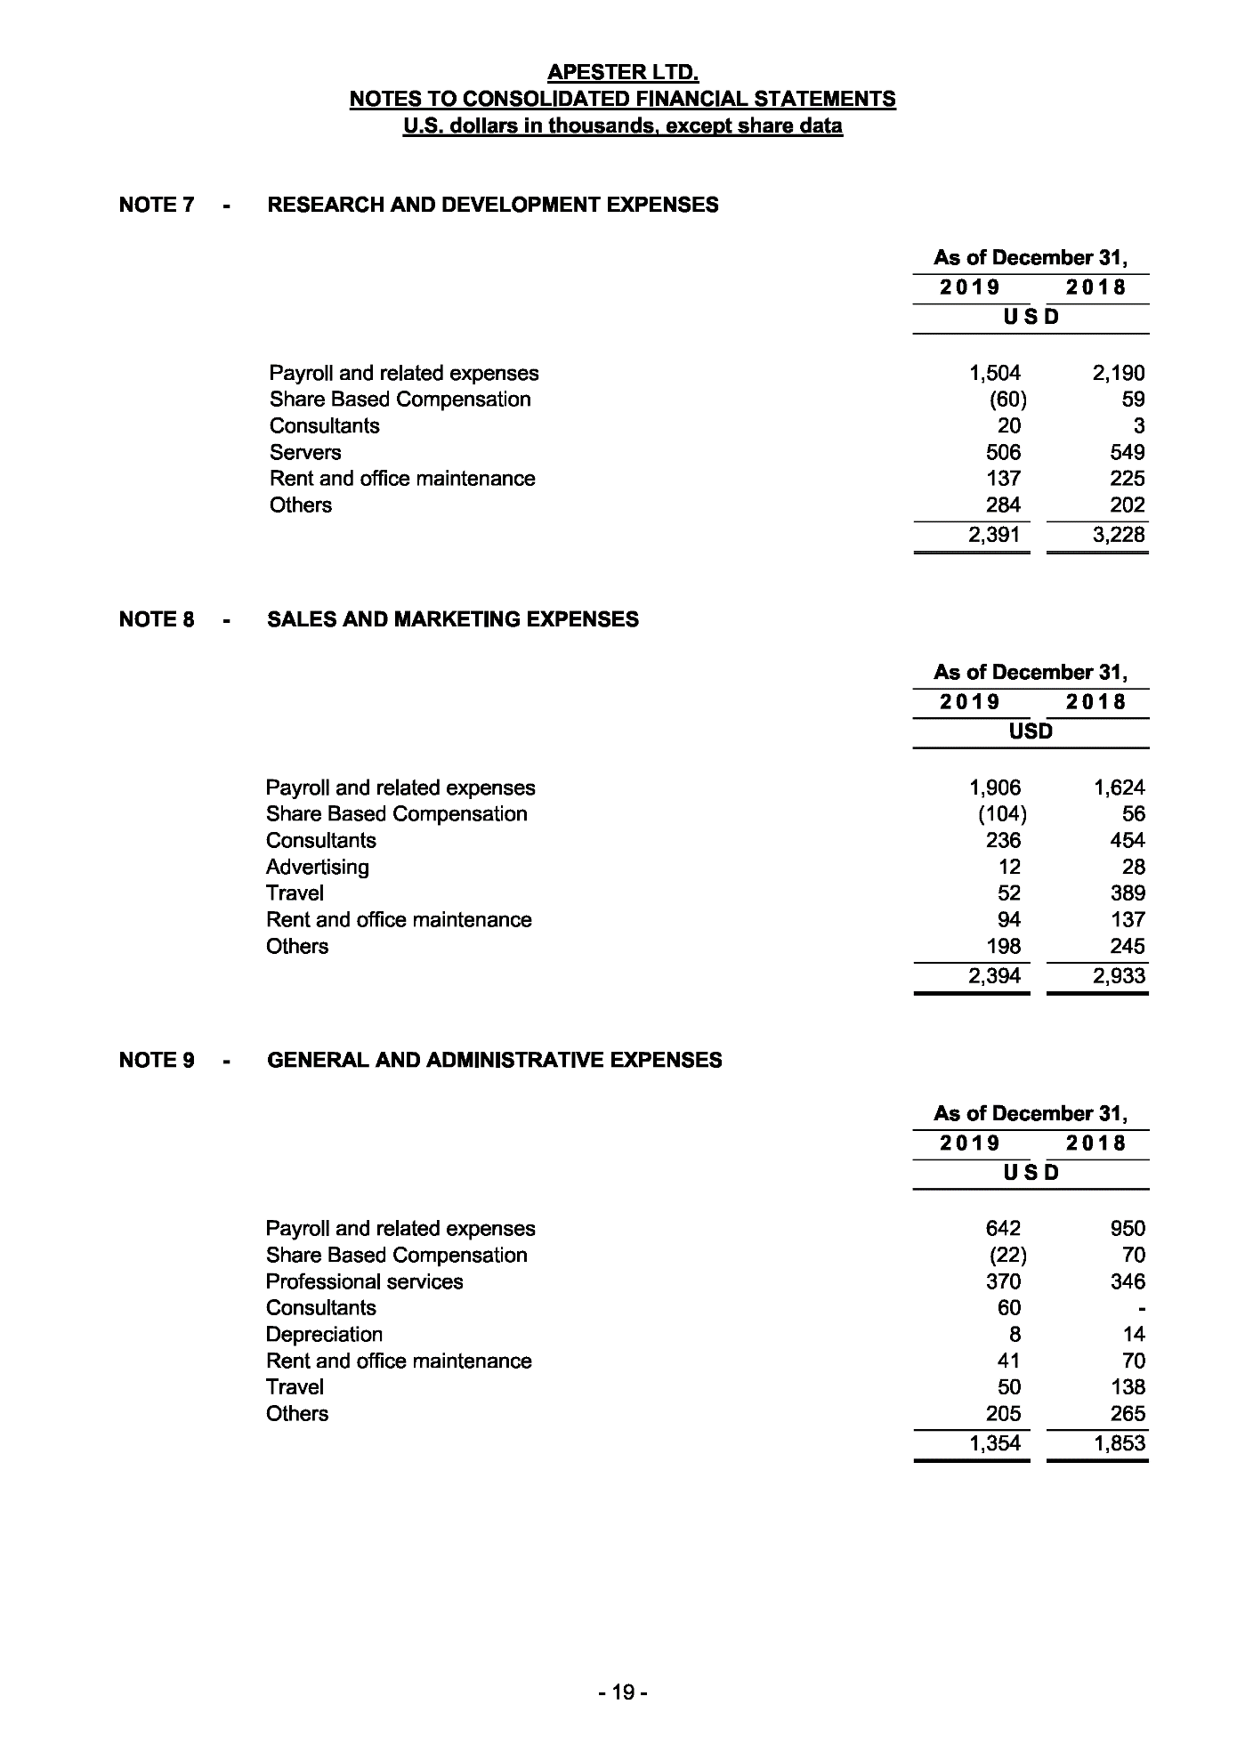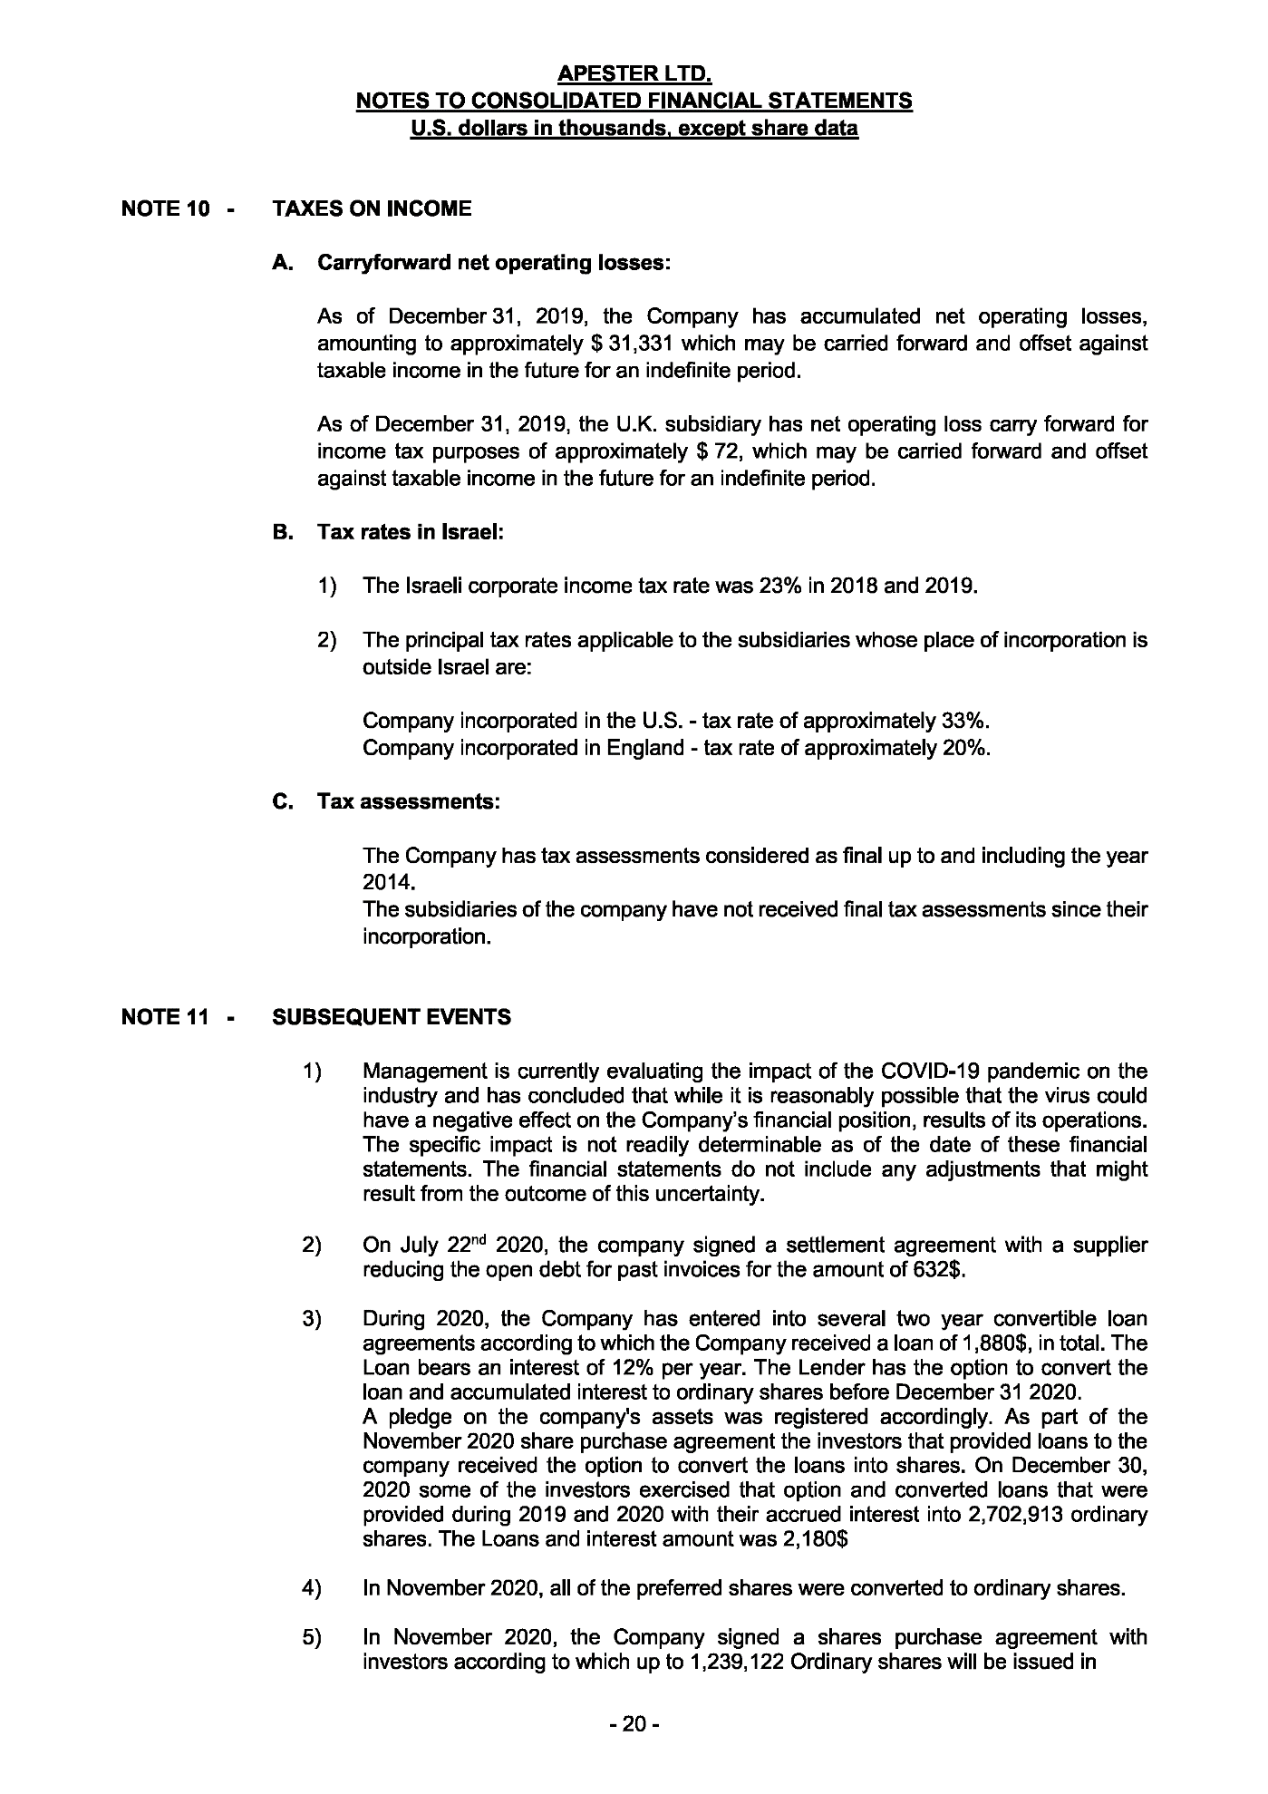

PART VIII
UNAUDITED PRO FORMA FINANCIAL INFORMATION OF THE GROUP

SECTION A – ACCOUNTANT’S REPORT ON THE UNAUDITED PRO FORMA FINANCIAL INFORMATION OF THE GROUP

Crowe U.K. LLP
Chartered Accountants
Member of Crowe Global
55 Ludgate Hill
London EC4M 7JW, UK
Tel +44 (0)20 7842 7100
Fax +44 (0)20 7583 1720
DX: 0014 London Chancery Lane
www.crowe.co.uk

21 September 2022

The Directors
Sivota PLC
New London House
172 Drury Lane
London WC2B 5QR

Dear Sirs and Madams,

Introduction
We report on the unaudited pro forma Statement of Financial Position of Sivota PLC (the “Company”) as at 31 December 2021 and on the unaudited pro forma Statement of Comprehensive Income for the year ended 31 December 2021 (together, the “Pro Forma Financial Information”) set out in Section B “Unaudited Pro Forma Financial Information of the Company” of Part VIII “Unaudited Pro Forma Financial Information of the Company” of the Company’s prospectus dated 21 September 2022 (the “Document”).

Opinion

In our opinion:

• the Pro Forma Financial Information has been properly compiled on the basis stated; and

• such basis is consistent with the accounting policies of the Company.

Responsibilities

It is the responsibility of the directors of the Company (the “Directors”) to prepare the Pro Forma Financial Information in accordance with Section 1 and Section 2 of Annex 20 of the UK version of the Commission Delegated Regulation (EU) 2019/980 supplementing Regulation (EU) 2017/1129 which is part of UK law by virtue of the European Union (Withdrawal) Act 2018 (the “Prospectus Regulation”).

It is our responsibility to form an opinion, in accordance with Section 3 of Annex 20 of the Prospectus Regulation, as to the proper compilation of the Pro-Forma Financial Information and to report that opinion to you in accordance with Section 3 of Annex 20 of the Prospectus Regulation.

In providing this opinion, we are not updating or refreshing any reports or opinions previously made by us on any financial information used in the compilation of the Pro Forma Financial Information, nor do we accept responsibility for such reports or opinions beyond that owed to those to whom those reports or opinions were addressed by us at the dates of their issue.

Basis of preparation

The Pro Forma Financial Information has been prepared on the basis described, for illustrative purposes only, to provide information about how:

- the acquisition by the Company of Apester;

- the assignment of borrowings from Apester to the Company;

- the issue of the placing shares and subscriber shares; and

- and settlement of the associated costs (together, the “Adjustments”)

might have affected the assets, liabilities, equity and earnings presented on the basis of the accounting policies adopted by the Company in preparing the Company’s audited financial information for the period ended 31 December 2021. This report is required by Section 3 of Annex 20 of the UK Prospectus Regulation and is given for the purpose of complying with that requirement and for no other purpose.

Basis of opinion

We conducted our work in accordance with Standards of Investment Reporting issued by the Financial Reporting Council in the United Kingdom. We are independent of the Company and 3DBT in accordance with the Financial Reporting Council’s Ethical Standard, as applied to Investment Circular Reporting Engagements, and we have fulfilled our other ethical responsibilities in accordance with these requirements.

The work that we performed for the purpose of making this report, which involved no independent examination of any of the underlying financial information, consisted primarily of comparing the unadjusted financial information with the source documents, considering the evidence supporting the adjustments and discussing the Pro Forma Financial Information with the Directors.

We planned and performed our work so as to obtain all the information and explanations which we considered necessary in order to provide us with reasonable assurance that the Pro Forma Financial Information has been properly compiled on the basis stated and that such basis is consistent with the accounting policies of the Company.

Declaration

For the purpose of Prospectus Regulation Rule 5.3.2R(2)(f), we are responsible for this report as part of the Document and declare that, to the best of our knowledge, the information contained in this report is in accordance with the facts and that this report makes no omission likely to affect its import. This declaration is included in the Document in compliance with item 1.2 of Annex 1 of the Prospectus Regulation.

Yours faithfully,

Crowe U.K. LLP
Chartered Accountants

SECTION B – UNAUDITED PRO FORMA FINANCIAL INFORMATION OF THE COMPANY

Set out below is the unaudited pro forma Statement of Financial Position of the Company as at 31 December 2021 and the unaudited pro forma Statement of Comprehensive Income for the year ended 31 December 2021(together, the “Pro Forma Financial Information”). The Pro Forma Financial Information has been prepared on the basis of the accounting policies adopted by the Company in preparing its audited financial information for the period ended 31 December 2021, incorporated by reference in Part VI “Financial Information of the Company” of this Document and on the basis set out in the notes below, to illustrate the effects of:

- the acquisition of Apester;
- the assignment of the Convertible Loans;

- the issue of the Placing Shares at the Issue Price;

- the issue of the Subscription Shares at the Issue Price; and

- settlement of the Transaction Costs (together, the “Pro Forma Adjustments”),
on the assets, liabilities and equity of the Company had the Pro Forma Adjustments occurred on 31 December 2021 and on its earnings for the year ended 31 December 2021 had the Pro Forma Adjustments occurred on 1 January 2021.
The Pro Forma Financial Information has been prepared for illustrative purposes only. Due of its nature, the Pro Forma Financial Information addresses a hypothetical situation and, therefore, does not represent the Company’s actual financial position as at 31 December 2021 or of its earnings for the year ended 31 December 2021. It is based on:
- the audited financial information of the Company for the period ended 31 December 2021, incorporated by reference in Part VI “Financial Information of the Company” of this Document; and

- the Apester Financial Information for the year ended 31 December 2021, included in Part VII “Financial Information of Apester” of this Document.

Users should read the whole of this Document and not rely solely on the Pro Forma Financial Information contained in this Section B “Unaudited Pro Forma Financial Information of the Company” of Part VIII “Unaudited Pro Forma Financial Information of the Company” of this Document.
The report on the Pro Forma Financial Information is set out in Section A “Accountant’s Report on the Unaudited Pro Forma Financial Information of the Company” of Part VIII “Unaudited Pro Forma Financial Information of the Company” of this Document.

Unaudited pro forma Statement of Financial Position
 | Company  As at  31 December 2021  (Note 1)  $’000 | Adjustment  Apester  As at  31 December 2021  (Note 2)  $’000 | Adjustment  Acquisition and  consolidation  of Apester  (Note 3)  $’000 | Adjustment  Fundraising and  settlement of Transaction Costs  (Note 4)  $’000 | Pro forma  balances  as at  31 December 2021  $’000
Property, plant and equipment | - | 58 | - | - | 58
Right-of-use-assets | - | 7 | - | - | 7
Developed technology | - | - | 8,655 | - | 8,655
Customer relationships | - | - | 2,608 | - | 2,608
Goodwill | - | - | 1,458 | - | 1,458
Non-current assets | - | 65 | 12,721 | - | 12,786
Trade receivables | - | 2,307 | - | - | 2,307
Other receivables | 55 | 338 | - | - | 393
Short-term deposits | - | 76 | - | - | 76
Cash and cash equivalents | 1,012 | 541 | (1,800) | 14,797 | 14,550
Current assets | 1,067 | 3,262 | (1,800) | 14,797 | 17,326
Total assets | 1,067 | 3,327 | 10,921 | 14,797 | 30,112
Share capital | 81 | 27 | (27) | 155 | 236
Share premium | 1,246 | 35,965 | (35,965) | 14,889 | 16,135
Capital reserve from share-based transactions | - | 1,260 | (1,260) | - | -
Other reserve | - | 222 | (222) | - | -
Retained deficit | (494) | (43,791) | 43,591 | (247) | (941)
Equity attributable to Shareholders | 833 | (6,317) | 6,117 | 14,797 | 15,430
Non-controlling interests | - | - | 6,404 | - | 6,404
Equity | 833 | (6,317) | 12,521 | 14,797 | 21,834
Right-of-use lease liabilities | - | - | - | - | -
Other payables | - | 61 | - | - | 61
Borrowings | - | 4,540 | (954) | - | 3,586
Non-current liabilities | - | 4,601 | (954) | - | 3,647
Trade payables | 231 | 2,872 | - | - | 3,103
Other payables and accruals | 3 | 1,495 | - | - | 1,498
Warrants | - | 23 | - | - | 23
Right-of-use lease liabilities | - | 7 | - | - | 7
Borrowings | - | 646 | (646) | - | -
Current liabilities | 234 | 5,043 | (646) | - | 4,631
Total liabilities | 234 | 9,644 | (1,600) | - | 8,278
Equity and liabilities | 1,067 | 3,327 | 10,921 | 14,797 | 30,112

Unaudited pro forma Statement of Comprehensive Income

 | Company  for the period from 22 September 2020 to 31 December  2021  (Note 1)  $’000 | Adjustment  Apester  Year ended  31 December  2021  (Note 2)  $’000 | Adjustment  Acquisition and  consolidation  of Apester  (Note 3)  $’000 | Adjustment  Fundraising and  settlement of Transaction Costs  (Note 4)  $’000 | Pro forma  results  $’000
Revenue | - | 9,233 | - | - | 9,233
Cost of sales | - | (7,160) | - | - | (7,160)
Gross profit | - | 2,073 | - | - | 2,073
Research and development | - | (2,265) | - | - | (2,265)
Sales and marketing | - | (3,224) | - | - | (3,224)
Administrative expenses | (516) | (3,719) | (1,783) | (240) | (6,258)
Other operating income | - | 16 | - | - | 16
Operating loss | (516) | (7,119) | (1,783) | (240) | (9,658)
Finance costs | (14) | (628) | 51 | - | (563)
Loss before tax | (502) | (7,747) | (1,732) | (240) | (10,221)
Taxation | - | - | - | - | -
Loss after taxation | (502) | (7,747) | (1,732) | (240) | (10,221)
Attributable to: |  |  |  | -
Shareholders | (502) | (4,455) | (1,059) | (240) | (6,256)
Non-controlling interests | - | (3,292) | (673) | - | (3,965)
Loss after taxation | (502) | (7,797) | (1,732) | (240) | (10,221)

Notes

- The assets, liabilities and equity of the Company as at 31 December 2021 has been extracted, without adjustment, from the audited Company financial information incorporated by reference in Part VI “Financial Information of the Company” of this Document, and translated from £ to $ at the rate of £1 to $1.35, being the exchange rate as at 31 December 2021 per www.oanda.com.

Unaudited pro forma Statement of Financial Position

 | Company  As at  31 December  2021  £’000 | Adjustment  Company  As at  31 December  2021  $’000
Other receivables | 41 | 55
Cash and cash equivalents | 749 | 1,012
Current assets | 790 | 1,067
Total assets | 790 | 1,067
Share capital | 60 | 81
Share premium | 922 | 1,246
Retained deficit | (365) | (494)
Equity | 617 | 833
Trade payables | 171 | 231
Other payables and accruals | 2 | 3
Current liabilities | 173 | 234
Equity and liabilities | 790 | 790

The results of the Company for the period from 22 September 2020 to 31 December 2021 has been extracted, without adjustment, from the audited Company financial information incorporated by reference in Part VI “Financial Information of the Company” of this Document, and translated from £ to $ at the rate of £1 to $1.38, being the average exchange rate for the year ended 31 December 2021 per www.oanda.com.

Unaudited pro forma Statement of Comprehensive Income

 | Company  Six months  ended  31 March  2021  £’000 | Adjustment  Company  Six months  ended  31 March  2021  $’000
Administrative expenses | (375) | (516)
Operational loss | (375) | (516)
Finance income | 10 | 14
Loss before tax | (365) | (502)
Taxation | - | -
Loss after taxation | (356) | (502)

- The audited financial information of Apester as at 31 December,without adjustment from the audited Apester Financial Information included in Part VII “Financial Information of Apester” of this Document.

The adjustment represents the acquisition by the Company of 57.5 per cent. of the enlarged share capital of Apester for cash consideration of $12,000,000 and the assignment of $1,600,000 of Convertible Loans. Associated costs of the acquisition of Apester are $200,000. On the basis that the $12,000,000 will remain within the Group post-acquisition, the net adjustment to cash is an outflow of $1,800,000, comprising the aggregate of the assignment of the Convertible Loans and the payment of the acquisition costs.
As at 31 December 2021, the net liabilities of Apester were $6,317,000, increasing to a net asset position of $5,683,000 following the issue of the $12,000,000 new shares to the Company on Acquisition. Following a fair valuation exercise on the assets and liabilities of Apester, intangible non-current assets comprising “developed technology” to the value of $8,655,000 and “customer relationships” to the value of $2,608,000 have been recognised on consolidation, together with “goodwill” of $1,458,000. On consolidation, Apester’s “share capital” of $27,000, its “share premium” of $47,965,000, its “capital reserve from share-based transactions” of $1,260,000, its “other reserve” of $222,000 and its “retained deficit” of $43,791,000 are all cancelled. Furthermore, a “non-controlling interest” of $6,404,000 arises on consolidation, representing 42.5 per cent. of Apester’s net assets on acquisition, as adjusted for fair values.

The adjustment of $419,000 to “administrative expenses” on the Statement of Comprehensive Income represents the annual amortisation charge applied against the fair value of “intangible assets” recognised on acquisition. Of the aggregate adjustment to “loss after taxation” of $1,583,000, $910,000 is allocated to Shareholders and $673,000 to non-controlling interests on consolidation.

- The adjustment of $14,797,000 to “cash and cash equivalents” reflects the Gross Proceeds from the issue of the new Ordinary Shares at the Issue Price, less settlement of the Transaction Costs of $745,000. The Fundraising results in an increase to “share capital” of $155,000 and an increase to “share premium” of $15,387,000.

Of the $745,000 Transaction Costs, $498,000 has been allocated against “share premium” and $247,000 allocated against the “retained deficit” in accordance with IFRS.

The adjustment of $247,000 to “administrative expenses” in the Statement of Comprehensive Income relates to the allocation of Transaction Costs to “retained deficit”, translated at the average exchange rate for the year ended 31 December 2021.

- With respect to the adjustments to the unaudited pro forma Statement of Comprehensive Income, none will have a continuing impact on the Company.

- The Pro Forma Financial Information does not reflect any changes in the trading position, or any other changes arising from other transactions, since 31 December 2021, save for the adjustments included in Note 2 and Note 4 above.

PART IX
TAXATION

Taxation in the UK
The following information is based on UK tax law and HMRC practice currently in force in the UK. Such law and practice (including, without limitation, rates of tax) is in principle subject to change at any time. The information that follows is for guidance purposes only. Any person who is in any doubt about his or her position should contact their professional advisor immediately.

Tax treatment of UK investors
The following information, which relates only to UK taxation, is applicable to persons who are resident in the UK and who beneficially own Ordinary Shares as investments and not as securities to be realised in the course of a trade. It is based on the law and practice currently in force in the UK. The information is not exhaustive and does not apply to potential investors:
- who intend to acquire or may acquire (either on their own or together with persons with whom they are connected or associated for tax purposes) more than 10 per cent. of any of the classes of shares in the Company; or
- who intend to acquire Ordinary Shares as part of tax avoidance arrangements; or
- who are in any doubt as to their taxation position.
Such Shareholders should consult their professional advisers without delay. Shareholders should note that tax law and interpretation can change and that, in particular, the levels, basis of and reliefs from taxation may change. Such changes may alter the benefits of investment in the Company.
Shareholders who are neither resident nor temporarily non-resident in the UK and who do not carry on a trade, profession or vocation through a branch, agency or permanent establishment in the UK with which the Ordinary Shares are connected, will not normally be liable to UK taxation on dividends paid by the Company or on capital gains arising on the sale or other disposal of Ordinary Shares. Such Shareholders should consult their own tax advisers concerning their tax liabilities.

Dividends

Where the Company pays dividends, no UK withholding taxes are deducted at source. Shareholders who are resident in the UK for tax purposes will, depending on their circumstances, be liable to UK income tax or corporation tax on those dividends.

UK resident individual Shareholders who are domiciled in the UK, and who hold their Ordinary Shares as investments, will be subject to UK income tax on the amount of dividends received from the Company.

Dividend income received by UK tax resident individuals will have a £2,000 per annum dividend tax allowance. Dividend receipts in excess of £2,000 will be taxed at 8.75 per cent. for basic rate taxpayers, 33.75 per cent. for higher rate taxpayers and 39.5 per cent. for additional rate taxpayers.
Shareholders who are subject to UK corporation tax should generally, and subject to certain anti-avoidance provisions, be able to claim exemption from UK corporation tax in respect of any dividend received but will not be entitled to claim relief in respect of any underlying tax.

Disposals of Ordinary Shares
Any gain arising on the sale, redemption or other disposal of Ordinary Shares will be taxed at the time of such sale, redemption or disposal as a capital gain.
The rate of capital gains tax on disposal of Ordinary Shares by basic rate taxpayers is 10 per cent., and for upper rate and additional rate taxpayers, is 20 per cent.
Subject to certain exemptions, the corporation tax rate applicable to its taxable profits is currently 19 per cent. and the rate will increase to 25 per cent. after 1 April 2023.

Further information for Shareholders subject to UK income tax and capital gains tax
“Transactions in securities”
The attention of Shareholders (whether corporates or individuals) within the scope of UK taxation is drawn to the provisions set out in, respectively, Part 15 of the Corporation Tax Act 2010 and Chapter 1 of Part 13 of the Income Tax Act 2007, which (in each case) give powers to HMRC to raise tax assessments so as to cancel “tax advantages” derived from certain prescribed “transactions in securities”.

Stamp duty and stamp duty reserve tax

No UK stamp duty or stamp duty reserve tax will be payable on the allotment and issue of Ordinary Shares pursuant to the Fundraising.
Most investors will purchase existing Ordinary Shares using the CREST paperless clearance system and these acquisitions will be subject to stamp duty reserve tax at 0.5 per cent. Where Ordinary Shares are acquired using paper (i.e. non-electronic settlement), stamp duty will become payable at 0.5 per cent. if the purchase consideration exceeds £1,000.
The above comments are intended as a guide to the general stamp duty and stamp duty reserve tax positions and may not relate to persons such as charities, market makers, brokers, dealers, intermediaries and persons connected with depositary arrangements or clearance services to whom special rules apply.

THIS SUMMARY OF UK TAXATION ISSUES CAN ONLY PROVIDE A GENERAL OVERVIEW OF THESE AREAS AND IT IS NOT A DESCRIPTION OF ALL THE TAX CONSIDERATIONS THAT MAY BE RELEVANT TO A DECISION TO INVEST IN THE COMPANY. THE SUMMARY OF CERTAIN UK TAX ISSUES IS BASED ON THE LAWS AND REGULATIONS IN FORCE AS OF THE DATE OF THIS DOCUMENT AND MAY BE SUBJECT TO ANY CHANGES IN UK LAWS OCCURRING AFTER SUCH DATE. LEGAL ADVICE SHOULD BE TAKEN WITH REGARD TO INDIVIDUAL CIRCUMSTANCES. ANY PERSON WHO IS IN ANY DOUBT AS TO HIS TAX POSITION OR WHERE HE IS RESIDENT, OR OTHERWISE SUBJECT TO TAXATION, IN A JURISDICTION OTHER THAN THE UK, SHOULD CONSULT HIS PROFESSIONAL ADVISER.

PART X
ADDITIONAL INFORMATION
  - Responsibility statements

The Directors whose names appear on page 34, and the Company accept responsibility for the information contained in this Document and confirm that to the best of their knowledge, the information contained in this Document is in accordance with the facts and that the Document does not omit anything likely to affect its import.
  - The Company

L

    - The Company was incorporated as a public limited company under the Companies Act on 22 September 2020 with number 12897590. The Company’s LEI is 213800X6JMYWKEPLSE77.
    - The registered office and principal place of business of the Company are set out on page 4 of this Document.
    - The Company is subject to the Listing Rules and the Disclosure Guidance and Transparency Rules (and the resulting jurisdiction of the FCA) to the extent such rules to companies with a Standard Listing pursuant to Chapter 14 of the Listing Rules apply. The Company also operates in conformity with its Articles.
    - The principal legislation under which the Company operates, and pursuant to which the Ordinary Shares are and will be created is the Act.

    - The liability of the members of the Company is limited to the amounts, if any, due to the Company in respect of Shares held by them.
    - The accounting reference date of the Company is 31 December, and the current accounting period will end 31 December 2022.
    - On Readmission the Company’s interests in other bodies corporate will consist of the following. The Company is considered to have control of Apester by virtue of its shareholding and its majority board position.

Company | Country of Incorporation | Holding | Principal Activities
Apester Limited | Israel | 57.5% | Operations
Apester Inc | Delaware | 57.5% (indirect) | Sales and Marketing
Apester UK Ltd | England | 57.5% (indirect) | Sales and Marketing
  - Share Capital

    - The issued share capital of the Company as it will be at Readmission, all of which is issued and credited as fully paid, is as follows:
Class of Share |  | Number | Nominal Value
Ordinary |  | 12,585,000 | £0.01
Deferred |  | 4,950,000 | £0.01
    - The share capital history of the Company since incorporation is as follows:
      - on incorporation of the company, 50,000,000 Ordinary Shares to the original subscriber at par;
      - on 18 December 2020, 4,950,000 Ordinary Shares were redesignated as deferred shares; and
      - on 22 July 2021, 1,035,000 Ordinary Shares were issued to subscribers in connection with the Company’s listing on the Main Market.
    - The issued Ordinary Share capital of the Company (all of which was fully paid up and free from all liens) as at 31 December 2021, being the date of the most recent balance sheet, as at the date of this Document and on Readmission will be as follows:
 | Number of Ordinary Shares | Nominal value per Ordinary Share | Aggregate nominal value
As at 31 December 2021 | 1,085,000 | £0.01 | £10,850
As at the date of this Document | 12,585,000 | £0.01 | £125,850
As at Readmission | 12,585,000 | £0.01 | £125,850
    - The Deferred Shares carry no voting rights, no rights to dividends and on a return of capital are only entitled to a return once a sum of £1,000,000 has been paid on each Ordinary Share.
    - At a General Meeting of the Company held on 21 February 2022, Shareholders passed resolutions to authorise the Directors, in accordance with sections 551 and 561 of the Act, to exercise any power of the Company to allot or grant rights to subscribe for or to convert any securities in the capital of the Company into Ordinary Shares of £0.01 each up to an aggregate nominal amount of and to disapply pre-emption rights in relation to:
      - £150,000 in respect of the Fundraising;
      - a maximum aggregate nominal amount as is equal to 33 per cent. Of the Enlarged Share Capital in respect of allotments of Ordinary Shares in the period from Readmission to the Company’s first annual general meeting following Readmission; and
      - a maximum aggregate nominal value as is equal to 25 per cent. of the Enlarged Share Capital in relation to the Company’s share option plan to be adopted after Readmission.
    - Save as disclosed in this Part X:
      - the Company holds no Ordinary Shares in treasury;
      - no issued Ordinary Shares of the Company are under option or have been agreed conditionally or unconditionally to be put under option;
      - no share or loan capital of the Company has been issued or is now proposed to be issued, fully or partly paid, either for cash or for a consideration other than cash;
      - no commission, discount, brokerage or any other special term has been granted by the Company or is now proposed in connection with the issue or sale of any part of the Share or loan capital of the Company;
      - no persons have preferential subscription rights in respect of any share or loan capital of the Company or any subsidiary; and
      - no amount or benefit has been paid or is to be paid or given to any promoter of the Company.
  - General

    - The Ordinary Shares are in registered form and may be held in either certificated form or uncertificated form. The Registrar will be responsible for maintaining the Company’s register of members and arranging for it to be kept at a location within the United Kingdom. Temporary documents of title will not be issued. The ISIN of the Ordinary Shares is GB00BMH30492. The SEDOL of the Ordinary Shares is BMH3049.
    - The Placing Shares and Subscription Shares rank in full for all dividends or other distributions hereafter declared, paid or made on the Ordinary Share capital of the Company and will rank pari passu in all other respects with the Ordinary Shares in issue on Readmission.
    - CREST is a paperless settlement procedure enabling securities to be evidenced otherwise than by a certificate and transferred otherwise than by a written instrument. The Articles permit the holding of Ordinary Shares under the CREST system. Accordingly, settlement of transactions in the Ordinary Shares following Readmission may take place within CREST if any Shareholder so wishes. However, CREST is a voluntary system and Shareholders who wish to receive and retain share certificates are able to do so.
    - Applications will be made for the Enlarged Share Capital to be readmitted to trading with a Standard Listing on the Official List. A Standard Listing will afford investors in the Company a lower level of regulatory protection than that afforded to investors in companies with Premium Listings on the Official List, which are subject to additional obligations under the Listing Rules.
    - Except as stated in this Part X:
      - the Company does not have in issue any securities not representing share capital;
      - there are no outstanding convertible securities, exchangeable securities or securities with warrants issued by the Company; and
      - no person has any preferential rights for any share capital of the Company; and no share or loan capital of the Company is currently under option or agreed conditionally or unconditionally to be put under option.
  - Major Shareholders

    - The Directors are aware of the following holdings of Ordinary Shares which, as at the LPD and immediately following Readmission, will represent more than 3 per cent. of the Company’s Ordinary Shares or Voting Rights:
Shareholder | Number of Ordinary Shares | Percentage of issued share capital on Readmission
Prytek Investment Holdings PTE Ltd | 1,787,950 | 14.2%
Ophir Yahalom | 1,670,020 | 13.3%
Ronen Kirsch | 1,418,728 | 11.3%
Schroders (held via Chase Nominees Limited) | 1,247,750 | 9.9%
Trico Fuchs Ltd (Yishai Fuchs) (held via Vidacos Nominees Limited) | 1,213,392 | 9.6%
Ehud Levy (held via Vidacos Nominees Limited) | 1,023,167 | 8.1%
Hagai Tal (held via Vidacos Nominees Limited) | 606,207 | 4.8%
Ziv Ben Barouch | 531,396 | 4.2%
    - Except for the holdings stated above, the Directors are not aware of any persons who, directly or indirectly, jointly or severally, exercise or could exercise control over the Company.
    - Any person who is directly or indirectly interested in 3 per cent. or more of the Company’s issued share capital will be required to notify such interests to the Company in accordance with the provisions of Chapter 5 of the Disclosure Guidance and Transparency Rules, and such interests will be notified by the Company to the public.
    - Those interested, directly or indirectly, in 3 per cent. or more of the issued share capital of the Company do not now, and, following Readmission, will not, have different voting rights from other holders of Ordinary Shares.
  - Interests of the Directors, management and key personnel
The interests of the Directors and their Connected Persons and the management and key personnel (whose names appear in Part III of this Document) in the share capital of the Company immediately following Readmission will be as follows:

Director/ Connected Person | No. of Ordinary Shares | Percentage of Enlarged Share Capital
Tim Weller (through Joh Berenberg Gossler & Co KG) | 400,000 | 3.18%
Ziv Ben Barouch | 325,000 | 2.58%
Neil Jones | 17,100 | 0.14%
(1) 19.2.1

  - Articles of Association
    - The Articles of the Company are available at Companies House and at the Company’s registered office, a summary of which is set out below. The Company’s objects are unrestricted. There are no provisions in the Articles that would have the effect of delaying, deferring or preventing a change in control of the Company.
    - There are no rights of pre-emption in respect of transfers of issued Ordinary Shares. However, in certain circumstances, the Company’s Shareholders may have statutory pre-emption rights under the Act in respect of the allotment of new Ordinary Shares in the Company. These statutory pre-emption rights would require the Company to place new Ordinary Shares for allotment to existing Shareholders on a pro-rata basis before allotting them to other persons. In such circumstances, the procedure for the exercise of such statutory pre-emption rights would be set out in the documentation by which such shares are offered to the Company’s Shareholders.
    - Each Ordinary Share confers the right to receive notice of and attend all meetings of Shareholders. Each holder of Ordinary Shares present at a general meeting in person or by proxy has one vote, and, on a poll, one vote for each Ordinary Share of which he is the holder. The Deferred Shares confer no rights to: (i) receive notice of, (ii) attend, or (iii) vote at a meeting of the Shareholders.
    - On a winding up, a liquidator may, on obtaining any sanction required by law:
      - divide amongst the holders of the Company’s Ordinary Shares (in specie or in kind) the whole or any part of the assets of the Company, and may, with the like sanction, determine how such diversion is to be carried out; and
      - pay to the holders of the Deferred Shares an amount equal to the nominal amount paid up thereon, once the holders of Ordinary Shares have been discharged in full and the sum of £1,000,000 has been paid on each Ordinary Share in issue at the time.
    - The Ordinary Shares confer upon their holders the right to participate in any profits which the Company may from time to time determine to distribute in respect of any financial period. The Deferred Shares do not confer on their holders any such rights.
    - Subject to the provisions of the Act and if the profits of the Company justify such payments, the Board may declare and pay interim dividends on Ordinary Shares of such amounts as and when they think fit. All dividends are apportioned and paid pro-rata according to the amounts paid on the Ordinary Shares. No dividend or other monies payable on or in respect of an Ordinary Share will bear interest as against the Company. The Board may retain any dividend or other monies payable on or in respect of an Ordinary Share on which the Company has a lien, and may apply them towards the satisfaction of the debts, liability or engagements in respect of a lien. A dividend may be retained if a shareholder has failed to comply with the statutory disclosure requirements of the Act. Any dividend unclaimed for twelve years will be forfeited and revert to the Company. The Deferred Shares confer no rights upon their holders to participate in or receive any dividend declared or paid by the Company.
    - Subject to the provisions of the Act and to any rights attaching to existing shares, the Board may issue shares which can be redeemed at the option of the Company, or the holder and the Board may determine the terms, conditions and manner of redemption.
    - All or any of the rights or privileges attached to any class of shares in the Company may be varied or abrogated with the consent in writing of the holders of three quarters in nominal value of the issued shares of that class or with the sanction of a special resolution passed at a separate general meeting of the holders of shares of that class. At every such separate general meeting the quorum is two persons holding or representing by proxy one-third in nominal value of the issued shares of that class.
    - The Company may make arrangements for any class of its shares to be issued in uncertified form and in accordance with and subject as provided in the CREST Regulations and transfer of title of those shares shall be effected by means of relevant system in the manner provided for and subject as provided for in the CREST Regulations. Shares held in uncertificated form may be changed to certificated form.
    - In order to transfer shares, the instrument of transfer of any such shares must be in any usual form or in such other form as may be approved by the Board, or in the case of shares in uncertificated form, by means of a relevant system as provided in the CREST Regulations. The Articles contain no restrictions on the free transferability of fully paid Ordinary Shares, provided that the transfer is permitted by the uncertificated securities rules or, for shares in certificated form, the transfer is in favour of not more than four transferees, the Company has no lien over the shares in question, the transfer is in respect of only one class of share, it is duly stamped or shown to the Board to be exempt from stamp duty and the provisions in the Articles relating to registration of transfers have been complied with
    - Key provisions of the rights attaching to the shares are set out below:

Rights of Shareholders
The Articles provide that each Ordinary Share confers upon the Shareholder:

- the right to one vote on a show of hands and on a poll to one vote for every Ordinary Share of which he is the holder at a meeting of the Shareholders (subject to to any special terms as to voting on which any shares may have been issued or may for the time being be held and to any suspension or abrogation of voting rights under the Articles);
- the right to receive dividends according to the amounts paid up (otherwise than in advance of calls) on the Ordinary Shares on which the dividend is paid by the Company; and
- the right in the distribution of the surplus assets of the Company on its liquidation to an Ordinary Share in proportion to the amount to which, at the commencement of the winding up, the Ordinary Shares held by him are paid up.
Ordinary Shares may be purchased, redeemed or otherwise acquired for any consideration provided that such redemption or acquisition does not contravene the requirements of the Act.
The Articles provide that each Deferred Share confers upon the holders of such Deferred Shares:
- no right to vote at a meeting of the Shareholders;
- no right to receive dividends; and
- on a return of capital on a winding up on the Company, be entitled to receive an amount equal to the nominal amount paid up thereon, but only afternoon the rights of the ordinary Shares have been discharged in full and a sum of £1,000,000 has been paid in respect of each Ordinary Share in issue at the time.

Variation of rights
Subject to the provisions of the Act, if at any time the share capital of the Company is divided into shares of different classes, any of the rights for the time being attached to any share or class of shares in the Company may be varied or abrogated either with the consent in writing of the holders of not less than three quarters of the issued shares of the class or with the sanction of a special resolution passed at a separate general meeting of the holders of shares of the class duly convened and held as provided in the Articles. The foregoing provisions of this paragraph shall apply also to the variation or abrogation of the special rights attached to some only of the shares of any class as if each group of shares of the class differently treated formed a separate class the separate rights of which are to be varied.

Payment of Dividends
Subject to the provisions of the Act and the Articles, the Company may, by ordinary resolution declare that dividends may be paid to members according to their respective rights and interests in the profits of the Company. However, no dividend shall exceed the amount recommended by the Board.
The Board may declare and pay such interim dividends (including any dividend payable at a fixed rate) as appear to the Board that the profits available for distribution justify the payment. If the Board act in good faith, they do not incur any liability to the holders of shares for any loss they may suffer by the lawful payment of an interim dividend on any other class of shares ranking with or after those shares.
Unless otherwise provided by the rights attached to the Ordinary Shares, all dividends shall be declared and paid accordingly to the amounts paid up on the Ordinary Shares in respect of the period in which the dividend is paid, may be declared or paid in any currency and no dividend or other monies payable by the Company or in respect of an Ordinary Share shall bear interest as against the Company. The Board may deduct from any dividend in respect of an Ordinary Share all such sums as may be due from him or her to the Company on account of calls or otherwise in relation to the Ordinary Shares of the Company. The Board may, by ordinary resolution of the Company direct, or in the case of an interim dividend may without the authority of an ordinary resolution direct, that payment of any dividend declared may be satisfied wholly or partly by the distribution of assets, and in particular of paid up shares or debentures of any other company.
All dividends, interest or other sum payable and unclaimed for twelve months after having become payable may be invested or otherwise made use of by the Board for the benefit of the Company until claimed and the Company shall not be constituted a trustee in respect thereof. All dividends unclaimed for a period of twelve years after having become due for payment shall (if the Board so resolves) be forfeited and cease to remain owing by the Company.

Pre-emption rights of Shareholders
Shareholders have pre-emption rights as set out in the Act, subject to any additional authority given by special resolution. The pre-emption provisions shall not apply to the allotment of any shares for a consideration other than cash or in connection with an employees’ share scheme, and, accordingly, the Board may allot or otherwise dispose of any unissued shares in the capital of the Company for a consideration other than cash to such persons at such times and generally on such terms as they may think fit.
A reference in the foregoing paragraphs to the allotment of any shares includes the grant of a right to subscribe for, or to convert any securities into, shares but such reference does not include the allotment of any relevant shares pursuant to such a right.

Winding Up and Return of Capital
Under the Articles, on a voluntary winding up of the Company the liquidator may, on obtaining any sanction required by law, divide among the members in kind the whole or any part of the assets of the Company, whether or not the assets consist of property of one kind or of different kinds; and vest the whole or any part of the assets in trustees upon such trusts for the benefit of the members as he, with the like sanction, shall determine.
If the Company is wound up, the liquidator may set the value he deems fair on a class or classes of property; and determine on the basis of that valuation and in accordance with the then existing rights of members how the division is to be earned out between members or classes of members. The liquidator may not, however, distribute to a member without his consent an asset to which there is attached a liability.

Disclosure of Interests in Shares
The provisions of Chapter 5 of the Disclosure Guidance and Transparency Rules and section 793 of the Act apply to the disclosure of interests in shares.
Chapter 5 details the circumstances in which a person may be obliged to notify the Company that he has an interest in voting rights in respect of shares (a “notifiable interest”). An obligation to notify the Company arises: (a) when a person becomes or ceases to be interested (by way of a direct or indirect holding of shares or of certain “Qualifying Financial Instruments” (as defined in the Disclosure Guidance and Transparency Rules) or other instruments creating a long position on the economic performance of the shares) in three per cent. or more of the voting rights attaching to the shares; and (b) where such person’s interests alters by a complete integer of one per cent. of the voting rights attaching to the shares.
The Act permits the Company to serve a notice on any person where the Company has reasonable cause to believe such person is interested in the shares or has been interested in the shares at any time during the three years immediately preceding the date on which the notice is issued. Such notice may require the person to confirm or deny that he has or was interested in the shares and, if he holds, or has during that time held, any such interest to give such further information as may be required in accordance with the Articles. Where such Shareholder fails to comply with the terms of the notice within the period specified in such notice the Shareholder will be in default (such Shareholder’s shares being referred to as “Default Shares”). The Board may direct that voting rights and dividend rights be suspended in respect of Default Shares.
Under the Disclosure Guidance and Transparency Rules, a person must notify the Company of the percentage of its voting rights if, at any time after the date on which the Articles came into force, the percentage of voting rights which he holds as shareholder or through his direct or indirect holding of financial instruments (or a combination of such holdings):
- reaches, exceeds or falls below 3 per cent., 4 per cent., 5 per cent., 6 per cent., 7 per cent., 8 per cent., 9 per cent., 10 per cent. and each 1 per cent. threshold thereafter up to 100 per cent.; or
- reaches, exceeds or falls below an applicable threshold in (a) as a result of events changing the breakdown of voting rights and on the basis of information disclosed by the Company in accordance with the Articles.
A person shall not be required to aggregate his holdings in the circumstances prescribed in rule 5.4 of the Disclosure Guidance and Transparency Rules.
The Company must at the end of each calendar month during which an increase or decrease has occurred, notify to a RIS for distribution to the public the total number of voting rights and capital in respect of each class of share which it issues.
An obligation to give a notice to the Company in relation to notifying of the change in his percentage of voting rights shall be fulfilled as soon as possible and in any event before the end of the second working day after the relevant person learns the relevant threshold was reached or crossed.
In addition, under the Articles, and in accordance with the process set out under the Articles, where notice is served by the Company under section 793 of the Act (a “section 793 notice”) on a member, or another person appearing to be interested in shares held by that member, and the member or other person has failed in relation to any shares (the “default shares”, which expression includes any shares allotted or issued after the date of the section 793 notice in respect of those shares) to give the Company the information required within the prescribed period from the date of service of the section 793 notice, the following sanctions apply, unless the Board otherwise decide:
- the member shall not be entitled in respect of the default shares to be present or to vote (either in person, by proxy or by corporate representative) at a general meeting or at a separate meeting of the holders of a class of shares or on a poll or to exercise any other right conferred by membership in relation to any such meeting or poll; and
- where the default shares represent at least 0.25 per cent. in nominal value of the issued shares of their class (excluding any share of their class held as treasury shares):
  - a dividend or other amount payable in respect of the default shares shall be withheld by the Company, which has no obligation to pay interest on it, and the member shall not be entitled to elect to receive shares instead of a dividend, and
  - no transfer of any certificated default shares shall be registered unless the transfer is an excepted transfer; or
    - the member is not himself in default in supplying the information required; and
    - the member proves to the satisfaction of the Board that no person in default in supplying the information required is interested in any of the shares the subject of the transfer.
The Company is subject to the City Code. Other than as provided by the City Code and the Act, there are no rules or provisions relation to mandatory bids and/or squeeze-out and sell-out rules relating to the Ordinary Shares.

  - Dividends and Distributions
Subject to the provisions of the Act and the Articles, the Board may declare dividends in money, shares or other property
  - Working Capital

The Company is of the opinion that the working capital available to the Group taking into account the Net Proceeds is for at least the next 12 months from the date of this Document sufficient for its present requirements.
The Company has no specific plans to make any additional acquisitions during the next 12 months. However, the Company is in the early stages of identifying potential acquisition targets but it is not expected that any such transaction would complete in the next 12 months unless further working capital is raised.
  - Directors
    - The Company’s Directors currently hold or have held directorships, partnerships or positions on the administrative, management or supervisory bodies of the following companies within the five years prior to the publication of this Document (other than in respect of the Company and its subsidiary companies):

Tim Weller
Current directorships and partnerships | Former directorships and partnerships
Eudoros Bidco Limited | AVCJ Group Limited (dissolved
Incisive Business Media Limited | Breakthrough Publishing Limited (dissolved)
Incisive Business Media (IP) Limited | Buckley Press Limited (dissolved)
Incisive Media Group Holdings Limited | Buckley Publishing Company Limited (dissolved)
Incisive Media Private Equity Information Limited | Buckpill Limited (dissolved)
Incisive Media Private Equity Information (IP) Limited | Central Banking Publications Limited (dissolved)
Issets Property Limited | Chartis Research Limited (dissolved)
Moy Sheep Farms LLP | Cift Limited (dissolved)
Pixomondo Inc | City Financial Communications Limited (dissolved)
Project Martin Topco Limited | Conjecture Limited (dissolved)
Resi Design Limited | Dial Square 86 Limited
Sohonet Group Limited | DWT Conferences Limited (dissolved)
TrustedReviews Limited | Global Professional Media Limited (dissolved)
Trust Pilot A/S | IMark Communications Limited (dissolved)
Trustpilot Group plc | Incisive Financial Publishing Limited (dissolved)
Weller Management Limited | Incisive Business Media Limited
 | Incisive Business Media (IP) Limited
 | Incisive Media Group Holdings Limited
 | Incisive Media Private Equity Information Limited
 | Incisive Media Private Equity Information (IP) Limited
 | Incisive Financial Publishing Limited (HK) (dissolved)
 | Incisive Interactive Marketing LLC (dissolved)
 | Incisive Media Group Limited
 | Incisive Media Holdings Limited (dissolved)
 | Incisive Media Investments Limited (dissolved)
 | Incisive Media US Holdings Inc (dissolved)
 | Incisive Photographic Limited (dissolved)
 | Incisive RWG Inc
 | Incisive Services Limited (dissolved)
 | Incisive TBP Group Limited (dissolved)
 | Infopro Digital (Bidco) Limited
 | Infopro Digital (Holdco) Limited (dissolved)
 | Infopro Digital (Investco) Limited (dissolved)
 | Infopro Digital Insurance Information Limited (dissolved)
 | Infopro Digital Insurance Information (IP) Limited (dissolved)
 | Infopro Digital Limited
 | Infopro Digital Risk Limited (dissolved)
 | Infopro Digital Risk (IP) Limited
 | Infopro Digital RWG Limited
 | Infopro Digital Services Limited
 | Initiative Europe Consulting Limited (dissolved)
 | Initiative Europe Holdings Limited (dissolved)
 | Initiative Europe Limited (dissolved)
 | InternetQ plc
 | Learned Information (Europe) Limited (dissolved)
 | Legal Week Limited (dissolved)
 | Legal Week (IP) Limited (dissolved)
 | Matching Hat Limited (dissolved)
 | Minimob Limited
 | MSM International Limited (dissolved)
 | Open Door Media Publishing Limited
 | Recoverex Limited (dissolved)
 | Sapphire Holdco Limited
 | Sapphire Midco Limited
 | Sapphire Topco Limited
 | Stylus Media Group Limited
Superawesome Limited

The Heather Club Limited

 | The Financial Services Forum Limited
 | TI Media Limited
 | Timothy Benn Publishing Limited (dissolved)
 | Top Furbco Limited (dissolved)
 | Tremor International Ltd
 | VNU Business Publications Ltd (dissolved)
 | Web Recruitment Services Limited (dissolved)
 | Wejo Limited
 | XGTF Limited (dissolved)
Ziv Ben Barouch
Bringg Delivery Technologies Limited | Nutrino Health Ltd
Clint East Ltd | Staq Inc
Context-Based 4 Casting Ltd
Discuss.io Inc
Pereg Ventures GP LP
Pereg Ventures GP LLC
Pereg Ventures LLC
Pub Amiram Ltd
Zollo Social Shopping Ltd
Neil Jones
Apothecom Scopemedical Limited | Adamson Ussher Marketing Limited (dissolved)
Atomic Communications Holdings Limited | Alternate Resources Limited (dissolved)
Atomic PR UK Limited | Atlantic Group Holdings Limited (dissolved)
Axis Healthcare Europe Limited | Atlantic Public Relations Limited (dissolved)
Canyon Associates Limited | Avenue Healthcare Knowledge Management Limited (dissolved)
Catalyst Communications Group Limited | Ballard Associates Limited (dissolved)
CD&R Artemis Holdco 1 Limited | Beaumark Limited (dissolved
Citigate Communications Group Limited | Brand Health International Limited (dissolved)
Citigate Dewe Rogerson Limited | Brand Health International Validation Limited (dissolved)
Citigate Dewe Rogerson (Beijing) Consulting Services Co., Ltd | CD&R Artemis Holdco 1 Limited
Conscientia Communications Limited | Chris Parry Promotions Limited (dissolved)
Creativ-Ceutical Limited | Citigate Broad Street UK Limited (dissolved)
Creativ-Ceutical SARL | Citigate Europe Limited (dissolved)
Dewe Rogerson Group Limited | Citigate Northern Ireland Public Affairs Limited (dissolved)
Dewe Rogerson Limited | Citigate Public Affairs Limited (dissolved)
Grayling (CEE) Limited | Citigate Sponsorship Limited (dissolved)
Grayling Communications Limited | Citigate Westminster Limited (dissolved)
Grayling International Limited | Counsel Group Limited (The) (dissolved)
Grayling SA | David Baker Associates Limited (dissolved
Grayling UK Limited | Dewe Rogerson UK Limited (dissolved)
Holmes & Marchant Communications Limited | EHPR LTD (dissolved)
Holmes & Marchant Corporate Design Limited | Ergo Communications Services Limited (dissolved)
HS Corporate Investments Limited | Facet Group Holdings Limited (dissolved)
Huntsworth Communications Limited | Fred Communications Limited (dissolved)
Huntsworth Dormant (IH) Limited | Grayling Dormant 1 Limited (dissolved)
Huntsworth Dormant (IL) Limited | Grayling Kenya Limited (dissolved)  Hatch Group Limited (dissolved)
Huntsworth Dormant 7 Limited | Hatch International Limited (dissolved)
Huntsworth Financial Group Limited | Harrison Cowley 222 Limited (dissolved)
Huntsworth GCS Acquisiton LLC | Harnett Milan Limited (dissolved)
Huntsworth Giant Inc | Haslimann Taylor Limited (dissolved)
Huntsworth Health Limited | Hatch Group Limited (dissolved)
Huntsworth Healthcare Group Limited | Holmes & Marchant Central Limited (dissolved)
Huntsworth Investments Limited | Holmes & Marchant Field-Force Limited (dissolved)
Huntsworth Limited | Holmes & Marchant Healthcare Limited (dissolved)
Huntsworth Proton UK Bidco Limited | Holmes & Marchant Publishing Limited (dissolved)
Huntsworth Spain, SL | Hunter Holdco 3 Limited  Hunter Holdco 4 Limited  Huntsworth (CB) Limited (dissolved)
Jants Productions Limited  Just Communicate Limited | Huntsworth (12) Limited (dissolved)
Mainstream Limited | Huntsworth Dormant 1 Limited (dissolved)
Mainstream Presentations Limited | Huntsworth Dormant 2 Limited (dissolved)
Nucleus Holdings Limited | Huntsworth Dormant 4 Limited (dissolved)
Quiller Associates Limited | Huntsworth Dormant 5 Limited (dissolved)
Sanchis y Asociados Imagen Comunicación, S.A.U | Huntsworth Dormant 6 Limited (dissolved)
Team LGM Limited | Huntsworth Group Limited (dissolved)
The Creative Engagement Group Ltd | IOL Limited (dissolved)
The Creative Engagement Group (Holding Co) Ltd | MacLaurin Ltd (dissolved)
The Moment Content Company Limited | Masterguide Limited (dissolved)
The Moment Content Group Limited | Park Avenue Productions Limited (dissolved)
The Moment Productions Limited | Pineblue Limited (dissolved)
The Quiller Consultancy Limited | Strategy Communications Limited (dissolved)
The Rocket Science Group Holdings Limited | Superfresh Hygienics Limited (dissolved)
Tonic Life Communications Limited | Tactical Holdings Limited (dissolved)
Ulysses Odin Bidco Limited  WRG Group Limited | Tactical Marketing Limited (dissolved)
WRG Public Events Limited | TMG Group Holdings Limited (dissolved)
WRG Worldwide Limited | The Development Counsel Limited (dissolved)
 | Trimedia Communications UK Limited (dissolved)
 | Trimedia Limited (dissolved)
 | V B Communications Limited (dissolved)
 | Woodside Communications Limited (dissolved)

    - None of the Directors has at any time within the last five years:
      - had any convictions in relation to fraudulent offences;
      - been declared bankrupt or been the subject of any individual voluntary arrangement;
      - been associated with any bankruptcy, receivership or liquidation in his or her capacity as director or senior manager;
      - been the subject of any official public incrimination and/or sanctions by statutory or regulatory authorities (including designated professional bodies);
      - been disqualified by a court from acting as a director;
      - been disqualified by a court from acting as a member of the administrative, management or supervisory bodies of any company or from acting in the management or conduct of the affairs of any company;
      - been a partner or senior manager in a partnership which, while he or she was a partner or within twelve months of his or her ceasing to be a partner, was put into compulsory liquidation or administration or which entered into any partnership voluntary arrangement;
      - owned any assets which have been subject to a receivership or been a partner in a partnership subject to a receivership where he or she was a partner at that time or within the twelve months preceding such event; and/or
      - been a director or senior manager of a company which has been placed in receivership, compulsory liquidation, creditors’ voluntary liquidation or administration or which entered into any company voluntary arrangement or any composition or arrangement with its creditors generally or any class of creditors, at any time during which he or she was a director or senior manager of that company or within twelve months of his or her ceasing to be a director or senior manager.

    - Save as set out in paragraph 17 (Related Party Transactions) and paragraph 19 (Material Contracts) of this Part X, and in respect of their respective interests and duties as Directors, and members of the management and key personnel of the Company as applicable, none of the Directors, or members of the management and key personnel of the Company has any actual or potential conflicts of interest between their duties to the Company as applicable and their private interests or other duties.

  - Directors’ remuneration
    - Details of the aggregate remuneration and benefits in kind granted to the Company’s Directors during the last financial year together with an estimate of the aggregate amount payable and benefits in kind to be granted for the current financial year are set out below:
Current Directors | 2021 | 2022 (estimate)*
Tim Weller | Nil | £70,000
Ziv Ben-Barouch | £18,000 | £70,000
Neil Jones | Nil | £22,500
*in each case, such annual fee shall only commence being paid following completion of a fundraise by the Company of at least £8,000,000.
  - Directors’ terms of employment

    - Tim Weller
On 14 July 2021, Tim Weller entered into a letter of appointment with the Company to act as non-executive Chairman. Under this agreement Tim Weller agreed not to be paid any fees until the Company had undertaken a fundraise of at least £8,000,000. As the Company has raised £11,500,000, from Readmission he will be paid £70,000 per annum. The appointment is capable of termination by either party giving to the other not less than 3 months’ notice in writing. Tim Weller is required to commit 20 days a year to the Company’s business.
    - Ziv Ben-Barouch
On 14 July 2021, Ziv Ben-Barouch entered into an agreement with the Company to act as CEO. Under this agreement Ziv Ben-Barouch is paid £18,000 per annum to act as chief executive officer. As the Company has raised £11,500,000, from Readmission he will be paid £70,000 per annum. The appointment is capable of termination by either party giving to the other not less than six months’ notice in writing.
    - Neil Jones
On 14 July 2021, Neil Jones entered into a letter of appointment with the Company to act as non-executive director. Under this agreement Neil Jones agreed not to be paid any fees until the Company had undertaken a fundraise of at least £8,000,000. As the Company has raised £11,500,000, from Readmission he will be paid £22,500 per annum. The appointment is capable of termination by either party giving to the other not less than 3 months’ notice in writing. Neil Jones is required to commit 20 days a year to the Company’s business.
  - Pension Arrangements

There are currently no pensions or other similar arrangements in place with any of the Directors which require the Company to set aside or accrue amounts.
  - Litigation
There are no and have been no governmental, legal or arbitration proceedings (including any such proceedings which are pending or threatened of which the Company is aware), during the previous 12 months which may have, or have had in the recent past significant effects on the Group’s financial position or profitability.
  - Employees and Premise

The Company has no employees, other than the Directors, and has no premises.
    - Apester

Apester’s employees numbers as at 31 March 2022 and at the end of each financial year covered by Apester’s historical financial information set out in this Doucment are as follows:
 | 31 March 2022 | 31 December 2021 | 31 December 2020 | 31 December 2019
Office and management | 7 | 8 | 7 | 7
Technical | 14 | 19 | 15 | 18
Sales and Marketting | 11 | 18 | 14 | 15
Total | 32* | 45 | 36 | 40
*there is another employee (not inclued) who is currently on long term leave without pay in accordance with Israeli laws.
    - There has been a reduction in the number of employees in Apester since December 2021 in accordance with its business plan prepared in connection with Apester’s working capital analysis. According to the business plan the operational cash burn during the years 2022-2023 was expected to circa $6,500,000.
  - Intellectual Property Rights, Contracts and Manufacturing Processes
    - Company
There are no patents or other intellectual property rights, licences, particular contracts or new manufacturing processes which are of material to the business or profitability of the Company.
    - Apester
Save as disclosed in Part II of this Document, the Directors are not aware of any patents or other intellectual property rights, licences, particular contracts or manufacturing processes which are of material to the business or profitability of Apester.
  - Related Party Transactions

    - The Company
Other than the following documents, the Company has not entered into any related party transactions since its incorporation:
      - the relationship agreement (which is further detailed at paragraph 21.2.2 of this Part X); and
      - the letters of appointment and service agreement with the Directors.
    - Apester
Other than the following matters and documents, Apester has not entered into any related party transactions in the last three financial years preceding the date of this Document and from 1 July 2021 up to the date of this Document:
      - as set out in note 19 to Apester’s accounts to 31 December 2020;
      - the indemnification agreements (which are further detailed at paragraph 19.2.1 of this Part X); and
      - the 2021 SPA (which is further detailed at paragraph 21.2.5 of this Part X).
  - Significant Change

Since 31 December 2021, being the last financial period for which financial information has been published, to the date of this Document, there have been no significant changes in the financial performance or financial position of the Group.
  - Material contracts

    - Company

The following are all of the contracts (not being contracts entered into in the ordinary course of business) that have been entered into by the Company since the Company’s incorporation which: (i) are, or may be, material to the Company; or (ii) contain obligations or entitlements which are, or may be, material to the Company as at the date of this Document:
      - Apester SPA
On 24 January 2022, the Company and Apester entered into an SPA which was amended by a deed of amendment entered into on 12 May 2022, the Apester SPA, pursuant to which Apester agreed to issue to the Company 14,947,409 Preferred Seed Shares at a price of c.$0.80 per share, being an aggregate amount of $12,000,000, of which of which $6,000,000 was paid on 12 May 2022 and of which $6,000,000 is due to be paid within 90 days of completion.
The transactions contemplated by the Apester SPA, namely the Company becoming the holder of 14,947,409 Preferred Seed Shares in the capital of Apester completed on 12 May 2022.
The Preferred Seed Shares represent 57.5 per cent. of Apester’s issued voting share capital. Apester has agreed under the terms of the Apester SPA to use the proceeds it received from the Company for certain working capital and general corporate purposes and not to use any proceeds (other than $2,000,000 to repay a certain specified loan) to repay any loans or indebtedness.
The investment values Apester at $16,000,000 on a fully diluted basis (excluding certain out of the money options but including a 6 per cent. unallocated option pool).
Under the terms of the Apester SPA, Apester gave certain customary representations and warranties including in respect of corporate matters concerning Apester and its group, as well as in relation to financial information, material contracts, intellectual property, data protection, anti-bribery, employment and business and operations. The Company also gave Apester certain limited customary warranties. The aggregate liability under the indemnities in accordance with the terms of the Apester SPA is the total aggregate amount invested ($12,000,000).
The Apester SPA is governed by the laws of Israel.
The Preferred Seed Share rights are set out in Apester’s new articles of association as adopted prior to completion of the Apester SPA. Each Preferred Seed Share has a right to vote at a general meeting as if it had been converted into an ordinary share in Apester. On a liquidation or any distribution event the holders of the Preferred Seed Shares are entitled to receive as a priority amount the higher of (i) 50 per cent. of the amount originally invested less amounts received in any preference in any prior distribution event plus an amount equal to any declared but unpaid dividends or (ii) the pro-rata portion of the relevant proceeds had the Preferred Seed Shares been converted into ordinary shares immediately prior to the relevant liquidation or distribution event.
Following payment of the Preferred Seed Share liquidation preference, if applicable, Prytek is entitled, by virtue of the rights attached to its shares, to receive from the remaining distributable proceeds available for distribution (if at all), in respect of each of the 8,676,710 ordinary shares held by it, as a priority before other holders of ordinary shares of Apester, the higher of (i) 50 per cent. of the Prytek Share Price less amounts received in any prior distribution event plus an amount equal to any declared but unpaid dividends or (ii) the pro-rata portion of the relevant proceeds had Prytek’s Prytek ordinary shares participated with the remaining ordinary shares of Apester in such liquidation or distribution event.
Prytek Share Price equals to $1.38301 per each Prytek Ordinary Share, as shall be proportionately adjusted pursuant to the terms of Apester’s articles of association. The conversion price of the Preferred Seed Shares at the date of issuance is 1:1 subject to certain adjustments, including an anti-dilution protection and other capitalisation events.

The holder of the majority of the Preferred Seed Shares (which, following completion of the Apester SPA, is the Company as the sole holder of the Preferred Seed Shares) has certain consent and veto rights to various corporate matters proposed by Apester, such matters include, without limitation, the alteration of the authorised and issued share capital of Apester or any member of its group, and any amendment to Apester’s articles of association or any other action that would have the effect of adversely amend or change the rights, preferences, privileges or powers of, or the restrictions provided for the benefit of the Preferred Seed Shares. As the holder of Preferred Seed Shares, the Company is entitled to appoint three directors out of the five directors of Apester, which the Company exercised following completion of the Apester SPA, this right is not dependent on the Company’s holding of voting rights or shares in Apester. In additional, each board committee must include at least two of the Company’s appointees.
      - May 2021 CLA assignment agreements
The Company entered into assignment agreements on 24 January 2022 with Hagai Tal and Ehud Levi (the Lenders) pursuant to which the May 2021 CLAs, the First Side Letter and the Second Side Letter (as defined at paragraph 19.2.7 below) issued by Apester were assigned to the Company such that the Company becomes the lender under the Convertible Loans and the holder of the associated options. Apester was not a party to the assignment agreements however it received, and acknowledged receipt of, a notice of the assignment. The terms of the Convertible Loans and the share options are set out at paragraph 19.2.7 below. The Company has paid $1,650,000 for the acquisition of the Convertible Loans representing outstanding principal and interest as at closing.
The assignment agreements and the Convertible Loans are governed by Israeli law.
      - Apester Investor Rights Agreement
Conditional on Readmission the Company and Apester entered into an investor rights’ agreement dated 12 May 2022. Pursuant to this agreement, the Company and its affiliates are granted certain registration rights on the occurrence of certain events following an IPO of Apester. Such registration rights include (without limitation):
      - Demand Rights. During certain prescribed time periods, upon the request of the holders of more than 50 per cent. of the shares in the capital of Apester held by holders of Preferred Seed Shares, Apester is required to file a registration statement under the United States Securities Act of 1933 (or other equivalent laws). Apester is required to give notice of the request to the other holders of registrable securities and offer them an opportunity to include their shares in the registration statement.
      - Piggyback registration rights. The right to request that Apester includes their registrable securities in underwritten offerings undertaken by it in the future for its own account or the account of other securityholders, subject to specified exceptions.
      - Form F-3 Demand Rights. Once Apester becomes eligible to file a registration statement on Form F-3, upon the request of a shareholder, Apester is required to file a registration statement on Form F-3 in respect of the preferred or ordinary shares held by the preferred shareholders. Following a request to effect such a registration, Apester is required to give notice of the request to the other holders of registrable securities in Apester and offer them an opportunity to include their shares in Apester in the registration statement.
      - Cutback. In the event that the managing underwriter advises the registering shareholders that marketing factors require a limitation on the number of shares that can be included in a registered offering, the shares in Apester will be included in the registration statement in an agreed order of preference among the holders of registration rights.
      - Termination. All registration rights granted to holders of registrable securities terminate on the fifth anniversary of an IPO of Apester.
The investor rights’ agreement is governed by Israeli law.
      - Registrars’ Agreement
On 15 December 2020, the Company and Computershare Investor Services plc (Computershare) entered into an agreement pursuant to which Computershare agreed to provide certain registrar services to the Company from admission for an annual fixed fee. The agreement runs for an initial period for 3 years and then automatically renews for successive 12-month periods, save that notice can be given six months prior to the end of any such period to terminate the agreement. The agreement contains customary warranties given by the Company to Computershare.
      - Relationship Agreement
On the Company’s initial admission to trading on the Main Market, Ziv Ben-Barouch held 29.95 per cent. of the Company’s then issued share capital. Due to the size of such holding, the Company and Ziv Ben-Barouch entered into the Relationship Agreement to effect from the Company’s initial admission to trading on the Main Market.
The Relationship Agreement regulates the ongoing relationship between the Company, Ziv Ben-Barouch and his associates. The principal purpose of the Relationship Agreement is to ensure that the Company can carry its business independently from Ziv Ben-Barouch. The Relationship Agreement contains, among other things, undertakings from Ziv Ben-Barouch that:
      - he will exercise, and will procure that each of his associates will exercise, all voting rights attaching to his shareholding in the Company so as to ensure that the Company and members of its Group are at all times capable of carrying on its business independently of him and his associates;
      - all transactions and arrangements between the Company or any member of its Group and Ziv Ben-Barouch or any of his associates shall be conducted at arm’s length and on normal commercial terms;
      - he will not, and that he will procure that none of his associates will, enter into any contract or arrangement with any Company or any member of its Group without the prior approval of a majority of the independent directors; and
      - he will not, and that he will procure that none of his associates will, use his requisition a general meeting of the Company for the purpose of proposing, or exercise any voting rights in favour of, any resolution:
        - to amend the Articles or any other constitutional document of the Company in any manner which would conflict or be inconsistent with the terms of the Relationship Agreement;
        - to remove any independent director from office;
        - to appoint any person as an additional director; or
        - that would result in the independent directors ceasing to represent a majority in number of the directors,
unless, in any such case, the relevant proposal has the prior approval of a majority of the independent directors.
On Readmission, Ziv Ben Barouch’s holding in the Company will be diluted to 2.90 per cent. and therefore, the Relationship Agreement terminate in accordance with its terms.
      - Lock-in Agreements
On the Company’s initial admission to trading on the Main Market, each of the Directors entered into a lock-in agreement with the Company and Canaccord. Pursuant to the terms of the agreements, the Directors agreed for a period of 12 months from such date that they would not and will not transfer or dispose of any Ordinary Shares they hold and, for a further 12 months thereafter, they will only dispose of Ordinary Shares via Canaccord (or such other retained broker of the Company from time to time). The Directors have agreed to enter into new Lock-in Agreements such that the 12 month period will recommence from Readmission.
      - Broker on-going engagement letter
The Company and Canaccord entered into an agreement dated 29 June 2021 pursuant to which Canaccord agreed to act as the Company’s retained broker following the Company’s initial admission to trading on the Main Market. The annual fee payable by the Company is £10,000 per annum, which will increase to £40,000 per annum from Readmission. The engagement letter contains customary indemnities from the Company in favour of Canaccord.
      - Placing Agreement
The Company, the Directors, and Canaccord entered into a Placing Agreement, dated 13 May 2022, pursuant to which Canaccord agreed, subject to certain conditions, to use reasonable endeavours to procure purchasers for the Placing Shares.
The Placing Agreement provides for Canaccord to be paid an aggregate cash commission of 5 per cent. of the aggregate value at the Issue Price of the Placing Shares (save for certain placees for which the commission is discounted to 2.5 per cent.).
      - Subscription Agreement
The Company and the Subscribers have entered into Subscription Agreements dated 12 May 2022 pursuant to which the Subscribers agree to subscribe for Subscription Shares at the Issue Price.
The Subscribers are all “Qualified Investors” of the type specified in the First Appendix to the Israeli Securities Law, 5728-1968.
      - Management Services Agreement
The Company and Apester entered into a management services agreement dated 12 May 2022 whereby Apester will receive certain management services from the Company. The annual management fee will equal 2 per cent. of the total investment made by the Company into Apester. The initial management fee at Readmission will be $240,000 plus VAT (as applicable).
The management services agreement will terminate on the earlier of (1) the lapse of five years from the completion of the SPA, (2) the consummation of an acquisition of Apester, or (3) the consummation of an IPO of Apester.
The management services agreement is governed by Israeli law.
    - Apester
The following are all of the contracts (not being contracts entered into in the ordinary course of business) that have been entered into by Apester into in the two years preceding the date of this Document which: (i) are, or may be, material to Apester; or (ii) contain obligations or entitlements which are, or may be, material to Apester as at the date of this Document.
      - Apester SPA and investor rights agreement
Apester is a party to the Apester SPA as further described at paragraph 19.1.1. Apester is also party to the investor rights agreement set out at paragraph 19.1.2.
      - Indemnification Agreement
Under an Indemnification Agreement dated 12 May 2022, Apester undertook to exempt and indemnify each of its directors to the fullest extent permitted under the Companies Act. The maximum indemnification amount set forth in such agreements is limited to an amount equal to the higher of $5,000,000 and 50 per cent. of Apester’s total shareholders’ equity as reflected in its most recent consolidated financial statements prior to the date on which an indemnity payment is made. The maximum amount set forth in such agreements is in addition to any amount paid (if paid) under insurance and/or by a third-party pursuant to an indemnification arrangement.
      - Kreos Loan
On 2 April 2017, Apester entered into a loan agreement with Kreos Capital V (Expert Fund) I, L.P as subsequently amended on 18 July 2018, 17 March 2019 and 25 January 2021, pursuant to which Kreos advanced US $3,000,000 to Apester at an interest rate of 11.75 per cent.. The loan is repayable on 15 February 2022. The loan agreement is governed by Israeli law.
      - Tiglon SAFE Agreement
Pursuant to a “Simple Agreement for Future Equity” agreement dated 23 August 2020 (the Tiglon SAFE), Tiglon Ltd invested $100,000 in Apester. Apester received an exercise notice from Tiglon on 27 January 2021, converting the Tiglon SAFE into 247,824 Ordinary shares at a conversion price of $0.403512. The Tiglon SAFE is governed by Israeli law.
      - 2020 SPA
Pursuant to a share purchase agreement dated 9 November 2020 (the 2020 SPA), all outstanding Preferred Seed Shares in Apester were converted into ordinary shares, such that the authorised share capital of Apester following the initial closing consisted of NIS 1,000,000 divided into 100,000,000 ordinary shares. Following the conversion, Apester issued an aggregate of 1,009,884 Ordinary Shares through January 2021, in consideration of an aggregate amount of $815,000 and converted outstanding loans in the amount of $2,307,962 in consideration of 3,869,728 Ordinary Shares. The 2020 SPA is governed by Israeli law.
Name | No. of Ordinary Shares | Loan Amount
TargetMatch Ltd. | 26,053 | $21,026
Wellborn Apester General Partnership | 130,878 | $105,622
Prytek Investment Holdings PTE Ltd. | 2,702,913 | $2,181,314

      - 2021 SPA
Pursuant to a share purchase agreement, dated 18 February 2021 (the 2021 SPA), Apester issued an aggregate 1,155,228 Ordinary Shares against a $1,500,000 investment by Prytek. The 2021 SPA also allowed for Prytek to invest an additional $500,000 by 26 May 2021, but Prytek did not take up this option. The 2021 SPA is governed by Israeli law.
      - May 2021 CLAs
Pursuant to a Convertible Loan Agreement dated 19 May 2021 as amended on 22 August 2021, Apester was extended funding by Hagai Tal in the amount of $1,500,000 (the Principal Amount), bearing interest at an annual rate of 3.2 per cent. until repayment or conversion (in case of conversion, interest is waived), and pursuant to a Convertible Loan Agreement dated 31 May 2021, Apester was extended funding by Ehud Levy in the amount of $75,000, bearing interest at an annual rate of 3.2 per cent. until repayment or conversion (in case of conversion, interest is waived) (both of these convertible loan agreements together, the May 2021 CLAs).
Pursuant to a side letter to the May 2021 CLAs, dated 19 May 2021 as amended on 22 August 2021 (First Side Letter), Hagai Tal was granted a right to invest an additional amount (up to a maximum of 9.9 per cent. of Apester's entire issued share capital) in exchange for ordinary shares in Apester, at an exercise price per share equal to the price per ordinary share in any IPO by Apester, subject to the conversion of the Principal Amount.
Pursuant to a further side letter to the May 2021 CLAs, dated 31 May 2021 (Second Side Letter), Ehud Levy was granted (i) a right to invest $75,000 (but not less than such amount) in consideration for 57,761 ordinary shares in Apester, at a price per share of $1.298445 for a period of 12 months from closing, subject to the conversion of the principal amount extended by Ehud Levy under the May 2021 CLA into shares; and (ii) a right to invest an additional amount (up to a maximum of 9.9 per cent. of Apester's entire issued share capital) in exchange for ordinary shares in Apester, at an exercise price per share equal to the price per ordinary share in any IPO undertaken by Apester.
As set out at paragraph 19.1.2 above, the Company has renegotiated the terms of the May 2021 CLAs, such that, as from the date of the Company’s acquisition of the May 2021 CLAs, the interest rate will increase to 6 per cent. and the May 2021 CLAs will be capable of conversion into Preferred Seed Shares. If the May 2021 CLAs are not converted on an IPO or deemed liquidation event (as defined in Apester’s articles of association), Apester will be required to repay all outstanding principal and interest on the loans in full in 24 monthly instalments starting February 2024.
      - July 2021 Undertaking
Pursuant to an Irrevocable Undertaking dated 1 July 2021 (July 2021 Undertaking) as amended on 18 October 2021, Apester was extended funding in the form of a loan by Prytek in the amount of up to $3,000,000 (the Funding). An amount of $2,000,000 was withdrawn by the Company (the Outstanding Funding Amount) and the remainder is deposited with an Escrow Agent. The Outstanding Funding Amount including all interest accrued thereon (12 per cent. per annum) is payable within 7 days from the Closing of the Company’s investment in Apester.
Pursuant to a notice sent by Prytek to Apester, Prytek assigned all of its rights to the July 2021 Undertaking in favour of Mount Street US (Georgia) LLP.

  - Capitalisation and Indebtedness
    - Capitalisation

The following table shows the Group’s capitalisation as at 30 June 2022, as extracted without material adjustment from the unaudited, consolidated management information as at that date:

Unaudited
as at
30 June 2022
£
Total Current Debt
Guaranteed | -
Secured | -
Unguaranteed/Unsecured | -
Total Non-Current Debt
Guaranteed | -
Secured | -
Unguaranteed/Unsecured | -
Shareholder Equity
Share capital | 12,585,000
Share premium | (207,189)
Total | 12,377,811

There has been no material change in the capitalisation of the Company since 30 June 2022.
    - Indebtedness
The following table shows the Group’s indebtedness as at 30 June 2022, as extracted without material adjustment from the unaudited, consolidated management information as at that date:

Unaudited consolidated
as at
30 June 2022
£
A. | Cash | 7,196,000
B. | Cash equivalent | -
C. | Other current financial assets | -
D. | Liquidity (A) + (B) + (C) | 7,196,000
F. | Current bank debt | -
G. | Current portion of non- current debt | -
H. | Other current financial debt | -
I. | Current Financial Indebtedness (F) + (G) + (H) | -
J. | Net Current Financial Indebtedness (I) - (D) | (7,196,000)
K. | Non-current Bank loans | -
L. | Bonds Issued | -
M. | Other non-current loans | 1,240,000
N. | Non-current Financial Indebtedness (K) + (L) + (M) | 1,240,000
O. | Net Financial Indebtedness (J) + (N) | (5,956,000)

There has been no material change in the indebtedness of the Company since 30 June 2022.

The Group has no indirect or contingent indebtedness.

As at the date of this Document, the Group had consolidated cash reserves of £5,191,000.
  - General fina
For the period covered by the historical financial information of the Company, the auditors of the Company were Crowe U.K. LLP. Crowe U.K. LLP are Chartered Accountants and Registered Auditors and are based at 55 Ludgate Hill, London, EC4M 7JW and are regulated by the Institute of Chartered Accountants in England and Wales. Crowe U.K. LLP have no material interests in either the Company or Apester.

  - Other Information
    - Except for the Company’s obligations to issue and allot Ordinary Shares pursuant to the Fundraising there are no rights and/or obligations over the Company’s unissued share capital nor does there exist any undertaking to increase the Company’s share capital.
    - The Company has no significant investments in progress other than the Investment.

    - No exceptional factors have influenced the Company’s activities.
    - The Transaction Costs are estimated at £550,000, including VAT and are payable by the Company out of existing cash reserves, and the Gross Proceeds.
    - Crowe U.K. LLP of 55 Ludgate Hill, London EC4M 7JW has given and not withdrawn its ‎ consent to the inclusion in this Document of its ‎accountant’s reports on the audited financial information of the Company included in Section A “Accountant’s Report on the Financial Information of the Company” of Part VI Financial Information of the Company” of this Document and the Pro ‎Forma Financial Information included in Section A “Accountant’s Report on the Unaudited Pro Forma Financial Information ‎of the Group” of Part VIII “Unaudited Pro Forma Financial Information of the Group” of this Document ‎and has authorised the contents of those reports for the purposes of the Document and Rule 5.3.2R(2)(f) of the Prospectus ‎Regulation Rules. In addition, Crowe U.K. LLP has given and not withdrawn its written consent to the issue of this Document with the ‎inclusion herein of the references to its name, business address and qualification‎. ‎Save for the remuneration payable in respect of its role as auditor to the Company, Crowe U.K. LLP ‎does not have a material interest in the Company.‎ Crowe U.K. LLP is registered to carry out audit work by the Institute of Chartered Accountants in England and Wales and the Financial Reporting Council.
    - The auditors of Apester are Brightman Almagor Zohar & Co (a member of the Deloitte Global Network), chartered accountants and registered auditors, of 1 Azrieli Center, Tel Aviv, 6701101 Israel who have audited the Company’s accounts for each of the two financial years ended 31 31 December 2019 and 31 December 2020. Brightman Almagor Zohar & Co is a member of the Institute of Certified Public Accountants in Israel. Brightman Almagor Zohan & Co has no material interest in the Company. Kost Forer Gabbay & Kasierer (a member of Ernst & Young Global) audited Apester’s accounts for the financial year ended 31 December 2018.
    - Canaccord is acting as financial adviser and broker to the Company in relation to the Placing and Readmission and has given and not withdrawn its consent to the inclusion in this Document of its name and references to it.
    - The information in this Document that is sourced from third parties has been accurately reproduced and as far as the Company is aware and able to ascertain from information published by that third party, no facts have been omitted which would render the reproduced information inaccurate or misleading.
    - Copies of this Document and the following documents:
      - the Articles;
      - the historical financial information of the Company as set out in Part VI of this Document;
      - the accountant’s report issued by Crowe UK LLP on the Company’s Financial Information as incorporated by reference into the Document;
      - the letters of consent referred to in this paragraph of this Part X.
will be available for inspection from the registered office of the Company during normal office hours on any day, Saturdays, Sundays and public holidays excepted. In addition, this Document and the documents listed above will be published in electronic form and be available on the Company’s website at https://sivotacapital.com/.

PART XI
DEFINITIONS
The following definitions apply throughout this Document, unless the context requires otherwise.

£ or UK Sterling | Pound Sterling, the lawful currency of the UK
Act | the Companies Act 2006, as amended
Acquisition(s) | the acquisition by the Company of a holding in a target company
Acquisitions Committee | a committee consisting of Independent Directors set to assess any proposed acquisition or transaction involving a non-Independent Director
Apester | Apester Limited, a company incorporated and registered in Israel with registered number 514624170
Apester Board | the directors of Apester from time to time
Apester SPA | the conditional share purchase agreement entered into between (1) the Company and (2) Apester dated 24 January 2022 as amended by a deed of amendment dated 12 May 2022 pursuant to which the Company acquired Preferred Seed Shares in Apester
Articles | the articles of association of the Company in force from time to time
Audit Committee | the audit committee of the Company, being a duly appointed sub-committee of the Board
Board | the directors of the Company from time to time
City Code | the UK City Code on Takeovers and Mergers
Company | Sivota PLC, a company incorporated in England and Wales under the Act with company number 12897590
Completion | completion of the Investment, Placing and Subscription which occurred on 12 May 2022
Connected Persons | has the meaning set out in section 252 of the Act and includes a spouse, children under 18 and any company in which the relevant person is interested in shares comprising at least one-fifth of the share capital of that company
Convertible Loans or CLAs | the convertible loans in Apester which are, subject to Readmission, to be acquired by the Company
CREST | the relevant system (as defined in the CREST Regulations) for paperless settlement of share transfers and holding shares in uncertificated form
CREST Regulations | the Uncertificated Securities Regulations 2001 of the UK (SI 2001/3755) (as amended)
Deferred Shares | the deferred shares of £0.01 each in the capital of the Company
Directors | the directors of the Company as at the date of this Document, whose names are set out on page 34 of this Document
Disclosure Guidance and Transparency Rules | the FCA’s Disclosure Guidance and Transparency Rules sourcebook
Document or Prospectus | this prospectus
Enlarged Share Capital | the issued ordinary share capital of the Company, comprising the Ordinary Shares as it will be on Readmission
EU IFRS | International Financial Reporting Standards adopted pursuant to Regulation (EC) No 1606/2002 as it applies in the European Union
EUWA | the European Union (Withdrawal) Act 2018, as amended
Existing Ordinary Shares | the 1,085,000 ordinary shares of £0.01 each in issue immediately prior to Completion
Existing Shareholders | Shareholders as at the date of this Document
FCA | the Financial Conduct Authority of the United Kingdom
Fundraising | the Placing and the Subscription
FSMA | the Financial Services and Markets Act 2000 (as amended)
GAAP | generally accepted accounting principles
General Meeting | the general meeting of the Shareholders held on 21 February 2022 at 10 a.m.
Gross Proceeds | the funds received in relation to the Fundraising
Group | Sivota PLC and Apester Limited and their respective subsidiaries (save for in Part VII (Financial Information of Apester) where Group shall mean Apester Limited and its subsidiaries)
IFRS | International Financial Reporting Standards, as adopted by the UK
Independent Director(s) | in connection with any proposed acquisition of transaction introduced by a Director or in relation to which a Director has a material conflict or which constitutes a related party transaction, the non-conflicted Directors
Investment | the acquisition by the Company of Preferred Seed Shares in the capital of Apester for an aggregate of $12,000,000 in accordance with the terms of the Apester SPA
Issue Price | £1.00 per Placing Share and Subscription Share
Listing Rules | the listing rules made by the FCA pursuant to section 73A of FSMA, as amended from time to time
Lock-In Agreements | the respective lock-in agreements relating to, in aggregate, 781,470 Ordinary Shares entered into between the respective parties and the Company further details of which are set out in paragraph 19.1.6 of Part X
London Stock Exchange or LSE | London Stock Exchange plc
LPD | 20 September 2022, such date being the latest practicable date for certain information to be obtained and disclosed in this Document
Main Market | the regulated market of the London Stock Exchange for officially listed securities
MAR | the Market Abuse Regulation (Regulation 596/2014) as in force in the United Kingdom pursuant to EUWA
Member State | any member states of the European Economic Area
Net Proceeds | £10,950,000, comprising the Gross Proceeds of £11,500,000 less total transaction costs of £550,000
Official List | the Official List of the FCA
Ordinary Shares | ordinary shares of £0.01 each in the capital of the Company
Panel | the Panel on Takeovers and Mergers
Placees | those persons who have signed Placing Letters
Placing | the placing by Canaccord on behalf of the Company of the Placing Shares pursuant to the Placing Agreement
Placing Agreement | the agreement dated 12 May 2022 between: (i) the Company; (ii) the Directors and (iii) Canaccord
Placing Letters | the letters from investors dated 12 May 2022 making applications for Placing Shares
Placing Shares | the 2,181,350 new Ordinary Shares in the capital of the Company allotted to the Placees pursuant to the Placing
Preferred Seed Shares | preferred seed shares in the capital of Apester having the rights set out in Apester’s articles of association (including the right to vote)
Premium Listing | a Premium Listing under Chapter 6 of the Listing Rules
Pro Forma Financial Information | the unaudited pro forma statement of financial position as at 31 December 2021 and the unaudited pro forma statement of comprehensive income for the year ended 31 December 2021, included in Section B: Pro Forma Financial Information of the Group of Part VIII Pro Forma Financial Information of the Group of this Prospectus.
Prospectus Regulation | Regulation (EU) 2017/1129
Prospectus Regulation Rules | the prospectus regulation rules made by the FCA pursuant to section 73A of FSMA, as amended from time to time
QCA Corporate Governance Code | the Corporate Governance Code issued by the Quoted Companies Alliance from time to time
Registrar | Computershare Investor Services PLC
Readmission | the readmission of the Existing Ordinary Shares and the admission of the Placing Shares and the Subscription Shares to listing on the Official List, by way of a Standard Listing, and to trading on the Main Market, becoming effective
Remuneration and Nomination Committee | the remuneration and nomination committee of the Company, being a duly appointed sub-committee of the Board
RIS | regulatory information service
SEC | US Securities and Exchange Commission
Securities Act | United States Securities Act of 1933, as amended
Shareholders | holders of Ordinary Shares
Standard Listing | a Standard Listing under Chapter 14 of the Listing Rules
Subscribers | a subscriber for Subscription Shares pursuant to the Subscription
Subscription | the subscription for Subscription Shares by the Subscribers at the Issue Price
Subscription Agreement | the agreements dated 12 May 2022 made between: (i) the Company, and (ii) the Subscribers, further details of which are set out in 20.1.10 of Part X
Subscription Shares | the 8,977,165 new Ordinary Shares issued at the Issue Price by the Company pursuant to the Subscription
Takeover Code | the City Code on Takeovers and Mergers as published by the Panel, as amended from time to time
Transaction | the Investment and completion of the Placing, Subscription and Readmission
Transaction Costs | the costs incurred (or to be incurred) of approximately £550,000 in connection with the Fundraising and Readmission
UK Corporate Governance Code | the UK Corporate Governance Code issued by the Financial Reporting Council in the UK from time to time
UK or United Kingdom | the United Kingdom of Great Britain and Northern Ireland
uncertificated or in uncertificated form | a share or other security recorded on the relevant register of the relevant company concerned as being held in uncertificated form in CREST and title to which, by virtue of the CREST Regulations, may be transferred by means of CREST
United States or US | has the meaning given to the term “United States” in Regulation S of the Securities Act
VAT | UK value added tax
Voting Rights | all the voting rights attributable to the capital of the Company which are currently exercisable at a general meeting

PART XII
GLOSSARY OF TECHNICAL TERMS

Term | Definition
AI | artificial intelligence;
API | application programming interface;
ARPU | average revenue per user
B2B | business to business;
CAGR | compound annual growth rate;
Client | those who do business with Apester via the usage business model are referred to as “clients”. In the usage model the Company allows its clients to use the platform for free while it generates income by providing the clients with advertisement demand through Apester’s platform;
CRM | customer relationship management;
Customer | those who do business with Apester via the SaaS business model are referred to as “customers” with Apester generating incoming by the customer paying a subscription fee;
DMP | data management platform;
First-Party | data about a company’s customers that is collected and owned by that company;
HTML | hypertext markup language;
KPI | key performance indicator;
LTV | lifetime value;
publisher | any business, individual or otherwise that prepares and issues or delivers, content to an audience over digital methods including, without limitation, content websites, blogs, online magazines etc.;
ROI | return on investment;
SaaS | software as a service;
SMB | small and medium business;
SME | small to medium enterprise; and
Zero-Party | data which a customer intentionally and proactively shares with a brand.

https://www.prnewswire.com/news-releases/digital-experience-platform-market-size-worth--43-43-billion-globally-by-2028-at-13-4-cagr-verified-market-research-301432876.html

