Company number: 01091347

THE COMPANIES ACT 2006
PUBLIC COMPANY LIMITED BY SHARES
RESOLUTIONS
of
NORTH ATLANTIC SMALLER COMPANIES INVESTMENT TRUST PLC
Passed 20 June 2023

At the Annual General Meeting of the Company held on Tuesday 20 June 2023, the following TWO ORDINARY resolutions and FOUR SPECIAL resolutions were duly passed as Special Business at the meeting:

ORDINARY RESOLUTION

RESOLUTION 11 – AUTHORITY TO ALLOT SHARES

THAT the directors of the Company be generally and unconditionally authorised to exercise all the powers of the Company to allot relevant securities for the purposes of section 551 of the Companies Act 2006 (the 2006 Act) up to an aggregate nominal amount of £225,631.81 provided that this authority shall expire at the conclusion of the next annual general meeting of the Company after the date of the passing of this resolution, except that the Company may before such expiry make an offer or agreement which would or might require relevant securities to be allotted after such expiry and the directors of the Company may allot relevant securities in pursuance of any such offer or agreement as if the authority conferred by this resolution had not expired and that this authority shall be in substitution for all previous authorities conferred upon the directors of the Company pursuant to section 551 of the 2006 Act but without prejudice to the allotment of any relevant securities already made or to be made pursuant to such authorities.

RESOLUTION 15 - WAIVER OF RULE 9 OF THE TAKEOVER CODE

To approve the waiver by the Panel on Takeovers and Mergers of any requirement under Rule 9 of the City Code on Takeovers and Mergers (the Takeover Code) for Christopher Mills and persons presumed to be acting in concert with him under the Takeover Code (the Concert Party) to make a general offer to shareholders of the Company as a result of market purchases by the Company of up to 1,353,791 ordinary shares in the capital of the Company pursuant to the authority to be sought under Resolution 13 above which would have the effect of increasing the Concert Party's aggregate interest to 34.52% of the Company's voting rights.

SPECIAL RESOLUTIONS

RESOLUTION 12 – DISAPPLICATION OF PRE-EMPTION RIGHTS

THAT, subject to and conditional upon the passing of Resolution 11 above and in substitution for all existing authorities, the directors of the Company be generally empowered, pursuant to sections 570 and 573 of the 2006 Act, to allot equity securities (as defined in section 560(1) of the 2006 Act) for cash as if section 561 of the 2006 Act did not apply to any such allotment provided that this power shall be limited to:

- the allotment of equity securities in connection with a rights issue or other pro rata offer in favour of holders of ordinary shares of the Company where the equity securities respectively attributable to the interests of all the holders of ordinary shares of the Company are proportionate (as nearly as may be) to the respective number of equity securities held by them subject in each case to such exclusions or other arrangements as the directors of the Company may consider necessary or expedient to deal with fractional entitlements or legal, regulatory or practical difficulties under the laws of any territory or the requirements of a regulatory body; and

- the allotment (otherwise than pursuant to sub-paragraph (a) above) of equity securities up to an aggregate nominal amount of £33,844.77

and such authority shall expire at the conclusion of the next annual general meeting of the Company after the date of the passing of this resolution except that the Company may before such expiry make an offer or agreement which would or might require equity securities to be allotted after such expiry and the directors of the Company may allot equity securities in pursuance of such offer or agreement as if the power conferred by this resolution had not expired.

RESOLUTION 13 – TO AUTHORISE THE COMPANY TO MAKE MARKET PURCHASES OF ITS OWN ORDINARY SHARES.
THAT the Company be and is generally and unconditionally authorised, in accordance with the Company’s articles of association and section 701 of the 2006 Act, to make one or more market purchases (within the meaning of section 693(4) of the 2006 Act) of ordinary shares of the Company on such terms and in such manner as the directors of the Company may from time to time determine provided that:

- the maximum aggregate number of ordinary shares of the Company authorised to be purchased is 1,353,791 (representing 10% of the Company’s issued ordinary share capital);
- the minimum price which may be paid for an ordinary share of the Company is 5 pence (the nominal value) (exclusive of expenses (if any) payable by the Company);

- the maximum price (exclusive of expenses (if any) payable by the Company) which may be paid for an ordinary share of the Company purchased under this authority is an amount equal to the higher of (i) 105% of the average of the middle market quotations for an ordinary share of the Company derived from the Official List for the five Business Days immediately preceding the day on which the ordinary share of the Company is purchased, and (ii) the higher of the price of the last independent trade and the highest current independent bid for an ordinary share of the Company on the trading venue where the purchase is carried out; and

- the authority hereby conferred shall expire at the conclusion of the next annual general meeting of the Company after the passing of this resolution except that the Company may before such expiry make a contract or contracts to purchase ordinary shares of the Company under this authority which will or may be completed or executed wholly or partly after such expiry.

RESOLUTION 14 – NOTICE OF MEETINGS

THAT a general meeting other than an AGM may be called on not less than 14 clear days’ notice.

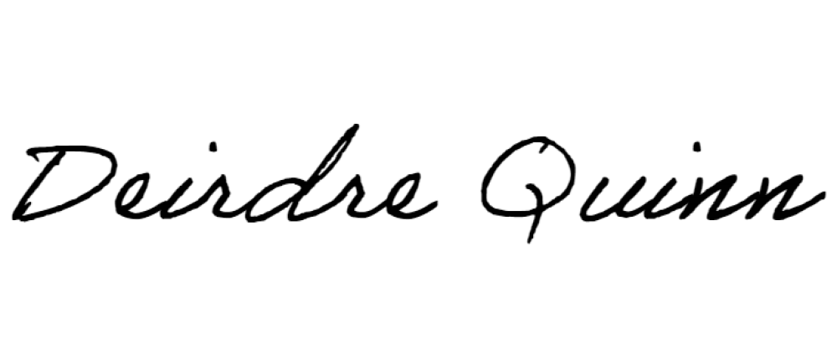
_____________________________
For and on behalf of Kin Company Secretarial Limited
Company Secretary, North Atlantic Smaller Companies Investment Trust Plc

