Premier Foods plc

Incorporated in England & Wales, number 05160050

Registrable resolutions passed at the General Meeting 2021

The following special resolution was duly passed by the requisite majority at the General Meeting of Premier Foods plc (the “Company”) held on Monday 11 January 2021.

Resolution 1.

THAT the share premium account of the Company be cancelled.

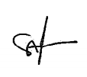

Simon Rose
General Counsel & Company Secretary

11 January 2021

