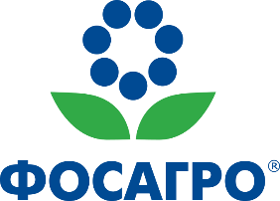

PhosAgro Publishes Integrated Annual Report for 2024

**Moscow –** PJSC PhosAgro (MOEX, LSE: PHOR), one of the world’s leading vertically integrated phosphate-based fertilizer producers, announces the publication of its Integrated Annual Report for 2024.

PhosAgro’s Board of Directors gave the report approval at a meeting on 17 April 2025.

The report is now available to view or download in PDF format on the Company’s website at www.phosagro.ru. An English-language version of the report will soon be available through the National Storage Mechanism: <https://data.fca.org.uk/#/nsm/nationalstoragemechanism>.